


SEPA guidance:
How to fill in your Landfill Emissions Return
Version 2.0 August 2025
IND-LF-G-014

This guidance has been updated to meet accessibility standards and to replace certain references to legislation with references to the Environmental Authorisations (Scotland) Regulations 2018. It has not been reviewed beyond this. We are aware that sections of this guidance may need to be updated, and this work will be completed in due course.

Contents

How to fill in your data submission 2
Site information 2
Monitoring Data 3
Landfill Gas Volumes 3
Discharge flow rates and volumes 4
I take monthly samples. How do I record this? 5
The table doesn’t have enough rows to include all my monitoring 5
The table has more rows than I need 6
The table has more parameters than we monitor for compliance limits 6
I have made a mistake – how do I fix it? 6
I was unable to collect a sample– how do I record this? 6
My sample is below the limit of detection – how do I record this? 6
If you would like this document in an accessible format, such as large print, audio recording or braille, please contact SEPA by emailing equalities@sepa.org.uk

How to fill in your data submission
The data returns spreadsheet has several worksheets (tabs) at the bottom for different types of monitoring data. They are: Perimeter Landfill Gas, Leachate Depth, Treated Leachate Effluent, Surface Water Discharge, Groundwater, Landfill Gas Flare, Landfill Gas Utilisation, and Landfill Gas Volumes. There is also a worksheet for ‘Site information’.
Please check our website before completing the Landfill Emissions Return form to confirm you have the latest version, as we may make changes to the form. We will do our best to keep any changes to a minimum. Once you have filled in your monitoring results, send the spreadsheet to landfill@sepa.org.uk.

Site information
This information allows us to identify which site the monitoring data is for and includes operator name, site name, permit number, which reporting period the data is for and contact details for the person filling in the form. The reporting periods are repeated in Table 1 below.
Table 1: Reporting periods for landfill emissions data returns
Quarter | Reporting Period | Submission Deadline
1 | 1 January – 31 March | 15 May
2 | 1 April – 30 June | 15 August
3 | 1 July – 30 September | 15 November
4 | 1 October – 31 December | 15 February

Please ensure the authorisation number is in the format PPC/X/0012345 or your EASR authorisation reference number, i.e. all 7 digits are included. An incorrect format will return an error message.
You will need to identify which authorisation conditions relate to the monitoring data you’re submitting, for example Condition 6.2.1, 8.4.1, 8.5.1, 8.6.2, 10.5.1, etc. Please note that you are only being asked to submit monitoring data for the parameters and frequencies as required by your authorisation for that specific reporting period.

Monitoring Data
Each type of monitoring data has its own separate tab at the bottom. If your site does not have a particular type of emission (for example leachate is taken off-site by tanker and not discharged) leave the relevant tab blank.
Each worksheet contains a table. This is where you fill in the monitoring results for your monitoring points, as required by your permit.
With the exception of gas volumes, you only need to report monitoring data that has a compliance limit against it. You can find the compliance limit for leachate depth in the ‘Infrastructure’ schedule of your permit and the limits for gas flares and utilisation in in the ‘Environmental Monitoring and Discharge Locations’ schedule. All other limits are in the ‘Environmental Limits’ schedule of your permit.
You must enter the correct monitoring point ID as defined in your authorisation or Management Plan unless agreed otherwise, followed by the date the sample was taken including day, month and year. Add the results for each parameter into the correct column, taking care to ensure the units match those at the top of the column (e.g., mg/l or µg/l) as shown in Figure 1 below.
Figure 1: Filling in emissions monitoring results
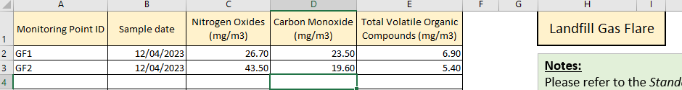

Landfill Gas Volumes
This only needs to be filled in once a year, at the end of Q1, for the whole previous calendar year. That means in May 2024, you need to fill in the landfill gas volumes for 2023. To complete this section, you need to know how much landfill gas has been flared or utilised in your engines, what the average concentration of Methane (CH4) is in the gas, how many hours your flares and engines have been running and the average flare flow.
If you have several engines/flares that utilise gas from different parts of your landfill, please complete a separate row for each area of the landfill with the corresponding CH4 concentration.
This data is collated for all landfills and sent on to the National Atmospheric Emissions Inventory (NAEI) on behalf of Defra and BEIS.

Discharge flow rates and volumes
For the treated leachate and surface water discharges, we ask for the maximum flow rate and the maximum daily volume. The maximum flow rate should be a snapshot for the day the samples were taken or the 24hrs leading up to the sample. For example, if your samples are taken on 23 August at 2pm, the maximum flow rate should be the highest flow rate measured either between 0:00 and 23:59 on 23 August, or between 2pm on 22 August and 2pm on 23 August.
The maximum daily volume should be the maximum measured during a month, either 30 days leading up to the sample being taken or the calendar month in which the sample was taken. For example, if your samples are taken on 23 August, the maximum daily volume should be the highest daily volume measured either between 24 July and 23 August, or between 01 August and 31 August. You should submit only the volume for the day that had the highest daily volume in that period.

Frequently Asked Questions

I take monthly samples. How do I record this?
You will have to enter the monitoring results for each month in a separate row. Start by typing the correct monitoring point ID as specified in the Authorisation or Management Plan, adding the date the sample was taken in the next column, followed by the monitoring results. Repeat this for each sample that was taken at the monitoring point, then move on to the next monitoring point as shown in Figure 2 below. Alternatively, you can enter all samples taken during the first month/sampling round, then move on to the next month/sampling round.
Figure 2: Recording monthly emissions samples
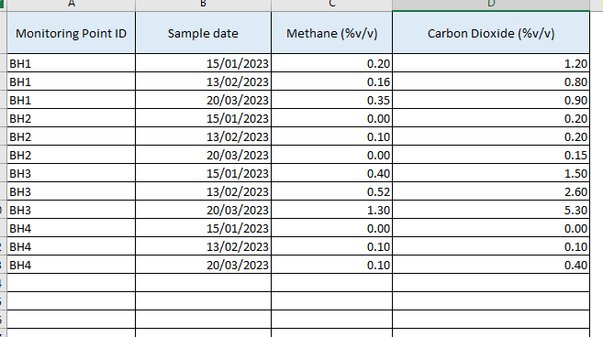

The table doesn’t have enough rows to include all my monitoring
Select the last row of the table. Right-click, then select ‘Insert’. A new row will be inserted in the table. Repeat until you have enough rows for your monitoring data. You can insert several rows at once by selecting multiple rows before inserting new rows.

The table has more rows than I need
If a table has more rows than you need for your monitoring data, leave the remaining rows blank.

The table has more parameters than we monitor for compliance limits
If there are any parameters in the table that you are not required to monitor or do not have a compliance limit for in your permit, leave these columns blank.

I have made a mistake – how do I fix it?
If you have made a mistake, you can click on the cell(s) containing the mistake and press ‘delete’ on your keyboard. This removes the content from the cell without deleting the cell itself.
To delete a whole row from your table, select the row by clicking on the number to the left of the row. Right-click somewhere in the row. In the menu that pops up, select ‘delete’ to remove the row, or ‘Clear contents’ to remove what you had typed in this row. Be careful not to delete the wrong row.

I was unable to collect a sample– how do I record this?
Complete a row for the borehole and month in question. Leave the monitoring result blank, this way we know an attempt was made to sample. You may wish to supply the reason for the missing sample result separately by email, and include it in your Annual Monitoring Report.

My sample is below the limit of detection – how do I record this?
If your sample has been reported as being below the limit of detection, please report this as 0. We may review this position in the future if it becomes necessary.

This guidance has been updated to meet accessibility standards and to replace certain references to legislation with references to the Environmental Authorisations (Scotland) Regulations 2018. It has not been reviewed beyond this. We are aware that sections of this guidance may need to be updated, and this work will be completed in due course.

Disclaimer
This guidance is based on the law as it stood when the guidance was published.
Whilst every effort has been made to ensure the accuracy of this guidance, SEPA gives no warranty, covenant or undertaking (express or implied) regarding the fitness for purpose of, or any error, omission or discrepancy in this guidance. Reliance on its contents and the contents of any websites that are linked to or from this guidance is entirely at the user’s own risk. SEPA is not liable for any loss or damage that may come from using this guidance. This includes:
- any direct, indirect and consequential losses
- any loss or damage caused by civil wrongs, breach of contract or otherwise.
SEPA reserves the right to depart from this guidance and take appropriate action as it considers necessary or appropriate. Operators are responsible for ensuring that they are compliant with the law. If necessary, independent legal / specialist advice should be sought.

