


WAT-G-027

EASR Guidance
Version 1.0 August 2025
Maintenance, replacement and removal of existing engineered structures

Contents
1. Purpose 3
2. Introduction 3
3. Understanding maintenance, replacement and removal activities 3
3.1 Maintenance and/or partial replacement (less than 50%) 5
3.1.1. Prior authorisation is not required 5
3.2 Replacement of 50 per cent or more 6
3.3 Removal 6
3.4 Key parts of a watercourse and loch 7
3.5 What are the potential issues 8
3.5.1 Risks to the water environment 8
3.6.2 Climate change 10
4 Good practice 11
4.1 Good practice key issues 13
4.1.1 Maintenance or replacement of an existing engineering structure 13
4.2.3 Removal of an engineering structure 19
Appendix 1 examples: maintenance, replacement and removal 22
1. Bank works - examples 22
1.1 Authorisation usually not required 22
1.2 Authorisation likely to be required 23
2. Crossings and instream structures - examples 24
2.1 Authorisation usually not required 24
2.2 Authorised by General Binding Rule activity 6 25
2.3 Authorised by General Binding Rule activity 14 25
2.4 Authorisation likely to be required. 25
Disclaimer 27

If you would like this document in an accessible format, such as large print, audio recording or braille, please contact SEPA by emailing equalities@sepa.org.uk

Purpose
This document provides information and guidance for anyone undertaking the maintenance, replacement, or removal, of an existing engineered structure (excluding impoundments) in or in the vicinity of inland surface waters and details when authorisation is required by SEPA under the Environmental Authorisation (Scotland) Regulations 2018, (EASR).

Introduction
This guidance sets out our regulatory approach to maintenance, replacement and removal of existing engineered structures. It demonstrates Good Practice requirements and will help you select sustainable engineering solutions that minimise harm to the water environment. This focuses on the environmental aspects that should be considered when undertaking a project. Using this document will help with the process of obtaining an authorisation for engineering works. It is not intended as a technical design manual, and it is important to recognise that any engineering works must be designed to suit site specific conditions.
This guidance does not cover any other permissions that may be required.

Understanding maintenance, replacement and removal activities
Maintenance and replacement of an existing engineered structure, means any work needed to keep structures in the state of repair necessary to ensure that they can continue to serve their normal, intended functions.
Removal refers to the taking away of all (or part) of an existing engineered structure, with no replacement structure being put in place. This includes the restoration of the bank and bed where the structure used to occupy.
Engineered structures includes all types of crossings, culverts installed for land gain, instream structures, bank protection and other bank work structures such as steps, ramps and embankments and floodwalls which are located on the bank top or in the in the vicinity zone.
The authorisation requirements for maintenance and replacement of existing engineered structures depends on the degree of change to:
- The footprint of the existing structure.
- The activity type.
- Physical character of the watercourse or loch.
Many routine and small-scale maintenance and replacement works will not require prior authorisation as most will meet all the criteria set out in section 3.1. Where this is the case, these can proceed by following good working practices and adhering to relevant general binding rules to prevent or minimise harms.
Authorisation is always required for the removal (full or partial) of an existing engineered structure at a level specified by the type and scale of the activity being removed.
Our regulatory approach to maintenance, replacement and removal of existing engineered structures can be divided into three different groups.
- Maintenance and/or partial replacement (less than 50%) ( section 3.1).
- Replacement of 50 per cent or more (section 3.2).
- Removal (full or partial) (section 3.3).
Details on these are set out in the sections below, with examples provided in Appendix 1

3.1 Maintenance and/or partial replacement (less than 50%)
This section sets out the conditions under which prior authorisation is not or is required when undertaking maintenance or partial replacement of an existing engineered structure.

3.1.1. Prior authorisation is not required
Prior authorisation (by registration or permit) is not required for maintenance or replacement works (less than 50%) of an existing engineered structure where all the criteria below are met:
- There is no increase in existing footprint*.
- The structure remains the same structure type**.
- There are no alterations to the bank height (see figures 1 and 2).
- There are no alterations to the natural bed level (see figures 1 and 2).
- There are no alterations to the channel width (see figure 1).
Footnotes:
*Footprint is the length, width and area of a structure in its most recent form. Note that new bed reinforcement occupying less than or equal to 10% of channel width at an existing structure can be undertaken provided the work complies with the relevant General Binding Rule (GBR14).
**The structure type must remain the same. For example, a clear span bridge with natural bed, cannot have an artificial bed or have instream piers installed. Likewise, low impact bank protection (green / soft) cannot be made into high impact (grey/ hard) bank protection.
Where prior authorisation is not required you must comply with:
- Water General Binding Rule (GBR) 7 for the installation and removal of any temporary: crossings, structures or works, and
- Water GBR 9 for the operation of any vehicle, plant, or other equipment in or near any surface water or wetland.

3.1.2. Prior authorisation (by registration or permit) is required:
- Prior Authorisation is required (as specified by the type of activity and its scale) for any maintenance or replacement of less than 50 per cent of a structure that cannot meet any of the criteria listed above; or
- Any replacement of 50 per cent or more.
For example, where maintenance works involved repairing damaged bank works but also increasing the length (increasing the footprint) of existing registration scale bank protection from 30m to 40m a registration application for a bank works would be required.
Some examples of maintenance of existing engineered structures are set out in Appendix 1

3.2 Replacement of 50 per cent or more
The replacement of 50 per cent or more of an existing structure requires authorisation at the level specified by the type of activity and its scale.
For example, the replacement of 70 metres of damaged rip rap bank protection, which is 120 metres long (i.e., 58% of the overall length), requires a Permit application for ‘Any Other Bank Works’.
Some examples of replacement of whole or part replacement are set out in Appendix 1

3.3 Removal
All removals, (including partial removal) where no replacement structure is put back in place, will require authorisation at a level as specified by the type of activity and its scale:
- A registration is required for the removal (full or partial) of any Water GBR or registration scale engineered structure. This registration covers any type of engineered structure.
- Permit is required for removal of any permit scale engineered structure or where the standard conditions of a registration removal activity cannot be complied with. This should be applied for on the relevant activity type application form. E.g. removing a bridge with piers an application should be made on the crossings permit application form.

3.4 Key parts of a watercourse and loch
Key parts and terms of a watercourse and loch are shown in Figures 1 and 2 below.
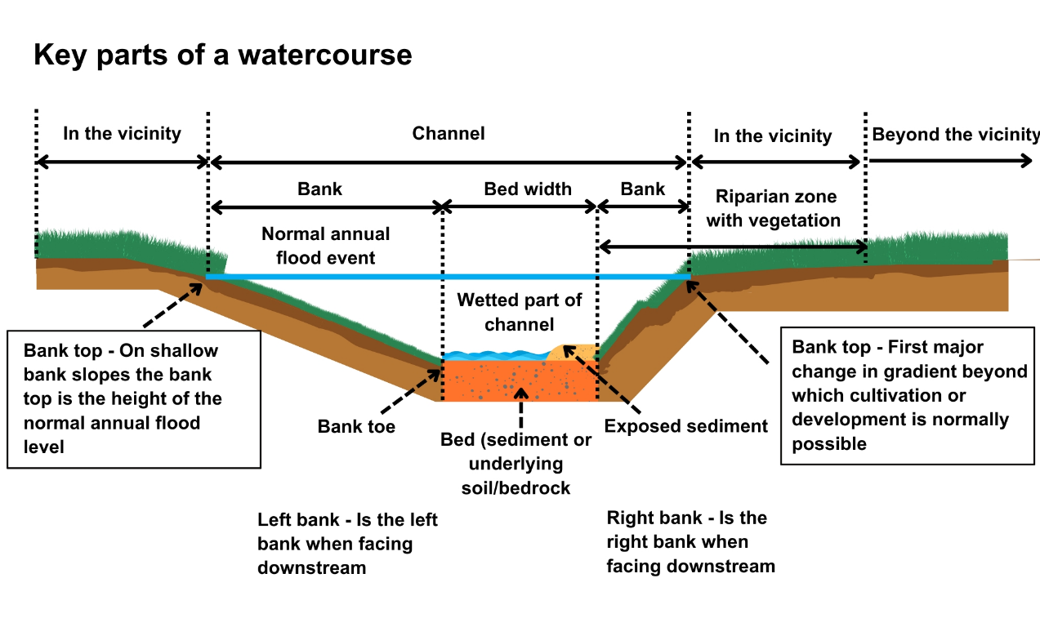
Figure 1 Key Parts of a Watercourse
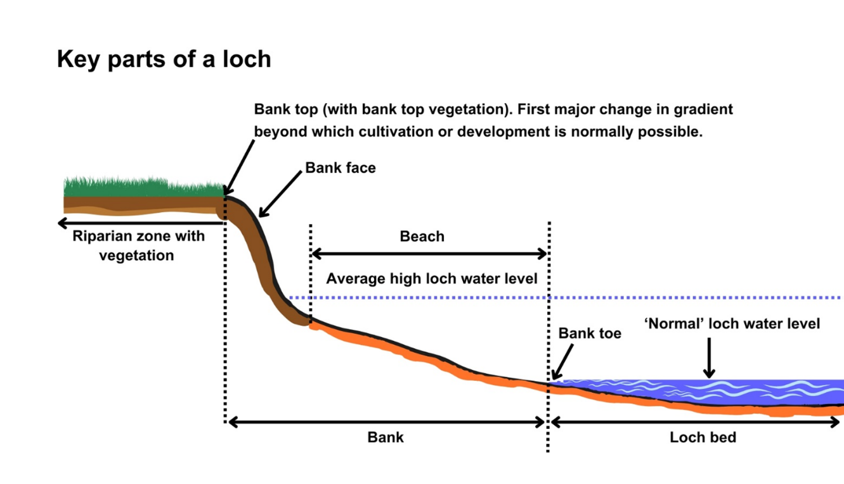
Figure 2 Key Parts of a Loch

3.5 What are the potential issues
Carrying out any engineering works and any associated construction and temporary works, including works such as access and temporary crossings, can pose risks of harm to the water environment. It is important to carefully consider your design and construction options to ensure risks to the water environment and other users are minimised.
Potential issues from maintenance and replacement are linked to the activity type (bank works, crossing, culvert installed for land gain or instream/in-loch structure) and the scale of the works taking place. You should consult the relevant activity guide for activity specific risks. General risks from working in or near watercourse and lochs are set out in the section below.
Potential issues when removing an existing engineering structure primarily relate to:
- The restoration and reinstatement of the area directly affected by the removal.
- The upstream and downstream impacts, which could take place after the removal.
For example, the removal of a bridge with piers will disturb the riverbed and this could affect the movement and deposition of sediment.
Where structures are removed with the aim of improving the morphology of the river, (e.g. removing a culvert or bed reinforcement which is an impasse to fish) can lead to unexpected adjustments to the banks and bed and risk knick point migration (especially in a high energy rivers). To avoid such impacts assessment and advice by geomorphologists is always recommended prior to carrying out the removal.

3.5.1 Risks to the water environment
The main risks to the water environment from carrying out this activity can be grouped as follows:
Harm to fish
This including impacts on fish migration, spawning and fry development, loss of habitat and direct impacts such as stranding or physical damage.
Scheduling the timing of works to avoid fish spawning times and fish emergence times. Key fish species to consider include salmon and trout (normally October – May), lamprey species (normally March – July). However these times can vary and you should contact Fisheries Management Scotland if you are unsure what fish species are present or what times should be avoided.
Temporary works such as crossings, channel isolation or diversions, blasting, vibration or pile driving, sheet pilling or using artificial lighting at night can affect fish or migrating fish. You should carefully manage these works to minimise any impact and carry out fish rescues, where appropriate.
For more information see WAT-G-032 EASR Guidance: Fish Protection
Physical impacts and pollution
Physical impacts to the bed and banks of the watercourse which can lead to instability resulting in increased erosion or deposition, loss of habitats and increased flood risk.
Carefully managing construction works is essential to prevent and minimise pollution from sedimentation, leaking oil from machinery and the entry of potentially polluting materials into water such as unset concrete.
Sites should be restored following works to management impacts from disturbance.
Further information on construction works and mitigation can be found in WAT-G-034 EASR Guidance: Construction works and silt/pollution mitigation.
Invasive non-native species
Any Invasive Non-Native Species (INNS) present in or adjacent to site could have the potential to spread. You should identify and plan works with adequate biosecurity measures in place to prevent any spread of INNS. Further guidance can be found in EASR-G-001 EASR Guidance: Invasive non-native species (INNS)
Protected areas and species
You should identify any Protected areas (e.g. SSSI, SAC, SPA) in or adjacent to site and consider any impacts from the works on Protected species such as freshwater pearl mussels and otter. You should contact NatureScot where your activity is in a Protected area or may impact protected species. For further information see WAT-G-008 EASR Guidance: Assessment of impact on Protected areas from inland water activities.
Impacts to other users of the water environment
There could be potential impacts on other water users such as water supplies, fishing, water sports.
All the risks to the water environment, as detailed above, will vary according to:
- The type and design of the engineering activity
- The timing of the works.
- The working methods and mitigation.
- The reinstatement methods.

3.6.2 Climate change
Climate change is already affecting Scotland’s rivers and lochs. Climate change predictions indicate there will be significant increases in winter precipitation over the coming decades, which suggests that large floods will occur more frequently. Summer rainfall is also likely to become more intense.
These changes are making rivers more powerful, which means they will have a greater ability to erode their beds and banks, transport sediment, move from side to side on their floodplains and adjust their planform. These changes are a river’s way of dissipating the excess energy of floods.
Changing flood frequency means that many channels will:
- Need to increase in size via bed and bank erosion to accommodate larger volumes of water before spilling on the floodplain and,
- Have more energy and a greater ability to erode their beds and banks, transport sediment, and adjust their planform.
Any new engineering works should recognise these changes by dissipating energy and provide space for a degree of natural adjustment and not overly constrain rivers. Works that either ignore or attempt to resist rather than to dissipate excess flow energy are more likely to
- Fail, potentially damaging infrastructure,
- Require more maintenance and higher ongoing costs,
- Damage species and habitats and
- Pose a greater threat to surrounding land uses upstream of, within, and downstream of the footprint of the works.

4 Good practice
All engineering works should follow the principles of Good Practice wherever possible. All permit applications must meet Good Practice to be granted.
Good Practice is achieved when the chosen option serves a demonstrated need, while minimising ecological harm, at a cost that is proportionate. Meeting Good Practice ensures that modifications to the morphology of rivers and lochs are sustainable.
A summary of the key steps in meeting good practice are set out in the box below:
Good practice summary
- Demonstrate need
- State the reasons for carrying out the activity and the benefits it will bring.
- Identify and understand the problem or need.
- Identify and appraise options
Use sustainable river management principles to:
- Identify a number of options (minimum of three, including do nothing)
- Carry out an options appraisal.
- Justify the selected option
- State why it represents the best practical environmental option.
- Use all reasonable mitigation
- State the mitigation measures you propose to minimise impacts.
- Submit method statement(s) detailing how the works will be carried out.
You should refer the relevant activity guides for the type of engineered structure you are maintaining, replacing, or removing for further details:
- WAT-G-022 EASR Guidance Engineering Activity Guide Bank Works;
- WAT-G-24 EASR Guidance Engineering Activity Guide Crossings; and
- WAT-G-25 EASR Guidance Engineering Activity Guide Instream and In-loch Structures)

4.1 Good practice key issues
Whilst the details on meeting good practice are set out in the relevant activity guides, as above, some key issues for maintenance, replacement and removal of existing engineered structures are set out below. Understanding these issues will help you to meet good practice.

4.1.1 Maintenance or replacement of an existing engineering structure
When considering the maintenance or replacement of an existing structure you should consider the following key issues:
- What purpose does the existing structure deliver (e.g. crossing for railway) and how significant is it (national infrastructure etc.)? Does it need to be maintained or replaced?
- What is the scale and significance of the damage?
  - If its small scale, can you consider doing nothing in the short term and monitor the situation in case the issue resolves itself through river adjustment?
- How did the structure get damaged? For example, through wear and tear, flood events, poor design, other nearby structures, etc.
- Is the existing structure poorly designed or poorly located? (see figures 3 and 4) For example:
  - Is the structure too small to cope with current flow conditions?
  - Have increases in flow velocity led to significant scour and damage? (see fig 4)
- Is the damage a one off or likely to continue?
- Does the structure have wider impacts on the environment? If so, you should consider addressing these by modifying or replacing it. For example:
  - Does the existing structure cause a barrier to the movement of fish and other wildlife?
  - Does the existing structure increase flood risks?
  - Will the existing structure cope with climate change impacts (e.g., increased flood frequency and intensity)?
- Has there been significant channel adjustment that has led to damage? (Figure 5) If so:
  - Will these adjustments continue and will your structure cope with them?
  - Can the cause of the channel adjustments be addressed alongside structure maintenance?
  - Rather than maintaining the structure, can you consider modifying or replacing your structure to better cope with channel adjustment in the future?
- If poor structure design has caused the problem in the first place you should consider replacing it with a better structure. Maintenance or like for like replacement will be harder to justify as meeting good practice. For example:
  - Failure to address the cause of the damage, is likely to lead to the structure being damaged again and ongoing maintenance commitments.
  - Cost is a consideration, but you should consider the full life costs, including ongoing maintenance.
  - Will options that address the cause of a problem, even if more expensive initially, be more effective and cheaper in the long term?
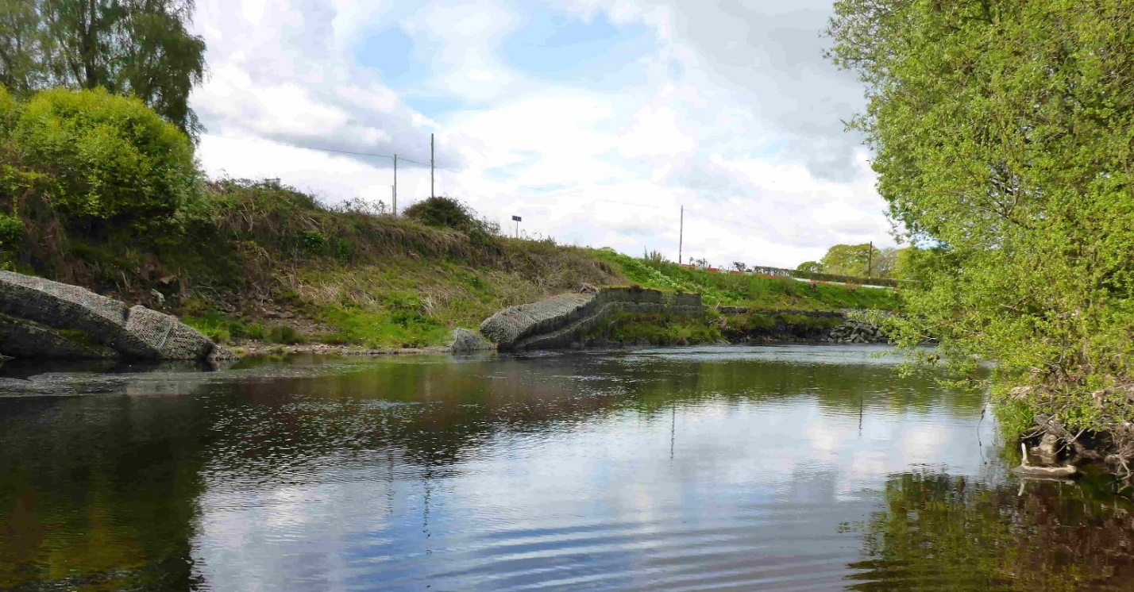
Figure 3 – Photograph of collapsed gabion baskets undermined by bed toe scour.
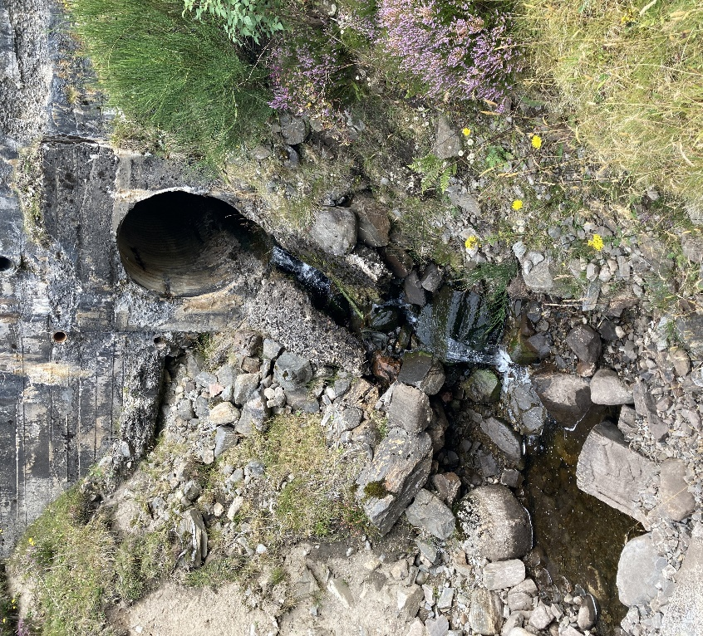
Figure 4 – Photograph of scour downstream of an undersized pipe culvert leading to undermining of the structure.

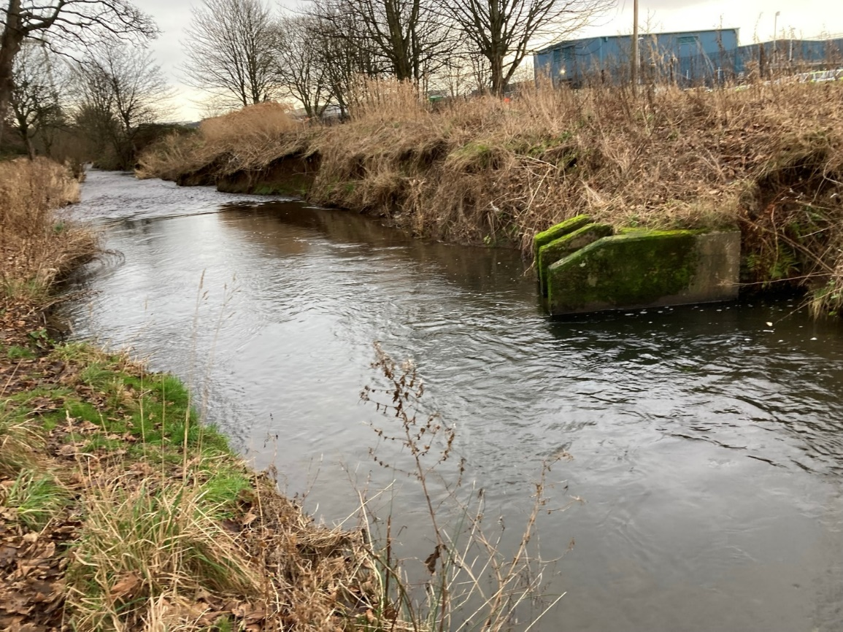
A
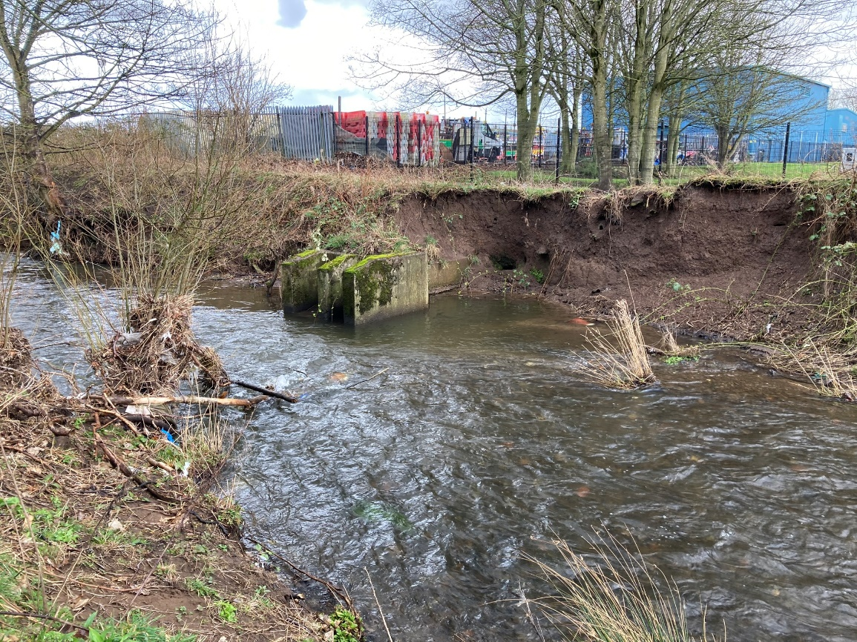
B
Figure 5A and 5B Photographs of bank erosion around outfalls initially caused by historic channel modification (A) but then intensified as the outfalls became more exposed (B).
Examples of how you might justify your chosen option for maintenance and replacement are shows in the boxes below:
Example of how you might justify maintenance of your structure:
- A bottomless arch culvert on a minor road is being undermined due to riverbed scour. This scour is probably caused by an undersized crossing leading to increased flow velocity.
- You can’t ‘do nothing’ because the structure will probably collapse in the short to medium term and is a necessary, but low use access route.
- You consider maintaining or replacing the structure but choose maintenance by underpinning the scoured footings.
- Although replacing the crossing would be the best environmental option, it is considered disproportionately expensive because:
  - The crossing has not had a significant impact on the surrounding river,
  - It is not creating a barrier to fish passage, and
  - Its undermining has been gradual, despite some significant high flows recently, suggesting maintenance may not need to be repeated in the short term.

Example of how you might justify replacement of your structure:
- A bottomless arch culvert on a major road is being undermined due to riverbed scour. This scour is probably caused by an undersized crossing leading to increased flow velocity.
- You can’t ‘do nothing’ because the structure will probably collapse in the short to medium term and is a major transport route.
- You consider maintaining or replacing the structure but choose to replace the structure.
- Although maintaining the structure would be the cheapest option in the short-term, replacement is not considered disproportionately expensive because:
  - Yhe crossing has had a significant impact on the surrounding river,
  - It creates a barrier to fish passage,
  - Its undermining has been due to frequent intense floods that could reflect a changing climate, and
  - Replacing the structure improves the environment, reduces maintenance burdens, and will be cheaper than maintenance over the long term.

4.2.3 Removal of an engineering structure
When considering the removal of an existing structure you should consider the following key issues?
- Where the structure is no longer serving a purpose, you should consider removing it to reduce your maintenance burdens and to improve the water environment.
- Before deciding a removal should take place you should consider the site characteristics and level of impact to the surrounding watercourse.
- You should produce a plan on how you will restore the river and surrounding areas post-removal.
  - At lower-risk sites, restoration may be limited to replanting of riparian vegetation.
  - At higher-risk sites, restoration may need to be more extensive. For example, the structure may have been stabilising the riverbed or banks (Figure 6).
- Removing the structure without appropriate channel restoration could lead to increased instability that causes problems elsewhere. This is likely to be a greater problem in higher energy reaches or locations where the bed and banks are less stable.
- You should assess whether an existing structure has led to an unnatural channel form around the structure (e.g., a step on the bed due to downstream incision). If so, you may need to consider whether more direct channel modification is needed to reduce the risk of instability. In these cases, you should refer to the channel modifications activity guide.
For example, the restoration at the site shown in Figure 6 created a step-pool channel. More information on the considerations needed for a step-pool channel can be found in WAT-G-023 EASR Guidance Engineering: Activity Guide: Channel modification. We recommend you engage a qualified and experienced fluvial geomorphologist to help develop your design.
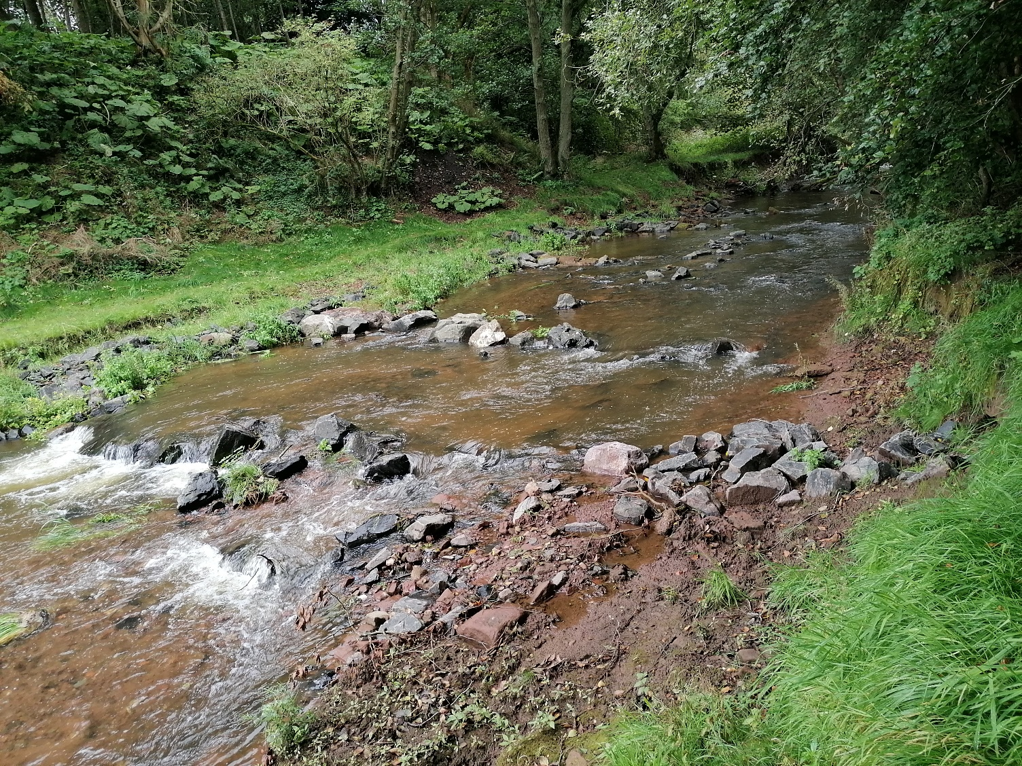
Figure 6 – Photograph of a site where a step-pool channel was created to ‘stabilise’ the river around a removed weir. Without these there have likely been channel instability
An example of how you might justify your chosen option for removal is shown in the box below:
Example of how you might justify removal of your structure:
- A pipe culvert for an access track is being undermined due to riverbed scour. This scour is probably caused by an undersized crossing leading to increased flow velocity.
- You can’t ‘do nothing’ because the structure will probably collapse in the short to medium term, and this may lead to other impacts in the water environment.
- You consider maintaining or replacing the structure but choose to remove it.
- Although maintaining the structure would be the cheapest option in the short-term, you chose to remove because:
- The crossing has had a significant impact on the surrounding river,
- It creates a barrier to fish passage,
- Its undermining has been due to frequent intense floods that could reflect a changing climate, and
- You no longer need this access track because a new road crosses the river elsewhere. Removing it improves the environment, and removes the maintenance burden, meaning it will be cheaper than maintenance over the long term.

Appendix 1 examples: maintenance, replacement and removal
Some common examples of maintenance, replacement and removal are listed below.
These are grouped by the main Activity types and listed in order of increasing level of authorisation control, note this is not an exhaustive list.

Bank works - examples
Examples of maintenance, replacement and removal for bank works are listed below:

1.1 Authorisation usually not required
- Any maintenance, replacement or removal of bank works on watercourses not shown on the 1:50,000 scale Ordnance Survey maps (Landranger series) do not require authorisation.
- Repointing a masonry retaining wall.
- Repair and replacement of section of failed rip rap (less than 50% of existing length) with new rip rap, no changes to overall footprint, bank height, channel width or bed level.
- Reinforcement or changes to an existing embankment, beyond the vicinity (more than the shorter of 10m or 2 channel widths from bank top) of a watercourse by addition of material on landward side of the embankment.
Authorisation is usually not required as SEPA does not require authorisation for existing embankments beyond the vicinity zone, unless changes are proposed that would adversely affect a wetland (which is dependent on a body of surface water). If in doubt, please check your proposals with us.
- Repairing (like for like) any length of existing embankments or existing flood walls, which are located within the vicinity (the shorter of 10 metres or 2 channel widths from the bank top) of a watercourse. The damage must have occurred within the last 18 months, and the repair must not increase the height or fundamentally alter the materials the embankment is made from.
- Replacing, heightening, lowering, or removing less than 500 metres (as measured along the bank) of existing embankments or existing flood walls which are located in the ‘in the vicinity zone’ (away from the bank top but no further than 10m or 2 channel widths from bank top, whichever is the shorter, from a watercourse).
- Note in all cases where authorisation is not required you must still comply with Water GBRs 7 and 9, where relevant.

1.2 Authorisation likely to be required
- Repairing a section of failed rip rap and extending the length by 10 metres. This increases the scale of the existing bank protection overall so authorisation is required.
- Modifying an existing concrete and boulder retaining floodwall to form a new shell tied to the old wall. For example, by drilling rebar into the existing structure, putting shuttering in front of this, and then pouring concrete behind that.
- Authorisation is required because it is changing the nature of the structure from one that had some energy dissipation features (i.e. roughness and voids) to a much smoother concrete wall. This could lead to altered hydraulics that have a greater impact on the water environment. The level of authorisation required depends on the type of activity and its scale. If a permit is required, it will need to meet the principles of good practice.
- Filling existing gabion wall baskets with concrete. Like example 7, authorisation is required because it is changing the nature of the structure from one that had some energy dissipation features (i.e., roughness and voids) to a much smoother concrete wall. This could lead to altered hydraulics that have a greater impact on the water environment. The level of authorisation required depends on the type of activity and its scale. If a permit is required, it will need to meet the principles of good practice.
- Complete removal of an existing masonry wall and replacement with a concrete wall.
- Authorisation required because replacements of 50 percent or more require a new authorisation according to the type of activity and its scale.
- Replacing willow spilling with rock armour. Authorisation required because the proposal changes the activity type from low to high impact bank protection and this would have a significantly different impact on the water environment. The authorisation required depends on the type of activity and its scale.
- Replacing, heightening, lowering, or removing 500 metres or more (as measured along the bank) of existing embankments or existing flood walls that are located within the vicinity (the shorter of 10 metres or 2 channel widths from the bank top) of a watercourse. Authorisation as a permit is required.

2. Crossings and instream structures - examples
Examples of maintenance, replacement and removal for crossings and instream structures are listed below. Details on many of these techniques can be found in CIRIA Culvert, screen and outfall manual (C786)

2.1 Authorisation usually not required
Usually no authorisation is required for the examples below, provided the works are of a scale that they do not change the nature and type of structure or change the overall footprint, bank height, bed level or channel width. If in doubt please check with us.
- Vegetation removal in or around a structure
- Repairing pointing on stone bridge (abutments and arch).
- Patch repairs such as filling scour in a concrete culvert invert with concrete but without changing bed level.
- Arch grouting/ ring stitching / grouting backfill.
- The installation of replacement joints and seals.
- Reinforcement works that do not affect the overall footprint of the structure. e.g. retro reinforcement, backfill replacement, underpinning, spandrel tie bars, pattress plates.
- Waterproofing and drainage improvements: bonded or loose-laid waterproofing membrane above the arch, expanding water reactive grout etc.
- Applying protective coatings or installing coated galvanised steel/glass reinforced plastic (GRP) sheets in a steel culvert or fusion welded patch repairs to plastic culverts.
- Replacing a broken trash screen does not require authorisation as long as the bar spacing is not reduced. Ideally it should not be less than that recommended in the CIRIA Culverts Screen and Outfall Manual (CIRIA C786) These alterations can affect fish passage and should be discussed with SEPA and the local district salmon fishery board before proceeding.
- Repairing an existing culvert using different materials (e.g., infilling base of eroded corrugated plastic pipe culvert with concrete) may not require authorisation because it normally doesn’t alter the flow dynamics. However, you should always check with SEPA.
- Repairing and/or replacing less than 50 percent of an existing engineered structure

2.2 Authorised by General Binding Rule activity 6
Complete replacement of single span footbridge with no part of the structure on bed or bank. An application for authorisation is not required provided the works can comply with Water General Binding Rules Activity 6, and General Binding Rules 7 and 9 (for any temporary works or the operation of vehicles, plant or other equipment in or near any inland surface waters)

2.3 Authorised by General Binding Rule activity 14
Adding new bed reinforcement that will occupy no more than 10% of the channel width and affect no more than 10 metres of channel length.

2.4 Authorisation likely to be required.
- Filling scour in the natural bed of an arch culvert with new concrete invert will require authorisation because it will change the nature and type of the activity and increase its footprint. The level of authorisation will depend on its scale.
- New debris deflectors to be cast on to existing bridge piers will require authorisation if the deflectors take up more than 10% of the bed width and will be considered a new instream structure activity. If the deflectors occupy less than 10% of the channel width then no authorisation would be required to modify these piers.
- A new trash screen on an existing culvert will require authorisation as a new instream structure if the trash screen is fixed to the bed of a watercourse or fixed to the invert of a culvert. Authorisation is required because the overall footprint of the culvert is increased. If the new trash screen was replacing an existing trash screen, like for like, and not decreasing the bar spacing then no authorisation would be required.
- Installing a liner into an existing culvert usually requires authorisation because the lining may reduce the size of the culvert, alter the flow dynamics and may affect fish passage.
There are many techniques which can be employed for this process (e.g. slip lining, lining with pipe segments, spray lining, cured in place lining etc.). The requirements for authorisation will depend on the relative change to the capacity (change in footprint of the structure) and flow dynamics of the culvert (fish passage/ sediment movement).
We recommended that all such proposals are discussed with us and the local district salmon fishery board before proceeding.
- Surface thickening of a culvert requires authorisation because the thickening will reduce the size of the culvert and alter the flow dynamics within it, which could affect fish passage and sediment transport.
- Replacing a road culvert (collapsed within last 18 months) with one of same type requires authorisation: Replacements of 50 percent or more of the existing structure require new authorisation according to the type of activity and its scale.
- Complete removal of old railway bridge would require new authorisation according to the type of activity and its scale.

Disclaimer
Whilst every effort has been made to ensure the accuracy of this guidance, SEPA gives no warranty, covenant or undertaking (express or implied) regarding the fitness for purpose of, or any error, omission or discrepancy in this guidance. Reliance on its contents and the contents of any websites that are linked to or from this guidance is entirely at the user’s own risk. SEPA is not liable for any loss or damage that may come from using this guidance. This includes:
- Any direct, indirect and consequential losses.
- Any loss or damage caused by civil wrongs, breach of contract or otherwise.
SEPA reserves the right to depart from this guidance and take appropriate action as it considers necessary or appropriate. Operators are responsible for ensuring that they are compliant with the law. If necessary, independent legal / specialist advice should be sought.

