


Scotland’s National Water Scarcity Plan
July 2020

Overview

This is Scotland’s first national water scarcity plan, setting out how water resources will be managed prior to and during periods of prolonged dry weather. This is to ensure the correct balance is struck between protecting the environment and providing resource for human and economic activity. It sets out:

- the high-level principles.
- what steps we and others are currently taking in preparation for periods of water scarcity.
- what assessment methods we will use to determine the most appropriate response to water scarcity.
- what action we will take during a period of water scarcity; what action we expect others to take.

Following consultation, SEPA has taken on board views from a range of interested parties and individuals and updated the plan accordingly. The plan will be reviewed as more experience is gained and tools are developed.

For information on accessing this document in an alternative format or language, please contact SEPA by emailing equalities@sepa.org.uk
If you are a user of British Sign Language (BSL), the Contact Scotland BSL service gives you access to an online interpreter, enabling you to communicate with us using sign language. contactscotland-bsl.org

Table of contents
1. Introduction 3
2. Impacts of Water Scarcity 4
3. Roles and Responsibilities 7
3.1 SEPA 8
3.2 Scottish Water 10
3.3 Scottish Government 11
3.4 Other Organisations 12
4. Deciding when to take action 13
4.1 Water Scarcity Level 13
4.2 Hierarchy of Action in Response to Dry Weather 17
5. Communication 39
6. Way Forward 41
6.1 Action Plans 41
6.2 Future Planning 42
Glossary 43
Annex 1 – Water Saving Advice 44
Annex 2 – Water Scarcity Indices 45
Annex 3 – Water Saving Measures 48
Annex 4 – Clarification of Criteria used to Determine Significant Water Scarcity 51

Update Summary
Version | Description
v1.1 | Revision to clarify when Significant Water Scarcity is reached (Annex 4) – July 2020.
V1.2 | Updated accessibility and template of the document – January 2025.

Introduction

Although generally considered a wet country, Scotland can be vulnerable to periods of dry weather, which can result in pressure upon the environment and water users in some areas. In addition, climate change is likely to bring uncertainty and, with a projected decrease in summer rainfall, may exert pressure in areas that have not yet experienced water scarcity.
It is vitally important that Scotland is prepared to deal with water scarcity both now and in the future and people work together to plan for and manage water scarcity events. This plan sets out how we will work with water users (authorised abstractors and recreational users) and key organisations, such as Scottish Water, to manage water resources during periods of low rainfall. All water users have a role to play to ensure that resources are used sustainably and the potential impact on the environment is reduced.
The tables in section 4 set out the high-level approach we would take with each sector to manage periods of water scarcity. Working closely with others, we may develop prioritised catchment specific triggers to better manage events at a local level (see section 6) where persistent problems occur.
We will review this plan in conjunction with the river basin management plans and will update it as required as we learn from experience of managing our water resources during periods of prolonged dry weather. The measures in the river basin management plans will reduce the pressure on water resources during dry periods by improving current significant pressures on the water environment. The steps set out in the water scarcity plan are in addition to those steps which alone may not be sufficient to protect the environment and key water supplies in prolonged dry periods.
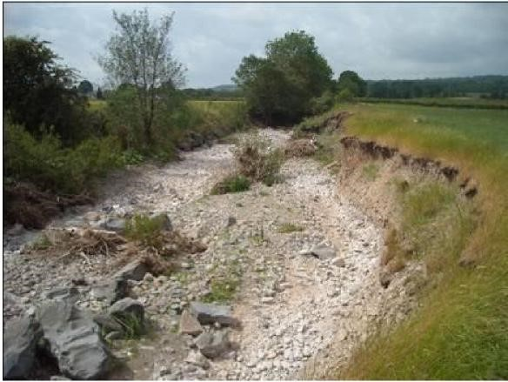

Impacts of Water Scarcity

Dry weather conditions causing low river flows and loch levels are natural and the ecology can generally adapt to the natural range of conditions. If dry weather is prolonged however, there comes a point where environmental impacts do occur, and this is exacerbated when water is abstracted. Fortunately, we are not subjected to regular long term and widespread dry spells in Scotland. However, we do sometimes see localised and short-term dry periods which can cause environmental problems, and put stress on public water supplies and private abstractions as seen in the mid 1970s, 1984, 2003 and 2008.

The impacts on abstractors will depend on the resilience of the systems within a particular area of the country. Areas with little storage (few or small reservoirs) will be affected by short dry periods, whereas groundwater and areas with greater storage can cope with longer dry periods before suffering from potential shortages. If an area rarely has extended dry periods then water resource supplies are often designed with less storage. Areas of the country which are more prone to dry periods may have more storage and may therefore be less vulnerable to short periods of dry weather.

As river levels drop, the depth and width of the channel will contract and flow velocities will reduce. This may fragment the river and reduce the suitable habitat space.

Over a longer time frame, lower rainfall will cause a drop in groundwater levels and spring flows
which could cause lowering of water tables in wetlands. Drier weather will also cause an increased deficit of moisture in soils meaning less runoff into rivers and a greater need to irrigate crops. Drier soils can also increase the risk of flash floods if heavy rain follows dry weather.

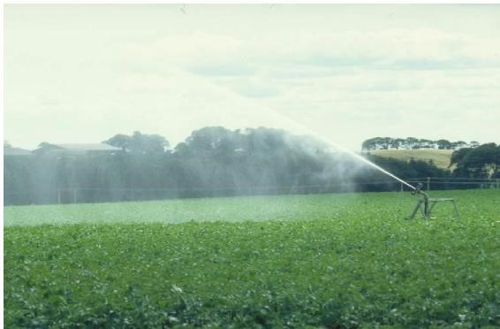

Fish populations can be affected in a number of ways. In very shallow rivers the oxygen content can fall (as the water temperature rises or through respiration by aquatic plants) causing fish kills. A low flow in a river may prevent migratory fish from moving upstream and disrupt food supplies by impacting on aquatic invertebrates.

Climate Change predictions suggest that summers in Scotland are likely to get drier, potentially leading to an increase in summer water scarcity. Figure 1 shows a decrease in summer rainfall of 10-20% with a smaller change in the extreme northwest.

Figure 1: Projected change in summer precipitation by the 2050s, showing the probability of drier summers under three scenarios.

Unlikely to be | Central | Likely to be
drier than this | projection | drier than this
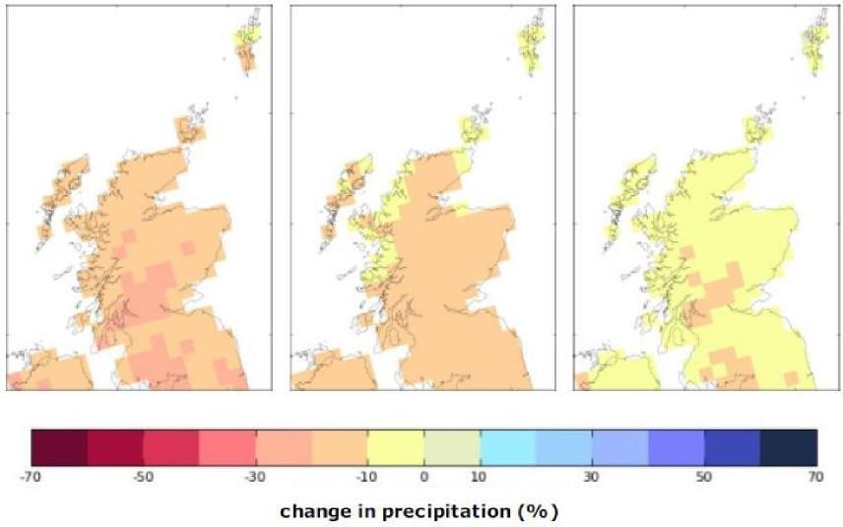

The Scottish Government has set out how Scotland should adapt to climate change whilst ensuring we achieve sustainable economic growth.

Visit the preparing for a new climate web page to find out more.

If Scotland is to experience warmer, drier summers, there may be more periods of water scarcity with implications for water resource management particularly in areas with limited water storage. Drier summer months will put river catchments under more pressure from abstractions, reducing the available resource for water users. Lower summer flows would also reduce the ability of rivers to dilute pollutants with the possibility of increased treatment costs for dischargers.

3. Roles and Responsibilities

The successful management of water resources requires collaboration of all stakeholders to minimise impacts during periods of water scarcity. Organisations, companies and individuals should plan in advance to ensure they have taken all the steps to enable them to respond in a manner that will minimise the effects upon the environment, themselves and others.

Households and businesses should always use water efficiently to limit pressure on water supplies and the environment. There are a number of useful sources of information regarding water saving advice for households and businesses which are summarised in Annex 1. These can lead to reduced energy consumption, lower costs and fewer greenhouse gas emissions. By further reducing water usage during dry periods, all water users can help extend the available resource.

Abstraction and impoundment activities are authorised under the Water Environment (Controlled Activities) (Scotland) Regulations 2011 (CAR). The Regulations include a duty to use water efficiently; therefore we expect best practice to be undertaken as part of daily operations.
Leakage and wastage should be kept to a minimum. The quantities of water abstracted should be the minimum required for that activity and techniques such as recirculation and water storage should be considered where appropriate. Any measure during a period of water scarcity should be in addition to day to day good practice.

SEPA encourages operators to have contingency plans if the supply is essential for the smooth operation of their business.

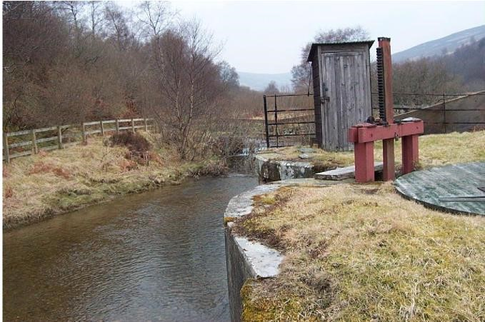

The following bodies are responsible for water scarcity management:

3.1 SEPA

SEPA’s key role is to protect the water environment. During dry periods, when the water environment comes under pressure, SEPA is required to balance the need for sustainable water use whilst protecting the environment.

Whilst protecting the environment, SEPA can also allow temporary deterioration to protect key abstractors, provided the circumstances are a result of prolonged water scarcity and all practicable steps are taken to prevent environmental impact and do not compromise the recovery of the environment.
During periods of dry weather SEPA will set up an internal Water Scarcity Management Group consisting of operational, science and communications staff to ensure decisions are made quickly using the most up to date information. SEPA monitors the ecology and water flows and levels of rivers and lochs throughout the year with more effort during periods of water scarcity. For example, during extensive dry periods SEPA will target increased monitoring to understand the impacts of low flows. The water scarcity indices described in section 4 combined with local evidence will determine what action to take. This information will be published on our website to allow people to act early and to show what action we are taking.
The Water Environment (Controlled Activities) (Scotland) Regulations 2011 (CAR)
SEPA regulates activities such as abstractions, impoundments, discharges and engineering works through CAR. Provisions under regulation 18 allow for a flexible approach to ensure swift but temporary action can be taken in emergency situations such as periods of water scarcity. This is commonly known as a Fast Track CAR variation and is explained here in the Scottish Government policy statement - Scottish Government policy statement - use of CAR 2011 emergency provisions and detailed here in the SEPA regulatory method - CAR 2011 - Emergency Provisions and Accelerated Determination

3.2 Scottish Water

Scottish Water monitors its water supply sources throughout the year to make sure sufficient resource is available to meet customer demand. During prolonged dry weather when supply levels drop, drought contingency plans are put in place to maintain a constant drinking water supply. Plans have been developed for key supply sources and further prioritised plans are being developed. This water scarcity plan reflects the high level approach used with those plans and the Scottish Water tables (Tables 5 and 6) are used primarily where a drought plan with specific measures has not been agreed with Scottish Water. Scottish Water works closely with SEPA and the Scottish Government to ensure that any changes to operating practice and new abstractions minimise the impacts on the environment and other users. Further work is being undertaken to assess areas which will be more vulnerable than others in the future.

In addition, Scottish Water will work with their customers to encourage water saving measures with further reductions considered during prolonged dry periods.

3.3 Scottish Government

The Scottish Ministers have established a clear policy and legislative framework to enable a balance to be struck between protecting public water supplies, the water environment and other users during periods of prolonged dry weather.

Water orders may be made by Scottish Water where needed to protect public water supplies.
As a period of prolonged dry weather continues, difficult decisions may have to be taken when there are competing priorities for water use. Ministers may issue a direction to SEPA, setting out how SEPA should use its powers to help deal with the emergency situation. Before issuing a direction, Ministers must take advice from SEPA and responses to any consultations with interested parties. Such action is most likely to be needed when water shortage has become widespread and severe and key water supplies have to be protected.

The Water Resources (Scotland) Act 2013

This sets out the legal framework for Water Shortage Orders. Part 7 of the act says:
- Scottish Water may propose to the Scottish Ministers that they make a water shortage order if it believes that there is;
- a serious deficiency of water supplies in an area, or
- a threat of a serious deficiency of water supplies in an area.
A Water Shortage Order may permit Scottish Water to carry out various actions such as to gain access to land to abstract from an alternative source or to impose water saving measures on organisations or individuals if deemed necessary, including the imposition of hosepipe bans.
The Water Resources (Scotland) Act 2013 can be found on the Scottish Government website here; The Act with a news briefing.

3.4 Other Organisations

In managing water scarcity, SEPA, Scottish Water and the Scottish Government take advice from other bodies, such as Scottish Natural Heritage (SNH), fisheries boards and trusts. Any proposal which could affect a designated site should be discussed with SNH at the earliest opportunity and actions which might affect the fish population should be discussed with the local fisheries trusts and boards. If the proposal is unlikely to damage the features of a SSSI or have a significant effect upon a European protected area or species then SEPA will consider authorising the application. Otherwise SEPA will consult SNH and if there is likely to be a significant effect on a European site or species, we will undertake an appropriate assessment and may refuse the proposal. It is critical therefore that potential impacts from any proposals are considered well in advance.

Deciding when to take action

Problems caused by dry weather happen gradually and measures taken early can lessen the effects or prevent them from occurring. SEPA has therefore developed a staged approach to ensure the action taken is proportionate to the severity of the event. Analytical tools and monitoring allow us to measure the severity of a dry period and act accordingly.
Other supporting local evidence such as ecological impacts (e.g. fisheries advice) water quality impacts, flow monitoring or feedback from authorised operators will be crucial to inform final decisions.
Following experience of applying these indices in 2018, the criteria used to determine Significant Scarcity have been amended. Please see Annex 4.

4.1 Water Scarcity Level

A water scarcity index is a measure of how exceptional a period of water scarcity is. SEPA has developed a water scarcity index to allow better planning and response to prolonged dry spells (see Annex 2) for more information on how it is calculated). This water scarcity index can be calculated using rainfall or flow data using departure from long term average figures and gives the following levels of warning:

Table 1: SEPA’s Water Scarcity levels
Normal conditions
Water scarcity early warning
Water scarcity alert
Moderate water scarcity
Significant water scarcity
Extreme water scarcity

The index can be calculated for different time periods. A 30 day index will be used for managing agricultural water usage and abstractions from rivers with little or no groundwater component. An index of 90 days picks up anomalies from the long term average and will assist with the early warning of water scarcity. This is a good compromise between using longer term data which won’t be sensitive enough to pick up changes in sources with little or no storage and using shorter term data (e.g. daily) which would not account for the effects of continued dry weather. SEPA will make use of the following indices:

Table 2: 30, 90 and 180 day indices
Indices | Purpose
30 day rainfall and flow | Managing abstractions from rivers, including agricultural abstractions.
90 day rainfall and flow | Early warning of possible water shortages and to assess supplies with storage.
180 day rainfall and flow | To assess cumulative impacts of longer term events.

For public water supply, the period used will vary according to the storage available and the ‘critical period’ (length of time a reservoir takes to empty in its driest year). A similar approach would be taken for other users with storage reservoirs.

Where appropriate, we would also use rainfall forecasts and soil moisture deficit in conjunction with water scarcity indices to provide early warning of a likely impact as shown in Table 3 below. A catchment in the alert index alone will not be as at risk if the soil moisture deficit is low and rainfall is also expected. This is especially relevant for agricultural catchments where drier soils mean an increased requirement to irrigate crops.

Table 3: Indication of soil moisture deficit and forecasted rainfall in relation to water scarcity
Level | Flows index |  | Rainfall index |  | Soil moisture deficit |  | Rainfall (in 5 day forecast)
Normal conditions | <0.25 |  | <0.25 |  | 0-20mm |  | N/A
Early  Warning | 0.25 |  | 0.25 |  | 20-60mm |  | <30mm
Alert | 0.5 |  | 0.5 |  | 60-100mm |  | <30mm
Moderate scarcity | 1.0 | OR | 1.0 | + | >100mm | + | <50mm
Significant scarcity | 2.0 |  | 2.0 |  | >100mm |  | <50mm
Extreme water scarcity | 2.5 |  | 2.5 |  | >100mm |  | <50mm
Returned back to normal | <0.25 |  | <0.25 |  | 0-20mm |  | N/A

The water scarcity data provides us with early warning and context to assess the likely severity of an event. However the final decision to amend a CAR authorisation to limit abstraction rates to protect the environment or to allow more abstraction to maintain supplies will be based on additional local factors (see figure 2).The information will include data and expertise from third parties such as fisheries interests and operator data to explain current water levels within a reservoir for example. The indices also act as a trigger for further investigation such as catchment visits and increased monitoring and reporting.

Figure 2: The main factors used in the decision to amend a CAR authorisation

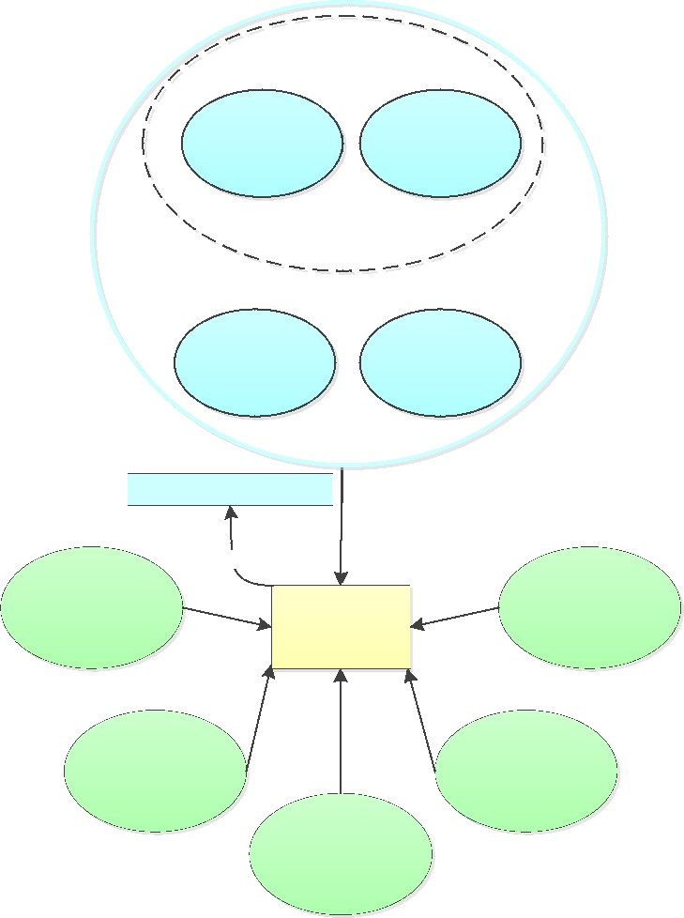

Water scarcity index

Flow Index

Rainfall index

+

+

Rainfall forecast Soil moisture deficit

Water scarcity level

experience

Water level and
monitoring

Factors used in
decision making

Reservoir levels

Ecology monitoring
and assessment (inc
environmental

standard)

Impact on abstractors

Impact on water users

4.2 Hierarchy of Action in Response to Dry Weather
There are various measures which can be taken to reduce the effects and limit the impact on the environment and people. We would expect all stakeholders to act responsibly and to work together to minimise the impacts and prolong the available resource. In the majority of cases it is expected that prior consideration of water resource management options should improve the reliability of water supplies and reduce environmental impact.
We strongly encourage operators to minimise water use as far as possible as outlined in Annex 3 and draw up contingency plans for managing resources during periods of water scarcity to minimise the impact upon their business. The plans should also look ahead to build in resilience to possible effects of climate change (see section 6). Effort should be prioritised based on environmental risk and impact on business.
As the effects of dry weather become more severe it may be necessary for us to progressively review authorised abstraction volumes and compensation flows from dams to mitigate impacts on people and the environment, using Regulation18 of the Water Environment (Controlled Activities) (Scotland) Regulations 2011 (CAR). The decision to implement the most appropriate solution set out in Tables 4 - 8 will be based on a mixture of available information including the water scarcity level explained in the previous section together with local data, knowledge and experience.
Once the level of risk drops we will progressively remove restrictions on abstractors and remove any changes put in place to protect the environment or public water supplies.
It is important that operators maintain enough storage to meet the conditions set out in their authorisation. If an operator is having frequent problems with securing sufficient water during dry periods then we would welcome discussion of alternative sources or encourage consideration of alternatives such as water re-circulation or water storage.
This is the first water scarcity plan in Scotland so we will learn from specific events and update our approach accordingly. During a period of water scarcity we will review the situation frequently to ensure measures are taken early to limit the impact on the environment and water users at that time and until conditions recover.
Tables 4 - 8 below have been developed by SEPA to show an indicative hierarchy of actions for different sectors. The tables summarise the main steps likely to be involved but do not provide an exhaustive list of every possible action. As the situation improves SEPA will gradually remove any restrictions put in place.

The steps are designed to trigger the consideration of action rather than being automatic. Each event will be a result of a combination of factors so it is important to allow flexibility to take those on board. Some steps may be more appropriate to bring forward and others to put back. For example, a CAR emergency notice may be issued sooner in a flashy catchment where alternative supplies are limited and the abstraction is key, e.g. a public water supply on a remote island. Similarly some steps are more appropriate in certain scenarios than others. E.g. environmental constraints may limit alternative supplies.

Any changes to CAR authorisations, to allow more abstraction, restrict abstraction or to modify mitigation requirements will be evidence based using local knowledge and data.

Steps such as leakage reduction are in addition to good practice.

Table 4: Hierarchy of action in response to dry weather – Generic (not covered by other tables) (states action in addition to previous level)
Level | Action | When level triggered  (conditions expected) | Abstractor response | SEPA action
Normal conditions | Planning | - Flows giving no cause for concern;  (<0.25 water scarcity indices); and  - Low soil moisture deficit. | - Routinely implement water saving measures.  - Create contingency plan. | - Monitor water scarcity indices, soil moisture levels, river and loch levels and ecology.  - Issue monthly situation report.  - Develop action plans.
Early Warning | Minimising water use | - Low flows (0.25 - water scarcity indices); and  - No notable rain in forecast; and  - Medium soil moisture deficit. | - Further checks that equipment is not leaking.  - Consider upcoming water requirements (e.g. scheduling batch processes). | - Web page updated as source of information to operators /media/public.  - Raise awareness with abstractors/associations to say care may need to be exercised.
Alert | Staggering abstractions within the same catchment | - Low flows (0.5 - water scarcity indices); and  - No notable rain in forecast; and  - High or very high soil moisture deficit. | - Where there are multiple abstractions in the same catchment, work with other abstractors to allocate different times to those abstractions if conditions worsen.  - Consider reducing the volume/rate of abstraction.  - Consider alternative sources where limited environmental impact. | - Set up Water Scarcity Management Group.  - Start to plan visits to impacted rivers to assess situation.  - Draft situation report for webpage  - Notify operators that abstractions may be staggered if conditions worsen.  - Initiate catchment meetings with abstractors (if Moderate levels occur).  - Consider use of emergency provision notices for impacted catchments.  - Assess applications for fast track CAR emergency provisions.
Moderate scarcity | Limiting abstraction or, if possible, switching to alternative sources | - Very low flows (1.0- water scarcity indices); and  - No significant rain in immediate forecast; and  - High or very high soil moisture deficit; and  - Evidence of developing impacts. | - Reduce the volume/rate of abstraction.  - Reduce the duration of abstractions.  - Switch to an alternative source, if available within current authorisation (e.g. groundwater).  - Switch to previously identified sustainable alternative sources. | - Target ecology surveys and visit impacted catchments.  - Hold catchment meetings with abstractors.  - Draft/issue CAR emergency provision notices for impacted catchments.  - Limit the rate of abstraction (e.g. limit the volume that can be abstracted in a period)  - Limit the duration of abstractions.  - Ensure public awareness of developing situation through advising the media.
Significant scarcity | Temporarily suspending abstraction | - Very low flows (2.0 - water scarcity indices); and  - High or very high soil moisture deficit; and  - No significant rain in forecast; and  - Increasing evidence that extensive impacts are developing. | - Where possible switch to alternative supplies following discussion with SEPA.  - Prepare for potential impacts on your business if the period of water scarcity continues. | - Consider further limitations of abstraction rate or temporary suspension of abstractions as necessary to protect key water supplies and the water environment.  - Arrange update meetings with abstractors in impacted catchments.  - Issue CAR emergency suspension/variation notices as required for impacted catchments to protect the environment.  - News release to local and national press.
Extreme water scarcity | Protect key water supplies | Widespread impacts;  - Very lows flows (3.0 - water scarcity indices); and  - Very high soil moisture deficit; and  - Evidence of extensive impacts such as river fragmentation or fish being stranded. | - Expect impacts on your business due to water scarcity. | - The primary focus for SEPA will be protecting key water supplies and the environment.  - Emergency powers will be used to secure alternative supplies to avoid public water supply sources being compromised by other abstractions.
Returned back to normal | Post event | - When levels drop below 0.25 on water scarcity indices and conditions return to normal. | - Use the recent experience to consider modifications to operating practice and review/ consider contingency plan for future events. | - Progressively lift suspensions and temporary variations of abstractions.  - Review effectiveness of procedures and communication with abstractors and third parties and update accordingly.  - In extreme or repeated water scarcity discuss sustainable solutions with abstractors.

4.2.1 Scottish Water
Scottish Water carries out extensive monitoring of their supply zones and provides weekly updates to SEPA with more frequent communication where required. During the extended dry period in the south west of Scotland in 2010, frequent dialogue between Scottish Water, SEPA and the Scottish Government ensured that there was successful management of potential water scarcity.

The monitoring carried out by Scottish Water will be complemented by SEPA’s river monitoring data and predictive tools to give early warning of possible water scarcity and also to inform effective decision making. Scottish Water has an ongoing project, producing drought plans for their sources. The plans include colour coded operating rules which match the levels in table 5 below.

The weekly update from Scottish Water shows whether sources are in normal operation or one of the coloured zones. SEPA’s hierarchy of action, shown in Table 5 relates to Scottish Water’s reservoir control curves and reacts to the resource available in their reservoirs

Table 5: Hierarchy of action in response to dry weather – Scottish Water Reservoirs (states action in addition to previous level)
Level | Action | When level triggered  (conditions expected) | Abstractor response | SEPA action
Normal Operation | Planning | - Levels giving no cause for concern. | - Normal operation with routine ongoing production of drought plans.  - Routine leakage reduction measures. | - Check Scottish Water’s weekly Water Update.  - Comment on draft Scottish Water drought plans as received.
Close Monitoring | Planning and monitoring storage changes | - Warns that the resources are below normal, but is not in itself a cause for concern. | - Normal operation, but monitor these sources more closely. | - Local operations teams made aware of drop in storage levels.  - At this stage SEPA continues to check Scottish Water’s weekly Water Update, but does not expect any extra actions as a result of water scarcity.
Drought Watch | Beginning actions associated with water scarcity | - Where action should be taken to reduce demand and some drought measures may be applied for. | - Scottish Water publicise reduced supply levels to encourage water saving.  - Scottish Water start to reduce demand, by targeted additional leakage measures and rezoning from sources less affected by the dry weather where practical.  - At this stage, some Water scarcity measures may be applied for – this is dependent on Scottish Water’s local drought plan for the area. | - Check Scottish Water’s drought plan for the area supplied by the reservoir concerned and see what measures can be expected.  - Check with Scottish Water what demand management measures are in place and whether they have particular concerns for the sources concerned.  - If Scottish Water advises that emergency CAR applications are imminent, or if a large number of sources are at yellow, set up Water Scarcity Management Group.  - Check SEPA water scarcity indices to assess severity of dry period.  - Draft emergency CAR notices.  - Draft media situation report.
Drought Warning | Continuing actions for water scarcity | - Continue demand reduction measures. Emergency CAR applications are often (but not always) needed for zones in Amber. | - Scottish Water would be continuing demand measures and publicity.  - Emergency CAR applications would be expected. These may have an impact on the environment in order to preserve public water supply. | - Set up that Water Scarcity Management Group if not already done.  - Emergency CAR applications expected.  - Update media reports to reflect information issued by Scottish Water.  - Issue emergency CAR notice.
Drought Impact | Water scarcity measures should all be in place by this stage | - Have in place all powers and practicable actions available to reduce demand and increase supply as necessary. | - Scottish Water would be continuing demand measures and publicity.  - Comply with emergency CAR notices.  - Possible applications to the Scottish Government for a Water Shortage Order. | - By this stage, emergency CAR measures should be in place and SEPA would continue liaising with Scottish Water to check that demand saving measures are adequate.  - Advise Scottish Government on water shortage applications.
Emergency storage | Protect key water supplies | - When reservoir reaches emergency storage. | - Frequent dialogue with SEPA and Scottish Government in relation to possible alternative water sources. | - Emergency powers will be used to secure alternative supplies for public water supply and avoiding public water supply sources being compromised by other abstractions.
Returned back to normal | Post event | - When reservoir storage returns to normal operation levels. | - Use the recent experience to consider modifications to operating practice and update Water scarcity plans for future events. | - Progressively lift suspensions and temporary variations of abstractions.  - Review effectiveness of procedures and communication with Scottish Water and third parties and update accordingly.

Table 6: Hierarchy of action in response to dry weather – Scottish Water river abstractions (states action in addition to previous level)
Level | Action | When level triggered  (conditions expected) | Operator response | SEPA action
No problem | Planning | - Flows giving no cause for concern  (<0.25 water scarcity indices); and  - Low soil moisture deficit. | - Normal operation with routine ongoing production of drought plans.  - Routine leakage reduction measures. | - Assess weekly situation update from Scottish Water.  - Comment on draft drought plans as received.
Early Warning | Close Monitoring | - Low flows (0.25 – water scarcity indices); and  - No notable rain in forecast; and  - Medium soil moisture deficit. | - No additional action needed. | - Local operations teams made aware of drop in storage levels.  - At this stage SEPA continues to check Scottish Water’s weekly Water Update, but does not expect any extra actions as a result of water scarcity.
Alert | Start discussions with Scottish Water | - Low flows (0.5 – water scarcity indices); and  - No notable rain in forecast; and  - High or very high soil moisture deficit. | - Additional Water efficiency measures ( e.g targeted leakage reduction).  - Frequent monitoring of river levels. | - Set up Water Scarcity Management Group  - Draft media situation report.  - Set up dialogue with Scottish Water to discuss measures to be taken.  - Compare river levels and water scarcity indices.
Moderate scarcity | Minimising abstraction | - Very low flows (1.0 water scarcity indices); and  - No significant rain in immediate forecast; and  - High or very high soil moisture deficit; and  - Evidence of developing impacts. | - Consider switching to alternative sources, if available with current authorisation.  - Consider other non authorised sources and discuss emergency provision application with SEPA.  - Prepare publicity measures in case conditions worsen. | - Monitor impacted catchments.  - Check all practical water efficiency and publicity measures are being taken.  - Discuss the content of emergency provision applications for alternative sources if necessary.  - Draft CAR emergency provision notices for impacted catchments.
Significant scarcity | Temporarily alterations to operating practices to prolong resource | - Very low flows (2.0 – water scarcity indices); and  - High or very high soil moisture deficit; and  - No significant rain in forecast; and  - Increasing evidence that extensive impacts are developing. | - Possible emergency provision application for alternative sources.  - Publicise the need to save water and take steps to prolong the available resource.  - Possible applications to the Scottish Government for a Water Shortage Order. | - Check river levels daily.  - Issue CAR emergency provision variations if necessary.  - Continue to monitor impacted catchments.  - Consider further limitations of abstraction rate or temporary suspension of abstractions as necessary to protect key water supplies and the water environment.  - Consider temporary suspension of hands off flows to prolong resource.  - Advise Scottish Government on water shortage applications.
Extreme water scarcity | Protect key water supplies | Widespread impacts:-  - Very lows flows (3.0 – water scarcity indices); and  - Very high soil moisture deficit; and  - Evidence of extensive impacts such as rivers fragmenting or fish being stranded. | - Frequent dialogue with SEPA and Scottish Government in relation to possible alternative water sources. | - Emergency powers will be used to secure alternative supplies for public water supply and avoiding public water supply sources being compromised by other abstractions.
Returned back to normal | Post event | - When levels drop below 0.25 on water scarcity indices. | - Use the recent experience to consider modifications to operating practice and review/ consider contingency plan for future events. | - Progressively lift suspensions and temporary variations of abstractions.  - Review effectiveness of procedures and communication with Scottish Water and third parties and update accordingly.

Table 7: Hierarchy of action in response to dry weather – Irrigation catchments (states action in addition to previous level)

Level | Action | When level triggered  (conditions expected) | Abstractor response | SEPA action
Normal conditions | Planning | - Flows giving no cause for concern  (<0.25 water scarcity indices); and  - Low soil moisture deficit. | - Routinely implement water saving measures. | - Monitor water scarcity indices, soil moisture levels, river and loch levels and ecology.  - Issue monthly situation report.
Early Warning | Minimising water use | - Low flows (0.25 – water scarcity indices); and  - No notable rain in forecast; and  - Medium soil moisture deficit. | - Irrigating at night to minimise evaporation losses.  - Avoiding over-watering.  - Further checks that equipment is not leaking. | - Web page updated as source of information to operators/media/public.  - Start to raise awareness with irrigators in impacted catchments.
Alert | Staggering abstractions within the same catchment | - Low flows (0.5 – water scarcity indices); and  - No notable rain in forecast; and  - Medium soil moisture deficit. | - Where there are multiple abstractions in the same catchment, work with other abstractors to allocate different times to those abstractions.  - Consider reducing the volume/rate of abstraction. | - Set up Water Scarcity Management Group.  - Start to plan and undertake visits to impacted rivers to assess situation.  - Draft media situation report.  - Initiate catchment meetings with irrigators (if Moderate levels occur).  - Notify operators that abstractions may be staggered if conditions worsen.  - Consider temporary suspension of abstraction rates.  - Consider CAR emergency provision notices for impacted catchments.
Moderate scarcity | Limiting abstraction or, if possible, switching to alternative sources | - Very low flows (1.0 – water scarcity indices); and  - No significant rain in immediate forecast; and  - High or very high soil moisture deficit; and  - Evidence of developing impacts. | - Reduce the rate of abstraction (e.g. limit the volume that can be abstracted in a period).  - Reduce the duration of abstractions (e.g. shorten period of irrigation).  - Switch to an alternative source, if available within current authorisation (e.g. groundwater).  - Start to investigate potential alternative sources. | - Arrange/Hold catchment meetings with abstractors.  - Limit the rate of abstraction (e.g. limit the volume that can be abstracted in a period).  - Limit the duration of abstractions (e.g. shorten period of irrigation).  - News release and regional press re impact of dry weather.
Significant scarcity | Temporarily suspending abstraction | - Very low flows (2.0 – water scarcity indices); and  - High or very high soil moisture deficit; and  - No significant rain in forecast; and  - Increasing evidence that extensive impacts are developing. | - Prepare for potential impacts on your business if the period of water scarcity continues. | - Continued visits and communication with irrigators in impacted catchments.  - Issue CAR emergency suspension notices for impacted catchments.  - News release to local and national press.
Extreme water scarcity | Protect key water supplies | Widespread impacts:-  - Very lows flows (3.0 water scarcity indices) or rivers drying up; and  - Very high soil moisture deficit; and  - Evidence of extensive impacts such as rivers fragmenting or fish being stranded. | - Expect impacts on your business due to water scarcity. | - Discuss balancing the needs of different water users with the Scottish Government.  - Consider widespread suspension of further authorised abstraction limits to protect key abstractions or protected areas.
Returned back to normal | Post event | - When levels drop below 0.25. | - Use the recent experience to consider modifications to operating practice and review/ consider contingency plan for future events. | - Progressively lift suspensions and temporary variations of abstractions.  - Review effectiveness of procedures and communication with abstractors and third parties and update accordingly.

Table 8: Hierarchy of action in response to dry weather – Hydro power schemes (states action in addition to previous level)
Level | Action | When level triggered  (conditions expected) | Operator response | SEPA action
Normal conditions | Planning | - Flows giving no cause for concern  (<0.25 water scarcity indices). | - Routinely implement water saving measures.  - Normal operation.  - Consider contingency plan. | - Monitor water scarcity indices, soil moisture levels, river and loch levels and ecology.  - Issue monthly situation report.
Early Warning | Close Monitoring | - Warns that the resources are below normal, but is not in itself a cause for concern;  - Low flows (0.25 – water scarcity indices); and  - Low storage levels; and  - No notable rain in forecast. | - Review storage levels and ability to meet licensed mitigation | - Web page activated as source of information to operators/media/public.  - Weekly monitoring of the situation through water scarcity indices and hydrology reports.
Alert | Start discussions with operators | - Low flows (0.5 – water scarcity indices); and  - Low storage levels; and  - No notable rain in forecast. | - Operator should instigate contingency plan where in place for managing the resource during dry periods (e.g. monitoring downstream conditions). | - Set up Water Scarcity Management Group.  - Draft media situation report.  - Set up meetings with operators to discuss measures to be taken.  - Check flow levels and other monitoring data weekly.
Moderate scarcity | Review abstraction and mitigation | - Very low flows (1.0 – water scarcity indices); and  - Very low storage levels; and  - No significant rain in immediate forecast;  - Evidence of developing impacts. | - Consider prioritising mitigation over abstraction where appropriate (e.g. Prioritise fish passage where resources are limited).  - Begin dialogue with SEPA in respect of further mitigation if conditions worsen. | - Check flows in surrounding catchments.  - Draft CAR emergency provision notices for impacted catchments.  - Continue to monitor impacted catchments.  - Possible reductions of licensed limits to prolong resource.
Significant scarcity | Temporarily suspending abstraction and/or mitigation | - Very low flows (2.0 – water scarcity indices); and  - Very low storage levels; and  - No significant rain in forecast: and  - Evidence that extensive impacts are developing in the catchment. | - After agreement from SEPA, reduce compensation flows and hands off flows to reflect the current flow conditions in the surrounding catchment. | - Check river levels daily.  - Temporary suspension of licensed abstractions if required to protect the environment.  - Issue CAR emergency variations if necessary.  - Continue to monitor impacted catchments.
Extreme water scarcity | Protect key water supplies | Widespread impacts:-  - Very low flows (3.0 – water scarcity indices); and  - Very low storage levels; and  - Evidence of extensive impacts such as river fragmentation or fish being stranded. | - Continue to manage the available resource to ensure water environment is protected during prolonged dry period. | - Consider widespread suspension of licensed abstraction limits.
Returned back to normal | Post event | - When levels drop below 0.25. | - Use the recent experience to consider modifications to operating practice and review/ consider contingency plan for future events. | - Progressively lift suspensions and temporary variations of abstractions.  - Review effectiveness of procedures and communication with abstractors and third parties and update accordingly.

Communication

Good communication will ensure extended periods of low rainfall don’t cause problems which escalate unnecessarily. We will provide early warning of prolonged dry weather so water users can take appropriate steps to minimise the impacts on their business and the environment.
We will update our website to accommodate a range of information and advice that will assist operators, stakeholders and media. The frequency of updates will depend on the severity of the event, the potential impacts and rainfall forecast.

We propose to include the following information on the website:

- National plan.
- Sector based action hierarchy.
- Map displaying current river levels and long term rainfall data (example below).
- Report on the current situation and summary of action being taken to mitigate the impacts.
- FAQs.
- Advice and useful links.

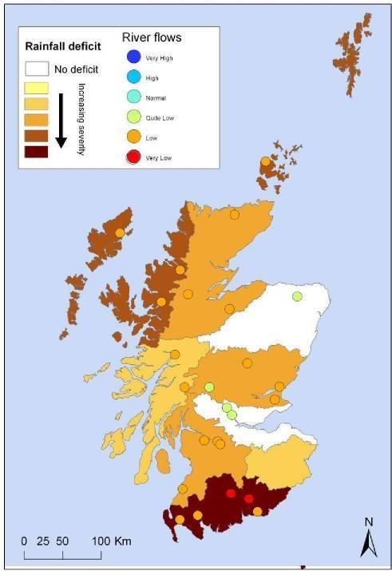

Operators should remain aware of the pressures on water resources and act accordingly. Any operators with concerns about meeting authorisation conditions should contact us at the earliest opportunity. You should be following good practice for your specific sector and be considerate of other water users in your area. There may be downstream private water supplies, other abstractors or sensitive sites. In prolonged dry conditions, we would recommend liaison with neighbours and other users to try and share the resource as much as possible. We can assist you in this process.

In addition, information gathered at a local level can help inform decision making. Third parties can also take proactive measures to help out. We would encourage and support the consideration of action such as trapping and moving fish to avoid them being stranded. Many measures may be practicable and we would welcome early discussion of such initiatives. If people notice fish in distress they should contact SEPA and their local fishery board to make them aware as early as possible.

Way Forward

6.1 Action Plans

To complement and enhance this national plan, we will collaborate with stakeholders to develop a series of action plans, where appropriate, to better manage water scarcity at a local level. Whilst this national plan sets out the principles of water scarcity management, the action plans will identify local triggers that will initiate specific measures to be taken and include specific steps related to individual authorisations or groups of authorisations. The action plans could be prioritised in a similar way to how Scottish Water has prioritised plan development to areas most at risk.

The action will be based on triggers initially at a catchment scale but could be refined where certain areas are particularly vulnerable.

Scotland has a valuable agricultural sector that produces high quality food renowned across the world. Soft fruit and vegetable production largely based in the south and east of the country often requires large volumes of water to be abstracted from the water environment to irrigate crops. This typically occurs during dry periods when the resource is already under stress. If we are to experience drier summers then that pressure is likely to increase. We will liaise with the farming community and their representatives to develop a plan which will seek to implement appropriate measures to mitigate the impacts on the environment while endeavouring to achieve proportionate use of water. It is important that as much work as possible is done in advance to enable the sector to manage prolonged dry periods in a more efficient manner. We are already working with the farming sector to review catchments which have been highlighted in the RBMP as currently being under pressure; that work will complement and support water scarcity planning. By making information available to those who irrigate it gives them a chance to take appropriate and timely action.

Funding is available for offline storage lagoons to collect and store water for irrigation in catchments identified as significantly impacted by abstraction for agriculture. These could provide additional water security where resources are under pressure already. See Annex 3 for more information.

6.2 Future Planning

The water scarcity plan will allow us to manage water resources in dry periods and contribute to the joined up approach set out in the river basin management plans.

Page 4 of the Scotland River Basin Management Plan states that “Working together to secure the sustainable use of the water environment will help maximise the benefits a healthy water environment can bring for people and businesses. It will also help identify, and make use of, opportunities to contribute to our wider goals, including those for improved resilience to climate change, biodiversity, forestry, flood risk management, fisheries and sustainable land use.”

Appendix 8 of the Scotland river basin management plan includes checks of whether action to address the main pressures on the water environment will also have implications on our ability to better cope with climate change. For example, measures to address the impacts of diffuse pollution such as managing inputs to land through improved soil management will also slow rainwater run-off and reduce the impacts of water scarcity and flood risk.

We will continue to raise awareness of the need to adapt to climate changes and adapt our approach accordingly whilst working with others. For example we will work with water users and environmental organisations to identify areas most at risk in dry periods now and in the future so they can consider contingency planning.

Glossary
Compensation Release: Water released from a reservoir to support a downstream river.

Control Curve: An operating rule for a reservoir showing storage for each month at which certain actions need to take place. It is often used to show when abstraction from the reservoir needs to be reduced.

Critical Period: The period of time a reservoir takes to empty in its driest year on record, assuming current demand.

Flashy river: A river which responds very quickly to rainfall, the flow of water rising rapidly to a high peak before receding similarly. Typical of small, steep, upland catchments.

Flow Percentile: The percentage of time for which a given flow is equalled or exceeded. For instance, Qn96, which is a proposed compensation figure, is the natural flow which is exceeded 96% of the time.

Hands off Flow: The flow in a river at which abstraction has to cease.

Multi-season reservoir: A reservoir with storage for more than one summer despite not filling in the intervening winter.

Soil Moisture Deficit: A measure of soil wetness calculated by the Met Office, indicating the capacity of the soil to absorb rainfall.

Annex 1 – Water Saving Advice
There are a number of very useful sources of information for those wishing to consider water saving measures.

- Scottish Water has produced a useful guide to the steps households can take to save water.
- There are enhanced capital allowances available for some energy and water saving equipment such as rainwater harvesting systems, vehicle wash-water reclaim kit etc.
- Zero Waste Scotland provides free advice on: water efficiency and effluent minimisation, implementing a water minimisation programme.
- Waterwise have useful case studies and water saving advice.

Good practice for irrigation

UKIA provides free access to good practice guides on irrigation.

Annex 2 – Water Scarcity Indices
In order to improve our ability to plan for and respond to water scarcity events, SEPA commissioned a study to find a methodology for measuring water scarcity severity in Scotland. The resulting analysis of historical water scarcity impacts in Scotland (Zaidman et al 2012) shows that it is departure from the norm rather than a measure of absolute water supply that determines whether water scarcity impacts occur and that suggested that a water scarcity index approach might work well.

A water scarcity index is a measure of how exceptional a period of water scarcity is. SEPA’s water scarcity index can be calculated using rainfall or flow data and is calculated for 30 day, 60 day, 90 day and 180 day periods, by subtracting the logarithm of current rolling mean from the logarithm of the long term mean and dividing this by the standard deviation, as shown by the equations in the box below.

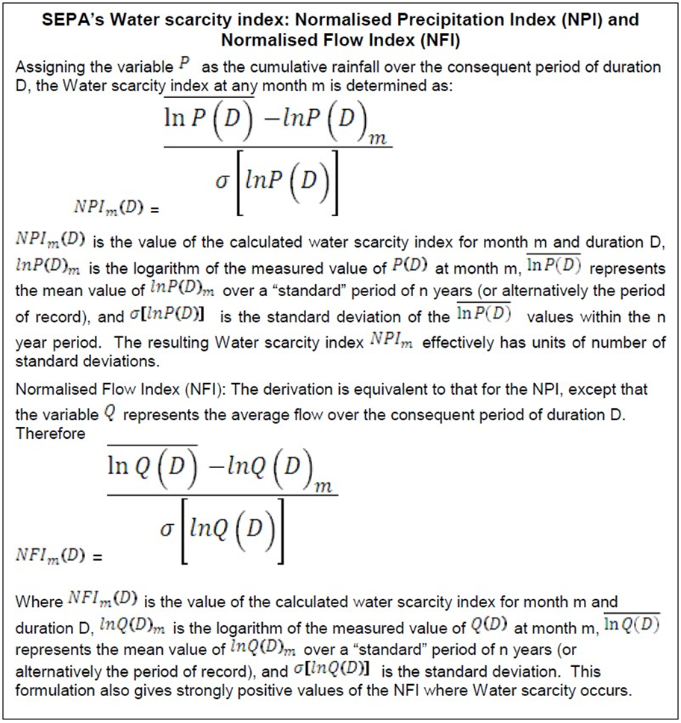

For the purposes of managing agricultural water usage and river flows with little or no groundwater component, we will use an index based on the cumulative flows over the previous month. This is a good compromise between using longer term data which won’t be sensitive enough to pick up changes in sources with little or no storage and using shorter term data (e.g. daily) which would not account for the effects of continued dry weather. For reservoirs, the period used will vary according to the storage available and the ‘critical period’ (length of time a reservoir takes to empty in its driest year).

Table 9: Water scarcity index
 | Rainfall index | River flow index
 | (Cumulative rainfall) | (Average flow)
Condition | 3 months | 1 month
Normal conditions | <0.25 | <0.25
Water scarcity early warning | 0.25 | 0.25
Water scarcity alert | 0.5 | 0.5
Moderate water scarcity | 1.0 | 1.0
Significant water scarcity | 2.0 | 2.0

Reference
Zaidman MD, Anderton A, Peacock A, Kinnear J & Lamb R 2012. Development of Drought and Low Flow Indices. Report prepared by JBA consulting for SEPA project EOSRAD57. March 2012.

Annex 3 – Water Saving Measures

Advance planning during periods when there is plenty of water is essential to managing periods of water scarcity. A number of possible water saving measures are outlined below.

Recirculation

Some operators may have the potential to recirculate water depending on the specific process. Cooling water isn’t required to be of high quality and should be recycled wherever possible given the large volumes used.

Altering Production Schedules

Depending on the type of operation there may be flexibility to balance supplies within the current abstraction licence. Where water supplies are used intermittently there may be scope to amend production dates to avoid periods where the resource is under stress.

Scheduling of Water Abstractions

Simple informal water scheduling already takes place in Scotland where operators agree who can abstract on specific days. The system works well where operators can work together to maximise the collective benefit from the available resource.

Management Agreements

A management agreement is a formal agreement between two or more operators based on the scheduling of abstractions set out above which provides a mechanism for achieving sustainable abstraction levels for all persons party to the agreement. The terms of the agreement are incorporated into the operators’ CAR authorisations, usually by variation, to formalise the arrangements for allocating water and establish limits on the quantity of water that can be abstracted from specific water bodies by each abstractor. We have authorised one management agreement and are monitoring its effectiveness with a view to expanding the approach to other catchments that are potentially at risk.

Water abstraction groups

Similarly water abstraction groups (WAGS) allow sharing of resource between operators; one licence is held and managed by a limited company and the company allocates resource to various abstractors. This mechanism avoids the need to vary conditions in multiple individual authorisations which is often the case when using a management agreement. WAGs can enable greater flexibility to share resource amongst a group of abstractors.

Amending mitigation in CAR authorisations

Dams and reservoirs often have conditions within their CAR authorisations requiring the provision of flows downstream of the impoundment (mitigating the impacts of the activity). Compensation flows are often enhanced during periods of fish migration by additional releases called freshets which mimic natural high flows.

In certain cases where flows are so low elsewhere in the catchment there may be scope to amend compensation flows and freshets downstream of dams (fast track CAR) for short periods. If fish are not moving elsewhere in the catchment then delivering a freshet may cause more problems such as stranding fish. Such decisions would be taken with advice from local fishery boards and trusts and discussed with operators on a case by case basis.

Alternative sources

Alternative supplies from other less impacted surface water bodies or groundwaters may be possible. New supplies may have impacts on the environment or other water users therefore this should be discussed and investigated with us at the earliest opportunity to allow an assessment of the potential impacts to be undertaken.

Considering storage

Off-line storage ponds allow water to be abstracted during high flows to be used during periods of low flows. While ponds require a large area of land they can provide security of resource, low maintenance and additional benefits such as biodiversity and flood prevention.

Funding for irrigation lagoons

To improve water security and reduced impacts on the water environment in periods of low flows. More information on this can be found on the Rural Payments and Services website.

Groundwater supplies and augmentation

Groundwater can provide a reliable supply of water when surface water resources are under stress. Groundwater could also be used to augment river flows when they are low either to protect valuable ecology or to top up the resource for subsequent abstraction downstream.
Augmentation of surface water already happens in parts of England.

Annex 4 – Clarification of Criteria used to Determine Significant Water Scarcity

Following a review of water scarcity events during 2018 and previous years, we are updating how ‘Significant Water Scarcity’ is determined in this national plan to provide greater transparency and clarity. The revised approach takes effect in June 2020.

The National Water Scarcity Plan sets out the hierarchy of action expected from those involved with water management and use, during prolonged dry periods. The slowly developing nature of these events, in comparison to flooding, allows us to take a staged approach that is proportionate to the risk to the environment and water users. As conditions worsen and reach Significant Water Scarcity we have said that temporary suspension of abstractions is required to protect the environment.

We have reviewed the hydrological conditions and ecological impacts in the 2018 drought and considered these alongside other evidence. While the conditions can vary, impacts always reflect a prolonged period of dry weather. When rivers remain at low flows for an extended period they are highly sensitive to further reductions of flow and/or abstraction, with a heightened risk of severe, long-lasting ecological impact.

To simplify and clarify our approach we will define Significant Water Scarcity when:

The average river flows in the region concerned have remained exceptionally low for 30 days in a row.

This will be defined when the five day mean flow is less than or equal to Q95 for 30 consecutive days.

Explanation of terms

The five day mean flow is the flow in a river averaged over a five day period. It is used to smooth out brief rises or falls in flow. These average river flows are calculated using a SEPA flow monitoring site that is representative of rivers in the region.

The Q95 is a term used to describe an exceptionally low flow level. It is a flow which, on average, a river only dips below for 5% of the time. This equates to 18 separate days in any year on average.

This clarification allows us to give notice to water users in at-risk catchments so contingency measures can be put in place.

SEPA will continue to work with stakeholders to provide useful information as early as possible to let water users make decisions about upcoming water usage.

Our Water Scarcity page has weekly updates and the latest positions.

The Drought Risk Assessment Tool displays which gauging stations have dropped below the Q95 level and for how many days. Abstraction licences will be grouped to the most relevant gauging station.

Figure taken from the Adapting to Climate Change Report UKCP09 probabilistic projections. The three projections relate to the 33, 50 and 67% probability levels from UKCP09 medium emissions scenario.
www.sepa.org.uk/environment/water/monitoring/
www.gov.scot/publications/implementing-water-environment-water-serviceshttps://www.gov.scot/publications/implementing-water-environment-water-services-scotland-act-2003-use-car/pages/0/scotland-act-2003-use-car/pages/0/
4 fms.scot/
Please see Annex 4 for updated definition of Significant Scarcity
To be used in conjunction with measures in Annex 3.
Levels coded as per Table 1.
An example of the action that might be taken.
See Table 3
Consider flexibility within operation, alternative supplies and water saving measures (see Annex 3)
As appropriate if measures are required to protect the environment and/or key abstractions
To be used in conjunction with measures in Annex 3.
Levels coded as per Scottish Water procedures.
An example of the action that might be taken.
See Table 3
To be used in conjunction with measures in Annex 3.
Levels coded as per Table 1.
An example of the action that might be taken.
See Table 3
To be used in conjunction with measures in Annex 3.
Levels coded as per Table 1.
An example of the action that might be taken.
See Table 3.
To be used in conjunction with measures in Annex 3.
Levels coded as per Table 1.
An example of the action that might be taken.
See Table 3
Consider flexibility within operation, alternative supplies and water saving measures (see Annex 3)
fms.scot/
www.sepa.org.uk/media/163445/the-river-basin-management-plan-for-the-scotlandhttp://www.sepa.org.uk/media/163445/the-river-basin-management-plan-for-the-scotland-river-basin-district-2015-2027.pdfriver-basin-district-2015-2027.pdf
www.sepa.org.uk/environment/water/river-basin-management-planning/the-current-plans/

