Agency Board meeting

25 February 2025

Quarter 3 financial monitoring report for period ending 31st December 2024

Purpose:
This report is to provide an update to the Board on the following areas:
- Actual results for quarter 3 (Q3) (1 April 2024 to 31 December 2024) show that SEPA is forecasting to deliver a balanced outturn and break-even position to the year end.
- A capital summary showing forecast spend in line with a budget of £5.4m.

Recommendations:
The Board are asked to note SEPA’s financial performance for the period ending 31 December 2024
Author(s): Ian Bryce, Deputy Head of Finance, Rosaleen Burke, Head of Finance
Corporate Leadership Team Sponsor: Angela Milloy, Chief Officer, Finance, Modernisation, and Digital.
Date: January 2025

Table 1: Scottish Environment Protection Agency – income and expenditure account 2024-2025
Description | Year to date actual £'000 | Year to date budget £'000 | Year to date variance  £'000 | Full year forecast £'000 | Full year budget £'000 | Full year variance £’000
Grant in Aid | 23,800 | 23,800 | 0 | 47,711 | 47,711 | 0
Charging Schemes | 49,491 | 49,800 | (309) | 52,662 | 52,879 | (217)
Other Income | 1,207 | 1,507 | (300) | 2,711 | 2,778 | (67)
Total Income | 74,498 | 75,107 | (609) | 103,084 | 103,368 | (284)
Staff Costs | 51,468 | 53,480 | 2,012 | 69,935 | 71,225 | 1,290
Other Staff Costs | 637 | 337 | (300) | 1,021 | 637 | (384)
Transport Costs | 649 | 694 | 45 | 917 | 977 | 60
Supplies & Services | 10,542 | 10,149 | (393) | 20,251 | 19,703 | (548)
Property Costs | 3,278 | 3,381 | 103 | 4,680 | 4,546 | (134)
Depreciation/impairment | 4,710 | 4,710 | 0 | 6,280 | 6,280 | 0
Total Operating Costs | 71,284 | 72,751 | 1,467 | 103,084 | 103,368 | 284
Operating Surplus/ (Deficit) | 3,214 | 2,356 | 858 | 0 | 0 | 0

Net results – balanced budget
- Net results for the full year forecast a balanced budget, it should be noted that the 2024-2025 budget was set net of £3.5m savings in staff costs. These savings are forecast to be met in full.
- At Q3 (period 1 April 2024 to 31 December 2024), the year-to-date variance of £0.85m is due to £1.5m lower than budgeted expenditure offset by £0.6m lower than budgeted income. The in year one off underspend will be fully utilised on corporate priorities which support transformation, resulting in a break-even position by the year end.
- Variances by accounting spend category will be explained in the remainder of the paper with the focus being on full year forecast.

Total income - £103.1m
- Total income for the full year is forecast at £103.1m or £0.3m less than the full year budget as a result of decreased charging fees mainly from radioactive substances, water and special waste consignment notes.

Grant in Aid (GiA)

Table 2: GiA budget allocation
 | Resource Budget Cash £000s | Resource Budget Non-Cash £000s | Total £000s
Base Budget Allocation 2024-25 | 39,911 | 6,280 | 46,191
Budget Adjustments
Waste water sampling | 278 |  | 278
Cleaner Air | 32 |  | 32
Water Environment Fund | 1,210 |  | 1,210
Total Adjustments | 1,520 | 0 | 1,520
Total Budget | 41,431 | 6,280 | 47,711

- SEPA’s revenue GiA is presented in Table 2 above at £47.7m. This is an increase of £1.5m since the budget was set. The table above provides a breakdown of confirmed in year budget adjustments; these will be fully offset by increased expenditure.

Charging Scheme income - £52.7m
- Graph 1 shows charging scheme income by media. The full year income outturn is £52.7m, which is £0.2m more than budget. This results in a net positive variance which includes:
- Applications - £0.25m positive variance in the applications forecast. The increase in application income is mainly due to higher than budgeted applications from water, air and radioactive substances, offset by a reduction in waste.
- Subsistence - £0.50m negative variance in the subsistence forecast in relation to reduced income from radioactive substances, water and special waste consignment notes.

Graph 1: Charging Schemes by media
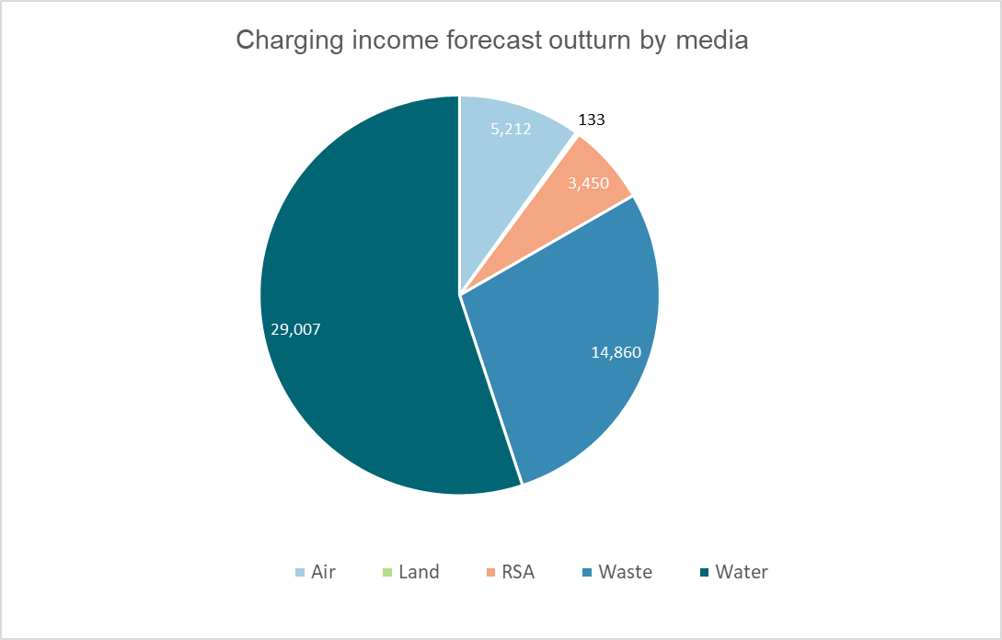
Graph 1 acronym: RSA – Radioactive Substances Activity

Other income - £2.7m
- The full year income outturn is £2.7m. Within other income, payments from other agencies and Scottish Landfill Tax are forecast to reduce slightly but offset by small increases against legal income and enforcement cost recovery.

Total expenditure - £103.1m
- Full year operating costs are £103.1m, £0.3m less than budget. Graph 2 below shows actuals against budget for the year by expenditure type.

Graph 2: Expenditure by type
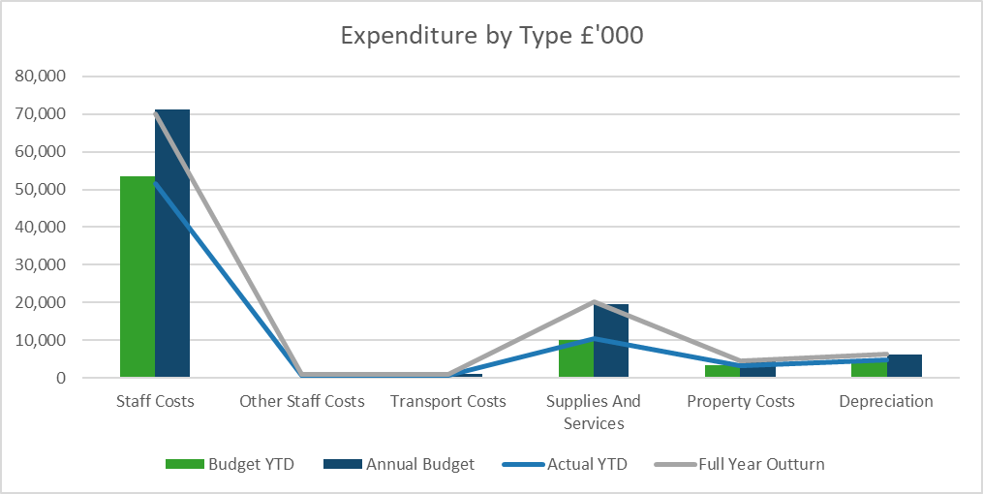
Staff costs and other staff costs
- Budgeted staff costs represent 69% of total expenditure. The vacancy management level (which represents savings due to vacant posts) was set at 4% or £3.5m. These savings have been achieved and accounted for in the forecast outturn.
- A forecast increase in vacancy savings is being offset by a forecast overspend in temporary workers and recruitment costs.

Transport costs
- Transport costs are reporting a small underspend of £60k, underspends in trains and mileage are the main reasons.

Supplies and services
- The full year forecast is currently reporting an overspend of £0.55m. There are several offsetting variances, with the most significant being:
- Software maintenance (£0.18m) in relation to spend on enterprise cloud support and logistics contract to facilitate hybrid working.
- Professional Services (£0.13m) in relation to the lone worker contract, desktop valuations and flood warning dissemination costs.
- Subcontracted work (£0.13m) mainly relates to ongoing projects in Environmental Quality and the migration of the Agresso finance system.
- The supplies and services forecast currently includes £0.3m general contingency, these funds are available to help manage risks in relation to unplanned expenditure.

Property costs
- The full year forecast is currently reporting an overspend of £0.13m. The most significant of which relates to reactive maintenance property maintenance £0.15m.

Capital

Table 3: Capital expenditure
Function | Budget £’000 | Approved projects £’000 | Main areas of risk within function budgets
Permitting | 60 | 25 | Integrated Authorisation Framework implementation planned for quarter 3 and quarter 4
Enforcement | 15 | 20 | Enforcement camera
Energy and materials | 0 | 89 | Materials data platform. Mostly internal staff costs.
Chemistry | 1,733 | 1,873 | Gas Chromotographers and nutrients analyser
Ecology | 500 | 240 | Laboratory reconfiguration and Sir John Murray refit
Environmental quality | 61 | 125 | Bathing water signage and recovery of SAGIS
Information systems | 972 | 326 | IS infrastructure and disaster recovery servers
Information systems (digital) | 1,783 | 1,365 | Integrated Authorisation Framework implementation
Workspaces | 206 | 224 | Fleet replacement
Hydrology | 1,070 | 1,245 | Gauging stations, data loggers and flood mapping
Budget reduction | (1,000)
Totals | 5,400 | 5,532

- SEPA’s capital budget provided by Scottish Government for the year is £6.4m. After discussions with Scottish Government colleagues and in light of the current savings commissions, it has been agreed to defer the capital budget by £1m to a revised total of £5.4m. SEPA has approved £5.5m worth of projects which have all been assigned a confidence assessment. As at the end of Quarter 3, over 80% of projects still to deliver have been assigned a rating of high confidence of delivery by the relevant project manager.

Statement of Financial Position
  - The Statement of Financial Position is tabled below.

Table 4: Statement of Financial Position period to 31 December 2024
Statement of Financial Position 31 December 2024 | Year to 31 March 2024  £’000 | Period to 31 December 2024  £’000
Non-current assets
Property, plant and equipment | 42,377 | 38,024
Intangible assets | 2,402 | 2,073
Assets under construction | 2,807 | 2,807
Employee retirement benefits | 21,527 | 21,527
Total non-current assets | 69,113 | 64,431
Current assets
Trade and other receivables | 4,189 | 2,795
Cash and cash equivalents | 899 | 2,070
Total current assets | 5,088 | 4,865
Total assets | 74,201 | 69,296
Current Liabilities
Trade and other payables | (11,206) | (4,471)
Provisions | (214) | (214)
Total current liabilities | (11,420) | (4,685)
Total assets less current liabilities | 62,781 | 64,611
Non current liabilities
Provisions for Liabilities and Charges >1 year | (6,022) | (6,022)
Future Lease Payments | (7,881) | (7,881)
Total non-current liabilities | (13,903) | (13,903)
Total Assets less total liabilities | 48,878 | 50,708
Taxpayers' equity and other reserves
General Fund | 30,544 | 32,374
Revaluation Reserve | 18,334 | 18,334
Total Taxpayers’ Equity | 48,878 | 50,708

Recommendation
- The Board are asked to note SEPA’s financial performance for the period ending 31 December.
END
<Report date here (month, year)>

