


WAT-G022
Version 1.0, August 2025

EASR Guidance:
Engineering:
Activity Guide:
Bank Works

Contents
1. Purpose 3
2. Introduction 3
3. Bank Works 3
3.1 What are Bank Works 3
3.1.1 Bank protection 3
3.1.2 Bank reprofiling 4
3.1.3 Embankments and floodwalls 4
3.1.4 Other bank works 5
3.1.5 Removal of Bank Works Structures 5
3.2 Key parts of a watercourse and loch 6
3.3 What are the potential issues with bank works 7
3.3.1 Key Activity Specific Issues 7
3.3.2 Risks to the Water Environment 8
3.4 Bank works and climate change 10
4. Good practice 12
4.1 Demonstrating need 13
4.1.1 Reasons for carrying out the activity 13
4.1.2 Identifying and understanding the problem or need 15
4.2 Identify and Appraise Options 17
4.2.1 Bank Reprofiling 19
4.2.2 Bank Protection 21
4.2.3 Embankments and Floodwalls 46
4.2.4 Other Bank Works 52
4.2.5 Removal of Existing Bank Work Structures 53
4.2.6 Options Appraisal 54
4.3 Justify the selected option 55
4.3.1 Possible justifications for your chosen bank works 55
4.4 Use all reasonable mitigation 57
5. Post Works Monitoring 58
5.1 Post project appraisal and site management 59
5.3 Post project appraisal at bank protection structures 59
Appendix 1: Monitoring erosion rate 61
Methods to Assess the Rate of Bank Erosion 61
Assessing whether erosion is normal or accelerated 62
Appendix 2. Types and Causes of Erosion 64
Types of Erosion 65
Causes of erosion 68
Appendix 3: Field survey checklist 69
Appendix 4: Good Practice Allowing Natural Processes 70
Appendix 5: Good Practice Riparian Management 71
Appendix 6 Good Practice High Impact Bank Protection 74
Appendix 7 Good Practice Structure removal and re-design 76
Disclaimer 78

If you would like this document in an accessible format, such as large print, audio recording or braille, please contact SEPA by emailing equalities@sepa.org.uk

Purpose
This document provides information and guidance for Bank Works which are subject to authorisation by SEPA under the Environmental Authorisations (Scotland) Regulations 2018, (EASR).

2. Introduction
This activity guide aims to demonstrate Good Practice requirements and to help select sustainable engineering solutions that minimise harm to the water environment. This focuses on the environmental aspects that should be considered when undertaking a project. Using this document will help with the process of obtaining an authorisation for works. It is not intended as a technical design manual, and it is important to recognise that any engineering works must be designed to suit site specific conditions.
This guidance does not cover any other permissions that may be required.

3. Bank Works

3.1 What are Bank Works
Bank Works is a term used by SEPA to describe any works, carried out between and including the bank top and the bank toe. It does not include works which only manages or removes vegetation. See Figure 3A Key Parts of a watercourse.
In relation to lochs, where there is no clearly definable bank zone, the bank top is considered to be the line along which terrestrial vegetation is present (this often equates to the average high-water level in a loch). See Figure 3B Key features of a loch.
Bank works fit into four broad categories:

3.1.1 Bank protection
Bank protection involves implementing measures to prevent erosion and stabilize the river or loch banks.
Bank protection can be carried out for a variety of reasons including protecting nearby land and infrastructure, maintaining the integrity of the river’s ecosystem and preventing sedimentation that could harm aquatic habitats.

3.1.2 Bank reprofiling
Bank reprofiling involves changing the shape of a river /loch bank.
Bank reprofiling is often carried out to reduce erosion, improve bank stability, improve flow conditions or improve habitat conditions. It can involve excavating, backfilling or grading a bank (using natural materials only such as locally sourced earth, vegetation, or surface protection) to achieve a lower gradient slope which can withstand greater flow velocities and support vegetation growth. Note that bank reprofiling must not be used as a method for regaining land lost to erosion.

3.1.3 Embankments and floodwalls
Embankment and floodwalls are structures designed to protect land and property from flooding.
Embankments are raised earth structures often located along bank tops to protect land from flooding (often agricultural land) when water levels are high. These structures can have a clay core and are often covered with grass.
Flood walls are vertical barriers constructed from concrete, brick or steel which are designed to be watertight to usually protect urban environments from flooding.
Only those embankments and floodwalls located on the bank top or bank slope are regulated as bank works and are subject to the contents of this guide.
Set back embankments and floodwalls which are located in the vicinity zone (for a watercourse this is the area away from the bank top for a distance of 10 metres or two channel widths, whichever is shorter, or for lochs a distance of 10 metres from the bank top), are regulated by us as activities in the vicinity zone, not as bank works.
Set back embankments and floodwalls which are located beyond the vicinity zone are only regulated by us where there is a potentially significant adverse impact to wetlands (which are dependent on a body of surface water). See WAT-G-028 EASR Guidance: Engineering Activities: in the vicinity, beyond the vicinity and affecting wetlands for further details.

3.1.4 Other bank works
Other bank work activities are any other activity which disturb or changes a bank. These are often structures which provide access to and from the river, for, recreational activities (fishing, boating, swimming), or emergency purposes. Examples include access steps, intakes, outfalls, ramps and boardwalks. They are typically constructed from materials such as concrete, stone, wood or reinforced earth to withstand water exposure and erosion.
Anyone doing bank works for intake and outfalls should also refer to our guidance WAT-G-036 EASR Guidance: Intakes and outfalls. Intakes and outfalls are usually authorised alongside the associated discharge or abstraction activities but may be applied for separately as a bank works activity and / or instream structure depending on the scale and design.

3.1.5 Removal of Bank Works Structures
The removal, or partial removal of redundant and/or failing bank works structures can cause disturbance at the location of the structure and adjacent bank causing some harm to the environment. Such structures include bank protection, outfalls, intakes, ramps and access steps.
Removal may be carried out due to the structure being redundant and no longer fulling its original purpose or because it is failing and requires replacing.
Removal works may also be required if you are replacing high morphological impact bank protection with a lower morphological impact approach such as the removal of rip-rap and replacement with root wads.

3.2 Key parts of a watercourse and loch
Key parts of a watercourse and loch are shown in Figures 3A and 3B below and explained in our Glossary.
Figure 3A: Key parts of a watercourse
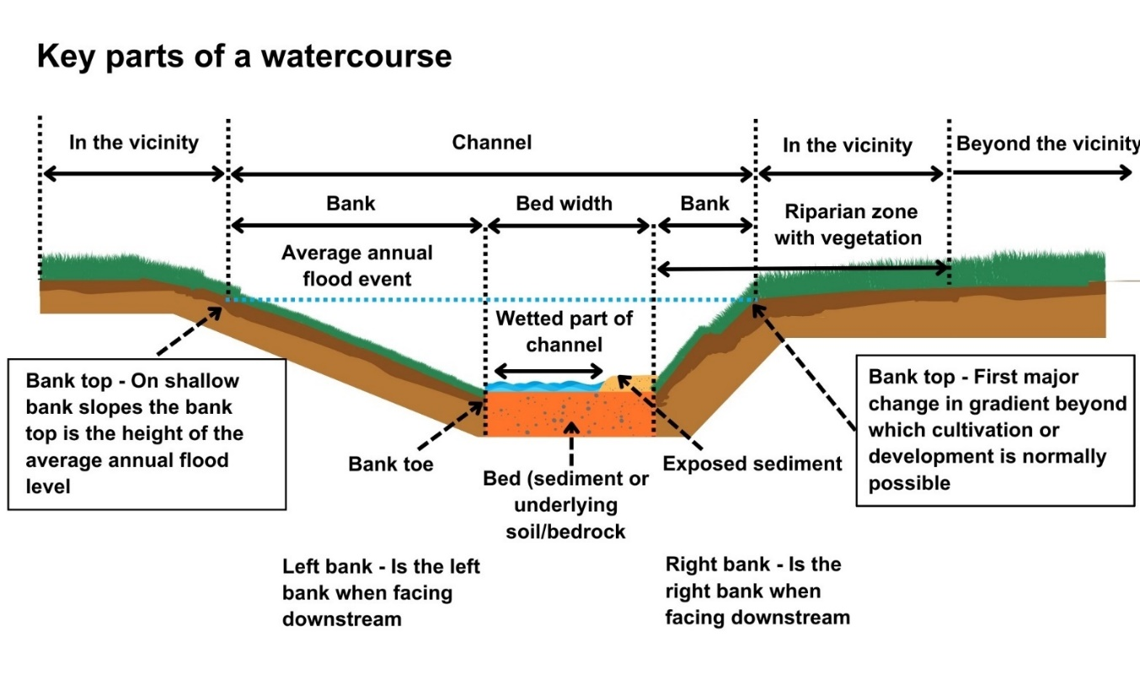
Figure 3B: Key parts of a loch
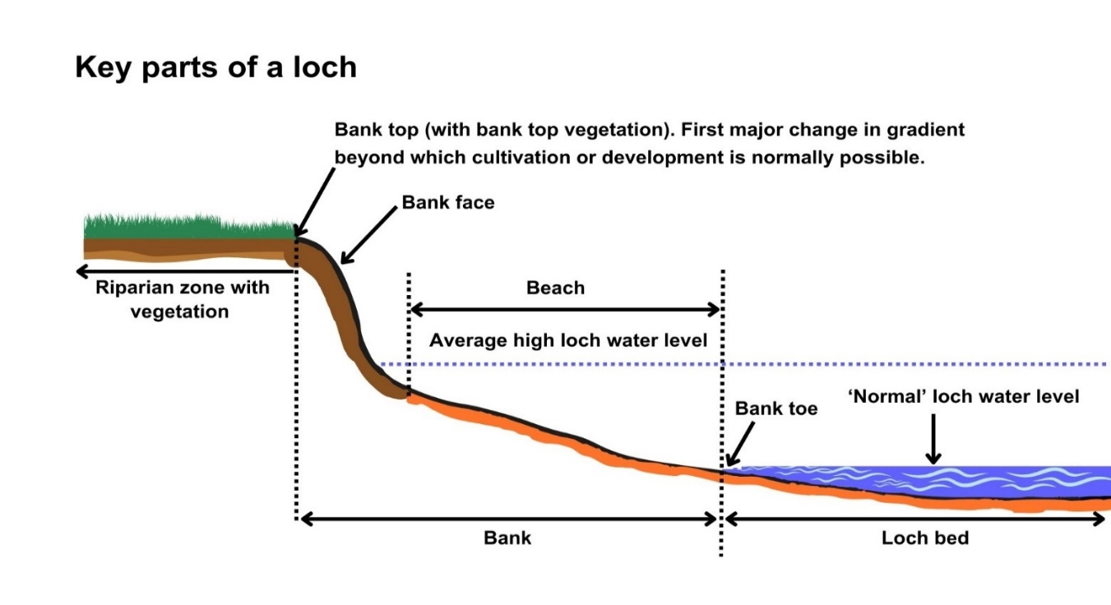

3.3 What are the potential issues with bank works
Carrying out any engineering works and any associated temporary works, including works such as access and temporary crossings, can pose risks of harm to the water environment.
To minimise potential impacts, it is important that a sustainable bank works option is chosen, its appropriately designed and constructed; that you understand the nature of the bank material and how the watercourse or loch is likely to respond to the works and that you consider the effect of the works on any nearby infrastructure or other water users.
This section summarises the main activity specific and general issues that need to be considered when designing bank works.

3.3.1 Key Activity Specific Issues
Bank works carried out over large lengths and/or when poorly designed and constructed can:
- Constrain rivers and lochs preventing natural erosion and channel migration, resulting in new or increased erosion of banks and scouring of the channel bed.
- Undermine the bank works, requiring increased maintenance works.
- Damage or reduce valuable riparian habitat and vegetation.
A key issue to understand for this activity is the erosion processes within the watercourse or loch and the potential for the works to cause additional erosion.

3.3.1.1 Bank Erosion
Bank erosion is one of most common reasons for carrying out bank protection works. It is important to fully understand the type and rates of erosion and the underlying and contributing factors which cause it.
Bank erosion is a natural river process and plays an important part in a healthy river system by creating habitats (such as pools, riffles, and bars) and refuges for aquatic species during high flows and dissipating energy. Bank erosion is often balanced by a similar amount of deposition elsewhere in the river system. Erosion rates are often affected by changes within the river system including climate change, large scale changes in drainage, land management and any kind of bank works. It is therefore important to understand how your proposed bank works will affect erosional patterns within the areas of work and the wider river reach.
When considering erosion as part of any bank works project you should consider:
- The location of your bank works (i.e. you might want to avoid placing bank works such as an outfall or access steps on a meander bend as where erosion risk is greater).
- The rate of bank erosion (i.e. is the bank actively eroding and if so, how quickly), techniques for assessing erosion rates are in Appendix 1.
- If a bank is actively eroding, how it is eroding i.e. through basal scour, fluvial entrainment or human activity (such as livestock poaching). Further details on the types and causes of erosion are in Appendix 2.
Understanding how erosional processes within the reach are working and how your bank works could affect those processes at your works site and adjacent reaches will allow you to develop a solution to your problem which minimises the risk of environmental harm resulting from your activity.

3.3.2 Risks to the Water Environment
The main risks to the water environment from carrying out this activity can be grouped as follows:
Harm to fish
This includes impacts on fish migration, spawning and fry development, loss of habitat and direct impacts such as stranding or physical damage.
Scheduling the timing of works to avoid fish spawning times and fish emergence times. Key fish species to consider include salmon and trout (normally October – May), lamprey species (normally March – July). However, these times can vary, and you should contact Fisheries Management Scotland if you are unsure what fish species are present or what times should be avoided.
Temporary works such as crossings, channel isolation or diversions, blasting, vibration or pile driving, sheet pilling or using artificial lighting at night can affect fish or migrating fish. You should carefully manage these works to minimise any impact and carry out fish rescues, where appropriate.
- For more information see WAT-G-032 EASR Guidance: Fish Protection
Physical Impacts & Pollution
Physical impacts to the bed and banks of the watercourse which can lead to instability resulting in increased erosion or deposition, loss of habitats and increased flood risk.
Carefully managing construction works is essential to prevent and minimise pollution from sedimentation, leaking oil from machinery and the entry of potentially polluting materials into water such as unset concrete.
Sites should be restored following works to manage impacts from disturbance.
Further information on construction works and mitigation can be found in WAT-G-034 EASR Guidance: Construction works and silt/pollution mitigation.
Invasive Non-Native Species
Any Invasive Non-Native Species (INNS) present in or adjacent to site could have the potential to spread. You should identify and plan works with adequate biosecurity measures in place to prevent any spread of INNS. Further guidance can be found in EASR-G-001 EASR Guidance: Invasive non-native species (INNS).
Protected areas and species
You should identify any Protected areas (e.g. SSSI, SAC, SPA) in or adjacent to site and consider any impacts from the works on Protected species such as freshwater pearl mussels and otter. You should contact NatureScot where your activity is in a Protected area or may impact protected species. For further information see WAT-G-008 EASR Guidance: Assessment of impact on Protected areas from inland water activities.
Impacts to other users of the water environment
There could be potential impacts on other water users such as water supplies, fishing, water sports.
All the risks to the water environment, as detailed above will vary according to:
- The type and design of the engineering activity.
- The timing of the works.
- The working methods and mitigation.
- The reinstatement methods.
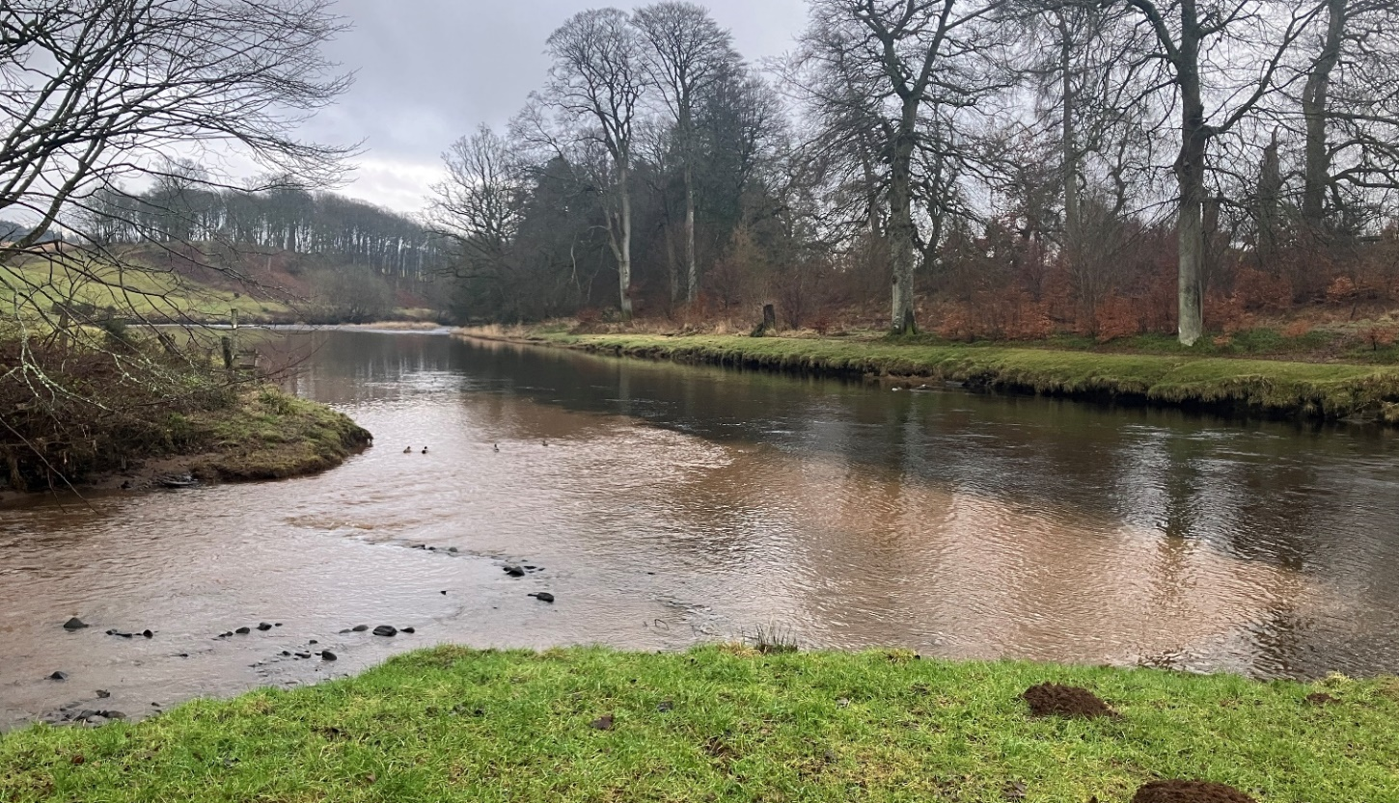
Figure 3C: Photograph showing the meeting of two streams, where one has clean water and the other has silt pollution from poor construction works upstream.

3.4 Bank works and climate change
Climate change is already affecting Scotland’s rivers and lochs. Climate change predictions indicate there will be significant increases in winter precipitation over the coming decades, which suggests that large floods will occur more frequently. Summer rainfall is also likely to become more intense
These changes are making rivers more powerful, which means they will have a greater ability to erode their beds and banks, transport sediment, move from side to side on their floodplains and adjust their planform. These changes are a river’s way of dissipating the excess energy of floods.
Changing flood frequency means that many channels will:
- Need to increase in size via bed and bank erosion to accommodate larger volumes of water before spilling on the floodplain.
- Have more energy and a greater ability to erode their beds and banks, transport sediment, and adjust their planform.
Any proposed bank works should recognise these changes by dissipating energy and provide space for a degree of natural adjustment and not overly constrain rivers. Works that either ignore or attempt to resist rather than to dissipate excess flow energy are more likely to:
- Fail, potentially damaging infrastructure.
- Require more maintenance and higher ongoing costs.
- Damage species and habitats.
- Pose a greater threat to surrounding land uses upstream of, within, and downstream of the footprint of the works.

4. Good practice
All bank work modifications should follow the principles of Good Practice. All permit applications must meet Good Practice to be granted.
Good Practice is achieved when the chosen option serves a demonstrated need, while minimising ecological harm, at a cost that is proportionate. Meeting Good Practice ensures that modifications to the morphology of rivers and lochs are sustainable.
To meet Good Practice the steps below should be followed.
Good Practice Summary
To meet Good Practice, you must:
- Demonstrate need
- State the reasons for carrying out the activity and the benefits it will bring.
- Identify and understand the problem or need.
- Identify and appraise options
Use sustainable river management principles to:
- Identify a number of options (minimum of three, including do nothing).
- Carry out an options appraisal.
- Justify the selected option
- State why it represents the best practical environmental option.
- Use all reasonable mitigation
- State the mitigation measures you propose to minimise impacts.
- Submit method statement(s) detailing how the works will be carried out.

4.1 Demonstrating need
Before undertaking any form of bank works there should be a clear and justifiable reason or need. You should also have a good understanding of the causes (including the underlying cause) and scale of the problem being addressed. You must:
- Specify the reasons for carrying out the activity and the benefits it will bring.
- Identify and understand the scale and nature of any problem or need.
- Demonstrate that you understand the underlying cause of any problem and have assessed its scale and significance.
- Submit supporting evidence to support this.

4.1.1 Reasons for carrying out the activity
You must provide us with:
- Clear reasons why you wish to carry out bank works.
- Where relevant, the type and details of what is being protected (e.g. infrastructure, buildings, valuable land, wildlife reserve).
The reasons for carrying out bank works will usually be one of the following:

Erosion Protection
Bank erosion is the most common reason for carrying out bank works. Although, bank erosion is a natural river process it can become problematic if it threatens the built environment and infrastructure, valuable land or creates a health and safety issue (e.g. prevent people being injured from an eroding footpath).
In these instances, there may be the requirement to reinforce the bank to prevent further bank retreat, but this should always be done sensitively to minimise the loss of the important role erosion plays in a healthy river system. It is always important to understand the reason for bank erosion (i.e. natural processes, land use or management changes, human induced) to ensure the underlying cause of the erosion is addressed. This approach will help improve the effectiveness of the bank protection and help limit the problem being transferred elsewhere or making the original problem worse.

Flooding
Bank works (such as embankments and flood walls) can be undertaken to protect the built environment (commercial and residential property), infrastructure and valuable land and property from flooding. Other reasons include controlling wildlife or conservation reason.

Access
Bank works may be undertaken to provide safe access for people and or boats to the water. An example would be steps to allow safe access for angling.

Intakes/ Outfalls
Bank works may be carried out to construct intakes to allow water to be abstracted for drinking water, irrigation, flood control, industrial processes, energy production or support sanitation systems. Bank works may also be required to construct outfalls to support urban drainage, flood control or wastewater disposal.

Habitat and Wildlife
Bank works may be carried out for habitat or species protection such as providing artificial otter holts.
Removing a redundant and or failing structure
Bank works may be required to remove or replace an old and/or redundant bank structure because they are no longer required or no longer safe to use. An example of removing a redundant or failing bank structure would be removing bank protection and replacing it with something else which is better suited to addressing the cause of the erosion.
Answering the questions below will help you describe why bank works may be required:
- What is at risk if the bank works do not proceed?
- Is infrastructure at risk?
- Are there flooding issues?
- Are there safety issues?
- Are there environmental benefits from the activity?
- How long is the solution expected to last?
- Has an economic analysis been carried out?

4.1.2 Identifying and understanding the problem or need
To identify the best solution to a problem or need it is crucial to:
- Understand the problem or need.
- Identify and understand, where relevant its causes, (including the underlying cause).
- Understand its value in terms of ecology and river function.
- Understand its impact on human activities, resources or health.
Significant funds and effort are often spent on engineering and maintenance to control and alleviate bank erosion. However, halting erosion can have a negative impact on habitats, disrupt the natural balance of the river and, crucially, can make the original problem worse because the river has more energy to erode elsewhere. Bank works can also be intrusive and therefore should only be carried out with due consideration and purpose.
To identify whether carrying out bank works is an appropriate solution you must assess what is causing the problem or need and whether the bank works will address it. Identifying the cause of the problem will require assessing and understanding the environment you are working in. This assessment will also help you to design bank works which are appropriate for the environment you are working in and assist you in developing suitable mitigation to limit any environmental harm, be sustainable long term and require minimal maintenance. Understanding the bank works location, adjacent reaches and wider environment should allow you to answer:
- Is this a new or long-term problem?
- Have recent environmental factors (high flow events) caused/ exacerbated the problem?
- Is there evidence that the problem will resolve naturally?
- Is there any survey data (including photos) to aid description of the problem? Has a similar problem occurred before (elsewhere) and how was this addressed?
Answering the questions in the box below will help you identify: the cause of the problem; the most appropriate option; the site constraints and help develop a sustainable design with minimal long term maintenance requirements.
Answering these questions will help identify the cause of the problem
- Can a simple cause and effect be described?
- Are there multiple causes?
- Are there wider sediment problems within the catchment?
- Are there other examples of this problem that can be referenced?
- Is the problem related in any way to other engineering structures or management?
- Have weather patterns (inc. unusual weather) had an effect?
- Has a geomorphologist or other field scientist assessed the problem?

4.1.2.3. Supporting Evidence
Supporting evidence should always be submitted to demonstrate the need for the bank works being applied for. It should demonstrate why it is being done and the problem or need, including its scale. The evidence provided could take the form of photographs, historic maps, survey data, anecdotal evidence or expert opinion. The type and form of information provided will depend on the nature of the site and the scale of the problem.

4.2 Identify and Appraise Options
It is a basic principle of good practice that when addressing any engineering problem, or need, several options are identified and evaluated (using an options appraisal to compare the advantages and disadvantages) to determine the best solution.
In all cases we will expect you to identify and consider a minimum of three options for comparison, including doing nothing. In some instances, there may be more than three possible options available.
There are three broad types of options to consider: do nothing non-engineering options engineering options
The key steps you should follow when considering and appraising options for bank works are:
- Identify a range of options (see sections 4.2.1 to 4.2.5 below).
- Taking into account the principle of sustainable river management (see box below.)
- Carry out options appraisal.
- Taking into account site specific requirements and long-term maintenance requirements.
To identify options for appraisal and help determine the best practical environmental option you should assess options against the sustainable river management principles detailed below:
Principles of sustainable river management
- Address the scale, significance and underlying cause of the problem or need.
- Consider the effects of climate change.
- Allow the river some room to move (where feasible).
- Respect channel form and processes.
- Consider and minimises maintenance requirements.
- Consider a range of options (i.e. modifying existing structure, non-engineering and engineering) for addressing the problem including ‘do nothing’.
- Consider how it addresses the underlying cause of the problem.

The fundamental aim of sustainable river management is to design and carry out engineering in a way that works with, rather than against, river/loch processes. This helps the engineering works and the habitats to be more resilient to the changes that occur over time. A solution should be developed that strikes a balance between addressing a problem or meeting a need, and ensuring river/loch processes, and therefore habitats, are not unduly impacted. Further details on these principles can be found within our ‘WAT-G-030 EASR Guidance Meeting Good Practice.
As the nature of a problem or need for bank works is varied and site specific, we cannot detail all possible solutions here. Where it is decided an engineering option is required, the best response may involve combining one or more engineering options with one or more non-engineering options. The key is to ensure impacts are minimised and mitigated as far as possible. For example, this may include using brash (a minimal/low impact engineering option) to pack and restore a bank that was eroded by cattle poaching and then fencing it off to create a riparian buffer strip and control cattle access (a non-engineering solution) and providing a limited amount of rip rap (a higher impact engineering option) to protect an existing crossing within the eroded reach.
The following sections provide information on options for various types of bank works and aims to help you consider potential options for comparison and to aid selecting the best practical environmental option and ensure the works are a sustainable use of the water environment.

4.2.1 Bank Reprofiling
This section covers the key points when identifying and appraising options for bank reprofiling.
Bank reprofiling involves changing the shape of a river or loch bank to reduce erosion/ improve bank stability, improve flow conditions or improve habitat conditions The bank slope is usually regraded to a gradient of less than 2:1 (distance: elevation), but a slope of 3:1 or less is often better for erosion protection as it encourages greater vegetation growth and subsequently greater energy dissipation. The reason that bank reprofiling is being proposed will dictate the issues that need to be considered when appraising options.
Bank reprofiling should not alter bank height or bed width. It is also important that reprofiled banks are graded smoothly into the banks upstream and downstream of works area to avoid abrupt changes in bank shape and strength which can cause instability and potential erosion.
Bank reprofiling can occur as a standalone activity or be undertaken alongside other bank works to improve bank stability or to make construction easier and reduce the maintenance burden of any structures being placed on the bank. Reprofiled banks should be seeded or turfed with native vegetation mixes and covered with a biodegradable geotextile to protect the bank from erosion while the vegetation establishes. The vegetation will help to stabilise the banks thereafter.

Figure 4A: Bank reprofiling on River Levern, Barrhead. Image (a) shows vertical banks reinforced with gabion baskets and image (b) shows the same banks with the gabion baskets removed and reprofiled as part a restoration project.
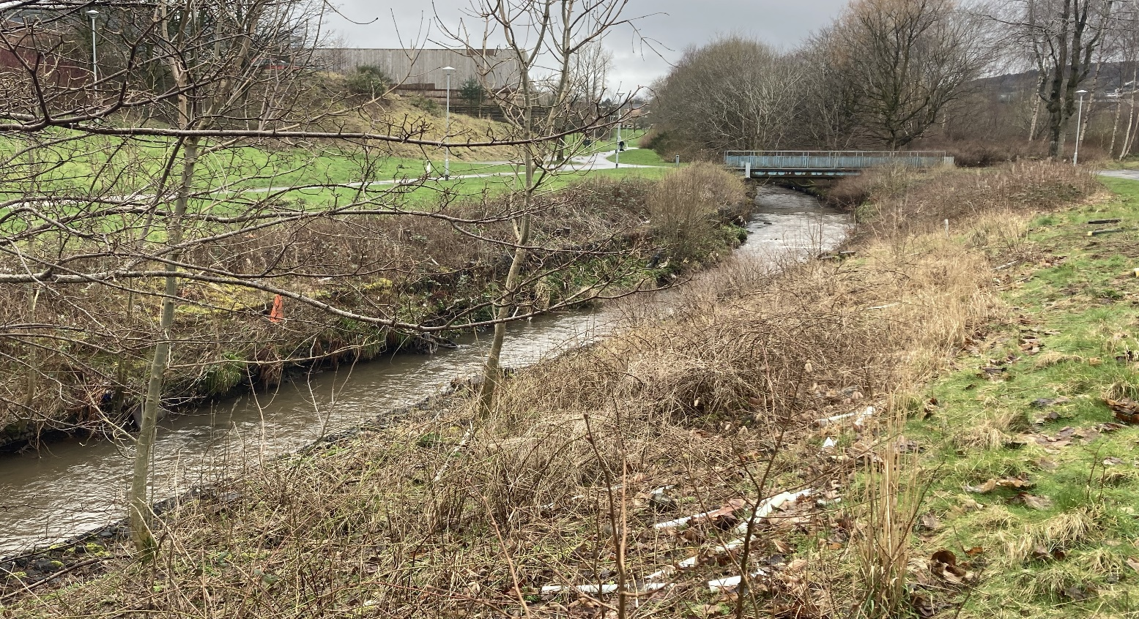
a
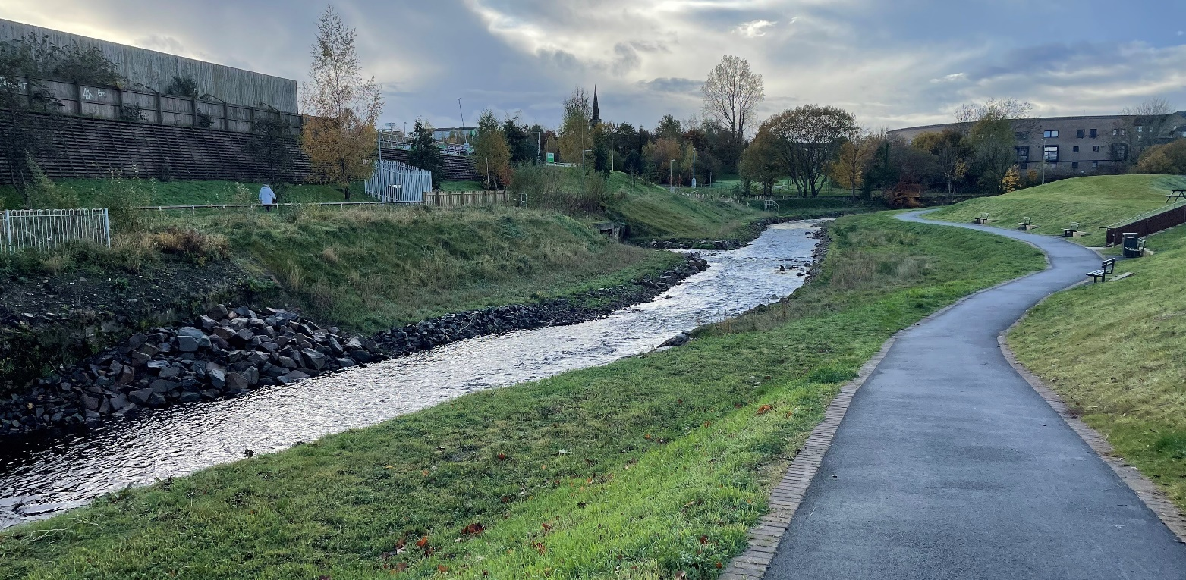
b
Bank reprofiling can also be carried out to create a two-stage channel. A two-stage channel is one which incorporates a low flow channel and higher inset floodplain within its banks (Figure 4B). This form of bank reprofiling can be a good option to use to manage erosion in over deepened channel if there is space available. A two-stage channel can also be a good option to help manage flood risk where sediment accumulation reduces channel capacity over time i.e. it provides more space for sediment to deposit and be sensitively managed without compromising capacity. In recreation areas it can also allow safer access to the channel for things like pond dipping and fishing. Reprofiling riverbanks to create a two-stage channel is also often used in river restoration projects to improve floodplain connectivity, especially in over deepened channels. It can also be used to increase the channel capacity as part of works to control flood risks.
Figure 4B: Two-stage channel under construction on the Garrel Burn, Kilsyth.
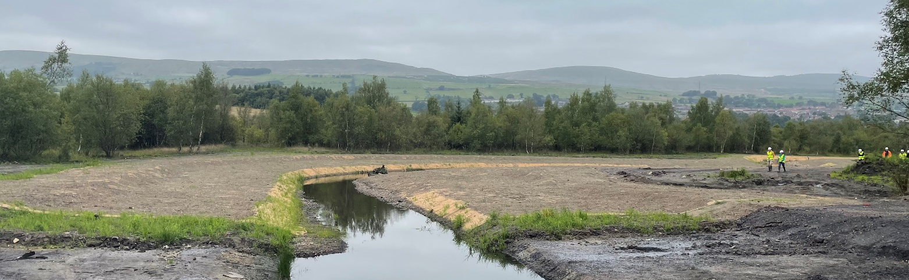

4.2.2 Bank Protection
This section covers identifying and appraising options for bank protection works. Some general rules of thumb for selecting an appropriate bank protection option are listed in the box below.
Bank protection ‘rule of thumb’ guide to selecting options
General rules:
- Look at other bank protection in the area to see what works and what doesn’t work.
- Look at other, similar rivers, to see what might work.
- Talk to other landowners who have used bank protection.
- Seek guidance from local conservation groups.
Situations where lower impact methods might be more suited:
- Where the bed and banks are composed of cohesive materials (e.g clays).
- Where tree and shrub riparian vegetation is present.
- Rural areas, where there is less likelihood of impacts to infrastructure.
- Sections of straight channel.
- To accompany non-engineering solutions.
Situations where higher impact methods might be more suited:
- Where infrastructure or built property is at risk.
- Where the banks (and bed) are composed of larger stones and rocks.
- Urban and/or semi urban settings.
- Channels where rates of erosion can be measured in metres per year.
Situation where toe protection might be more suited:
- Straight section of channel.
- Lowland (low energy) environments.
- Upland (high energy) environments where infrastructure or built property is not at risk.
- Outside of meander bends.
Situations where set-back protection might be more suited:
- Where erosion has been identified, and infrastructure could be put at risk at a future date.

4.2.2.1 Do nothing
Sometimes the problem may be more perceived than real, and an erosion issue may resolve itself by natural processes over time without causing any significant issues. A bank slump may stabilise and encourage riparian vegetation to grow on it and help to deflect flow away from the bank, protecting it from further erosion. This will depend on the space in which a river has to adjust, the nearby uses of the land and/or the presence of any important infrastructure.
A good understanding of the erosion problem (its root cause and scale) and the river environment will help ascertain whether a ‘do nothing’ approach is a viable option.
Further details are set out in Appendix 4.
Detailed guidance on natural river recovery is available in our guide will-the-river-do-the-work.

4.2.2. Non-engineering options
In certain cases, simple non-engineering options may be enough to address a bank erosion issue, especially where the rates of erosion are slow.
There are many good reasons to use non engineering options
- Normally no requirement to obtain SEPA authorisation for works
- Often cheaper and grants may be available to undertake works.
- Often have greater aesthetic appeal.
- Often better for river ecology, more sustainable and require less maintenance.
Non-engineering options can be achieved by managing the cause of the bank erosion (either controlling a particular activity, altering riparian management, or developing a catchment plan to address wider causes such as changes to discharge). Managing the cause can also be used in combination with other options. Example options include:
- Fencing to exclude livestock - fencing can be carried out to address bank erosion caused by excessive livestock grazing and trampling or carried out in combination with other methods to ensure establishment of a riparian zone to aid stabilisation of the river or loch bank.
- Riparian planting – tree planting / native vegetation - the planting of trees and native bank side vegetation can be carried out by itself as a measure to stabilise areas which are slowly eroding or in combination with other engineering methods.
Further details on riparian management are set out in Appendix 5.
- Introduce access and /or speed restrictions for motorboats - where waves from boat wash are impacting a loch shore or watercourse, introducing speed restrictions and restricting access could solve an evolving erosion problem giving the bank time to stabilise naturally.

4.2.2.3 Engineering Options
Where there is a demonstrated need for protection, and controlling the cause of the erosion is not enough to address the problem or need, an engineering option may be necessary. The selected engineering solution should be appropriate and proportionate to the type, location and rate of erosion, as well as the property, infrastructure or resources at risk.
There are a wide range of engineering bank protection methods, which have varying levels of morphological impact on the watercourse or loch. Low impact methods are preferred where possible. The use of higher impact methods will require greater justification for their use.
Bank works engineering solutions can be divided into 3 broad groups:
- Methods with minimal impacts on morphology (sustainable bank protection).
- Methods with low impacts on morphology.
- Methods with higher impacts on morphology.
Combinations of options using a variety of engineered methods along with non-engineering options should always be considered to minimise the length of higher impact methods and increase energy dissipation. For example, where a road or footpath is threatened by bank erosion, the problem could be addressed by:
- ‘Do-nothing’ - allow the river to erode and move the road or footpath to another location.
- Non-engineering – planting the bank with fast growing trees and/or vegetation to stabilise the bank and dissipate energy which may encourage deposition and natural protection of the bank.
- Combine lower impact and higher impact engineering – directly protecting the bank from erosion using a variety of low and high impact methods for example using parts of trees, reprofiling and biodegradable geotextiles where the bank is further away from the road/footpath, and some more robust methods such as rip rap in areas where infrastructure is directly threatened.
- Engineering bank works: rip rap used to protect the bank from further erosion.
- Engineering non-bank works: realign the river away from the road (channel modification).
A selection of the different bank protection methods grouped by their level of morphological impact are outlined below.

1.Bank Protection methods with minimal impacts on morphology (sustainable bank protection)
There are a number of sustainable bank protection methods (sometimes also known as green or rough bank techniques) using trees or parts of trees which have minimal impacts on morphology and can be carried out without requiring an application for authorisation. Sustainable bank protection methods can usually be carried out under General Binding Rule 25.
These include use of:
- Willow stakes and willow spilling.
- Use of brash and small trees.
- Large wood.
- Whole trees.
- Root wads.
A brief description of these techniques is given below, with further good practice advice set out in WAT-G-029 EASR Guidance: Engineering: Sustainable Bank works.

1a. Willow stakes and spilling
Woody stems, usually live willow, woven into a vertical fence and anchored using live willow stakes or timber posts, provide physical protection against flowing water (Figure 4C). Spilling fences may also be made from dead wood. The technique suits low to medium energy rivers.
Figure 4C: An example of willow spilling for erosion protection.
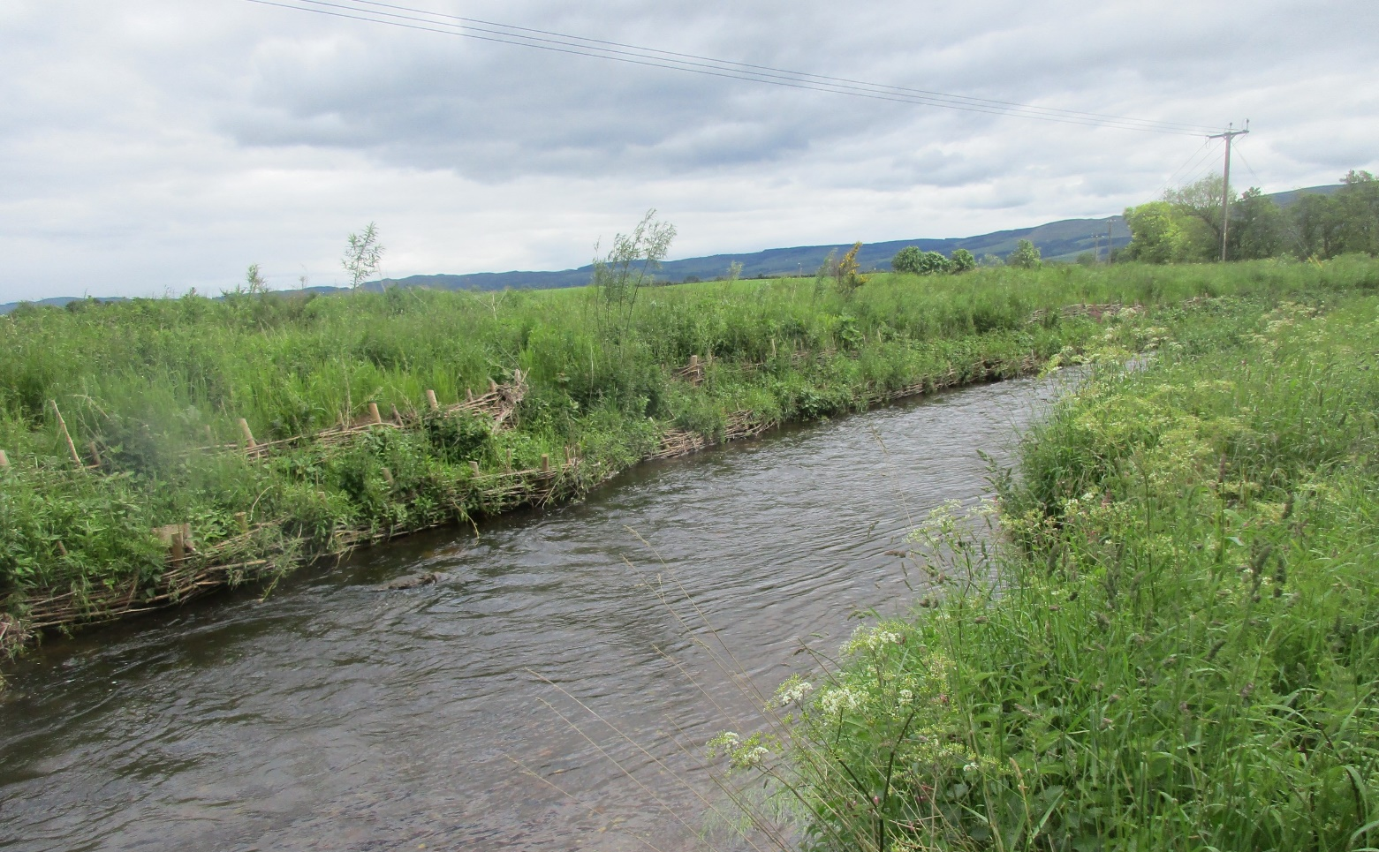

1b. Brash and small tree methods
Brash and small trees with branches are good for diffusing flow energy due to their flexibility and because the river loses some of its energy when flowing between and around the individual pieces of the brash or branches. Brash and small trees can be used on a range of stream sizes and can be combined with willow spiling for additional stability. The size and weight of the brash and small trees can be adapted to reflect differences in energy conditions, with heavier more solid branches being used in higher energy rivers.
The overall aim is to create a secure rough and flexible matrix that dissipates energy and encourages sediment to drop out, building up and reinstating the bank. Brash methods include branch packing, brushwood bundles and brushwood layering. These can be used individually, together or alongside other methods:
- Branch Packing - Technique in which alternate layers of compacted backfill and branches are used to fill holes in stream banks. The branches can be alive or dead. If live material is used this can grow shoots and encourage vegetation growth which increase bank protection further.
- Brushwood bundles - bundles of live (and likely to root, such as willow) or dead untreated brushwood bound together. The bundles are usually set into shallow trenches on the riverbank, parallel to the direction of flow. The bundles slow the flow of water and trap silt and sediment. Coir rolls (see biodegradable geotextiles) may also be used in place of brushwood bundles.
- Brushwood layering or mattresses - a thick layer of branch cuttings installed to cover and physically protect stream banks. The mattresses are effective at trapping fine sediment during flooding and work well on a wide range of steep banks and fast flowing streams.

Figure 4D: Using brash layers to protect the bank from erosion.
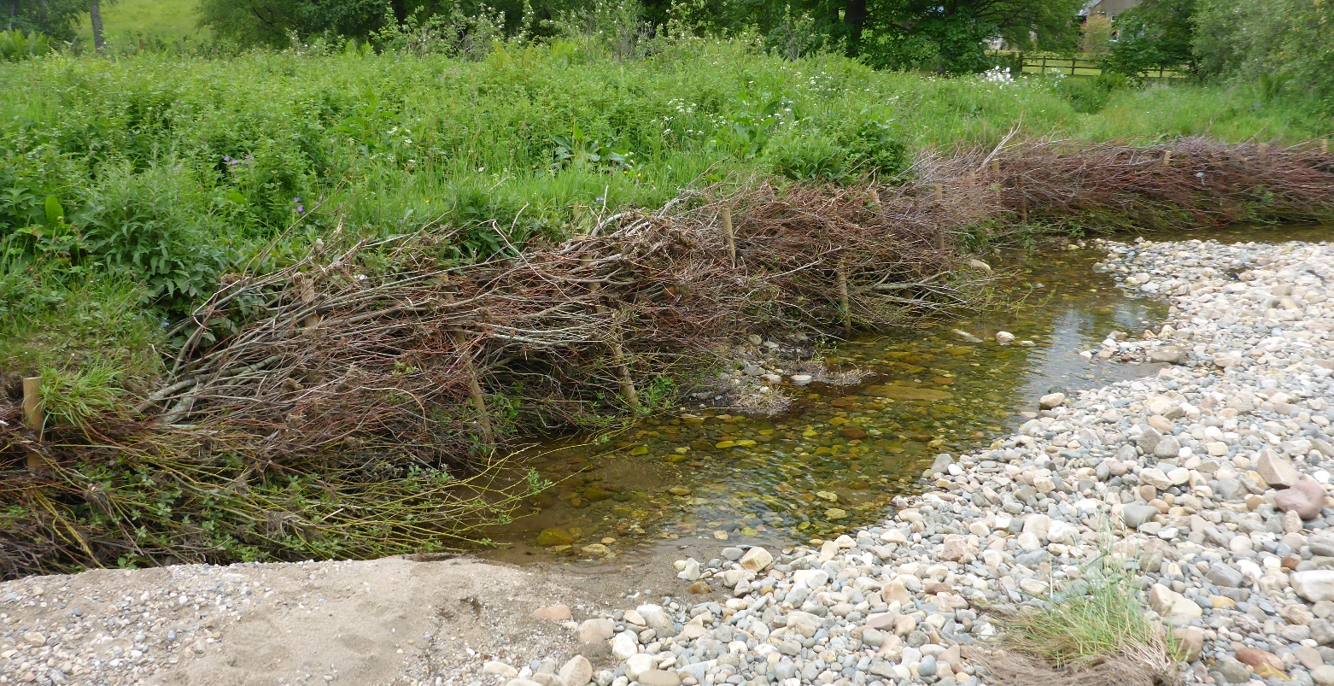
1c. Large wood
Large wood can be used on its own or in combination with the other methods. If the energy of your river is high, it can be used like a weightier form of brash and small trees. It can also be used to protect the bank toe from undercutting whilst willow spiling establishes.
1d. Whole trees
Whole trees (usually coniferous trees due to the regular branching and the ease of sourcing these) with most branches still attached are placed and secured parallel to the bank (with the trunk facing upstream) along the bank toe extending part way up the bank or over the full vertical height of the bank depending on the situation (Figure 4E).
The tree revetments and roughness from the tree branches dissipate flow energy and deflect erosional forces away from the bank. The trees should overlap each other by a quarter of their length and be securely anchored using steel cable and anchor posts. The trees should not occupy more than one-third of the wetted channel width.
The increase in bank roughness can also trap fine sediments, particularly along the bank toe, which, over time may colonise with vegetation, increasing bank stability. Whole trees can provide excellent bank protection, even in high energy rivers.
Figure 4E: Whole trees with branches still attached on the side exposed to the flows of the water successfully protecting the borders.
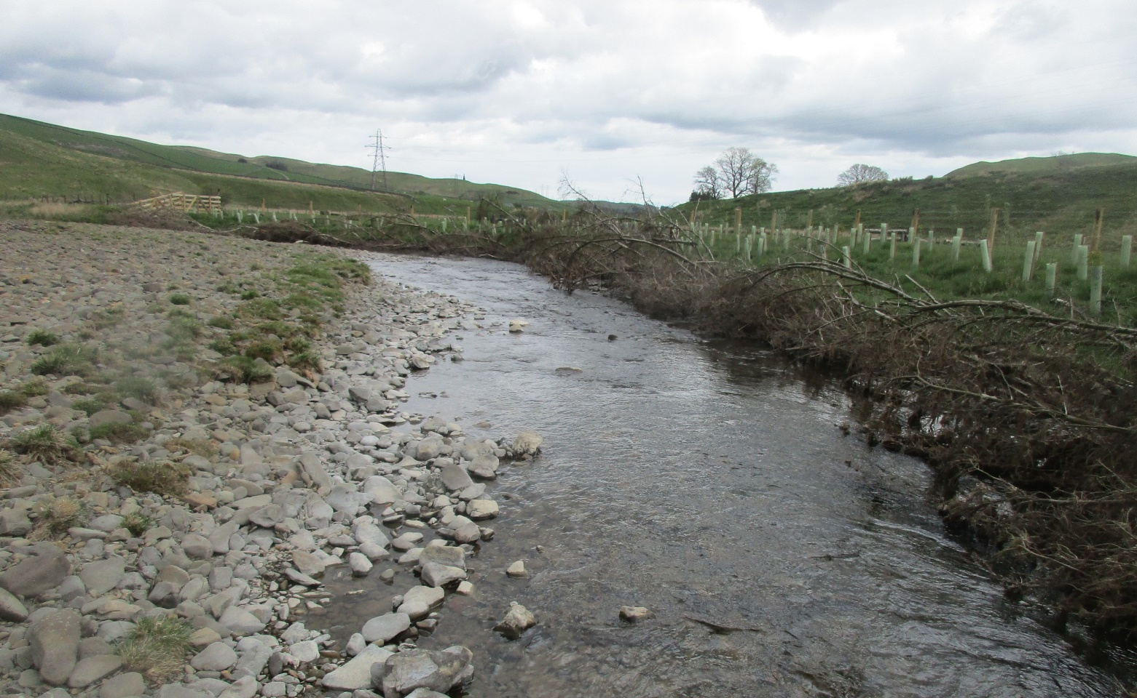

1e. Root wads
Logs are buried within the river or loch bank with their root wads lining the exposed bank and angled in an upstream direction (Figure 4F) The roots increase bank roughness and therefore dissipate the flow energy, sheltering the bank behind. The root wads have the advantage of not only protecting the eroding bank but also providing some ecological benefit through the creation of small scour pools in between the root plates, which provide habitat for juvenile fish and invertebrates; refuges during high flow events; shade in the summer and protection from predators. Whole trees can provide excellent bank protection, even in high energy rivers.

Figure 4F: Root wads being used to protect an eroding bank in Perthshire. This photo was taken immediately following construction.
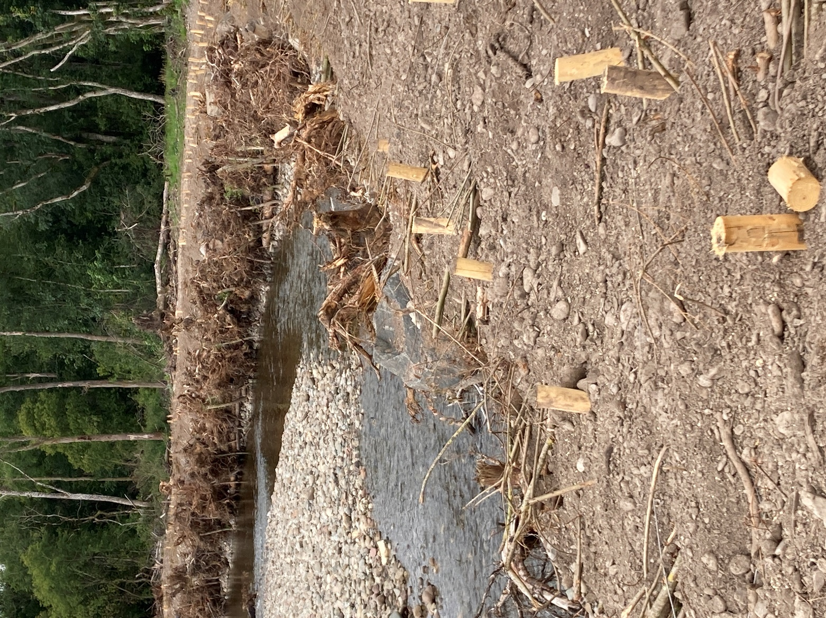

2. Bank protection methods with low impacts on morphology
Methods which have a low morphological impact, also often referred to as green or soft bank protection methods, use natural or biodegradable materials. They include:
- Biodegradable geotextiles.
- Use of untreated wood or un-mortared rock/stone restricted to the bank toe.
- Reprofiling.
A brief description of each of these is given below:

2a. Biodegradable geotextiles
Biodegradable geotextiles are matting or rolls of natural fibre placed on or over a bank face to prevent erosion or stabilise exposed soils on the riverbank while allowing vegetation to establish (Figure 4G). The geotextiles are typically made from coir (coconut fibre), but can also be made using jute, straw or wood fibres, which all gradually decompose overtime, further increasing soil fertility. The matting can also be bought pre-seeded to increase the rate at which vegetation re-establishes and acts as a rooting base for marginal plants. It can be woven and pressed into many shapes including rolls (which are usually compressed into a relatively solid matrix) and matting of various thicknesses. The textiles can be used in conjunction with re-vegetation schemes to aid rapid re-establishment and improve water quality (prevent soils being washed into the watercourse) and subsequently stabilise an eroding bank.
Figure 4G: Biodegradable matting used to protect a bank from erosion while vegetation re-established on the Garrel Burn, North Lanarkshire.
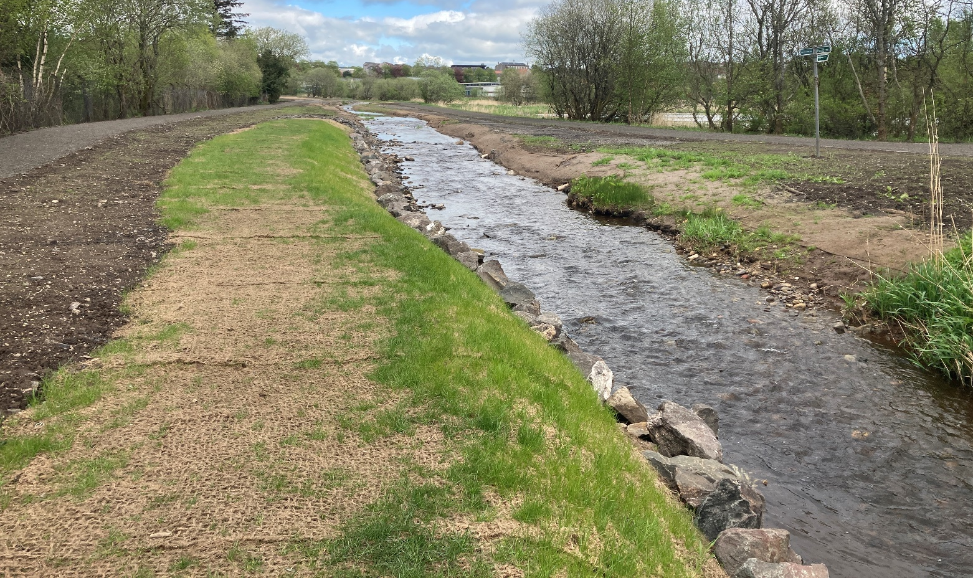

2b. Wood or un-mortared rock restricted to bank toe
If the main cause of any bank erosion is basal scour (i.e. bank toe being eroded causing the bank face above to become unstable), it may be possible to limit further erosion by just protecting the bank toe. The placement of un-mortared rock or stone pitching (Figure 4H), untreated timber or vegetated coir rolls along the toe of the bank protects the area of the bank most vulnerable to erosion and hence help maintain its overall stability. Taking this approach addresses the cause of the bank instability with limited effects on the morphology and ecology of the river reach. Toe protection should only be placed or anchored at the toe of the bank below the normal water level.
Consideration should be given to the sizing and placement of stones to prevent displacement during high flows. The toe protection should be flush with the bank face and buried into the bed to help anchor the stone/wood/material securely, preventing it from being dislodged during high flow events. Embedding the toe protection into the riverbed and ensuring it is flush with the bank face reduces the risk of it being undercut or out flanked subsequently helping to maintain the integrity of the bank over time.
Figure 4H: Bank toe protection using boulders along the Gala Water.
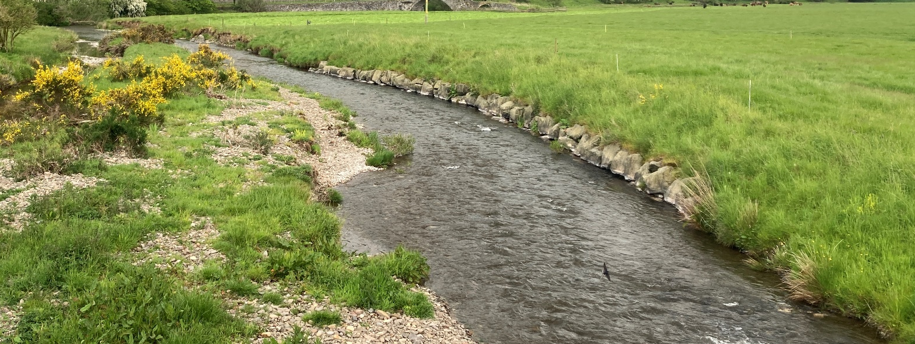

2c. Reprofiling
Reprofiling can be used as bank protection technique by itself, in combination with other bank protection measures or as a river restoration technique. See section above on reprofiling.

3. Bank protection methods with higher impacts on morphology
In some instance there is a requirement to use more engineered forms of bank protection, for example when there is a need to protect a major road from erosion. More engineered bank protection methods have higher impacts on channel morphology. They include techniques such as:
- Non-biodegradable geotextiles.
- Reinforced (compacted) earth folded between layers of geotextiles.
- Rock rolls / mattresses.
- Gabion mattress (‘reno mattress’); gabion tubes.
- Stone/rock revetments.
  - Rock Armour (rip rap).
  - Hand pitched stone.
  - Grouted revetment.
- Low Level Piling.
- Concrete revetment.
- Retaining walls.
  - Concrete.
  - Masonry (grouted revetment).
  - Hand pitched stone.
  - Timber.
Erosion measures using these kinds of materials is sometimes also referred to as ‘grey’ or ‘hard’ bank protection methods. The environmental impacts from these vary depending on the river environment within which they are placed. In some instances, the bank can be protected using a combination of higher and lower impact methods.
As these structures/methods often deflect rather than absorb river energy, it important to ensure they are graded smoothly into the adjacent banks to avoid there being any abrupt changes in bank strength and roughness. Failure to do this can cause instability and erosion in these areas which over time could undermine the bank protection measures installed.
If you are planning to install long lengths of higher impact bank protection consideration should be given to the potential adverse impacts on adjoining and opposite banks (where there may be increased erosion). If not carefully designed, such works can transfer the erosion problem elsewhere and the requirement for further bank protection measures. The lengths of high impact bank protection methods should be minimised to only the area requiring protection wherever possible combined with lower impact techniques. For example, placing stone around the bridge abutments and first few meters of bank but then grading this into a lower impact method for areas beyond that.
Where it is possible and feasible to do so, lower morphological impact methods should be used or used in combination with high impacts methods to lessen their impact on the environment. The selected bank protection solution should always be based on what is being protected, the energy in the river or loch environment and other site-specific factors (soils, land use, access).
Some additional good practice principles for these techniques are set out in Appendix 6.
The methods below are listed in order of increasing impact on river morphology.

3a Non-biodegradable geotextiles
Non-biodegradable geotextiles are synthetic meshes, fabrics and mats that are used in various civil engineering projects (i.e. in road and rail construction), erosion control and environmental protection (Figure 4i). The textiles are made from polymers such as polypropylene, polyester or polyethylene, which often take over 100 years to breakdown down. The long-life span of these products makes them popular for application where long-term protection or reinforcement is required. Non-biodegradable geotextiles are often popular because they are durable, strong, flexible and cost-effective. Consideration should however be given to reducing inputs of plastics and microplastics into the water environment. Long lasting biodegradable geotextiles should be considered as an alternative wherever possible.
The geotextiles come in various forms including woven (fibres weaved together), non-woven (bonded using heat) and knitted (interlocking loops of yarn). Woven matting is often used in bank protection projects where the larger voids allow vegetation to colonise the exposed bank surface. The geotextile can be laid on a wide range of bank slopes to encourage good re-establishment of vegetation and energy dissipation if woody vegetation is being established. For geotextile to perform well it needs to be installed over a smooth surface and be well pegged down.
Figure 4i: Non-biodegradable geotextile used to protect during construction.
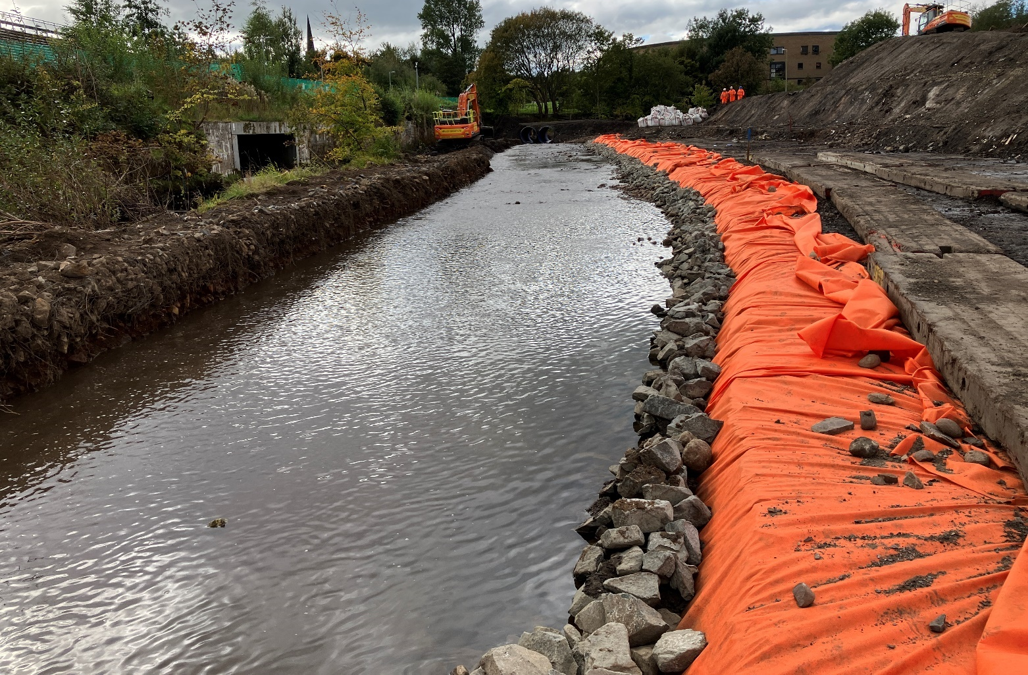

3b Reinforced earth
Reinforced (compacted) earth (also known has mechanically stabilised earth) is a construction method where the stability and strength of soil is increased by incorporating reinforcing material with in it. Reinforcing material can be things like geogrids, geotextiles or metal strips. It is a popular bank protection technique in areas prone to erosion, slope instability or high flows. Generally, three methods are used to reinforce earth:
- Reinforcement layers: where a synthetic geotextile is sandwiched between compacted soil. Geotextile layers are usually pinned into place. Often used to create steep, erosion-resistant banks that can become vegetated.
- Facing elements: an exposed surface is protected using vegetated geocells, to prevent erosion. For example, a retaining wall is constructed using geotextile bags filled with soil and pinned together to prevent erosion about bridge abutments.
- Interlocking mechanisms: enhance stability by increasing friction between the soils and reinforcing layers. For example, trapping soils within cellular structure so it cannot move laterally to increase load capacity. Seed can be mixed into the soil before placement to encourage vegetation establishment.
When using this form of bank protection, it is important to recognise that hard unvegetated earth will potentially deflect a lot of flow energy downstream in the short-term after installation which could increase scour. It may also not be suitable in high energy rivers or those which are very dynamic and move actively across their floodplain. Where possible designs should encourage vegetation growth to increase energy dissipation and enhance biodiversity.

3c Rock rolls/ mattresses
Rock-rolls are cylinder shaped net bags filled which rocks (Figure 4J). If the bags are placed behind each other and pinned together they create a rock roll mattress (Figure 4K). They are a more malleable alternative to a gabion mattresses and gabion tubes. The malleable nature of the bags means they can more easily mould to the shape of the bank and respond to changes flow forces.

Figure 4J: Rock rolls placed one on top of the other for scour protection.
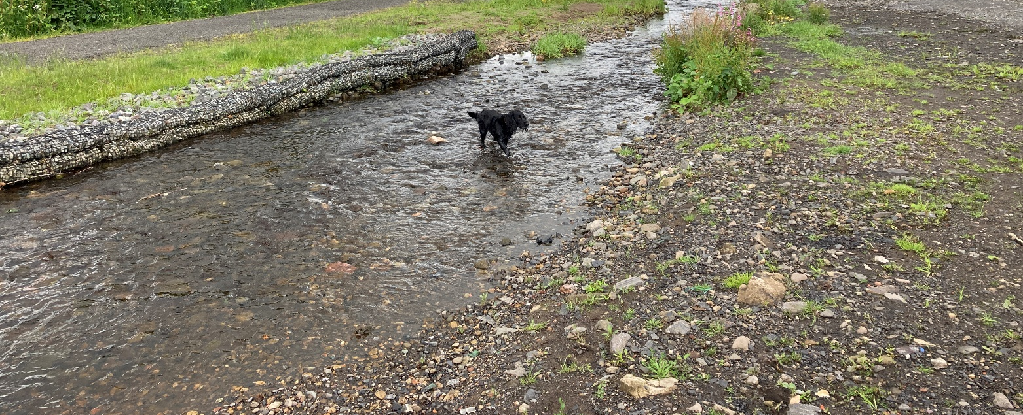
The rocks can also have better ecological and environmental outcome compared to other high impact methods as smaller rocks used in the rock rolls trap fine sediment within the void spaces between the rocks which allows vegetation to colonise. Once colonised with vegetation the rocks are often not visible, and the increased roughness created by the vegetation increases energy dissipation and subsequently enhances erosion protection. Vegetation colonisation is often greater compared to gabion alternatives due to the rock rolls/mattresses being more malleable and the generally larger rock size and void spaces.
Figure 4K: Rock roll mattress used protect a bank face from erosion.
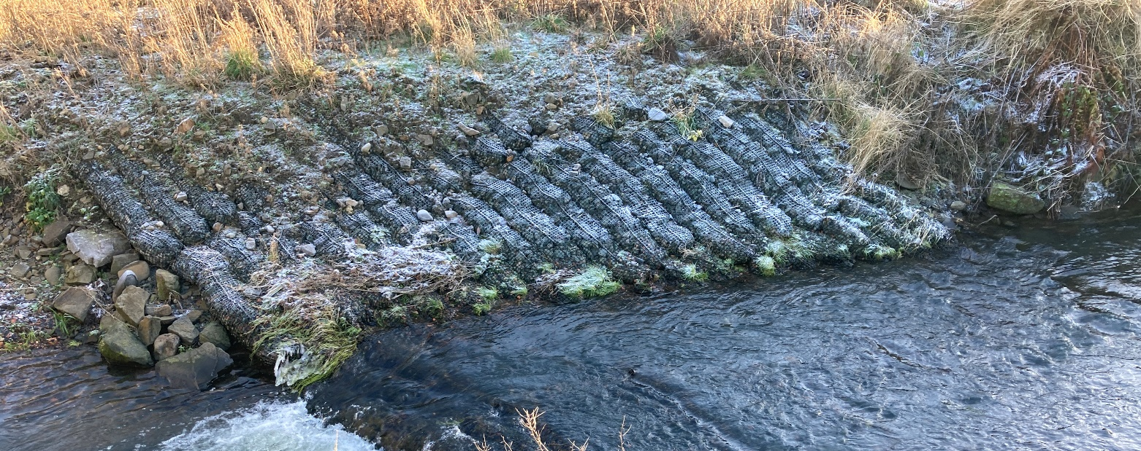

3d Gabion baskets and mattresses (‘Reno mattresses’) Gabion tubes
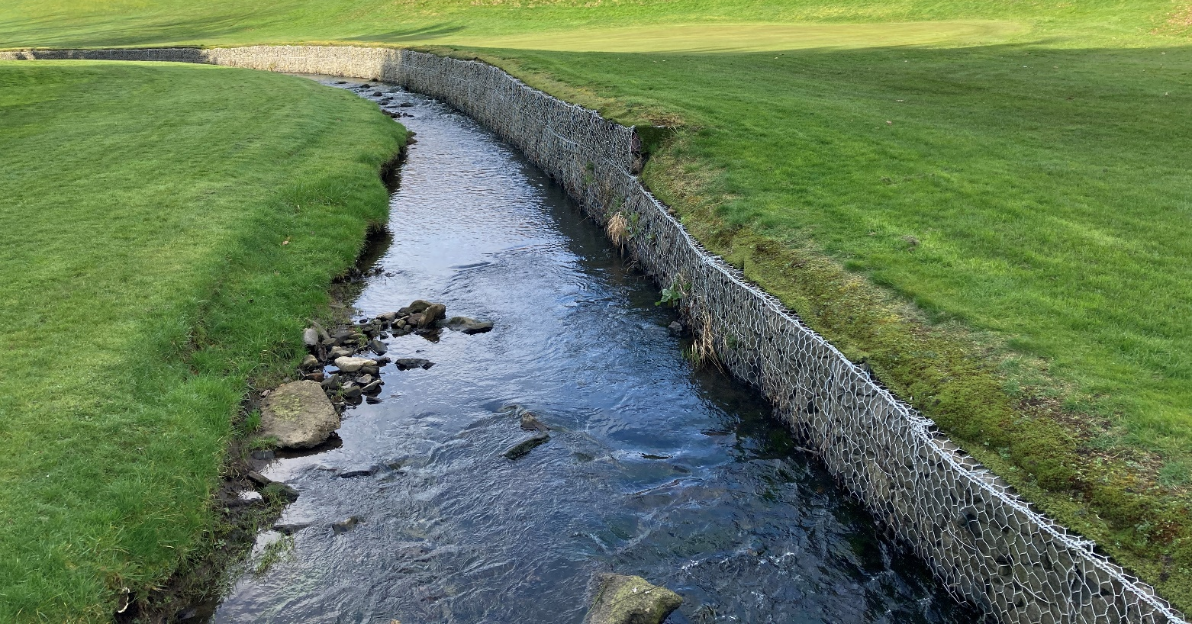
Gabion baskets are wired mesh containers filled with rocks or stones (typically 100 – 200 mm in size). The baskets are often laid side by side and one on top of the other to protect banks from erosion (Figure 4L). They are commonly used in location where it is not possible to reduce the bank slope. The energy dissipation and roughness of the basket’s face will increase with the size of stone used to fill it. However, consideration also needs to be given to how the size of stone used effects the packing of the baskets. The less tightly packed the basket the more easily it can deform and fail. Large voids can also result in flow “disappearing” into the baskets/mattresses. Gabion tubes are similar to gabion basket but are cylindrical in shape.
Figure 4L: Gabion baskets used to protect a golf course green from erosion.

Gabion mattresses (Figure 4M) are composed of series of shallow wire cages filled with rock or stones pinned together, to make a structure that can be laid on a shallow bank or at the bank toe. The cages used in a gabion mattress are generally shorter and wider than a gabion basket. The more rectangular shape and interlocking cages allows them fit over wide range of terrains. Gabion baskets and mattresses are highly prone to damage and failure due to impact from gravel, cobbles and boulders moving along the channel.
Figure 4M: Example of poor use of a reno mattress on a riverbed and gabion baskets on the banks. Note that flow has disappeared under the mattress and the erosion forces have simply been transferred to the channel immediately downstream causing significant scour and a barrier to fish passage.
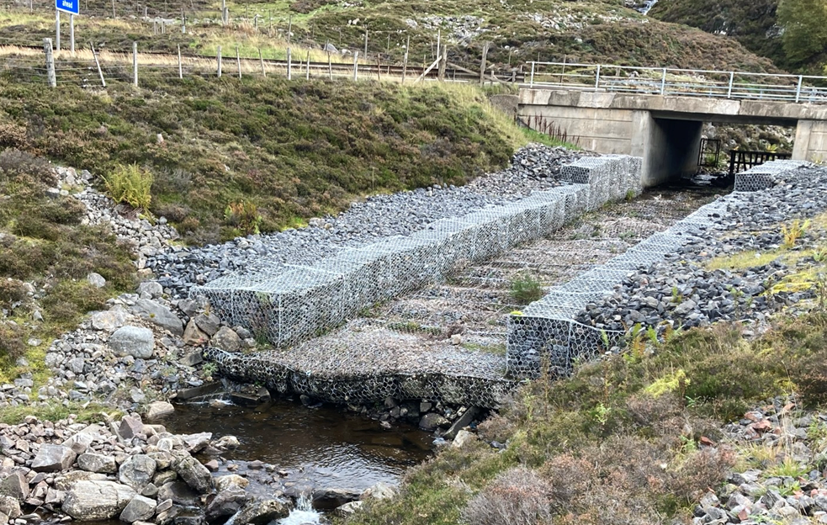
The gabion reno-mattress being laid at a relatively shallow angle (closer to the horizontal than to the vertical) and with many voids should lead to slightly more energy dissipation than stone revetments. Fine sediment can also accumulate within the pore spaces between the rocks encouraging vegetation to colonise, further increasing surface roughness and energy dissipation. However, the rigid baskets are still prone to failure which can introduce fragments of metal or plastic pollution into river/loch that can be harmful to aquatic wildlife.

3e Stone Revetments

Rock armour (rip rap)
Rock armouring for bank protection involves placing large (typically greater than 450 mm) fragments of quarried rock on riverbanks (Figure 4N). The rock armour works by absorbing flow energy and deflecting it away from the bank. Rock armouring is a durable technique that can be used for banks that are exposed to high water velocities. Angular rocks are generally preferred as they interlock together better than rounded boulders. Rock armouring is best suited to slopes with a gradient of 2:1 (horizontal: vertical) or less. A synthetic geotextile lining under/behind the rip rap may be required to prevent the washing out of underlying soil.
Rocks and stones used in rock armouring are typically larger than that used in gabions, creating much larger voids and a hydraulically rougher surface allowing greater energy dissipation.
Figure 4N: Example of rip rap rock armouring on riverbank in Stirlingshire.
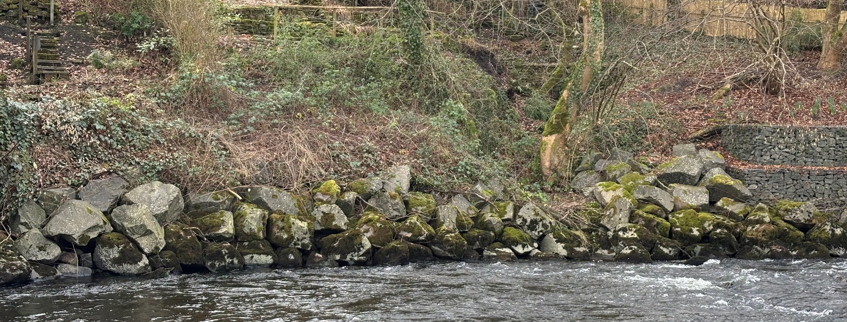

Hand pitched stone
A hand pitched stone revetment is a traditional technique using un-mortared stone to create a vertical or sloping wall (Figure 4o). If the toe of the bank is not being scoured/undermined and the bank is stable (i.e. not washing out from behind the stone), pitching can last for decades. It is usually used to protect the bank toe, with trees and woody vegetation protecting the bank face and top.

Figure 4o: Hand pitched stone wall used for bank protection.
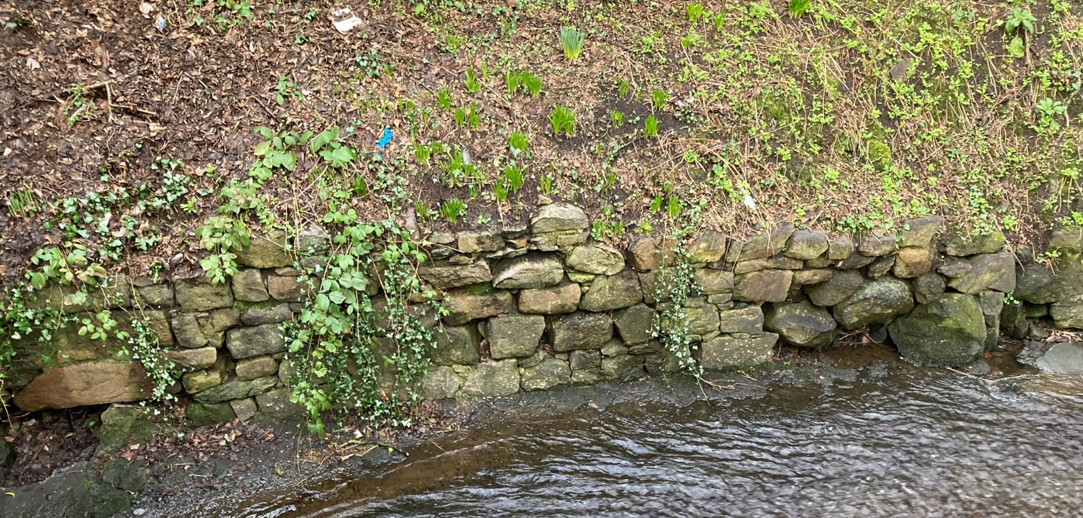

Grouted revetment
A grouted revetment comprises individual blocks of stone or brick bound together using grout/mortar to increase the stability of the protection, leading to a more monolithic structure. It often reduces the permeability of the bank surface, so drainage must be considered to avoid revetment becoming undermined.

3f. Low level piling
A low-level piling revetment is generally used to prevent undercutting and toe erosion, particularly in lochs (or coastal areas) were there is wave action. The technique involves driving relatively short piles (e.g. steel, timber or plastic) into the bed of a river or loch so that they sit below the normal water level. This technique is often used with other bank protection measures such as rock armouring or gabion baskets to increase toe protection and reduce the risk of the bank face protection being undermined.

3g. Concrete revetment
Concrete revetments are of typically sloping structure which can protect a bank or shoreline from erosion These revetments come in a variety of forms and can even be used to mimic the shape of natural materials such as cobbles or boulders. Mass concrete structures are often reinforced internally with steel. The durability of concrete depends on its composition (cement content and aggregate size/shape/grading) and exposure conditions. Concrete structures are significantly weakened if the internal reinforcement corrodes due to exposure to water and air. Concrete will last for decades under most circumstances but will need to be periodically checked for deterioration or undermining.

3h. Retaining Walls
A retaining wall is typically a vertical/near vertical and sometimes benched structures sometimes used to form a river or loch bank to support a mass of soil/earth and prevent erosion. They can be made from concrete (including concrete bags), gabion baskets, sheet piling, wood/timber or masonry materials (such as bricks, stones, concrete blocks). Further details on each material used to create a retaining wall is provided below:
- Concrete: typically the concrete is reinforced with steel (Figure 4P). Drainage holes are incorporated into some designs to reduce water pressure behind the wall to increase its stability. The wall’s durability depends on the composition (cement content and aggregate size/shape/grading) and design. The sharp edges found on many concrete structures (e.g. sides or toe) are prone to hydraulic scour. Concrete structures are significantly weakened if the internal reinforcement corrodes due to exposure to water and air. Concrete will last for decades under most circumstances but will need to be periodically checked for deterioration or undermining. In some situations, precast concrete panels can be used to speed up the installation time and reduce the risk of pollution during construction.

Figure 4P: Concrete retaining wall to protect infrastructure in a small town in the Scottish Borders.
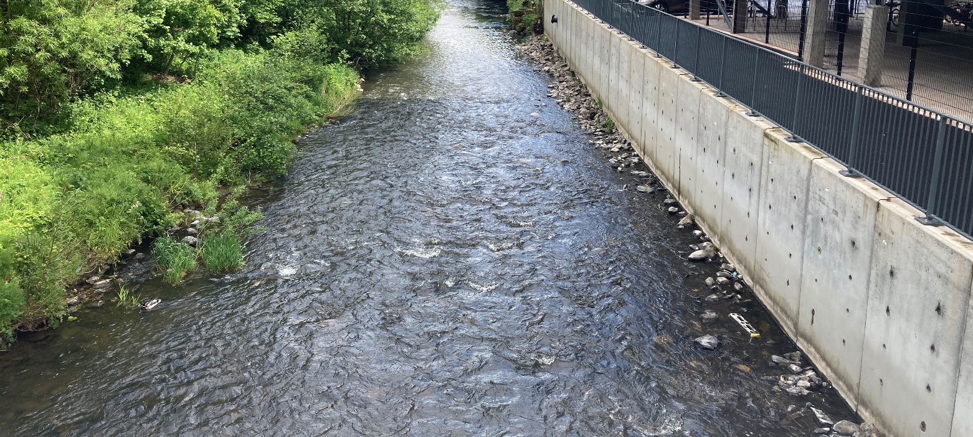
- Masonry: typically constructed using masonry units such as block stone, bricks or concrete blocks (Figure 4Q). The blocks are placed vertically on top of each other to the desire height along a set length of bank, usually by hand. The blocks will usually be bonded together using a cement based mortar to improve strength. The walls are sometimes constructed so they incline very slightly towards the bank for added stability. It is recommended that engineering bricks (resistant to sulphate attack) with strong lime-free mortar should be used.

Figure 4Q: Masonry wall along the Den Burn in Aberdeen.
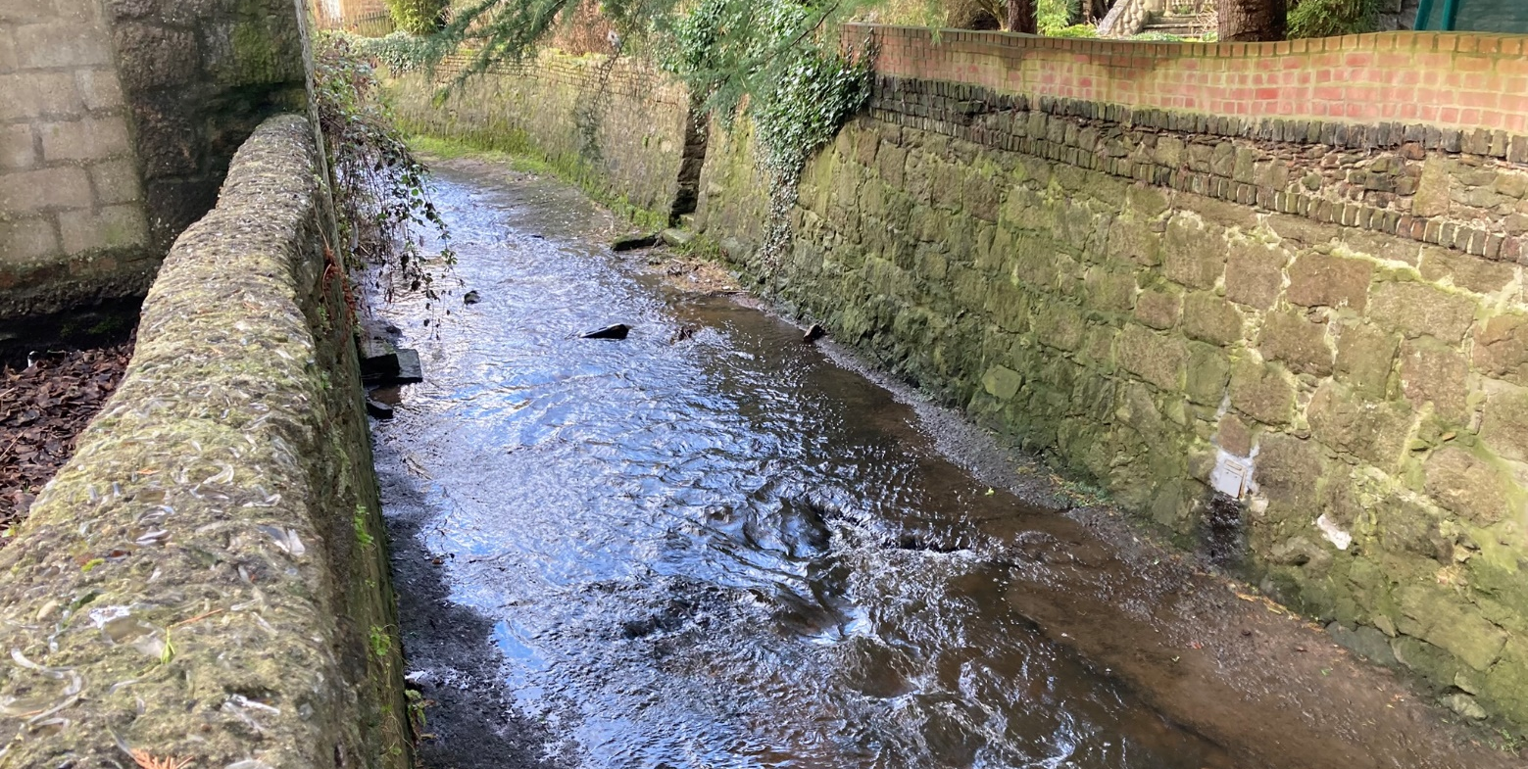

- Sheet piling: a retaining wall made form sheet pilling consists of sections of profiled interlocking metal (normally steel), plastic, vinyl or sawn timber driven vertically into the bed of the river to create an artificial bank surface (Figure 4R). As the materials used are designed to lock together, they create a solid wall which protects the bank from erosive forces of the water. Sheet piling can also be used to support riverbanks which are failing. In some instances, drainage holes are incorporated in the design to reduce water pressure behind the sheet pilling, which increases the stability of the wall.

Figure 4R: Example of sheet pilling retaining wall in Stirlingshire.
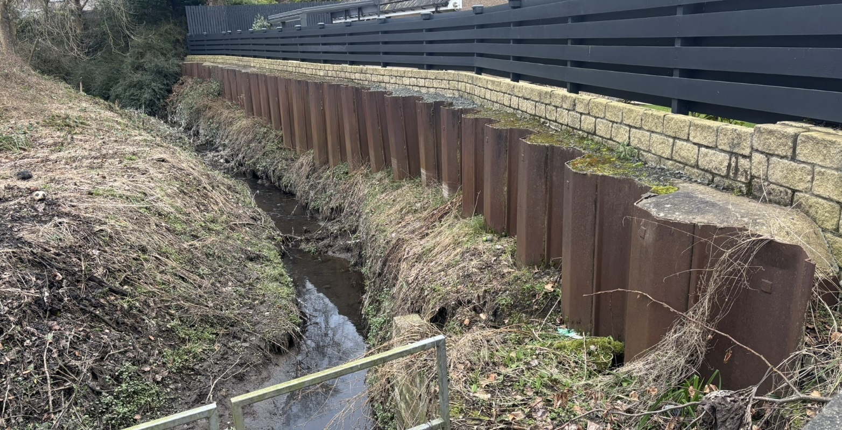
- Gabion wall: These are square or rectangular wire cages filled with rock or stone, which are stacked vertically and pined together horizontally to create a wall (Figure 4S). The gabion structure can slightly reduce water velocity through increased friction (compared to other retaining walls), which leads to some dissipation of erosive energy. More details on gabions can be found above.
Figure 4S: Gabion wall.
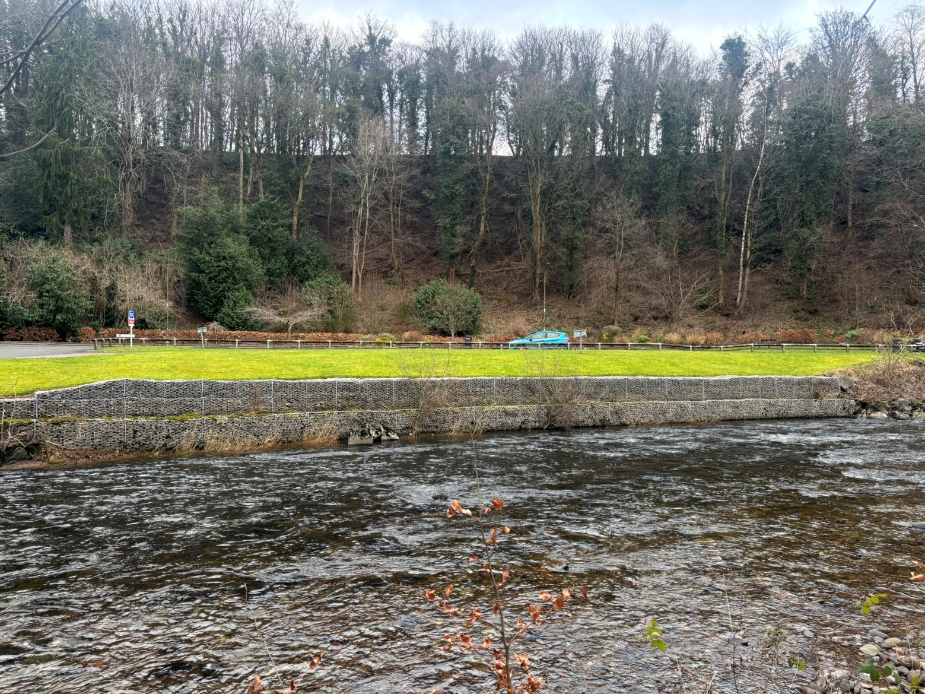
- Timber walls – Consists of timber posts driven into the bed of the river and the timber planks or logs attached horizontally to create continuous coverage of the bank face (Figure 4T). Hard woods such as oak are also popular as their decay rate is slower than soft woods like pine. The timber used should be untreated to prevent harmful chemical leaching into the watercourse.
Figure 4T: Timber walls used to protect bank from erosion.
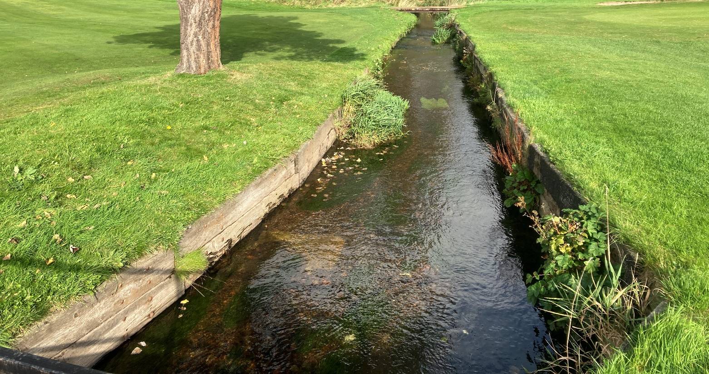

4.2.3 Embankments and Floodwalls
This section looks at identifying and appraising options for embankment and floodwalls which are located at the top of the bank face i.e. increasing the height of the river or loch bank top.
For guidance on embankments or floodwalls which are not located on the bank top but are located in the vicinity (within 10 metres of the bank top) and beyond the vicinity (i.e. greater than 10 metres from the bank top) please refer to WAT-G-028 EASR Guidance: Engineering Activities: in the vicinity, beyond the vicinity and affecting wetlands.
Embankments and floodwall along the banks of river are often used increase the capacity of the channel to reduce the frequency of, or prevent, the land adjacent to the river from flooding. The adjacent land may need to be protected from flooding to protect property, infrastructure (including public rights of ways) or valuable agricultural land.
When embankments and floodwalls are built right on the edge of a river, they can significantly change the hydraulics during high flows when the water would usually spread out over the floodplain. Constraining more flow in the channel increases the energy of high flows increasing erosion of the bed and banks in that section and increasing deposition downstream where the river corridor widens causing a reduction in the energy. Over time the erosion of the bank could cause the embankment to become undermined or create a hole (breach) allowing flood to spill onto the floodplain again.
During extreme flood events, embankments and floodwalls can be overtopped by floodwater. As the flood recedes, significant volumes of water can be trapped on the floodplain behind the embankment increasing the time that land and property is not accessible. Overtopping can also cause significant scour on the landward side of the embankment causing sudden failure/breaching allowing a large volume of water to rush through into the floodplain. This can have devastating consequences for any land, property or infrastructure in those areas.
Because of these issues, it's important to think carefully about whether these embankments or floodwalls need to be placed so close to the riverbank. Setting embankments and floodwalls as far back as possible gives the river more space. This reduces the effect on the hydraulics and consequent changes to erosion and deposition patterns, the likelihood of the embankment or floodwall being breached and potentially reducing the height, and therefore cost, of the structure needed.

Do Nothing
Before deciding on the favoured approach to your issue or need, you should always consider the option of doing nothing.
Sometimes if the consequences of flooding are low or can be easily dealt with then the best solution might be to simply allow the flooding to occur. For example, if the river is flooding recreational ground, such as a park or sports pitches, and this does not occur often it might be better to just allow this happen and manage use of the area so that there is no threat to life, property or infrastructure. The area would also drain more quickly when the water levels drop allowing recreational use to resume more quickly. A good understanding of the need or problem and the river environment will help ascertain whether a ‘do nothing’ approach is a viable option.

Non-Engineering Solutions
In some instances, simple non (river) engineering options may be enough to address the problem or need (e.g. a flooding issue). There are many good reasons to use non engineering options, such as:
- Normally no requirement to obtain SEPA authorisation for works.
- Reduced maintenance burden.
- May be cheaper and grants may be available to undertake works.
- Improves the aesthetic appeal of area for the local community.
- Is better for river ecology and local wildlife.
- Improves access to the river for recreation activities.
Non-engineering options which may be feasible in certain situations are:
- Moving back from the river: – investigate whether it is possible to move the assets under threat back from the river. For example, a footpath could be re-routed.
- Change in land use/ management: investigate changing the land use along a river corridor away from built development towards habitat and biodiversity enhancement or changing the use of a frequently flooded field from arable to pasture.
- Nature-based solutions: in some situation planting trees in the upper catchment and along riverbanks can help with flooding in the lower catchment.
- Working within the natural river environment in this way will improve the climate resilience and biodiversity of an area and reduce maintenance costs.

Engineering Solutions
Where there is a demonstrated need (e.g. for flood protection), which cannot be solved by a change in land use or management practices then an engineering option may be necessary. The selected engineering solution should be appropriate and proportionate to the property, infrastructure, land or resources at risk.
There are a range of engineering methods, which have a varying level of morphological impact on watercourses and lochs.
Engineering solutions to address flooding issues can be divided into two broad groups:
- Methods with low impacts on morphology.
- Methods with higher impacts on morphology.
Low impact methods are preferred where possible. The use of higher impact methods will require greater justification. The different options in each of these group are discussed in the sections below.

Flood protection methods with low impacts on morphology
Natural flood management techniques and set-back embankments are two methods which can offer flood protection and have a low (or sometimes positive) morphological impact.
- Nature based engineering: in smaller catchment nature-based solutions could be an effective method of reducing localised flooding. This would include techniques such as river and wetland restoration (see our guidance WAT-G-023 EASR Guidance Engineering: Activity Guide: Channel modification) to improve floodplain connection and more natural flow rates. Restoring channels and wetland can be hugely beneficial for morphology of the river and surrounding ecology. Other techniques include the placement of leaky wood structures in smaller upper catchment streams.
- Set-back embankment: a set-back embankment is one which is placed at least 10 m back from the bank top (Figure 4U). Placing the embankment away from the bank top widens the river corridor, helping maintain more natural channel processes (erosion, deposition, sediment transfer) and riparian habitat. Further details on the set-back embankments are located in our guidance WAT-G-028 EASR Guidance: Engineering Activities: in the vicinity, beyond the vicinity and affecting wetlands.
Figure 4U: Set back embankment on the River Nith, Ayrshire.
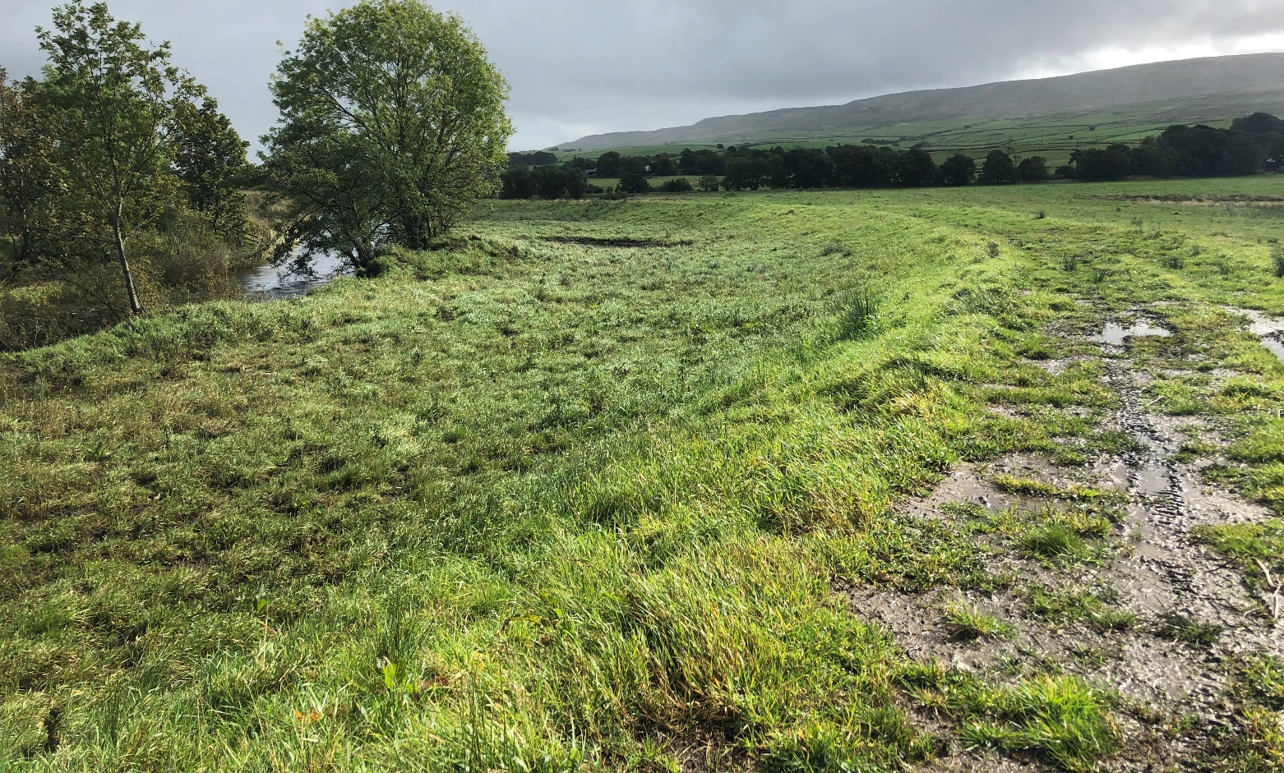

Flood protection methods with higher impacts on morphology
In some instance there will be a requirement to use more engineered forms of flood protection, for example when there need to protect a property or major road from flooding. As embankments can affect drainage it is always important to consider this during the design process, especially as seepage and poor drainage can cause embankments to fail. Formal embankments and floodwalls have a higher impact on channel morphology and therefore we would always encourage you to set these back from the bank top as much as is feasible. Note if your embankment or floodwall will not be located at the bank top (i.e. does not increase the height of the bank face) you should refer to our guidance ‘WAT-G-028 EASR Guidance: Engineering Activities: in the vicinity, beyond the vicinity and affecting wetlands

Earth embankment
Earth embankments are structures formed using natural materials like soil, clay, and gravel to increase the level of an area of ground (Figure 24). In some cases, the earth embankment is made with an impermeable clay core to help control seepage and provides greater stability. They are commonly used for flood control but can also be used to support roads and railways.
Figure 4V: Earth embankment.
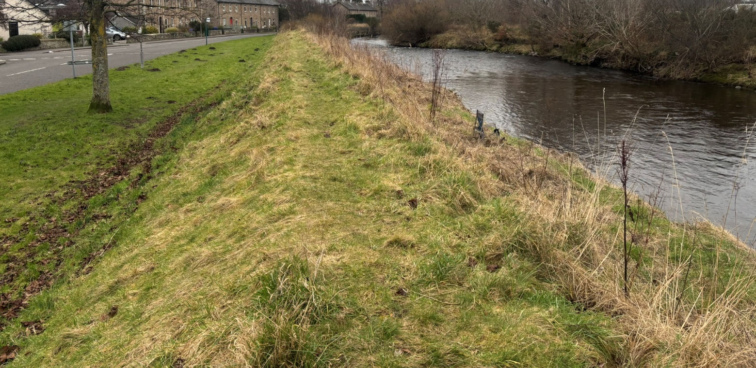

Reinforced earth embankment
Reinforced embankments are often formed using natural materials like soil, clay, and gravel but incorporate other materials such as geotextile to increase their stability and durability. These are commonly used in locations where soil quality is poor or where the embankment is also acting a retaining wall.

Flood wall
A flood wall is a vertical wall placed along a river or loch to protect an area from flooding. The walls are designed to withstand high water pressures or wave impact (Figure 4W). Their design often includes drainage pipes to help reduced pressure behind the wall. The walls can be fixed height or be designed to rise as the water level rises.
Figure 4W: Flood wall constructed as part of a flood scheme in Aberdeenshire.
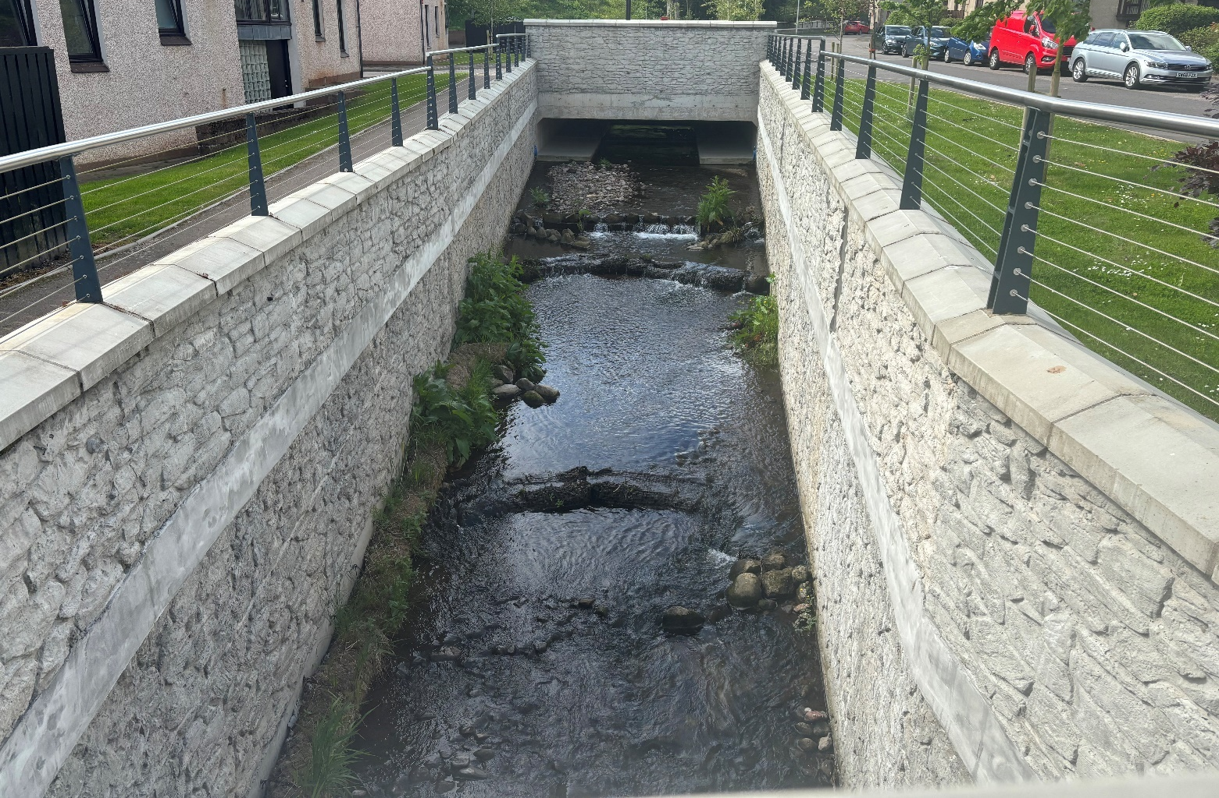

4.2.4 Other Bank Works
Other bank works includes all any activity taking place on a river or loch bank not for the purposes of erosion and flood protection. It includes activities such as access steps, intakes and outfalls, ramps and boardwalks.

Do Nothing
Sometimes the problem or need may be more perceived than real therefore before undertaking any bank works you should access whether there is a need for the bank works or if another solution is feasible.

Engineered Solutions
If a problem or need cannot be addressed without bank works, care should be taken to minimise the impact of the works on the water and surrounding terrestrial environments. The risks of erosion to any new bank works structures and the nature of the river type should be carefully considered before deciding on a favoured design. Some common types of other banks works are outlined below.
- Intakes/Offtakes – are structures designed to take water from a river and divert it for use elsewhere, for example water abstracted from a river for irrigation. There a range of intake structures depending on the use of the abstracted water. Intakes often need to be carefully designed and, if required, a suitable management plan in place, to limit changes to sediment transport processes within a river, fish entrapment and loss of bankside habitat. Further details on the types of intakes and good practice methods are in WAT-G-036 EASR Guidance: Intakes and Outfalls.
- Outfalls –are structures where water or liquid waste is discharged into a river or loch usually from a pipe or drain. Further details on the types of outfalls and good practice methods are in WAT-G-036 EASR Guidance: Intakes and Outfalls.
- Steps – steps made from range of materials can be installed on a river or loch bank to allow people access to the water for different recreational activities including fishing, kayaking or boating.
- Ramps – ramps, like steps, can be constructed on the riverbank or a loch shore to allow people access to the water for a range recreational activities including fishing, kayaking or boating. Ramps have the advantage over steps of being more accessible to people of all ages and abilities. They can be made of different materials including concrete, geotextile matting and wood depending on the type of river or loch.

4.2.5 Removal of Existing Bank Work Structures
Sometimes there is a need to completely or partially remove an existing bank structure. This may be because it is in a poor state of repair and can no longer fulfil its intended purpose or is no longer required.
Before committing to undertaking a full or partial removal the process of considering doing nothing, non-engineering options and various options for removal is still valid.
In some cases, removal of an existing structure will help to re-naturalise a river or loch and is to be encouraged. Other times the removal may cause large scale disruption and potential impacts such that on balance, it may be considered better to leave, or part remove the structure. However, in most instances we would encourage you to discuss your proposal with us.
As well as the general risk to the environment from working in or near water some key issues to consider when removing an existing structure are:
- To make sure the bank is restored properly.
- To grade disturbed areas smoothly into the existing bank line.
- To re-establish vegetation by re-seeding returfing the disturbed areas and install surface protection (e.g. coir matting) to enable the vegetation to establish and stabilise the banks.
- Depending on the site-specific situation and river type, consider installing suitable bank protection measures to prevent the bank from eroding.
Some key considerations about structure removal are set out in Appendix 7.

4.2.6 Options Appraisal
The options appraisal should include:
- Comparison of at least 3 options (including doing nothing).
- Costs (including capital, construction and maintenance costs).
- Feasibility of construction.
- How well it addresses the problem or need and whether it tackles the underlying cause.
- Maintenance requirements.
- Impacts upon physical river attributes (morphology).
  - Channel form, allow the river room, riparian areas, sediment movement etc.
- Impacts on ecology.
  - Fish, other aquatic and riparian wildlife.
  - Impacts on conservation designations, important species and habitat features.
- Impacts on other users of the water environment (such as angling, kayaking etc).
The cost evaluation should assess whether the costs for each option are proportionate.
The suitability of the best option will always depend on the needs and the details of each situation. In some cases, you may need to implement a variety of methods to address the problem or need.

4.3 Justify the selected option
After evaluating all the alternatives, the best practical and environmental option, with proportionate costs, should be chosen and justification provided.
This does not always mean adopting a lowest impact engineering approach or adopting the cheapest solution. The best practical environmental option means choosing the approach that effectively addresses the problem or need and minimises negative environmental impact as far as practical.
Proportionate costs are those that correspond to the level environmental harm being minimised or the environmental benefits that the option provides.
Large absolute cost in itself does not constitute disproportionate cost.
For example, incurring significant costs to prevent significant environmental harm or achieve significant environmental benefits e.g. safeguarding protected species and designated sites, is likely to be considered proportionate. But incurring significant costs for minor environmental benefits would likely to be considered disproportionate.
The reason for choosing your bank works option may be for one or a number of reasons. These should be made clear so we can assess whether Good Practice has been met.

4.3.1 Possible justifications for your chosen bank works
Some possible justifications for your chosen bank works option are detailed below.
Channel Form
Channel type, particularly the energy regime, and bank material may determine the most suitable bank works options. Natural, un-modified channels are a particular shape for a good reason. They represent a long-term balance between the forces of water flowing downhill and resistance caused by sediment and vegetation. Any project that significantly alters channel form (i.e. width, depth, slope, planform) will affect the natural balance in the river with consequences for erosion and deposition of sediment. Options which accommodate natural river form are encouraged.
Environmental Benefits
Justification for a chosen banks works method could be related to the environmental benefits it creates or how it minimises environmental disruption. For example, the selected bank works option may create habitat for terrestrial and aquatic wildlife, improve water quality or increase climate resilience.
How well it addresses the problem or need and whether it tackles the underlying cause.
The chosen option may be the one that addresses the overall problem or need whilst minimising adverse impacts.
Economic Savings
An economic saving would be realised by undertaking your preferred bank works options because of reduced construction and operation costs. For example, the selected bank works option reduces the costs associated with land loss, property damage, or long-term maintenance of infrastructure.
Costs
Whilst low environmental impact options are preferred, we recognise that the costs for a chosen option must be proportionate for the situation. Where an option with lower environmental impacts has been rejected due to financial cost you must provide details.
Feasibility of construction
In certain cases, (for example, where access or space is very limited) it may not be possible to apply lower impact techniques so higher impact techniques may be justified.
Maintenance
How often will a structure have to be replaced, or how often will an activity need to be repeated? Projects that work against natural processes often result in high maintenance. Has this cost been built into consideration of alternatives? A project which takes account of natural processes, such as sediment erosion, transport and deposition, could avoid or reduce these costs.
Aesthetic and Recreational Value/ Impacts on other water users
The preferred bank works method may be related to the appearance of the river or loch bank for a particular reason such as for a garden or golf course. Other reasons could be linked to recreation use of the area such a sports fields or tourism.
Health and Safety
The chosen bank works options may be required to ensure the health and safety of people accessing the river for maintenance works.

4.4 Use all reasonable mitigation
To minimise impacts on the water environment and other water users you must plan to use all reasonable mitigation when carrying out any bank works.
Mitigation measures for a proposal should:
- Limit, or offset, potential impacts, including those from construction.
- Be proportionate to the environmental risk.
- Be prioritised by the balance of factors such as environmental benefit, cost, and ease of implementation.
- Not be used to compensate the impacts of an unjustified activity.
As every case is different there is no single answer to what mitigation is considered reasonable.
You should understand the risks and issues.as set out in section 3.3
A method statement should be submitted including details on how you intend to carry out the works including the mitigation measures you intend to take and how you will maintain them. Details can be found in our section 5.2 of our guidance WAT-G-030 EASR Guidance Engineering Meeting Good Practice.
Using suitable mitigation will help you to comply with Permit conditions. In certain cases, specific conditions relating to mitigation requirements will be specified within the Permit.
Further guidance is available in our in our guidance WAT-G-034 EASR Guidance: Construction works and silt/pollution mitigation.

5. Post Works Monitoring
After your bank works have been installed, you should undertake post-project appraisal to help identify any problems that need to be investigated and addressed (e.g. post construction snagging issues and emerging issues) and to monitor how well the works address the original problem or need.
It’s especially important to check the works after the first moderate to high flow event to see how they have coped and whether any issues have emerged or are at risk of emerging. This can include issues such as:
- Damage to restored bed and banks.
- Defective installation or materials (e.g. poorly secured coir matting becoming dislodged).
- New erosion of banks upstream or downstream, or bed at the toe of the bank which could threaten the integrity of the bank works.
- Livestock gaining entry to fenced off areas and damaging planted trees etc.

5.1 Post project appraisal and site management
Frequent inspection and maintenance of bank works is required to ensure that any damage can be repaired before it progresses to a more significant failure. The following points summarise the suggested appraisal methods:
- All projects should be inspected at reasonable intervals and at least annually. New projects should be inspected as soon as possible after the first significant high flow.
- Photos of the works should be taken periodically at established points. Photos should be taken at least twice a year, ideally in the spring and autumn (when vegetation is low) to capture any changes due to winter high flows. To allow comparisons between repeated photographs, they should be taken during low water periods and at corresponding water levels. If it is safe to do so, you may wish to take extra photographs during higher flows to record the performance of the engineering.
- The development of the vegetation should be monitored and correlated, at least visually, to the degree of or lack of erosion occurring on the treated streambank. Plantings are assumed to be effective if the vegetation is growing well in all bank areas, and observation suggests erosion is not occurring. The frequency of monitoring should be a minimum of once per growing season (preferably near the end of summer) for at least three consecutive years.

5.3 Post project appraisal at bank protection structures
Most conventional bank protection structures fail because of undermining or washout of soil behind the structure. Care should be taken during design to prevent this from happening e.g. bury the toe well below the bed and use geotextile to prevent washout. Careful inspection of the toe area can also help prevent failures by identifying damage before it progresses to failure. Inspection of the toe zone should occur during low water periods, when the toe is more likely to be visible. Areas below normal water level should be inspected for evidence of sediment movement along the toe or streambank erosion that could undermine the toe. The bank behind the structure should also be inspected for depressions which may indicate ground subsidence due to washout. The following conditions may suggest a need for repairs:
- Areas of bare soil within the toe zone.
- Displacement of larger sediment like cobbles and boulders within the toe zone.
- Scour along the toe that results in loss of support to the upper bank.
- Evidence of bed degradation (lowering) or scour holes that might undermine the toe.
- Movement or loss of large rock protecting the foundation of walls, or movement (settling, tilt, or horizontal displacement) of the structure.
- Movement or deformity of the structure.

Appendix 1: Monitoring erosion rate
Erosion rates can vary widely, within and between rivers, and may suddenly accelerate due to natural causes or human activity. To determine if the rate of erosion is significant you should consider the context, the rate of erosion (how much bank is lost each year) and what is at risk. Understanding these factors will help you select an appropriate response to the problem. For example, an erosion rate of 0.5 m per year on a stable, lowland river near a house might be considered significant and require prompt action. The same rate might not be considered significant for a high-energy river, which changes position more rapidly, in a remote area which doesn’t threaten people, infrastructure, buildings or valuable land.

Methods to Assess the Rate of Bank Erosion
Determining Erosion Rates
- Photographic Surveys: Use repeat fixed point photography.
- Direct Measurements: Measure from a fixed reference point.
As rates of erosion are linked to flow and weather conditions, erosion should ideally be monitored over several years or seasons.
Key Points to Remember
- Fixed Reference Point: Always use a fixed point to track erosion.
- Photographs: Ensure all photos are named and dated.
- High Flow Events: Erosion rates are higher during and after these events. Track erosion over various flow conditions and record the date and height of floods.
- Record Keeping: if possible, record flow or rainfall between assessments.
Using Fixed Markers
- Markers: use stakes placed at a known distance from the top of the bank.
- Measurements: periodically measure the distance from the marker to the top of the bank.
As a rough guide if the erosion is more than one channel width from the risk or only a few centimetres per year, consider monitoring before taking immediate action.

Assessing whether erosion is normal or accelerated
Indicators of normal bank erosion
- Meander bends: erosion on the outside of meander bends, perhaps with bank collapse.
- Vegetation: some vegetation establishing / or growing on eroded faces.
- Localised scour of finer sediments at the toe of the bank.
- Scour around tree roots: where the bank line has not retreated from treeline.
- Historic bank collapse evidence that these have stabilised and re-vegetated.
Erosion which is part of a natural river processes should generally be allowed to continue (see Appendix 4).
Indicators of accelerated bank erosion:
- Higher erosion rate: significantly greater than on comparable rivers.
- Recent and sustained increase in the rate of erosion (for months or years).
- Vegetation is no longer establishing on eroded faces.
- Erosion on opposite banks for long sections.
- Channel widening is the channel getting wider or already wider than adjacent reaches.
- Bed erosion/incision: evidence of the channel bed is eroding, (cutting down vertically) e.g. a lack of gravels in the bed, exposure of underlying clay or bedrock, or undermined structures (e.g. bridge foundations).
- Sediment Deposition: Lots of sediment has accumulated at/near the site of the eroded bank(s).
Reasons for accelerated erosion should be investigated. If there is no risk to people, infrastructure building or valuable land it may be allowed to continue without any intervention (see Appendix 4 for further details).

Appendix 2. Types and Causes of Erosion
Bank erosion is a natural process. It can be temporary or long lasting and comprise of more than one type and have more than one cause. This erosion can become problematic due to natural reasons and/or human activity.
Identifying the type of bank erosion and whether it is a temporary or long-lasting problem can help identify the cause and aid the selection of appropriate control measures.
Natural erosion varies between river types and is more common in higher-energy upland and transitional type rivers. Natural events like flooding, a meander cutoff or trees falling into the river can trigger dramatic and sudden changes in erosion. Understanding the river type can be helpful in identifying both the cause of erosion and what response is appropriate. Details on river types are set out in WAT-G-033 EASR Guidance: Inland surface waters and river subtypes.
Human activity can be an exacerbating factor or the main reason for the initiation of problematic bank erosion. This can include removing riparian vegetation, new engineering instream structures or livestock grazing.
How a river or loch bank erodes (i.e. mode of failure) varies depending on site specific conditions, the most important being the bank material, specifically its level of cohesiveness, and bankside vegetation. However, other factors such as high banks caused by bed lowering and channel terracing, freeze-thaw processes, livestock trapping and vehicle movements can cause and exacerbate the erosion of any bank.
A field visit to investigate and record the erosion can be useful to help identify what its extent, type and cause may be. For guidance on how to do this, see Appendix 3, which describes the structure of a simple field survey. If it is not readily apparent after some investigation the type or cause of erosion, you should seek advice either from an experienced river geomorphologist, or from local conservation groups who may have background knowledge of the river.

Types of Erosion
There are three broad types of bank erosion, which are:
- Bank scour - occurs when the force of the water against the bank causes sediment to be removed (Figure A2A).
- Bank collapse - occurs when the bank becomes so saturated with water (often from heavy rain or flooding) or by undercutting from bank scour that its structural integrity is compromised causing it to fail. (figure A2B).
- Direct erosion – caused directly or exacerbated by land management practices, livestock grazing and trampling, bank and instream structures vehicles etc. (fig A2C).
Figure A2A: showing full height bank scour erosion around a meander.
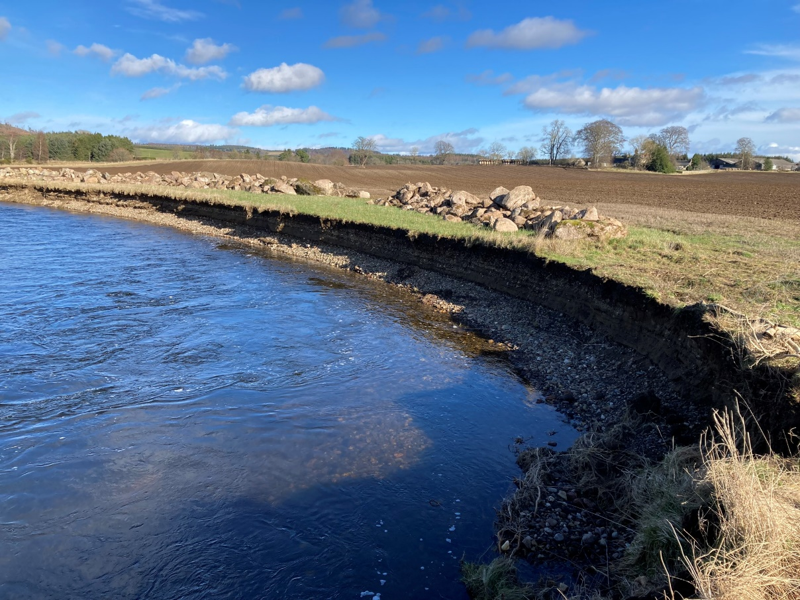

Figure A2B: Showing bank collapse on actively meandering lowland river.
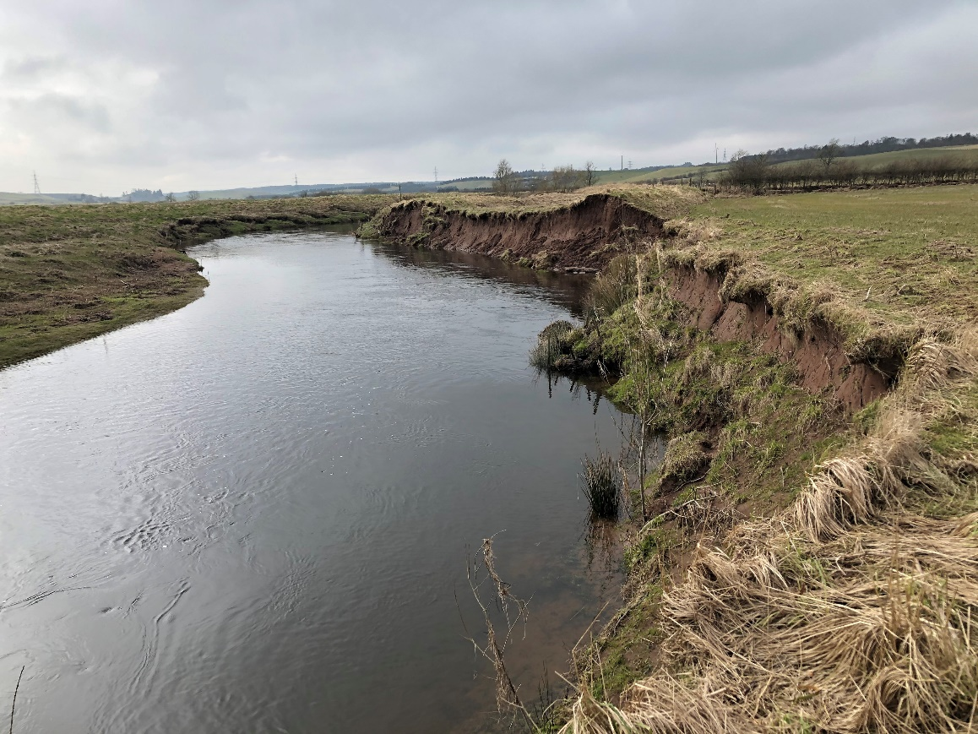
Figure A2C: Showing bank top erosion through land use practices (grazing up to water’s edge and no riparian zone)
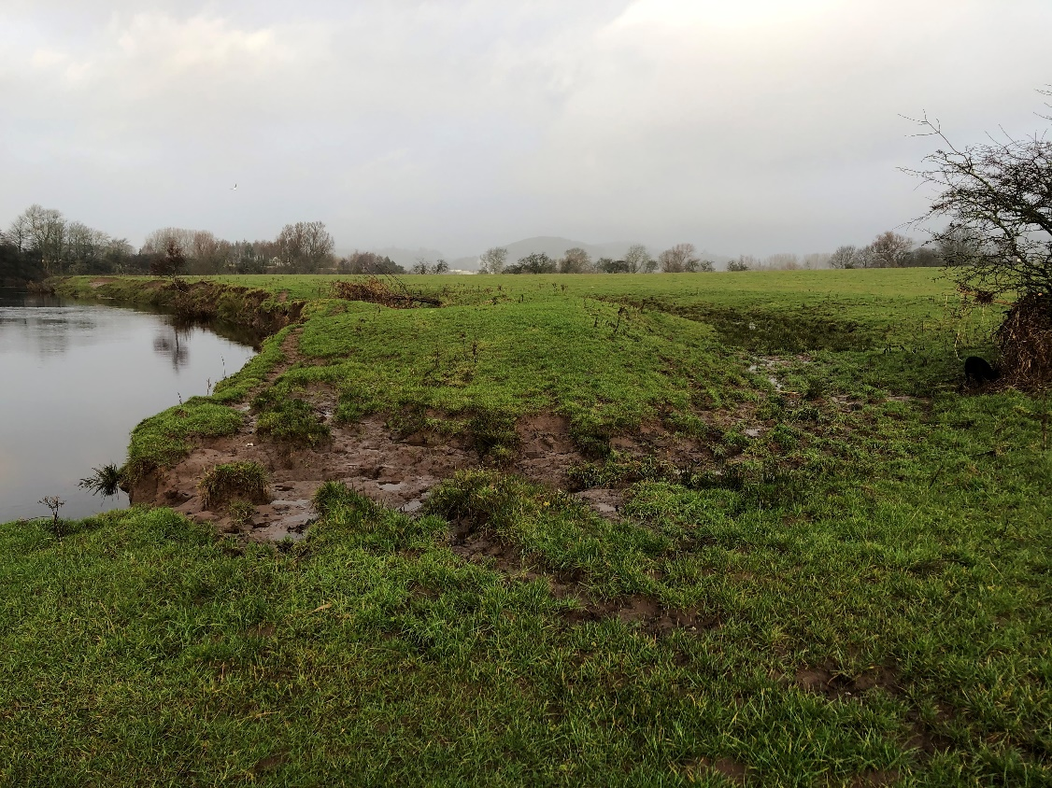
Understanding which of these processes is driving the erosion of the bank will help you develop and implement a sustainable to long-lasting solution. For example, if the erosion is due to bank collapse you will want to look at methods which help stabilise the bank and improve its drainage, such as riparian vegetation that increases soil stability and structure and helps remove moisture from the soil, drainage improvements or terracing the bank help manage water flow and waterlogging or retaining wall with drainage holes to provide structural support to the bank. However, if the issue is bank scour, then consider methods that protect the bank and dissipate high flow energy (thereby reducing erosion forces) such as root wads, whole trees or rip-rap. The causes of direct erosion can be managed through changes in land management activities, fencing of areas of the bank or bank side trees planting.
When considering bank erosion problems and potential options, it is also useful to consider what section of the bank is eroding. There are three different zones that may erode:
- Bank toe - the section below the water surface at normal flow conditions. Erosion at the toe of the bank creates an overhang which over time reduces the structural integrity of the upper bank causing it to fail This is sometimes known as undercutting.
- Upper bank zone - the section above the water surface at normal flow conditions. Erosion of the upper bank is common round meander bends where the hydraulic action of the water removes sediment from the face causing the river to migrate or when water clogged soils cause a bank to slump.
- Riparian zone - the land running adjacent to the river channel – around 10 m wide. Erosion of the riparian zone can occur due to livestock, vehicle or human movements along the bank top.
Understanding which section of the bank is eroding allows you to select a solution which directly targets the vulnerable section of bank which can reduce the resources required to solve the problem and limit the damage or loss of habitats. For example, if the bank toe is eroding and over time causing the upper bank to fail then using protection just along the bank toe will protect the bank from failure in the future.

Causes of erosion
Erosion can be cased or exacerbated by several factors both natural and from human activity. These include:
- Increase in high flow events caused by climate change, alterations to land drainage, flood control structures.
- Changes to bank heights up or downstream (due to embankments, floodwalls, scour etc).
- Change to the height of the stream bed from dredging or gravel extraction etc.
- Loss of sediment supplied from upstream due to sediment removal, dredging or bank protection etc.
- Changes or loss of riparian vegetation can reduce bank strength and expose soils to erosion. (includes grasses, reeds, trees and shrubs etc).
- Livestock management including grazing patterns, breeds and stocking density.
- Burrowing by animals.
- Land use changes.
- Existing or new engineering structures.
- Debris or fallen trees, other bank works, croys etc. which direct flow into the banks causing localised scouring. (note fallen trees can also provide valuable habitats).
- Failure of existing or new bank works.
- Vehicle access to the river and banks.
- Saturation of banks from off stream sources.
- Recreational access to river and banks.
- Wave action by boats or wind.

Appendix 3: Field survey checklist
You may wish to use the list below to undertake a simple site survey. This information may also be useful as supporting evidence if you need to apply for an engineering licence. A survey is of little use if you can’t remember exactly when, where or by who it was done, so a note of the following will help:
- Date, river and name of surveyor.
- Location and grid ref (e.g. NS 3345 1973; 250 m upstream of Byres Bridge).
- Weather (e.g. dry at time of survey; recent light rain; floods 2 weeks ago).
- Photographs and descriptions (e.g. 1 – erosion viewed from upstream).
- A sketch map of the section in question, showing:
- The river (including flow direction and any features of interest e.g. gravel bars, fallen trees, existing bank protection).
- The erosion (location, type (if you know what type it is) and extent).
- Any important or relevant features (e.g. land use, areas of sediment deposition, or buildings or roads).
- The location of any photographs taken.
- A sketch of the channel cross-section at the erosion site.
- Your notes on the type and cause of erosion (Appendix 2, above, lists the type of erosion and possible causes).

Appendix 4: Good Practice Allowing Natural Processes
Allowing natural processes to happen gives the river room to move and allows natural adjustment. In some cases, this means doing nothing for existing erosion, which means no capital or maintenance costs. In other cases, the approach of allowing natural processes may follow the removal of an existing structure.
Key Features
- By allowing natural processes to continue, the river is given room to move.
- Allows the natural development of habitats for flora and fauna.
- Should be used where the cause of erosion is natural, or where the river is recovering from some form of past management.
- Unlikely to be appropriate where the river has de-stabilised very significantly, for example where the river is very incised, and this incision is working upstream.
- This approach should be adopted if putting in structures to prevent erosion are likely to make the original problem worse.
- If the rate of erosion is high, it should continue to be monitored.
- It does not threaten human health, infrastructure or valuable resources.
Benefits
- Best environmental option.
- Working with nature, most sustainable.
- Least expensive option.
Potential impacts/problems
- Erosion is often seen as a negative process, so riparian owners may be resistant to the principle of letting it continue.
- May result in loss of land.
- Not appropriate where erosion is threatening human health, infrastructure or valuable resources.

Appendix 5: Good Practice Riparian Management
Changing riparian management and use can reduce or solve erosion without using new engineering.
Riparian management
Various forms of riparian management can help control erosion. Fencing or hedging the bank creates a riparian buffer strip. This helps prevent direct bank erosion through cattle trampling or human access. Vegetation may establish naturally, or it may need to be planted. Mature vegetation also stabilises banks and prevents erosion. Buried fencing can also help to reduce the erosion caused by burrowing (e.g. of rabbits). Other forms of management may involve re-planting the bank with grasses, shrubs or trees, removing invasive species, or management of trees or fallen timber
Key Features
Riparian buffers restrict access and therefore reduce direct erosion (e.g. by recreational access or by poaching).
Planting or encouraging the growth of other natural riparian vegetation may be necessary, and fencing is likely to be needed for good growth.
Mature riparian vegetation can significantly stabilise and protect eroding banks from scour, reducing bank erosion.
Mature riparian vegetation can act as filters, reducing the amount of sediment that gets into the river from surrounding land.
Tree removal can help some problems such as erosion from tree fall but should be kept to a minimum.
Coppicing can stimulate root growth, significantly strengthening the bank.
Removal of invasive species and replacement with native species is likely to increase bank strength and reduce erosion.
Allowing timber from mature trees to fall into the river can help improve in-stream habitats.
Installation
- Buffer strips should be wide enough to allow for natural channel adjustment. This will depend on channel type and activity. As a minimum, on a loch or on stable parts of a river the boundary or fence should be set back from the top of the bank approximately the same distance as the height of the bank. On more active parts of a river the boundary should be set back further.
- The type of boundary should be related to its purpose, i.e. dependant on the type of livestock, vehicles or recreational use that is being restricted.
- Fences or hedges should be installed parallel to the flow direction where possible. Where boundaries cross the river, they should be designed to allow movement of debris and sediment. Crossings should therefore be made on stable, straight sections of river if possible. To allow the downstream flow of debris and sediment, a simple swing gate may be needed.
- Planting of appropriate native vegetation may be necessary. This may include grasses, shrubs and trees. Removal of invasive species, such as Japanese Knotweed, may also be needed.
Maintenance
Fencing and hedging will require maintenance visits. Short term-management may be intensive, but this should decrease in the long term. The rate of bank erosion should be monitored to assess effectiveness.
Design Life
A typical timber post and wire riverside fence can last between 10-20 years if maintained properly. A well-established hedge and buffer strip can last for hundreds of years.
Benefits
- A well-managed, mature buffer strip can provide significant natural bank protection.
- Involves minimal disturbance and reduces future disturbance of bankside habitat.
- A well-developed riparian buffer strip will promote sediment storage and facilitate filtering of pollutants from overland flow.
- May contribute to improved health and safety conditions for livestock.
- Timber fall from the established riparian zone can improve in-stream habitats.
- Plant cover increases hydraulic roughness on channel banks and floodplains, slowing flow velocity and reducing scour.
- Provides good habitat.
Potential impacts/problems
- If placed too close to an eroding bank, fencing may be undermined.
- Fencing materials may be costly and are labour intensive to install.
- Riparian vegetation may not readily colonise sandy/gravel banks.
- Where invasive species are present, they are likely to colonise the fenced off bank and benefit from reduced grazing pressure.
- A management plan and regular maintenance is likely to be needed, but this should decrease as hedges and buffer strips reach maturity.

Appendix 6 Good Practice High Impact Bank Protection
High impact (sometimes referred to as grey or hard) bank protection may be required where human health, infrastructure or valuable resources are at risk. It is usually a robust engineering structure that solidly defends a particular section of river or loch bank. However, this strength often means significant environmental impact either directly, through loss of natural banks, or indirectly, as this type of protection interferes the most with natural river processes.
Higher Impact bank protection
This includes any type of full bank protection made of artificial or non-biodegradable materials. This includes geotextiles made of plastic or other non-biodegradable materials. Installing higher impact bank protection often requires specialist knowledge, and appropriately experienced individuals should undertake the work (e.g. civil or environmental engineers).
Types of protection
- Vertical structures.
- Revetments.
Installation
Often requires specialists (e.g. civil engineering contractors).
Design Life
Variable, depending on circumstances, but often long-life (several decades).
Costing
Variable, but typically more expensive than other methods.
Maintenance
Variable depending on the structure and how well it is tied into the existing bank. Will usually need maintenance in the long term (decades) to ensure structural integrity. Should be designed to have minimal impact on sediment movement to minimise ecological damage and sediment maintenance.

Benefits
- Most robust type of bank protection.
- Can be used in confined spaces.
Potential impacts/problems
- Major direct environmental impact. Loss of bank habitat, disturbance to and loss of bed habitats; loss of bank vegetation; potential for scour at the edges (base and sides) of the structure.
- Major indirect negative environmental impacts: may starve downstream reaches of sediment or deflect flow to another area (e.g. channel bed or opposite bank); may cause unnecessary or unusual sedimentation, disrupting habitat dynamics.
- May de-stabilise the channel leading to major impacts elsewhere.
- Generally, more expensive than other types of bank protection.

Appendix 7 Good Practice Structure removal and re-design
Some structures cause erosion of the bed or banks. Removing or re-designing them to a more appropriate form may cost the same as, or less than, new bank protection engineering.
Erosion downstream of bank protection
New erosion downstream from bank protection is very common. Bank erosion is a mechanism by which a river or loch dissipates high flow energy. Preventing erosion by protecting a section of bank will normally just move the problem elsewhere. It may instead be better either to remove the structure protection and allow monitored erosion to see if the channel becomes stable, or to re-design the structure so that it dissipates more energy.
Erosion caused by scour at a structure
Structures built on the banks of rivers (for instance bridge abutments/piers, or existing protection) can be prone to local scour around their foundations. Local scour is the removal of sediment around the base of a structure caused by the erosive action of flowing water on the bank/bed material.
Situations where a structure could be removed
- Where the structure can easily be removed and the impacts of doing so will be less than leaving it in place.
- The structure is causing erosion or deposition.
- The structure is derelict or is in a state of disrepair, for instance old bank protection works or croys.
- The structure no longer serves a purpose.
- The structure is not meeting its intended purpose.
- The costs would not be prohibitive.
- The damage caused during or after removal can be adequately mitigated.
Situations where a structure should not be removed
- If the structure is embedded in the bed or banks and would cause greater disruption than the proposed bank protection.
- If the structure controls the bed level (shown by a significant change in channel bed level (water level) upstream and downstream).
- If the structure has an existing function that cannot be removed or changed.
- Prohibitive cost.
- The structure is required, and redesign would be technically unacceptable.
- Removal would involve in-channel works which could cause longer term damage.
Situations where a structure could be re-designed
- The structure is needed but it is causing a negative environmental impact.
- The re-design minimises negative environmental impact.
- The cost of re-design is the same as, or less than, the cost of new works.
Situations where a structure should not be re-designed
- The re-designed structure will still cause erosion (e.g. of adjacent channel bed).
Important considerations
- When considering the removal of a structure it is important to assess the function of that structure and what impacts could occur if the structure were removed. A river system may have adjusted “dynamic equilibrium” due to the introduction of the structure. Removal of the structure may once again upset the equilibrium causing erosion or deposition problems which did not previously exist. Whenever removing or re-designing a structure, expert advice should always be sought (suitably experienced geomorphologist and/or civil/hydraulic engineer).
Benefits
- Removing the cause removes the problem.
- Removal is likely to benefit river ecology.
- A permit fee may not be required.
- Potentially cheaper than other options (e.g. adding concrete walls to the edges of abutments.
Potential impact/problems
- Structures should not be removed where they serve a particular purpose.
- Fresh sandy / gravely bank surfaces are unstable and may not be colonised quickly.
- Where invasive species are present, they are likely to colonise the new bank surface first.
- Care should be taken to ensure minimal bed and bank disturbance during removal works.
- Manifestation of erosion or deposition problems which did not previously exist.

Disclaimer
Whilst every effort has been made to ensure the accuracy of this guidance, SEPA gives no warranty, covenant or undertaking (express or implied) regarding the fitness for purpose of, or any error, omission or discrepancy in this guidance. Reliance on its contents and the contents of any websites that are linked to or from this guidance is entirely at the user’s own risk. SEPA is not liable for any loss or damage that may come from using this guidance. This includes:
- any direct, indirect and consequential losses
- any loss or damage caused by civil wrongs, breach of contract or otherwise
SEPA reserves the right to depart from this guidance and take appropriate action as it considers necessary or appropriate. Operators are responsible for ensuring that they are compliant with the law. If necessary, independent legal / specialist advice should be sought.

