


WAT-G-025

EASR Guidance:
Version 1.0, August 2025

Engineering
Activity Guide:
Instream and
In-loch Structures

Contents
1 Purpose 4
2 Introduction 4
3 Instream and in-loch structures and the placement of boulders 4
3.1 What is an instream, in-loch structure or boulder placement? 4
3.1.1 Bed reinforcement 4
3.1.2 Flow deflectors 5
3.1.3 Placement of boulders 5
3.1.4 Placement of large wood 6
3.1.5 Management of beaver dams 6
3.1.6 In-loch structures 6
3.1.7 Other instream and in-loch structures 7
3.2 Key parts of a watercourse and loch 7
3.3 What are the potential issues with installing instream and in-loch structures? 9
3.3.1 Key Activity-specific issues 9
3.3.2 Risks to the Water Environment 10
3.4 Instream structures and climate change 13
4 Regulatory position statements on specific instream and in-loch structures 14
4.1 Regulatory position on the placement of large wood in the water environment 14
4.1.1 Background 14
4.1.2 Works not requiring authorisation 15
4.1.3 Large wood works subject to authorisation 18
4.1.4 Other considerations 19
4.2 Regulatory Position on the Management of Beaver Structures 21
4.2.1 Works carried out using hand tools, ropes and grapnels 21
4.2.2 Works carried out using machinery 21
4.2.3 Other activities 22
4.2.4 Requirements under other legislation 22
4.3 Regulatory position on the installation of fish counters and traps in the water environment 23
4.3.1 Fish counters and fish traps where there is no construction on the bed or banks of an inland surface water 23
4.3.2 Fish trap/counter installed into the channel bed 24
4.3.3 Fish counter / trap laid on the bed and creating an impoundment 24
5 Good practice 26
5.1 Demonstrate need 27
5.1.1 Bed reinforcement 27
5.1.2 Flow deflectors 28
5.1.3 Placement of boulders 30
5.1.4 In-loch structures 32
5.1.5 Other instream or in-loch structures 32
5.2 Identify and appraise options 33
5.2.1 Bed reinforcement 35
5.2.2 Flow deflectors 45
5.2.3 Placement of boulders 47
5.2.4 In-loch structures 51
5.2.5 Options Appraisal 53
5.3 Justify the selected option 54
5.3.1 Possible justifications for your chosen option 54
5.4 Use all reasonable mitigation 57
5.4.1 Mitigation: Bed Reinforcement 58
5.4.2 Mitigation: Flow deflectors 60
5.4.3 Mitigation: Boulder placements 60
5.4.4 Mitigation: In-loch structures 61
6 Post-works monitoring 61
6.1 Post project appraisal and site management 62
Disclaimer 63

If you would like this document in an accessible format, such as large print, audio recording or braille, please contact SEPA by emailing equalities@sepa.org.uk

Purpose
This document provides information and guidance for instream and in-loch structures and the placement of boulders in inland watercourses and lochs that are subject to authorisation by the Environmental Authorisations (Scotland) Regulations 2018 (EASR).

Introduction
This activity guide aims to demonstrate Good Practice requirements and to help select sustainable engineering solutions that minimise harm to the water environment. This focuses on the environmental aspects that should be considered when undertaking a project. Using this document will help with the process of obtaining an authorisation for works. It is not intended as a technical design manual and it is important to recognise that any engineering works must be designed to suit site specific conditions.
This guidance does not cover any other permissions that may be required to carry out this activity.

Instream and in-loch structures and the placement of boulders
An instream or in-loch structure is any structure (excluding temporary structures, bridge piers and impounding works) that occupies a portion of the bed of a loch, river, burn or ditch. It includes bed reinforcement, jetties, platforms, marinas, croys, groynes and other flow deflectors. Specific activity categories are described in section 3.1 below.

What is an instream, in-loch structure or boulder placement?

Bed reinforcement
Bed reinforcement refers to alterations to the bed that increase its resistance to erosion. It is commonly installed under bridges to prevent their abutments or piers from being undermined, which could lead to the collapse of the bridge. It can also be installed over essential infrastructure (e.g. sewerage or gas pipes) to prevent it from being damaged or destroyed.
Poorly designed bed reinforcement can:
- Lead to the loss or damage of plants, animals and their habitats
- Create a barrier to the movement of fish and other wildlife.
- Prevent sediment and woody material being moved downstream.
- Cause bed and bank erosion and channel adjustment.
- Increase flood risk through decreasing channel capacity.
Further details are set out section 5.2.1

Flow deflectors
Any structure on the bed of the channel that usually abuts one of the banks and deflects part of the flow to another part of the channel. This includes
- Croys, which are built out into a stream for the purposes of addressing bankside erosion, or for habitat and fisheries enhancements
- Groynes, which are built perpendicular from the riverbank or loch edge with the primary purpose of stopping sediment transport and longshore drift (in lochs), encouraging deposition and stopping erosion and,
- Outfall pipes that protrude into the channel
Deflectors made of large wood are covered in section 3.1.4 below.
Further details are set out in section 5.2.2

Placement of boulders
This refers to boulders placed in rivers to manipulate flow and enhance habitats. This is usually carried out for fisheries enhancement, habitat restoration or to increase channel stability. Boulders are defined as being greater than 256 millimetres wide along the longest axis. If the material being introduced to the watercourse is smaller than this, it will be considered a sediment addition activity. This activity is covered in our guidance WAT-G-026 EASR Guidance Engineering: Activity guide: Sediment Management.
Further details are set out in section 5.2.3

Placement of large wood
Large wood placement is defined as the placement of trees, logs (often with root wads attached), branches and other woody material greater than 10 centimetres in diameter into a watercourse to mimic natural wood accumulation. The placement of large wood in watercourses is often used in river restoration projects to kick-start natural river processes and channel evolution as well as to improve habitat complexity at a more local scale.
See our regulatory position on the placement of large wood for further details.

Management of beaver dams
This refers to the management and any human modifications made to dams and lodges constructed by beavers. These are made of wood and often cover a portion of the riverbed. They may impound or direct flow, resulting in changes to the location of flooding or erosion during high flows that landowners may not see as desirable. Beavers have been protected by law as a European Protected Species since 2019. However, there are some activities that can be carried out to reduce the impact of their structures on land, which are addressed in our regulatory position on the management of beaver structures.

In-loch structures
These refer to any structure that occupies a portion of the bed of a loch. This includes jetties (piers), fishing platforms, pontoons, mooring poles, marinas and boat slips that extend into a loch, which may be solid or stilted structures. It also includes flow deflectors installed within a loch, such as groynes designed to stop erosion or provide habitat.
Lochs can be separated into 2 functional zones. The off-shore zone, which can be characterised by deep water, fine sediment and no rooted vegetation and the near-shore zone, which starts at the lakeward limit of rooted vegetation and carries on up through the water until the riparian zone, defined as 15 metres landward of the high water line. The latter has a greater diversity of habitats, supporting a range of different plant and aquatic species. This is the zone that also has the most active processes which can affect the characteristics of the loch, such as longshore sediment transport and erosion due to wave action. However, actions that take place in the nearshore zone can also have impacts on the offshore zone through the type and volumes of sediment that are delivered to these deeper areas of the loch, which can impact the ecology within.
See section 5.2.4 for further details on in-loch structures.

Other instream and in-loch structures
This category includes intakes and outfalls into both rivers and lochs, as well as any other structures that does not fall into the categories described above. It includes instream turbines instream heat exchangers, trash screens and fish traps which are covered in Section 4.3.
Intakes and outfalls are structures which remove, return or add flow to, a river or loch. An intake may include a screen set into the channel bed, as is sometimes done to collect water for a hydropower scheme. An outfall could include the pipe or channel (tailrace) returning water from a hydropower scheme powerhouse to the channel or discharging effluent from a treatment facility. Some may require bed reinforcement or scour protection installed at the downstream extent of the structure. Please see our guide on WAT-G-036 EASR Guidance Intakes and outfalls for further details.
Some outfalls can be constructed and installed under Water General Binding Rule (GBR) 6 if they can comply with all the rules, which include, not creating a barrier to fish migration, not narrowing the channel and not raising the height of the bank.
The installation of a new intake is not covered by a GBR. If they do affect the channel bed, they will require authorisation as an ‘other instream or in-loch structure’.

Key parts of a watercourse and loch
The key parts of a watercourse and loch are shown in Figures 3A and 3B below and explained in our glossary
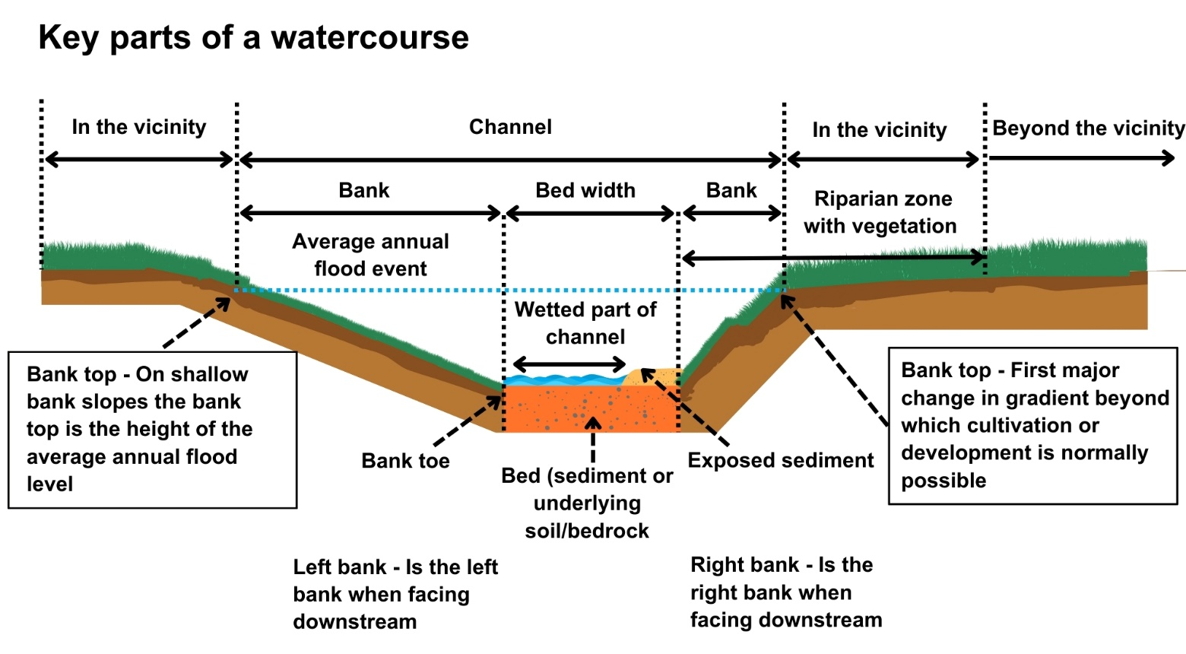
Figure 3A: Key parts of a watercourse

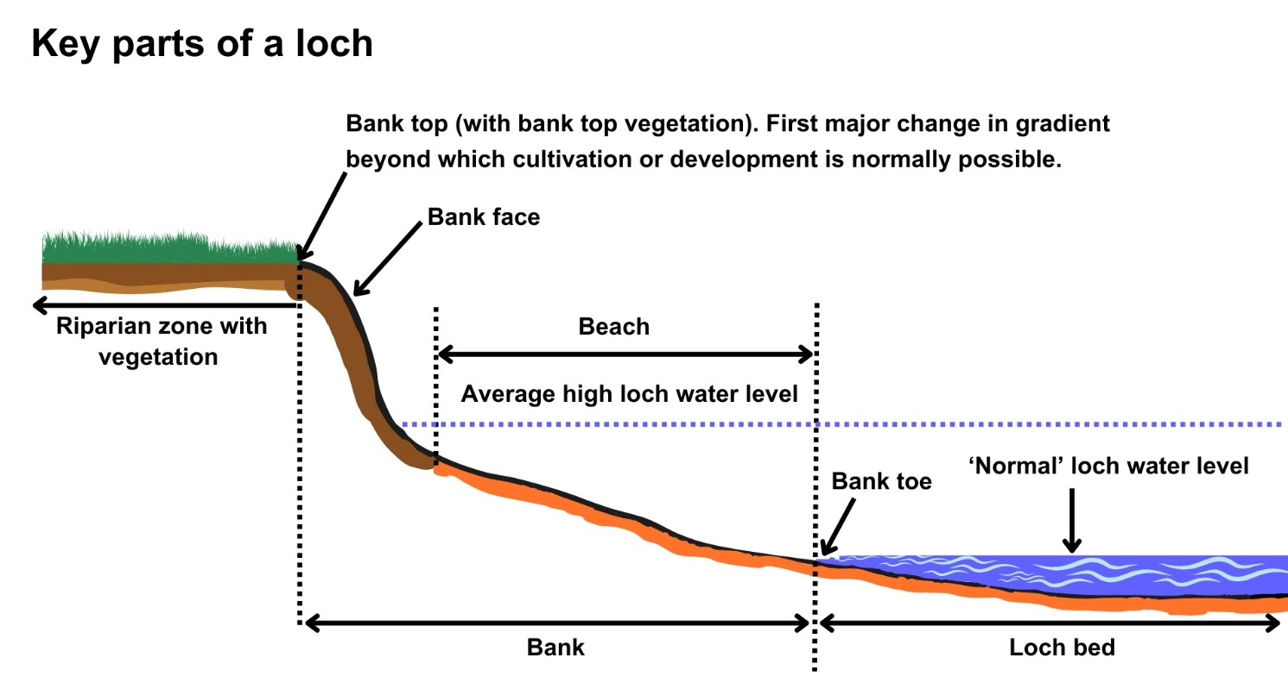
Figure 3B: Key parts of a loch

What are the potential issues with installing instream and in-loch structures?
Carrying out any engineering works and any associated temporary works, including works such as access and temporary crossings, can pose risks of harm to the water environment.
To minimise potential impacts, it is important that a sustainable option is chosen, its appropriately designed and constructed; that you understand the nature of the watercourse or loch and how it is likely to respond to the works; and that you consider the effect of the works on any nearby infrastructure or other water users.
This section summarises the main activity-specific issues and general issues that need to be considered when designing instream and in-loch structures.

Key Activity-specific issues

Barriers to fish passage and other wildlife
Migration and movement throughout the river catchment is essential to the survival of many aquatic species including salmon, trout and lamprey. Poorly designed in-stream structures can prevent migratory and non-migratory fish species from moving throughout river networks to access essential habitats for spawning and feeding, which leads to a reduction in, or loss of, populations.
Poorly designed instream structures, particularly bed reinforcement, can present a partial or complete barrier to fish passage. Some of the main problems include:
    - Bed reinforcement that is installed too high above the bed of the channel.
    - Channel narrowing, such as by bridge embankments and piers etc, which increases flow speed and scours the bed material off a bedrock or reinforced surface.
    - Bed reinforcement that is so smooth the natural bed material reinstated on top of it after construction is scoured off, exposing the reinforcement.
These problems commonly create flows that are too fast or shallow for fish to swim through. Without slower flow areas in which to rest such as pools, the fish cannot maintain the swimming speeds necessary to get past the obstacles, become exhausted and are washed downstream.
Where a barrier is created by an existing or newly installed instream structure, corrective works must be undertaken to resolve the issue. An example would be to install. baffles on bed reinforcement to raise flow depths and reduce flow velocities sufficiently to allow fish to swim over it). All authorisations contain a condition to ensure fish passage is not impeded, so failure to undertake corrective works may result in an enforcement notice being served to ensure the issue is addressed.

Barriers to sediment transport
Rivers carry a significant amount of sediment as well as water. River sediment covers all natural riverbed materials including silts, sands, gravels, cobbles and boulders. This is stored and transported throughout the river creating habitats for many species such as spawning gravels for fish and gravel bars and islands essential for many invertebrates.
When designing instream structures, you should consider how they will impact patterns of sediment transport, erosion and deposition. This may require sediment removal at the structure that can increasing long term maintenance costs and can lead to the loss of important species and habitats. For more information on sediment management see WAT-G-026 EASR Guidance: Engineering: Activity Guide: Sediment Management.

3.3.2 Risks to the Water Environment
The main risks to the water environment from installing, maintaining or removing any type of in-stream or in-loch structures or the placement of boulders can be grouped as follows:

Harm to fish
This includes impacts on fish migration, spawning and fry development, loss of habitat and direct impacts such as stranding or physical damage.
To avoid these impacts, schedule the works to avoid fish spawning and fish emergence times. Key fish species to consider include salmon and trout (normally October to May), lamprey species (normally March to July). These times can vary, however, and you should contact Fisheries Management Scotland if you are unsure what fish species are present or what times should be avoided.
Temporary works such as crossings, channel isolation or diversions, blasting, vibration or pile driving, sheet pilling or using artificial lighting at night can affect fish or migrating fish. You should carefully manage these works to minimise any impact and carry out fish rescues, where appropriate.
For more information see WAT-G-032 EASR Guidance: Fish Protection.
Physical Impacts & Pollution
Physical impacts to the bed and banks of the watercourse can lead to increased erosion or deposition, loss of habitats and increased flood risk.
Carefully managing construction works is essential to prevent and minimise pollution from sedimentation, leaking oil from machinery and the entry of potentially polluting materials into water such as unset concrete.
Sites should be restored following works to manage impacts from disturbance.
Further information on construction works and mitigation can be found in WAT-G-034 EASR Guidance: Construction works and silt/pollution mitigation.
Invasive Non-Native Species
Any Invasive Non-Native Species (INNS) present in or adjacent to the site could potentially be spread by the works. You should ensure adequate biosecurity measures are in place to prevent this. Further guidance can be found in EASR-G-001 EASR Guidance: Invasive non-native species (INNS)
Protected areas and species
You should identify any Protected areas. For example, Sites of Special Scientific Interest (SSSI), Special Areas of Conservation (SAC) and Special Protection Areas (SPA) in or adjacent to the site and consider any impacts from the works on Protected species such as freshwater pearl mussels and otter. You should contact NatureScot where your activity is in a Protected area or may impact protected species. For further information see WAT-G-008 EASR Guidance: Assessment of impact on Protected areas from inland water activities.
Impacts to other users of the water environment
There could be potential impacts on other uses of the water environment such as water supply, fishing and water sports.
All the risks to the water environment, as detailed above, will vary according to type and design of the engineering activity.
- Timing of the works.
- Working methods and mitigation.
- Reinstatement methods.
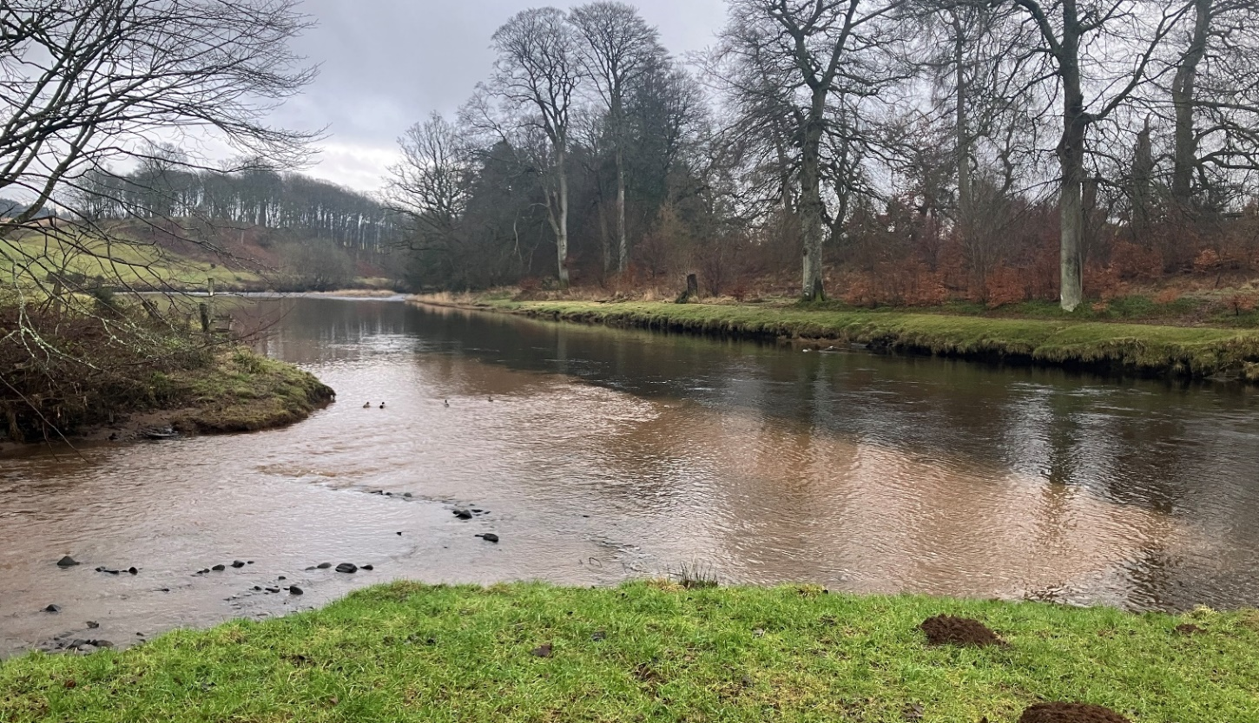
Figure 3C: Photograph showing the meeting of two streams, where one has clean water and the other has silt pollution from poor construction works upstream.

Instream structures and climate change
Climate change is already affecting Scotland’s rivers and lochs. Climate change predictions indicate there will be significant increases in winter precipitation over the coming decades, which suggests that large floods will occur more frequently. Summer rainfall is also likely to become more intense These effects are expected to become more severe and widespread.
These changes are making rivers more powerful, which means they will have a greater ability to erode their beds and banks, transport sediment, move from side to side on their floodplains and adjust their planform. These changes are a river’s way of dissipating the excess energy of floods.
Increasing flood frequency means that many channels will:
- Need to increase in size by eroding their beds and banks to accommodate larger volumes of water and,
- Have more energy and a greater ability to erode their beds and banks, transport sediment, and adjust their planforms.
The design of instream and in-loch structures should take into consideration the increasing frequency of bigger floods and the associated increase in movement of large wood and sediment. Designs should account for the natural adjustments to bed level that will occur as it undergoes sequences of scour and deposition in the river reaches upstream and downstream of the works site. Designs that treat rivers as static, rather than dynamic systems that change in response to flow energy are more likely to fail, to require more maintenance, to create more environmental damage, and to pose a greater threat to land uses adjacent to the channel upstream of, within, and downstream of the footprint of the works. For example, the placement of boulders and deflectors needs to take into consideration how patterns of scour and deposition are likely to change and what impacts this might have on the channel during an extreme flood event. If flow is deflected towards a bank, this could increase erosion and possibly undesirable channel instability. Works should therefore consider if this is appropriate at this location and what infrastructure or land may be threatened as a result.

Regulatory position statements on specific instream and in-loch structures
We have several specific regulatory positions which set our regulatory approach for specific types of instream and in-loch structures including large wood, beaver structures and fish counters and traps These are set out in the sections below.

Regulatory position on the placement of large wood in the water environment
This section sets out SEPA’s regulatory position relating to the placement of large wood within the water environment (rivers, and lochs)

Background
Scotland’s rivers historically would have had an abundance of wood within them due to a greater presence of riparian woodlands.
This abundance created a wide range of complex habitats, more food source variability, greater floodplain connectivity and increased channel roughness, which slowed flows, reduced erosion and created refuge areas for aquatic species during high flow events. However, centuries of deforestation, agricultural and urban expansion, over-grazing, the introduction of invasive non-native species and the active removal of wood from rivers have resulted in river systems that are wood-poor and oversimplified.
Although work is ongoing to restore Scotland’s woodlands, it will take decades before they are providing a source of woody material to the river systems. The placement of large wood structures allows some of the benefits of in-channel wood to be realised over the short term while newly planted woodland matures and begins falling into rivers. These structures only provide temporary benefits, however, and constant inputs of new wood are needed to bring about sustainable long-term change. This activity should, ideally be undertaken in combination with riparian tree planting rather than in isolation.
Large wood can be placed within a river or loch for a variety of purposes, including habitat enhancement, natural flood management and bank protection. It is often used in river restoration projects to act as catalyst for restoring natural river processes and natural channel evolution as well as to improve habitat complexity at a more local scale.
Habitat Enhancement
The introduction of large wood either parallel to or projecting from the banks can alter the physical structure of the channel, alter flow dynamics and lead to the creation of micro and mesohabitats for different species’ life stages, as well as providing refuge and resting places for fish and other aquatic species.
Natural Flood Management (NFM)
The introduction of large wood can significantly increase channel roughness, thus slowing flows and increasing instream water levels during moderate to high flows and thereby increasing water storage on the floodplain. It may also increase the degree of hydraulic connectivity between stream flow and groundwater and between streamflow and the floodplain. If the intention of any structures installed for the purposes of NFM is to slow or hold back flows, then careful consideration must be given to its design which may include the need for hydraulic modelling to assess risk. Note that an authorisation would be required for any structure considered to be an impoundment. Note also that SEPA does not directly regulate flood risk under EASR.
Bank protection
Bank protection works can be undertaken with large wood using techniques that involve the placement of trees or parts of trees. These are covered within our guidance WAT-G-022 EASR Guidance: Engineering: Activity Guide: Bank Works and WAT-G-029 EASR Guidance: Engineering: Sustainable Bank works.

Works not requiring authorisation
The placement of wood will not require authorisation where it will clearly mimic natural processes. This is achieved where the principles below are followed:
Wood placement will:
- Increase habitat availability and complexity,
- Not create an impediment to fish passage,
- Only have a localised effect on flows and sediment dynamics,
- Not create a complete impediment to flow under normal flow conditions,
- Not create a complete impediment to sediment transport under normal flow conditions,
- Not cause disturbance to the natural channel bed outside the footprint of the wood structure,
- Not cause any disturbance to the riverbed in channels with a gradient greater than 2 percent (for example, step-pool and cascade channels)
- Not involve the removal of large boulders from the surrounding channel bed, except at the exact location where the wood is placed,
- Not result in significant fine sediment input to the channel during construction,
- Not be placed in areas where their presence could cause a risk of damage to infrastructure or buildings.
In addition:
- Any boulders used for anchoring large wood structures should be of the same rock type as, and no larger than, other boulders found in the vicinity,
- If no boulders material is present on site, then the size should not exceed 300 mm in the longest dimension,
- Only use natural wood, i.e., wood not treated with preservatives,
- The placement is predominantly wood, rather than boulders.
- Only uses appropriate fixing methods for the situation and desired outcome.
- The wood may be dug in and buried into the channel bed as long as bed material is only disturbed at the location it is placed.
- You should contact NatureScot where you are proposing to work within a protected area or in an area for protected species such as Freshwater Pearl Mussels,
Following these principles should ensure that the risk of environmental harm or damage to surrounding infrastructure, buildings or land is negligible and that the wood provides an environmental benefit by increasing morphological and thus habitat diversity.
Note that SEPA does not regulate the clearance of riparian woodland but advises that the removal of bankside vegetation should be minimised as much as feasibly possible.
See Figures 4A and 4BA for examples of wood structures that don’t require authorisation and those which would require authorisation.
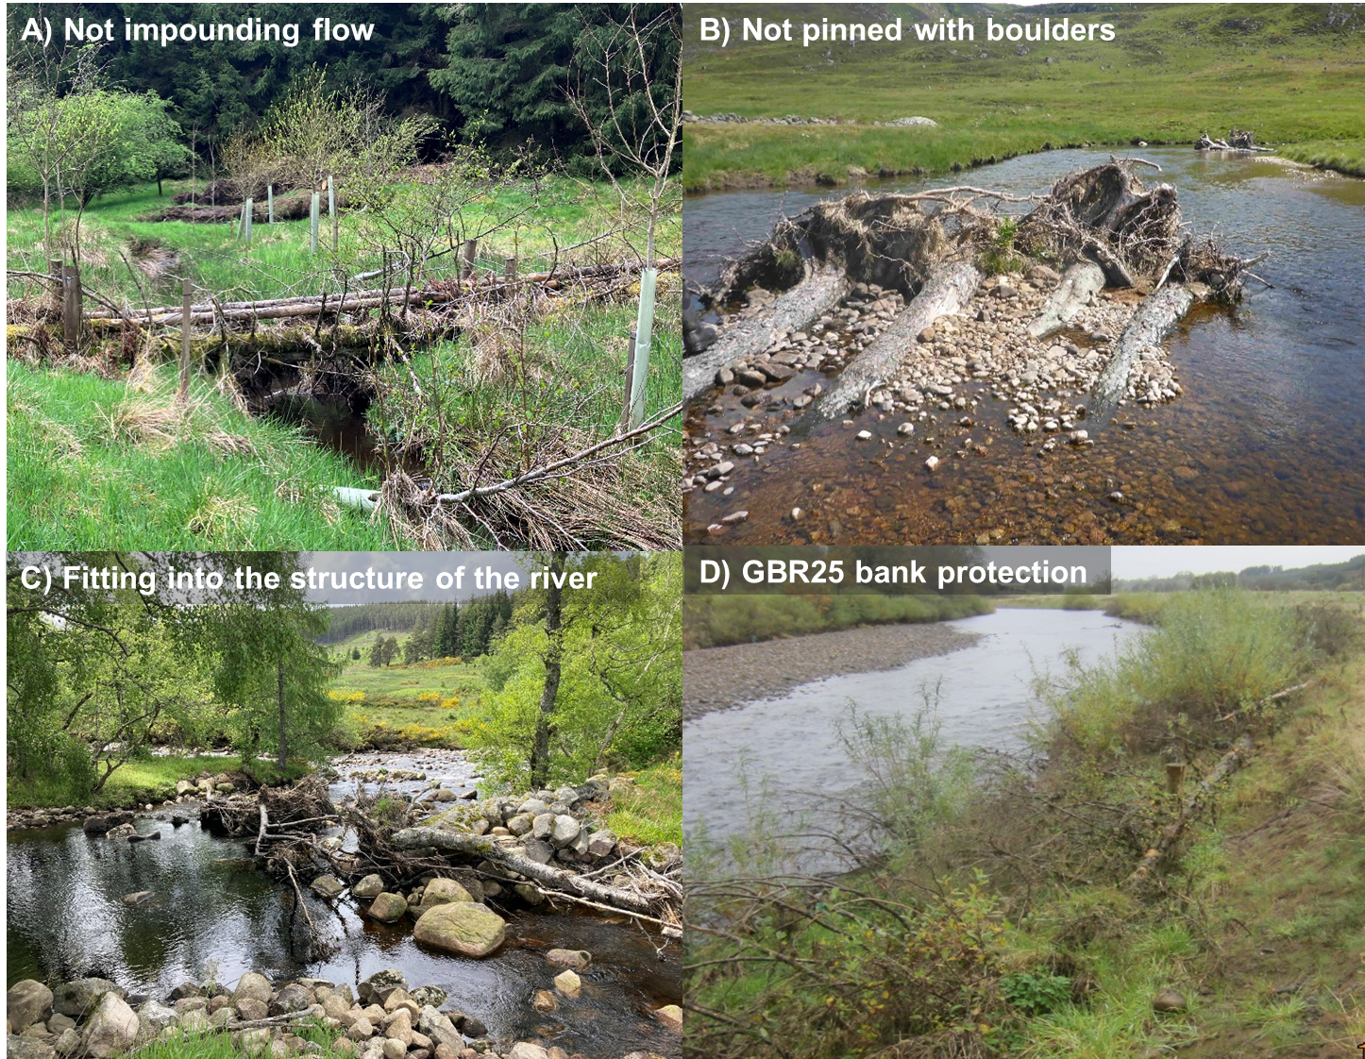
Figure 4A:Examples of structures that do not require authorisation to be installed as they comply with the criteria including A) not impounding the follow, B) not pinning the wood in place with boulders larger than found in the vicinity or 300 millimetres C) fitting well into the structure of the river and D) complying with the conditions as set out in the GBR25 activity.

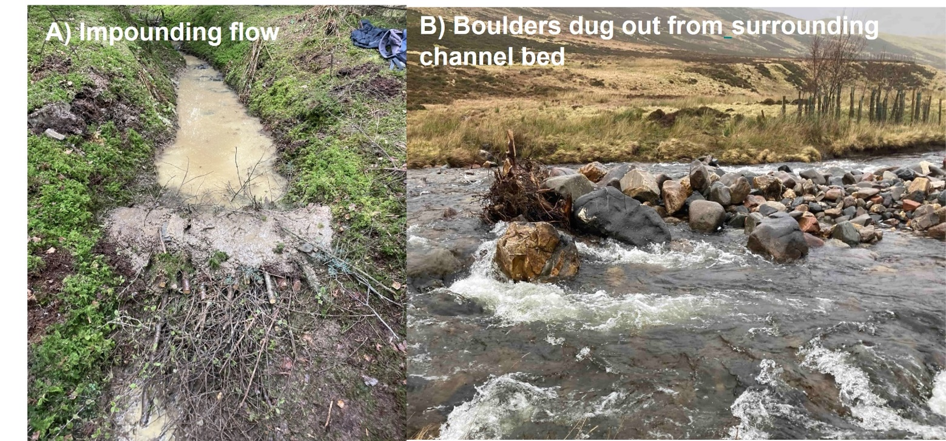
Figure 4B: Examples of structures that would require a permit due to A) impounding flow and B) where the installed wood is dominated by boulders rather than wood (right image).

Large wood works subject to authorisation
Works that do not meet the criteria in section 4.1.2 will be subject to authorisation.

Large wood works authorised by GBR
In certain situations, the placement of large wood may be authorised by Water GBR 8,14 or 25. providing the GBR conditions are met. No consultation or prior authorisation is required from us. In such situations the operation of vehicles, plant and other equipment must comply Water GBR 9 and any temporary crossings, structures and works musty comply with Water GBR 7.
If your work proposals cannot comply with the principles in section 4.1.2 or the GBR’s conditions you will need to apply for authorisation. You may also wish to discuss your proposals with us at this stage.

Large wood works authorised by Registration or Permit
Any proposals involving the placement of large wood that do not meet the criteria set out in section 4.1.2 or where you cannot comply with a GBR will require you to apply for authorisation.
Proposals requiring an application to be made include:
- Impoundment of water across the full channel width, e.g. using logs, planks etc). Such structures are likely to interrupt fish passage and hydrological and morphological river processes.
- Proposals where boulders and stones make up a high proportion of the structure.
Where the aim of the project is to deliver environmental benefits, we will waive the application fee because the activity is delivering an environmental service.

Other considerations
When selecting areas for large wood placement, a range of factors should be considered to ensure the best possible environmental and social outcomes. These include:
- Site-specific sensitivities, such as conservation designation, protected species, and riparian habitat. Additional permissions regarding protected species from NatureScot may be required to undertake the proposed work or techniques and construction methods and timings may need adjustment. For large projects in sensitive areas, you should discuss your proposals with us before work is carried out.
- The placement of wood structures near to property and infrastructure needs to be carefully designed to reduce the risk of adverse impacts, such as flooding caused by the blockage of bridges and culverts or erosion that threatens structural integrity.
- How environmental damage that could be caused accessing the site can be mitigated.
- When harvesting trees with attached root wads to use for bank protection or habitat enhancements, it is important that the root wads remain as intact as possible. Careful consideration should therefore be given to how the trees will be handled, transported and stored prior to placement. Furthermore, the minimum length of tree trunk needed to ensure the structure can have the desired morphological and ecological effect and be installed securely should be determined pre-harvesting.
- Large wood structures perform best in gravel-bed systems but need to be appropriately sized for the channel in which they are placed to deliver maximum morphological and ecological benefits.
- Bed and bank composition and stability should be considered when selecting locations for large wood placement. There is an increased risk of lateral channel movement in rivers that are actively incising, which could create issues if increased channel adjustment is not an aim of the project. More thought may be required when anchoring wood to more resistant bed and bank materials such as clay, bedrock and large boulders. Conversely, care must be taken when anchoring large wood structures in less resistant, sandy banks to reduce the risk of out-flanking. Large wood structures are generally most effective in gravel bed rivers that are moderately stable, morphologically (i.e. not showing signs of excessive erosion or deposition).
- We recommend that the construction phase of any large wood project is supervised by suitably qualified personnel to ensure the wood is installed as per the design and in a manner that will deliver the greatest environmental benefit, whilst minimising the risk of harm to the environment or surrounding infrastructure and land use.
- Potential impacts to other water users, such as canoeists, wild swimmers, or anglers, or to long-term research or monitoring sites should be considered. If adverse impacts are possible, it may be beneficial to discuss the projects with the relevant groups so that a solution acceptable to all can be reached.

Regulatory Position on the Management of Beaver Structures
This section sets out our regulatory position for activities proposed for the management of structures created in the water environment by beavers.
The activities covered largely involve the notching or removal of beaver dams and the installation into beaver dams of flow devices (devices which allow water to flow through beaver dams). Specifically, this section explains what works can be undertaken without requiring prior authorisation.

Works carried out using hand tools, ropes and grapnels
The breaching, partial or complete removal of a beaver dam using hand tools and/or ropes and grapnels does not require authorisation.
Any work in or around watercourses must be completed without causing pollution, such as the escape of silty water downstream (e.g. silt trapped behind a beaver dam).

Works carried out using machinery
In all cases where machines are used in connection with works which are not subject to authorisation care should be taken not to cause harm to the water environment, (by preventing pollution, considering timing and method of works etc)
Installing flow devices in beaver dams
Where a flow device will be installed using boulders to secure any ancillary fencing, this may be done without prior authorisation from us provided:
- Any boulders used for anchoring should be of the same rock type as, and no larger than, other boulders found in the vicinity,
If no boulders material is present on site, then the size should not exceed 300 millimetres in the longest dimension,
For any other approach, please consult with us to determine the regulatory requirements.

Other activities
For any other proposed activity which involves beaver dams that is not covered by the points above, please consult with us to determine the regulatory requirements.

Requirements under other legislation
This guidance does not cover permissions that may be required under legislation other than EASR.
NatureScot should be consulted prior to undertaking any works to ensure compliance with species protection legislation. This includes works in/near beaver lodges and burrows used for breeding and may include dams). More information and contact details for the NatureScot beaver licencing team can be found at Beavers and Licensing | NatureScot.

Regulatory position on the installation of fish counters and traps in the water environment
This section sets out our regulatory position for the installation of fish counters and traps.
A range of different structures can be installed within the channel bed to either count or trap fish. These are generally considered to be instream structures.
As fish traps and counters vary with how they interact and affect the channel bed, the authorisation requirements also vary, as summarised below.

Fish counters and fish traps where there is no construction on the bed or banks of an inland surface water
If the counter or trap does not require any construction on the channel bed or banks (Figure 4C) and complies with the following best practice rules, then no authorisation will be required.
- Installation and use of the counter or trap should not involve digging or disturbance that affects the banks or bed of watercourse or loch.
- The structure should be maintained in a good state of repair and kept clear of debris and obstructions.
- The structure is temporary in nature (i.e. in place no longer than 12 months).
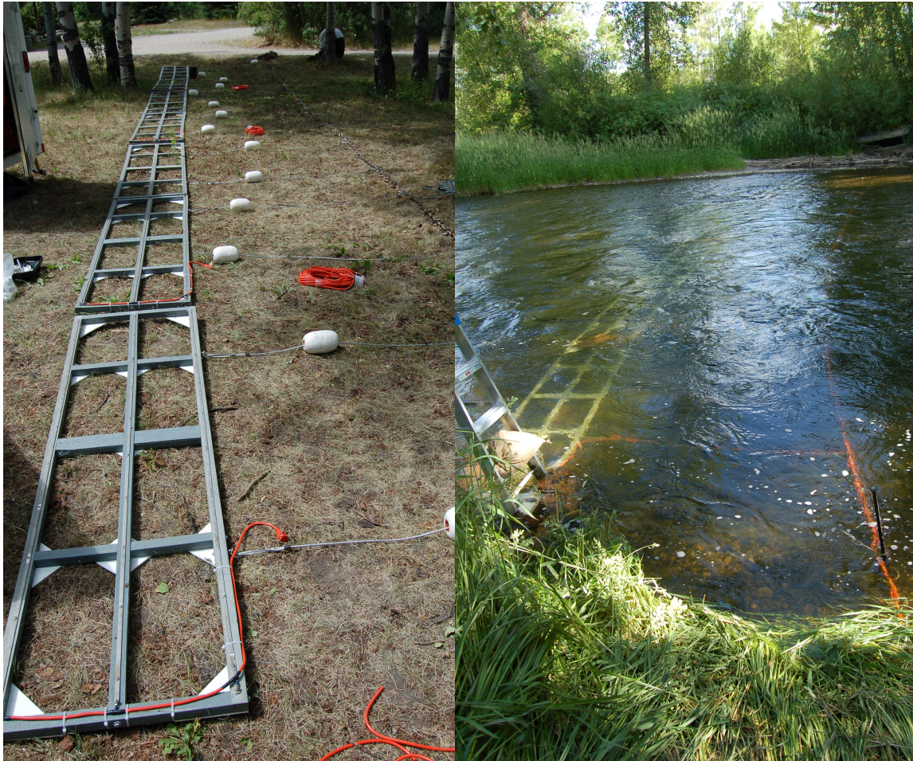
Figure 4C: Example of a fish counter not requiring any construction on the bed or banks. Photo supplied by Instream Fisheries Research.

Fish trap/counter installed into the channel bed
Fish traps and counters can also be installed into the channel bed. Croys are sometimes used to direct fish to one side of the river or towards perched counting units or counters buried in the channel bed. In all such cases authorisation would be required as instream structures.

Fish counter / trap laid on the bed and creating an impoundment
If a structure would increase the height of the channel bed and create an impoundment, it will require authorisation as an impoundment (Figure 4D). This is because it can have a greater impact on both habitats and the movement of sediment and water through the reach, and will require assessment to ensure appropriate mitigation is in place.
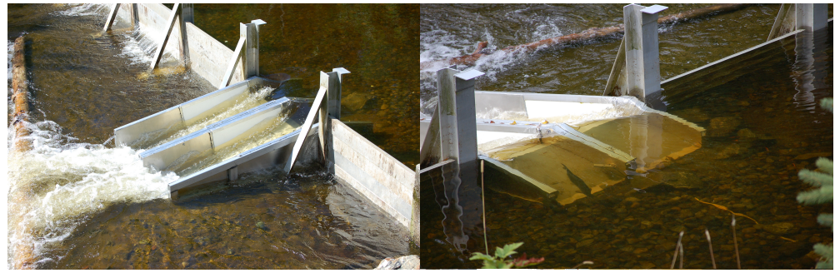
Figure 4D: Fish counters that create an impoundment require authorisation as an impoundment. Photograph supplied by Instream Fisheries Research.

Good practice
All new and modified instream structures, in-loch structures and the placement of boulders should follow the principles of Good Practice. All permit applications must meet Good Practice to be granted.
Good Practice is achieved when the chosen option serves a demonstrated need, while minimising ecological harm, at a cost that is proportionate. Meeting Good Practice ensures modifications to the morphology of rivers and lochs are sustainable.
To meet Good Practice the steps below should be followed.
Good Practice Summary
- Demonstrate need
- State the reasons for carrying out the activity and the benefits it will bring.
- Identify and understand the problem or need.
- Identify and appraise options
Use sustainable river management principles to:
- Identify a number of options (minimum of three, including do nothing)
- Carry out an options appraisal.
- Justify the selected option
- State why it represents the best practical environmental option.
- Use all reasonable mitigation
- State the mitigation measures you propose to minimise impacts
- Submit method statement(s) detailing how the works will be carried out.
Guidance on how to undertake the good practice steps and what might need to be considered are discussed in the sections below.

Demonstrate need
Before undertaking any instream / in-loch structure or boulder placement there should be a clear and justifiable reason or need. Where relevant, you should also have a good understanding of the causes (including the underlying cause and scale of any problem being addressed.
You must:
- Specify the reasons for carrying out the activity and the benefits it will bring
- Identify and understand the problem or need

Bed reinforcement
Bed reinforcement can often damage or destroy riverbed habitat, create potential barriers to fish and affect the movement of sediment.
It is important that we understand your reasons for undertaking any new bed reinforcement. In many cases works will be needed to protect valuable infrastructure such as existing bridges, culverts or flood walls. You should also show you understand the causes and underlying cause of the problem you intend to address.
To demonstrate need and understand the problem or need you are addressing you should:
- Make sure you understand the nature and type of river processes taking place
- See our guidance WAT-G-033 EASR Guidance: Inland surface waters and river subtype
- If the channel is predominantly bedrock, is the bed reinforcement necessary or can you reduce how much is planned to be installed?
- What are the reasons for any scour being addressed?
- Increased flows because of human land use changes in the catchment upstream?
- Increased flows because of climate change?
- The presence of engineering modifications elsewhere that are destabilising the channel bed, for example:
  - Upstream hard bank protection that is deflecting flow energy onto and scouring the riverbed.
  - Channel straightening downstream that has introduced an upstream migrating knick point.
  - Channel straightening or deepening upstream that has increased flow speeds through the affected reach? If a bridge or culvert is involved, are they undersized for the expected river flows?
  - The failure of another nearby structure such as a weir?
  - Has a lack of maintenance contributed to the problem? What state of repair is the bridge / culvert / flood wall in – could replacing it be an option?
- If the work is to protect bridge piers
- Could this be achieved by partial rather than full width bed reinforcement?
- Would a replacement offer a more sustainable and lower risk option
- If bed reinforcement is proposed for an existing ford
- Could a bridge be installed or an alternative crossing point used to provide a more sustainable option?
- You should provide details of recent inspection/ survey findings including photographs, which show why new bed reinforcement is required.

Flow deflectors
Flow deflectors and croys are usually installed to enhance habitat, most commonly for fish. Croys may also be installed to allow anglers safe access into deeper parts of the river. Groynes are similar structures but are used to reduce bank erosion by deflecting flow away from the riverbank.
Despite flow deflectors usually being installed to improve habitat (Figure 5A), you still need to demonstrate why they are needed. Where fisheries managers try to modify river channels to restore and enhance degraded fisheries and improve fishing opportunities, care should be taken to ensure the benefits outweigh the negative impacts. Considering the following questions will help provide the rationale for the works:
- Is the habitat type that would be created something that would be found naturally at this location?
- Why is it missing?
- Could this habitat be introduced by treating the cause of its absence, rather than constructing it? (e.g. reducing artificially elevated levels of coarse sediment input from upstream to stop pools being filled in).
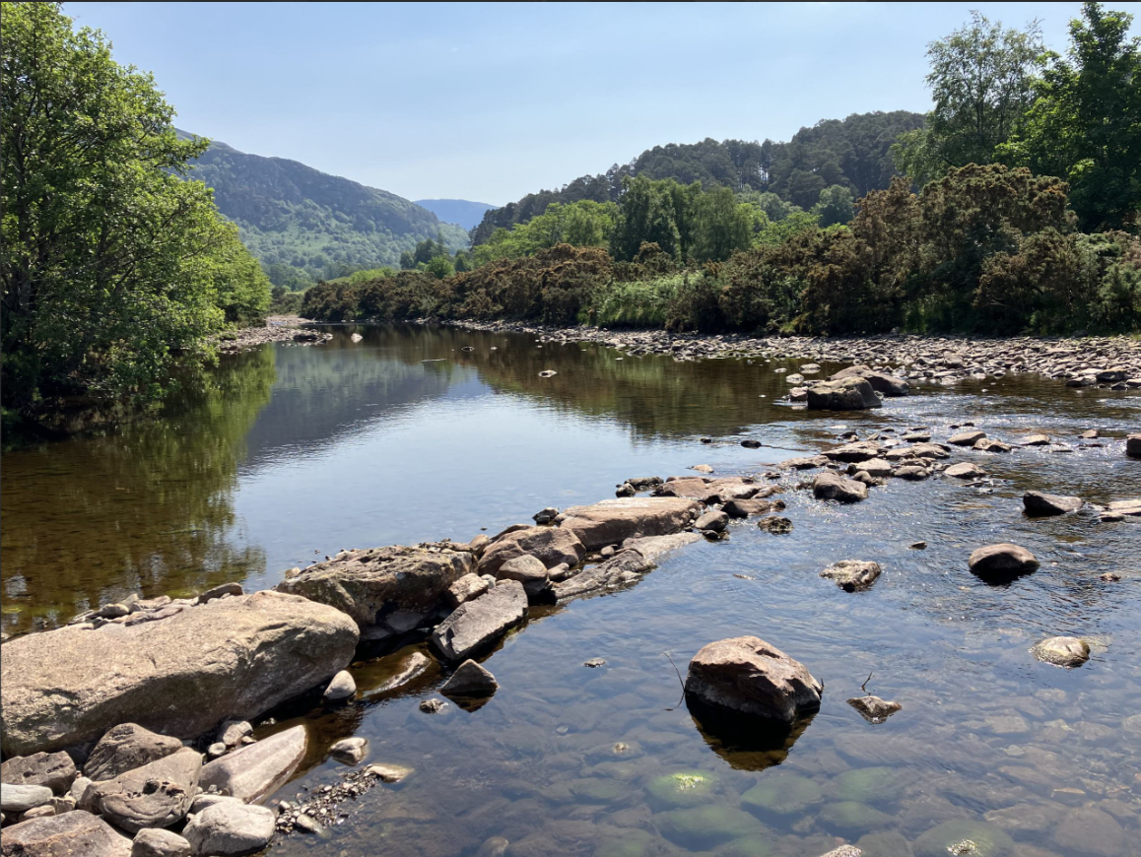
Figure 5A: Example of a croy that has been built out into the river to enhance fish habitat.

Placement of boulders
Boulders are usually installed in a river to increase habitat complexity and provide cover for fish and macroinvertebrates. This is mostly undertaken in streams with oversimplified habitat, for example because of channel straightening or reinforcement on both banks. Even if the works are being carried out for environmental reasons, the applicant still needs to describe why this action is needed and show that it is appropriate for the proposed location. For example, boulders should not be installed into locations where they would not naturally occur (e.g. sand bed streams).
Assessments should demonstrate why this habitat feature is not currently present and needs to be reinstated at the proposed location. For example, showing that boulders have been removed from the channel to protect its banks and that they need to be reintroduced to provide refuge areas for juvenile salmonids.
Boulders can also be used to stabilise riverbeds that are rapidly adjusting.
Figure 5B shows gully formation by a small stream cutting into an old quarry filled with soft sediments. This erosion is moving towards a culvert crossing and a road upstream and so represents a significant hazard. Installing boulder steps could halt the erosion and stabilise the stream channel and. Figure 5C shows an example of boulder steps being used to stabilise a channel following removal of a downstream weir. More information about step-pool and cascade channel design can be found in WAT-G-023 EASR Guidance: Engineering: Activity Guide: Channel modification.
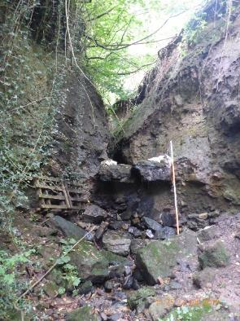
Figure 5B A small stream incising into an old quarry on the Cuddie Water

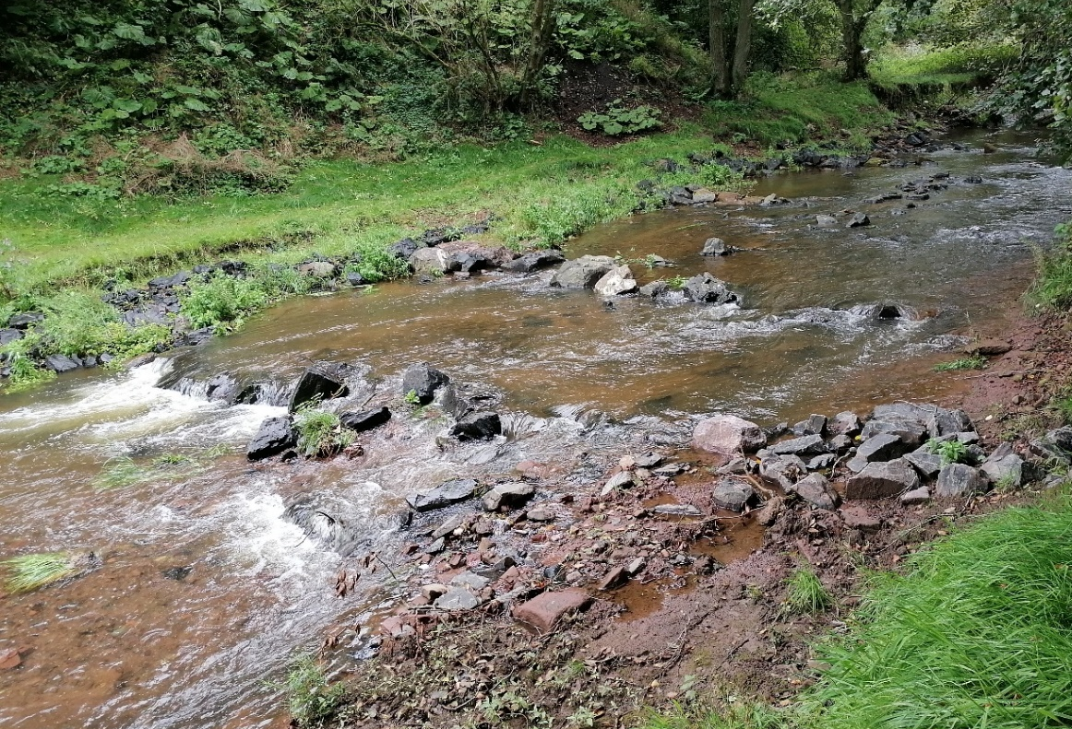
Figure 5C: Series of steps constructed within the channel bed to stop bed incision following the removal of a downstream impoundment

In-loch structures
You must be able to justify why this activity is required in the context of your proposed works location. For example, if the proposal is to build a new pier or boat slip it must be explained why existing infrastructure is unsuitable and why the infrastructure is required. If groynes are required to slow erosion, evidence demonstrating the nature and extent of the erosion, why it is occurring, and an explanation of how the groynes will address the cause of the problem must be provided to help SEPA to understand the scale of the problem and the need for the works. Similarly, if structures such as deflectors and groynes are required to create habitat the application should demonstrate:
- What habitat these instream structures are expected to create.
- That the habitat created would be expected to occur within this system naturally; and
- Why the habitat is currently missing from the system.
In all cases you should provide us with a clear explanation of the need for the works and a clear explanation of how the proposed solution will address the underlying cause of the problem. In the case of influencing sediment movement in lochs, care should be taken to fully understand the loch processes and specialist advice may be required.
Supporting evidence including photographs, inspection/ survey results etc should be supplied with any permit application.

Other instream or in-loch structures
This category includes instream and in-loch structures that do not fall into the categories described elsewhere. It includes:
- Intakes and outfalls, see WAT-G-036 EASR Guidance Intakes and Outfalls for further details
- Fish screens and traps which require authorisation as covered in Section 4.3
- Any other instream or in-loch structures not described elsewhere
As the nature of such structures can vary we cannot cover specific issues in this section. However, the general principles of demonstrating need still require to be followed., In all cases where a permit is required you should be able to:
- Specify the reasons for carrying out the activity and the benefits it will bring
- Identify and understand the problem or need

Identify and appraise options
It is a basic principle of good practice that when addressing any engineering problem, or need, several options are identified and evaluated (using an options appraisal to compare the advantages and disadvantages) to determine the best solution.
In all cases we will expect you to identify and consider a minimum of three options for comparison, including doing nothing. In some instances, there may be more than three possible options available.
There are three broad types of options to consider: do nothing, non-engineering options engineering options
The key steps you should follow when considering and appraising options are:
- Consider key site-specific requirements (e.g. river type and processes, ecological requirements, other water users etc)
- Identify a range of options. -taking into account principle of sustainable river management (see box below)
- Carry out options appraisal -taking into account site specific requirements and long-term maintenance requirements.
To identify options for appraisal you should follow the sustainable river management principles detailed below:
Principles of sustainable river management
- Address the scale, significance and underlying cause of the problem or need,
- Consider the effects of climate change,
- Allow the river some room to move (where feasible),
- Respect channel form and processes,
- Consider and minimises maintenance requirements,
- Consider a range of options (i.e. modifying existing structure, non-engineering and engineering) for addressing the problem including ‘do nothing’.
- Consider how it addresses the underlying cause of the problem

The fundamental aim of sustainable river management is to design and carry out engineering in a way that works with, rather than against, river and loch processes. This helps the engineering works and the habitats to be more resilient to the changes that occur over time, including those associated with climate change. A solution should be developed that strikes a balance between addressing a problem or meeting a need and ensuring that river and loch processes, and therefore habitats, are not unduly impacted. Further details on these principles can be found within our guidance ‘WAT-G-030 EASR Guidance: Engineering: Meeting Good Practice’’.
The following sections provide information on options for various types of instream structures, in-loch structures and the placing of boulders, and will help you to select the best practical environmental option and ensure the works are a sustainable use of the water environment.
As the nature of a problem or need that requires the installation of an instream or in-loch structures or the placing of boulders is varied and site specific, we cannot detail all possible solutions here. Where it is decided an engineering option is required, the best response may involve combining one or more engineering options with one or more non-engineering options. The key is to ensure impacts are minimised and mitigated as far as possible.

Bed reinforcement
A range of options that could deliver the required outcome should be listed and appraised so that the options with the lowest environmental impact can be selected. A key aim is that to minimise the impact, the works should maintain the natural channel bed slope, width and characteristics such as bed material and roughness. Without this, excess bed and bank erosion or excess sediment deposition can occur upstream and downstream of the reinforcement. Key factors to consider when identifying options, are set out in sections 5.2.1.1 to 5.2.1.5 below.

Depth of burial below natural bed level
The most effective way of reducing the impact of bed reinforcement is to bury it as far below the riverbed as possible (Figure 5D). Riverbed levels fluctuate naturally over time and can experience high levels of scour after large floods, so bed reinforcement should be buried below the maximum expected depth of scour whenever possible, as this will help to reduce the likelihood of the reinstated bed material being scoured away during floods (see section 5.2.1.3 for more on this).
Generally, the bed reinforcement and the layer of reinstated bed material should be buried to a depth of at least the thickness of the largest stone on the bed below the natural bed level. If the riverbed is made of finer material, such as gravel, then this depth will need to be more than the coarsest grain and scour depth will likely need to be calculated on a site-by-site basis. Guidance on how to do this can be found in CIRIA Manual on scour at bridges and other hydraulic structures.
Design options should look to retain or reproduce key riverbed features such as boulder ribs or clusters, (figure 5E) which provide additional roughness and valuable habitat within the river and can also help reduce smaller sized sediment upstream being scoured.
How the increase in high flows due to climate change might impact riverbed scour should also be considered when deciding the depth at which to install the bank protection (see CIRIA’s Manual on scour). Well buried protection will both reduce the impact on the river and reduce potential scour and damage to the protection, increasing its lifespan and reducing maintenance costs.
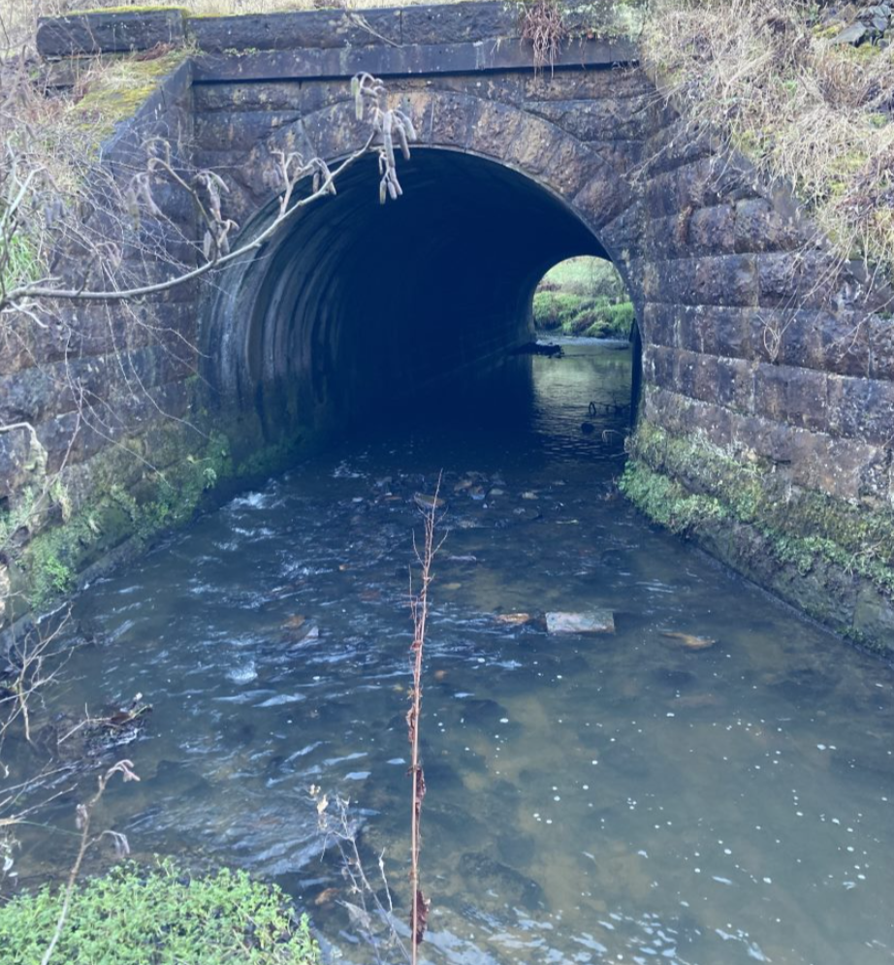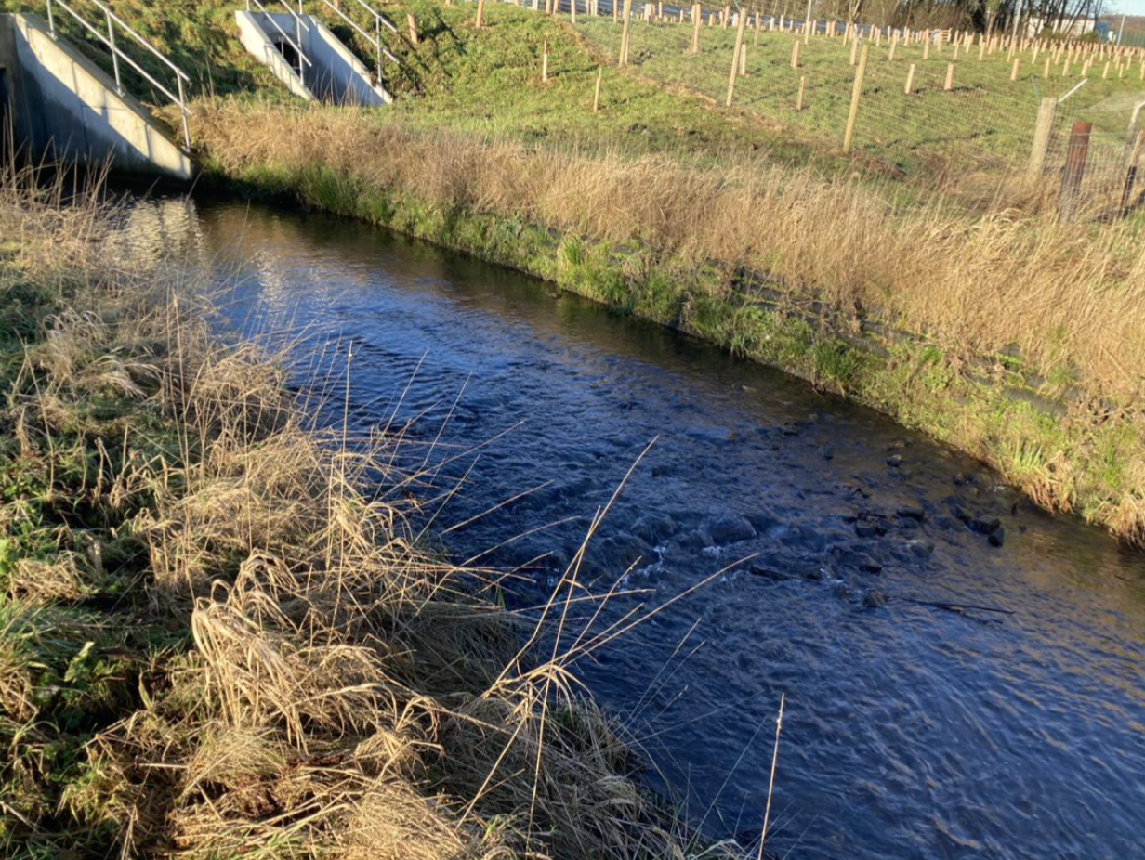
A)
B)
Figure 5D Examples where bed reinforcement has been buried deep enough to allow the reinstated natural bed to remain on top, minimising the impact on the river. A) shows a Victorian open culvert where bed reinforcement was added recently and B) shows a much newer culvert with bed protection that extents downstream of it.
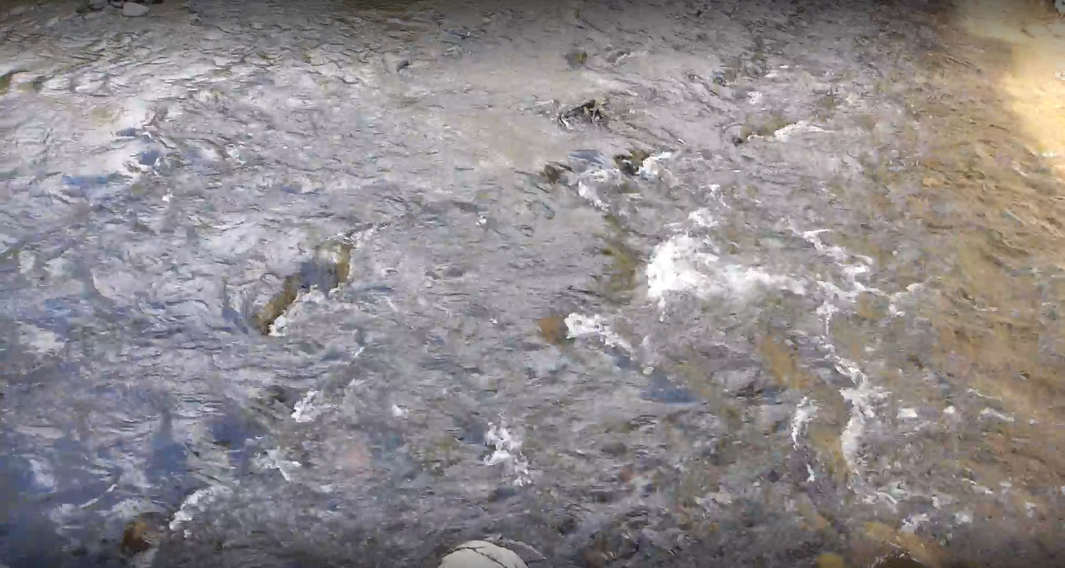
Figure 5E: Boulder ribs and clusters running from roughly the bottom to the top of the picture

Bed reinforcement and channel width
Bed reinforcement works should not reduce the wetted river channel width, for example by blocking off some of the spans between bridge piers. If a large part of the flow is forced through one bridge span flow velocities will increase, which can cause the reinstated bed material to be eroded and the reinforcement to become a barrier to fish (Figure 5F).
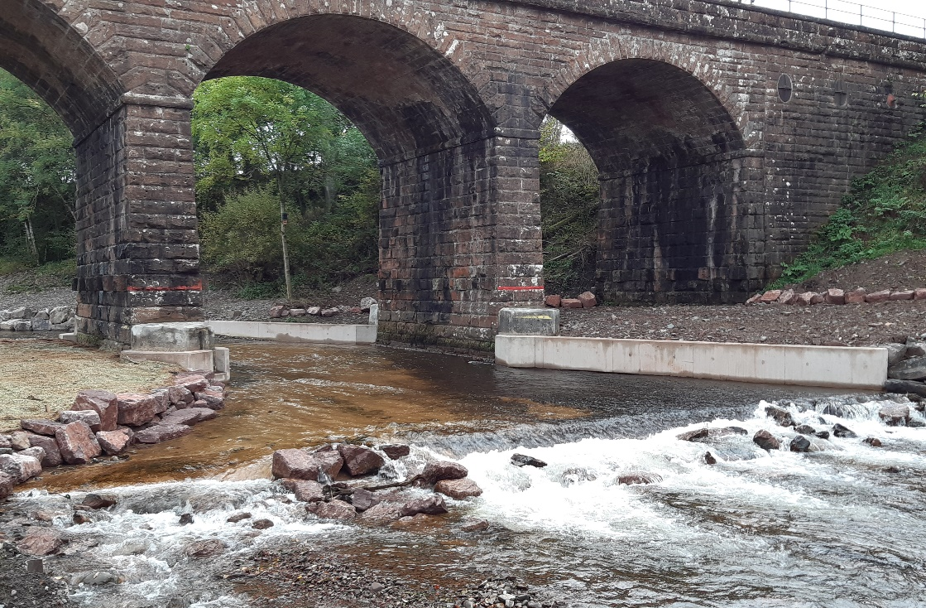
Figure 5F: Example of a bridge apron where the channel was narrowed and the bed reinforcement was constructed too high above the natural bed elevation and too smoothly, causing the reinstated bed material to be flushed away and the bed reinforcement to form a partial barrier to fish.

Bed reinforcement surface texture
Bed reinforcement should not create a flat, smooth surface as it is easier for high flows to scour the reinstated bed material off this to expose the underlying reinforcement (Figure 5G). If some bed material is removed, it potentially makes it easier for more of the material to be transported by subsequent floods. This may cause the channel bed to lower, and for this bed lowering and erosion to continue into the reach upstream, as the river tries to create a flatter slope. Bed lowering creates higher, steeper banks which are less stable, and more prone to erosion. Exposed bed reinforcement can also create shallow fast flow, which can create a partial barrier to fish.
The rougher the surface, the better it will be at retaining bed material. For example, boulders or rip-rap sized rock to protect a pipeline crossing will be better at retaining natural bed material than a smooth concrete layer. If a concrete slab or mattress is to be used its surface should be roughened before reinstating the sub-surface and surface armour layer. Several techniques exist for doing this, including embedding cobbles or boulders into the wet concrete (Figure 5H) or attaching wooden baffles to the cured concrete (Figures 5I and 5J) It can also be useful to install a structure at the downstream end of the bed reinforcement to help prevent sediment being pushed off it during high flows. This could be a baffle at the very edge of the reinforcement, boulders that stick up above the level of the slab (Figure 5K), or an engineered step-pool feature.
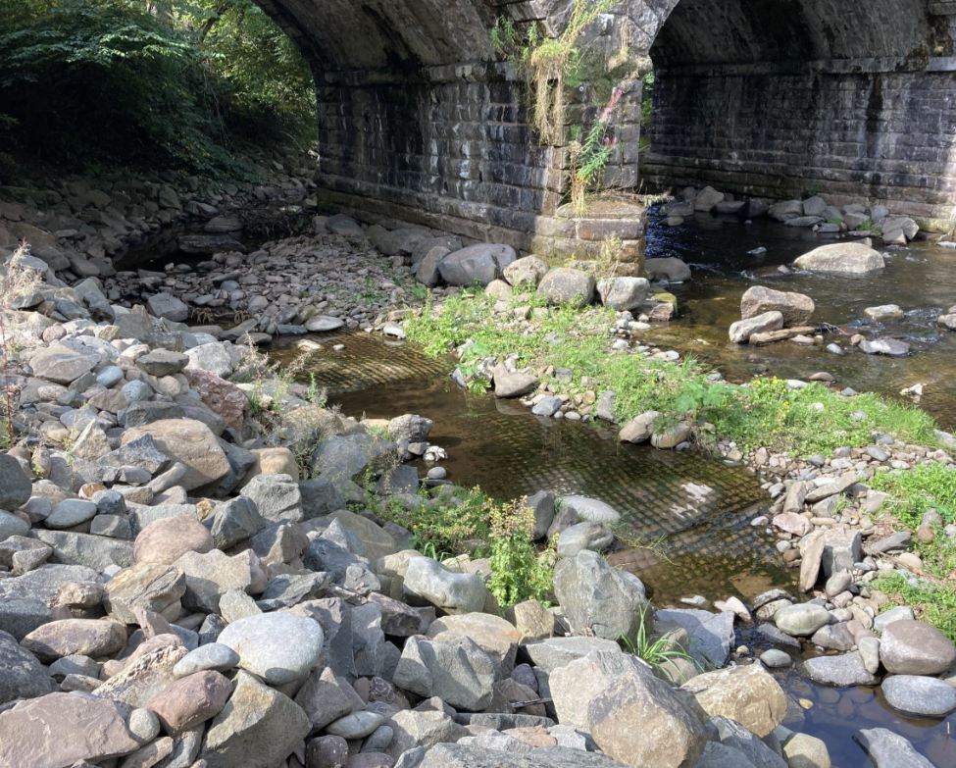
Figure 5G: This shows how bed reinforcement that is too smooth and hasn’t been buried sufficiently deeply has led to the natural bed material being scoured away to leave the reinforcement exposed.
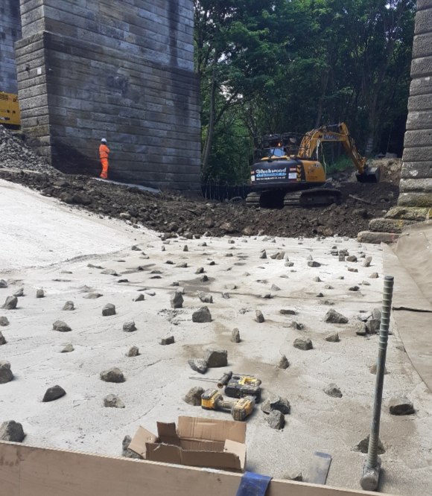
Figure 5H: Concrete slab bed reinforcement with embedded cobble-sized sediment to roughen its surface

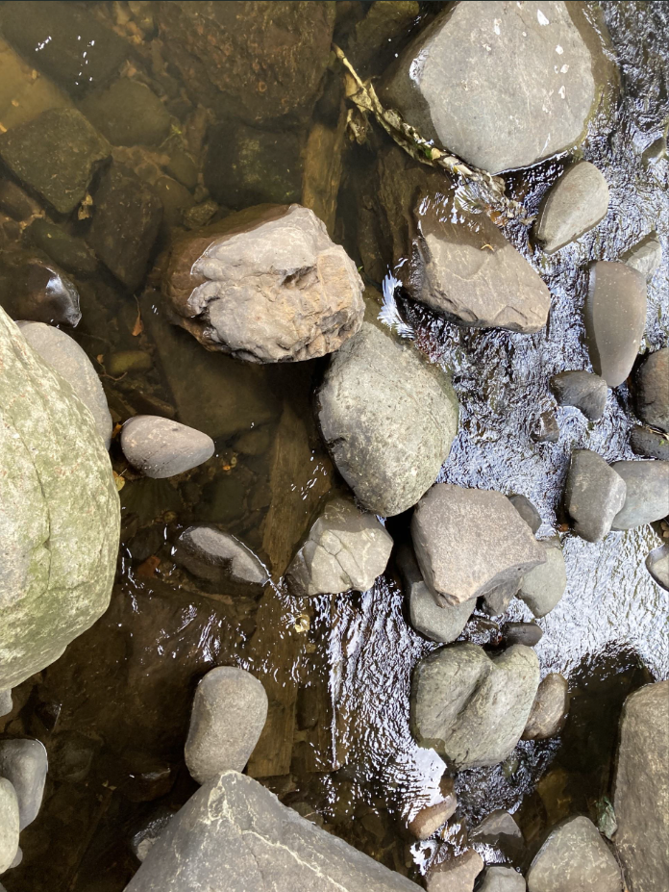
Figure 5I: Wooden baffle attached to concrete mattress bed reinforcement (hidden) to retain the reinstated natural bed material. Flow is from bottom to top of the photograph.
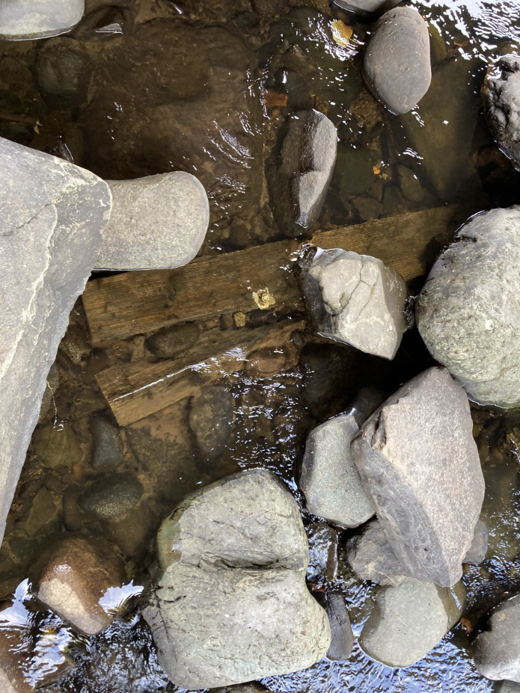
Figure 5J: Wooden baffle attached to concrete mattress bed reinforcement (hidden) to retain the reinstated natural bed material. Flow is from top to bottom of the photograph
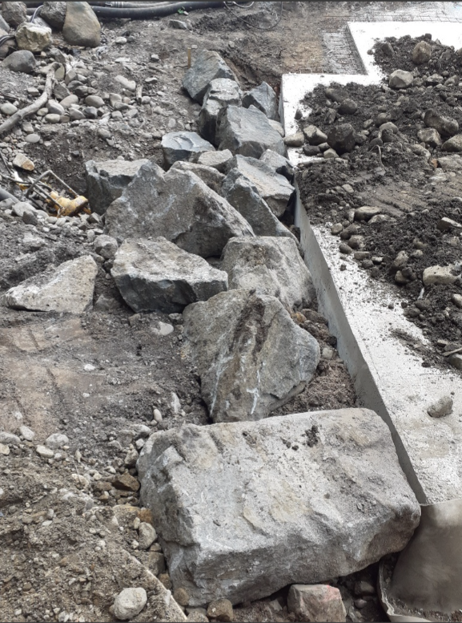
Figure 5K: Boulders installed at the downstream end of concrete slab bed reinforcement to help retain the natural bed material reintroduced onto the slab.

Bed reinforcement and flow volume
Assessing how the bed reinforcement is going to impact the volume of flow in the channel especially at times of low flows is vital. If a material is used that is too porous it can result in flow going through the bed rather than over it, this can create a dry section of river that fish cannot pass and a loss of instream habitat. This commonly happens with reno mattresses (Figure 5L), which are easily broken up by the erosional force of flood flows and the coarse sediment bouncing along the channel bed. As they break up the wires protrude into the flow and can damage or kill fish.
Other types of bed reinforcement, such as boulder rip rap, can also have large gaps in between the individual stones, which therefore need to be filled with finer material to avoid creating a dry riverbed during low flows. Wherever possible, the natural bed material that was moved to allow the rip rap to be placed should be used to fill the gaps (Figure 5M).
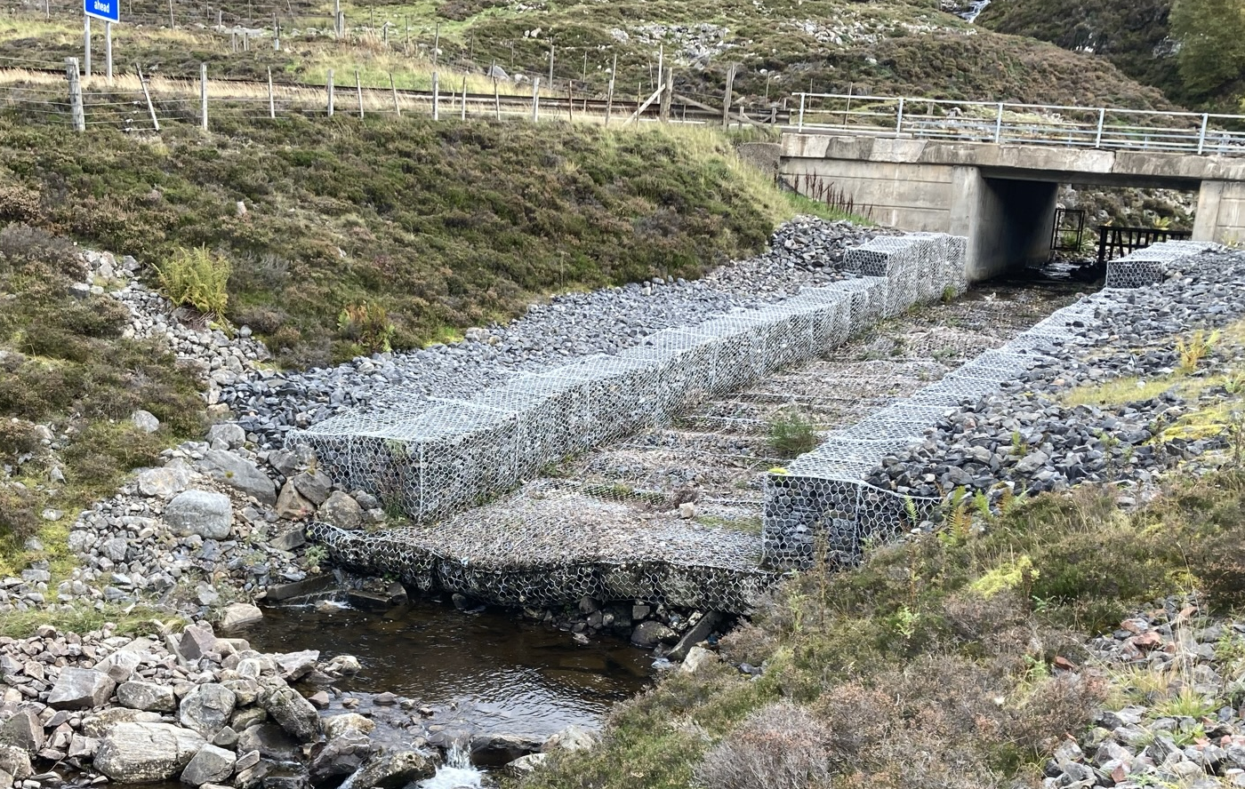
Figure 5L: Location where reno-mattresses have been used as bed protection, causing the river to flow subsurface through the mattresses creating a barrier to fish and a loss of habitat.
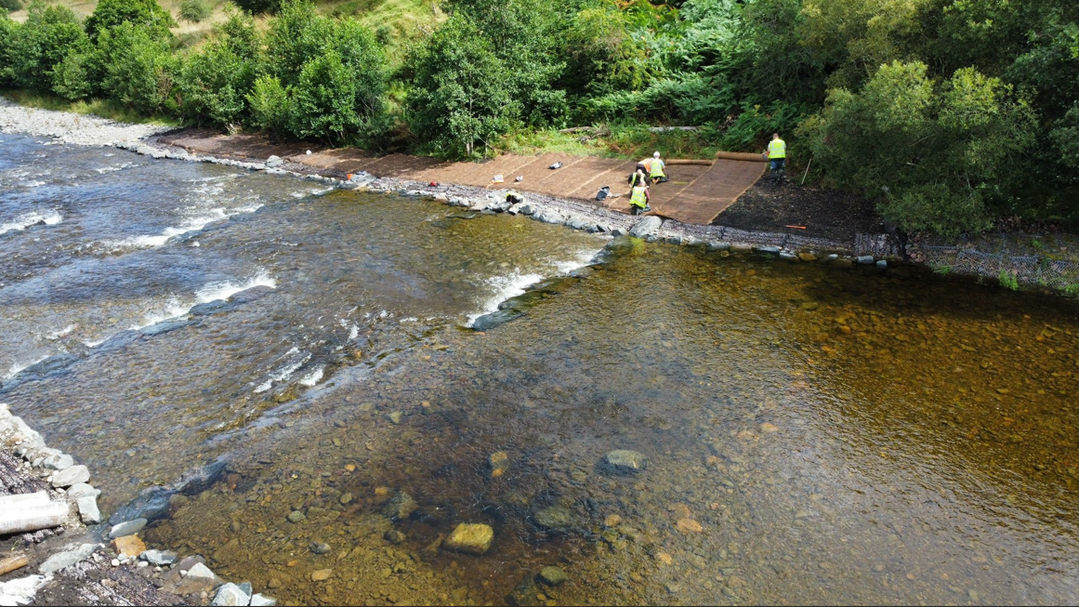
Figure 5M: A boulder rip rap rock ramp protecting a high-pressure gas pipeline. The boulders making up the body of the ramp and the gaps between the boulders have respectively been covered and filled with natural bed material removed to allow the ramp to be built. Photograph courtesy of Ineos

Other considerations and summary
There have been recent developments in the types of materials that can be used for bed reinforcement (e.g. pillows or bags filled with concrete or stone). If a less common, novel approach is proposed, it is beneficial for the application to include evidence of this technique working in a river of a similar character (e.g. size and slope). This could include photographs demonstrating that this surface is rough enough to retain bed material and additional information about the biodegradability and longevity of any casing, assessing what is likely to happen to it over the lifetime of the bed reinforcement.
The selected bed reinforcement option should ideally be the one that will have the least impact on the river channel. Ideally it should be buried as far below the natural bed as possible, not narrow the channel, have a roughened surface to help retain natural bed materials and to provide variation in flows, and not allow flow to percolate through it.

Flow deflectors
The options appraisal should take account of the river processes both at the proposed site and in the river system upstream and downstream. Rivers which have been artificially straightened generally have lower habitat diversity and may be missing riffle and pool flow units, which are essential for different life stages of fish. Flow deflectors aim to create or increase these habitat types. An alternative approach would be to apply measures that encourage meandering and increase the sinuosity of the channel, allowing those habitats to form naturally. The options appraisal should therefore consider whether river improvements can be carried out at the larger, reach scale to create the desired habitats or whether local-scale flow deflectors are needed. The former approach may take longer but also is likely to provide improved and more sustainable habitat diversity in the long run. It also removes the risk of unplanned bank erosion that may arise from installing hard structures within a mobile river.
Options should also consider human modifications happening at the catchment-scale that may be impacting upon local fish habitats. For example, reservoirs regulate flow by decreasing flood peaks and disconnecting the sediment supply. Both flow and sediment are needed to create and maintain habitat. In this case, habitat restoration options may include moving sediment to below the reservoir and modifying flow releases to increase flood flows. These larger-scale approaches would benefit habitats across much longer stretches of river than just the areas where the deflectors are proposed.
If flow deflectors are selected as the best approach to habitat enhancement, then consideration should be given to the number, type and alignment that are used. The exact layout and angle of the flow deflectors will determine the patterns of erosion and deposition within the reach (see Figure 5N). The options appraisal should map the expected distribution of new habitats expected to form because of the structures. This will also help to identify the risk of unwanted channel changes, e.g. bank erosion, so that appropriate mitigation can be incorporated into the design.
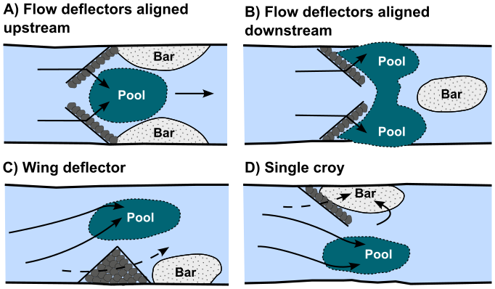
Figure 5N: Different types and alignments of flow deflectors create different patterns of scour and deposition. a) Flow deflectors aligned upstream create a pool in the middle of the channel with deposition on either side, b) flow deflectors aligned downstream create a pool that spans the channel but is largest on the banks, with deposition forming in the mid-channel downstream of the pool, c) triangular or wing flow deflectors create a pool at the tip of the deflector and deposition downstream of and on the same side of the channel as the deflector, and d) a single flow deflector will create deposition in its lee with a pool forming at its point.
Careful consideration needs to be given to what the flow deflector is constructed of and where this material is sourced from. Any boulders used should ideally be of the same or similar rock type as other coarse sediment found in the vicinity. No boulders should be removed from the riverbed to stabilise the deflector unless it is removed from the exact location in which the deflector is to be installed. Large boulders play a key role in locking the bed into place and protecting smaller material from being washed away during floods, so their removal can cause bed scour and lowering. If they are only removed from the exact footprint of the deflector, the deflector should replicate the boulder’s stabilising role. Every effort should be made to site deflectors such that no boulders need to be removed from the channel, however, with boulders ideally being sourced locally from the valley, so long as this can be done without damaging sensitive habitats or soils. Locally sourced boulders are more likely to look like they could be found within a river, because even if they have only been moved by glaciers, they are more likely to have rounded edges than rock sourced from a quarry, which typically has very angular edges. As a last resort, however, washed boulders from a quarry are acceptable.
If sourcing sediment from the bed of a river channel out with the immediate area in which the flow deflector is being installed, then prior authorisation (registration or permit) for the sediment removal would be required.

Placement of boulders
Options choices for this activity centres on the number and distribution of boulders within the design. This includes whether they are introduced as single boulders, pairs, clusters or channel spanning morphological units such as steps. The assessment should consider how the patterns of flow and sediment erosion and deposition are impacted for each configuration and how this is likely to affect the wider reach (Figure 5P).
Risks to the channel associated with each configuration should also be considered. For example, if boulders are placed too close to the bank or fill the channel to constrict flow, they may increase bank erosion Understanding the expected patterns of scour and deposition is essential for justifying the selected option and assessing the proposed risk.
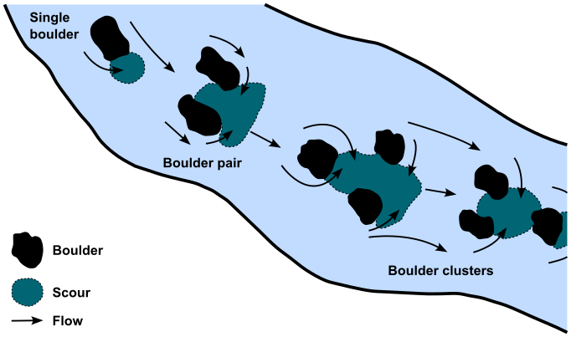
Figure 5P: Different configurations of boulders can create different patterns of scour and fish cover within a river. The examples show the effects of single boulders, boulder pairs, or boulder clusters on scour patterns.
If boulders are being used to create step features to stabilise the bed, the patterns of erosion and deposition will differ from those created by individual or clusters of boulders. Step alignment determines the patterns of erosion and deposition and whether any bank scour is likely. Concave steps, where the middle of the step points upstream, will create scour in the middle of the channel (Figure 5Q). If the step has a convex shape (the middle points downstream) this will push flow towards the banks, increasing the risk of bank scour. How much bank erosion is acceptable at a site is thus one factor to consider when deciding on step alignment.
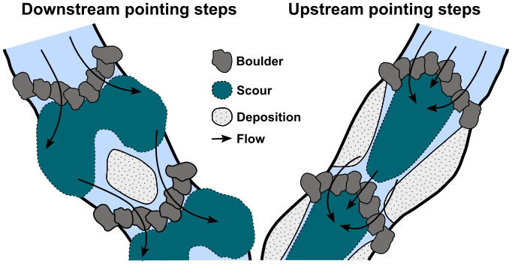
Figure 5Q: Patterns of scour and deposition due to differences in step configuration (convex versus concave).
If boulders are being placed to restore habitat, it is useful to understand what this habitat would have looked like prior to boulders being removed. The best way to do this is to find a reference channel reach with similar characteristics but that has not undergone the same modifications.
The bottom photograph in Figure 5R shows a section of river from which boulders were removed and used to create a stone wall as bank protection. This section has a channel bed made of finer material, and with a more simplified character (i.e. lower habitat diversity). In contrast, the refence channel reach in the top photograph shows how the boulders are arranged as clusters and steps, thus increasing habitat diversity.
If suitable reference reaches are present and this habitat can be mimicked, it can greatly increase the quality and sustainability of the restored habitat and provide a clear rationale for why that option was selected.
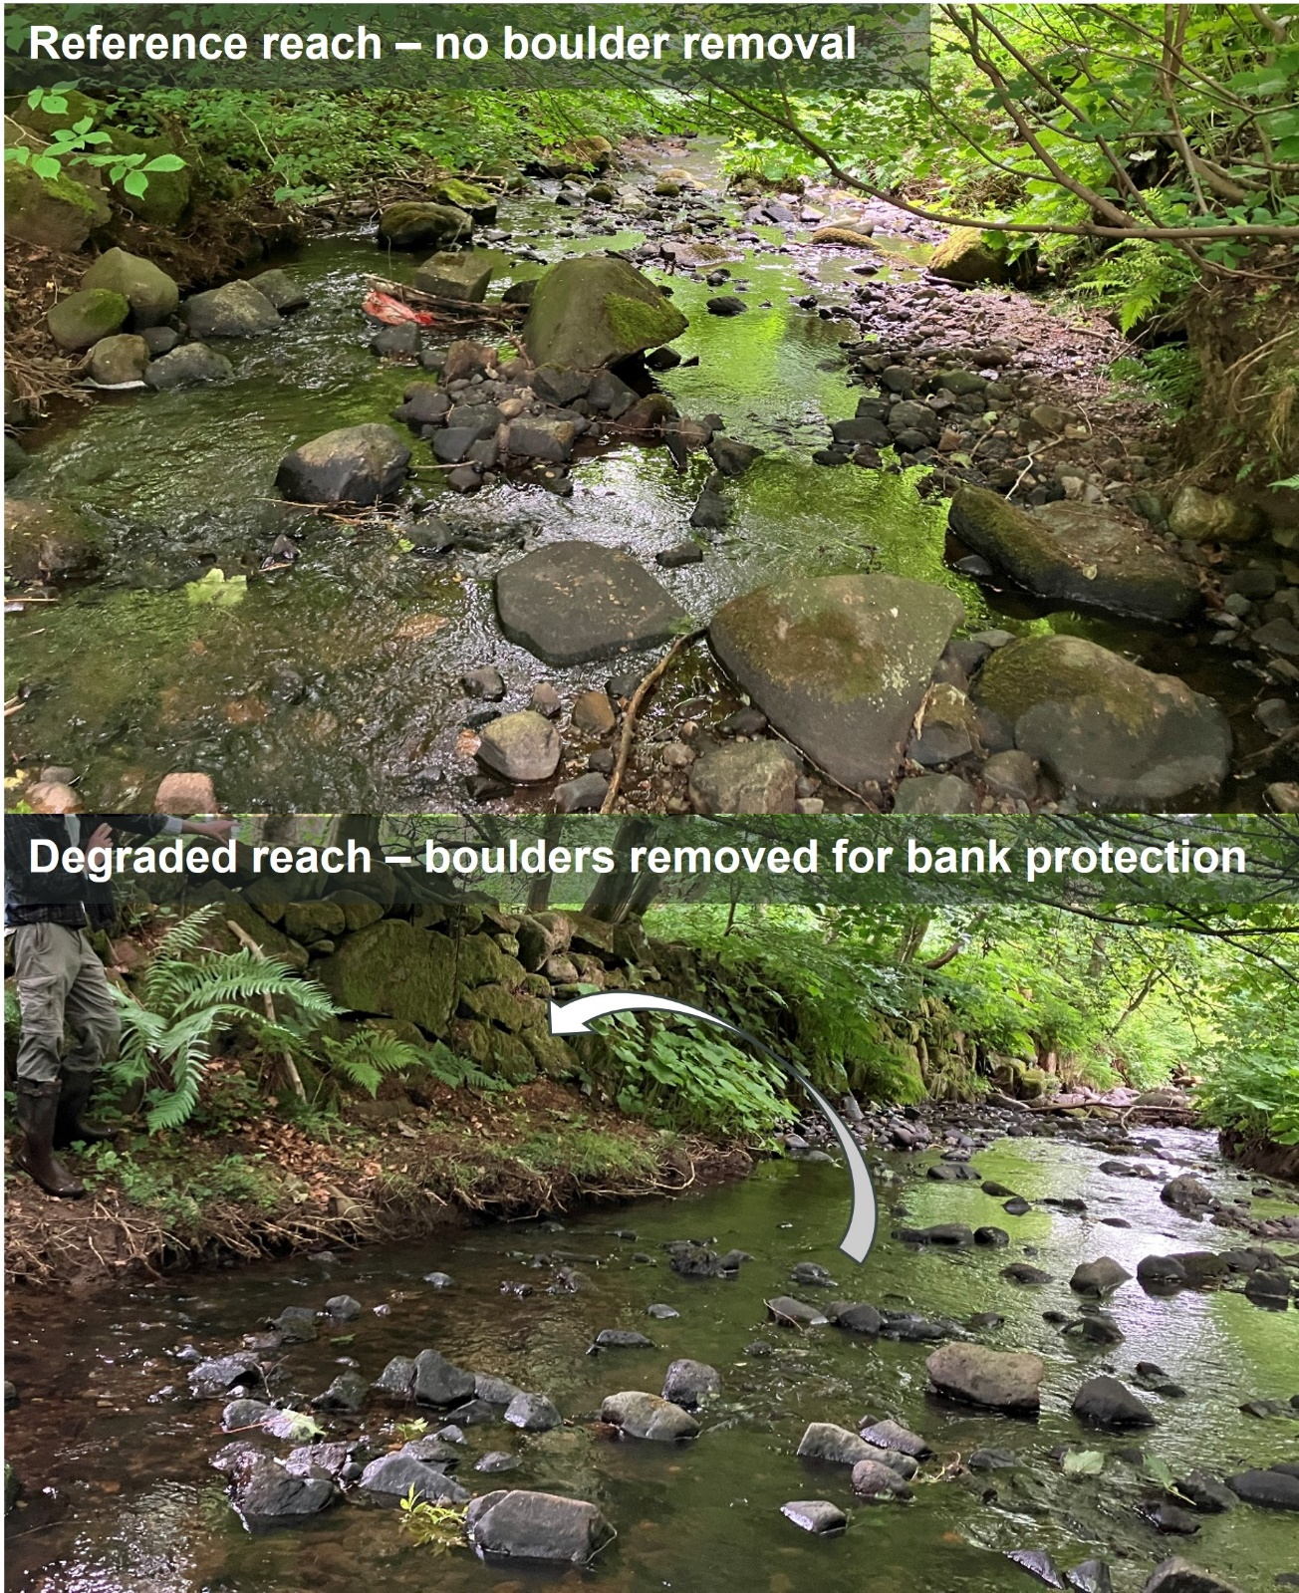
Figure 5R: Photographs showing a degraded reach, where the coarse material has been removed and used to build bank protection and the reference reach upstream, which has not been modified and is going to be used as a basis for design when the boulders are placed back in the channel as part of the restoration of the degraded reach.
As mentioned in section 5.2.2 , the source of the boulder material is important. This is discussed in full in that section, but the key highlights are that the boulders should:
- Be of the same or similar rock type as other coarse sediment found in the vicinity,
- Not be removed locally from the riverbed, as this may increase the instability of the channel, and
- Look like it would naturally be found within a river. For example, boulders that are rounded in appearance, rather than square cut, look far more natural.
If the proposal is to remove the material from the riverbed out with the immediate area where the boulders are to be placed, then prior authorisation (registration or permit) for the sediment removal would be required.

In-loch structures
Regulating activities within lochs is based on the premise that altering the physical structure of the loch can affect its ecological communities. Every effort should therefore be made to limit the extent of disturbance to the loch’s structure and to the physical processes responsible for creating it. Recognising that lochs are not static entities but have processes which shape their characteristics and the habitats they contain is essential for designing sustainable in-loch structures.
The identification and appraisal of in-loch structure options should consider the issues discussed below.
Sediment is transported along the shore of lochs by wave action and currents in a process known as longshore drift. If a structure blocks this process it will cause deposition against the side of the structure facing the longshore drift and erosion of the shore zone on the other side. The length of shoreline impacted by this deposition and erosion will depend on the structure’s design, including its length and height.
For example, structures built on stilts are preferable to solid-body structures (Figure 5S), as sediment can continue to move through the structure. If a solid-body structure is needed, keeping its height and length to the absolute minimum necessary to do the job is important.
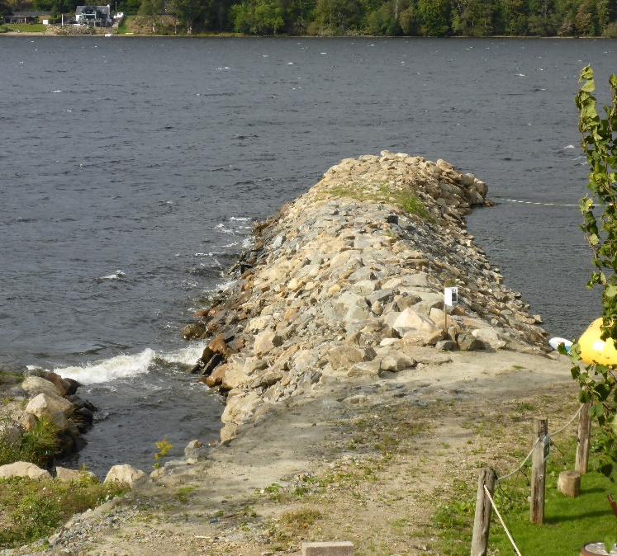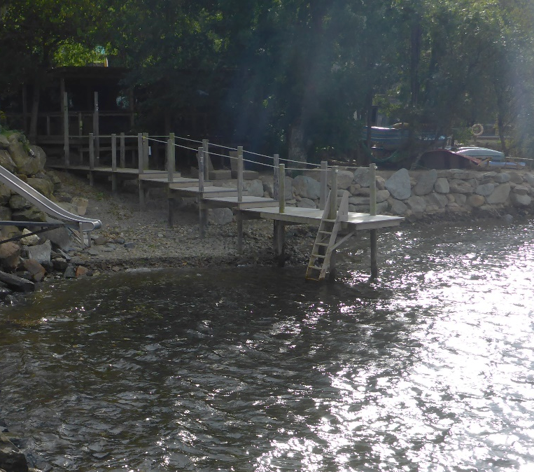
Figure 5S Photo on left shows solid structures such as this one will interrupt the patterns of longshore drift along the loch shore and can cause deposition at the front and a starvation of sediment behind. Photo on R shows a structure built on stilts, which is are far less likely to block sediment transport.
The location, size, shape and orientation of the hard surfaces of a structure relative to the predominant wave direction, can affect how waves interact with the shore zone and the amount of scour they generate. Efforts should be made to create rough surfaces orientated at shallow angles to the predominant wave direction, as this will help to dissipate some of the wave energy and minimise the amount deflected onto the shore zone. Such surfaces include those made of interlocking boulders with many gaps in-between. Hard, flat surfaces such as vertical concrete walls can deflect much wave energy onto the loch bed in front of the structure, which may increase scour and eventually undermine the structure causing it to fail.
If bank or bed protection in the shore zone is required as part of the development (e.g. protecting the loch edge next to a new solid-body pier), lower impact methods should be included in the optioneering. These could include sustainable bank protection using whole trees and parts of trees (see Water GBR 25 and WAT-G-029 EASR Guidance: Engineering: Sustainable Bank works) or placing the protection in the shore zone as far away as possible from the water’s edge and only using the minimum amount that is necessary. Such options will help to minimise the activity’s overall impact.

Options Appraisal
Once several potential options have been identified, an options appraisal to find the best practical environmental option should be carried out in all cases.
The options appraisal should include:
- Comparison of at least 3 options (including doing nothing).
- Costs (including capital, construction and maintenance costs).
- Feasibility of construction.
- How well it addresses the problem or need and whether it tackles the underlying cause.
- Maintenance requirements.
- Impacts upon physical river attributes (morphology).
  - Channel form, allow the river room, riparian areas, sediment movement, etc.
- Impacts on ecology.
  - Fish, other aquatic and riparian wildlife; and
  - Impacts on conservation designations, important species and habitat features.
- Impacts on other users of the water environment (such as angling, kayaking etc).
The cost evaluation should assess whether the costs for each option are proportionate.
The nature of the best option will always depend on the needs and the details of each situation. In some cases, you may need to implement a variety of methods to address the problem or need.

Justify the selected option
After evaluating all the alternatives, the best practical and environmental option, with proportionate costs, should be chosen and justification provided. Justification should also be provided to explain why other options have been rejected.
This does not always mean adopting a lowest impact engineering approach or adopting the cheapest solution. The best practical environmental option means choosing the approach that effectively addresses the problem or need and minimises negative environmental impact as far as practical.
Proportionate costs are those that correspond to the level environmental harm being minimised or the environmental benefits that the option provides.
Large absolute cost in itself does not necessarily constitute disproportionate cost.
For example, incurring significant costs to prevent significant environmental harm or achieve significant environmental benefits, e.g. safeguarding protected species and designated sites, is likely to be considered proportionate. But incurring significant costs for minor environmental benefits would likely to be considered disproportionate.
There may be one or several reasons for selecting a preferred option and these should be made clear so we can assess whether Good Practice has been met.

Possible justifications for your chosen option
Some possible justifications for your chosen option are detailed below.
Channel and Loch Form
Different channel morphological types have different amounts of flow energy and different bed material that may have a significant bearing on which option is most appropriate.
Any project which significantly alters channel form (i.e. width, depth, slope, planform) will affect the natural balance in the river with consequences for erosion and deposition of sediment.
Options which accommodate natural river form and minimise alteration of flow and sediment transport patterns are encouraged. You should explain why the proposed option is appropriate for a river of that type and how it will minimise the impact on the water body’s natural features.
For bed reinforcement, this might include the need for using boulder-sized sediment on the surface of the reinstated bed material in a moderately steep plane bed channel type, but coarse gravel or cobbles in a lower gradient active meandering or plane riffle channel type.
While lochs are generally of one specific morphological type, for example a long, narrow and deep Highland loch such as Loch Ness, or a more rounded and shallower loch such as Loch Leven in Fife, different sections of the shore zone can nevertheless look and behave very differently. Sections of shore exposed to the predominant direction of wind and waves will typically be composed of coarser sediments, such as cobbles, boulders, or even bedrock, while more sheltered sections will have much more sand and gravel and depositional features such as beaches. These different types of shore zone represent a balance between the amount of energy to which they are exposed and the way they look, i.e. their shape. The justification for your option may therefore be based on the site-specific loch processes
Environmental Benefits
Justification for a chosen method could be related to the environmental benefits it creates or how it minimises environmental disruption. For example, the selected option may create habitats for terrestrial and aquatic wildlife, improve water quality or increase climate resilience.
How well it addresses the problem or need and whether it tackles the underlying cause
When identifying the underlying cause of a problem ( covered in section 5.1)it is very important to differentiate between causes located elsewhere in the catchment., If there are no underlying causes located elsewhere in the catchment, it may be appropriate to proceed with an instream or in-loch structural solution. If the underlying cause is elsewhere in the catchment, however, a structural solution may still be appropriate if it would take too long or is out with the gift of the applicant to address it. For example, a railway bridge whose foundations are being scoured because of accelerated runoff from upstream coniferous plantations must be stabilised rapidly to prevent the bridge collapsing and potential loss of life
Economic Savings
An economic saving is represented by a reduction in future expenses realised by undertaking the preferred option. For example, the selected option reduces the costs associated with maintaining the infrastructure it is protecting, e.g. scour protection below a hydropower scheme outfall, land loss, e.g. due to gulley erosion or property damage.
Costs
Whilst low environmental impact options are preferred, we recognise that the costs for a chosen option must be proportionate for the situation. Where an option with lower environmental impacts has been rejected due to financial cost you must provide details.
Feasibility of construction
In certain cases, especially where access is very limited this may rule out lower impact approaches and mean that there is only space to install a higher impact technique.
Maintenance
How often will a structure have to be replaced, or how often will an activity need to be repeated? Projects that work against natural processes often result in high maintenance. For example, a solid jetty that blocks sediment transport may require dredging, whereas a stilted one that allows sediment transport beneath it could avoid this need entirely. Such cost-benefit assessments should be undertaken for all proposed works.
Aesthetic and Recreational Value/ Impacts on other water users
The preferred option may be selected because of its appearance relative to the aesthetics of the surrounding water course, loch or landscape. Alternately, it may be required for a particular end goal such as for public access, angling, or infrastructure needs.
Health and Safety
The solution chosen must also consider the health and safety of people who either use the river or loch or need access to undertake maintenance works. In some cases, these considerations may dictate that a particular structural design is required.

Use all reasonable mitigation
To minimise impacts on the water environment and other water users you must plan to use all reasonable mitigation when installing any instream or in-loch structures or when placing boulders.
Mitigation measures for a proposal should:
- Limit, or offset, potential impacts, including those from construction.
- Be proportionate to the environmental risk.
- Be prioritised by the balance of factors such as environmental benefit, cost, and ease of implementation.
- Not be used to compensate the impacts of an unjustified activity
As every site is different, what constitutes appropriate mitigation will vary on a case-by-case basis, there is no single answer to what mitigation is considered reasonable.
In determining suitable mitigation, you should fully understand the risks and issues associated with the proposed activity, as set out in section 3.3, context of the site.
Details of the mitigation measures to be used and how they will be maintained should be included in a method statement, which should also explain more generally how the works will be undertaken. Requirements for method statement be found in our section 5.2 of our guidance WAT-G-030 EASR Guidance Engineering Meeting Good Practice. Where drawings are being used to support an application, mitigation measures should also be shown.
Using suitable mitigation will help you to comply with permit conditions. In certain cases, specific conditions relating to mitigation requirements will be specified within the Permit.
Further guidance is available in our guidance WAT-G-034 EASR Guidance: Construction works and silt/pollution mitigation.
Some specific mitigation measures for the main types of instream and in-loch structures and the placement of boulder are described in sections 5.4.1 to 5.4.4.

Mitigation: Bed Reinforcement
Mitigation measures incorporated into the design for new or modified bed reinforcement should include making sure the structure is passable to fish and other wildlife, increasing the roughness of the reinforcement and installing scour protection. Other improvement measures within the wider reach may sometimes also be considered to offset impacts associated with the structure.
Bed reinforcement should not create a flat, smooth surface as it is easier for high flows to scour the reinstated bed material off this to expose the underlying reinforcement which can create shallow fast flow, which can create a barrier to fish. In addition, the design should not create any steps which would be a barrier to fish and other wildlife
It’s important that bed reinforcement designs provide a rough surface so that sediment is retained on top of the structure and / or turbulence is increased so fish can move though. The rougher the surface, the better it will be at retaining bed material
If a concrete slab or mattress is to be used its surface should be roughened before reinstating the sub-surface and surface armour layer. Several techniques exist for doing this, including embedding cobbles or boulders into the wet concrete or attaching baffles to the cured concrete (see Figure 5T below).
If the bed reinforcement is designed too high and the river velocities are too fast, then even baffles will not hold bed material (as seen in Figure 5F). Therefore, this mitigation approach is no substitute for designing bed reinforcement which is placed below the natural level of scour of the river.
Scour protection such as boulders may also be required at the downstream toe of the structure, to help hold the bed material on top of the reinforcement and prevent scour at this point. This protection would create a rough and graded transition from the reinforced section of bed to the natural riverbed. Without it, there is a high likelihood that turbulence during floods would erode the section of natural riverbed in contact with the downstream edge of the bed reinforcement, which would undermine the downstream edge of the bed material reinstated over the bed protection and eventually lead to most, or all, of the reinstated bed material being scoured away.
Bed material removed during construction should be stored with the surface layer separated from the material underneath. The surface of a riverbed is coarser than the underlying material (the sub-surface layer) and provides a protective armouring effect that prevents the finer sub-surface sediment from easily being eroded. This armoured layer is formed of grain sizes that can withstand the flow velocities at this location of all but the largest floods.
Once the bed reinforcement has been installed, the sub-surface layer should be reinstated followed by the armour layer to reinstate this natural scour protection.
It may be helpful to take photographs of the surface layer before it is removed, particularly if there are boulder ribs or clusters across the bed. Boulder ribs and clusters provide additional roughness and valuable habitat within the river and can also help reduce smaller sized sediment upstream being scoured. Photographs would help guide the recreation of these features as the natural bed material is being reinstated.
Mitigation may also be considered for the river reach upstream and downstream of the proposed works to help offset the long-term damaging impact bed reinforcement can have on river habitats. This could include replanting the riparian margin with native shrubs and trees to enhance the bank habitat. It could also involve removing any obsolete engineering, such as redundant embankments or bank protection.
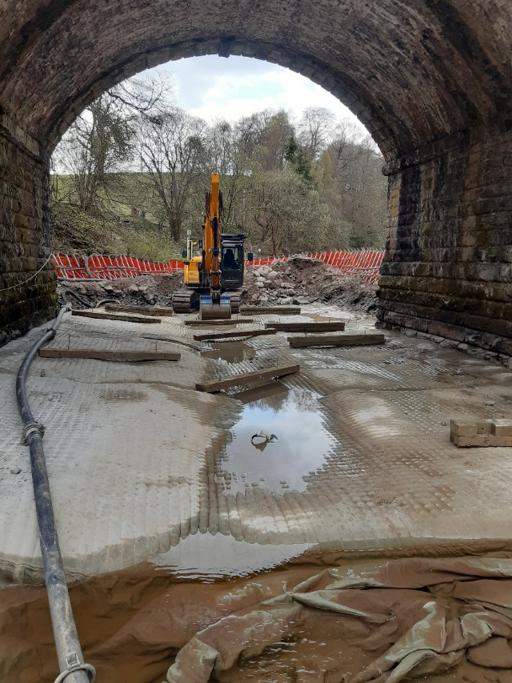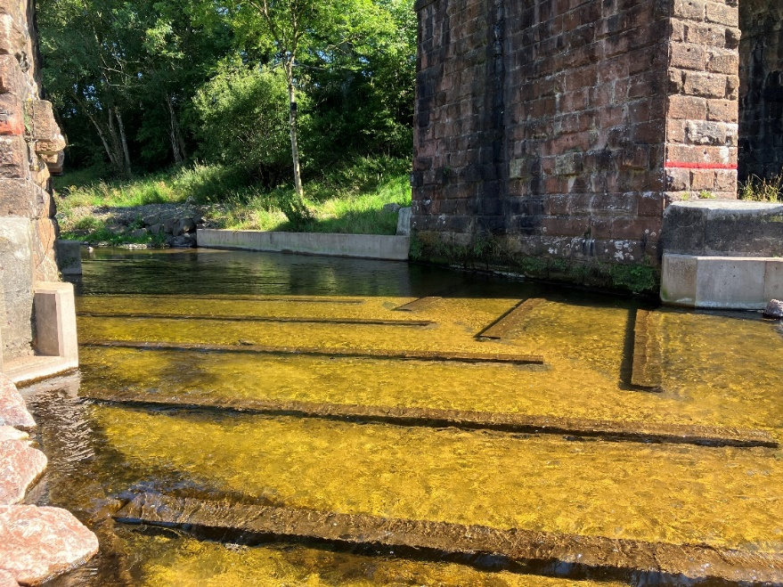
B)
A)
Figure 5T: Examples of mitigation carried out post works to fix issues with bed reinforcement creating fish barriers. A) Photograph of bed reinforcement being modified with baffles to increase roughness and retain bed material (this is the same location as Figure 9). Photograph courtesy of Forth Rivers Consulting B) Baffles installed to slow flow, allowing fish passage over bed reinforcement which was built too high (this is the same location as Figure 5F).

Mitigation: Flow deflectors
Where bank erosion is likely from installing a new flow deflector, then mitigation can be provided by using use of low impact bank protection techniques such as planting of trees or shrubs (under Water GBR 25) which will also boost biodiversity in the riparian zone and enhance local instream habitats.

Mitigation: Boulder placements
Specific mitigation is unlikely to be required for this activity as it is usually carried out to improve habitat. Care should always be taken to ensure that the location and size of the placements do not interaction with any other structures in the vicinity in a way that could cause unintended and undesirable impacts.

Mitigation: In-loch structures
Mitigation should consider how the loch is being impacted by current modifications.
Mitigation within the design should ensure that effects on sediment movements are minimised (see section 5.2.4).
In addition, where the installation of the structure will involve the removal of vegetation, suitable measures should be considered to offset this loss, as vegetation in the riparian zone offers an important habitat, food source and shading / cover to loch edges.
Other offsetting measures could be to help address excessive volumes of fine sediment into the loch that could be remedied as part of the works. This could include eroding banks due to poaching or drainage delivering high sediment loads. Mitigation could include fencing of banks where livestock are accessing the loch or altering intakes to include sediment settlement areas, which can be routinely cleared.
If the new works are replacing an obsolete structure, the removal of the obsolete structures should be considered.

Post-works monitoring
After your engineering works have been completed, you should undertake post-project appraisal to help identify any problems that need to be investigated and addressed (e.g. post construction snagging issues and emerging issues) and to monitor how well the works address the original problem or need
It is especially important to check the works after the first few high flow events and in the first couple of months to see how they have coped and whether any issues have emerged or are at risk of emerging. These might include:
- Failure to restore the bed or banks suitably after the structure has been installed.
- Construction materials left behind.
- Identify defective installation or materials.
- Sudden new bed or bank erosion upstream or downstream that threaten the structure or adjacent infrastructure, building or farmland.
- Installed flow deflectors or boulders causing bank erosion.
- Reinstated bed material being scoured off bed reinforcement creating a barrier for fish.
- Livestock gaining entry to fenced off areas and damaging planted trees etc.
- Failure of riparian trees to become properly established.

Post project appraisal and site management
Inspection and maintenance of project sites should always be carried out at appropriate intervals to ensure that any issues are identified and can be addressed before they can develop into more serious problems. New projects should be inspected after the first major high flow or series of high flows.
Photographs should be taken periodically at established points and ideally at least twice a year, in the spring and autumn. To allow comparisons among repeated photographs, they should be taken during low water periods and at corresponding water levels.
The development of any vegetation planted as part of any mitigation efforts should be monitored to assess its effectiveness roughly once per growing season (preferably near the end of summer) for at least three consecutive years.
Many instream structures fail due to scour and erosion of sediments and materials around and underneath the structures. Care should be taken during design to present this happening e.g. bury bed reinforcement well below the scour level of the bed and make sure the surface is rough prevent the reinstated bed material being washed off. Careful inspection of the area where the instream or in-loch structure has been installed can also help prevent failures by identifying issues before they progress. Inspections of instream or in-loch structures should occur during low water periods, when both the structure and the channel bed and banks are more likely to be visible. Changes to the character of the river or loch most commonly seen are erosion to the channel or loch bed or banks and / or increases in sediment deposition.

Disclaimer
Whilst every effort has been made to ensure the accuracy of this guidance, SEPA gives no warranty, covenant or undertaking (express or implied) regarding the fitness for purpose of, or any error, omission or discrepancy in this guidance. Reliance on its contents and the contents of any websites that are linked to or from this guidance is entirely at the user’s own risk. SEPA is not liable for any loss or damage that may come from using this guidance.
This includes:
- any direct, indirect and consequential losses
- any loss or damage caused by civil wrongs, breach of contract or otherwise
SEPA reserves the right to depart from this guidance and take appropriate action as it considers necessary or appropriate. Operators are responsible for ensuring that they are compliant with the law. If necessary, independent legal / specialist advice should be sought.

