



SEPA 2024/25
June 2025
Corporate Performance Report

Contents

1. Performance summary 2
2. What we have achieved 5
3. Suite of organisational KPIs summary 26

For information on accessing this document in an alternative format or language, please contact SEPA by emailing equalities@sepa.org.uk

1. Performance summary
Our Annual Operating Plan (AOP) for 2024/25 included 12 performance measures. These measures help us to report on our delivery against our strategic objectives, operational effectiveness and our impact on the environment in Scotland. They help us be accountable to the Scottish Government, the people of Scotland and their communities.
This report provides a summary of our performance over the year, April 2024 - March 2025. It highlights our successes and achievements as well as any areas where improvements can be made.
We have successfully achieved 11 performance measures and partially achieved one performance measure, set out in our AOP 2024/25.
Some highlights this year are:
- Climate resilience - we issued 289 regional flood alerts, 370 local flood warnings and 3 severe flood alerts on time. We also issued 100% of daily flood guidance statements to responders (more than 900 people). Our warnings, alerts and statements help category 1 responders, local authorities and the people of Scotland take lifesaving action and make informed decisions.
- Water environment - we published the 2023 classification results in the state of the water environment report. The results show that the overall condition of our water environment continues to improve. The proportion of surface waters and groundwaters combined assessed as being in good or high overall condition increased to 67.9% in 2023, from 67.1% in 2022, while 98.4% of surface waters and groundwaters have not deteriorated. Our commitment to protecting and improving Scotland’s water environment, one of our strategic priorities, is demonstrated in this evidence.
- Business environmental performance – we made a commitment in 2024/25 to tackle environment crime and to take robust action against those who do not comply to protect the people and the environment of Scotland. This year we saw a greater than 95% increase in the number of recorded interventions used to tackle environmental crime, from 87 in 2023/24 to 167 in 2024/25. These interventions led to an overall reduction of 93 illegal sites, or 29.3%, from our 2023/24 baseline (313 known sites).
During 2024/25 we worked to strengthen our performance framework and our reporting mechanisms. We fully embedded performance measurement into our Annual Operating Plan 2025/26 development process, working collaboratively with teams across the Agency to develop Objectives and Key Results (OKRs) and confirm a range of Key Performance Indicators (KPIs).
Going forward, these strengthened measures will more effectively enable the Agency to monitor and report on delivery against our strategic priorities, our impact on the environment in Scotland and our organisational effectiveness. This will also help ensure our priorities are more clearly communicated and understood to key stakeholders, providing a more complete picture of how well we are doing and how we can be held accountable by the people and communities of Scotland.
We will use our strengthened performance framework to continue to refresh and improve our reporting as we move into 2025/26.

A high-level summary of the progress of each performance measure for 2024/25 is below.

 | Priority | Aim | Measure | 2024-25 performance | Status
1 | Net Zero | Greenhouse gas emissions are reduced | Annual greenhouse gas emissions in the Scottish Pollutant Release Inventory– Reducing | 13.5% reduction | Achieved
2 | Net Zero | Greenhouse gas emissions are reduced | Annual reports of greenhouse gas emission by SEPA - Reducing | 0.05% reduction | Partially achieved.
3 | Climate resilience | The impact of flooding and water scarcity is reduced. | Number of flood warnings and alerts issued by SEPA - Maintaining | 662 flood warning and alerts issued | Achieved
4 | Climate resilience | The impact of flooding and water scarcity is reduced. | Proportion of developments approved in accordance with SEPA’s advice on flood risk – Maintaining | 98.4% resolved | Achieved
5 | Water environment | The condition of the water environment is improving. | Classification of water bodies across Scotland - Increasing | Increase to 67.9% from 67.1% in 2022. | Achieved
6 | Resource efficiency | Resource efficiency is improved. | Rates of waste to landfill in annual Scottish household waste data - Reducing | 14.8% reduction of household landfilled waste. | Achieved
7 | Business environmental performance | Interventions to tackle environmental crime are increasing. | Number of successful interventions per year – Increasing | 95% increase from previous year | Achieved
8 | Our organisation | Enabling aims. | Percentage of customer complaints responded to within statutory timescales - Maintaining | 89.5% against 85% target | Achieved
9 | Our organisation | Enabling aims. | Number of vehicles in our fleet to electric and enhancing our EV charger facilities - Increasing | 25 electric vehicles from 22 baseline | Achieved
10 | Our organisation | Enabling aims. | Percentage of Freedom of Information (FOI) requests and Environmental Information Requests (EIRs) responded to within statutory timescales - Increasing | 94.8% against 90% target | Achieved
11 | Our organisation | Enabling aims. | Percentage efficiency savings – Maintaining | 5.6% against 3% target | Achieved
12 | Our organisation | Enabling aims. | Percentage of invoices paid within 10 days – Maintaining | 92% against 90% target | Achieved

2. What we have achieved

Our statutory purpose is to protect and improve the environment in ways that, as far as possible, also contribute to improving health and well-being and achieving sustainable economic growth. To help us achieve our purpose, our Corporate Plan 2024-2027 and our Annual Operating Plan 2024/25, sets out five strategic priorities that we will focus our work on – net zero, climate resilience, water environment, resource efficiency and business environmental performance – as well as our organisation and transformation. It is an ambitious programme of priorities, and we access our performance against measures set in those areas.

Net Zero

Our ambition is to fully play our part in helping Scotland become a net zero country by 2045 and reduce our own emissions towards net zero.

With our precious environment under threat from the global climate emergency, as Scotland’s environmental regulator we are requiring and encouraging businesses to reduce their impacts. In response to the global climate emergency, the Scottish Government set out a pathway to meet Scotland’s ambitious emissions reduction targets over the period to 2032 (as progress towards a net zero target in 2045). Meeting these targets will require a collective effort from all sectors.

Annual greenhouse gas emissions
We collect greenhouse gas emissions data through the Scottish Pollutant Release Inventory (SPRI). SPRI provides a valuable picture of the amount of pollutants released in Scotland from SEPA-regulated industrial sites. It is a publicly accessible electronic database and aims to provide information for policy makers, academics and the public about the pressure Scottish industry puts on the environment through greenhouse gas and other emissions.
We published the 2023 SPRI data in September 2024. The data shows that the global warming potential of greenhouse gas emissions from SEPA-regulated industrial sites, decreased by 13.5% (1.51 megatonnes CO₂e (carbon dioxide equivalent)), between 2022 and 2023.
The energy sector remains the highest emitter in Scotland’s industrial data inventory, accounting for 40.0% of the overall greenhouse gas emissions. The sector reported a 22.9% decrease in greenhouse gas emissions in 2023. Information reported by some operators of major emitters indicated that changes in production this year contributed to the reduction in emissions. Given this is a single year of data, it would not be appropriate to draw firm conclusions from the decrease seen in 2023, however there continues to be a long-term downward trend overall.
Figure 1: Global warming potential of greenhouse gases reported to SPRI since 2007 (MtCO2e)
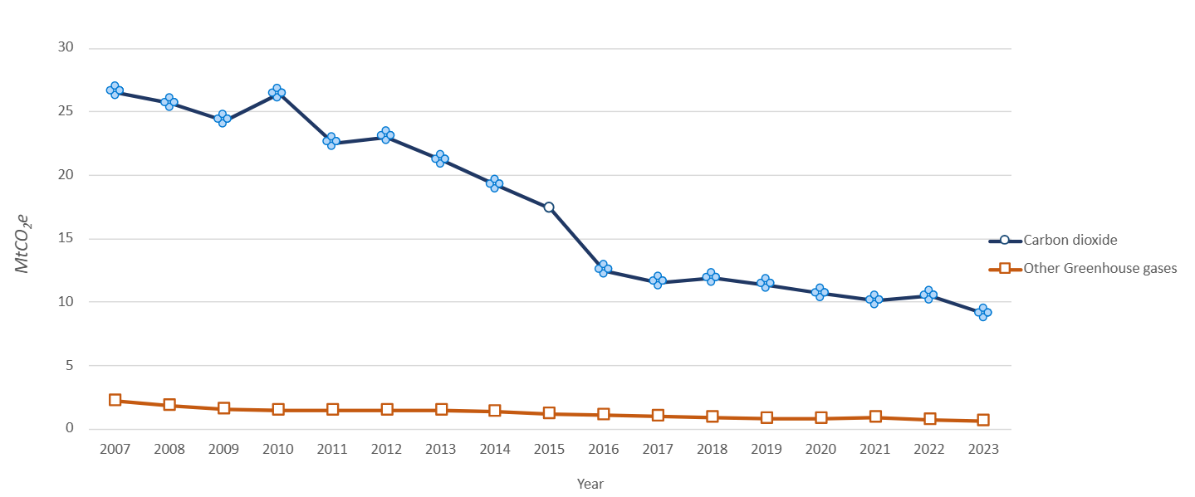
We are part of a pilot project on energy efficiency and decarbonisation at industrial sites. This project aims to provide a more holistic and robust approach to our work in this area and enable us to deliver an options assessment of energy efficiency regulatory approaches. We have determined a site selection methodology and an initial list of identified sites. We are currently applying the methodology and anticipate contacting shortlisted sites by the end of June 2025.

Our greenhouse gas emissions
As well as encouraging businesses to reduce their impacts, we must also take steps to do the same and reduce our greenhouse gas emissions. Our Net Zero Routemap sets out our goal to reduce all our greenhouse gas emissions to at least net zero by 2035, with an interim target to reduce our direct greenhouse gas emissions by 15% by March 2026. This means our target is 1481 tCO2e by March 2026.
Overall, our direct emissions for 2024/25 are 1,741tCO2e, a small reduction from our emissions in our baseline year of 2022/23 when they were 1,742tCO2e.
Figure 2: Our direct emissions for 2024/25

We have seen a significant reduction in emissions from our workspaces however this has been offset by an increase in those from travel. Marine fuel is a significant source of emissions, and our travel emissions are heavily influenced by a large increase in use of our survey vessel, the Sir John Murray (SJM). The SJM has returned to operational capacity and has also travelled for refurbishment. We have recently entered into a sharing agreement with Marine Scotland to optimise the shared value from the vessel and will be selling the vessel by the end of 2025/26.
If we exclude the SJM emissions out of the graph below, we can report that many other sources of emissions have seen reductions.

Figure 3: Our annual emissions for 2024/25 excluding the Sir John Murray

Emissions from workspaces have declined as the percentage of staff working from home has reduced and they return to our buildings. We are likely to see further workspace emission reductions as we implement our Workspaces Strategy. This includes closing some buildings (for example Stornoway and Arbroath recently) and taking up opportunities for shared services and collaborating with key stakeholders and partners.
Emissions associated with our grey fleet (private vehicles) have reduced by almost 30% against our baseline. This is a significant shift and indicates positive behaviour change by staff as we encourage pool fleet vehicles to be used over private vehicles. These reductions are expected to grow as we increase the number of electric vehicles in our pool car fleet and implement our new fleet strategy.
Based on the data for these workspaces and (non SJM) travel emissions, we still consider our Net Zero Routemap target to reduce emissions from these sources by 15% by 31 March 2026 from a 2022/23 baseline to be appropriate. We currently remain on track to achieve this.

Climate Resilience

Our ambition is that the damaging impacts of floods and droughts is reduced, and that operators are prepared for and resilient to the impacts of a changing climate.

As our climate changes, flooding, along with water scarcity, are becoming frequent natural hazards in Scotland. Devasting impacts from flooding and water scarcity can be seen on people, communities, on activities such as disruption of travel, the natural and built environment and our economy.

Flood alerts, flood warnings and severe flood warnings
As Scotland’s flood forecasting and warning authority, and strategic flood risk management authority, we have a vital role to play in protecting people and communities. Our 24/7 flood forecasting and warning service enables people, businesses, and communities to take action to protect themselves. We also advise civil contingency responders before and during flood events. This is part of Scotland’s multi-agency emergency planning and incident response.
As part of our response, and working with the Met Office, we issue a daily flood guidance statement to more than 900 responders to make sure that communities across Scotland are able to prepare and take action sooner to protect themselves from flooding. Ahead of flooding periods, we issue regional flood alerts and local flood warnings to inform the public. We operate a network of rainfall, river, and coastal water level gauges. These feed into our real-time forecasting models, along with meteorological forecasts. A dedicated communication system issues the flood guidance statements, alerts and warnings.

Figure 4: Total number of flood alerts, flood warnings and severe flood warnings issued
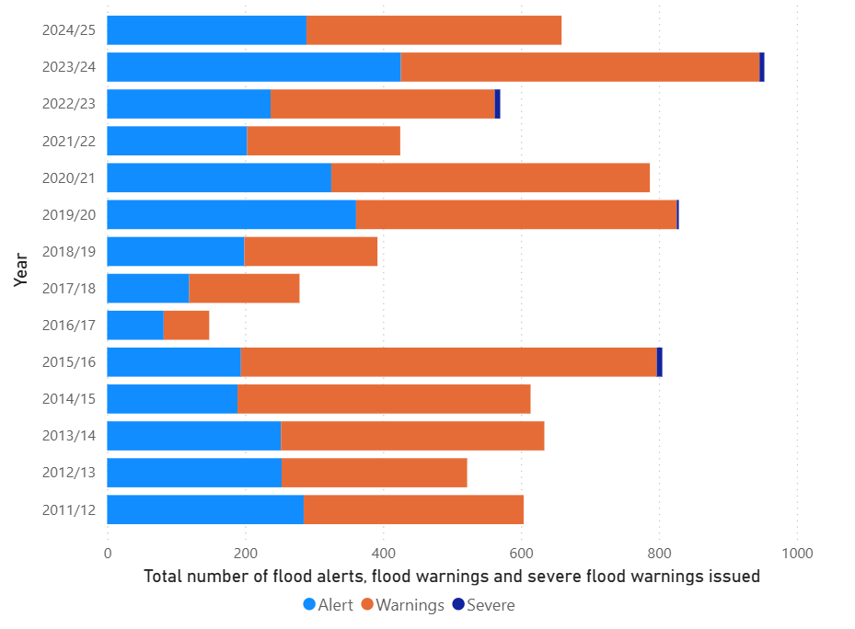
During 2024/25, a total of 289 regional flood alerts, 370 local flood warnings and three severe flood warnings were issued. This is above the average activity over the last 14 years (244 alerts, 342 warnings, two severe flood warnings). There were periods of disruption throughout the year due to the weather, such as coastal flooding during Storm Kathleen in April 2024, and the severe flooding in northern and central Scotland during the preparations for Hogmanay, which affected the Spey valley, the Great Glen and the River Tay and River Forth catchments.
However, during quarter four of 2024/25, a total of 30 flood alerts and 60 flood warnings were issued. This was the lowest number for the period January-March since 2012/13. It reflects that the period has been dry for most of Scotland as highlighted in the April 2025 water scarcity report (Current water situation update | Beta | SEPA | Scottish Environment Protection Agency). Together, above average flooding coupled with periods of water scarcity is a further indication of the impacts of a changing climate on Scotland’s environment.
During 2024/25, we issued all daily flood guidance statements on time, exceeding both targets.
KPI 02 | Baseline | Target | Q4 Performance | 2024/25 result
Percentage of daily Flood Guidance Statements and Scottish Flood Forecasts issued on time ​ | 2023/24  84% by 10:30  98% by 11:00 | Maintain at 2024 baseline or above. | 95% by 10:30  100% by 11:00 | Achieved  88% by 10:30  100% by 11:00

Developments approved in accordance with our advice on flood risk
We also deliver flood risk advice, evidence and guidance for the land use planning system, to ensure new developments can avoid flood risk and help existing communities and services become more resilient to flooding. We take a proportionate, risk-based approach to focus our site-specific advice to the highest risk places and work with partner authorities to support the implementation of National Planning Framework 4.
Consultations on flood risk advice | Quarter 1 | Quarter 2 | Quarter 3 | Quarter 4 | 2024/25 result
Number of consultations for flood risk advice from planning authorities responded to | 378 | 419 | 323 | 358 | 1478
Number of consultations that were new applications previously not advised on | 256 | 264 | 198 | 237 | 946
Number of applications approved to go ahead in flood risk areas against SEPA’s advice during the same time period notified to Scottish Ministers | 2 | 5 | 3 | 5 | 15

We responded to 1478 consultations on 946 separate planning applications, when adjusting for cases spanning reporting periods and multiple applications at the same location. 98.4% were resolved in line with SEPA’s advice on flooding, which is a high rate of success but a slight reduction from 2023/24 of approximately 99%. As a result, 15 developments were approved against SEPA’s advice, following notification to Scottish Ministers, an increase from 11 developments in 2023/24. Some of this variation is likely attributable to the policy shift that came with the introduction of NPF4 in February 2023 bedding into the planning system.
During 2024/25, we increased our responses to planning consultations within time​ to 86% from the 2023/24 baseline of 70%.
KPI 03 | Baseline | Target | Q4 performance | 2024/25 result
Percentage of responses to planning consultations within time​ | 70% within time cumulatively 2023-24. | Increase the percentage of consultations responded to within time. | 94% of consultations responded to within time. | Achieved.  The cumulative figure for the year is 86% of consultations responded to within time.

Water Environment

Our ambition is for the water environment to be protected with no deterioration of condition and that more of our water environment is improved to a good or better condition.

Scotland is well known for the quality of its water environment – our beautiful rivers, lochs, wetlands and seas. Our water environment supports a rich diversity of wildlife and habitats. It plays an important part in our economy and brings with it physical activities and social interaction which can have a great impact on local communities, and health and wellbeing. Classification is the approach (based on EU and UK guidance) used to define the state of Scotland’s water environment and is produced annually for all 3,652 water bodies in Scotland.

Classification of water bodies across Scotland
We completed the 2023 classification of the water environment and published the 2023 State of the Environment Report on 22 November 2024. Since the start of water environment classification for River Basin Management Planning in 2008, the overall condition of Scotland’s water bodies has improved each year.
In 2020, the proportion of our water environment (surface waters and groundwaters combined) assessed as being in good or high overall condition was 66.4%, in 2022 this increased to 67.1%, and in 2023 it increased again to 67.9%. Specifically, in 2023 the overall condition of 43 water bodies were upgraded to good or high. Only 16 water bodies were downgraded to less than good condition. This means that 3,593 out of 3,652 water bodies, or 98.4%, have not deteriorated.
The percentage of surface water bodies that were classed as good or better in 2008 was 61% and is now 65.6%, demonstrating an improvement of 4.6% since 2008. The number of surface water bodies classed as bad overall condition has decreased from 224 in 2008 to 57 in 2023, an improvement of 74.6% that indicates an upward trend in overall condition.

The graph below shows the long-term trend in the overall condition of surface water bodies.
Figure 5: Long-term trend in the overall condition of surface water bodies
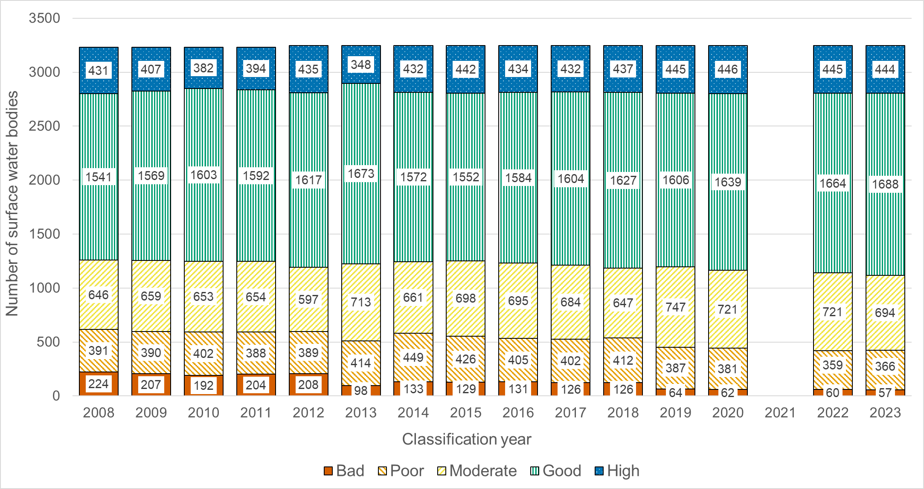
The percentage of groundwater bodies that were classed as good in 2008 was 77.3% and is now 85.9%, demonstrating an improvement of 8.6% since 2008. The graph below shows the long-term trend in the overall condition of groundwater bodies.
Figure 6: Long term trend in the overall condition of groundwater bodies
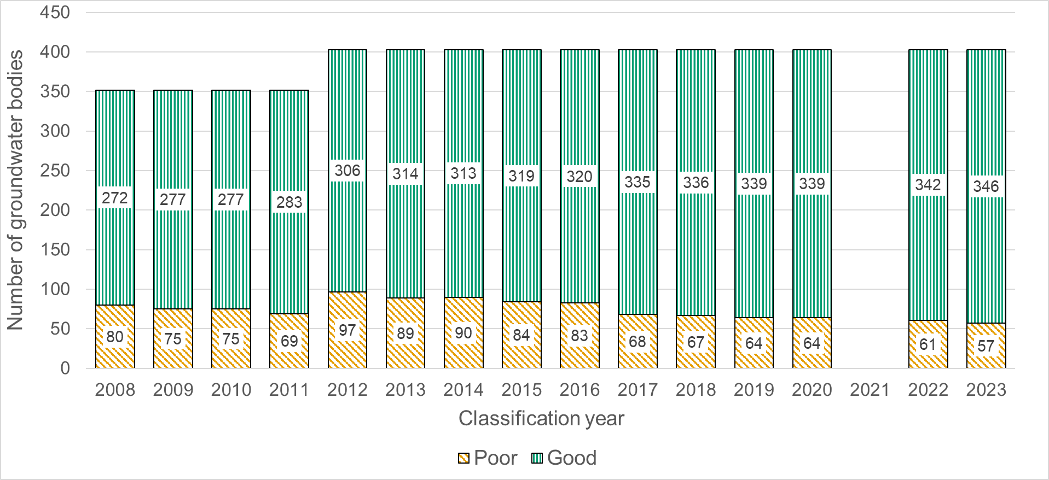
Please note that data is not available for 2021 in both graphs due to the COVID pandemic.
While we are not wholly responsible for delivering this measure, as the regulator and responsible authority for River Basin Management Planning, we are tasked with protecting and improving the water environment. We do this by protecting the water environment from deterioration through permitting, compliance activities, incident response, and our advisory role in relation to new developments. We also aim to secure improvement through our regulatory work with key sectors and through our deployment of the Water Environment Fund.
The consistent improvement in water environment quality is a testament to the work of people across the Agency and our partners throughout Scotland who are committed to safeguarding and enhancing our precious water environment.

Resource Efficiency

Our ambition is to fully play our part in helping Scotland to transition to a circular economy, and that the management of waste does not cause harm to the environment or communities.

Scotland’s, and indeed the world’s, material resources are under significant stress and in many cases, we are using more than we can replenish. Scotland has set out an ambitious plan that will help us maximise progress towards a circular economy. We have a critical role in regulating those that produce and manage waste, to protect the people of Scotland and their communities. We also work with operators to create less waste and improve resource efficiency through innovation.

Rates of waste to landfill
In 2024/25, we played a contributing role to the national outcome for Scotland to reduce the rates of household waste going to landfill. We are responsible for the collation and publication of the required data, all of which was provided and verified on time, enabling publication of the Waste Landfilled in Scotland 2023 statistics in October 2024. We worked in partnership with Scottish Government to publish these official statistics in a new fully accessible and interactive format.
We are seeing a positive reduction in the rates of waste to landfill reported annually. The statistics show a 14.8% reduction of household waste landfilled in Scotland from the previous year. The total amount of household waste was the lowest amount generated since the start of the current time series in 2011. The amount of Scottish household waste landfilled decreased by 30.2% from 2022 as can be seen in the graph below.
Figure 7: Waste Landfilled in Scotland by Category 2005-2023
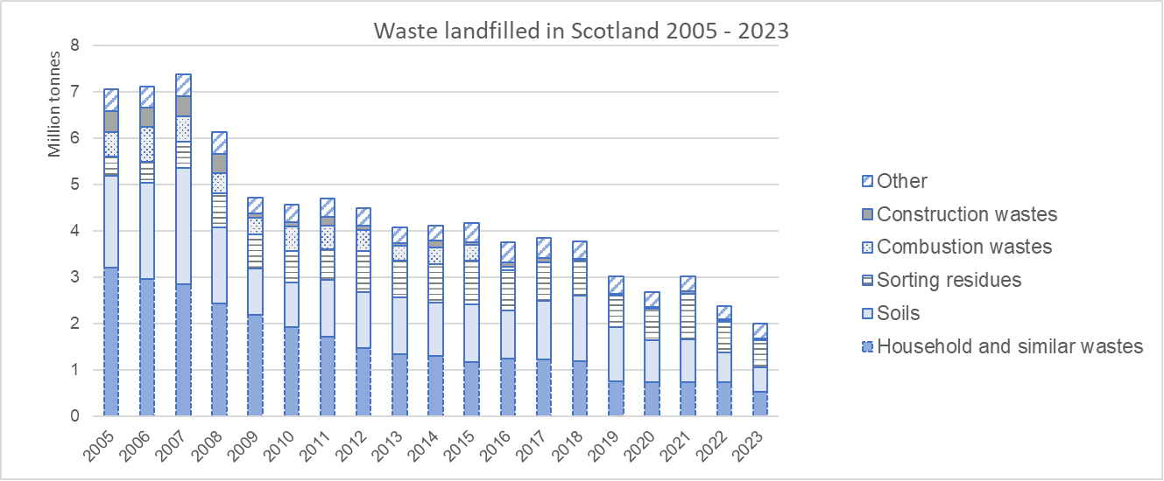
Along with publishing the statistics, we work to deliver actions to digitally disrupt illegal waste collection and highlight landowner roles and responsibilities. Disruption efforts are focused on both overt challenge of operators and follow-up formal enforcement when there is sufficiency of evidence. Below we have captured a breakdown of our actions taken this year. Please note this is the first full year of data.
Action | 2024/25 result
Information Notices Issued | 13
Profiles closed | 28
Texts to unlicensed operators | 59
Public Facebook posts | 84
Waste Carrier Applications Received | 9
Fixed Monetary Penalties Issued | 7

Over 2024/25 we have been preparing for the implementation of UK Extended Producer Responsibility (EPR) reforms by auditing producer data supplied during 2024. We also assisted producers in the lead up to the implementation of new legislation which came into force on 1 January 2025.
We continue to support the DEFRA led programme for a UK wide Digital Waste Tracking (DWT) system. The programme has gone through a review and reset with the intention to launch the system in April 2026 with it becoming mandatory for some users in October 2026. This is evidenced in the following stakeholder letter: Digital Waste Tracking: Stakeholder Letter | Campaign Monitor. Options for UK DWT system implementation in 2025/26 are still under consideration by DEFRA and the devolved administrations.

Business Environmental Performance

Our ambition is to protect the environment and communities from harm; for Scotland to be an inhospitable place for environmental crime and regulation enables businesses to reduce their environmental impact.

It is our role, as Scotland’s principal environmental regulator, to regulate activities which can harm the environment such as the storage, transport, treatment and disposal of waste or the management of radioactive substances. Businesses that have a high environmental performance reduce pollution and the impact they have on communities.

Successful interventions
Some operators carry out activities illegally and our target for 2024/25 was to reduce the number of known (“baseline”) illegal sites, by increasing the number of successful interventions that tackle environmental crime.
Illegal Sites and illegal operators are those which are operating without the required environmental authorisation or in contravention of environmental legislation. When interventions addressing illegality have sufficiently reduced an illegal site’s risk score, the site is considered to be successfully “concluded”.
An intervention can be any action that we take, or in collaboration with partners, to tackle and disrupt illegal activity or non-compliance. For example multi agency ‘road stop’ exercises, removal of social media profiles used for advertising or awareness raising with local communities. Enforcement actions are more specific and include final warning letters, information notices issued for enforcement/interventions purposes, statutory notices, Fixed Monetary Penalties, Variable Monetary Penalties and enforcement undertakings. Previously we only reported enforcement actions: interventions are not restricted to these.
We consider our interventions to be successful when the number of interventions increase, and the number of illegal sites decrease. The graph below shows that we deployed a total of 167 interventions during 2024/25, including 29 interventions in quarter four. This represents a greater than 95% increase on the 87 recorded interventions used to tackle environmental crime in 2023/24.
Figure 8: Number of interventions used to tackle environmental crime in 2024/25
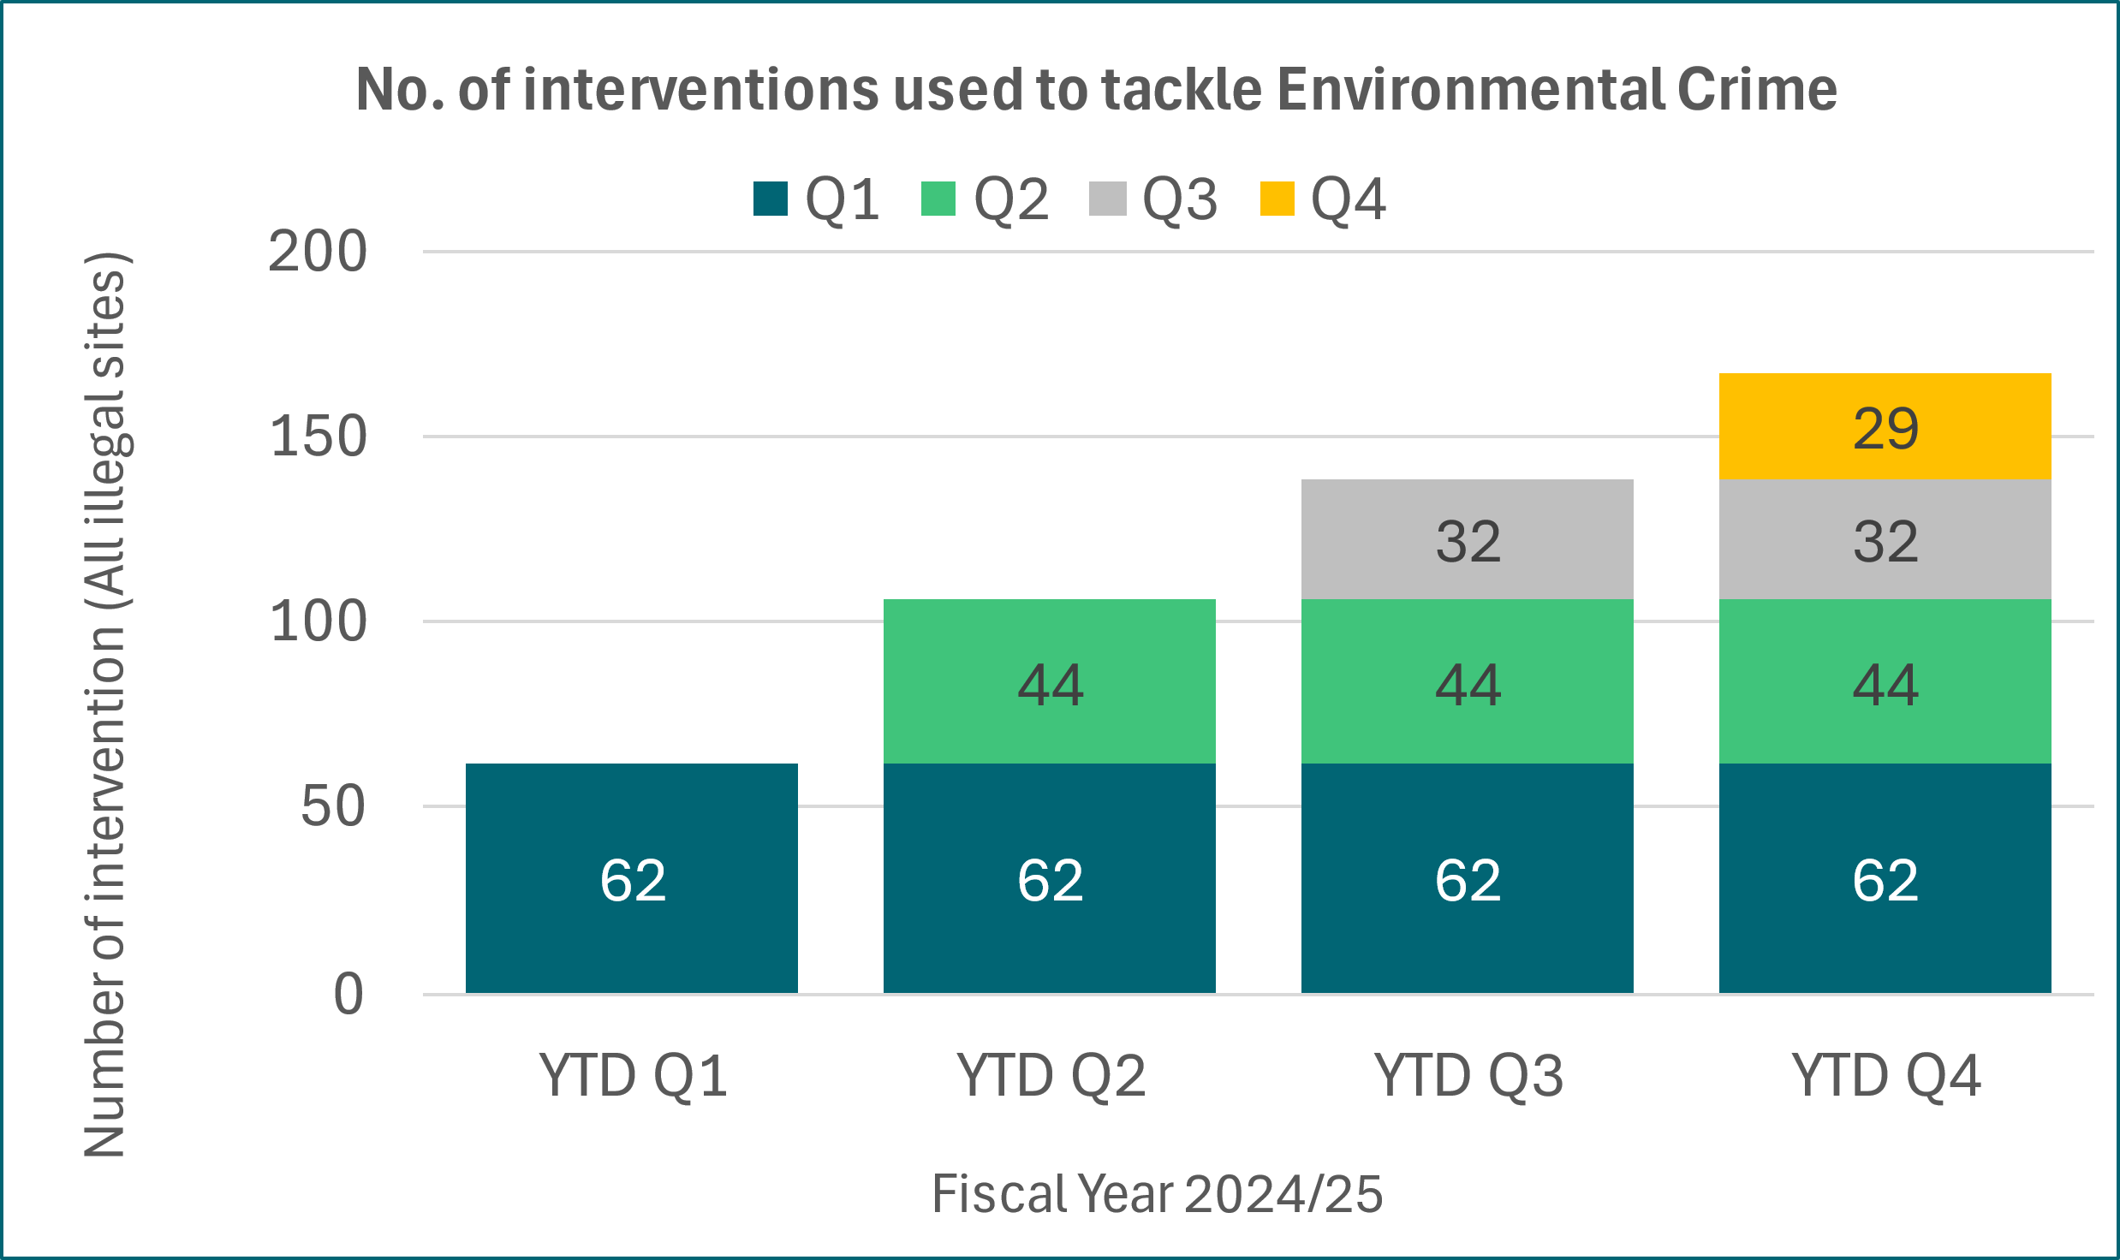
Figure 8 below demonstrates the breadth of actions undertaken during 2024/25 by illustrating a sample of the types of interventions used.
Figure 9: The breadth of actions undertaken during 2024/25
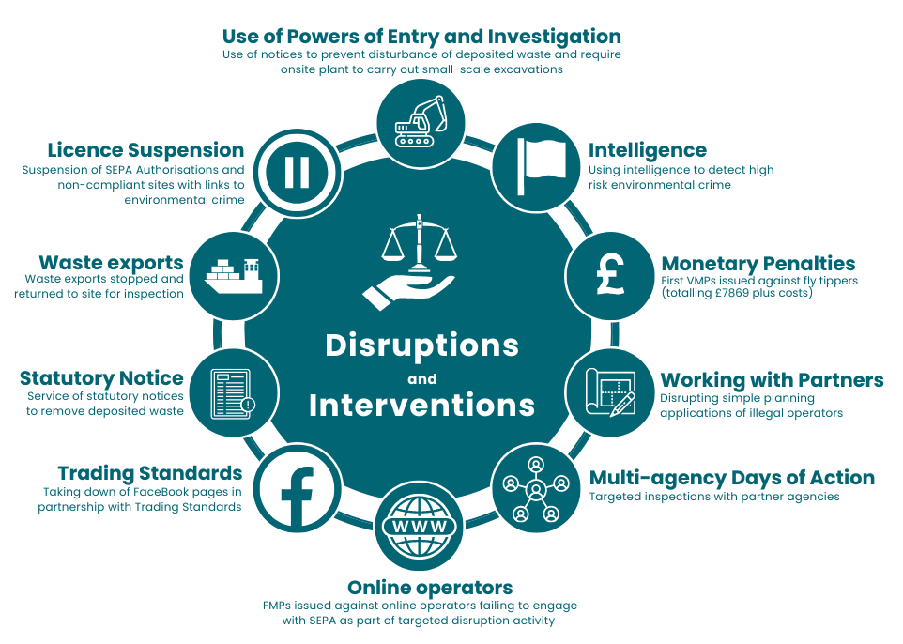
Figure 10: Number of illegal sites and number of enforcement actions taken during 2024/25
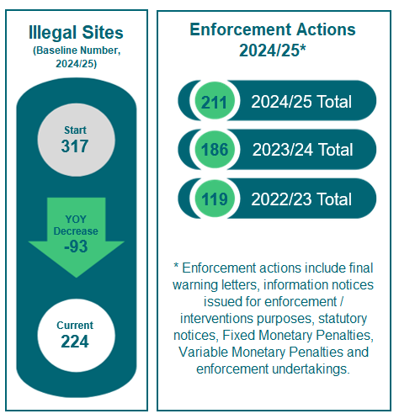
At the start of 2024/25, we had a baseline of 317 known illegal sites. During 2024/25, the interventions undertaken delivered an overall reduction of 93 baseline illegal sites, meaning 224 from our baseline remain open.
During 2024/25, through improved detection we identified an additional 116 new illegal sites. We closed 11 of those meaning 105 newly found sites remain open. We will start 2025/26 with a baseline of 329 illegal sites.
Over the last three years, we have implemented an interventions approach that has delivered year-on-year increases in both our detection of environmental crime and the successful conclusion of illegal sites.
During 2024/25, three of the 93 baseline illegal sites we closed were assessed as posing a high risk to the environment. One of these sites was in Aberdeenshire where a local man was given a 150-hour community payback order, a £3,000 Confiscation Order and an 18-month supervision requirement. The illegal activities at this site included keeping controlled waste without the required authorisation, disposing of controlled waste by burning and failing to remove waste from the site. Many local residents living in the vicinity of the site complained over a two-year period regarding the deposit and burning of waste and the impact it was having on the local community.
The KPI’s below support the Business environmental performance theme:
We also have a legal obligation across various sectors to complete permit reviews. We must complete these within the legally required or internally set deadlines.
KPI 04 | Baseline | Target | Q4 Performance | 2024/25 result
Percentage of statutory permit reviews completed on time. | 85% of statutory permit reviews completed on time in the previous year. | 80% of statutory permit reviews completed within the required timeframe. | Same as 2024/25 result. | Not achieved.  31% within the required timescale.
Unfortunately, we did not manage to achieve our target of completing 80% of statutory permit reviews within the required timeframe. Progress with completing the 2024/25 reviews was restricted as the focus was completing the backlog of statutory permit reviews and medium combustion plant permit variations. Given this, we focussed our attention to those that could potentially cause the most environmental harm and those that cover the implementation of other new legislation (i.e. delivery of 165 new and varied permits under Phase 1 and 2 of the Medium Combustion Plant Directive). We also focussed on maintaining delivery of day-to-day authorisation work such as new applications (noted in KPI06) and variations, and to complete the best available techniques conclusions (BATc) reviews.
Going forward into 2025/26, although no statutory permit reviews are due during this period, we are setting the KPI to drive performance to reduce the backlog and have a programme of actions in place to help. These actions include a dedicated Permit Reviews Team focusing on the Food, Drink and Milk permit reviews, ensuring the 28 outstanding medium combustion plant permit applications and variations will be finalised and issued, and the recruitment of further resource. Following the implementation of the new Integrated Authorisation Framework (IAF), further resource will be allocated to permit review work. This is not likely until after April 2026.
KPI 05 | Baseline | Target | Q4 Performance | 2024/25 result
Percentage of statutory reports published by the scheduled date​ ​ | On-time publication rate from the previous year. | 100% | This target was met in quarter three. | Achieved.  Four out of four statutory reports published during 2024/25 on time by the scheduled date.

KPI 06 | Baseline | Target | Q4 Performance | 2024/25 result
Percentage of applications determined within statutory determination times | 92% for all applications  75% for permitting (licences)  97% for permitting (registrations) | Increase the percentage of applications determined within statutory timelines. | Same as 2024/25 result. | Achieved.  94% for permitting (all applications).  84% for permitting (licences)  98% for permitting (registrations).

Our Organisation and Transformation

Our ambition is to focus on our people as we ensure SEPA is an efficient, effective and sustainable organisation.

Our people are our greatest asset and we work together to deliver on our commitments to the people of Scotland. We continue to invest in and develop our people so they can be their best and make the biggest impact. We use this expertise to provide information and services to people and communities with a strong focus on continuous improvement to deliver better services.
We understand the importance of working closely with other organisations, communities and businesses to design the services they use.
We have led and engaged with a range of initiatives to further the objectives of public sector reform. We have reset our Agency to transform areas and embed a customer and delivery focus in everything we do.

Customer complaints
We know how important our customers are and place great value on handling and responding to customer complaints in a timely manner. In 2024/25, we responded to 89.5% of customer complaints within statutory timescales against a target of 85%. We responded to 92% of Stage 1 complaints and to 87% of Stage 2 complaints within the target timescales. During 2024/25 we also set a KPI alongside this measure to help improve performance up to 90%.
Figure 11: Customer complaints responded to in 2024/25 within timescales
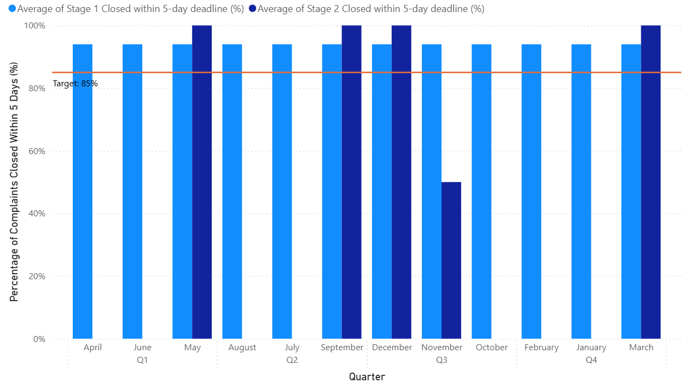

Electric vehicles
We have achieved our aim by increasing the number of electric vehicles in our fleet to 25, against a baseline of 22. We did this by replacing older diesel vehicles. We also enhanced electric charging facilities over our estate by installing two replacement charging units at the Angus Smith building to increase reliability.

Freedom of Information and Environmental Information Requests
In 2024/25, we processed 94.8% of Freedom of Information (FOI) requests and Environmental Information Requests (EIR) requests within the statutory timescales of 20 working days, achieving our aim of processing at least 90%. Our responses complete on or under time is significantly above the 2023-24 baseline of 82%, shown as the green line in the graph below.
Figure 12: Percentage of responses sent on or under time limit during 2024/25
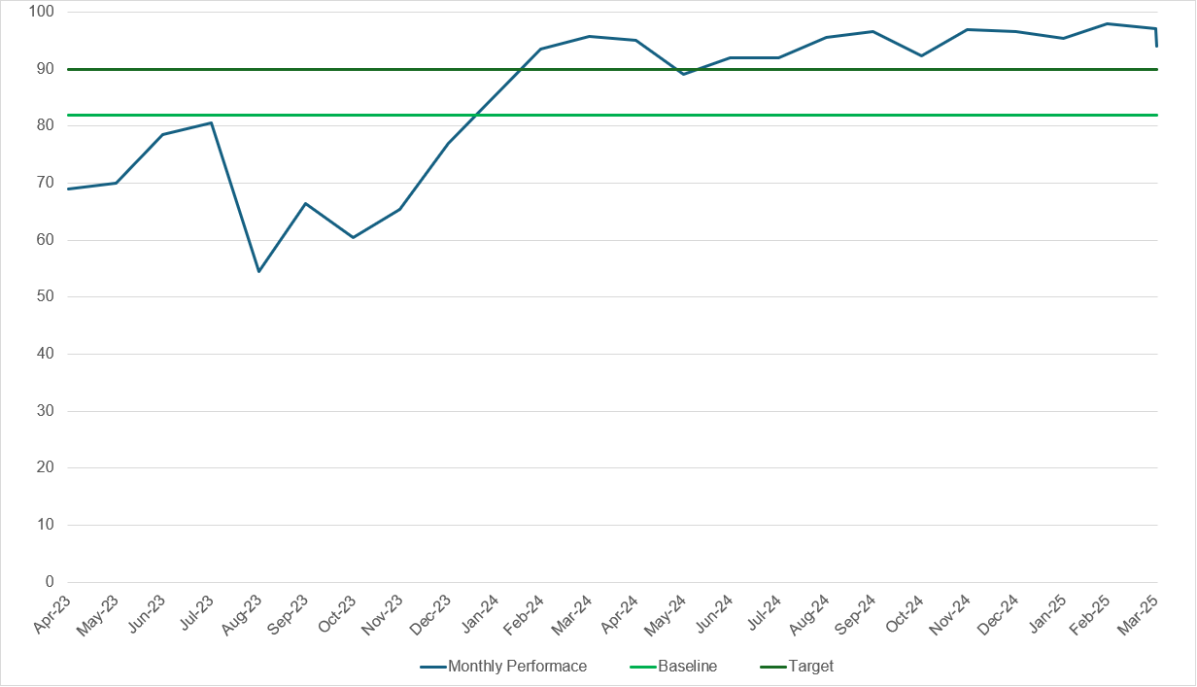
We continue to receive a high number of EIRs, with 1,887 received in 2024/25 compared to 1,623 in 2023/24, an increase of 16%. The number of FOI requests received has remained relatively stable, with 52 received in 2024/25 compared to 54 in 2023/24, a slight decrease of 4%. Requests primarily concerned the water environment, in particular areas such as flooding, combined sewer overflows, water resources, and sewage discharges, as well as for regulatory information, such as permits and enforcement notices.

Figure 13: Number of environmental information and freedom of information requests received 2024/25
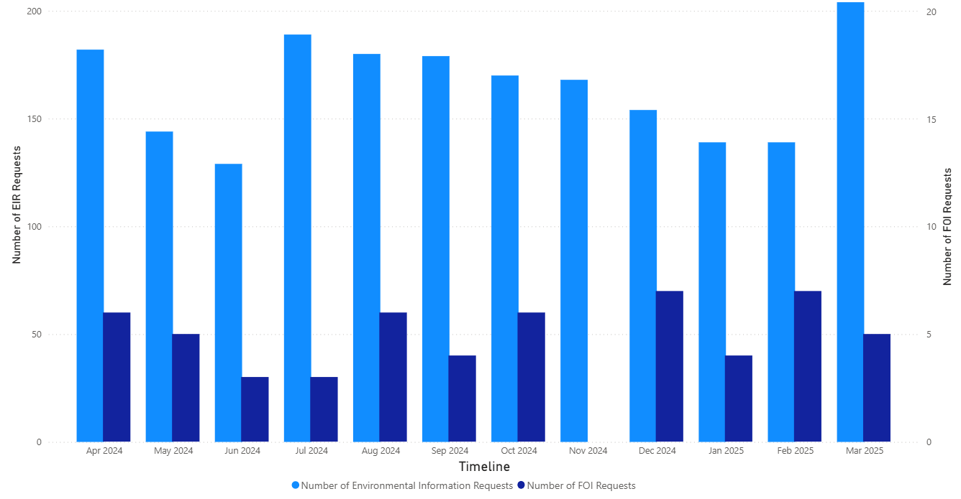
We consolidated the capacity in the Access to Information Team which has enabled work to improve the efficiency and sustainability of the service while continuing to maintain a high level of performance. This was recognised in November 2024, when the Scottish Information Commissioner closed the level two intervention on SEPA. In March 2025, the team won two national awards at the eCase FOI Awards recognising the consistently excellent performance as well as the commitment and dedicated of the team.

Efficiency savings
In the 2022 Resource Spending Review, the Scottish Government set an expectation that public bodies would deliver annual recurring efficiency savings of at least 3% of their cash revenue grant in aid. In 2024/25, this equated to £1.2m of our revenue budget. In 2024/25, we realised 5.6% efficiency savings, against a 3% target, achieving this measure.
To achieve a balanced budget in 2024/25, we set a vacancy management savings target of £3.5m, which is £2.3m higher than the target required by Scottish Government. Vacancy savings by the year end are expected to be in the region of £4.6m.

Invoices
We are working to the Scottish Government target to pay all valid invoices within 10 working days. During 2024/25 we paid 92% of all valid supplier invoices within 10 working days, against a target of 90%, achieving this measure.

3. Suite of Organisational KPIs Summary
KPI No | KPI | Baseline | Target | Q4 Performance | 2024/25 performance | Status
KPI 12 | Employee Voluntary Turnover Rate | 2024 baseline established as 6.05% for voluntary leavers in 2023-24. This excludes deceased, dismissed, end of fixed term contract and voluntary severance.  2024 baseline for all leavers established as 7.89%. | Less than 6.05% for voluntary leavers. | 0.32% employee voluntary turnover rate. | The cumulative total average is 1.06%. | Achieved
KPI 13 | Number of "Near Miss/Hazard spotted" Reports Submitted​ | 2024 baseline established:  16 Hazard spotted  14 Near miss reports. | Increase the number of hazards spotted and near misses reported to H&S on the 2024 baseline. | 10 Hazard spotted  21 Near miss reports. | 68 Hazard spotted  62 Near miss reports. | Achieved
KPI 14 | Number of reportable health and safety incidents (Number of RIDDOR)​ | 2024 baseline established as 0. | Maintain, or achieve a reduction in, the number of reportable incidents each year, aiming for a zero-incident target. ​ | 0 reportable H&S incidents (RIDDOR). | 0 reportable H&S incidents (RIDDOR). | Achieved
KPI 15 | Net Promoter Score (NPS) from external stakeholders – Member of Scottish Parliament sentiment towards SEPA ​ | Favourability sentiment score baseline of 69% established in 2023.  Awareness sentiment score baseline of 82% established in 2023. | Favourability sentiment score is greater than 69%.  Awareness sentiment score is greater than 82% | Not applicable - This is an annual measure so progression cannot be monitored on a quarterly basis. | Favourability sentiment score is 52%  Awareness sentiment score is 82%  Comparability and analysis on the sample is limited and so there is no clear driver for the change. SEPA will be developing a new broader approach to reputation and sentiment analysis to support our understanding and response. | Partially achieved
KPI 16 | Customer satisfaction / experience score | Baseline to be established. | This will be determined once the baseline is established. Will start in quarter two 2025. | Will report in quarter three 2025. | Not applicable | Not reported as yet
KPI 17 | Employee engagement score ​ | Baseline to be established. | Maintain at baseline or above | Will report in Q2 2025 | Not applicable | Not reported as yet
KPI 18 | Absenteeism Rate​ | Overall organisational lost working time due to sickness absence in 2023-2024 was 3.09%. | Maintain at 2024 baseline or below | 3.13% | The cumulative total average is 2.96%. | Achieved
KPI 19 | Absenteeism Rate due to workplace stress​ | Overall organisational lost working time due to stress and mental health reasons in 2023-2024 was 0.9%. | Maintain at 2024 baseline or below | 1.23%. | The cumulative total average is 0.86%. | Achieved
KPI 20 | Gender Balance in Leadership Positions​ | 50.6% of employees being paid at Band A, B and CLT levels were female, as at 31/3/2024. | 50% or above. | 47.25%. | The cumulative total average is 47.80%.  There will be ongoing fluctuations of this indicator over time due to natural turnover in positions across band B+ roles. We will continue to keep this under review as recruitment opportunities at these levels arise. | Not achieved
KPI 21 | Debt Recovery Rate​ | For 2023-2024, the debt recovery rate for debtors paid within 90 days was 95%. | Achieve a debt recovery rate of 80% or higher for all receivables within 90 days of the due date.​ | 86.8%. | The cumulative total is 88.5%. | Achieved
KPI 22 | Percentage of up-to-date Business Continuity Plans​ (BCPs) | For 2023-2024, 32% of Business Continuity Plans were current and compliant with SEPA’s review schedule. | Achieve and maintain 100% of business continuity plans being reviewed and updated within the scheduled timeframe each year.​ | See 2024/25 performance. | 96%  24 out of 25 Business Continuity Plans are up to date. The remaining plan is in progress and due to be completed early in 2025/26.  Note: This does not include one additional Business Continuity Plan added in quarter four due to a new function being agreed. If removed, this would increase to 96%. | Partially achieved
KPI 23 | Number of security breaches ​  Note: A security breach is defined as an activity that compromises our security, including any case where protected data is confirmed to have been accessed by individuals motivated to abuse the information. | 2024 baseline established as 65 (of which 33 were personal data breaches) using the number of security breaches reported in the previous year  Quarter one = 13  Quarter two = 16  Quarter three = 11  Quarter four = 25 | Short term, to increase awareness and need for staff to report security breaches.  Longer term, to achieve a year-over-year reduction in the number and significance of security breaches. | 37 (17 personal data breaches) | 108 security breaches reported (56 were personal data breaches), a 66% increase from baseline.  Awareness raising during the year, targeted at Information Asset owners reiterated the importance of reporting incidents which is reflected in the increased incident reporting. A key focus has been to provide advice and guidance to staff involved in individual incidents, which will be reinforced in forthcoming staff training in 2025-26 | Achieved
KPI 24 | Number of reportable security breaches to Information Commissioner​ | Zero | Zero | No personal data breaches reported to the Security Incident Response Group (SIRG) in quarter four met the criteria to be reported to the Information Commissioner. | Zero | Achieved
KPI 25 | Time to recruit from offer to start date | 2024 baseline established as 61 days. This indicator measures the time taken from when a job offer is made to when the candidate starts. | 40 days. | See 2024/25 performance. | 56 days.  We are reducing the time taken from offer to start date compared to the 2024 baseline however we did not achieve the target of 40 days.  We recognise it will be difficult to significantly improve performance until our new recruitment systems are in place and electronic pre-employment screening system is live. This has been delayed due to a potential data impact risk identified. | Partially achieved
KPI 26 | Average cost per hire​ | 2024 baseline established as £2,000 per role. | Reduce by 10% to £1,800 | The average cost per hire for quarter four was £965. | The average cost per hire over quarter two-quarter four 2024/25 was £1,342 against a target of £1,800. Please note this does not include quarter one data as we began capturing information in quarter two. | Achieved
KPI 27 | Percentage of mandatory training completed​ | 2024 baseline established as 80%. | 90% | See 2024/25 performance | 98.1% | Achieved
KPI 28 | Number of Employee Development Activities Completed | 2024 baseline established as 265 employee development activities:  124 facilitated workshops run.  Six Learning Plans created.  135 E-Learning Courses Available | Increase the number of (relevant) workshops, learning plans and e-learning courses to meet employee needs | 33 workshops delivered.  One learning plan published with three in progress.  69 e-learning courses available. | We delivered 368 employee development activities:  151 facilitated workshops run.  Six Learning Plans created.  211 E-Learning Courses Available. | Achieved
KPI 29 | Number of SEPA solely owned or leased buildings​ | A baseline of 11 buildings has been established. | A reduction of up to two workspaces per annum. | One workspace reduced - Arbroath | Two SEPA leased workspaces now successfully exited (Stornoway and Arbroath) | Achieved

These are national outcomes for Scotland and SEPA plays a contributing role.
The trajectory of this target has been changed to maintaining. It was previously set to increasing against a performance of 99% in 2023/24 in error.
These are national outcomes for Scotland and SEPA plays a contributing role.
These are national outcomes for Scotland and SEPA plays a contributing role.
This report is being prepared early and some of the data for 2024-25 are still not available.
We have revised our previously reported figures for quarter one to quarter three due to the way we manually track cases. We have moved to a new electronic system going forward into 2025/26.
Information reported was extracted from SEPA systems on 03/04/2025. Systems may be updated after this date and each quarter.

