


Annual Procurement Report
December 2024
2023-2024

Contents

1. Introduction 5
2. Summary of procurement activity during the period 6
3. General duties under Procurement Reform (Scotland) Act 2014 10
4. Contract Register 12
5. Achievements against SEPA Procurement Strategy 13
6. Future regulated procurement activity 2023-2025 27
7. Benefits 29
Annex 1 - Regulated procurements completed in financial year 2023-2024 31
Annex 2 - Summary of business area procurements to be conducted in the next two financial years 37

Introduction
The SEPA Annual Procurement Report meets the statutory duty of the Procurement Reform (Scotland) Act 2014 by detailing SEPA’s performance and progress during Financial Year (FY) 2023-2024 in alignment with the SEPA Procurement Operating Plan 2021–2024 (our Corporate Procurement Strategy).
Our Procurement activity supports SEPA’s contribution to the Scottish Government’s National Performance Framework Outcomes and the United Nations Sustainable Development Goals, set out within Scotland’s National Performance Framework and our procurement activity is embedded in the delivery of all our corporate outcomes.
The financial analysis has been conducted on data extracted from SEPA’s finance and procurement system, Agresso. Table 1 summarises SEPA’s key procurement statistics for the FY’s 2022-2023 and 2023-2024.
Note: all figures in the report are exclusive of VAT.

Table 1 – Key procurement management information
Scottish procurement information Hub Dashboard (DXC Technology) | FY 2022-2023 | FY 2023-2024
Total number of contracts placed | 151 | 147
Total value of transactions reported | £19,707,137 | £20,943,102
Number of transactions (purchase orders) | 6,132 | 6,537
Expenditure with Small and Medium-sized Enterprises | 39.72% | 40.22%
Active supplier accounts in this period | 664 | 717

Summary of procurement activity during the period

Analysis results
The overall procurement activity remains high with 147 contracts let in FY 2023-2024. However, there continues to be a rise in the number of higher value procurements in both terms of volume and value. These have risen by 21% and 22% respectively since the previous FY 2022-2023 report.
These are ‘regulated’ procurements with a value greater or equal to £50k that require the necessary levels of scrutiny and robustness to ensure compliance with the Procurement Regulations as detailed in the next section 2.2. Details are provided in the following tables:
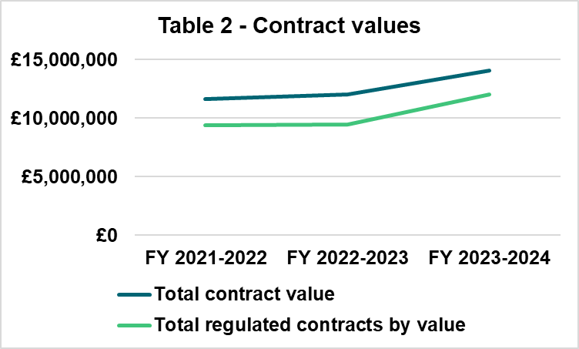

The procurement function continues to be extremely busy with demand increasing year on year and we capture our successes herein. We also show progress against our Corporate Procurement Strategy and identify opportunities for improvement where appropriate.

Legal and procedural framework
SEPA undertakes all regulated procurement within the legal and procedural frameworks, as shown below, and have ensured that our Procurement Strategy supports delivery in alignment with these frameworks.
- Procurement Legislation both domestic and international.
- The Scottish Government’s Procurement Journey (providing guidance on best practice).
- The Scottish Model of Procurement.
- The Scottish Government’s Sponsorship team instructions to SEPA.
- Scottish Procurement Policy Notes (SPPNs).
- SEPA Delegated Levels of Authority Policy.
- Regulated procurement activity.

In line with Procurement Legislation, this Annual Procurement Report must include:
“(a) A summary of the regulated procurements that have been completed during the year covered by the report”

As previously reported above at 2.1, the total regulated procurement commitment was £12,045,655. A listing of regulated contracts awarded is included in Annex 1.
“(b) A review of whether those procurements complied with the authority’s procurement strategy”

There were no regulated procurements i.e. greater than £50,000 which did not comply with the Procurement Strategy. A further analysis of our performance against our Strategy is shown in Section 3.
“(c) A summary of any community benefit requirements imposed as part of a regulated procurement that were fulfilled during the year covered by the report”

Procurement is required to consider whether to impose Community Benefit Requirements as part of any procurement which has an estimated value of the contract equal to or greater than £4,000,000 over the term of the contract. As part of our recent tender for Total Facilities Management, we included community benefit requirements in accordance with the Procurement Reform (Scotland) Act 2014. These requirements focused on training and recruitment, availability of sub-contracting opportunities, and initiatives aimed at improving the economic, social, or environmental wellbeing of Scotland.

While the community benefits will not be delivered in the FY 2023-2024, they were considered within the procurement undertaken during this period. Bidders were asked to provide details of the community benefits they would deliver as part of the contract, including a timetable for delivery and reporting mechanisms. Part of the award will be to contractualise and report outputs as part of contract and supplier management responsibilities.
“(d) A summary of any steps taken to facilitate the involvement of supported businesses in regulated procurements during the year covered by the report”

In February 2024, we invited a representative from the Scottish Government to provide an update on the Supported Business Dynamic Purchasing System (DPS) and sub-contract opportunities. This initiative was part of our efforts to facilitate the involvement of supported businesses in our regulated procurements. The meeting highlighted the benefits and processes of the Supported Business DPS, and our team discussed integrating these opportunities into our procurement strategies to promote inclusivity and social value. In addition, key prime contractors will also be encouraged to identify opportunities through their respective supply chains.
“(e) A summary of the regulated procurements the authority expects to commence in the next two financial years”

Annex 2 provides a summary of business area procurements to be conducted in next two financial years.

General duties under Procurement Reform (Scotland) Act 2014

Sustainable Procurement duty
The Sustainable Procurement Duty requires consideration of economic wellbeing, community and environment. What is commonly known as the triple bottom line. Where proportionate and pragmatic the Scottish Government’s Sustainability Test is applied.

SEPA has a target to reduce its emissions to net zero while at the same time taking actions that repair the environment. Our Net Zero Routemap sets our ambition to reduce greenhouse gas emissions and outlines the steps that we will take over the 2022-2024 time period to get there. Our future sourcing strategies and tenders will extend to include specific emissions targets to help us further embed sustainability measures wherever we are able to specify these.

Progress has been made as evidenced in our recent tender for Total Facilities Management, which included requirements for carbon net zero initiatives and asked suppliers to detail measures to reduce environmental impacts across GHG Emissions, Materials, Water, and Waste. Part of the award will be to contractualise and report outputs as part of contract and supplier management responsibilities.

Further progress is reflected in the case studies at section 5.

Small and Medium-sized Enterprises (SME)
As part of the Scottish public sector, SEPA acknowledges it has a role in contributing to Scotland’s economic success. While we do seek to leverage existing available framework agreements in our strategies (e.g. internal or external frameworks), to further encourage SME suppliers, we advertise through Public Contracts Scotland using either the Quick Quotes functionality, or formal tendering formats.

SME expenditure for FY 2023-2024 was 40.22% compared with 39.72% in FY 2022-2023 representing an increase of 1.3% of overall expenditure.

Dynamic IT frameworks such as the Scottish Government’s Dynamic Purchasing System and the Crown Commercial Services G Cloud 13 allow for greater accessibility to the IT SME community.
The Procurement Team also consider opportunities for lotting requirements to allow access to the SME community as part of our procurement strategies. In addition, the Procurement Team has used the following opportunities to engage with potential suppliers:
- Supplier Development Programme (SDP) Membership - SEPA continues to actively engage with the SDP to enhance our procurement processes and support supplier growth.
- SEPA (when applicable and proportionate) uses soft market tests and wider market engagement to notify the suppliers of upcoming opportunities and help shape our procurement approaches. This proactive approach ensures that we are well-informed about market capabilities and trends. Some examples include the Scottish Borders Flood Forecasting Project and the Total Facilities Management procurements.

Supplier payments
SEPA complies with the Scottish Government’s prompt payment policy and Scottish Government’s Public Finance Manual in that all suppliers’ invoices not in dispute are paid within the terms of the relevant contract, normally 30 days from receipt, however we strive to achieve payments within 10 days. Our performance has been consistent over the past two financial years as outlined below:

Table 4: Supplier payments
FY | Within 10 days | Within 30 days
2022-2023 | 93% | 97%
2023-2024 | 92.5% | 98.6%

Contract Register
The Public Reform (Scotland) Act 2014 requires a register of current contracts to be published on the Internet. SEPA’s contract register is accessible on our website.

Achievements against SEPA Procurement Strategy
Our Procurement Strategy is part of an ongoing drive to be more commercial, flexible, responsive, and innovative; to do a better job at a lower cost and become a world class Environmental Protection Agency (EPA). The strategy documents four key aims:
Figure 1 – SEPA’s Procurement Strategy (Procurement Operating Plan 2021-2024) four key aims
43
3
1
2
Our performance against each aim is monitored on an ongoing basis and forms a core part of the Procurement Team’s activity. Plans are underway to review and refresh the current Corporate Procurement Strategy to align with both wider organisational corporate change for the forthcoming three years 2024-2027. This will include a full refresh of current procurement policy and approach to contract and supplier management.
A summary of our performance to date against each aim is tabulated the following pages:

Table 5 - Aim 1: Supporting the development of a Net Zero organisation
How will we deliver | What will success look like | Achievements thus far
Supporting effective decision making to drive down direct greenhouse gas (GHG) emissions.  Reducing supply chain GHG emissions, water use, waste and materials use by:  - working with our suppliers to understand their impacts;  - joint action planning;  - more robust procurement processes.  Improving governance for capital procurement. Working with relevant Central Purchasing Bodies (e.g., Scottish Government, Crown Commercial Service, Scotland Excel, etc.) to influence Framework Agreements so they remain fit for purpose.  Avoiding compromise with other key objectives including Fair Work First and contracting with Supported Businesses. | All new contracts which have an impact on direct emissions will have SEPA targets which align with our goal.  Our action plan is continually reviewed to ensure Net Zero targets are met and is supported by procurement roadmap activities.  Our high impact contracts will contain a requirement for suppliers to work with us towards achieving SEPA goals. | Consideration of our Sustainable Procurement Duty continues to be applied in a proportionate and pragmatic manner to achieve the triple bottom line of community, environment and economic benefits on a case by case basis. This and use of innovative technologies is best evidenced in the following two Water Environment Fund (WEF) case studies:  - Flood Defenses Asset Assessment Project and;  - Halter Burn Weir (Fish Barrier Removal Design).

Case study 1 - Flood Defenses Asset Assessment Project

The project
In Scotland flood protection schemes are owned and maintained by 32 different local authorities.
Following a competitive tender, SEPA appointed Jacobs to explore how a national consistent approach could be developed to better understand flood defences.
The work involved:
- Reviewing current UK regulatory guidance, specifications and standards for conducting detailed assessments of flood defence assets.
- Testing concepts through a case study in partnership with a local authority, focussing on how to account for uncertainty.

What innovative mapping technologies have we explored?
- Testing a new approach to determine the standard of protection of existing flood defences, accounting for uncertainty in the hydrology and hydraulic modelling chains.
- Exploring new methods to assess the likelihood and probability of failure of the flood protection schemes in Scotland based on their condition.
- Developing methods to economically quantify the benefits of our flood warning service in areas with of defences, the costs when defences may fail, and how this information could help with emergency planning.
- Establishing a baseline for the economic benefits that flood defences provide to Scotland’s communities across a range of events.

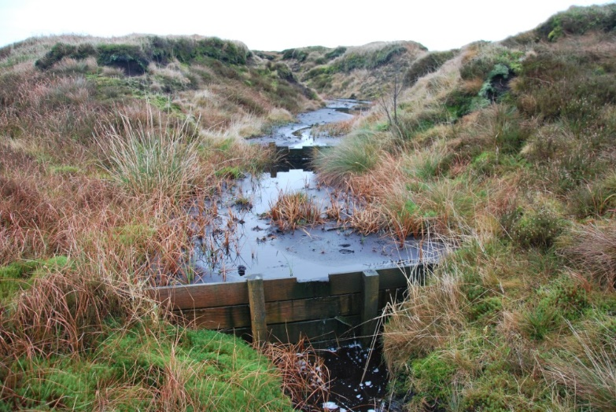
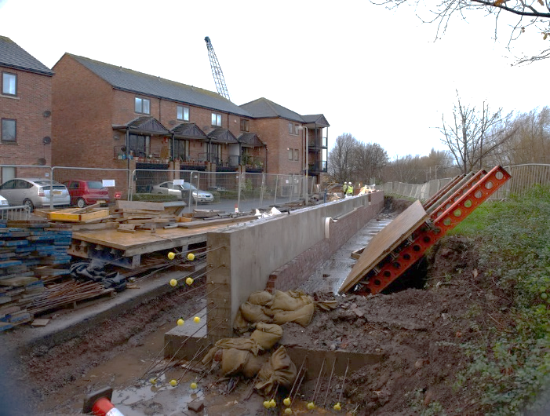

Figure 3: Urban Flood Alleviation Scheme
Figure 2: Nuclear (Copyright wiki)
Low Tolerance to uncertainty High
High Consequence of failure Low
Figure 4: Upland natural flood management

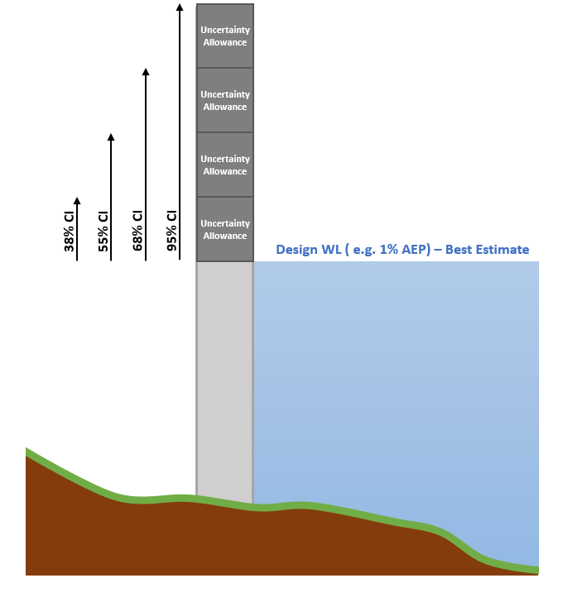
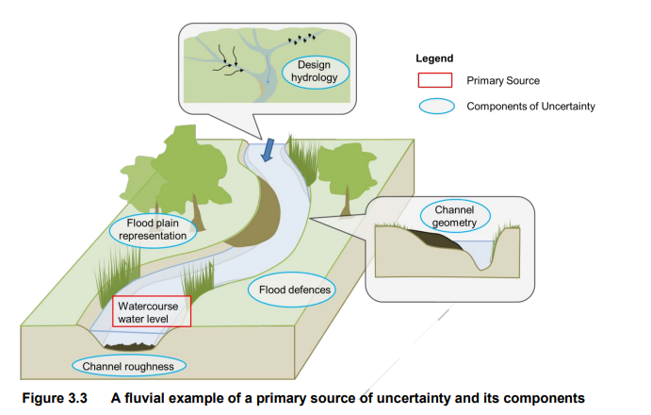
Case study 2 - Halter Burn Weir (Fish Barrier Removal Design) - WEF Case Officer: Francis Hayes

Climate resilience
In the SEPA Corporate Plan 2024-2027, our ambition is:
- That the damaging impact of floods and droughts is reduced.
- That operators are prepared for and resilient to the impacts of a changing climate.
One way we will achieve this ambition is by improving our understanding of Scotland’s flood risk protection assets.

What was achieved?
- The scope helped us explore innovative techniques to demonstrate how a national consistent approach could be taken for flood defences in Scotland and highlighted the importance of this work.
- The project identified the approaches taken by the UK regulatory authorities to understand flood defences in England, Wales and Northern Ireland.
- It outlined potential approaches, techniques and methods for achieving these goals.
- This approach was tested on a case study location to validate the theory and gather insights. This provided a valuable understanding of the scale of the task.
- Ultimately the project has identified the importance of this information for building resilient and sustainable communities.

How are we incorporating Net Zero?
The project began just as SEPA embarked on its ambitious approach to Net Zero, allowing Case Officer Francis Hayes to guide its direction early on, ensuring designers and contractors focus on reducing carbon emissions and enhancing sustainability.
The most sustainable and climate resilient way to improve fish passage at redundant weirs is often full weir removal. Installing an additional structure such as a concrete fish pass or modifying the existing weir means an increase in the carbon costs and long-term maintenance requirements. While not all weirs can be removed, the Halter Burn Weir project has been focussed solely on removal to ensure the most resilient and sustainable option from the start.
WEF observes that consultants and design engineers are increasingly focusing on low carbon, climate-resilient, and sustainable designs, and WEF is actively promoting and accelerating these approaches.

The project
SEPA has directly commissioned the design of a full weir removal operation at the Halter Burn, Yetholm Mains, Scottish Borders.
The removal of the weir, planned for 2025, will open around 4km of upstream river habitat to native migratory fish such as sea trout and Atlantic salmon.
In 2023 we completed a concept design for the weir’s removal and during 2024 we will develop a detailed design and procurement documentation to fully remove the weir.
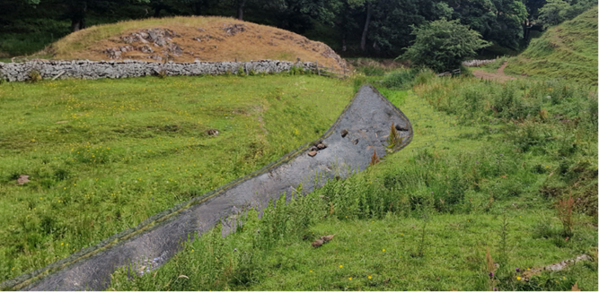
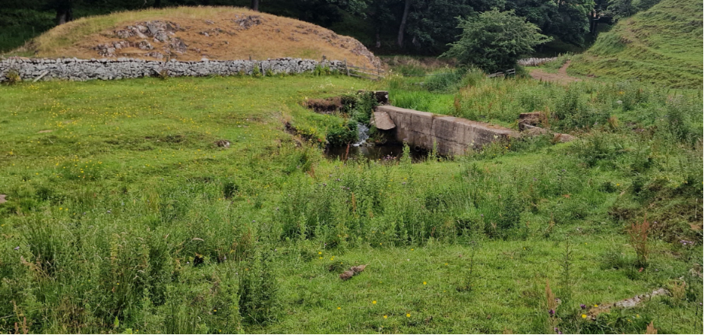
Figure 1: Image of Halter Burn Weir before (left image).
Figure 2: Image of Halter Burn Weir after concept design (right image).

What techniques are being used?
The Halter Burn Project follows Royal Institute of British Architects (RIBA) principles to set sustainability outcomes at each stage, currently at RIBA 3 and 4 for Developed and Technical Design. The procurement process included legally binding requirements for designers and contractors to work sustainably and report carbon costs.
The project scope advertised within the tender informed bidders that they must adhere to SEPA’s core values of sustainability and in particular Net Zero carbon delivery of the weir removal project.

What has happened so far?
The design work is at an early stage but already the designer has undertaken a single site visit for all surveyors on the same day, using only one vehicle for travel, to reduce the carbon cost of field work (as opposed to field surveyors attending site alone and using separate travel arrangements).
Additionally, the design team has begun reviewing the potential materials for use on the weir removal site and are actively assessing the carbon cost of each material. For example, assessing ‘rock roll’ bank protection versus natural materials sourced on-site, or even allowing the river to form its own riverbanks naturally after weir removal.
A carbon calculator is being identified for the project which best suits our needs and may either be the Environment Agency’s bespoke tool or an equivalent.

Table 6 - Aim 2: Supporting SEPA’s modernisation
How will we deliver | What will success look like | Achievements thus far
Ensuring the support our Procurement Team offer is well informed, agile, and dynamic.  Evaluating, managing, and mitigating procurement and supply chain risk.  Delivering innovative contracting approaches.  Developing key commercial skills across the organisation through:  - Further development of our training on Discover and other corporate learning platforms.  - Making the most of Microsoft 365 (Teams) – Running short masterclass style sessions for relevant colleagues will help to build the knowledge and skills required to be effective contract and supplier relationship managers.  - Coaching relevant colleagues to deliver robust contract management. Supporting our staff through coaching will ensure they experience practical learning.  - Delivering effective and efficient self-service.  - Feeding into the new Job Evaluation Scheme and System at the appropriate time to ensure commercial skills are recognised as an important part of people’s roles.  - ‘Rightsizing’ the procurement function depending on the developing role of the team. | Procurement is considered as an option early in decision making.  The Procurement Team are actively involved in key decision making across the organisation.  Our staff have the commercial skills to be confident in their management of our suppliers.  An increase in the £15k threshold for involving our Procurement Team in tendering exercises is feasible as competency across the organisation increases. | The Procurement Team continues to be flexible and resilient during financial year 2023-2024. There was a significant increase in the number of regulated procurements taken forward and contracts put in place by the Procurement Team. An increase in relative terms of c20% compared to the preceding FY 2022-2023.  Early and planned stakeholder engagement has led to the successful completion for award of £12m Total Facilities Management contract. This has been accomplished without challenge. Award expected early in next reporting period.  A focus on sustainable delivery has led to the development and use of weighted sustainability questions for tenders; these are aligned with and promoting SEPA corporate goals.  The Procurement Team participated in a series of Teams sessions during the Manager Development Programme in October and November 2023. These sessions were designed to engage with managers across the organisation, raise awareness of the procurement function and the regulations that govern procurement activities. Ensuring managers are well-equipped to navigate procurement processes effectively.  The Procurement Team supported WEF colleagues in developing an innovative construction related procurement strategy to support the move from traditional construction contracts to design and build approach and focus on maximising value for money (VFM).  The Head of Procurement and Contract Management role was successfully recruited and appointed in December 2023 as part of ‘rightsizing’ the Procurement function. In addition, the department is actively seeking to recruit two posts at Procurement Team Manager and Procurement Specialist levels to replace staff retirements.

Table 7 - Aim 3: Effectively managing risk and seeking opportunities with our supply chain
How will we deliver | What will success look like | Achievements thus far
Working with our suppliers to understand the risks and opportunities as they see them.  Working with our suppliers to ensure effective contingency plans are in place for key risks.  Assessing our supplier’s preparedness for the materialisation of developing risks such as cyber security and climate change.  Playing an active role in developing key markets where there is limited competition and/or resilience.  Working with the Scottish Supplier Development Programme (SDP) to reduce barriers to SMEs seeking to enter our supply chain. | Resilience and risk will be actively managed in our supply chain – reducing the likelihood and impact of future service disruption.  Strong, collaborative relationships with suppliers, leading to improved communication, trust, and mutual support in managing risks and opportunities.  A more diverse supplier base, including a higher number of SMEs, contributing to innovation and resilience in the supply chain. | As with all organisations, SEPA is facing external supply chain risks. Significant risks include:  - Higher energy costs.  - Inflation.  - Supply chain shortages.  - Supplier workforce demographics and skill shortages.  - The talent war with demand exceeding supply for key skills.  - Geo-political considerations and international conflict.  - Higher interest rates.  Ongoing management of risks is essential. More effective planning with consideration of supplier lead times was conducted during FY 2023-2024 through continual development of our procurement pipeline approach with a red, amber, green (RAG) status tracker and regular stakeholder planning sessions.

Table 8 - Aim 4: Supply chain management
How will we deliver | What will success look like | Achievements thus far
Identifying business areas where the supply chain impacts are most significant.  Working with the relevant stakeholders to support the effective articulation of supply chain risks and opportunities in procurement plans.  Supporting our regulatory colleagues to understand the supply chain impacts of our regulated businesses. | Plans will effectively consider those business areas with the most significant supply chain impact.  Regulatory colleagues, responsible for delivery, will feel well equipped to support and advise regulated businesses on reducing supply chain impact. | Regular capital spend planning meetings have taken place to ensure mitigation of risk where appropriate.  SEPA continues to be an associate member of the Advanced Procurement for Universities and Colleges centre of procurement expertise. This has allowed access to contractual coverage across a number business requirements.  The Procurement Team continues to support regulatory colleagues through regular Public Procurement Group attendance. In addition, the Head of Procurement and Contract Management was nominated chair of collaborative Environment and Economy Leaders Group (EELG) and leading review of collective spend opportunities to capture efficiencies at government level and supporting colleagues throughout the public sector.  Leading SEPA’s first Procurement Capability Improvement Programme (PCIP) – a Government audit on the maturity of the procurement function. First review scheduled for 20 August 2024. This is linked to wider Scottish Government initiatives demonstrating alignment with policy, driving improvement plans for the function and enhancing brand and reputation of the function and SEPA.

Future regulated procurement activity 2023-2025
A summary of the regulated procurements expected to commence in the next two financial years is categorised by business area and project expenditure. This can be subject to change due to budgets and prioritisation (Annex 2).
Our Procurement Pipeline is managed by our Procurement Team Manager, in consultation with function heads. It is subject to change to meet operational demands and shifting priorities, however we recognise there are opportunities to improve the level of ‘real-time’ engagement from functions to ensure Procurement can make those pipeline adjustments in a more flexible manner.
Route to market is a key consideration in any procurement and this will be influenced by multiple factors including specification, market availability, suitability of existing contracts and available external collaborative framework agreements, the anticipated value of requirements, as well as our general and specific duties under the Procurement Reform (Scotland) Act 2014, S.18 and Part 2.
Procurement route selection continues to be a critical component in our sourcing strategies to ensure the optimal route to market is selected that will meet SEPA’s needs and Annual Operating Plan objectives, to deliver best value for money and ensure compliance with the legal and regulatory frameworks within which we operate.
- Framework for delivery
The delivery of future regulated procurements and associated annual procurement reporting will be supported by the following framework:

Figure 5: Framework for delivery
- Procurement Policy Contract and Supplier Management Policy
- Annual Procurement Report
- Regulatory Compliance
- Customer focus and engagement
- Pipeline review and planning
- Market engagement
- PCIP Action Plan
- Customer focus and engagement
- Pipeline review and planning
- Market engagement
- Procurement capability and capacity review

- Scottish Government Procurement Strategy
- SEPA Corporate and Annual Operating Plans
- Corporate Procurement Strategy

Benefits
The Scottish Government’s Procurement Benefits Reporting Guidance seeks to record and report benefits in a consistent manner across the public sector, allowing both non-cash and cash savings to be recorded. Benefits can be cash or non-cash and identified at the following stages:
- Forecast as part of a Procurement Strategy.
- Secured as a result of a sourcing process.
- Delivered throughout the life of the contract. What is the difference between cash and non-cash?
- Cash – reduced cost to SEPA against forecast as a result of the sourcing process. This can enable, for example, additional scope to be procured or budgets to be reduced or reallocated.
- Non-cash – benefits which may be measured in cash terms, but which do not free up financial resource – e.g. the delivery of community benefits.

Benefits calculation and recording, at all three stages and within cash and non-cash brackets, is at a relatively early phase within SEPA, albeit we continually achieve successes. This was identified as an opportunity for improvement in 2023-2024 with existing initiatives within our Procurement Strategy being directly mapped to benefits calculation skills, including how we assess best value in terms of environmental impacts, equality and diversity, community benefits and whole life-cycle costing into our tender evaluations where appropriate. Progress will continue to be demonstrated on an annual basis.

The table below represents the expenditure and benefits achieved as a result of procurement activity and progression from the previous reporting period.

Table 9: Value for money savings
FY | Influenceable spend | Cash savings | Non-cash savings | Total savings | % of contract spend
2022-2023 | £11,211,418 | £317,840 | 0 | £317,840 | 3%
2023-2024 | £14,050,442 | £415,760 | £396,351 | £827,111 | 6%

This concludes SEPA’s 2023-2024 Annual Procurement Report.
December 2024
Allan Ferguson
Head of Procurement and Contract Management
SEPA, Angus Smith Building,
6 Parklands Avenue, Eurocentral, Holytown,
North Lanarkshire,
ML1 4WQ

Annex 1 - Regulated procurements completed in financial year 2023-2024

SEPA’s regulated procurements completed in 2023-2024 per portfolio

Compliance and Beyond
Please note a wide range of regulated procurements were conducted during financial Year 2023-2024. The contracts put in place have varying contractual timeframes. The total value for multi-year agreements / longer term contract arrangements has been published.

Table 10 – Data, Evidence and Innovation portfolio
Description | Value (Ex. VAT)
AHER FTIR (Gasmet) | £127,999
Azure Overages 2024 | £160,000
Azure Overages December 2023 | £75,000
Biochemical Oxygen Demand Analysers | £131,110
Centrifugal Filters for Microbiology COVID19 Wastewater Sampling | £94,855
Cloud Hosting Services | £273,250
Coastal Flood Hazard Mapping (Scotland) Phase 2 | £294,929
Digital Architecture Post | £77,875
FEWS Support & Maintenance | £201,000
Flood Defences Asset Assessment Project | £209,615
Flooding Educational Project | £66,000
HIMS Software S&M | £125,874
ICP-OES Alkali metals analyser purchase | £66,971
Interim Business Analyst Requirement | £50,000
IS Policy & Procedures Review | £71,250
Milton of Campsie Gauging Station | £153,014
Network Strategy Review | £70,625
Nucleic Acid Kits for Microbiology COVID19 Wastewater Sampling | £60,863
Philiphaugh Gauging Station Rebuild | £54,386
Seil Sound Shellfish Water Protected Area (SWPA) Tracer Study | £81,218
SEPA SJM vessel maintenance expenses (transactional only) | £122,625
Service Contract for Thermo QExactive Plus & Ultimate 3000LC | £156,276
Software Licence, Development, Support & Maintenance for SEPA Flood Forecasting Models | £62,850
Software Value Added Reseller Services (SVARS) | £80,000
Spotfire Annual Support & Maintenance 2024-2027 | £241,291
Supply of Fabricated Steel | £140,000
Supply, Delivery, Installation & Commissioning of an Automatic Media Preparation and Dispensing System | £64,806
Supply, Installation and Commissioning of a High Capacity Fully Automated System for the Measurement of pH, Alkalinity, Electrical Conductivity and Fluoride | £153,255
Supply, Installation and Maintenance of Wave Buoys at Two Inshore Locations in SE Scotland | £279,000
Technical Assurance Service for M/Soft Azure | £300,000
Topographic Survey and Hydraulic Rating Development - Catchments in Scottish Borders | £72,443
Total | £4,118,380

Table 11 - Finance, Modernisation and Digital portfolio
Description | Value (Ex. VAT)
Agresso Maintenance Support 2023-2024 | £50,768
Audit Scotland Fees 2023-2024 | £76,161
Citrix Universal Hybrid Multi Cloud Workspace | £90,720
ESRI License | £480,000
HALO Helpdesk License Renewal | £179,265
Incident Response Retainer | £69,500
LIMS Support & Maintenance | £59,365
Microsoft Enterprise License Agreement | £2,686,151
Oracle Software Update License & Support Service | £99,595
Provision of Network Firewalls Security and Protection Services | £82,494
Security Operations Centre (SOC) XDR Managed Service | £209,512
Security Operations Centre annual Onboarding MDR | £450,000
Senior leadership Coaching | £85,950
Total | £4,619,481

Table 12 - Governance, Performance and Engagement portfolio
Description | Value (Ex. VAT)
Internal Audit Service | £292,000
Provision of a Consultation Platform | £79,980
Total | £371,980

Table 13 - People, Workspaces and Development portfolio
Description | Value (Ex. VAT)
Aberdeen Laboratory Refit | £590,786
AHER Vehicles x 2 | £51,370
Fieldwork Vehicles | £80,525
Insurance & Associated Services | £185,000
Interim IT Staff Services | £50,000
Interim Professional Staff Services SP-22-001 4th Generation | £50,000
Recruitment Services (Hays) | £60,000
Temporary Admin & Manual Staff (South Region) | £150,000
Temporary Admin & Manual Staff (North) | £50,000
Temporary Admin & Manual Staff (South Region) (transactional only) | £50,000
The Provision of Total Estate Management Services | £200,000
Total | £1,517,681

Table 14 - Regulation, Business and Environment
Description | Value (Ex. VAT)
Esk Barriers Water Environment Fund (WEF) | £126,703
General Office Supplies | £50,000
OBCR Subject Matter Expertise | £80,000
Provision of an Intelligence & Investigation Management System | £1,030,307
Provision of Communications Media Management Software | £52,530
Provision of NetRegs E-Learning and Assessments Platform | £78,593
Total | £1,418,133

Table 15 - Total regulated procurements completed in 2023-2024
Description | Value (Ex. VAT)
Overall total | £12,045,655

Annex 2 - Summary of business area procurements to be conducted in the next two financial years

Refer to our externally published contracts register to identify term contracts that are approaching their end and due for renewal. SEPA is actively working on a procurement pipeline, which includes a focus on enhancing market awareness of upcoming regulated procurement opportunities. Business specific procurements will be conducted as required to meet future business needs

Table 16 – Summary of business area procurements to be conducted in the next two financial years
Description | Function | Estimated start date | Estimated value
Freshwater Sondes | Chemistry | 01/04/2024 | £60,000
Technical Assurance Services | Information Systems | 01/07/2024 | £162,000
Flooding Professional Services | Water and Planning Function | 06/10/2024 | £166,000
Solution Architect | Information Systems | 07/10/2024 | £82,500
Transformation Services | Transformation Programme Office | 07/10/2024 | £83,000
Compliance and Onboarding Platform | HR | 01/11/2024 | £50,000
High Performance Computer Modelling Infrastructure | Information Systems | 01/11/2024 | £83,333
Provision of Embedding of Performance Framework (Phase 2) | Corporate Governance | 01/11/2024 | £50,000
Ballathie - Station and Cableway Rebuild | Hydrology | 01/12/2024 | £50,000
Craighead Mill Weir (RIBA3&4) [WEF] | Water and Planning Function | 01/12/2024 | £80,000
Fleet Operating Model Support | Workspaces | 01/12/2024 | £75,000
Mercury Analysers | Chemistry | 01/12/2024 | £50,000
Pressure Sensors22 | Hydrology | 01/12/2024 | £100,000
Employee Benefits (Child Care Vouchers) | HR | 08/12/2024 | TBC
Agresso Cloud Migration | Agresso | 01/01/2025 | £160,000
Recalibration of Firths of Forths and Tay | Hydrology | 05/01/2025 | £150,000
Waste Tracking | Energy, Industry and Materials | 06/01/2025 | £166,6676
North Esks - Lasswade & Dalmore (RIBA 1b&2) [WEF] | Water and Planning Function | 07/01/2025 | £90,000
Proficiency Testing | Chemistry | 27/01/2025 | £80,000
Replacement Firewall Appliances | Information Systems | 27/01/2025 | £83,333
Burnock Water & Water of Coyle (d/s Taiglum Burn) (RIBA 1b&2) [WEF] | Water and Planning Function | 01/02/2025 | £90,000
Montgarrie Weir (RIBA 1b&2) [WEF] | Water and Planning Function | 01/02/2025 | £50,000
User Research Web Refresh Project | Communications and Marketing | 01/02/2025 | £62,000
Backup Refresh / Migration | Information Systems | 02/02/2025 | £375,000
Debt Recovery Service | Finance | 07/02/2025 | £100,000
Outstation and Shaft Encoder Replacements | Hydrology | 17/02/2025 | TBC
Bathing Water VMS System | Environmental Quality | 28/02/2025 | £215,000
LIMS Support & Maintenance | Information Systems | 01/03/2025 | £59,365
ASB Laboratory Reconfiguration | Ecology | 31/03/2025 | £100,000
Fleet Replacement | Workspaces | 31/03/2025 | £125,000
Nutrients Analyser | Chemistry | 31/03/2025 | £91,667
Digital Programme | Information Systems | 01/04/2025 | TBC
Gas Chromatography High-Resolution Mass Spectrometry | Chemistry | 01/04/2025 | £1,550,000
Legal Services | Corporate Legal and Leadership Support | 01/04/2025 | £650,000
Network Firewalls Security & Protection Services | Information Systems | 01/04/2025 | £80,000
Occupational Health Services | HR | 01/04/2025 | £50,000
River Gauging Winch Framework | Hydrology | 01/04/2025 | TBC
Small (7M) Boat | Ecology | 01/06/2025 | £208,333
Future of Regulation Programme - Compliance Platform | Permitting | 01/07/2025 | TBC
Postal Services Hybrid mail | Energy Function | 01/07/2025 | £75,000
Cycle to Work Scheme | HR | 29/08/2025 | £90,000
Travel Services | Finance | 12/09/2025 | £200,000
Psychometric Testing Service for HR | HR | 23/09/2025 | £50,000
North Esks - Montague Bridge Weir and Ironmills (Melville Castle) (RIBA 3,4&5) [WEF] | Water and Planning Function | 01/10/2025 | £1,200,000
Stack Emission Monitoring Programme | Chemistry | 03/10/2025 | £166,000
Bathing Water Signage Consultancy | Environmental Quality | 05/10/2025 | £60,000
Cisco Nexus Core Network Device Replacement | Information Systems | 20/12/2025 | £124,548
HydroAcoustic Equipment (ADCPs) | Hydrology | 01/01/2026 | £50,000
Habits Surveys | Energy Function | 01/02/2026 | £390,990
HVAS Maintenance and Provision & Replacement of Air Filters | Energy Function | 29/03/2026 | £450,000
ESRI License | Information Systems | 01/04/2026 | £480,000
Environmental Radioactivity Monitoring | Energy Function | 11/04/2026 | £200,000

If you would like this document in an accessible format, such as large print, audio recording or braille, please contact SEPA by emailing equalities@sepa.org.uk

The Scottish Procurement and Commercial Directorate of the Scottish Government commission an external body DXC Technology, to conduct an annual national spend analysis programme through the Scottish Procurement Information Hub. This is carried out by organisations submitting specific transactional data for the relevant financial year. As such, the data included in this report was verified and provided by DXC Technology.
Hereafter references to SEPA Procurement Strategy means reference to our Procurement Operating Plan 2021–2024.
The Water Environment Fund (WEF) enables rivers to be restored by repairing damage, removing and easing barriers to migrating fish and improving vital fish stocks. SEPA uses WEF to directly commission the removal or easement of redundant weirs, contribute towards a partnership with local authorities for the restoration of urban rivers and surrounding green spaces, and for compensation for land owners/managers for income forgone due to giving over productive land to river restoration.
The Public Procurement Group (PPG) is the leadership group for public procurement across Scotland, made up of the Heads of Procurement Centres of Expertise and senior Scottish Government procurement officials, who work together to set the strategic direction and priorities for public procurement in Scotland.

