Project Facilitation

Authors:
Judith Bakker¹
Hayley Craig¹
Lynsey R. Harper¹
Edward Wort¹
Douglas W. Yu^{1,2}
Owen Middleton¹
Christian Devenish¹
Hannah Flintham¹
Nathan R. Geraldi¹
Evie Gardner¹
Mike Morris¹
James Whiting¹
Bastian Egeter¹
¹ NatureMetrics, 1 Occam Court, Surrey Research Park, Guildford GU2 7HJ, United Kingdom
² University of East Anglia, Earlham Rd., Norwich, Norfolk NR18 9NS, United Kingdom
NatureMetrics Project Management:
Bastian Egeter (2021-2023)
Cath Tayleur (2021-2022)
Sam Lacey (2022)
Judith Bakker (2022-2023)
SG & SEPA Project Management:
Willie Duncan (2021-2022)
Pauline Lang (2022-2023)
Please reference this document as follows: Bakker J., Craig H., Harper L. R., Wort E., Yu D.W., Middleton O., Devenish C., Flintham H., Geraldi N.R., Gardner E., Morris M., Whiting J., Egeter B. (2023) Phase 2 Technical Appendices - Developing Habitat Scale DNA Monitoring in Support of Post 2020 Biodiversity Reporting Requirements. NMP/001/20. NatureMetrics.
Dissemination status: Unrestricted
Acknowledgements: Funding for this work is provided by SG-RESAS, the Scottish Government’s Rural and Environment Science and Analytical Services. The authors would like to thank the Phase 2 Project Management Steering Group (MSG): Pauline Lang (Contract Manager, Lead Project Partner), Alistair Duguid (Scottish Environment Protection Agency, SEPA), Colin Bean (NatureScot), Iveta Matejusova (The Marine Directorate of Scottish Government (formerly Marine Scotland Science, MSS)), and Helen Jones (the Scottish Government’s Rural and Environment Science and Analytical Services division, SG-RESAS) for their substantial support and advice throughout the project. We also thank Colin Bean (NatureScot), Iveta Matejusova (The Marine Directorate (formerly Marine Scotland Science, MSS)), Pauline Lang, and Alistair Duguid (Scottish Environment Protection Agency, SEPA), as well as advisory board members Douglas Yu§ (NatureMetrics), Pippa Howard§ (NatureMetrics), Nadia Barsoum§ (Forest Research) for providing project guidance, technical advice and peer reviewing this work.
We thank the Technical Reviewing Group (TRG) for providing timely and constructive feedback to inform Phase 2 project development and delivery: We also thank a broad range of project stakeholders including key representatives from the Phase 2 Project Technical Reviewing Group (TRG); the Project Advisory Board; the Scottish DNA Hub; Loch Lomond and the Trossachs National Park (LLTNP), Cairngorms National Park; and other organisations for engaging their expertise and support during project development and production of this deliverable output. We specifically thank Nadia Barsoum§ (Forest Research); Kenny Kortland (Forestry and Land Scotland); Alan Bell, Dom Hall (LLTNP); Tom Butterworth§ (WSP); Simon Franks (LLTNP Trees and Woodland advisor); Scot Mathieson (SEPA); Colin Adams (Scottish Centre for Ecology and the Natural Environment, SCENE, University of Glasgow), Douglas Yu§ (University of East Anglia, NatureMetrics), Laia Rovira-Craven (SEPA), Nick Schurch (BioSS), Paul Woodcock (JNCC), Nigel Willby (University of Stirling), Bernd Haenfling (University of Highlands and Islands, UHI), Lauren Cook (Natural History Museum; CEFAS), Pete Hollingsworth (RBGE), Philip Boulcoutt (The Marine Directorate, formerly Marine Scotland Science, MSS), David Cooke (James Hutton Institute), Rob Ogden (University of Edinburgh) for providing their specialist expertise, and feeding ideas or suggestions into project development. We also thank SEPA lead and SG-CAMERAS Board partner Peter Singleton for project support.
We are extremely grateful to The Marine Directorate (formerly Marine Scotland Science, MSS), SEPA, and NatureScot for provisioning extensive in-kind support to both the Phase 1 pilot study and the Phase 2 main sampling campaign, which included facilitating staff time, their expertise, and operational resources needed to enable site access and field monitoring and/or laboratory analysis for the project to be mobilised across the four different habitat types, especially the following people and organisations: Iveta Matejusova (Marine habitat) from The Marine Directorate (formerly Marine Scotland Science, MSS); Peter Pollard, Kirsten Davidson, Lorraine Quinn, Ian Lorimer, Annette Ross, Ian Milne, and Pauline Lang (Marine, Freshwater, Peatland, and Woodland habitats) from SEPA; Colin Bean (Freshwater and Woodland habitats) from NatureScot. We are extremely grateful to all SEPA Marine Ecology team members who were involved in undertaking the sample analyses for marine benthic invertebrates and particle size analysis (PSA) from the marine habitat sampled during Phase 2 project work, with particular thanks to: Myles O’Reilly, Stephen Nowacki, Ryan Eustace, Emma Priestley, Calum Clark, Nick Woods, and Will Townshend. This in-kind support was needed to produce laboratory results for comparing outcomes of using conventional and eDNA methods in the marine environment. For the freshwater fieldwork, we thank Oliver Taylor and Lewis Campbell (NatureMetrics) for assistance with sample collection, Hannele Honkanen (SCENE, University of Glasgow) and David Scott-Park (Portnellan Farm) for permitting sampling at Loch Lomond shoreline sites. For the peatland fieldwork we thank Marco Fioratti (NatureMetrics) for assistance with sample collection, Richard Cooper (LLTNP Peatland ACTION) for help with identifying all the peatland sites and meeting us on site in 2021; Hamish Thomson (Woodlands Trust Glen Finglas), site contact and for providing transport for sampling in 2021, and Emily Gray for sampling permission; Emma Paterson, Nicola Colquhoun, and Ian Dingwall (Auchlyne Estate) for permitting sampling at the site and facilitating site access; Royal Scottish Forestry Society (owners of Cashel site) and Peter Phillips (Cashel site contact); Jane Lindsay and Claire Campbell (SEPA) for providing transport and expertise which enabled site access and the peatland condition assessments to be undertaken at Auchlyne and Glen Finglas in 2022; Alan Bell, Richard Cooper, Guy Cole, and Natasha Craven (LLTNP) providing transport and expertise which enabled site access and the peatland condition assessments to be undertaken at Cashel in 2022. For the woodland fieldwork we thank Marco Fioratti (NatureMetrics for assistance with sample collection, site contact Fraser Lamont (RSPB Inversnaid) for meeting us on site to show the experimental plots for woodland sampling in 2021; Colin Leslie, Juli Titherington, Emyr Algieri, Brian Duff (Forestry and Land Scotland) for assisting with site information, site permissions, and/or identifying potential sampling locations; Alan McDonnell, and Marian Bruce (Trees for Life) for providing site information for the 2022 forest sites in Glen Affric and Glen Moriston; Piers Voysey and Peter Ferguson (Rothiemurchus Estate); Richard Lewis (Collie Coire Chulic site contact/owner); Alex Caraffi (Glen Falloch site contact); Emily Warner for providing advice and site info on Glen Affric and Glen Moriston sites; Kirsty North, Stan Phillips (Nature Scot) for advice on SSSI consent requirements; and Brodie Thomas (NatureScot) for field assistance during the woodland sampling in 2022. We are extremely grateful to Forest Research for providing in-kind support for planning and carrying out a significant part of the woodland work, including sharing data and metadata from a parallel Forest Research project, facilitated by Nadia Barsoum. We are grateful to Cathy Benett, Alison Bell, Annette Ross, and Andy Gowans for their expertise and help in facilitating SEPA data requests. We are also thankful to Tim Foster (SEPA) for their guidance and support with data management. We thank MSG and TSG members for peer review and constructive feedback to help inform and improve the final version of the Phase 2 deliverable outputs.
The authors are also very grateful to all participants of the project knowledge-exchange (KE) events, representing a broad range of individuals and organisations, in Scotland and beyond, for their interest in the project outcomes and using DNA-based approaches for biodiversity monitoring/reporting purposes, as well feedback provided and expert contributions to discussion on 3rd May 2023, 17th May 2023, and 7th June 2023. We specifically want to thank the 7 June 2023 KE event hosts at LLTNP, including Dom Hall, Simon Jones, and Gordon Watson together with their colleagues managing event coordination especially Jane Cook, Cara Thom, Lauren McInnes, and Rachael McLauchlan. Thanks to the KE event sponsor Pete Hollingsworth of RBGE on behalf of the Scottish DNA Hub. We also thank KE event coordinator Pauline Lang, co-chairs Alistair Duguid, Laia Rovira-Craven, Colin Bean, Iveta Matejusova, and convener Scot Mathieson for creating the conditions for stakeholder engagement and facilitating discussions to help the project outcomes. We also thank representatives from the following organisations for participating in the May and June 2023 KE events and for helping to improve project deliverables: Scottish Environment Protection Agency (SEPA), The Marine Directorate (formerly Marine Scotland Science, MSS), NatureScot, Scottish Government, Scottish Government’s Rural and Environmental Science and Analytical Services (SG-RESAS) division, Loch Lomond and the Trossachs National Part (LLTNP) Authority, Cairngorms National Park (CNP) Authority, Royal Botanic Garden Edinburgh (RBGE), Moredun Research Institute, Science and Advice for Scottish Agriculture (SASA), Forestry and Land Scotland, Scottish Forestry, Forest Research, James Hutton Institute (JHI), Biomathematics and Statistics Scotland (BioSS), Joint Nature Conservation Committee (JNCC), Natural England, University of Stirling, University of the Highlands and Islands (UHI), Natural History Museum (NHM), Scottish Association for Marine Science (SAMS), Trees For Life, Scottish Badgers, Royal Zoological Society of Scotland (RZSS), Historic Environment Scotland (HES), University of Glasgow, Natural Resources Wales (NRW), University of Edinburgh, Loch Lomond Fisheries Trust (LLFT), Scotland’s Rural College (SRUC), National Museums Scotland (NMS), Centre for Environment, Fisheries & Aquaculture Science (CEFAS), Department for Environment, Food & Rural Affairs (DEFRA), Shetland Oil Terminal Environmental Advisory Group (SOTEAG).
Finally, we thank the Scottish Government project funder (SG-RESAS Contract Research Fund) and the Co-ordinated Agenda for Marine, Environment and Rural Affairs Science (SG-CAMERAS) Board Partnership, in collaboration with the Scottish DNA Hub, for commissioning this project and their ongoing support.
§Project Advisory Board Member

Contents
Project Facilitation 1
1 Preface 1
2 Executive Summary 1
3 Assay Details, Target and Non-target Species 6
4 Sampling Plan Overview 8
4.1 Marine 8
4.2 Freshwater 8
4.3 Woodland 11
4.4 Peatland 12
5 Overview of Taxa Detected 13
5.1 Marine Lochs 14
5.2 Freshwater Lochs 17
5.3 Woodland 18
5.4 Peatland 20
6 Sample Level Metrics 22
6.1 Marine Lochs 23
6.2 Freshwater Lochs 44
6.3 Woodland 57
6.4 Peatland 71
7 Random Forest Classification Tables 82
7.1 Marine 82
7.2 Freshwater 84
7.3 Woodland 86
7.4 Peatland 88
8 Conventional Marine Results 90
8.1 Description of Marine Biotope Classification Data 90
9 CPET Species 94
10 Sample Replicate Plots – Marine 100
11 Morphology vs eDNA – Marine Invertebrates & Eukaryotes 102
12 Historical Fish Records - Freshwater 104
13 AMBI Results 110
14 Gapfinder Outputs 113
15 OTU Tables 113
16 Site Photographs 114
16.1 Woodland 114
16.2 Peatland 120
17 References 123

Preface
The Phase 2 Technical Appendices presented here contains supplementary information, such as additional data analyses that were either not essential or too lengthy to be included in the core deliverable (Phase 2 Main Report) output. This includes extra data that has been analysed and underpins the results/discussion (whether they are fruitful or otherwise) but has not been provided upfront in the Phase 2 Main Report. This is primarily for more specialist technical and scientific experts as well as anyone interested in further evidence underpinning the other core Phase 2 project deliverable outputs. For outputs such as Operational Taxonomic Units (OTU) tables and Gapfinders, these have been produced as separate excel files and referred to in this document.

Executive Summary
Biodiversity loss is widely recognised as one of the most urgent global challenges to be addressed in the next decade. The Scottish Biodiversity Strategy sets out a clear ambition to be Nature Positive by 2030, and to have restored and regenerated biodiversity across the country by 2045 (Scottish Government 2022). To protect, restore, and regenerate biodiversity, it is necessary to be able to accurately describe and quantify ecological change. Biodiversity monitoring through environmental DNA (eDNA) analysis is increasingly being used for tracking species diversity and composition in ecosystems as it is a scalable and high-resolution method. The overall goal of this project was to investigate and test the applicability of eDNA-based monitoring approaches for biodiversity assessment and reporting purposes across a broad range of habitat types in Scotland.
Samples were collected across four habitat types: marine lochs, freshwater lochs, woodland, and peatland. The survey sites were mostly situated in and around the focal study area of Loch Lomond and the Trossachs National Park (LLTNP) but eDNA sampling included other parts of Scotland such as the Cairngorms National Park. This was a Proof-of-Concept study across small numbers of sites and gradients of condition across Scotland. This work was undertaken to help establish scientific evidence, blended with practical learning-by-doing experience, and provide key recommendations, including future perspectives, to inform the development and implementation of eDNA-based habitat monitoring programmes for Scotland going forward. Throughout this document we use the term ‘eDNA-based’ to encompass all DNA collected from environmental substrates, which includes both extracellular DNA and whole organisms such as soil fauna samples and microeukaryotes in marine sediments (Pawlowski et al. 2020).
Across the four surveyed habitat types we found that eDNA-based data can detect compositional shifts in species communities that are associated with ecosystem state or habitat classification (freshwater: loch Water Framework Directive Overall Status, marine: biotope, woodland: restoration/regeneration class, peatland: restoration class). Using Random Forest algorithms, the eDNA-based data can be used to classify sites according to ecosystem state or restoration gradient class. These findings were most evident for the freshwater and woodland habitats. While the data for the marine and peatland habitats were not sufficient for classification.
Numerous species with important biodiversity monitoring designations can also be detected including SSSI-listed species, IUCN threatened species, PMF and invasive species (species whose introduction or spread threatens biological diversity).
In some cases, eDNA-based data can likely be fed directly into existing community-based indicator metrics. For example, marine sediment health scoring categories were comparable to those calculated from morphological surveys and freshwater loch chironomid scoring produced similar values to those produced using best-matching conventional (CPET) data. However, this approach underuses much of the data and alignment of eDNA-based data into existing models can produce differing results and might consequently not be accepted. eDNA-based data should primarily be viewed as a 'new' tool, with new models, not necessarily as a tool to shoehorn into existing indices (with exceptions).
Developing national eDNA-based datasets to operationalise these findings will require well-considered site choices along well-defined gradients that are of highest priority for meeting monitoring and reporting needs. The breadth of potential applications is large. Successful future development and implementation will depend on posing targeted biomonitoring questions for specific objectives within national and international reporting frameworks.
The specific Key Recommendations from this project are:
- For freshwater lochs, build a national ecosystem-state prediction tool based on the methods presented in the project. This would be a scalable and efficient method for tracking loch quality state and change. It will require multiple lochs across a wide geographic range.
- As part of the ecosystem-state prediction tool, conduct a validation study for chironomid scoring by conducting side-by-side studies with conventional methods (CPET).
- For marine monitoring of vertebrate PMF species, develop standard monitoring guidance using aquatic eDNA sampling.
- For marine sediment health scoring, validate further at sites with greater pollution gradients.
- For marine biotope classification, conduct further research into optimal eDNA assays for maximised indicator species detection.
- For woodland, and other terrestrial habitats which use fungi as part of SSSI selection, further validate eDNA-based approaches for detection of SSSI-listed fungal species.
- For woodland restoration/regeneration monitoring, we initially recommend using eDNA-based data at the site level to monitor programme progress. In the longer term, a national eDNA-based survey across multiple woodland types in Scotland could be used as input to a systematic conservation planning exercise to rank woodlands by conservation value, and the higher-value woodlands can then be used as restoration targets.
- For peatland, there was a clear difference between degraded and restored peatlands, but the classification model was unable to predict status, due to the small size of this dataset. Classification of restoration status from eDNA-based data will require a large training dataset with a suitable sampling design and clear status definitions.
The Key Knowledge Gaps & Barriers are:
- Using eDNA-based data for biomonitoring at a national level in a regulatory context requires ecological frameworks based on national baselines, such as Ecological Quality Ratio (EQR) models. There are currently very few such frameworks based on or incorporating eDNA data (the Lake Fish Classification Index being the exception). Developing such frameworks requires large scale studies with focussed objectives. Biomonitoring at local scales is already possible through careful study design.
- The number of samples required for biomonitoring at the national level using eDNA-based data remains largely unanswered. This is partially due to fact that the breadth of potential applications is large, spanning numerous taxonomic groups, habitats, and biomonitoring objectives. Identifying the number of samples required for each specific biomonitoring objective is required.
- There are numerous eDNA-based projects being carried out in Scotland at various scales and in various contexts of biomonitoring, yet the data is not being captured in a systematic and unified way. Standardised guidance for formatting and storing eDNA-based data in publicly available databases would allow research in this area to progress faster. Systems such as the European Nucleotide Archive provide platforms for that could be used to store and access eDNA-based data for biomonitoring.
- There remains opportunity to develop minimum standards and validation scales to ensure consistency across projects and providers.
In most cases, eDNA-based approaches can be used to classify sites along ecological gradients. Until larger ecological biomonitoring frameworks for eDNA-based data are developed, eDNA-based approaches for national level reporting will likely remain underutilised. In the meantime, practitioners are using them for efficient surveying of key taxonomic groups. Local and regional projects are already using eDNA-based approaches to monitor negative and positive impacts of land management and restoration. The true power of eDNA-based data lies in the ability to generate huge datasets that can be used build national-level models of biodiversity and characterise ecological conditions for robust and consistent monitoring and reporting purposes.
Overall, eDNA-based approaches can provide the necessary scaling up of biodiversity monitoring for a national monitoring strategy across multiple habitat types, increasing the number of samples that can realistically be collected and analysed, and improve the reporting efficiency through standardised field and laboratory methodologies and data formats.

Assay Details, Target and Non-target Species
For all data analyses in this project, only target Operational Taxonomic Units (OTUs) were used. These are OTUs belonging to taxa that are targeted by the selected assay, for example, for the fish assay, only OTUs identified as fish were utilised (with the exception of reporting marine mammal PMF species). It should also be noted that OTUs that could not be assigned to at least Kingdom level were excluded.
Table 1: Summary of the assays used; target taxa; non-target taxa; gene; forward primer sequence; reverse primer sequence and references.
Assay | Target | Non-Target | Gene | Fwd sequence | Rev sequence | Reference
Vertebrates | Chordates | n/a | 12S | ACTGGGATTAGATACCCC | TAGAACAGGCTCCTCTAG | (Riaz et al. 2011; Kelly et al. 2014)
Fish | All fish | Non-fish chordates (e.g., mammals) | 12S | GYYGGTAAAMYTCGTGCCAGC | CATAGYGGGGTATCTAATCCCRGTTTG | (Miya et al. 2015)
Freshwater insects/invertebrates | All non-chordate animals | Chordates | COI | GGDACWGGWTGAACWGTWTAYCCHCC | CAAACAAATARDGGTATTCGDTY | (Leese et al. 2021)
Soil invertebrates | All non-chordate animals | Chordates | 18S | GGWACWRGWTGRACWITITAYCCYCC | TANACYTCNGGRTGNCCRAARAAYCA | (Capra et al. 2016)
Marine sediment invertebrates | All non-chordate animals | Chordates | COI | GGWACWGGWTGAACWGTWTAYCCYCC | TANACYTCNGGRTGNCCRAARAAYCA | (Leray et al. 2013)
Marine sediment bacteria | Bacteria | Archaea | 16S | GTGYCAGCMGCCGCGGTAA | GGACTACNVGGGTWTCTAAT | (Caporaso et al. 2011)
Soil bacteria | Bacteria | Archaea | 16S | GTGYCAGCMGCCGCGGTAA | GGACTACNVGGGTWTCTAAT | (Caporaso et al. 2011)
Soil fungi | Fungi | n/a | ITS2 | GCATCGATGAAGAACGCAGC | TCCTCCGCTTATTGATATGC | (White et al. 1990)
Marine sediment eukaryotes | Eukaryotes | n/a | 18S | CCCTGCCHTTTGTACACAC | CCTTCYGCAGGTTCACCTAC | (Amaral-Zettler et al. 2009)

Sampling Plan Overview
A brief outline is given here - for full details, please see the Phase 1 Pilot Study Findings & Phase 2 Sampling Plan (Egeter et al. 2023).

Marine
Based on the results of the pilot study, while Loch Goil is part of the Upper Loch Fyne and Loch Goil MPA, water and sediment samples were collected by The Marine Directorate (formerly Marine Scotland Science, MSS) predominantly from Loch Long to mitigate the effects of freshwater input. Four different sediment-based biotopes in Loch Long were selected for sample collection.
The following key sources of best available data were used to inform sampling design for the marine habitat:
- Moore 2013; NatureScot Commissioned Report 631: Biological analyses of underwater video from research cruises in the Clyde Sea (Loch Goil and the south of Arran) and in Orkney (Rousay Sound and Stronsay Firth)
- Allen et al. 2013; SNH Commissioned Report 437: Marine biological survey to establish the distribution of Priority Marine Features within the Clyde Sea area
- Consultation with key stakeholders from Scottish Government agencies

Freshwater
Following the pilot study, freshwater lochs became the focus of the freshwater habitat Phase 2 eDNA survey. The total number of sites, sampling locations, and sample assays was initially decided based on balancing the project budget and resources available, with obtaining the range of sites and level of replication required to address whether eDNA metabarcoding can enable assessment of habitat condition of Scottish freshwater lochs. However, the decisions regarding exactly how many reasonably representative samples to collect and at which freshwater lochs sites to sample, beyond Loch Lomond, required extensive consideration and consultation with key project stakeholders with relevant technical expertise and practical experience of operationalising monitoring resources across Scotland.
The collection of 10 shoreline samples in winter was previously identified as the minimum sampling effort required to detect ≥85% of fish species present in UK lakes (Li et al. 2019). However, this level of sampling effort may or may not be achievable for freshwater lochs if eDNA shoreline monitoring approaches were upscaled in the future.
It was decided that six samples per freshwater loch were to be collected from the shoreline. This approach was standardised across all freshwater lochs sampled for the Phase 2 eDNA survey. This fixed sample number was considered the reasonable balance between the minimum required for DNA-based sampling, loch accessibility reasons (not all parts of the sampled lochs were accessible by land), and available contractor resources (budgetary constraints) to deliver the project work in 2022. By taking that key decision, it was possible to increase the total number of freshwater lochs that could be sampled for metabarcoding analysis from the shoreline, and in doing so expand breadth of the overall habitat pressure gradient assessed.
Following extensive consideration and consultation with key project stakeholders, including experts from SEPA and NatureScot, a total of 15 freshwater lochs were selected based on their location within, or their proximity to LLTNP, accessibility by road, and where shoreline sampling would be sufficient (to minimise resource constraints, also keeping in mind potential future monitoring programmes). All 15 lochs had previously been classified by SEPA using the WFD ‘overall status’ designations and we chose them against the criteria specified that could be met for high, good, moderate, and poor classification status.
It was important that the lochs were reasonably reflective of WFD overall status as high, good, moderate, and poor or bad ecological status, whilst also ensuring the overall hydrology status remained high so that impacts from major known confounding factors (such as hydrology pressure from impoundment or abstraction due to hydropower or water supplies) were reasonably minimised wherever feasible, especially if any Scottish lochs are designated as Heavily Modified Waterbodies (HMWBs) and Grouped Waterbodies. We selected lochs that were:
- Lowland situated (Altitude type <200 m according to WFD-UTKAG, 2004)
- Have a large surface area (size type ≥ 0.5 km² in surface area according to WFD-UTKAG, 2004)
- Situated within a reasonably similar geographic area and climatic envelope, with most lake sampling constrained to the LLTNP focal study area, with some acceptable distances up to a 100 km radius beyond LLTNP boundaries
- Reasonably representative of standing waterbodies located within the focal study area of LLTNP:
  - Mostly low alkalinity, with some acceptable and occasional deviation into moderate alkalinity (according to WFD-UKTAG, 2014)
  - A balanced mixture of deep and shallow waterbody depth types, with 'very shallow’ being the occasional exception (according to WFD-UKTAG, 2014)
  - Mostly clear water colour types, with some acceptable and occasional deviation into humic, polyhumic, or unknown types (according to WFD-UKTAG, 2014)
- Reasonably representative of a range of land use categories including moorland, arable, woodland, and urban land cover in the surrounding catchments
- There is recent evidence that some freshwater lochs are impacted by climate change (May et al. 2022). It was found that Loch Achray and Loch Lubnaig situated in LLTNP to be amongst the most rapid warming standing waters in Scotland, with water temperatures having increased by between 1.0 and 1.3°C per year during 2015-2019)

The following key sources of best available data were used to inform sampling design for the freshwater habitat:
- SEPA Water Classification Hub
- UK Lakes Portal
- Water Framework Directive e.g.,
  - WFD-UKTAG (2004) Guidance on Typology for Lakes for the UK | wfd uktag
  - WFD-UKTAG (2014) UKTAG Lake Assessment Methods (wfduk.org)
- Assessing climate change impacts on the water quality of Scottish standing waters | CREW | Scotland's Centre of Expertise for Waters
- Space Intelligence Scotland Landcover
- Nature Scot Professional advice – protected areas and species
- Lochwinnoch Nature Reserve, Renfrewshire, Scotland - The RSPB
- Consultation with key stakeholders from Scottish Government organisations

Woodland
Within the scope of the project objectives, we aimed to assess whether eDNA communities and derived metrics can indicate overall woodland condition across a restoration gradient, from unforested, recently planted/reforested, and mature Scots pine woodland habitats. We used eDNA metabarcoding data to track woodland restoration of Scots pine at different stages of regeneration. This means that chronosequences (the different stages of regeneration) of restored woodland were used as a proxy for monitoring over time.
It was decided to focus on restoration gradient in Caledonian pine forest, Scots pine (Pinus sylvestris). This increased our chances of obtaining clear, unequivocal results, which is a common aspiration across all key stakeholders. Moreover, using Scots pine has the benefit of tying into pre-existing and parallel work by Forest Research. Although these Forest Research experimental Scots pine sites are not within LLTNP, the setup of the sites warranted sufficient merit to include in this study. Because not all sites had all three categories, one of the Cairngorms Forest Research sites, Rothiemurchus, situated within the Cairngorms National Park, was chosen to be included in the main sampling campaign of this project. Moreover, Rothiemurchus had their own adjacent young and natural regeneration mature Scots pine, which made for a better comparison.
By using monoculture stands of Scots pine at different stages of regeneration, space was substituted for time by using chronosequences of restoration. Three chronosequence categories were chosen instead of four to obtain better replication per treatment; unforested, recently planted/reforested, and mature condition. All sites were required to contain all the chosen age categories. Within each site, the different categories were required to be the same forest type, i.e. Scots pine. To further exclude confounding factors, the different categories were also required to be in similar environments, e.g. we did not want to compare areas on a steep slope or high plateau with lochside areas. Ideally, the sites needed to have each of the categories in adjacent stands, or at least in close proximity to each other.
Categories were a chronosequence of forest age. Three categories were selected; unforested (which may range from grassland to moorland), recently planted/reforested, and mature condition. Unforested areas are representative of an area that would be forest if it wasn’t grazed (such as grassland or moorland). Mature condition forest is the target, while recently planted/reforested is “regenerating” forest on its way to target status. The sampling locations and their respective categories were chosen based on the above and on extensive consultation with all key stakeholders. Two of the woodland sites selected for Phase 2 eDNA sampling were situated within the LLTNP and are both SSSI (Coille Coire Chuilc and Glen Falloch), while Rothiemurchus sits within the Cairngorms National Park. Coille Ruigh and Ghubhais are both SSSI and SAC areas. Those sites which did not fall within Scotland’s designated site network functioned to provide replicates for the chronosequences established for the woodland sites.

Peatland
Within the scope of the project objectives we aimed to test whether peatland sites of differing condition categories (degraded or restored) have different biological communities that can indicate overall condition using eDNA metabarcoding.
Site selection criteria required sites with varying peat condition - degraded and restored. Originally a third category (unimpacted) was proposed. However, because 70% of Scotland’s blanket bog and 90% of Scotland’s raised bog peatland is degraded (Artz et al. 2014), as such, the Peatland ACTION officer was unable to suggest any good/unimpacted condition peatland within LLTNP. Furthermore, despite searching while on site, no patches of good/unimpacted condition peatland were identified at any of the sites. Accordingly, it was not possible to find unimpacted areas to include in this study. Site selection was then based on two categories.
Based on the criteria three sites were selected. Glen Finglas, Auchlyne, and Cashel. Glen Finglas and Auchlyne contain drained and restored (through grip blocking) peatland. The Cashel site covers a large area on the south-east side of LLTNP but did not contain any areas that were not drained. However, restoration work is expected to start in 2023. When selecting damaged/drained areas this should be based on locations that are likely to go forward for restoration as this will allow future restoration time series assessments to be made.
Sampling locations were based on the following criteria:
- Approximate density of sampling points at 2 per km²
- Within areas of known peat (e.g. using PEATMAP; (Xu et al. 2018); or Carbon and peatland 2016 map when available) and with varying condition between restored and degraded peat
- Within approximately 2 km of a road to allow accessibility
- Sample locations within Glen Finglas and Auchlyne were selected because these are upland blanket bog sites within LLTNP where restoration works have been undertaken as part of the Peatland ACTION project.
- Sampling locations were determined on site in consultation with a Peatland ACTION representative and site managers.

Overview of Taxa Detected
Taxonomic heat trees showing the number of OTUs across all samples for each habitat and assay. Each node (the circles) is a taxon and the edges (lines) show hierarchical relationships between taxa. The colour scale and the relative width of the node represent the number of taxa at each level.

Marine Lochs

Bacteria
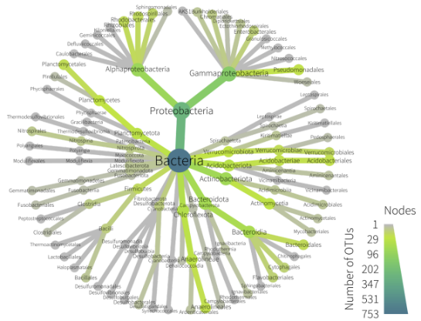

Sediment Eukaryotes
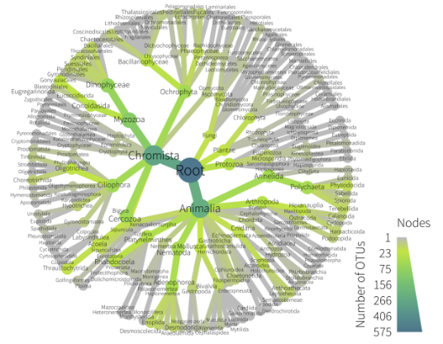

Sediment Invertebrates
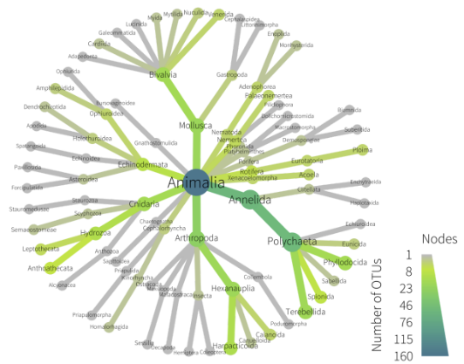

Fish
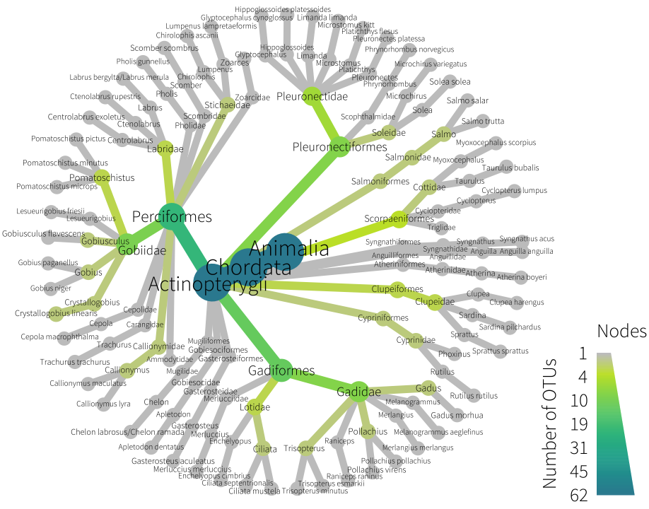

Freshwater Lochs

Vertebrates
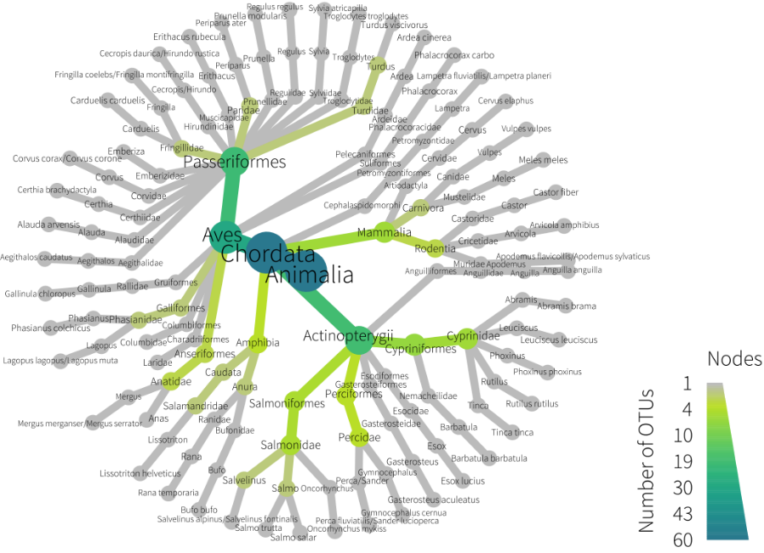

Freshwater Insects
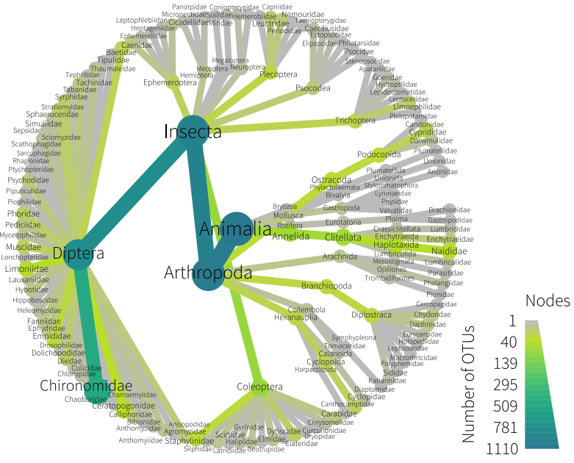

Bacteria
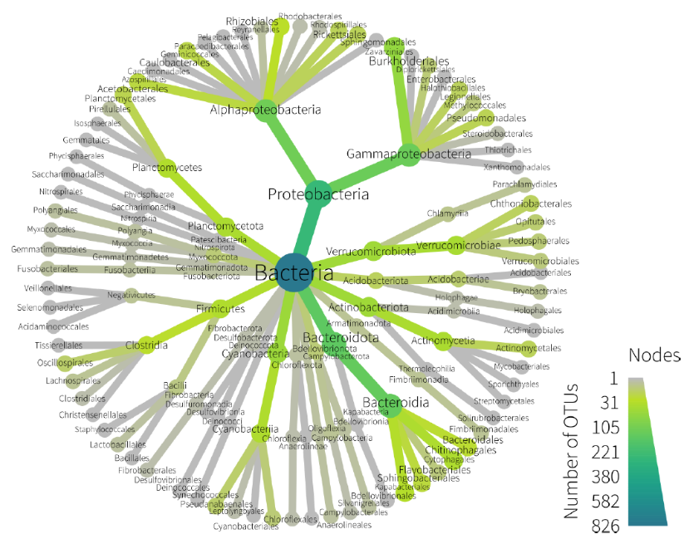

Woodland

Bacteria
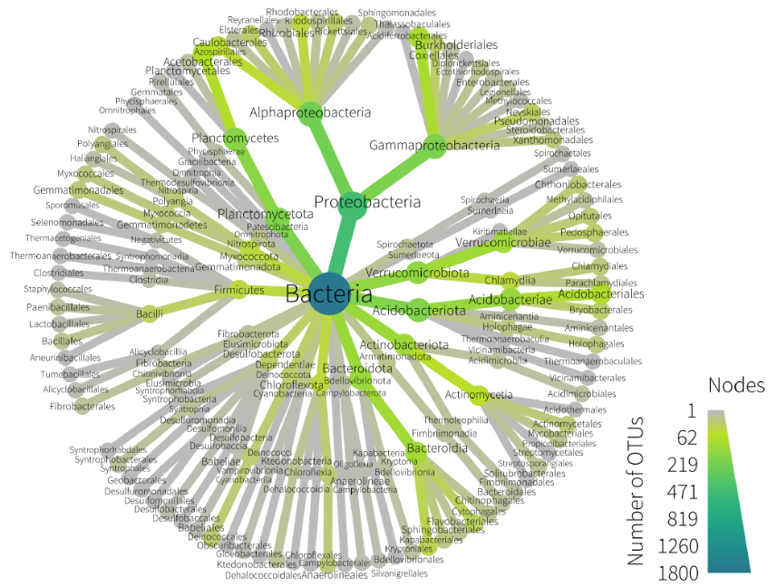

Fungi
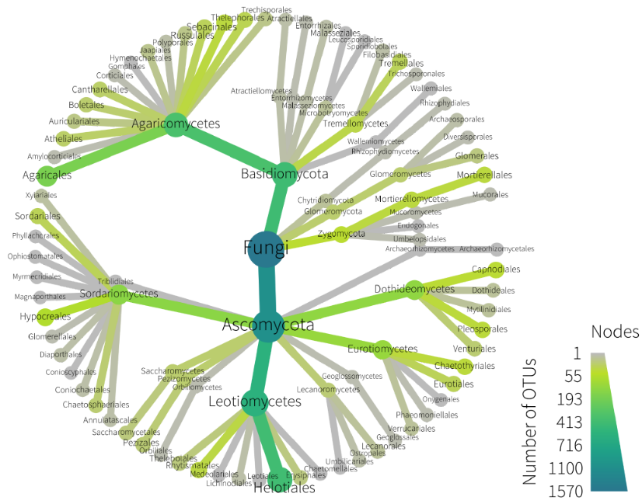

Soil Invertebrates
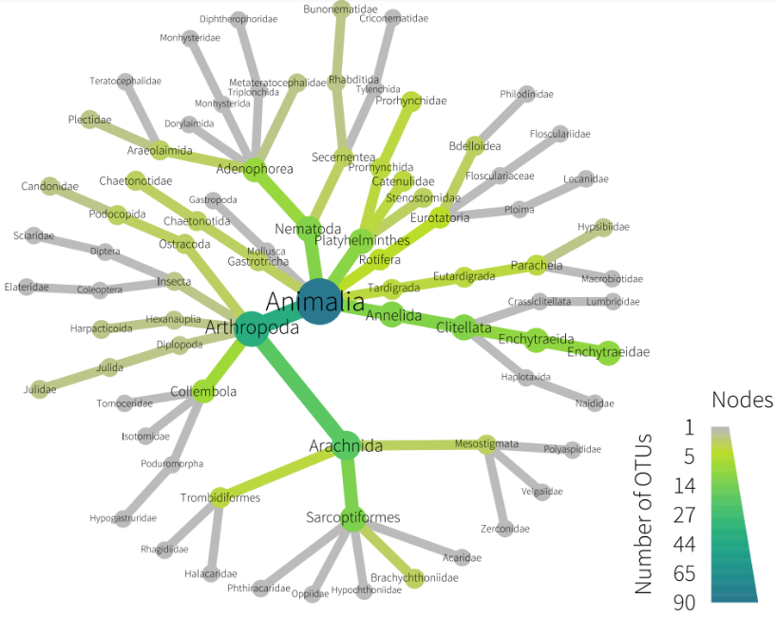

Peatland

Bacteria
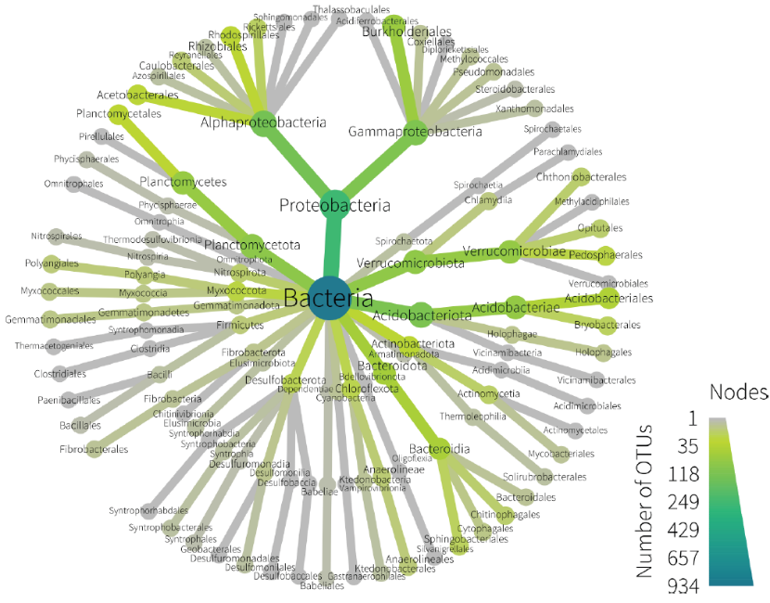

Fungi
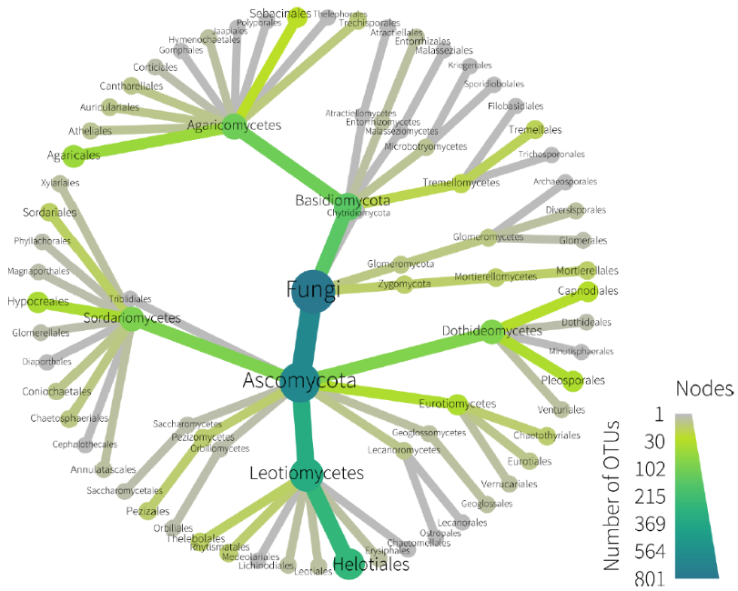

Soil Invertebrates
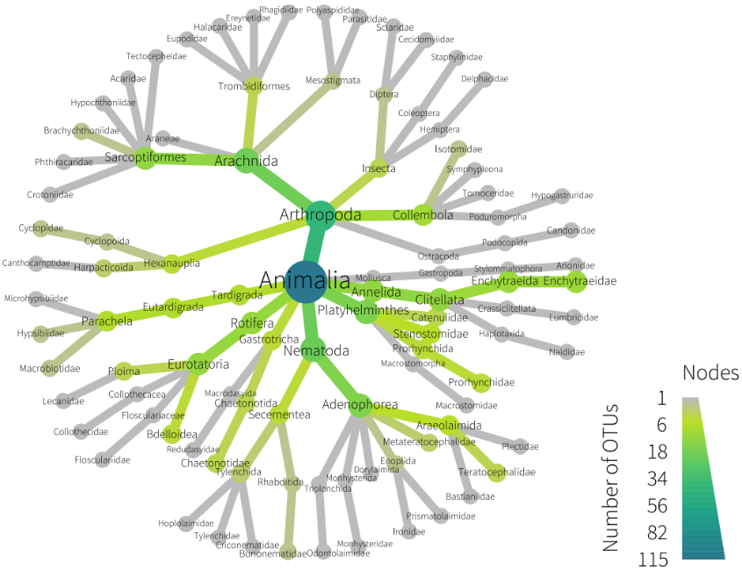

Sample Level Metrics
The figures in this section show the values and ranges for sample level metrics for all habitats and metrics interrogated in this project. The outputs of the models are shown below the plots. Results that showed clear and meaningful trends are discussed in the main report. In many cases there were statistically significant differences observed, but did not provide obvious and meaningful ecological inference – these are included in these Phase 2 Technical Appendices for completeness but not discussed further. For example, some marine biotopes had higher bacterial species richness than others – this is a useful descriptor of the biotopes but is not proposed as a core indictor for monitoring marine biotopes. For marine biotopes only Level-4 Particle Size Distribution biotopes are shown, as there were no community differences found for Level 5 biotopes.
Boxplots show the medians and percentiles for each group.

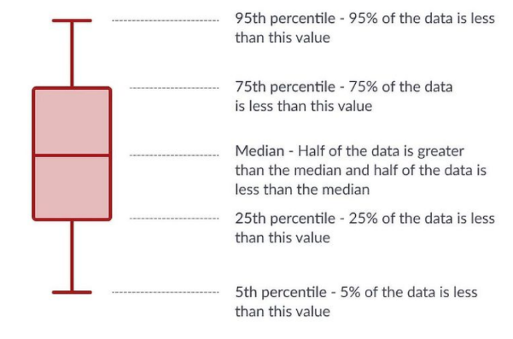

Marine Lochs

Bacteria
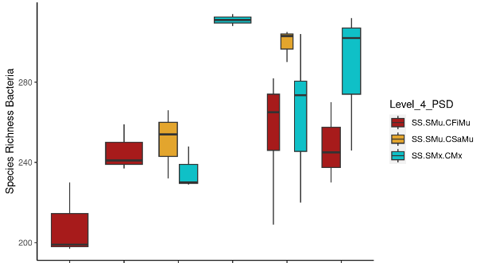
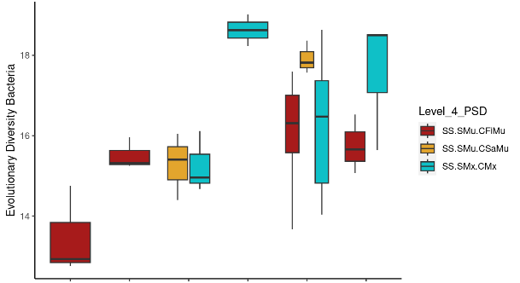
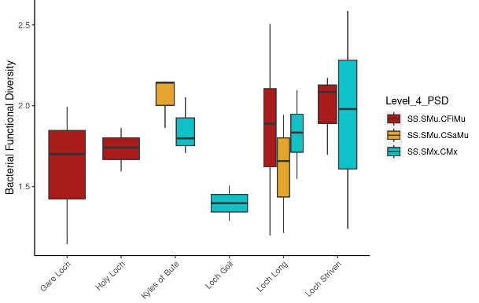

Figure 1: Medians and percentiles for Bacterial sample-level metrics.

## Species_Richness_Bacteria ~ Level_4_PSD + water_depth + salinity +
## temperature + (1 | Site)
## $`emmeans of Level_4_PSD`
## Level_4_PSD emmean SE df lower.CL upper.CL
## SS.SMu.CFiMu 260 15.1 4.96 221 298
## SS.SMu.CSaMu 284 16.8 7.78 245 323
## SS.SMx.CMx 281 15.8 5.53 242 320
##
## Degrees-of-freedom method: kenward-roger
## Confidence level used: 0.95
##
## $`pairwise differences of Level_4_PSD`
## 1 estimate SE df t.ratio p.value
## SS.SMu.CFiMu - SS.SMu.CSaMu -24.16 10.41 48.6 -2.320 0.0624
## SS.SMu.CFiMu - SS.SMx.CMx -21.52 7.24 48.7 -2.973 0.0125
## SS.SMu.CSaMu - SS.SMx.CMx 2.64 12.02 49.7 0.220 0.9738
##
## Degrees-of-freedom method: kenward-roger
## P value adjustment: tukey method for comparing a family of 3 estimates
##
## [3] "\"for each increase of 1 unit water_depth, Species_Richness_Bacteria increases 0.7719 units (p=0.3685)\""
## [4] "\"for each increase of 1 unit salinity, Species_Richness_Bacteria increases 52.3507 units (p=0.0049)\""
## [5] "\"for each increase of 1 unit temperature, Species_Richness_Bacteria increases 13.8201 units (p=0.0162)\""
## Overall model p value for Level_4_PSD=0.00292528112487104

## Evolutionary_Diversity_Bacteria ~ Level_4_PSD + water_depth +
## salinity + temperature + (1 | Site)
## $`emmeans of Level_4_PSD`
## Level_4_PSD emmean SE df lower.CL upper.CL
## SS.SMu.CFiMu 16.2 0.743 4.95 14.3 18.1
## SS.SMu.CSaMu 16.9 0.850 8.58 15.0 18.9
## SS.SMx.CMx 17.1 0.783 5.57 15.2 19.1
##
## Degrees-of-freedom method: kenward-roger
## Confidence level used: 0.95
##
## $`pairwise differences of Level_4_PSD`
## 1 estimate SE df t.ratio p.value
## SS.SMu.CFiMu - SS.SMu.CSaMu -0.697 0.572 49.0 -1.217 0.4487
## SS.SMu.CFiMu - SS.SMx.CMx -0.892 0.397 49.1 -2.246 0.0734
## SS.SMu.CSaMu - SS.SMx.CMx -0.196 0.658 49.9 -0.298 0.9524
##
## Degrees-of-freedom method: kenward-roger
## P value adjustment: tukey method for comparing a family of 3 estimates
##
## [3] "\"for each increase of 1 unit water_depth, Evolutionary_Diversity_Bacteria increases 0.0527 units (p=0.2645)\""
## [4] "\"for each increase of 1 unit salinity, Evolutionary_Diversity_Bacteria increases 2.4572 units (p=0.0127)\""
## [5] "\"for each increase of 1 unit temperature, Evolutionary_Diversity_Bacteria increases 0.8006 units (p=0.0111)\""
## Overall model p value for Level_4_PSD=0.0549411779515557

## Bacterial_Functional_Diversity ~ Level_4_PSD + water_depth +
## salinity + temperature + (1 | Site)
## $`emmeans of Level_4_PSD`
## Level_4_PSD emmean SE df lower.CL upper.CL
## SS.SMu.CFiMu 1.84 0.123 0.80 -1.07 4.76
## SS.SMu.CSaMu 1.80 0.155 30.35 1.48 2.11
## SS.SMx.CMx 1.82 0.118 4.16 1.50 2.14
##
## Degrees-of-freedom method: kenward-roger
## Confidence level used: 0.95
##
## $`pairwise differences of Level_4_PSD`
## 1 estimate SE df t.ratio p.value
## SS.SMu.CFiMu - SS.SMu.CSaMu 0.0469 0.182 31.3 0.257 0.9642
## SS.SMu.CFiMu - SS.SMx.CMx 0.0218 0.119 49.4 0.183 0.9818
## SS.SMu.CSaMu - SS.SMx.CMx -0.0251 0.196 47.6 -0.128 0.9910
##
## Degrees-of-freedom method: kenward-roger
## P value adjustment: tukey method for comparing a family of 3 estimates
##
## [3] "\"for each increase of 1 unit water_depth, Bacterial_Functional_Diversity decreases 0.0017 units (p=0.9083)\""
## [4] "\"for each increase of 1 unit salinity, Bacterial_Functional_Diversity increases 0.1953 units (p=0.2802)\""
## [5] "\"for each increase of 1 unit temperature, Bacterial_Functional_Diversity decreases 0.0316 units (p=0.6943)\""

Sediment Eukaryotes
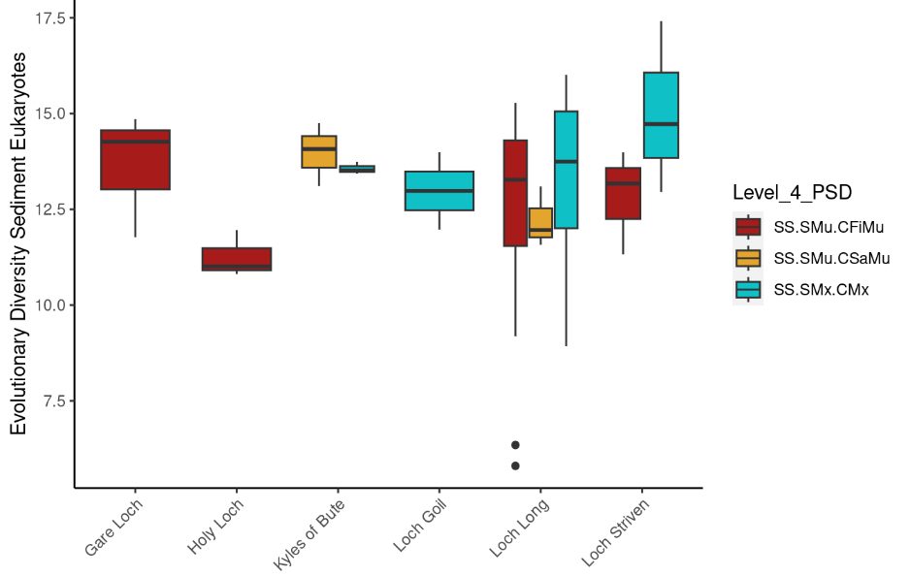
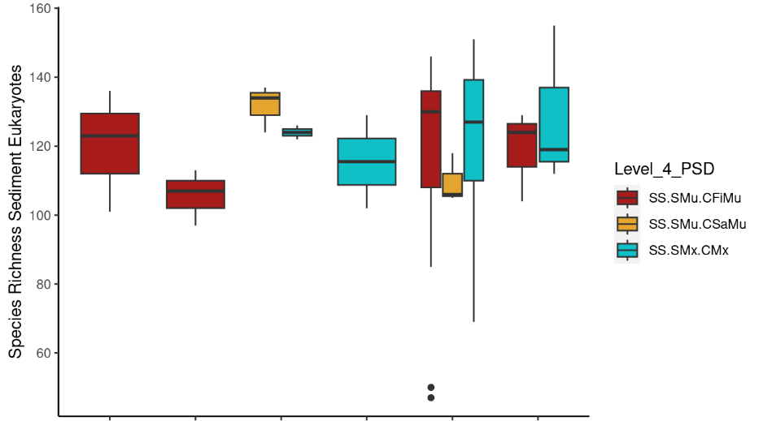

Figure 2: Medians and percentiles for Sediment Eukaryote sample-level metrics

## Species_Richness_Sediment_Eukaryotes ~ Level_4_PSD + water_depth +
## salinity + temperature + (1 | Site)
## $`emmeans of Level_4_PSD`
## Level_4_PSD emmean SE df lower.CL upper.CL
## SS.SMu.CFiMu 116 8.66 0.80 -87.9 321
## SS.SMu.CSaMu 119 10.85 30.35 96.5 141
## SS.SMx.CMx 123 8.28 4.16 100.4 146
##
## Degrees-of-freedom method: kenward-roger
## Confidence level used: 0.95
##
## $`pairwise differences of Level_4_PSD`
## 1 estimate SE df t.ratio p.value
## SS.SMu.CFiMu - SS.SMu.CSaMu -2.18 12.80 31.3 -0.170 0.9841
## SS.SMu.CFiMu - SS.SMx.CMx -6.57 8.38 49.4 -0.784 0.7143
## SS.SMu.CSaMu - SS.SMx.CMx -4.39 13.72 47.6 -0.320 0.9451
##
## Degrees-of-freedom method: kenward-roger
## P value adjustment: tukey method for comparing a family of 3 estimates
##
## [3] "\"for each increase of 1 unit water_depth, Species_Richness_Sediment_Eukaryotes increases 0.1055 units (p=0.9195)\""
## [4] "\"for each increase of 1 unit salinity, Species_Richness_Sediment_Eukaryotes increases 6.5168 units (p=0.6057)\""
## [5] "\"for each increase of 1 unit temperature, Species_Richness_Sediment_Eukaryotes increases 2.3884 units (p=0.6721)\""
## Overall model p value for Level_4_PSD=0.715339598215641

## Evolutionary_Diversity_Sediment_Eukaryotes ~ Level_4_PSD + water_depth +
## salinity + temperature + (1 | Site)
## $`emmeans of Level_4_PSD`
## Level_4_PSD emmean SE df lower.CL upper.CL
## SS.SMu.CFiMu 12.5 0.769 1.52 8.0 17.1
## SS.SMu.CSaMu 13.0 1.045 27.46 10.9 15.2
## SS.SMx.CMx 13.7 0.765 5.13 11.7 15.6
##
## Degrees-of-freedom method: kenward-roger
## Confidence level used: 0.95
##
## $`pairwise differences of Level_4_PSD`
## 1 estimate SE df t.ratio p.value
## SS.SMu.CFiMu - SS.SMu.CSaMu -0.506 1.189 35.4 -0.425 0.9055
## SS.SMu.CFiMu - SS.SMx.CMx -1.151 0.789 49.5 -1.459 0.3192
## SS.SMu.CSaMu - SS.SMx.CMx -0.645 1.286 48.1 -0.502 0.8709
##
## Degrees-of-freedom method: kenward-roger
## P value adjustment: tukey method for comparing a family of 3 estimates
##
## [3] "\"for each increase of 1 unit water_depth, Evolutionary_Diversity_Sediment_Eukaryotes increases 0.0094 units (p=0.9233)\""
## [4] "\"for each increase of 1 unit salinity, Evolutionary_Diversity_Sediment_Eukaryotes increases 0.1911 units (p=0.8762)\""
## [5] "\"for each increase of 1 unit temperature, Evolutionary_Diversity_Sediment_Eukaryotes increases 0.1121 units (p=0.8365)\""
## Overall model p value for Level_4_PSD=0.316930904968486

Sediment Invertebrates
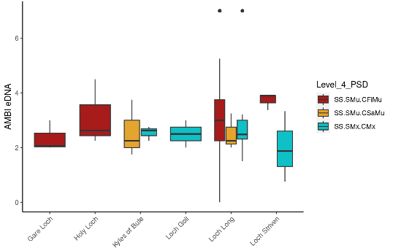
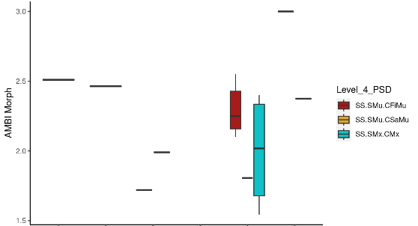
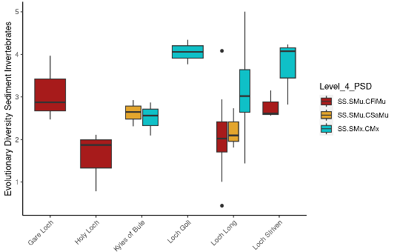
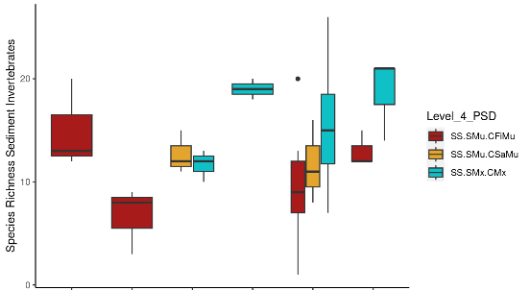

Figure 3: Medians and percentiles for Sediment Invertebrate sample-level metrics

## Species_Richness_Sediment_Invertebrates ~ Level_4_PSD + water_depth +
## salinity + temperature + (1 | Site)
## $`emmeans of Level_4_PSD`
## Level_4_PSD emmean SE df lower.CL upper.CL
## SS.SMu.CFiMu 10.4 1.58 4.46 6.17 14.6
## SS.SMu.CSaMu 14.9 2.39 19.08 9.93 19.9
## SS.SMx.CMx 15.0 1.73 6.16 10.78 19.2
##
## Degrees-of-freedom method: kenward-roger
## Confidence level used: 0.95
##
## $`pairwise differences of Level_4_PSD`
## 1 estimate SE df t.ratio p.value
## SS.SMu.CFiMu - SS.SMu.CSaMu -4.5395 2.37 47.5 -1.915 0.1455
## SS.SMu.CFiMu - SS.SMx.CMx -4.5876 1.61 49.8 -2.844 0.0174
## SS.SMu.CSaMu - SS.SMx.CMx -0.0481 2.61 49.4 -0.018 0.9998
##
## Degrees-of-freedom method: kenward-roger
## P value adjustment: tukey method for comparing a family of 3 estimates
##
## [3] "\"for each increase of 1 unit water_depth, Species_Richness_Sediment_Invertebrates decreases 0.3946 units (p=0.0485)\""
## [4] "\"for each increase of 1 unit salinity, Species_Richness_Sediment_Invertebrates increases 1.9163 units (p=0.5182)\""
## [5] "\"for each increase of 1 unit temperature, Species_Richness_Sediment_Invertebrates decreases 2.2423 units (p=0.0641)\""
## Overall model p value for Level_4_PSD=0.00671031298746801

## Evolutionary_Diversity_Sediment_Invertebrates ~ Level_4_PSD +
## water_depth + salinity + temperature + (1 | Site)
## $`emmeans of Level_4_PSD`
## Level_4_PSD emmean SE df lower.CL upper.CL
## SS.SMu.CFiMu 2.25 0.285 0.95 -1.91 6.40
## SS.SMu.CSaMu 2.90 0.362 29.16 2.16 3.64
## SS.SMx.CMx 2.99 0.276 3.84 2.22 3.77
##
## Degrees-of-freedom method: kenward-roger
## Confidence level used: 0.95
##
## $`pairwise differences of Level_4_PSD`
## 1 estimate SE df t.ratio p.value
## SS.SMu.CFiMu - SS.SMu.CSaMu -0.6475 0.426 31.4 -1.520 0.2956
## SS.SMu.CFiMu - SS.SMx.CMx -0.7457 0.279 47.6 -2.673 0.0272
## SS.SMu.CSaMu - SS.SMx.CMx -0.0983 0.458 45.8 -0.214 0.9750
##
## Degrees-of-freedom method: kenward-roger
## P value adjustment: tukey method for comparing a family of 3 estimates
##
## [1] "\"for each increase of 1 unit Level_4_PSDSS.SMu.CSaMu, Evolutionary_Diversity_Sediment_Invertebrates increases 0.6475 units (p=0.0851)\""
## [2] "\"for each increase of 1 unit Level_4_PSDSS.SMx.CMx, Evolutionary_Diversity_Sediment_Invertebrates increases 0.7457 units (p=0.0082)\""
## [3] "\"for each increase of 1 unit water_depth, Evolutionary_Diversity_Sediment_Invertebrates decreases 0.086 units (p=0.017)\""
## [4] "\"for each increase of 1 unit salinity, Evolutionary_Diversity_Sediment_Invertebrates decreases 0.0367 units (p=0.9305)\""
## [5] "\"for each increase of 1 unit temperature, Evolutionary_Diversity_Sediment_Invertebrates decreases 0.6641 units (p=0.001)\""
## Overall model p value for Level_4_PSD=0.0120269461819754

Fish
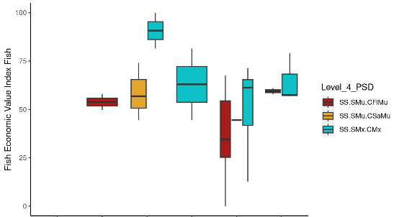
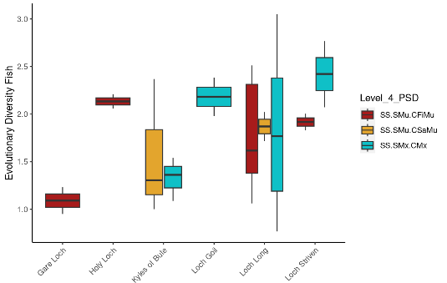
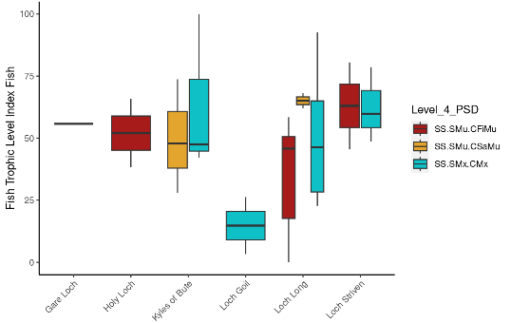
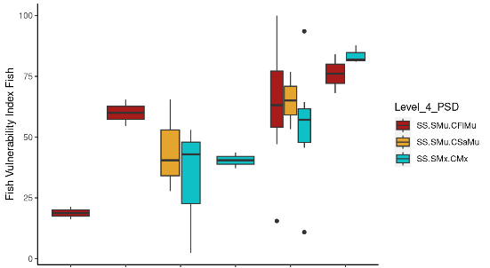
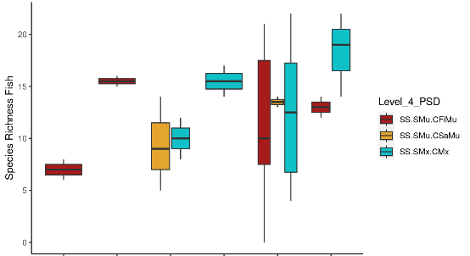

Figure 4: Medians and percentiles for Fish sample-level metrics

## Species_Richness_Fish ~ Level_4_PSD + water_depth + salinity +
## temperature + (1 | Site)
## $`emmeans of Level_4_PSD`
## Level_4_PSD emmean SE df lower.CL upper.CL
## SS.SMu.CFiMu 13.3 2.05 4.85 7.96 18.6
## SS.SMu.CSaMu 14.0 3.09 16.18 7.44 20.5
## SS.SMx.CMx 13.1 2.16 5.63 7.69 18.5
##
## Degrees-of-freedom method: kenward-roger
## Confidence level used: 0.95
##
## $`pairwise differences of Level_4_PSD`
## 1 estimate SE df t.ratio p.value
## SS.SMu.CFiMu - SS.SMu.CSaMu -0.713 3.14 33.8 -0.227 0.9719
## SS.SMu.CFiMu - SS.SMx.CMx 0.202 2.12 36.0 0.095 0.9950
## SS.SMu.CSaMu - SS.SMx.CMx 0.915 3.38 35.3 0.271 0.9605
##
## Degrees-of-freedom method: kenward-roger
## P value adjustment: tukey method for comparing a family of 3 estimates
##
## [3] "\"for each increase of 1 unit water_depth, Species_Richness_Fish decreases 0.5635 units (p=0.0422)\""
## [4] "\"for each increase of 1 unit salinity, Species_Richness_Fish increases 9.5619 units (p=0.0226)\""
## [5] "\"for each increase of 1 unit temperature, Species_Richness_Fish decreases 0.4364 units (p=0.7804)\""
## Overall model p value for Level_4_PSD=0.959989235946926

## Evolutionary_Diversity_Fish ~ Level_4_PSD + water_depth + salinity +
## temperature + (1 | Site)
## $`emmeans of Level_4_PSD`
## Level_4_PSD emmean SE df lower.CL upper.CL
## SS.SMu.CFiMu 1.94 0.213 5.06 1.39 2.48
## SS.SMu.CSaMu 2.05 0.318 15.89 1.38 2.72
## SS.SMx.CMx 1.79 0.225 5.58 1.23 2.36
##
## Degrees-of-freedom method: kenward-roger
## Confidence level used: 0.95
##
## $`pairwise differences of Level_4_PSD`
## 1 estimate SE df t.ratio p.value
## SS.SMu.CFiMu - SS.SMu.CSaMu -0.113 0.320 33.5 -0.354 0.9333
## SS.SMu.CFiMu - SS.SMx.CMx 0.143 0.218 35.0 0.658 0.7892
## SS.SMu.CSaMu - SS.SMx.CMx 0.256 0.344 34.5 0.745 0.7387
##
## Degrees-of-freedom method: kenward-roger
## P value adjustment: tukey method for comparing a family of 3 estimates
##
## [3] "\"for each increase of 1 unit water_depth, Evolutionary_Diversity_Fish decreases 0.0766 units (p=0.0081)\""
## [4] "\"for each increase of 1 unit salinity, Evolutionary_Diversity_Fish increases 1.2216 units (p=0.0069)\""
## [5] "\"for each increase of 1 unit temperature, Evolutionary_Diversity_Fish decreases 0.1397 units (p=0.3844)\""
## Overall model p value for Level_4_PSD=0.694842634584944

## Fish_Economic_Value_Index_Fish ~ Level_4_PSD + water_depth +
## salinity + temperature + (1 | Site)
## $`emmeans of Level_4_PSD`
## Level_4_PSD emmean SE df lower.CL upper.CL
## SS.SMu.CFiMu 58.7 9.65 4.51 33.1 84.4
## SS.SMu.CSaMu 64.7 12.84 9.40 35.9 93.6
## SS.SMx.CMx 58.2 10.15 5.38 32.7 83.8
##
## Degrees-of-freedom method: kenward-roger
## Confidence level used: 0.95
##
## $`pairwise differences of Level_4_PSD`
## 1 estimate SE df t.ratio p.value
## SS.SMu.CFiMu - SS.SMu.CSaMu -6.011 10.93 30.0 -0.550 0.8472
## SS.SMu.CFiMu - SS.SMx.CMx 0.504 8.65 29.6 0.058 0.9981
## SS.SMu.CSaMu - SS.SMx.CMx 6.515 13.58 29.8 0.480 0.8813
##
## Degrees-of-freedom method: kenward-roger
## P value adjustment: tukey method for comparing a family of 3 estimates

## [3] "\"for each increase of 1 unit water_depth, Fish_Economic_Value_Index_Fish decreases 0.9634 units (p=0.3024)\""
## [4] "\"for each increase of 1 unit salinity, Fish_Economic_Value_Index_Fish decreases 3.0425 units (p=0.8781)\""
## [5] "\"for each increase of 1 unit temperature, Fish_Economic_Value_Index_Fish increases 10.4516 units (p=0.0716)\""
## Overall model p value for Level_4_PSD=0.836958890347074

## Fish_Vulnerability_Index_Fish ~ Level_4_PSD + water_depth + salinity +
## temperature + (1 | Site)
## $`emmeans of Level_4_PSD`
## Level_4_PSD emmean SE df lower.CL upper.CL
## SS.SMu.CFiMu 59.8 8.36 1.01 -43.3 162.9
## SS.SMu.CSaMu 49.7 9.93 20.64 29.0 70.4
## SS.SMx.CMx 56.5 6.75 6.93 40.5 72.5
##
## Degrees-of-freedom method: kenward-roger
## Confidence level used: 0.95
##
## $`pairwise differences of Level_4_PSD`
## 1 estimate SE df t.ratio p.value
## SS.SMu.CFiMu - SS.SMu.CSaMu 10.09 12.52 17.6 0.806 0.7046
## SS.SMu.CFiMu - SS.SMx.CMx 3.32 8.83 30.7 0.376 0.9254
## SS.SMu.CSaMu - SS.SMx.CMx -6.77 12.64 33.0 -0.536 0.8544
##
## Degrees-of-freedom method: kenward-roger
## P value adjustment: tukey method for comparing a family of 3 estimates
##
## [3] "\"for each increase of 1 unit water_depth, Fish_Vulnerability_Index_Fish decreases 0.5841 units (p=0.5808)\""
## [4] "\"for each increase of 1 unit salinity, Fish_Vulnerability_Index_Fish increases 25.9619 units (p=0.0435)\""
## [5] "\"for each increase of 1 unit temperature, Fish_Vulnerability_Index_Fish decreases 11.3503 units (p=0.0452)\""
## Overall model p value for Level_4_PSD=0.581091054756048

## Fish_Trophic_Level_Index_Fish ~ Level_4_PSD + water_depth + salinity +
## temperature + (1 | Site)
## $`emmeans of Level_4_PSD`
## Level_4_PSD emmean SE df lower.CL upper.CL
## SS.SMu.CFiMu 40.6 9.68 4.48 14.8 66.3
## SS.SMu.CSaMu 51.7 14.32 15.18 21.3 82.2
## SS.SMx.CMx 55.3 9.82 5.79 31.0 79.5
##
## Degrees-of-freedom method: kenward-roger
## Confidence level used: 0.95
##
## $`pairwise differences of Level_4_PSD`
## 1 estimate SE df t.ratio p.value
## SS.SMu.CFiMu - SS.SMu.CSaMu -11.18 14.9 29.3 -0.749 0.7366
## SS.SMu.CFiMu - SS.SMx.CMx -14.71 10.7 32.9 -1.370 0.3679
## SS.SMu.CSaMu - SS.SMx.CMx -3.53 16.3 32.1 -0.216 0.9746
##
## Degrees-of-freedom method: kenward-roger
## P value adjustment: tukey method for comparing a family of 3 estimates
##
## [3] "\"for each increase of 1 unit water_depth, Fish_Trophic_Level_Index_Fish increases 1.1908 units (p=0.3608)\""
## [4] "\"for each increase of 1 unit salinity, Fish_Trophic_Level_Index_Fish decreases 8.8233 units (p=0.643)\""
## [5] "\"for each increase of 1 unit temperature, Fish_Trophic_Level_Index_Fish increases 2.6043 units (p=0.7206)\""
## Overall model p value for Level_4_PSD=0.309937992242174

Freshwater Lochs

Bacteria
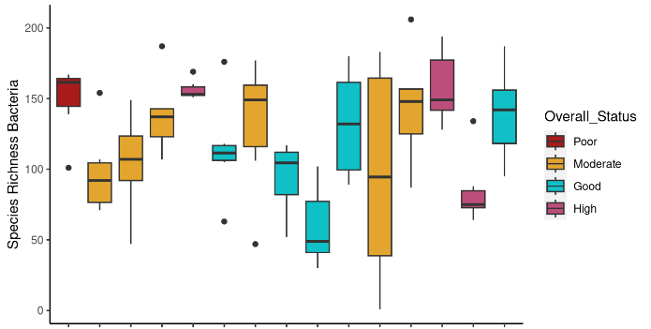

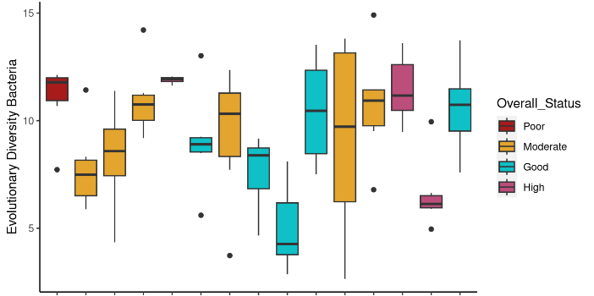

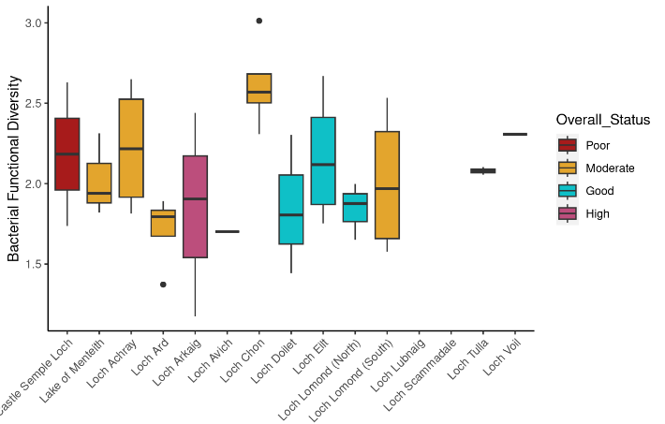

C

Figure 5: Medians and percentiles for Bacteria sample-level metrics. Contains SEPA data © Scottish Environment Protection Agency and database right (2023). All rights reserved.
## Species_Richness_Bacteria ~ Overall_Status + pH_field + Conductivity_field +
## (1 | Site)
## $`emmeans of Overall_Status`
## Overall_Status emmean SE df lower.CL upper.CL
## Poor 149 28.1 10.1 86.6 211
## Moderate 120 11.7 10.8 93.8 146
## Good 107 12.6 10.3 78.7 135
## High 134 16.5 10.6 97.0 170
##
## Degrees-of-freedom method: kenward-roger
## Confidence level used: 0.95
##
## $`pairwise differences of Overall_Status`
## 1 estimate SE df t.ratio p.value
## Poor - Moderate 29.4 30.3 10.1 0.970 0.7687
## Poor - Good 42.2 30.8 10.2 1.370 0.5432
## Poor - High 15.5 32.7 10.4 0.473 0.9635
## Moderate - Good 12.9 17.5 10.9 0.738 0.8796
## Moderate - High -13.9 20.7 11.2 -0.671 0.9057
## Good - High -26.8 20.6 10.2 -1.302 0.5815
##
## Degrees-of-freedom method: kenward-roger
## P value adjustment: tukey method for comparing a family of 4 estimates
##
## [4] "\"for each increase of 1 unit pH_field, Species_Richness_Bacteria increases 2.1443 units (p=0.8395)\""
## [5] "\"for each increase of 1 unit Conductivity_field, Species_Richness_Bacteria increases 52.2641 units (p=0.0752)\""
## Overall model p value for Overall_Status=0.444601670050066

## Evolutionary_Diversity_Bacteria ~ Overall_Status + pH_field +
## Conductivity_field + (1 | Site)
## $`emmeans of Overall_Status`
## Overall_Status emmean SE df lower.CL upper.CL
## Poor 11.01 1.941 10.1 6.69 15.3
## Moderate 9.41 0.813 10.9 7.62 11.2
## Good 8.48 0.872 10.3 6.55 10.4
## High 10.04 1.140 10.6 7.52 12.6
##
## Degrees-of-freedom method: kenward-roger
## Confidence level used: 0.95
##
## $`pairwise differences of Overall_Status`
## 1 estimate SE df t.ratio p.value
## Poor - Moderate 1.597 2.09 10.1 0.763 0.8693
## Poor - Good 2.521 2.13 10.2 1.182 0.6507
## Poor - High 0.963 2.26 10.4 0.426 0.9728
## Moderate - Good 0.923 1.21 10.9 0.766 0.8681
## Moderate - High -0.634 1.43 11.2 -0.445 0.9693
## Good - High -1.558 1.42 10.2 -1.095 0.6999
##
## Degrees-of-freedom method: kenward-roger
## P value adjustment: tukey method for comparing a family of 4 estimates
##
## [4] "\"for each increase of 1 unit pH_field, Evolutionary_Diversity_Bacteria increases 0.1768 units (p=0.799)\""
## [5] "\"for each increase of 1 unit Conductivity_field, Evolutionary_Diversity_Bacteria increases 2.9131 units (p=0.1236)\""
## Overall model p value for Overall_Status=0.569952242183404

## Bacterial_Functional_Diversity ~ Overall_Status + pH_field +
## Conductivity_field + (1 | Site)
## $`emmeans of Overall_Status`
## Overall_Status emmean SE df lower.CL upper.CL
## Poor 2.23 0.325 12.91 1.52 2.93
## Moderate 2.17 0.126 6.13 1.86 2.47
## Good 1.93 0.145 9.48 1.60 2.25
## High 1.88 0.232 10.28 1.36 2.39
##
## Degrees-of-freedom method: kenward-roger
## Confidence level used: 0.95
##
## $`pairwise differences of Overall_Status`
## 1 estimate SE df t.ratio p.value
## Poor - Moderate 0.0607 0.343 11.58 0.177 0.9979
## Poor - Good 0.2971 0.358 12.60 0.830 0.8394
## Poor - High 0.3503 0.407 12.09 0.861 0.8244
## Moderate - Good 0.2364 0.198 8.68 1.196 0.6445
## Moderate - High 0.2896 0.279 9.36 1.039 0.7318
## Good - High 0.0532 0.267 8.82 0.199 0.9970
##
## Degrees-of-freedom method: kenward-roger
## P value adjustment: tukey method for comparing a family of 4 estimates
##
## [4] "\"for each increase of 1 unit pH_field, Bacterial_Functional_Diversity decreases 0.1647 units (p=0.2151)\""
## [5] "\"for each increase of 1 unit Conductivity_field, Bacterial_Functional_Diversity increases 0.4663 units (p=0.2521)\""
## Overall model p value for Overall_Status=0.565413886170973

Vertebrates
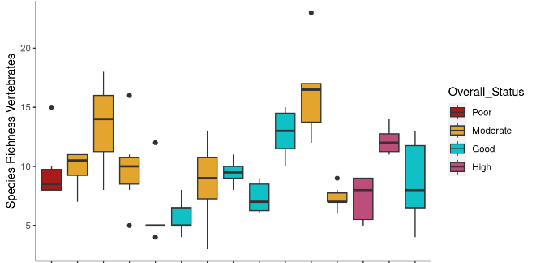
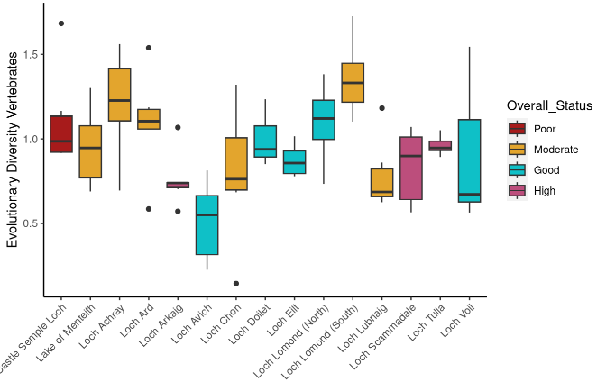

C

Figure 6: Medians and percentiles for Vertebrate sample-level metrics. Contains SEPA data © Scottish Environment Protection Agency and database right (2023). All rights reserved.

## Species_Richness_Vertebrates ~ Overall_Status + pH_field + Conductivity_field + (1 | Site)
## $`emmeans of Overall_Status`
## Overall_Status emmean SE df lower.CL upper.CL
## Poor 9.81 3.12 10.5 2.90 16.7
## Moderate 11.20 1.29 10.9 8.37 14.0
## Good 8.60 1.40 10.6 5.51 11.7
## High 8.26 1.82 10.8 4.25 12.3
##
## Degrees-of-freedom method: kenward-roger
## Confidence level used: 0.95
##
## $`pairwise differences of Overall_Status`
## 1 estimate SE df t.ratio p.value
## Poor - Moderate -1.40 3.37 10.5 -0.415 0.9746
## Poor - Good 1.20 3.42 10.6 0.352 0.9843
## Poor - High 1.54 3.62 10.7 0.426 0.9728
## Moderate - Good 2.60 1.91 11.0 1.359 0.5475
## Moderate - High 2.94 2.25 11.2 1.306 0.5778
## Good - High 0.34 2.28 10.6 0.149 0.9988

## Degrees-of-freedom method: kenward-roger
## P value adjustment: tukey method for comparing a family of 4 estimates
##
## [4] "\"for each increase of 1 unit pH_field, Species_Richness_Vertebrates decreases 0.7684 units (p=0.3648)\""
## [5] "\"for each increase of 1 unit Conductivity_field, Species_Richness_Vertebrates increases 4.2008 units (p=0.0532)\""
## Overall model p value for Overall_Status=0.497530609195422

## Evolutionary_Diversity_Vertebrates ~ Overall_Status + pH_field +
## Conductivity_field + (1 | Site)
## $`emmeans of Overall_Status`
## Overall_Status emmean SE df lower.CL upper.CL
## Poor 1.120 0.2093 10.2 0.655 1.58
## Moderate 1.052 0.0873 10.8 0.859 1.24
## Good 0.858 0.0941 10.4 0.649 1.07
## High 0.836 0.1230 10.7 0.564 1.11
##
## Degrees-of-freedom method: kenward-roger
## Confidence level used: 0.95
##
## $`pairwise differences of Overall_Status`
## 1 estimate SE df t.ratio p.value
## Poor - Moderate 0.0679 0.226 10.2 0.301 0.9900
## Poor - Good 0.2618 0.230 10.3 1.138 0.6756
## Poor - High 0.2834 0.244 10.4 1.161 0.6621
## Moderate - Good 0.1939 0.130 10.9 1.493 0.4733
## Moderate - High 0.2156 0.154 11.2 1.403 0.5225
## Good - High 0.0216 0.153 10.3 0.141 0.9989
##
## Degrees-of-freedom method: kenward-roger
## P value adjustment: tukey method for comparing a family of 4 estimates
##
## [4] "\"for each increase of 1 unit pH_field, Evolutionary_Diversity_Vertebrates decreases 0.0572 units (p=0.4475)\""
## [5] "\"for each increase of 1 unit Conductivity_field, Evolutionary_Diversity_Vertebrates increases 0.3279 units (p=0.1096)\""
## Overall model p value for Overall_Status=0.349735706897832

Freshwater Insects
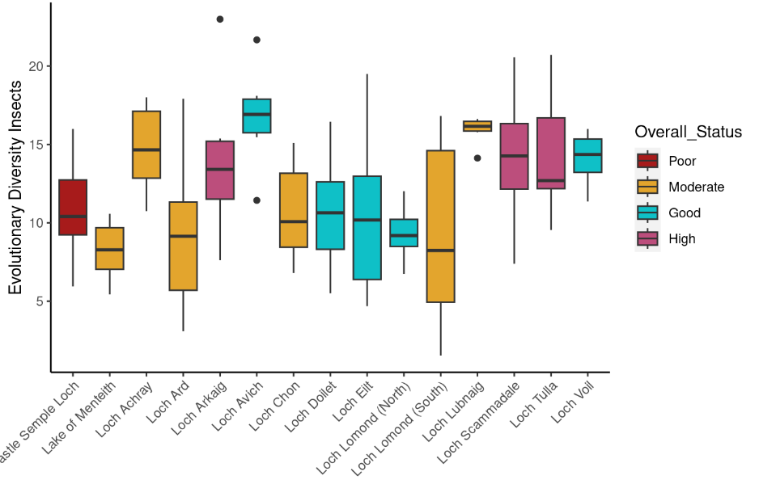
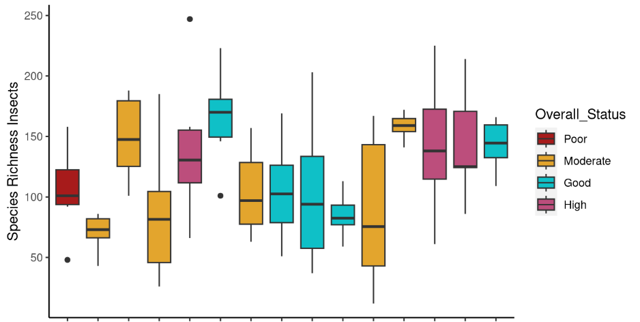
Ca

Figure 7: Medians and percentiles for Freshwater Insects sample-level metrics. Contains SEPA data © Scottish Environment Protection Agency and database right (2023). All rights reserved.

## Species_Richness_Insects ~ Overall_Status + pH_field + Conductivity_field +
## (1 | Site)
## $`emmeans of Overall_Status`
## Overall_Status emmean SE df lower.CL upper.CL
## Poor 105 32.2 10.1 33.4 177
## Moderate 110 13.5 10.7 80.5 140
## Good 119 14.5 10.3 87.1 151
## High 142 19.0 10.6 99.6 184
##
## Degrees-of-freedom method: kenward-roger
## Confidence level used: 0.95
##
## $`pairwise differences of Overall_Status`
## 1 estimate SE df t.ratio p.value
## Poor - Moderate -5.19 34.8 10.1 -0.149 0.9987
## Poor - Good -14.17 35.5 10.2 -0.400 0.9772
## Poor - High -36.57 37.6 10.3 -0.971 0.7682
## Moderate - Good -8.98 20.1 10.9 -0.447 0.9689
## Moderate - High -31.38 23.8 11.1 -1.317 0.5715
## Good - High -22.40 23.6 10.2 -0.948 0.7805
##
## Degrees-of-freedom method: kenward-roger
## P value adjustment: tukey method for comparing a family of 4 estimates
##
## [4] "\"for each increase of 1 unit pH_field, Species_Richness_Insects decreases 1.0063 units (p=0.9362)\""
## [5] "\"for each increase of 1 unit Conductivity_field, Species_Richness_Insects increases 31.6344 units (p=0.3669)\""
## Overall model p value for Overall_Status=0.598861623127089

## Evolutionary_Diversity_Insects ~ Overall_Status + pH_field +
## Conductivity_field + (1 | Site)
## $`emmeans of Overall_Status`
## Overall_Status emmean SE df lower.CL upper.CL
## Poor 10.8 2.93 10.1 4.32 17.4
## Moderate 11.4 1.22 10.7 8.67 14.1
## Good 12.2 1.32 10.3 9.30 15.2
## High 14.2 1.73 10.6 10.37 18.0
##
## Degrees-of-freedom method: kenward-roger
## Confidence level used: 0.95
##
## $`pairwise differences of Overall_Status`
## 1 estimate SE df t.ratio p.value
## Poor - Moderate -0.537 3.16 10.1 -0.170 0.9981
## Poor - Good -1.389 3.22 10.2 -0.431 0.9717
## Poor - High -3.345 3.42 10.4 -0.978 0.7645
## Moderate - Good -0.852 1.82 10.9 -0.467 0.9647
## Moderate - High -2.808 2.16 11.2 -1.299 0.5820
## Good - High -1.956 2.15 10.2 -0.911 0.7994
##
## Degrees-of-freedom method: kenward-roger
## P value adjustment: tukey method for comparing a family of 4 estimates
##
## [4] "\"for each increase of 1 unit pH_field, Evolutionary_Diversity_Insects increases 0.1167 units (p=0.9176)\""
## [5] "\"for each increase of 1 unit Conductivity_field, Evolutionary_Diversity_Insects increases 2.7139 units (p=0.3863)\""
## Overall model p value for Overall_Status=0.605564522392769

Woodland

Soil Invertebrates
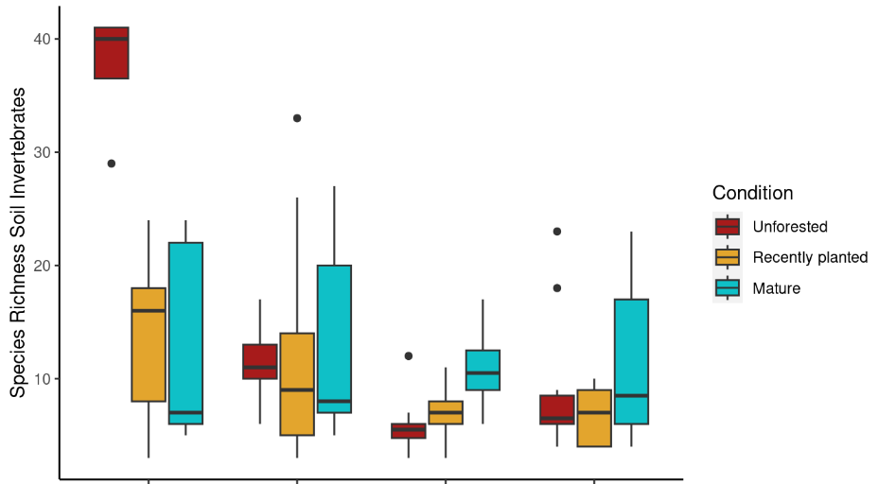
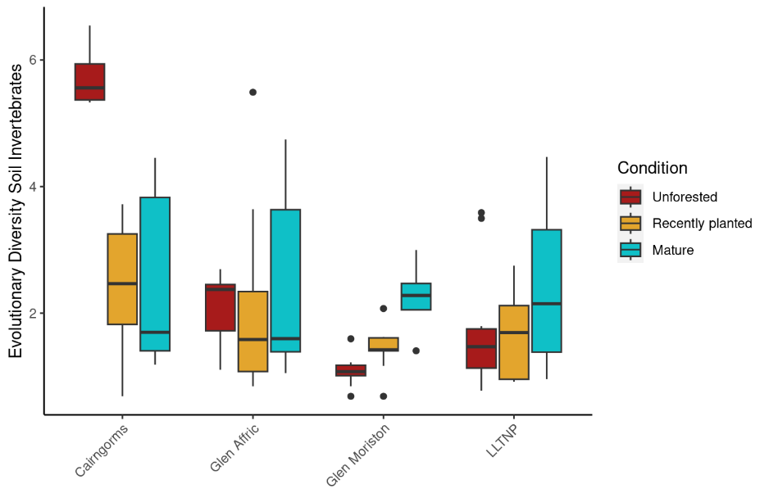
Figure 8: Medians and percentiles for Soil Invertebrates sample-level metrics.

## Species_Richness_Soil_Invertebrates ~ Condition + pH + Moisture +
## (1 | Site)
## $`emmeans of Condition`
## Condition emmean SE df lower.CL upper.CL
## Unforested 13.3 2.46 5.80 7.21 19.3
## Recently planted 10.4 2.30 4.51 4.27 16.5
## Mature 11.1 2.44 5.60 4.99 17.1
##
## Degrees-of-freedom method: kenward-roger
## Confidence level used: 0.95
##
## $`pairwise differences of Condition`
## 1 estimate SE df t.ratio p.value
## Unforested - Recently planted 2.910 1.94 90.1 1.498 0.2967
## Unforested - Mature 2.220 2.45 90.7 0.908 0.6370
## Recently planted - Mature -0.691 2.01 90.3 -0.344 0.9371
##
## Degrees-of-freedom method: kenward-roger
## P value adjustment: tukey method for comparing a family of 3 estimates
##
## [3] "\"for each increase of 1 unit pH, Species_Richness_Soil_Invertebrates increases 3.6344 units (p=0.0998)\""
## [4] "\"for each increase of 1 unit Moisture, Species_Richness_Soil_Invertebrates decreases 0.2062 units (p=1e-04)\""
## Overall model p value for Condition=0.326821069902751
## Evolutionary_Diversity_Soil_Invertebrates ~ Condition + pH +
## Moisture + (1 | Site)
## $`emmeans of Condition`
## Condition emmean SE df lower.CL upper.CL
## Unforested 2.29 0.352 6.38 1.44 3.13
## Recently planted 1.97 0.326 4.82 1.12 2.81
## Mature 2.21 0.348 6.13 1.36 3.05
##
## Degrees-of-freedom method: kenward-roger
## Confidence level used: 0.95
##
## $`pairwise differences of Condition`
## 1 estimate SE df t.ratio p.value
## Unforested - Recently planted 0.319 0.295 90.2 1.080 0.5286
## Unforested - Mature 0.079 0.371 90.9 0.213 0.9753
## Recently planted - Mature -0.240 0.305 90.5 -0.785 0.7131
##
## Degrees-of-freedom method: kenward-roger
## P value adjustment: tukey method for comparing a family of 3 estimates
##
## [3] "\"for each increase of 1 unit pH, Evolutionary_Diversity_Soil_Invertebrates increases 0.4916 units (p=0.1416)\""
## [4] "\"for each increase of 1 unit Moisture, Evolutionary_Diversity_Soil_Invertebrates decreases 0.0348 units (p=0)\""
## Overall model p value for Condition=0.480316164993715

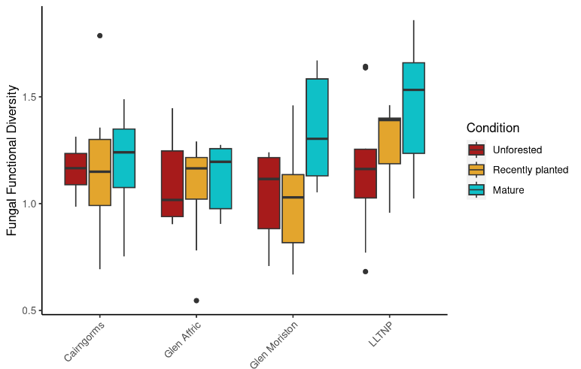
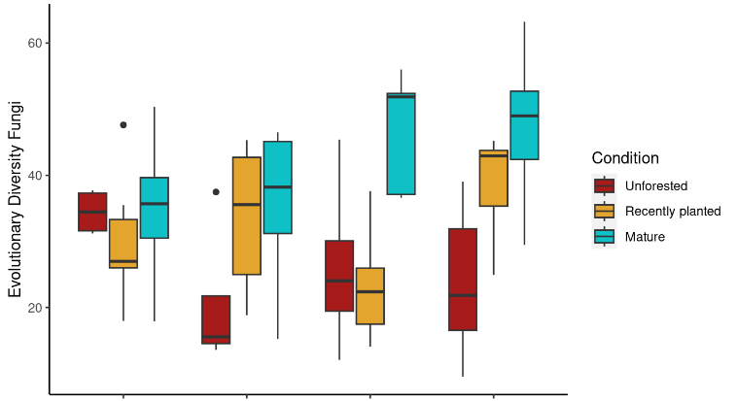
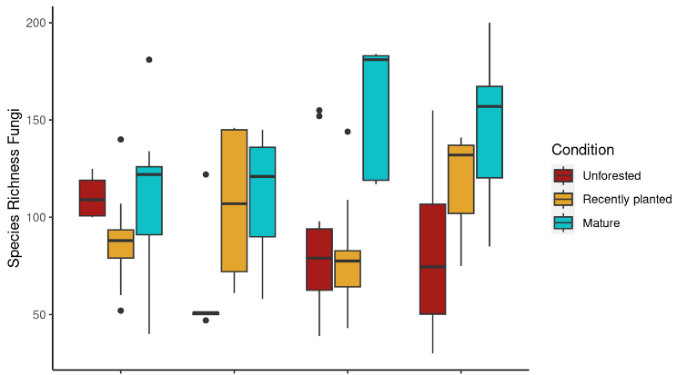
Fungi
Figure 9: Medians and percentiles for Fungal sample-level metrics.
## Species_Richness_Fungi ~ Condition + pH + Moisture + (1 | Site)
## $`emmeans of Condition`
## Condition emmean SE df lower.CL upper.CL
## Unforested 80.4 8.27 16.64 62.9 97.8
## Recently planted 96.2 6.89 9.37 80.7 111.7
## Mature 129.9 7.79 13.63 113.2 146.7
##
## Degrees-of-freedom method: kenward-roger
## Confidence level used: 0.95
##
## $`pairwise differences of Condition`
## 1 estimate SE df t.ratio p.value
## Unforested - Recently planted -15.8 9.43 93.8 -1.674 0.2205
## Unforested - Mature -49.6 11.57 94.0 -4.283 0.0001
## Recently planted - Mature -33.8 9.38 94.0 -3.600 0.0015
##
## Degrees-of-freedom method: kenward-roger
## P value adjustment: tukey method for comparing a family of 3 estimates
##
## [3] "\"for each increase of 1 unit pH, Species_Richness_Fungi increases 16.1293 units (p=0.119)\""
## [4] "\"for each increase of 1 unit Moisture, Species_Richness_Fungi decreases 0.5695 units (p=0.0133)\""
## Overall model p value for Condition=8.52353380234338e-05

## Evolutionary_Diversity_Fungi ~ Condition + pH + Moisture + (1 |
## Site)
## $`emmeans of Condition`
## Condition emmean SE df lower.CL upper.CL
## Unforested 24.7 2.50 13.14 19.3 30.1
## Recently planted 30.5 2.13 7.66 25.5 35.4
## Mature 40.9 2.37 10.89 35.7 46.1
##
## Degrees-of-freedom method: kenward-roger
## Confidence level used: 0.95
##
## $`pairwise differences of Condition`
## 1 estimate SE df t.ratio p.value
## Unforested - Recently planted -5.73 2.69 93.4 -2.127 0.0899
## Unforested - Mature -16.20 3.31 93.9 -4.893 <.0001
## Recently planted - Mature -10.47 2.68 93.9 -3.902 0.0005
##
## Degrees-of-freedom method: kenward-roger
## P value adjustment: tukey method for comparing a family of 3 estimates
##
## [3] "\"for each increase of 1 unit pH, Evolutionary_Diversity_Fungi increases 4.1431 units (p=0.162)\""
## [4] "\"for each increase of 1 unit Moisture, Evolutionary_Diversity_Fungi decreases 0.1781 units (p=0.0078)\""
## Overall model p value for Condition=9.88413061183587e-06

## Fungal_Functional_Diversity ~ Condition + pH + Moisture + (1 |
## Site)
## $`emmeans of Condition`
## Condition emmean SE df lower.CL upper.CL
## Unforested 1.07 0.0693 9.04 0.913 1.23
## Recently planted 1.12 0.0613 5.78 0.968 1.27
## Mature 1.31 0.0666 7.73 1.156 1.47
##
## Degrees-of-freedom method: kenward-roger
## Confidence level used: 0.95
##
## $`pairwise differences of Condition`
## 1 estimate SE df t.ratio p.value
## Unforested - Recently planted -0.0505 0.0668 92.7 -0.755 0.7313
## Unforested - Mature -0.2414 0.0822 93.3 -2.937 0.0115
## Recently planted - Mature -0.1909 0.0666 93.3 -2.867 0.0141
##
## Degrees-of-freedom method: kenward-roger
## P value adjustment: tukey method for comparing a family of 3 estimates
##
## [3] "\"for each increase of 1 unit pH, Fungal_Functional_Diversity increases 0.1345 units (p=0.0695)\""
## [4] "\"for each increase of 1 unit Moisture, Fungal_Functional_Diversity decreases 0.0021 units (p=0.205)\""
## Overall model p value for Condition=0.00633737036639761

Bacteria
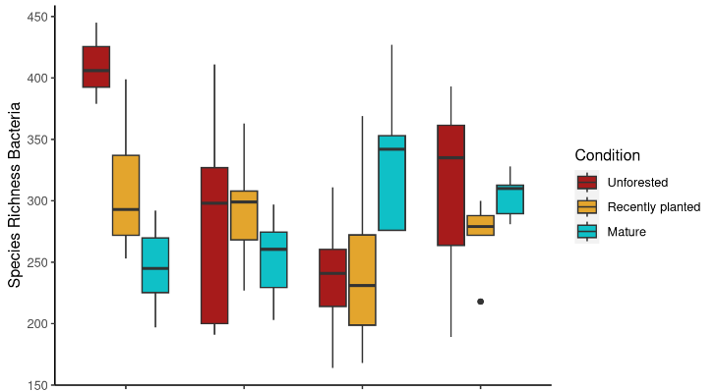
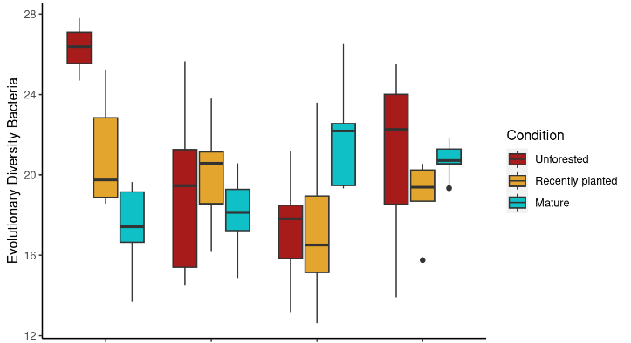
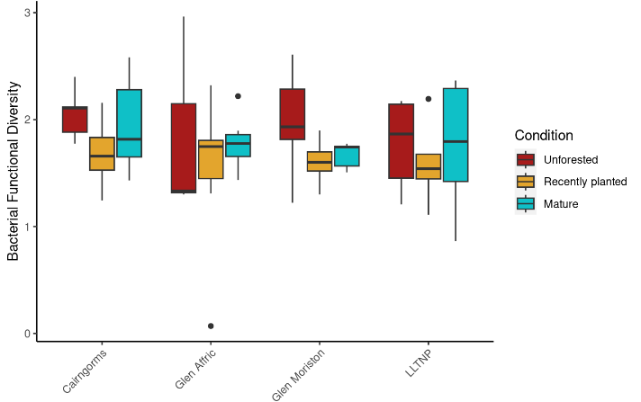

Figure 10: Medians and percentiles for Bacterial sample-level metrics.

## Species_Richness_Bacteria ~ Condition + pH + Moisture + (1 |
## Site)
## $`emmeans of Condition`
## Condition emmean SE df lower.CL upper.CL
## Unforested 272 15.8 9.26 237 308
## Recently planted 277 13.7 5.53 243 311
## Mature 293 14.8 7.19 258 328
##
## Degrees-of-freedom method: kenward-roger
## Confidence level used: 0.95
##
## $`pairwise differences of Condition`
## 1 estimate SE df t.ratio p.value
## Unforested - Recently planted -4.48 14.8 94.0 -0.304 0.9504
## Unforested - Mature -20.47 18.3 94.2 -1.117 0.5057
## Recently planted - Mature -15.99 14.2 93.4 -1.130 0.4983
##
## Degrees-of-freedom method: kenward-roger
## P value adjustment: tukey method for comparing a family of 3 estimates
##
## [3] "\"for each increase of 1 unit pH, Species_Richness_Bacteria increases 72.7748 units (p=0)\""
## [4] "\"for each increase of 1 unit Moisture, Species_Richness_Bacteria decreases 0.5914 units (p=0.1329)\""
## Overall model p value for Condition=0.454283577392559

## Evolutionary_Diversity_Bacteria ~ Condition + pH + Moisture +
## (1 | Site)
## $`emmeans of Condition`
## Condition emmean SE df lower.CL upper.CL
## Unforested 18.9 0.862 8.71 17.0 20.9
## Recently planted 19.2 0.752 5.31 17.3 21.1
## Mature 20.0 0.806 6.82 18.1 21.9
##
## Degrees-of-freedom method: kenward-roger
## Confidence level used: 0.95
##
## $`pairwise differences of Condition`
## 1 estimate SE df t.ratio p.value
## Unforested - Recently planted -0.292 0.785 93.9 -0.372 0.9267
## Unforested - Mature -1.064 0.975 94.1 -1.092 0.5214
## Recently planted - Mature -0.772 0.753 93.3 -1.026 0.5625
##
## Degrees-of-freedom method: kenward-roger
## P value adjustment: tukey method for comparing a family of 3 estimates
##
## [3] "\"for each increase of 1 unit pH, Evolutionary_Diversity_Bacteria increases 3.8599 units (p=0)\""
## [4] "\"for each increase of 1 unit Moisture, Evolutionary_Diversity_Bacteria decreases 0.0338 units (p=0.1078)\""
## Overall model p value for Condition=0.494672541365964

## Bacterial_Functional_Diversity ~ Condition + pH + Moisture +
## (1 | Site)
## $`emmeans of Condition`
## Condition emmean SE df lower.CL upper.CL
## Unforested 1.93 0.0918 22.1 1.74 2.12
## Recently planted 1.61 0.0734 18.1 1.46 1.76
## Mature 1.79 0.0801 21.5 1.62 1.96
##
## Degrees-of-freedom method: kenward-roger
## Confidence level used: 0.95
##
## $`pairwise differences of Condition`
## 1 estimate SE df t.ratio p.value
## Unforested - Recently planted 0.319 0.115 91.9 2.769 0.0185
## Unforested - Mature 0.138 0.138 81.6 0.997 0.5811
## Recently planted - Mature -0.181 0.112 89.8 -1.616 0.2442
##
## Degrees-of-freedom method: kenward-roger
## P value adjustment: tukey method for comparing a family of 3 estimates
##
## [3] "\"for each increase of 1 unit pH, Bacterial_Functional_Diversity increases 0.0117 units (p=0.9216)\""
## [4] "\"for each increase of 1 unit Moisture, Bacterial_Functional_Diversity decreases 0.0014 units (p=0.5759)\""
## Overall model p value for Condition=0.0130830267627195

Peatland

Soil Invertebrates
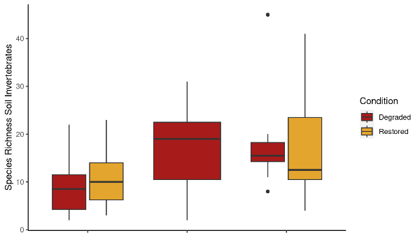
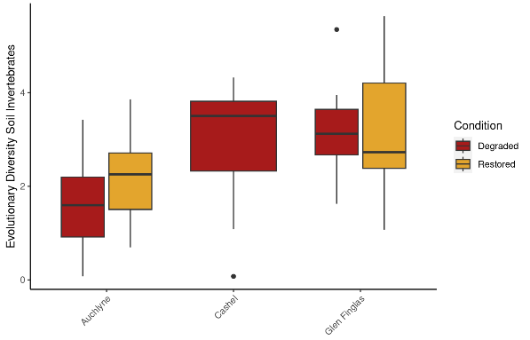

Figure 11: Medians and percentiles for Soil Invertebrates sample-level metrics.

## Species_Richness_Soil_Invertebrates ~ Condition + pH + Moisture +
## (1 | Site)
## $`emmeans of Condition`
## Condition emmean SE df lower.CL upper.CL
## Degraded 14.6 2.51 2.55 5.79 23.5
## Restored 14.9 3.18 3.82 5.87 23.9
##
## Degrees-of-freedom method: kenward-roger
## Confidence level used: 0.95
##
## $`pairwise differences of Condition`
## 1 estimate SE df t.ratio p.value
## Degraded - Restored -0.212 3.18 43.2 -0.067 0.9470
##
## Degrees-of-freedom method: kenward-roger
##
## [2] "\"for each increase of 1 unit pH, Species_Richness_Soil_Invertebrates increases 3.7054 units (p=0.2653)\""
## [3] "\"for each increase of 1 unit Moisture, Species_Richness_Soil_Invertebrates increases 0.2922 units (p=0.3892)\""
## Overall model p value for Condition=0.942710577625512

## Evolutionary_Diversity_Soil_Invertebrates ~ Condition + pH +
## Moisture + (1 | Site)
## $`emmeans of Condition`
## Condition emmean SE df lower.CL upper.CL
## Degraded 2.63 0.403 2.32 1.11 4.15
## Restored 2.74 0.476 3.43 1.33 4.16
##
## Degrees-of-freedom method: kenward-roger
## Confidence level used: 0.95
##
## $`pairwise differences of Condition`
## 1 estimate SE df t.ratio p.value
## Degraded - Restored -0.114 0.417 45.4 -0.274 0.7857
##
## Degrees-of-freedom method: kenward-roger
##
## [2] "\"for each increase of 1 unit pH, Evolutionary_Diversity_Soil_Invertebrates increases 0.2598 units (p=0.5526)\""
## [3] "\"for each increase of 1 unit Moisture, Evolutionary_Diversity_Soil_Invertebrates increases 0.0529 units (p=0.2407)\""
## Overall model p value for Condition=0.772994307029993

Fungi
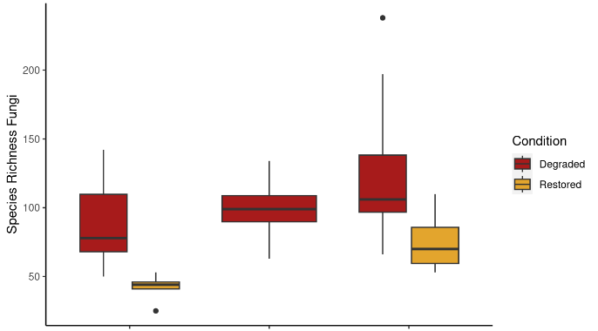
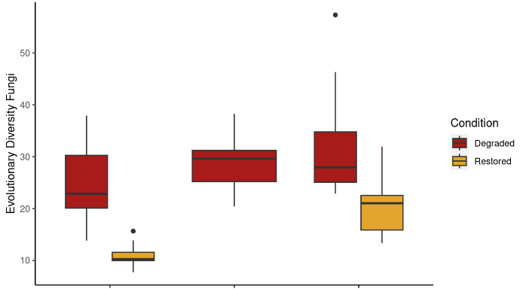
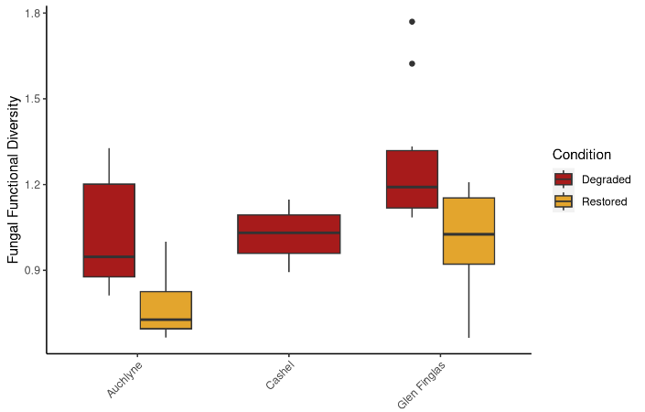

Figure 12: Medians and percentiles for Fungal sample-level metrics.

## Species_Richness_Fungi ~ Condition + pH + Moisture + (1 | Site)
## $`emmeans of Condition`
## Condition emmean SE df lower.CL upper.CL
## Degraded 102.9 10.2 2.28 63.6 142.1
## Restored 60.6 11.9 3.30 24.7 96.5
##
## Degrees-of-freedom method: kenward-roger
## Confidence level used: 0.95
##
## $`pairwise differences of Condition`
## 1 estimate SE df t.ratio p.value
## Degraded - Restored 42.2 9.96 45.7 4.241 0.0001
##
## Degrees-of-freedom method: kenward-roger
##
## [2] "\"for each increase of 1 unit pH, Species_Richness_Fungi increases 18.9778 units (p=0.0748)\""
## [3] "\"for each increase of 1 unit Moisture, Species_Richness_Fungi decreases 1.0506 units (p=0.3301)\""
## Overall model p value for Condition=5.02504441449867e-05
## Evolutionary_Diversity_Fungi ~ Condition + pH + Moisture + (1 |
## Site)
## $`emmeans of Condition`
## Condition emmean SE df lower.CL upper.CL
## Degraded 28.4 2.58 2.25 18.38 38.4
## Restored 16.5 2.96 3.21 7.42 25.6
##
## Degrees-of-freedom method: kenward-roger
## Confidence level used: 0.95
##
## $`pairwise differences of Condition`
## 1 estimate SE df t.ratio p.value
## Degraded - Restored 11.9 2.4 45.9 4.955 <.0001
##
## Degrees-of-freedom method: kenward-roger
##
## [2] "\"for each increase of 1 unit pH, Evolutionary_Diversity_Fungi increases 2.9095 units (p=0.2524)\""
## [3] "\"for each increase of 1 unit Moisture, Evolutionary_Diversity_Fungi decreases 0.1944 units (p=0.4542)\""
## Overall model p value for Condition=4.37656379491563e-06
## Fungal_Functional_Diversity ~ Condition + pH + Moisture + (1 |
## Site)
## $`emmeans of Condition`
## Condition emmean SE df lower.CL upper.CL
## Degraded 1.104 0.0774 2.12 0.789 1.42
## Restored 0.866 0.0872 3.08 0.592 1.14
##
## Degrees-of-freedom method: kenward-roger
## Confidence level used: 0.95
##
## $`pairwise differences of Condition`
## 1 estimate SE df t.ratio p.value
## Degraded - Restored 0.238 0.062 42.9 3.842 0.0004
##
## Degrees-of-freedom method: kenward-roger
##
## [2] "\"for each increase of 1 unit pH, Fungal_Functional_Diversity increases 0.1165 units (p=0.0774)\""
## [3] "\"for each increase of 1 unit Moisture, Fungal_Functional_Diversity increases 4e-04 units (p=0.9511)\""
## Overall model p value for Condition=0.00026561361257618

Bacteria
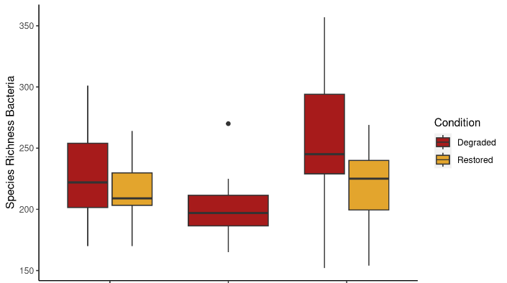
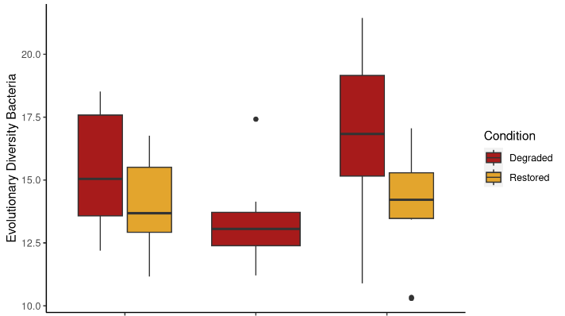
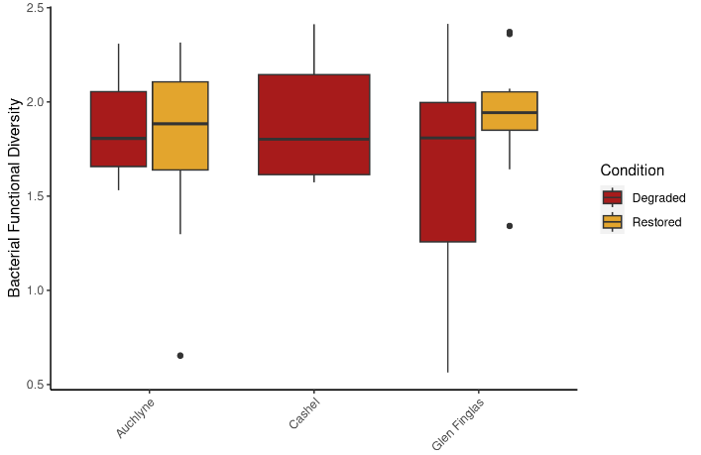

Figure 13: Medians and percentiles for Bacterial sample-level metrics.

## Species_Richness_Bacteria ~ Condition + pH + Moisture + (1 |
## Site)
## $`emmeans of Condition`
## Condition emmean SE df lower.CL upper.CL
## Degraded 228 14.6 2.22 171 285
## Restored 208 16.4 3.04 157 260
##
## Degrees-of-freedom method: kenward-roger
## Confidence level used: 0.95
##
## $`pairwise differences of Condition`
## 1 estimate SE df t.ratio p.value
## Degraded - Restored 19.5 12.6 45 1.545 0.1294
##
## Degrees-of-freedom method: kenward-roger
##
## [2] "\"for each increase of 1 unit pH, Species_Richness_Bacteria increases 50.345 units (p=4e-04)\""
## [3] "\"for each increase of 1 unit Moisture, Species_Richness_Bacteria decreases 0.6457 units (p=0.6338)\""
## Overall model p value for Condition=0.112650685729257

## Evolutionary_Diversity_Bacteria ~ Condition + pH + Moisture +
## (1 | Site)
## $`emmeans of Condition`
## Condition emmean SE df lower.CL upper.CL
## Degraded 15.0 0.932 2.17 11.3 18.8
## Restored 13.5 1.020 2.83 10.1 16.8
##
## Degrees-of-freedom method: kenward-roger
## Confidence level used: 0.95
##
## $`pairwise differences of Condition`
## 1 estimate SE df t.ratio p.value
## Degraded - Restored 1.56 0.707 45 2.203 0.0328
##
## Degrees-of-freedom method: kenward-roger
##
## [2] "\"for each increase of 1 unit pH, Evolutionary_Diversity_Bacteria increases 2.8291 units (p=5e-04)\""
## [3] "\"for each increase of 1 unit Moisture, Evolutionary_Diversity_Bacteria decreases 0.0597 units (p=0.4353)\""
## Overall model p value for Condition=0.0270071868165954

## Fungal_Functional_Diversity ~ Condition + pH + Moisture + (1 |
## Site)
## $`emmeans of Condition`
## Condition emmean SE df lower.CL upper.CL
## Degraded 1.104 0.0774 2.12 0.789 1.42
## Restored 0.866 0.0872 3.08 0.592 1.14
##
## Degrees-of-freedom method: kenward-roger
## Confidence level used: 0.95
##
## $`pairwise differences of Condition`
## 1 estimate SE df t.ratio p.value
## Degraded - Restored 0.238 0.062 42.9 3.842 0.0004
##
## Degrees-of-freedom method: kenward-roger
##
## [2] "\"for each increase of 1 unit pH, Fungal_Functional_Diversity increases 0.1165 units (p=0.0774)\""
## [3] "\"for each increase of 1 unit Moisture, Fungal_Functional_Diversity increases 4e-04 units (p=0.9511)\""
## Overall model p value for Condition=0.00026561361257618

Random Forest Classification Tables
This Section provides the results of the cross-validation tests of predictive classification using Random Forest.

Marine
Table 2: Cross-validation tests of predictive classification accuracy using Random Forest for Level 5 Biotopes. Each table reports one assay.
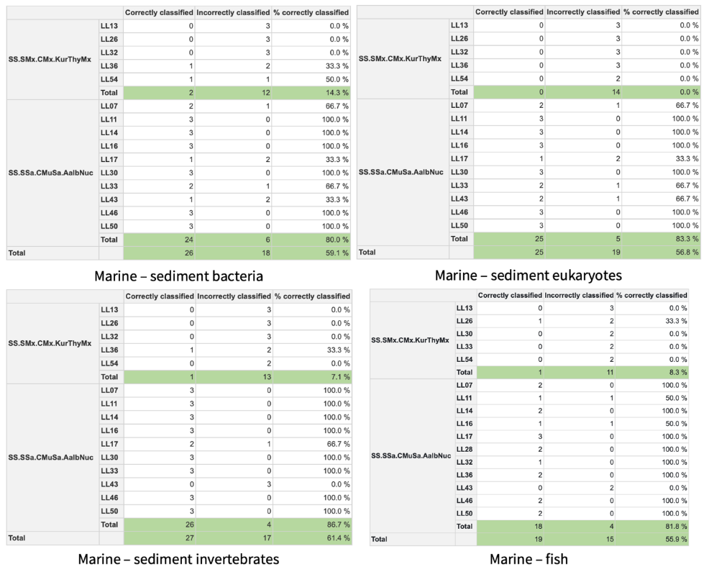

Table 3: Cross-validation tests of predictive classification accuracy using Random Forest Level 4 Biotopes. Each table reports one assay.
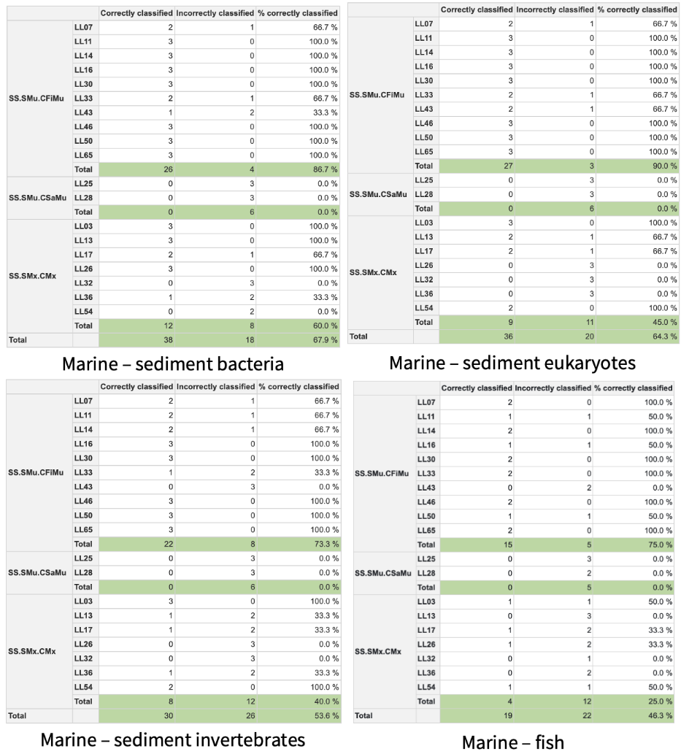

Freshwater
Table 4: Statistical output from the constrained ordination plot for fish communities.
 | Estimate | Std. Error | z value | Pr(>|z|)
Overall.Status.GroupedModerate_Poor(CLV1) | 0.675 | 0.477 | 1.416 | 0.157
PC1(CLV1) | -0.385 | 0.221 | -1.743 | 0.081
Overall.Status.GroupedModerate_Poor(CLV2) | 0.094 | 0.180 | 0.523 | 0.601
PC1(CLV2) | 0.165 | 0.087 | 1.889 | 0.059

R² for latent variables: 0.766
Partial R² for predictors and all LVs:
Overall.Status.GroupedModerate_Poor PC1
0.660 0.035

Table 5: Statistical output from the constrained ordination plot for freshwater invertebrate communities.
Freshwater invertebrates | Estimate | Std. Error | z value | Pr(>|z|)
Overall.Status.GroupedModerate_Poor(CLV1) | 0.120 | 0.863 | 0.139 | 0.889
PC1(CLV1) Moor <-> Urban/Woodland | -1.384 | 0.501 | -2.760 | 0.006
Conductivity..mS.cm.(CLV1) | -0.836 | 0.351 | -2.379 | 0.017
Overall.Status.GroupedModerate_Poor(CLV2) | 0.088 | 0.008 | 10.719 | 0.000
PC1(CLV2) | 0.005 | 0.004 | 1.262 | 0.207
Conductivity..mS.cm.(CLV2) | 0.005 | 0.003 | 1.462 | 0.144
R² for latent variables: 0.464
Partial R² for predictors and all LVs:
Overall.Status.GroupedModerate_Poor PC1
0.411 0.055
Conductivity..mS.cm.
0.045

Table 6: Statistical output from the constrained ordination plot for bacteria communities.
Freshwater bacteria | Estimate | Std. Error | z value | Pr(>|z|)
Overall.Status.GroupedModerate_Poor(CLV1) | 0.12 | 0.86 | 0.14 | 0.889
PC1(CLV1) Moor <-> Urban/Woodland | -1.38 | 0.50 | -2.76 | 0.006
Conductivity..mS.cm.(CLV1) | -0.84 | 0.35 | -2.38 | 0.017
Overall.Status.GroupedModerate_Poor(CLV2) | 0.09 | 0.01 | 10.72 | 0.000
PC1(CLV2) | 0.00 | 0.00 | 1.26 | 0.207
Conductivity..mS.cm.(CLV2) | 0.00 | 0.00 | 1.46 | 0.144

R² for latent variables: 0.1876
Partial R² for predictors and all LVs:
Overall.Status.GroupedModerate_ PC1
-0.0917 0.1458
PC2 Conductivity..mS.cm.
0.2201 0.0227

Table 7: Cross-validation tests of predictive classification accuracy using Random Forest. Each table reports one assay.
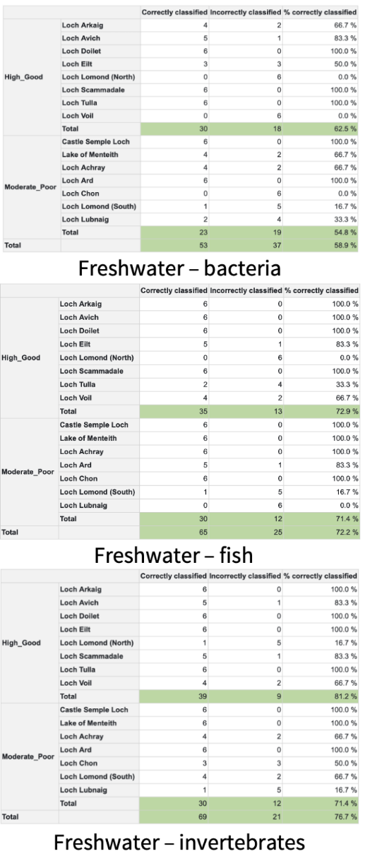

Woodland
Table 8: Cross-validation tests of predictive classification accuracy using Random Forest. Each table reports one assay.
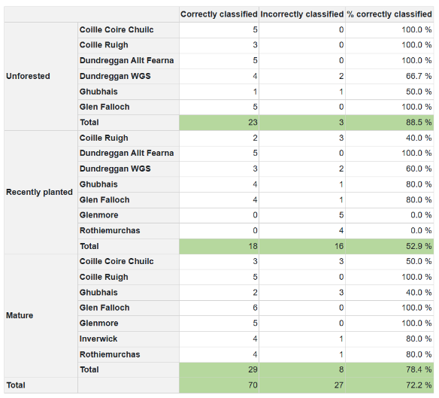
Woodland – soil bacteria
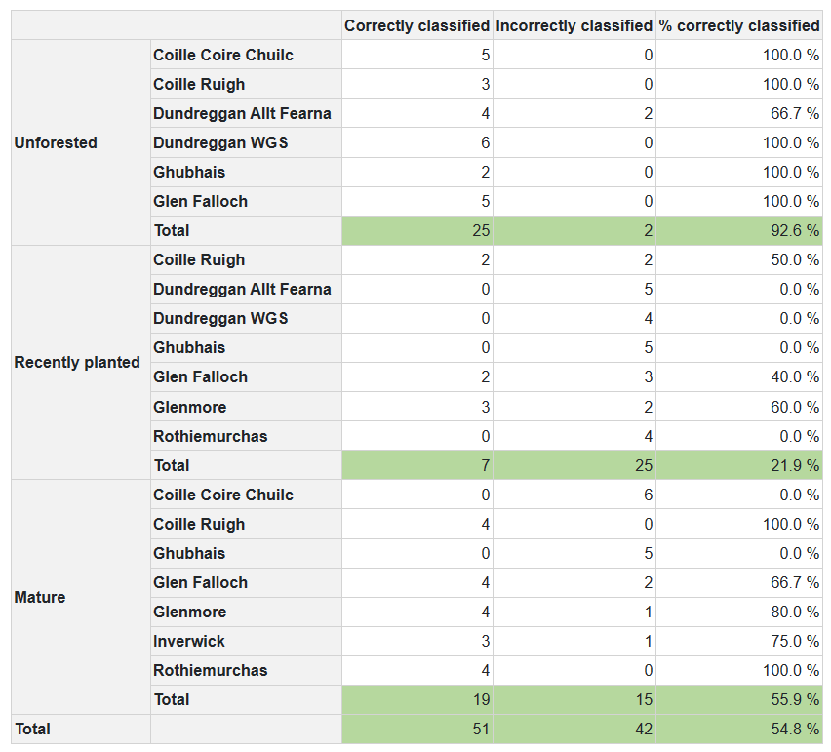
Woodland – soil invertebrates

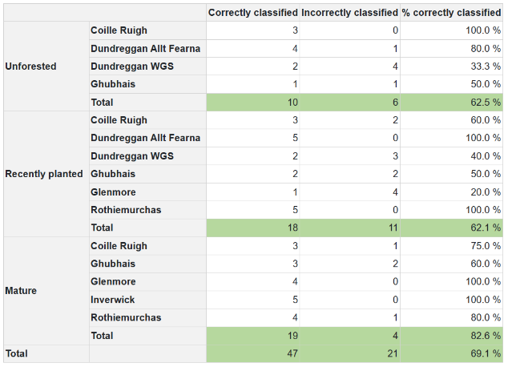
Woodland – soil fungi

Table 9: Condition and Area are both significant terms for explaining variation along CLV1 (yellow and blue highlighting respectively).
Estimate Std. Error z value Pr(>|z|)
ConditionRecently planted(CLV1) 1.65341363 0.69391489 2.3827326 0.0171846713
ConditionMature(CLV1) 3.85365416 1.15876637 3.3256524 0.0008821186
AreaGlen Affric(CLV1) 2.18681659 0.74533511 -2.9340045 0.0033461932
AreaGlen Moriston(CLV1) 2.92684661 0.92931529 -3.1494657 0.0016356931
Moisture(CLV1) 0.05469715 0.27953797 -0.1956698 0.8448686006
ConditionRecently planted(CLV2) 0.07270348 0.18103210 -0.4016055 0.6879743943
ConditionMature(CLV2) 0.07946056 0.28690471 -0.2769580 0.7818123534
AreaGlen Affric(CLV2) 0.10814597 0.10028265 -1.0784116 0.2808501180
AreaGlen Moriston(CLV2) 0.06708416 0.09431662 -0.7112655 0.4769197221
Moisture(CLV2) 0.09597152 0.08589613 1.1172975 0.2638671643

R² for latent variables: 0.0777
Partial R²for predictors and all LVs:
ConditionRecently planted ConditionMature AreaGlen Affric
0.0230 0.0485 0.1066
AreaGlen Moriston Moisture
0.0759 -0.0032

Peatland
Table 10: Cross-validation tests of predictive classification accuracy using Random Forest. Each table reports one assay.
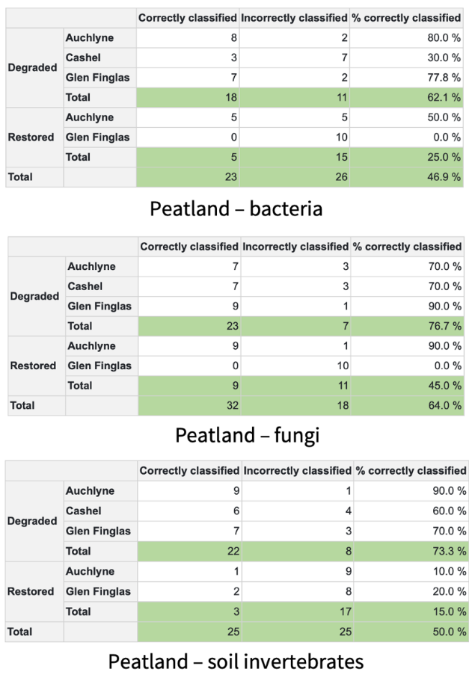

Estimate Std. Error z value Pr(>|z|)
ConditionRestored(CLV1) -0.00008983822 0.022243754 0.004038807 0.9967775074
Moisture(CLV1) -0.02065030985 0.005961297 3.464063351 0.0005320812
pH(CLV1) -0.00252918281 0.004415774 0.572760964 0.5668065533
ConditionRestored(CLV2) -0.96137169618 0.926336119 1.037821668 0.2993530872
Moisture(CLV2) -0.00415582524 0.020650187 0.201248793 0.8405040408
pH(CLV2) 0.06808298215 0.020288766 3.355698475 0.0007916483
[1] "From van Veen et al. (2022) The proportion of (generalized) variance explained by all p predictors and all d latent variables is"
R² for latent variables:0.2387
Partial R²for predictors and all LVs:
ConditionRestored Moisture pH
0.0285 0.1146 0.1180

Conventional Marine Results

Description of Marine Biotope Classification Data
Morphoanalysis was conducted for 20 samples (one from each station) by SEPA, using the marine invertebrates collected during the project (see main report for methods). Using the output data, the biotope for each sample was classified (see main report for methods). Below we present further details of the classification for each station. Marine morphological (benthic invertebrates) and PSD data is not included in this report but can be requested from SEPA for a different purpose.
LL3 was defined as “Cerianthus lloydii and other burrowing anemones in circalittoral muddy mixed sediment” (SS.SMx.CMX.ClloMx) as the sediment classification placed it as circalittoral mixed sediment habitat (SS.SMx), Cerianthus lloydii was observed and Modiolus was absent.
LL7 PSD would define it as circalittoral fine mud (SS.SMU.CFiMu), with the high abundance of Amphiura chiajei suggesting either “Brissopsis lyrifera and Amphiura chiajei in circalittoral mud” (SS.SMu.CFiMu.BlyrAchi) or “Atrina fragilis and echinoderms on circalittoral mud” (SS.SMu.CFiMu.AtrEch). However, there are several key species absent for both of these habitat types and a high abundance of Scalibregma inflatum, Abra nitida and Nucula species, which are more indicative of “Abra alba and Nucula nitidosa in circalittoral muddy sand or slightly mixed sediment” (SS.SSa.CMuSa.AalbNuc).
LL11 PSD would define it as circalittoral fine mud circalittoral fine mud (SS.SMU.CFiMu), with the high abundance of Amphiura filiformis suggesting “Atrina fragilis and echinoderms on circalittoral mud” (SS.SMu.CFiMu.AtrEch). However, as with station LL7, there are several key species (Cyclista lacerate, Atrina fragilis and Alcyonium digitatum) absent and a high abundance of Abra alba, Scalibregma inflatum and Nucula species, which are more indicative of “Abra alba and Nucula nitidosa in circalittoral muddy sand or slightly mixed sediment” (SS.SSa.CMuSa.AalbNuc).
LL13 was defined as “Kurtiella bidentata and Thyasira spp. in circalittoral muddy mixed sediment” (SS.SMx.CMx.KurThyMx) as the sediment classification placed it as circalittoral mixed sediment habitat (SS.SMx) and it had abundant Thyasira flexuosa, Scalibregma inflatum and Kurtiella bidentata and well as many of the other taxa important for defining this habitat type.
LL14 PSD would define it as circalittoral fine mud (SS.SMu.CFiMu), with the high abundance of Amphiura filiformis and some Amphiura chiajei suggesting “Atrina fragilis and echinoderms on circalittoral mud” (SS.SMu.CFiMu.AtrEch). However, as with station LL7, there are several key species (Cyclista lacerate, Atrina fragilis and Alcyonium digitatum) absent and a high abundance of Abra alba, which is more indicative of “Abra alba and Nucula nitidosa in circalittoral muddy sand or slightly mixed sediment” (SS.SSa.CMuSa.AalbNuc).
LL16 PSD would define it as circalittoral fine mud (SS.SMu.CFiMu), but as the sample is dominated by Abra alba, “Abra alba and Nucula nitidosa in circalittoral muddy sand or slightly mixed sediment” (SS.SSa.CMuSa.AalbNuc).
LL17 has a high abundance of Abra alba, which isn’t a commonly found species for circalittoral mixed sediment habitat (SS.SMx) category. “Abra alba and Nucula nitidosa in circalittoral muddy sand or slightly mixed sediment” (SS.SSa.CMuSa.AalbNuc) is therefore far more likely. Whilst this does not strictly follow the Particle Size Analysis (PSA) data, the substratum is described as being “Fine muddy sands occasionally with small gravel content”. As it is only just above the threshold for being described as a mixed sediment (6.8% gravel), this classification is appropriate.
LL25 Particle Size Distribution (PSD) defines it as circalittoral sandy mud (SS.SMU.CSaMu) with a high abundance of Ophiuridae. However, it contains several habitat characterising species for “Sparse Modiolus modiolus, dense Cerianthus lloydii and burrowing holothurians on sheltered circalittoral stones and mixed sediment” (SS.SMx.CMx.ClloModHo), namely Modiolus modiolus, Ceriathus lloydii and a burrowing holothurian (Leptosynapta). As this habitat category is mixed sediment typically with a low proportion of gravel (6.72%), this is not far from the 2.45% gravel recorded.
LL26 was defined as “Kurtiella bidentata and Thyasira spp. in circalittoral muddy mixed sediment” (SS.SMx.CMx.KurThyMx) as the sediment classification placed it as circalittoral mixed sediment habitat (SS.SMx) and it had a high abundance of Thyasira flexuosa, Scalibregma inflatum and Kurtiella bidentata and well as other taxa important for defining this habitat type.
There was no PSD data recorded for LL27 due to the high quantity of stones and shells, suggesting a mixed, coarse or hard substrate. There was a high abundance of Spirobranchus triqueter (recorded as Pomatoceros triqueter), Ophiothrix fragilis and Ophiocomina nigra. This suggests that the habitat can be classified as “Ophiothrix fragilis and/or Ophiocomina nigra brittlestar beds on sublittoral mixed sediment” (SS.SMx.CMx.OphMx), although Modiolus modiolus were also identified from this sample.
LL28 is defined by the PSD as a circalittoral sandy mud (SS.SMU.CSaMu), with an even abundance of the species defining “Amphiura filiformis, Kurtiella bidentata and Abra nitida in circalittoral sandy mud” (SS.SMu.CSaMu.AfilKurAnit).
LL30 is defined by the PSD as a circalittoral fine mud (SS.SMu.CFiMu), but is dominated by Abra nitida, Nucula nitidosa and Abra alba with no Kurtiella bidentata. We would therefore say that it is most similar to the habitat category “Abra alba and Nucula nitidosa in circalittoral muddy sand or slightly mixed sediment” (SS.SSa.CMuSa.AalbNuc), which is associated with slightly coarser sediments.
LL32 had some of the component species of “Abra alba and Nucula nitidosa in circalittoral muddy sand or slightly mixed sediment” (SS.SSa.CMuSa.AalbNuc) and “Kurtiella bidentata and Thyasira spp. in circalittoral muddy mixed sediment” (SS.SMx.CMx.KurThyMx). The PSD placed it as circalittoral mixed sediment habitat (SS.SMx), hence it will be defined as “Kurtiella bidentata and Thyasira spp. in circalittoral muddy mixed sediment” (SS.SMx.CMx.KurThyMx) in spite of the absence of the second to fourth most important taxa (Thyasira flexuosa, Kurtiella bidentata and Hilbigneris gracilis).
LL33 PSD defines it as circalittoral fine mud (SS.SMU.CFiMu), albeit with very similar percentages of sand and mud. The biological community is characteristic of “Abra alba and Nucula nitidosa in circalittoral muddy sand or slightly mixed sediment” (SS.SSa.CMuSa.AalbNuc), with a high abundance of Abra alba and Nucula nitidosa.
LL36 was dominated by Mya arenaria and the invasive polychaete Pseudopolydora paucibranchiata. However, these taxa which are not included in any of the possible biotopes based on the level 5 EUNIS classification. The most similar biotope is “Kurtiella bidentata and Thyasira spp. in circalittoral muddy mixed sediment” (SS.SMx.CMx.KurThyMx) as the sediment classification placed it as circalittoral mixed sediment habitat (SS.SMx) and it had a high abundance of Thyasira flexuosa, Scalibregma inflatum and Kurtiella bidentata and well as other taxa important for defining this habitat type.
LL43 PSD defines it as circalittoral fine mud (SS.SMU.CFiMu), with some of the component species of “Abra alba and Nucula nitidosa in circalittoral muddy sand or slightly mixed sediment” (SS.SSa.CMuSa.AalbNuc) and “Kurtiella bidentata and Thyasira spp. in circalittoral muddy mixed sediment” (SS.SMx.CMx.KurThyMx). Due to the PSD and the sample being dominated by Abra alba, it is defined as (SS.SSa.CMuSa.AalbNuc).
LL46 PSD defines it as circalittoral fine mud (SS.SMU.CFiMu) and it has a biological community is characteristic of “Abra alba and Nucula nitidosa in circalittoral muddy sand or slightly mixed sediment” (SS.SSa.CMuSa.AalbNuc), with a high abundance of Abra alba and Nucula nitidosa. The high abundance of Chaetozone zetlandica is unusual as it is generally associated with coarser substrates.
LL50 PSD defines it as circalittoral fine mud (SS.SMU.CFiMu) and it has a biological community is characteristic of “Abra alba and Nucula nitidosa in circalittoral muddy sand or slightly mixed sediment” (SS.SSa.CMuSa.AalbNuc), with a high abundance of Abra alba and presence of Nucula nitidosa. This also matches the 1.92% gravel content of the sediment, suggesting slightly mixed sediment.
LL54 was defined as “Kurtiella bidentata and Thyasira spp. in circalittoral muddy mixed sediment” (SS.SMx.CMx.KurThyMx) as the sediment classification placed it as circalittoral mixed sediment habitat (SS.SMx). It had Disporella hispida and other epifauna on the larger components of the sediment as well as soft sediment species such as Thyasira flexuosa, Scalibregma inflatum and Owenia fusiformis. However, Kurtiella bidentata and Nemertea were absent from the sample, so this is a suggested biotope.
LL65 PSD defines it as circalittoral fine mud (SS.SMU.CFiMu), but has an unusual biological community dominated by Chaetozone species, which are more characteristic of mixed or offshore sediments. No level 5 classification has been suggested.

CPET Species
Table 11: An initial investigation into the CPET taxa that are known to be detectable using the Freshwater Invertebrate approach taken in this project. While the known value is that c. 47% of taxa used for the Macroinvertebrates CPET are detectable, it is likely that in reality this proportion is far higher, as there are likely to be many cases where the taxonomy used by the Macroinvertebrates CPET approach is different to that used by NatureMetrics (gbif backbone).
Macroinvertebrates_CPET Species list | Detected in this project | Known from other NatureMetrics projects
Ablabesmyia longistyla | Yes | Yes
Ablabesmyia monilis | Yes | Yes
Ablabesmyia phatta
Acamptocladius (GENUS) |  | Yes
Acricotopus lucens |  | Yes
Anatopynia plumipes
Apsectrotanypus trifascipennis | Yes | Yes
Arctopelopia (GENUS) | Yes | Yes
Boreoheptagyia (GENUS)
Brillia flavifrons
Brillia bifida | Yes
Bryophaenocladius (GENUS) | Yes | Yes
Camptocladius stercorarius |  | Yes
Cardiocladius (GENUS) | Yes | Yes
Chaetocladius (GENUS) | Yes | Yes
Chironomus (Lobochironomus) carbonaria
Chironomus (Lobochironomus) dissidens
Chironomus annularius |  | Yes
Chironomus anthracinus |  | Yes
Chironomus aprilinus
Chironomus bernensis
Chironomus cingulatus | Yes | Yes
Chironomus commutatus |  | Yes
Chironomus dorsalis
Chironomus holomelas
Chironomus longipes
Chironomus longistylus
Chironomus luridus |  | Yes
Chironomus macani | Yes | Yes
Chironomus nuditarsis |  | Yes
Chironomus nudiventris
Chironomus obtusidens | Yes | Yes
Chironomus pallidivittatus
Chironomus piger
Chironomus plumosus group |  | Yes
Chironomus prasinus
Chironomus pseudothummi |  | Yes
Chironomus riparius |  | Yes
Chironomus salinarius
Chironomus tentans |  | Yes
Chironomus (GENUS) OTHER | Yes | Yes
Cladopelma (GENUS) | Yes | Yes
Cladotanytarsus atridorsum | Yes | Yes
Cladotanytarsus difficilis |  | Yes
Cladotanytarsus lepidocalcar
Cladotanytarsus new pupal species |  | Unsure
Cladotanytarsus (GENUS) OTHER | Yes | Yes
Cladotanytarsus vanderwulpi
Clinotanypus nervosus | Yes | Yes
Clunio marinus
Conchapelopia melanops | Yes | Yes
Conchapelopia (GENUS) OTHER |  | Yes
Constempellina brevicosta
Corynocera ambigua
Corynoneura arctica group |  | Unsure
Corynoneura fittkaui |  | Yes
Corynoneura scutellata group |  | Yes
Corynoneurella paludosa
Cricotopus (Cricotopus) bicinctus | Yes | Yes
Cricotopus (Cricotopus) trifascia |  | Yes
Cricotopus (SUB GENUS Cricotopus) OTHER | Yes | Yes
Cricotopus (Isocladius) brevipalpis
Cricotopus (Isocladius) intersectus group | Yes | Unsure
Cricotopus (Isocladius) sylvestris (Fabricius group) |  | Yes
Cricotopus (Isocladius) Pe |  | Unsure
Cricotopus (SUB GENUS Isocladius) OTHER | Yes | Yes
Crictopus (Nostococladius) lygropis
Cryptochironomus obreptans group |  | Unsure
Cryptochironomus redekei group | Yes | Yes
Cryptotendipes (GENUS)
Demeijerea rufipes | Yes | Yes
Demicryptochironomus (GENUS) | Yes | Yes
Diamesa (GENUS) | Yes | Yes
Dicrotendipes nervosus |  | Yes
Dicrotendipes notatus
Dicrotendipes pallidicornis
Dicrotendipes tritomus | Yes | Yes
Dicrotendipes (GENUS) OTHER | Yes | Yes
Diplocladius cultriger
Einfeldia pagana
Endochironomus albipennis
Endochironomus tendens |  | Yes
Endochironomus (GENUS) OTHER | Yes | Yes
Epoicocladius ephemerae
Eukiefferiella ancyla
Eukiefferiella claripennis | Yes | Yes
Eukiefferiella coerulescens
Eukiefferiella (GENUS) OTHER | Yes | Yes
Eurycnemus crassipes
Euryhapsis fuscipropes
Fleuria lacustris
Georthocladius luteicornis
Glyptotendipes (SUB GENUS Caulochironomus) |  | Unsure
Glyptotendipes (SUB GENUS Glycotendipes) |  | Yes
Glyptotendipes (Trichotanypus) signatus
Graceus ambiguus
Guttipelopia guttipennis
Gymnometriocnemus (GENUS) |  | Yes
Halocladius (SUB GENUS Halocladius)
Halocladius (Psammocladius) braunsi
Harnischia (GENUS) | Yes | Yes
Hayesomyia tripunctata
Heleniella ornaticollis
Heterotanytarsus apicalis | Yes | Yes
Heterotrissocladius (GENUS) | Yes | Yes
Kiefferulus tendipediformis | Yes | Yes
Kloosia pusilla
Krenopelopia (GENUS) | Yes | Yes
Krenosmittia (GENUS)
Labrundinia longipalpis
Larsia (GENUS) |  | Yes
Lauterborniella agrayloides
Limnophyes (GENUS) | Yes | Yes
Lipiniella araenicola
Macropelopia adaucta
Macropelopia nebulosa | Yes | Yes
Macropelopia (GENUS) OTHER |  | Yes
Metriocnemus (GENUS) | Yes | Yes
Microchironomus tener |  | Yes
Microchironomus (GENUS) OTHER |  | yes
Micropsectra atrofasciata | Yes | Yes
Micropsectra fusca
Micropsectra junci | Yes | Yes
Micropsectra (GENUS) OTHER | Yes | Yes
Microtendipes britteni
Microtendipes (GENUS) OTHER | Yes | Yes
Monodiamesa bathyphila
Monodiamesa ekmani
Monopelopia tenuicalcar |  | Yes
Nanocladius balticus
Nanocladius dichromis group | Yes
Nanacladius rectinervis group | Yes
Nanocladius (GENUS) OTHER | Yes | Yes
Natarsia (GENUS)
Neozavrelia longappendiculata
Neozavrelia (GENUS) OTHER
Nilotanypus dubius | Yes | Yes
Nilothauma brayi
Odontomesa fulva
Omisus caledonicus
Orthocladius (SUB GENUS Eudactylocladius) | Yes | Unsure
Orthocladius (SUB GENUS Euorthocladius) |  | Unsure
Orthocladius (Orthocladius) frigidus | Yes | Yes
Orthocladius (Orthocladius) rubicundus |  | Yes
Orthocladius (SUB GENUS Orthocladius) OTHER |  | Yes
Orthocladius (Pogonocladius) consobrinus | Yes
Orthocladius (Symposiocladius) holsatus
Orthocladius (Symposiocladius) lignicola
Pagastiella orophila
Parachironomus arcuatus | Yes | Yes
Parachironomus biannulatus | Yes | Yes
Parachironomus frequens | Yes | Yes
Parachironomus tenuicaudatus | Yes | Yes
Parachironomus (GENUS) OTHER | Yes | Yes
Paracladius conversus
Paracladopelma camptolabis group
Paracladopelma nigritulum
Paracricotopus niger
Parakiefferiella coronata | Yes | Yes
Parakiefferiella fennica
Parakiefferiella Pe 1 |  | Unsure
Parakiefferiella (GENUS) OTHER | Yes | Yes
Paralauterborniella nigrohalteralis |  | Yes
Paralimnophyes hydrophilus |  | Yes
Paramerina (GENUS)
Parametriocnemus (GENUS) | Yes | Yes
Parorthocladius nudipennis
Paraphaenocladius (GENUS) | Yes | Yes
Parapsectra nana
Parapsectra (GENUS) OTHER
Paratanytarsus laccophilus
Paratanytarsus tenellulus |  | Yes
Paratanytarsus (GENUS) OTHER | Yes | Yes
Paratendipes (GENUS) | Yes | Yes
Paratrichocladius rufiventris | Yes | Yes
Paratrichocladius skirwithensis
Paratrissocladius excerptus
Paratrichocladius GENUS (OTHER) |  | Yes
Phaenopsectra (GENUS) | Yes | Yes
Polypedilum (Polypedilum) arundinetum
Polypedilum (Polypedilum) cultellatum
Polypedilum (Polypedilum) nubeculosum group |  | Yes
Polypedilum (Polypedilum) pedestre | Yes | Yes
Polypedilum (Pentapedilum) nubens
Polypedilum (Pentapedilum) sordens group |  | Unsure
Polypedilum (Tripodura) pullum group |  | Unsure
Polypedilum (Tripodura) tetracrenatum
Polypedilum (GENUS) OTHER | Yes | Yes
Potthastia gaedii group | Yes | Unsure
Potthastia longimana group | Yes | Unsure
Procladius (Holotanypus) crassinervis
Procladius (SUB GENUS Holotanypus) OTHER | Yes | Unsure
Procladius (SUB GENUS Psilotanypus) | Yes | Unsure
Prodiamesa olivacea | Yes | Yes
Protanypus morio
Psectrocladius (Psectrocladius) barbimanus |  | Yes
Psectrocladius (Psectrocladius) brehmi
Psectrocladius (Psectrocladius) octomaculatus |  | Yes
Psectrocladius (Psectrocladius) oligosetus
Psectrocladius (Psectrocladius) schlienzi
Psectrocladius (Psectrocladius) species A |  | Unsure
Psectrocladius (SUB GENUS Psectrocladius ) OTHER | Yes | Unsure
Psectrocladius (Allopsectrocladius) platypus | Yes | Yes
Psectrocladius (Allopsectrocladius) obvius
Psectrocladius (Mesopsectrocladius) barbatipes
Psectrocladius (Monopsectrocladius) calcaratus | Yes
Psectrotanypus varius | Yes | Yes
Pseudochironomus prasinatus | Yes | Yes
Pseudodiamesa (GENUS)
Pseudokiefferiella parva
Pseudorthocladius (GENUS) | Yes | Yes
Pseudosmittia (GENUS) | Yes | Yes
Rheocricotopus (SUB GENUS Psilocricotopus) |  | Unsure
Rheocricotopus (SUB GENUS Rheocrictopus) | Yes | Unsure
Rheopelopia (GENUS) |  | Yes
Rheosmittia spinicornis
Rheotanytarsus (GENUS) | Yes | Yes
Saetheria reissi
Schineriella schineri
Sergentia (GENUS) | Yes
Smittia (GENUS) | Yes | Yes
Stempellina almi
Stempellina bausei | Yes | Yes
Stempellinella (GENUS) | Yes | Yes
Stenochironomus (GENUS)
Stictochironomus (GENUS) | Yes | Yes
Sympotthastia zavreli
Syndiamesa edwardsi
Synendotendipes (GENUS)
Synorthocladius semivirens | Yes | Yes
Tanypus punctipennis |  | Yes
Tanypus (GENUS) OTHER |  | Yes
Tanytarsus anderseni
Tanytarsus brundini | Yes | Yes
Tanytarsus buchonius |  | Yes
Tanytarsus chinyensis
Tanytarsus ejuncidus group |  | Yes
Tanytarsus gracilentis
Tanytarsus mendax | Yes | Yes
Tanytarsus pallidicornis |  | Yes
Tanytarsus signatus | Yes | Yes
Tanytarsus striatulus | Yes | Yes
Tanytarsus sylvaticus | Yes | Yes
Tanytarsus (SUB GENUS Part 1) OTHER | Yes | Unsure
Tanytarsus (SUB GENUS Part 2) OTHER | Yes | Unsure
Tanytarsus (SUB GENUS Part 3) OTHER |  | Unsure
Telmatopelopia nemorum
Telopelopia (GENUS)
Thalassosmittia thalassophilus
Thienemannia (GENUS) |  | Yes
Thienemanniella (GENUS) | Yes | Yes
Thienemannimyia (GENUS) | Yes | Yes
Tokunagaia tonolli
Tribelos intextus | Yes | Yes
Trissocladius brevipalpis
Trissopelopia longimana | Yes | Yes
Tvetenia discoloripes
Tvetenia (GENUS) OTHER | Yes | Yes
Virgatanytarsus (GENUS) | Yes | Yes
Xenochironomus xenolabis |  | Yes
Xenopelopia (GENUS) |  | Yes
Zalutschia humphresiae
Zavrelia pentatoma
Zavreliella marmorata
Zavrelimyia nubila
Zavrelimyia (GENUS) OTHER | Yes | Yes

Sample Replicate Plots – Marine
For each species, the m=3 sample replicates per station allow us to use occupancy modelling to estimate probability distributions of detection theta (q) and of occupancy psi (y), both of which normally have mean values less than 1. We can combine q and y to calculate the probability of detecting a species at a typical station: 𝜓(1−(1−𝜃)^{𝑚}) where m is the number of sample replicates. For instance, if q=0.47 and y=0.5 for species 1, the detection probability with m=5 sample replicates is 48%: 0.5(1−(1−0.47)⁵)=0.479); we can think of species 1 as contributing just under half a species to the station’s expected detected species richness. We calculated these values for all species, over each species’ occupancy and detection probability distributions, for 1 to 10 sample replicates, and summed over all species to estimate a range of species detected for each value of m.
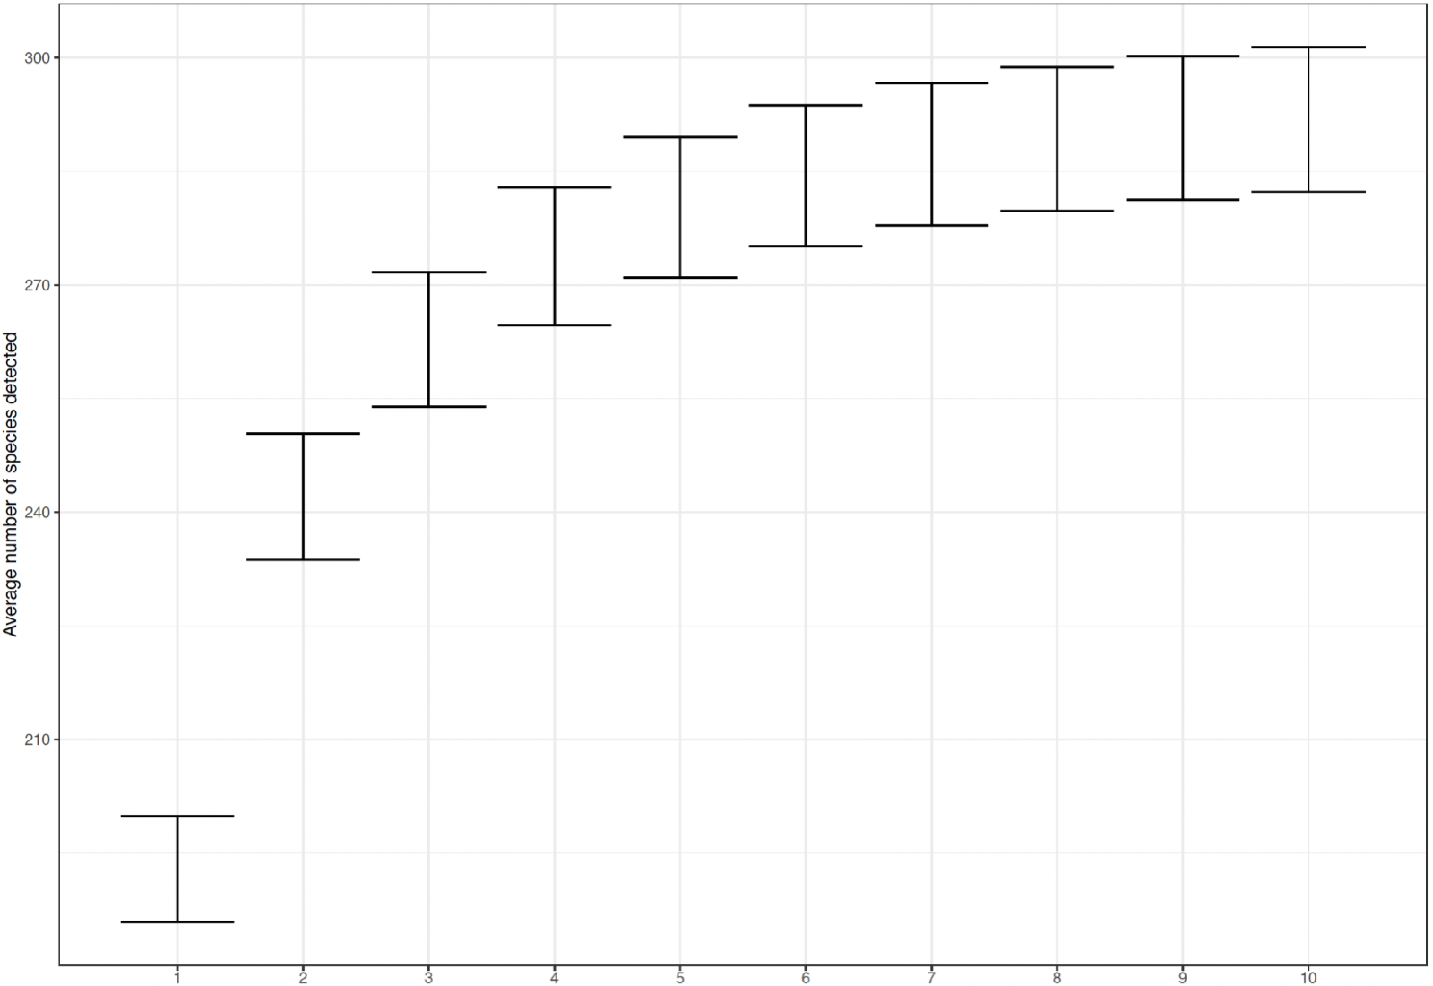
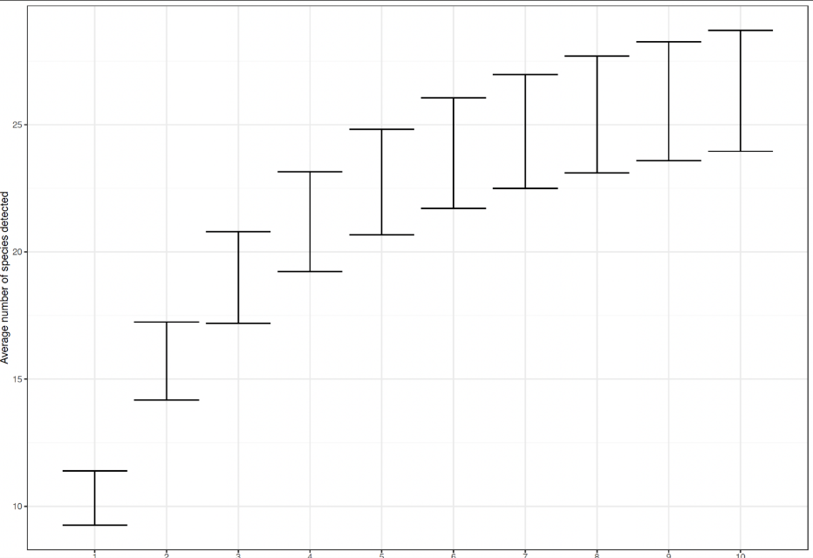
Marine sediment invertebrates

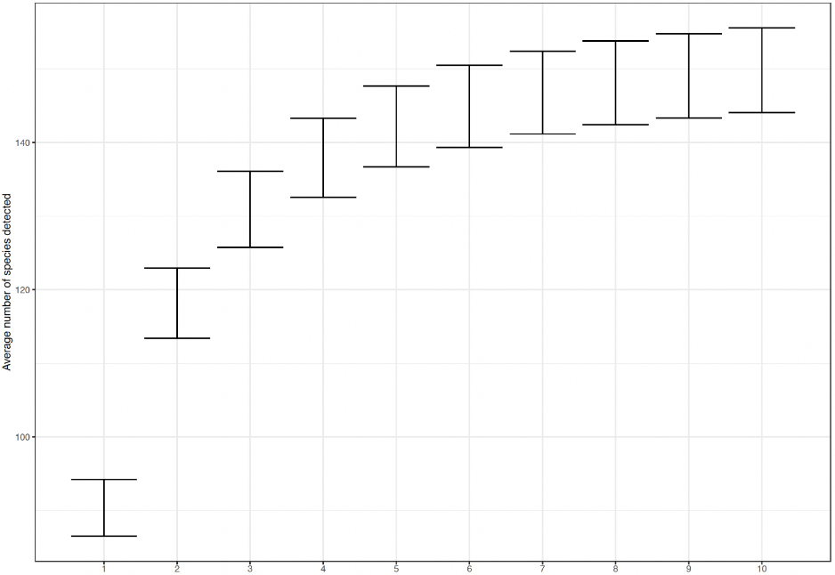Marine sediment eukaryotes
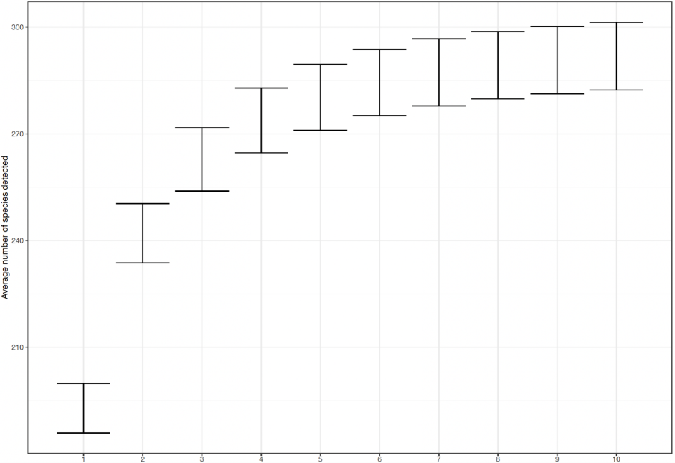Marine sediment bacteria

Morphology vs eDNA – Marine Invertebrates & Eukaryotes

Venn diagrams showing the phylum level detection overlap between visual morphology and eDNA-based metabarcoding. Between morphology and Invertebrate (18S) eDNA metabarcoding, between morphology and Eukaryote (COI) eDNA metabarcoding, and between Invertebrate (18S) and Eukaryote (COI) eDNA metabarcoding.

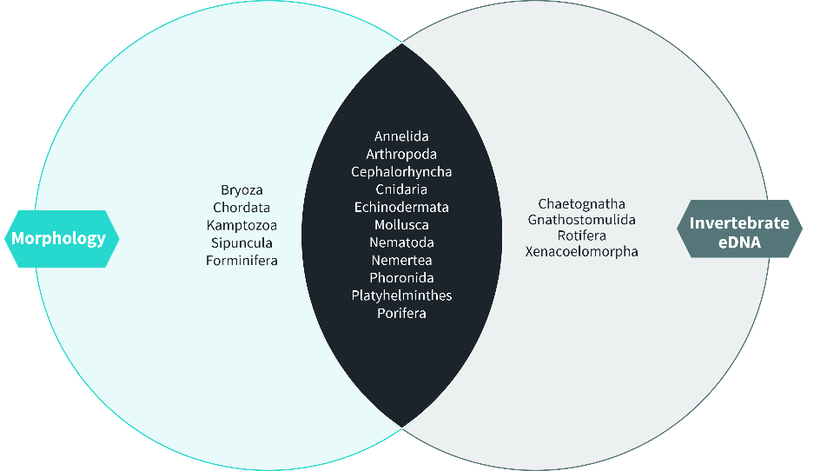
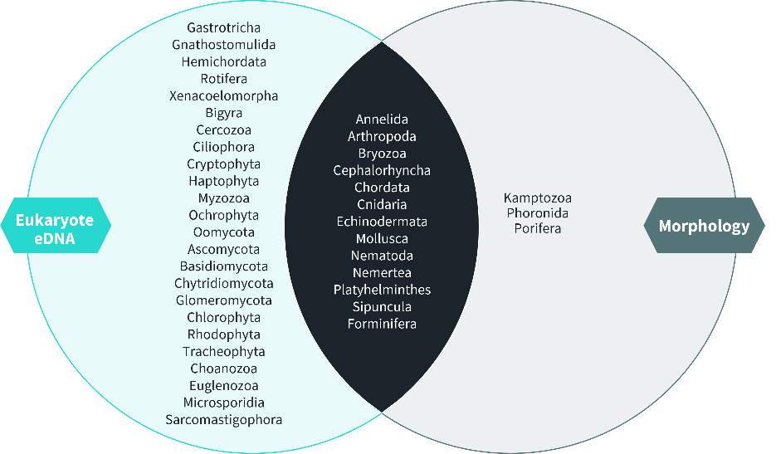


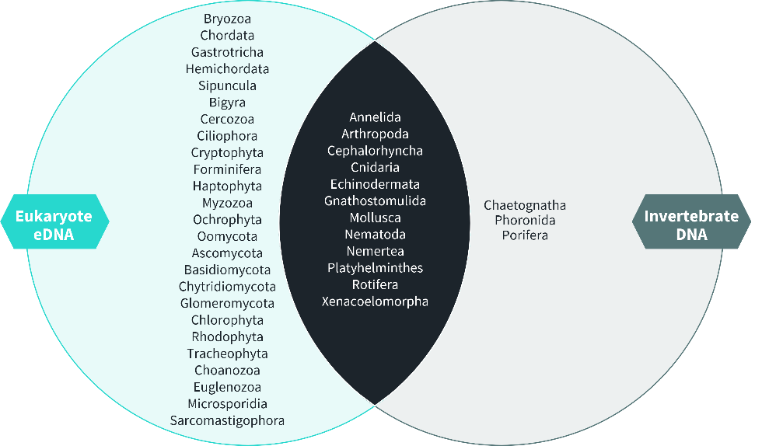

Historical Fish Records - Freshwater
Historical records of fish for each of the freshwater lochs included in the project were compiled from the following sources:
Adams. C.E., The fish community of Loch lomond, Scotland: its history and rapidly changing status. Hydrobiologia 290: 91-102, 1994
Etheridge, E.C. & Adams. C., Bream (Abramis brama), a new fish species confirmed in Loch Lomond. Glasgow Naturalist, 2008, 25, 93-94
Grant, A, Duguid, A & Adams, C. Reappearance of tench (Tinca tinca L.) in the waters of Loch Lomond. Glasgow Naturalist, 1997, 59-60.
Adams, C.E, Brown, D, & Tippet, R. 1990. Dace & Chub: new introductions to the Loch Lomond catchment. Glasgow Naturalist, 21, 509-513.
SEPA Loch Field Survey Records, Loch Lubnaig, 2010
NBN Atlas - UK’s largest collection of biodiversity information
Fish Lochaber | Loch & River Arkaig
Scottish Flyfisher - Argyle & Bute
St.Winnoch Angling Club Home Page (lochwinnochac.net)
Fishing | Local activities | Sunart Adventures
Fish Lochaber | Strontian
Loch Voil and Doine Permits - Angling Active Blog - Fishing News, Advice and Articles
Home - Lake of Menteith Fisheries (menteith-fisheries.co.uk)
Loch Chon | Fishing In The Trossachs
Loch Lomond Angling Improvement Association – Managed by anglers, for anglers (Pers. Comms. G. Bourhill (2023)

This is not considered to be a fully comprehensive list, but represents the best available matching data for the project.

Table 12. Historical Records of fish presence in freshwater lochs. “Y” denotes that one or more records were found for the presence of the respective fish species in the respective loch.
Species | Castle Semple Loch | Lake of Menteith | Loch Achray | Loch Ard | Loch Arkaig | Loch Avich | Loch Chon | Loch Doilet | Loch Eilt | Loch Lomond (North) | Loch Lomond (South) | Loch Lubnaig | Loch Scammadale | Loch Tulla | Loch Voil
Abramis brama |  |  |  |  |  |  |  |  |  |  | Y
Anguilla anguilla | Y |  | Y | Y |  | Y | Y |  | Y | Y | Y | Y | Y | Y | Y
Carassius carassius |  |  |  |  |  |  |  |  |  | Y | Y
Coregonus lavaretus |  |  |  |  |  |  |  |  |  | Y | Y
Chelon labrosus |  |  |  |  |  |  |  |  |  |  | Y
Esox lucius | Y | Y | Y | Y | Y | Y | Y |  |  | Y | Y | Y | Y | Y
Gasterosteus aculeatus | Y |  | Y |  |  | Y |  |  | Y | Y | Y | Y |  |  | Y
Gobio gobio |  |  |  |  |  |  |  |  |  | Y | Y
Gobiusculus flavescens |  |  |  |  |  |  |  |  |  |  |  |  | Y
Gymnocephalus cernua |  |  |  |  |  |  |  |  |  | Y | Y
Lampetra fluviatilis | Y |  | Y |  |  |  |  |  |  | Y | Y
Lampetra planeri | Y |  | Y |  |  | Y |  |  |  | Y | Y
Leuciscus cephalus |  |  |  |  |  |  |  |  |  | Y | Y
Leuciscus leuciscus |  |  |  |  |  |  |  |  |  | Y | Y
Barbatula barbatula | Y |  | Y |  |  |  |  |  |  | Y | Y
Oncorhynchus mykiss | Y | Y | Y |  |  | Y |  |  |  | Y | Y | Y | Y | Y
Perca fluviatilis | Y |  | Y |  |  | Y | Y |  |  | Y | Y | Y |  | Y
Petromyzon marinus |  |  |  |  |  |  |  |  |  | Y | Y
Phoxinus phoxinus | Y |  | Y | Y |  |  | Y |  | Y | Y | Y | Y |  |  | Y
Platichthys flesus |  |  | Y |  |  |  |  |  |  | Y | Y |  |  | Y
Pomatoschistus minutus |  |  |  |  |  |  |  |  |  |  |  |  | Y
Pungitius pungitus |  |  |  |  |  |  |  |  |  | Y | Y
Rutilus rutilus | Y |  | Y |  |  | Y |  |  |  | Y | Y
Salmo ferox |  |  |  |  | Y
Salmo salar | Y |  | Y | Y | Y | Y | Y | Y | Y | Y | Y | Y | Y | Y | Y
Salmo trutta | Y | Y | Y | Y | Y | Y | Y | Y | Y | Y | Y | Y | Y | Y | Y
Salmo trutta fario | Y |  | Y | Y |  | Y | Y |  |  | Y | Y | Y |  | Y
Salmo trutta trutta | Y |  | Y |  |  | Y |  |  |  | Y | Y
Salvelinus alpinus |  |  | Y | Y |  | Y | Y |  | Y | Y | Y | Y |  |  | Y
Tinca tinca |  |  |  |  |  |  |  |  |  | Y | Y
Trisopterus minutus |  |  |  |  |  |  |  |  |  |  |  |  | Y
Barbus barbus |  |  |  |  |  |  |  |  |  | Y | Y

AMBI Results
Table 13: Binary (presence vs no detection) was ultimately used for AZTI Marine Biotic Index (AMBI) and genetic AMBI (gAMBI) scoring. Results for each sample for the binary scoring and final condition are presented here.
Sample | AMBI | gAMBI | AMBI Condition | gAMBI condition
LL03.1 |  | 2.25 | NA | Good
LL03.2 |  | 2.333 | NA | Good
LL03.3 | 1.544 | 2.5 | Good | Good
LL03.Mean |  | 2.361 |  | Good
LL07.1 |  | 1.5 | NA | Good
LL07.2 |  | 3.75 | NA | Moderate
LL07.3 | 2.15 | 2.25 | Good | Good
LL07.Mean |  | 2.5 |  | Good
LL11.1 |  | 2.5 | NA | Good
LL11.2 |  | 3.6 | NA | Moderate
LL11.3 | 2.55 | 2.5 | Good | Good
LL11.Mean |  | 2.867 |  | Good
LL13.1 |  | 2.464 | NA | Good
LL13.2 |  | 3 | NA | Good
LL13.3 | 2.313 | 3.214 | Good | Good
LL13.Mean |  | 2.893 |  | Good
LL14.1 |  | 2.25 | NA | Good
LL14.2 |  | 5.25 | NA | Poor
LL14.3 | 2.167 | 4.5 | Good | Poor
LL14.Mean |  | 4 |  | Poor
LL16.1 |  | 3.9 | NA | Moderate
LL16.2 |  | 3.375 | NA | Moderate
LL16.3 | 3 | 3.9 | Good | Moderate
LL16.Mean |  | 3.725 |  | Moderate
LL17.1 |  | 0.75 | NA | High
LL17.2 |  | 3.333 | NA | Moderate
LL17.3 | 2.375 | 1.875 | Good | Good
LL17.Mean |  | 1.986 |  | Good
LL25.1 |  | 3.75 | NA | Moderate
LL25.2 |  | 2.25 | NA | Good
LL25.3 | 1.72 | 1.75 | Good | Good
LL25.Mean |  | 2.583 |  | Good
LL26.1 |  | 2.75 | NA | Good
LL26.2 |  | 2.625 | NA | Good
LL26.3 | 1.99 | 2.25 | Good | Good
LL26.Mean |  | 2.542 |  | Good
LL28.1 |  | 2 | NA | Good
LL28.2 |  | 3.25 | NA | Good
LL28.3 | 1.806 | 2.25 | Good | Good
LL28.Mean |  | 2.5 |  | Good
LL30.1 |  | 3 | NA | Good
LL30.2 |  | 1.5 | NA | Good
LL30.3 | 2.1 | 1.5 | Good | Good
LL30.Mean |  | 2 |  | Good
LL32.1 |  | 2.25 | NA | Good
LL32.2 |  | 3 | NA | Good
LL32.3 | 2.4 | 7 | Good | Bad
LL32.Mean |  | 4.083 |  | Bad
LL33.1 |  | 3 | NA | Good
LL33.2 |  | 7 | NA | Bad
LL33.3 | 2.25 | 3 | Good | Good
LL33.Mean |  | 4.333 |  | Good
LL36.1 |  | 1.5 | NA | Good
LL36.2 |  | 3 | NA | Good
LL36.3 | 1.723 | 2.455 | Good | Good
LL36.Mean |  | 2.318 |  | Good
LL43.1 |  | 3 | NA | Good
LL43.2 |  | 2 | NA | Good
LL43.3 | 2.51 | 2.063 | Good | Good
LL43.Mean |  | 2.354 |  | Good
LL46.1 |  | 2.625 | NA | Good
LL46.2 |  | 4.5 | NA | Poor
LL46.3 | 2.464 | 2.25 | Good | Good
LL46.Mean |  | 3.125 |  | Good
LL50.1 |  | 7 | NA | Bad
LL50.2 |  | 1.5 | NA | Good
LL50.3 | 2.313 | 0 | Good | High
LL50.Mean |  | 2.833 |  | Good
LL54.1 |  | 3 | NA | Good
LL54.2 |  | 2 | NA | Good
LL54.3 | 1.541 |  | Good | NA
LL54.Mean |  | 2.5 |  | Good
LL65.1 |  | 3.75 | NA | Moderate
LL65.2 |  | 4.5 | NA | Poor
LL65.3 | 2.543 | 3 | Good | Good
LL65.Mean |  | 3.75 |  | Moderate

Gapfinder Outputs
See separate Excel spreadsheet provided.

OTU Tables
These are provided in individual spreadsheets for each habitat type, with different taxon groups presented on different tabs.

Site Photographs
This section provides example site photographs for the Woodland and Peatland habitats sampled during the Phase 2 eDNA survey to provide context on the variability of sites Condition categories. Not all sites are included. All photographs were taken by NatureMetrics during field sampling.

Woodland

Unforested

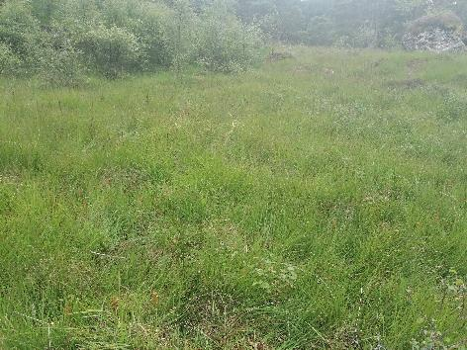 | Coille Coire Chuilc, Loch Lomond and the Trossachs National Park (LLTNP) (Image credit: Hayley Craig)
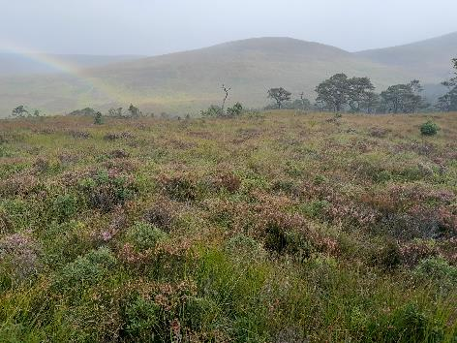 | Coille Ruigh, Glen Affric (Image credit: Marco Fioratti)
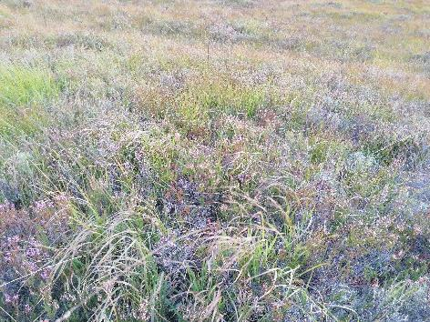 | Dundreggan Allt Fearna, Glen Moriston (Image credit: Hayley Craig)
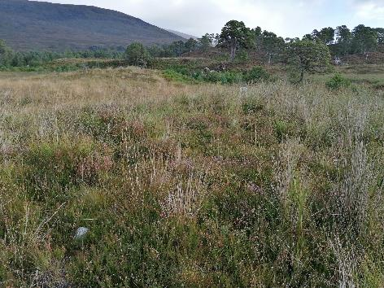 | Ghubnais, Glen Affric (Image credit: Hayley Craig)
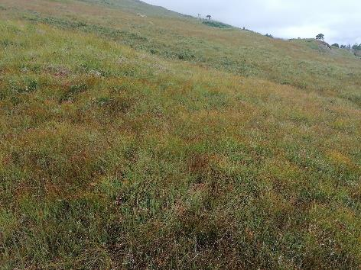 | Glen Falloch, LLTNP (Image credit: Hayley Craig)
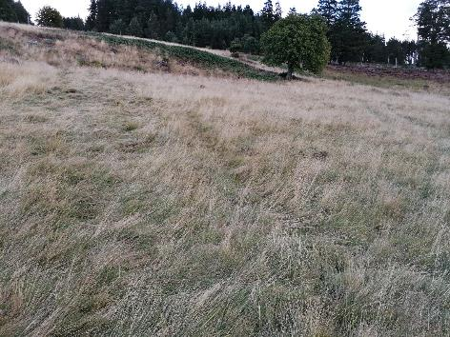 | Rothiemurchus estate, Cairngorms National Park (CNP) (Image credit: Hayley Craig)

Recently Planted/Regenerating
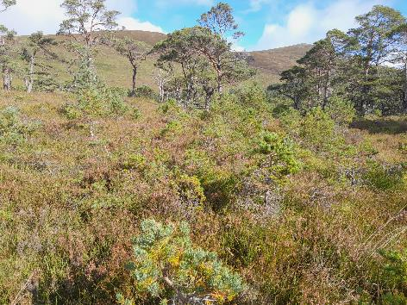 | Coille Ruigh, Glen Affric (Image credit: Marco Fioratti)
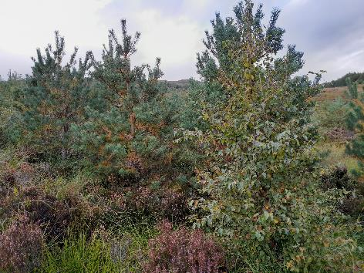 | Dundreggan Allt Fearna, Glen Moriston (Image credit: Marco Fioratti)
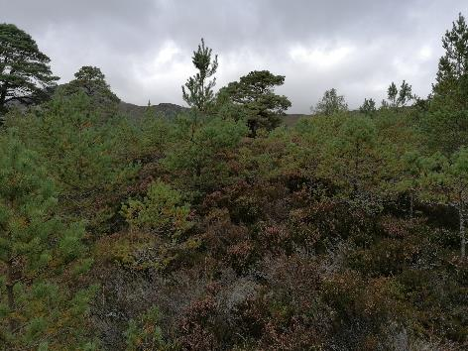 | Ghubnais, Glen Affric (Image credit: Hayley Craig)
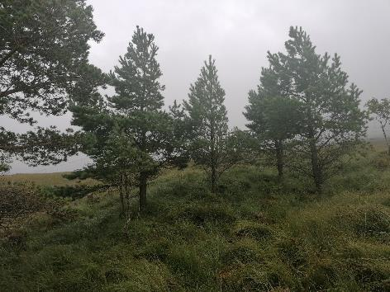 | Glen Falloch, LLTNP (Image credit: Hayley Craig)
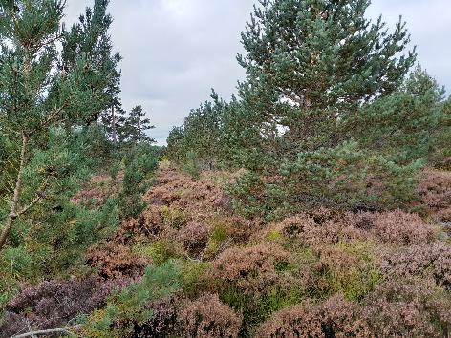 | Glen More, CNP (Image credit: Marco Fioratti)
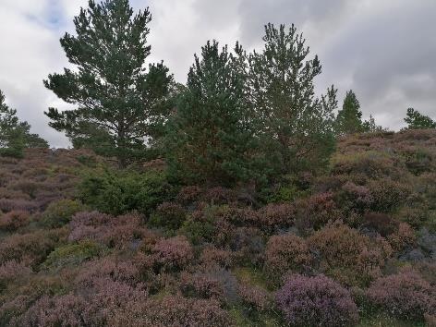 | Rothiemurchus estate, CNP (Image credit: Hayley Craig)

Mature

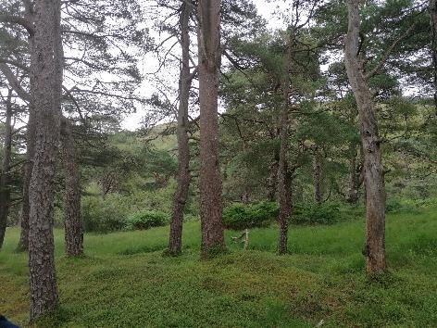 | Coille Coire Chuilc, LLTNP (Image credit: Hayley Craig)
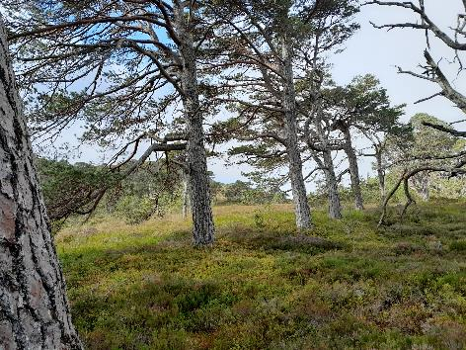 | Coille Ruigh, Glen Affric (Image credit: Marco Fioratti)
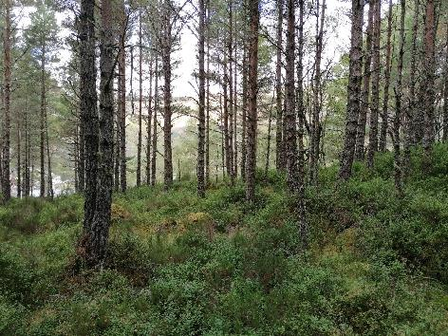 | Ghubnais, Glen Affric (Image credit: Hayley Craig)
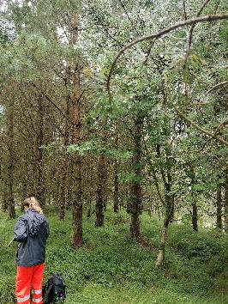 | Glen Falloch, LLTNP (Image credit: Hayley Craig)
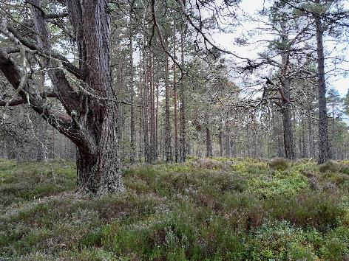 | Glen More, CNP (Image credit: Marco Fioratti)
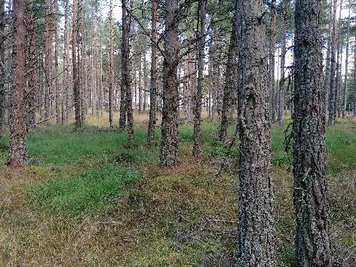 | Rothiemurchus estate, CNP (Image credit: Hayley Craig)

Peatland

Degraded
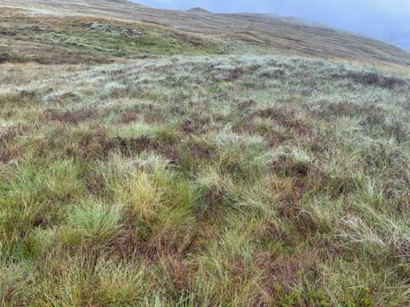 | Auchlyne, LLTNP (Image credit: Hannah Flintham)
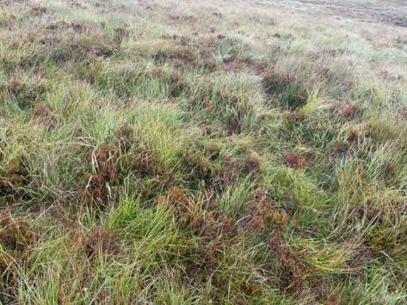 | Auchlyne, LLTNP (Image credit: Hannah Flintham)
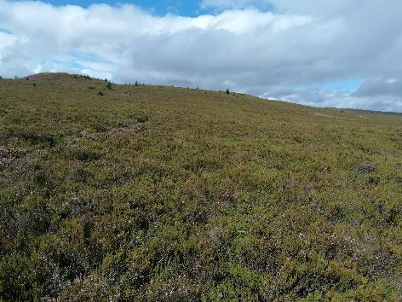 | Cashel, LLTNP (Image credit: Hayley Craig)
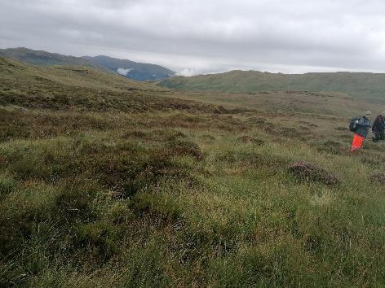 | Glen Finglas, LLTNP (Image credit: Hayley Craig)

Restored

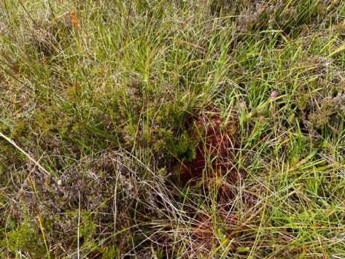 | Auchlyne, LLTNP (Image credit: Hannah Flintham)
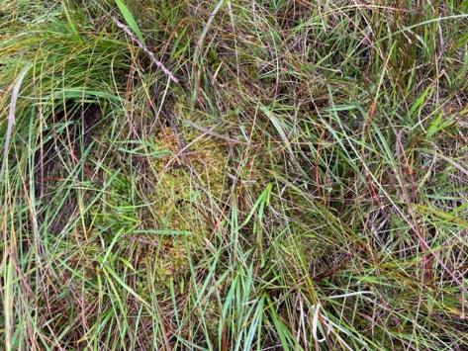 | Auchlyne, LLTNP (Image credit: Hannah Flintham)
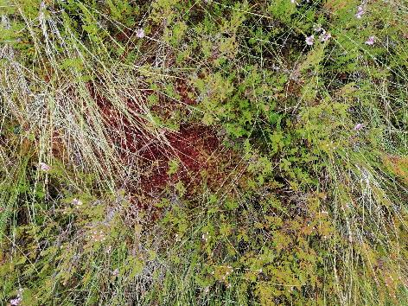 | Glen Finglas, LLTNP (Image credit: Hayley Craig)
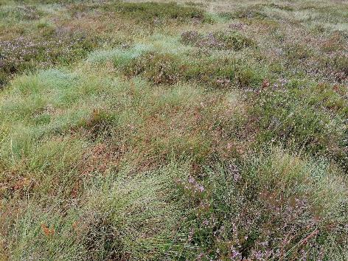 | Glen Finglas, LLTNP (Image credit: Hayley Craig)

References
Amaral-Zettler, Linda A., Elizabeth A. McCliment, Hugh W. Ducklow, and Susan M. Huse. 2009. “A Method for Studying Protistan Diversity Using Massively Parallel Sequencing of V9 Hypervariable Regions of Small-Subunit Ribosomal RNA Genes.” Edited by Gordon Langsley. PLoS ONE 4 (7): e6372. https://doi.org/10.1371/journal.pone.0006372.
Artz, R.R.E., D. Donnelly, R. Andersen, R. Mitchell, S.J. Chapman, J. Smith, P. Smith, R. Cummins, B. Balana, and A Cuthbert. 2014. “Managing and Restoring Blanket Bog to Benefit Biodiversity and Carbon Balance – a Scoping Study.”
Caporaso, J. G., C. L. Lauber, W. A. Walters, D. Berg-Lyons, C. A. Lozupone, P. J. Turnbaugh, N. Fierer, and R. Knight. 2011. “Global Patterns of 16S RRNA Diversity at a Depth of Millions of Sequences per Sample.” Proceedings of the National Academy of Sciences 108 (Supplement_1): 4516–22. https://doi.org/10.1073/pnas.1000080107.
Capra, E., R. Giannico, M. Montagna, F. Turri, P. Cremonesi, F. Strozzi, P. Leone, G. Gandini, and F. Pizzi. 2016. “A New Primer Set for DNA Metabarcoding of Soil Metazoa.” European Journal of Soil Biology 77 (November): 53–59. https://doi.org/10.1016/j.ejsobi.2016.10.005.
Egeter, Bastian, Hayley Craig, Lynsey R Harper, Edward Wort, and Judith Bakker. 2023. “Phase 1 Pilot Study Findings & Phase 2 Sampling Plan - Developing Habitat Scale DNA Monitoring in Support of Post 2020 Biodiversity Reporting Requirements.” NMP/001/20. NatureMetrics.
Kelly, Ryan P., Jesse A. Port, Kevan M. Yamahara, and Larry B. Crowder. 2014. “Using Environmental DNA to Census Marine Fishes in a Large Mesocosm.” Edited by Gretchen E. Hofmann. PLoS ONE 9 (1): e86175. https://doi.org/10.1371/journal.pone.0086175.
Leese, Florian, Mandy Sander, Dominik Buchner, Vasco Elbrecht, Peter Haase, and Vera M. A. Zizka. 2021. “Improved Freshwater Macroinvertebrate Detection from Environmental DNA through Minimized Nontarget Amplification.” Environmental DNA 3 (1): 261–76. https://doi.org/10.1002/edn3.177.
Leray, Matthieu, Joy Y Yang, Christopher P Meyer, Suzanne C Mills, Natalia Agudelo, Vincent Ranwez, Joel T Boehm, and Ryuji J Machida. 2013. “A New Versatile Primer Set Targeting a Short Fragment of the Mitochondrial COI Region for Metabarcoding Metazoan Diversity: Application for Characterizing Coral Reef Fish Gut Contents.” Frontiers in Zoology 10 (1): 34. https://doi.org/10.1186/1742-9994-10-34.
Li, Jianlong, Tristan W. Hatton-Ellis, Lori Jayne Lawson Handley, Helen S. Kimbell, Marco Benucci, Graeme Peirson, and Bernd Hänfling. 2019. “Ground-Truthing of a Fish-Based Environmental DNA Metabarcoding Method for Assessing the Quality of Lakes.” Journal of Applied Ecology 56 (5): 1232–44. https://doi.org/10.1111/1365-2664.13352.
May, Linda, Philip Taylor, Iain D. M. Gunn, Stephen J. Thackeray, Laurence R. Carvalho, Peter Hunter, Mairéad Corr, et al. 2022. “Assessing Climate Change Impacts on the Water Quality of Scottish Standing Waters.” Scotland’s Centre of Expertise for Waters CREW. https://www.crew.ac.uk/sites/www.crew.ac.uk/files/publication/CREW%20%E2%80%93%20Assessing%20climate%20change%20impacts%20on%20the%20water%20quality%20of%20Scottish%20standing%20waters_1%2Blink3_0.pdf.
Miya, M., Y. Sato, T. Fukunaga, T. Sado, J. Y. Poulsen, K. Sato, T. Minamoto, et al. 2015. “MiFish, a Set of Universal PCR Primers for Metabarcoding Environmental DNA from Fishes: Detection of More than 230 Subtropical Marine Species.” Royal Society Open Science 2 (7): 150088. https://doi.org/10.1098/rsos.150088.
Pawlowski, Jan, Laure Apothéloz-Perret-Gentil, Elvira Mächler, and Florian Altermatt. 2020. “Environmental DNA Applications for Biomonitoring and Bioassessment in Aquatic Ecosystems.” https://doi.org/10.5167/UZH-187800.
Riaz, Tiayyba, Wasim Shehzad, Alain Viari, François Pompanon, Pierre Taberlet, and Eric Coissac. 2011. “EcoPrimers: Inference of New DNA Barcode Markers from Whole Genome Sequence Analysis.” Nucleic Acids Research 39 (21): e145–e145. https://doi.org/10.1093/nar/gkr732.
Scottish Government. 2022. “Biodiversity Strategy to 2045: Tackling the Nature Emergency.” https://www.gov.scot/publications/scottish-biodiversity-strategy-2045-tackling-nature-emergency-scotland/pages/1/.
White, T.J., T. Bruns, S. Lee, and J. Taylor. 1990. “38 - AMPLIFICATION AND DIRECT SEQUENCING OF FUNGAL RIBOSOMAL RNA GENES FOR PHYLOGENETICS.” In PCR Protocols, edited by Michael A. Innis, David H. Gelfand, John J. Sninsky, and Thomas J. White, 315–22. San Diego: Academic Press. https://doi.org/10.1016/B978-0-12-372180-8.50042-1.
Xu, Jiren, Paul J. Morris, Junguo Liu, and Joseph Holden. 2018. “PEATMAP: Refining Estimates of Global Peatland Distribution Based on a Meta-Analysis.” CATENA 160 (January): 134–40. https://doi.org/10.1016/j.catena.2017.09.010.

Sites of Special Scientific Interest
International Union for Conservation of Nature
Priority Marine Feature
Using the AZTI Marine Biotic Index (AMBI)
Using the Water Framework Directive Chironomid Pupal Exuvial Technique (CPET)

