


IND-G-005

EASR guidance:
Version 1.0 August 2025
Registration activity
Petrol service stations

Contents
Introduction 1
What does this guidance apply to? 1
Petrol service stations 3
Overview 3
Petrol vapour recovery during unloading of petrol into tanks 3
Petrol vapour recovery during petrol refuelling of motor vehicles 3
Diagram 1: Petrol movement and petrol vapour recovery at a service station 4
Environmental controls 5
Site design and infrastructure 5
Stage I petrol vapour recovery 6
Stage II petrol vapour recovery 7
Deliveries 8
Management techniques 9
Maintenance 9
Stage I petrol vapour recovery 10
Stage II petrol vapour recovery 10
Operator training 11
Resource use and efficiency 11
Raw materials 11
Water 12
Waste 12
Heat 12
Energy 12
Interpretation of terms 13
Disclaimer 13

If you would like this document in an accessible format, such as large print, audio recording or braille, please contact SEPA by emailing equalities@sepa.org.uk

Introduction
This document provides information and guidance for anyone undertaking the unloading and/or refuelling of petrol at service stations which may be authorised under the Environmental Authorisation (Scotland) Regulations (EASR). It should be read alongside the standard conditions for this activity.

What does this guidance apply to?
This guidance applies to the majority of service stations selling petrol to road vehicle users.
It applies to service stations where 500 m³ (500,000 litres) of petrol over any 12-month period is unloaded into stationary storage tanks; and the petrol refuelling of motor vehicles takes place over the following thresholds measured over any 12-month period:
Activity | Authorisation threshold
Refuelling at a new service station | 500 m³ (500,000 litres)
Refuelling at an existing service station | 3,000 m³ (3,000,000 litres)
Refuelling underneath permanent living quarters or work areas | 100 m³ (100,000 litres)

The guidance also applies to service stations where 500 m³ (500,000 litres) of petrol over any 12-month period is unloaded into stationary storage tanks, but the threshold for petrol refuelling is not met. For example, at remote or rural service stations where there is a low demand for petrol.

‘new service station’ means a service station which is put into operation on or after 1st January 2012 or an existing service station where a significant alteration or renewal of the station infrastructure has been completed on or after 1 January 2012.
‘existing service station’ means a service station which was put into operation or for which planning permission was granted on or before 3 December 2011.
‘significant alteration or renewal of service station infrastructure’ means a major refurbishment of a service station e.g. changing tanks & pipes, but does not apply to refurbishing retail areas.
The guidance does not apply to service stations only used in connection with the construction and delivery of new vehicles. If the storage or unloading of petrol is taking place at a terminal, a permit is required from SEPA.

Petrol service stations

Overview
Petrol service stations are purpose-built facility where petrol is unloaded into stationary storage tanks and motor vehicles are refuelled with petrol.

Petrol vapour recovery during unloading of petrol into tanks
This type of petrol vapour recovery is known as Stage I. Petrol vapour is displaced from the service station storage tank as it is filled with petrol from the delivery tanker. This displaced petrol vapour is recovered and returned, through a vapour-tight connection line, to the road tanker delivering the petrol.

Petrol vapour recovery during petrol refuelling of motor vehicles
This type of petrol vapour recovery is known as Stage II. Petrol vapour is displaced from the motor vehicle fuel tank as the vehicle is refuelled i.e. re-filled with petrol. This displaced petrol vapour is recovered and returned to a petrol storage tank at the service station. The petrol vapour recovery uses a system on the petrol dispensing pump nozzle which is designed to recover at least 85% of the displaced petrol vapours from the motor vehicle fuel tank.
Petrol vapour recovery from the filling of storage tanks from the petrol delivery tanker is achieved by connecting two sets of pipework between the tanker and the tank. One feeds petrol to the tank, and the other collects petrol vapour back to the tanker.
Petrol vapour recovery from the refuelling of motor vehicles is achieved via a system fitted to the petrol dispensing pump nozzle which extracts the air around the nozzle during refuelling. This collects the majority of the escaping petrol vapour which is then fed back to the tank. Diagram 1 on the next page shows the connections discussed here.

Diagram 1: Petrol movement and petrol vapour recovery at a service station

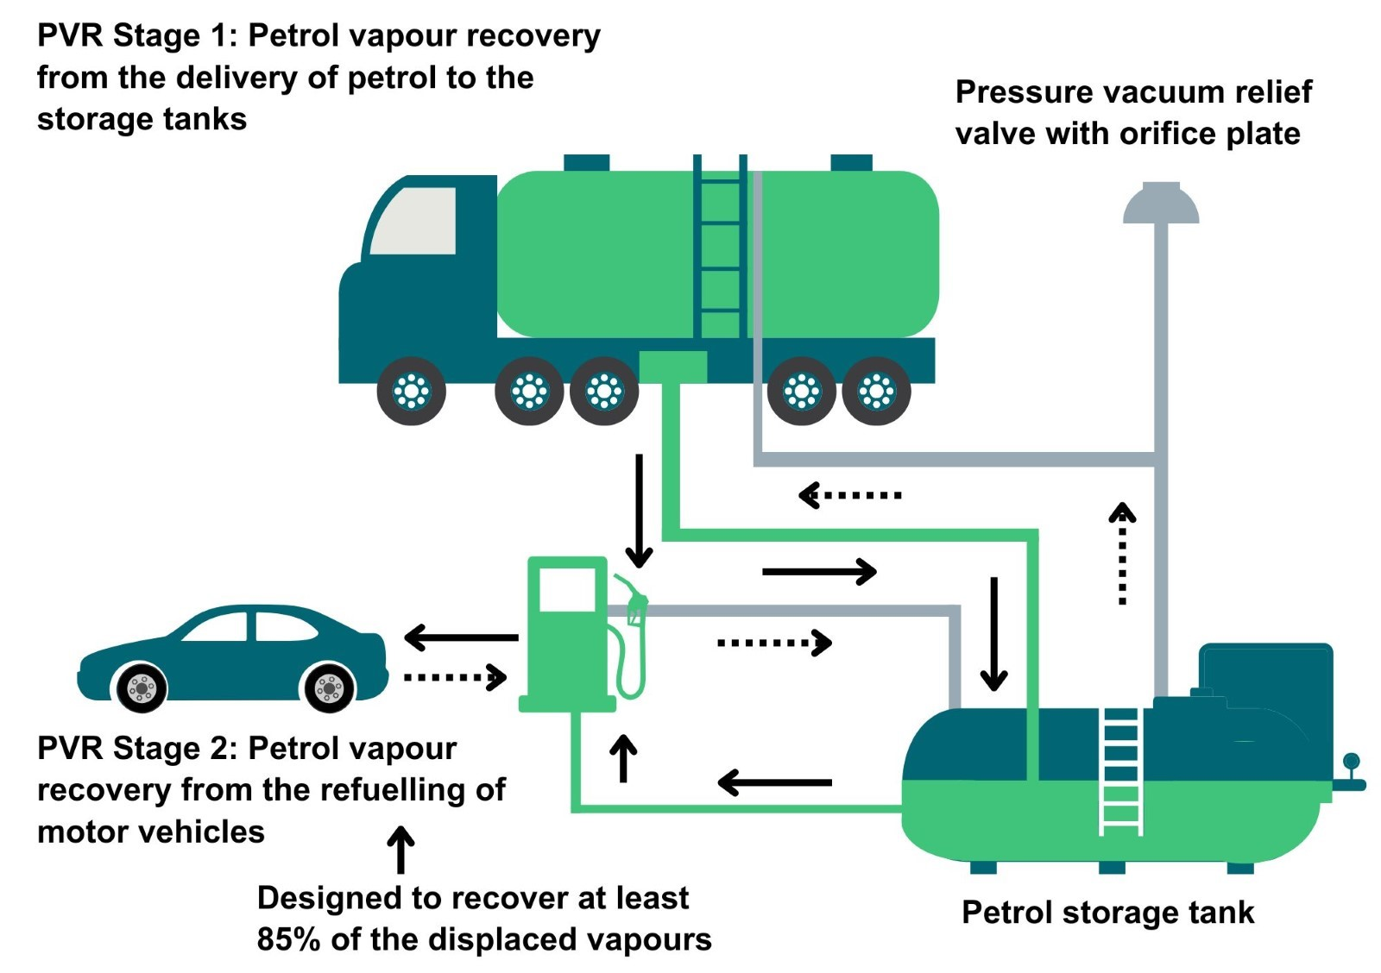

Environmental controls
It is expected that the methods described in this section are utilised to control emissions from petrol unloading and refuelling activities. Where other methods are used, they should offer at least an equivalent level of environmental protection.
Petrol vapour is the main emission from petrol service stations. This is a gaseous compound that evaporates from petrol. It is composed of volatile organic compounds (VOCs) and contributes to the formation of photochemical oxidants such as ozone which in high concentrations can impair human health and damage vegetation and materials. Some VOCs from petrol vapour are classified as toxic, carcinogenic or teratogenic.
These emissions represent a significant contribution to air pollution in urban areas and may also cause odour problems. Ozone is also a greenhouse gas and contributes to atmospheric warming and climate change. The fitting of petrol vapour recovery (PVR) equipment to the petrol storage tanks (usually located underground) and to the petrol dispensing pumps helps control emissions from the activities.

Site design and infrastructure
- Stage 1 petrol vapour recovery must be installed and properly functioning for all petrol service stations with an annual throughput of over 500m³ / 500,000 litres of petrol.
- The required petrol vapour recovery system must be fitted and fully functional.
- A diagram of where the fuel storage tanks are located and which type of fuel is stored in which tanks should be available on site.
- Stage II petrol vapour recovery must be installed in the following scenarios:
- At an existing service station (existed before 1 January 2012) where the annual throughput is over 3,000m³ / 3,000,000 litres of petrol.
- At a new (existed after 1 January 2012) or major refurbishment (undertaken after 1 January 2012) of an existing service station where the annual throughput is over 500m³ / 500,000 litres of petrol.
- At a service station situated under permanent living quarters or working areas where the annual throughput is over 100m³ / 100,000 litres of petrol.
- A major refurbishment of a service station means the significant alteration or renewal of the station infrastructure e.g. changing pipes and tanks; but does not apply to refurbishing retail areas.

Stage I petrol vapour recovery
- The unloading of petrol into tanks at a service station must be either directly from a road tanker or via an off-set filling pipe. It’s important to note that these deliveries may occur at any time of the day or night and are therefore generally controlled by the road tanker driver as the competent person.
- Vapours displaced by the delivery of petrol into service station tanks must be returned through a vapour-tight connection line to the road tanker. Loading operations must not take place if this system of petrol vapour recovery is not properly functioning.
- All reasonable and practicable steps should be taken to prevent uncontrolled leaks of petrol vapour from vents, pipes, connectors and manholes.
- A notice, nearby the vapour return connection points, reminding operators to connect the vapour return line before off-loading petrol must be displayed. This notice must also identify the maximum number of tanker compartments that may be unloaded at the same time.
- The fittings for delivery and vapour return pipes must be different to prevent mis-connection.
- Petrol storage tank pipes must be fitted with a pressure vacuum relief valve. The valve must only open outwards in the event of a potentially hazardous pressurisation and open inwards to allow air to enter when fuel is being dispensed.
- As an alternative to the pressure relief valve, an orifice vent device may be fitted to balance the storage tank vapour pressure to the atmospheric pressure.

Stage II petrol vapour recovery
- Petrol vapours, displaced by the filling of petrol into vehicle petrol tanks, must be recovered to a petrol storage tank.
- Motor vehicle re-fuelling must not take place unless an appropriate petrol vapour recovery system is in place and is fully functioning.
- The petrol vapour recovery system must be certified to have a hydrocarbon capture efficiency of not less than 85%, but no more than 115%, from the refuelling of motor vehicles.
- Where the recovered petrol vapour is transferred to a storage tank, the vapour/petrol ratio must be equal to or greater than 0.95 but less than or equal to 1.05.
- A sign, sticker or other notification must be displayed on, or in the vicinity of, the petrol dispenser to inform customers that a Stage II petrol vapour recovery system has been installed.

Deliveries
- To ensure all petrol vapour displaced from the petrol storage tanks is returned to the tanker, the vapour return hose must be connected before any petrol delivery hose and connected at the road tanker end first.
- Deliveries of petrol must not exceed the designated number of petrol tanker compartments that can be simultaneously discharged.
- The tanker driver must remain near the tanker and keep a constant watch on hoses and connections during unloading.
- All road tanker compartment vent and discharge valves must be closed on completion of the delivery.
- On completion of petrol unloading, the delivery hose must be discharged and disconnected before the petrol vapour hose is disconnected. The delivery hose must be disconnected at the tanker end first whilst the vapour hose must be disconnected at the storage tank end first.
- All connection points must be securely sealed after delivery to reduce petrol vapour leaks between deliveries.
- If operator is dip testing storage tanks or tanker compartments before or after delivery, the dip openings must be securely sealed prior to the delivery taking place and once it’s completed.
- Tanker compartment dip testing must not be performed whilst the vapour hose is connected, except in the case of split compartment deliveries although these should be kept to a minimum.

Management techniques
Good management techniques, training and well-maintained infrastructure are key to prevent and limit the consequences of accidents which could have an impact on the environment. For example, bunding should be used around liquid storage to contain any spillages, but good management and maintenance would take this a step further by ensuring that the integrity of the bunding is checked regularly to prevent leaks, and deliveries and movements around the site are well controlled. This will enable you to comply with environmental regulations, avoid incidents, and avoid any costs incurred through loss of resources.
- Effective control of emissions starts with proper management, supervision and training for process operators.
- Implement an environmental management system to help identify and provide a systematic approach to manage, monitor and control your environmental issues and maintain efficiency. These can be certified through ISO 140001, BS8555 or EMAS (Eco-Management and Audit Scheme) but can also be in-house.
- Develop and maintain an emergency response plans e.g. specific actions for preventing and mitigating spills or runoff that may affect water bodies. For best practice and guidance read the CIRIA Guide to Containment Systems for the prevention of pollution (C736F).

Maintenance
Maintenance can be categorised as ‘preventative’ or ‘corrective’ (also known as ‘reactive’). Preventative maintenance includes regular planned checks, servicing and maintenance of equipment to prevent or reduce failures and breakdowns which can lead to pollution incidents, safety concerns and costly downtime. Corrective maintenance includes identifying and repairing a fault once it has occurred with the aim of restoring equipment or systems to their optimum operational condition(s).
- All aspects of the petrol vapour recovery system must be properly maintained and there should be a written maintenance programme with a record that the maintenance has been carried out by an appropriately qualified person.
- The vapour containment integrity of both types of petrol vapour recovery systems must be tested at least once every three years, and always after repairs or substantial changes or significant events that lead to the removal or replacement of any of the components of the containment system.
- Equipment must be used properly and preventative maintenance carried out.
- Spares and consumables should be held on site so that rapid repairs can be carried out and there is no temptation to continue operating with ineffective emission controls in place.

Stage I petrol vapour recovery
- Petrol delivery and vapour return lines must be tested prior to operation and vapour return lines must be tested every 5 years for vapour containment integrity.
- Pressure vacuum relief valves or other similar devices on service station petrol tank vents must be checked for correct functioning, seating and corrosion at least once every 3 years.

Stage II petrol vapour recovery
- The petrol capture efficiency must be tested at least once a year in accordance with Standard EN 16321-2:2013, and every three years if automatic monitoring has been fitted.
- Any automatic monitoring system must automatically detect faults in the functioning of stage II PVR, including the automatic system itself, and indicate any faults to the operator. This system must also automatically stop the flow of petrol from the faulty dispenser if the fault is not rectified within seven days.
- A stage II PVR functioning fault exists where, for 10 consecutive filling operations, the vapour/petrol ratio average over the filling operation falls below 85% or exceeds 115%. Only filling operations of at least 20 seconds duration with the rate of petrol dispensed at least 25 litres per minute apply.
- If an automatic monitoring system has not been fitted, operators must undertake a weekly functionality test of the vapour recovery system including an inspection for torn, flattened or kinked hoses and damaged seals on vapour return lines.

Operator training
- Staff at all levels need to have training and instructions as to their duties to control emissions from the activity. This should include awareness of the SEPA registration requirements and actions to take in the event of incidents that may result in emissions from the activity.
- A training record should be kept for each member of staff.

Resource use and efficiency
Best practice for resource use and efficiency is to review and implement any potential opportunities to reduce emissions and wastes. In addition to reducing the impact on the environment, you will also benefit because resource efficiency is also about:
- Reducing costs (raw material and waste disposal).
- Maximising output of product or service from a given level of materials and energy (competitive advantage).
- Finding an outlet for surplus materials therefore removing them from the waste chain.
- Helping Scotland achieve its goal of becoming a zero waste society.
- Reducing pollution risks.
- Avoiding reputational impacts.
Resources include water, raw materials, energy, fuel and wastes used and produced throughout a regulated process. These can be manged in the following ways:

Raw materials
Raw material use should be managed by tracking stores and ensuring that all resources are stored appropriately to avoid contamination, spoilage or leaks. Automatic dosing equipment should be considered to ensure that optimum measured quantities are used throughout the process. LEAN methodologies that focus on reducing waste could be beneficial.

Water
Water should be stored in adequate containers and any pipework and taps maintained to avoid leaks and evaporation. Where possible use rainwater harvesting and recycled water.

Waste
Ensure waste is managed in line with the waste hierarchy (prevention > prepare for reuse > recycle > recover value > disposal). Segregate any waste and store appropriately to ensure that it can be managed as high up the hierarchy as possible.

Heat
Where heat is used or generated, ensure that optimum temperatures are maintained during the process; buildings, pipes and tanks should be insulated to minimise heat loss, and where possible any heat captured and used elsewhere.

Energy
Ensure energy is used efficiently across the site by monitoring energy use, ensuring any lighting, motors, compressors or other equipment is well maintained and working at optimum, rather than maximum, levels. Consider replacing with more energy efficient equipment during upgrades. Servicing to manufacturer’s recommendations and preventative maintenance, instead of only reactive maintenance after plant faults, are also important in ensuring equipment works optimally.

Interpretation of terms
Term | Definition
petrol | a light fuel oil obtained by distilling petroleum, used as a liquid fuel for cars and other vehicles.
resource | materials, water, waste, residues and energy used within, or produced from, the authorised activities and in any ancillary processes on site.
service station | an establishment, usually beside a road, selling fuel for road vehicles.
volatile organic compound | any organic compound having a vapour pressure of 0.01 kPa or more at 293.15K or having a corresponding volatility under the particularly conditions or use.

Disclaimer
This guidance is based on the law as it stood when the guidance was published.
Whilst every effort has been made to ensure the accuracy of this guidance, SEPA gives no warranty, covenant or undertaking (express or implied) regarding the fitness for purpose of, or any error, omission or discrepancy in this guidance. Reliance on its contents and the contents of any websites that are linked to or from this guidance is entirely at the user’s own risk. SEPA is not liable for any loss or damage that may come from using this guidance. This includes:
- Any direct, indirect and consequential losses.
- Any loss or damage caused by civil wrongs, breach of contract or otherwise.
SEPA reserves the right to depart from this guidance and take appropriate action as it considers necessary or appropriate. Operators are responsible for ensuring that they are compliant with the law. If necessary, independent legal / specialist advice should be sought.

