


Equality Mainstreaming and Outcomes Report 2025
iStock/mangrove99

Contents
Contents 2
Chief Executive’s Foreword 3
Facal-toisich an Àrd-oifigeir 6
Introduction 9
About us 10
Section 1: Mainstreaming equality 13
Section 2: Equality outcomes - our progress 29
Section 3: Our people 41
Section 4: Board diversity and succession planning.. 46
Section 5: Pay gaps and equal pay 52
Section 6: Our Equal Pay Policy 59
Appendix 1 - Specific duties of the Equality Act 60

If you would like this document in an accessible format, such as large print, audio recording or braille, please contact SEPA by emailing: equalities@sepa.org.uk

Chief Executive’s Foreword
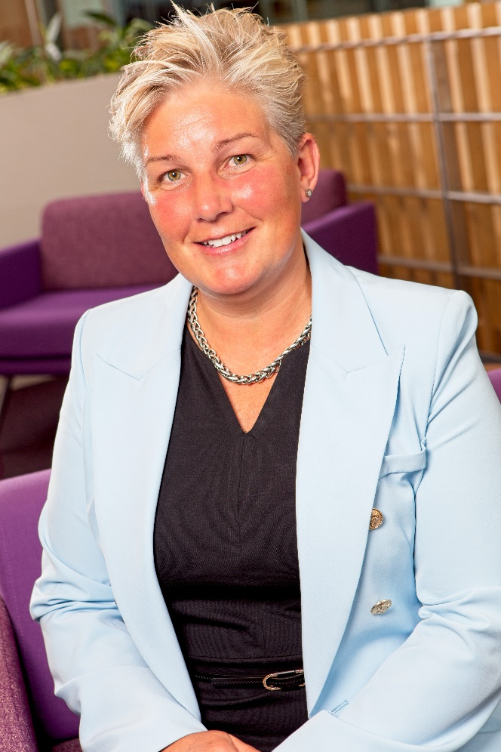
As the nation’s principal environmental regulator, the role we play is more important than ever as the environment that we all cherish is under threat. As the environment around us changes, we must review how we collectively work together to tackle the climate emergency and deliver on our commitments to the people of Scotland.​
Every day our people walk into a workplace that’s grounded in respect for their purpose and expertise. Here, they find enriching benefits, meaningful support, and opportunities to learn, so they can be their best and make the biggest impact.
Our job is to harness this expertise to provide information and services to the people and communities of Scotland. We must ensure that we are set up to deliver this as best we can, with accessibility and a customer focus prioritised in our work, to make our contribution to a more inclusive nation.
Our aim is to create a safe, welcoming environment, where SEPA employees feel they belong, are accepted, are heard at work and feel they are valued. We want to support our staff to have a greater understanding of equality and diversity and learn more about how to make inclusive decisions. By setting out and delivering our People Strategy, we’re enabling all SEPA colleagues to deliver on their outcomes and make a difference to the future of our environment.
To be effective in meeting the challenges of today and in the future, we are resetting our organisation. Over the last two years we’ve appointed a new Chair and six new Agency Board members, along with new appointments to our Corporate Leadership Team with a focus on transformation, innovation and collaborative working. As part of this reset, we have transformed our decision making by empowering leaders, managers and all our people to make the right decisions, at the right level, at the right time.
We take our duty to eliminate discrimination, to advance equality of opportunity and to foster good relations very seriously. We made the decision to adapt and refresh the available options in our Finance and HR management system to be in line with the updated 2021 Scottish Census categories. We’re also in the process of building a new recruitment system and will also align this with the Scottish census categories to allow us to gather and analyse applicant diversity data, as well as capturing candidate feedback on our processes.
We are continuing to transform our organisation to offer more efficient and resilient services that meet the diverse needs of our customer. A key element is improving our customer service offer through redesigning our customer hub with accessibility at its core and commencing work on a dedicated customer experience strategy. We’re also developing a new organisational performance framework and reporting mechanism. This has a focus on creating key performance indicators around equality to ensure that we deliver, monitor and report on how well we are fulfilling our duties.
I am proud to present the Agency’s sixth Equality Mainstreaming and Outcomes Report highlighting the work we have undertaken to mainstream equality into all that we do – for our people, the people of Scotland and our services for the environment. The report demonstrates the actions we have taken so far to achieve our equality outcomes since our last report in 2023. We understand that there is more to be done to ensure we continue to mainstream equality and achieve our outcomes.
Nicole Paterson, Chief Executive Officer

Facal-toisich an Àrd-oifigeir
Mar phrìomh riaghladair àrainneachd na dùthcha, tha an obair againn nas cudromaiche na bha i a-riamh leis gu bheil an àrainneachd a cha cho prìseil dhuinn ann an cunnart. Mar a bhios an àrainneachd mun cuairt oirnn ag atharrachadh, feumaidh sinn ath-sgrùdadh mar a dh'obraicheas sinn còmhla gus dèiligeadh ris an èiginn gnàth-thìde agus gus ar geallaidhean do mhuinntir na h-Alba a choileanadh.
Gach latha, bidh na daoine againn a’ tighinn gu àite-obrach a tha bonntaichte ann an spèis don adhbhar agus don eòlas aca. An seo, gheibh iad buannachdan beairteach, taic bhrìoghmhor, agus cothroman ionnsachaidh gus an urrainn dhaibh obair aig àrd an comais agus a’ bhuaidh as motha a thoirt gu buil.
’S e an obair againne an t-eòlas seo a chur gu feum gus fiosrachadh agus seirbheisean a sholarachadh do shluagh agus do choimhearsnachdan na h-Alba. Feumaidh sinn dèanamh cinnteach gu bheil sinn uidheamaichte gus seo a lìbhrigeadh cho math ’s as urrainn dhuinn, le prìomh àite nar n-obair aig ruigsinneachd agus cuimseachadh air ar luchd-cleachdaidh, gus an cur sinn ris an dùthaich a dhèanamh nas in-ghabhalaich.
Is e ar n-amas àrainneachd shàbhailte, aoigheil a chruthachadh, far am bi luchd-obrach SEPA a' faireachdainn gu bheil iad nam pàirt dhligheach den bhuidhinn, gu bheil iad a’ faighinn èisteachd agus gu bheil luach ga chur annta. Tha sinn airson taic a thoirt don luchd-obrach againn gus tuigse nas fheàrr fhaighinn air co-ionannachd agus iomadachd, agus barrachd ionnsachadh mu mar a nì sinn co-dhùnaidhean in-ghabhalach. Le bhith a’ cur an cèill agus a’ lìbhrigeadh ar Ro-innleachd Dhaoine, tha sinn a’ toirt comas do cho-obraichean SEPA uile na builean aca a lìbhrigeadh agus eadar-dhealachadh a dhèanamh don àrainneachd againn san àm ri teachd.
Gus a bhith èifeachdach a’ coinneachadh ri dùbhlain an latha an-diugh agus an ama ri teachd, tha sinn ag atharrachadh ar buidhne. Thar an dà bhliadhna a dh’fhalbh tha sinn air Cathraiche ùr agus sianar bhall ùr de Bhòrd na Buidhne ainmeachadh, còmhla ri daoine ùra san Sgioba Ceannardas Corporra, a’ cuimseachadh air cruth-atharrachadh, innleachdas agus co-obrachadh. Mar phàirt den obair seo, thug sinn cruth-atharrachadh air ar pròiseas co-dhùnaidh, a’ toirt cumhachd do cheannardan, manaidsearan agus ar daoine gu lèir gus na co-dhùnaidhean ceart a dhèanamh, aig an ìre cheart, agus aig an àm cheart.
Tha sinn leigte air ar dleastanas a choileanadh airson cur às do leth-bhreith, co-ionannachd chothroman adhartachadh agus deagh dhàimhean àrach. Rinn sinn co-dhùnadh na roghainnean san t-siostam riaghladh Ionmhais is Sgiobachd againn atharrachadh agus ùrachadh gus a bhith a rèir roinnean ùra Cunntas-sluaigh na h-Alba 2021. Tha sinn cuideachd an-dràsta a’ togail siostam fastaidh ùr agus bidh sinn a’ co-thaobhadh seo ri roinnean cunntas-sluaigh na h-Alba gus dàta iomadachd thagraichean a chruinneachadh agus a mhion-sgrùdadh, cho math ri fios air ais fhaighinn bho thagraichean mu ar pròiseasan.
Tha sinn a’ leantainn air adhart ag atharrachadh ar buidhne gus seirbheisean nas èifeachdaiche agus nas seasmhaiche a thabhann a choinnicheas ri feumalachdan eadar-dhealaichte ar luchd-cleachdaidh. Is e prìomhachas a bhith a’ leasachadh ar seirbheis luchd-cleachdaidh le bhith ag ath-dhealbhadh ar hub luchd-cleachdaidh gus ruigsinneachd a chur aig cridhe chùisean, agus a’ tòiseachadh air ro-innleachd shònraichte air eòlas luchd-cleachdaidh a chur an sàs. Tha sinn cuideachd a’ leasachadh frèam-obrach air dèanadas na buidhne agus dòigh aithris. Tha seo a’ cuimseachadh air cruthachadh prìomh chomharran coileanaidh a thaobh co-ionannachd gus dèanamh cinnteach gu bheil sinn a’ lìbhrigeadh, a’ sgrùdadh agus ag aithris air mar a tha sinn a’ coileanadh ar dleastanasan.
Tha mi pròiseil an siathamh Aithisg Àbhaisteachadh agus Builean Co-ionannachd aig a’ Bhuidhinn a thaisbeanadh a’ soilleireachadh ar n-obrach gus co-ionannachd àbhaisteachadh anns gach rud a nì sinn – airson ar daoine, muinntir na h-Alba agus ar seirbheisean airson na h-àrainneachd. Tha an aithisg a’ sealltainn na rinn sinn gu ruige seo gus ar builean co-ionannachd a choileanadh bhon aithisg mu dheireadh againn ann an 2023. Tha sinn a’ tuigsinn gu bheil barrachd ri dhèanamh gus a bhith cinnteach gun lean sinn oirnn ag àbhaisteachadh co-ionannachd agus a’ coileanadh ar builean.
Nicole Paterson, Àrd-oifigear

Introduction
Welcome to our Equality Mainstreaming and Outcomes Report 2025. This report demonstrates the progress we’ve made in mainstreaming equality across the Agency, and our progress against the four equality outcomes we set in 2022.

Structure of the report
The report is structured into the following sections:
- Section 1 – Mainstreaming equality.
- Section 2 – Equality outcomes progress.
- Section 3 – Our people – information about our people.
- Section 4 – Information on board diversity and succession planning.
- Section 5 – Pay gaps and equal pay.
- Section 6 – Statements on equal pay.

About us
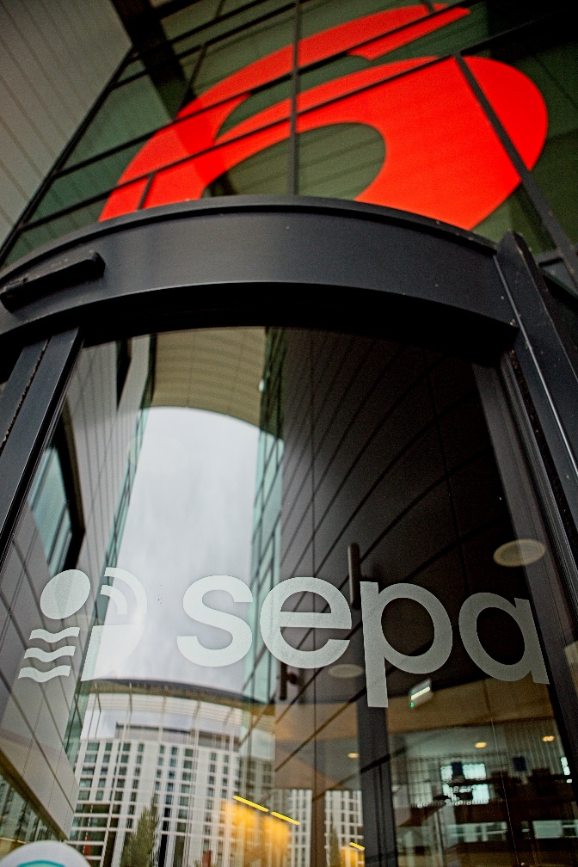
We’re the Scottish Environment Protection Agency (SEPA), Scotland’s principal environmental regulator. We’re a non-departmental public body and independent advisor on the environment, accountable to Scottish Ministers and the Scottish Parliament.
Our statutory purpose is to protect and improve the environment in ways that, as far as possible, also contribute to improving health and well-being and achieving sustainable economic growth.
We employ over 1,250 people across Scotland in a wide variety of roles contributing to achieving our five Corporate Plan priorities (Net Zero, Climate Resilience, Water Environment, Resource Efficiency and Business Environmental Performance) and the national outcomes set by the Scottish Government.
In 2024, we initiated a reset of the Agency. We’re building on a strong foundation to future proof the organisation and pass on a thriving planet for future generations. Since 2024, we’ve published our Corporate Plan for 2024-2027, invested in our people and launched our People Strategy, established our One SEPA modernisation / transformation programme, and begun our journey to develop a new performance framework.
We believe this reset will strengthen our ability to innovate and optimise our delivery of effective environmental outcomes for Scotland.

Our approach to equality and human rights
The Public Sector Equality Duty (‘the general duty’) requires that SEPA, in the exercise of its functions, has due regard for the need to:
- Eliminate unlawful discrimination.
- Advance equality of opportunity
- Foster good relations.
Furthermore, as part of the Equality Act 2010 (Specific Duties) (Scotland) Regulations 2012, we must:
- Report progress on mainstreaming the equality duty.
- Publish equality outcomes and report progress.
- Assess and review policies and practices.
- Gather and use employee information.
- Publish gender pay gap information and equal pay statements.
- Consider award criteria and conditions in relation to public sector procurement.
- Publish this mainstreaming report, equality outcomes and progress updates in a manner which is accessible to the public.

To ensure that equality, diversity and human rights are woven throughout our organisation, our approach focuses on several strands:
- Respecting human rights and equality in every interaction.
- Strategic direction for equality and human rights and making sure we deliver it.
- Developing ‘inclusive by design’ plans, tools, systems, processes and guidance.
- Supporting our people and create an environment for change.
- Strengthening our continuous improvement process.
- Using our data to aid decision making and help us all take action in respect of the Public Sector Equality Duty.

Section 1: Mainstreaming equality

This section demonstrates our continued commitment to the consideration of equality in all that we do. This includes our day-to-day duties and activities, as well as the delivery and development of our services.

People and Resources Committee
The People and Resources Committee is part of our Board governance structure. Its purpose is to provide assurance to the Board that we meet our obligations as an employer in relation to a range of people related matters, including well-being, development and support, workforce planning, and equality and diversity.
The Committee regularly reviews human resource policies and other human resource matters; remuneration matters including pay increases and pensions arrangements in line with Scottish Government pay remits; and ensures compliance with relevant legislation and Scottish Government requirements. The Committee also receives and considers reports from our Health and Safety Committee, identifying any people focused implications.

Equality Oversight Group
Our Equality Oversight Group has been fundamental in overseeing and progressing the equality outcomes we set in 2022 and supporting our lived experience groups. The group’s purpose is to help SEPA create a culture where all our people are supported to do well at work, ensure our services meet all our customers’ needs, and that as an organisation, we value diversity in our workforce.

‘One SEPA’ transformational change
Our transformational change programme, One SEPA, brings together a group of programmes which will transform areas of our organisation and offer better, more resilient services that meet the needs of our customers. As part of this work, we reviewed our customer experience to understand how we can improve it.
Using what we learned, we redesigned our customer hub to provide customer focused services that better meet the needs of those who contact us. We’ve begun to develop a customer experience strategy. We also looked at digital transformation, moving towards digital first, taking into account the importance of accessibility.

Equality and Human Rights Impact Assessments (EqHRIAs)
To mainstream equality and human rights into all aspects of our work, we need to make sure it becomes second nature for us to think about people’s differences and diverse needs. We redesigned our Equality Impact Assessment and incorporated Human Rights into our process and template. This is enabling us to take person-centred, evidence-based decisions to improve our services and better address inequalities. We completed and published 12 EqHRIAs on our website during the reporting period. We are currently working on a further 37. Further information on how we use EqHRIAs is provided in Section two. Along with EqHRIAs, we also consider Islands Communities Impact Assessments before undertaking projects.

Procurement award conditions and criteria
The Procurement Reform (Scotland) Act 2014 sets out the sustainable procurement duty, community benefit requirements in procurement and fair work practices in procurement. We embedded these into our Corporate Procurement Strategy and supporting Procurement Policy for 2024-2027. This has been approved by our Board and will be published on our website.
Where relevant and proportionate, we continue to consider how our procurement award criteria and performance conditions help us better perform the equality duty. This includes considering suppliers’ equality commitments as part of our contracting criteria, where relevant. In 2024, we awarded a contract of around £12 million to Mitie for the delivery of total facilities maintenance. We ensured community benefits and equality considerations are monitored as part of performance reporting.

Reasonable adjustments
We consider any reasonable adjustments, such as the physical workplace (for example, access or equipment), the ways things are done (flexibility in hours, patterns of work, how we communicate information, etc) and allocating someone to help an employee, applicant or service user. We rolled out assistive technology and updated our guidance to ensure that it is in line with best practice.
We are proactive in supporting our people with health issues and disabilities to improve their working environment and overcome any barriers while at work. Any support requirements are identified for new employees via our pre-employment checks so that we can be proactive about engaging with them to provide necessary supports for them commencing employment. We work with our occupational health provider and other external specialists to identify and implement appropriate supports for existing employees, where an emerging need is identified, or circumstances have changed. This can include workplace assessments, the provision of training for specialised equipment and ongoing reviews.
Looking forward, we will review our Reasonable Adjustment Guidance and work across the agency to streamline our internal processes to better support any identified needs.

Our people

People Strategy, our values and Behaviours Framework
We launched our People Strategy, setting out clear commitments to improve engagement and career opportunities, and enhance the support available to our people. The strategy provides enriching benefits, meaningful support and opportunities to learn. It aims to support us to continue to build a safe, welcoming, inclusive environment where our employees feel they belong and are valued.
Our People Strategy will enhance four key areas: how we work, employee support, personal and organisational development, and engaging and empowering teams. It is built upon our values: Purposeful, Professional and Passionate. It is supported by a Behaviours Framework which sets clear expectations to ensure everyone in the organisation feels respected and is a key enabler to meet the objectives set out in our Corporate Plan.

Strategic approach to our workspaces
We published our Strategic Approach to Our Workspaces which sets out clear commitments to reduce cost and minimise emissions from our workspaces. The strategy will deliver against these commitments through co-locating with other public sector organisations by default and ensuring our colleagues will have access to:
- Better workspace choice and working environments.
- Increased flexibility and choice in work locations.
- Inclusive, supportive and fully accessible work environments with:
  - Support for neurodiverse colleagues or colleagues with a disability.
  - Support for colleagues going through or have been through gender reassignment.
  - Quiet rooms and first aid rooms promoting wellbeing and inclusivity to all colleagues and making space for neurodiversity, prayer for people of all faiths and none, mental health breaks and breastfeeding parents.
We held regular drop-in sessions with colleagues to share the strategy and progress to date and identify any further considerations.

Talent and acquisition
We introduced a new, dedicated Talent Acquisition team to transform our approach to recruitment and selection. The initial focus has been on training for new colleagues before transferring all recruitment-related processes and activities from Human Resources to the Talent Acquisition team.
Engagement with candidates and hiring managers is underway to gain insight into how our processes, systems and approach can be improved. During 2025, we will be implementing a new Applicant Tracking System which will make the advertising and application stages more efficient and effective and improve the capture of equality data. Immediate improvements have been made to vacancy advertising with the use of templates that reflect our values and employee value proposition along with increased use of LinkedIn as a promotional tool. As an inclusive and equal-opportunity employer, we are committed to building a diverse workforce. We guarantee an interview to all candidates who disclose a disability and meet the essential qualifications/experience for the role, ensuring equal access to opportunities for everyone. Through improved systems and advertising we’re focused on enhancing diversity, equality and inclusion in all our talent acquisition activities.

Learning and development
All events and training packages are created with equalities in mind and aim to support an open and inclusive culture. The successful launch of our new Menopause and Periods Policy, was followed by additional sessions to provide continuing support and guidance to those who were experiencing the symptoms of menopause and periods and colleagues supporting those who are. The sessions were offered to everyone and outlined the practical support that we can provide for those who require it.

LGBTQ+ training
Developing our Transgender Equality Policy, strengthened relationships with partners including the Equality Network. It was from this relationship that we delivered LGBTQ+ Awareness sessions. The sessions gave attendees an introduction to LGBTQ+ awareness and terminology. This was to give a greater level of confidence and understanding for our people when interacting with or supporting LGBTQ+ people. The sessions were attended by over 90 SEPA colleagues.

Canva
"I really enjoyed working with SEPA delivering our LGBT+ awareness training sessions. The participants were very involved throughout and showed a lot of engagement and desire to do the right thing. They made the session fun and entertaining, and I would welcome the opportunity to work with them again in the future."
James H. Verardi (he/him), LGBT+ Training Officer, The Equality Network
On completion of the training colleagues said:
“I thought this was a really excellent course that should be mandatory for everyone in SEPA.” SEPA employee
“I learnt a lot and feel more comfortable taking part in discussions and conversations around LGBT+ issues now.” SEPA employee

Health and well-being
We introduced new guidance on ‘Speaking Up About Concerns,’ which is intended to empower our people to speak comfortably and safely about workplace worries. Resources are available to colleagues to facilitate raising concerns when they need to.
We continue to offer the Health Hero Employee Assistance Programme. It’s a free, confidential and independent counselling and information service for our people, providing advice on a wide range of family, work, financial and emotional matters. This is available 365 days a year, 24 hours a day.
We provide our people with a well-being day. This enables our colleagues to take a day’s paid leave to support their personal well-being or to participate in cultural or community events. It provides colleagues with the opportunity to put their well-being first. We also offer our people two paid volunteering days (pro-rated) per year to support causes which are important to them.
We have revised our safety cover system using learning from Scottish Women’s Aid to shape our thinking around safety when our people are out on SEPA business. We engaged and consulted with a wide range of our people across the agency who use safety cover in their day-to-day role. We worked with UNISON and the Digital Lived Experience group to ensure the safety cover system and the training was suitable for all our people.
The system provides a variety of options for our people to request safety cover including voice calls, voice notes or text functions.
Our people can proactively raise alerts to the highest level if needed as well as access the services provided by the lone worker support service. Ensuring access to appropriate help (from the emergency services) or support (for example talking on the phone with the user until they are in a safe place) will provide reassurance to our people.

Accessible working environments
In addition to our strategic approach to our workspaces, hybrid working has allowed us to remove the geographical barriers that were once in place for some of our positions. This has meant that we have been able to attract a wider number of applicants than before from more diverse backgrounds.
Hybrid working also benefits our disabled (and non-disabled) people as it enables them to better manage their health and well-being, allows a better work life balance and helps carers with caring responsibilities. We created guidance on hybrid working to give clarity on our approach and to help frame conversations between managers and employees. We also invested in hybrid meeting equipment for our offices allowing our people to have the flexibility to join meetings remotely.
As part of our hybrid working policy and guidance, we enable our people to work safely and comfortably from home by offering equipment. All our people are required to complete a display screen equipment self-assessment which helps us to identify what equipment is required. In response to feedback from our Digital Accessibility Lived Experience Group, we aim to undertake a co-ordinated review of our approach and processes around the identification and purchase of assistive equipment / technology to support reasonable adjustments.

Accessibility and inclusive communications
We continue to invest in accessibility and to build our inclusive communication approach. We are utilising new tools to support the ways in which we communicate, the language, tone and visual content that we use and our techniques for better audience reach. We are building capacity and skills across the agency through accessibility training developed in-house for our communication products, guidance and templates.
Our emails now include screen reader compatibility and alternative text descriptions supporting users with visual impairments. Our social media content has been improved, using images and text in a more accessible way. We have also introduced subtitles on internal and external videos.
We have embarked on an ambitious review of our entire website estate to improve accessibility requirements, including the decommissioning of content where required and uploading only accessible content. We are working closely with our people to help them understand their responsibilities and ensure that we are compliant.
We launched a beta website in December 2023, which is fully accessible and is the first step in ensuring our entire web estate meets accessible standards. Work was completed in early 2024 to update the templates on the legacy website to make these accessible too. We are currently auditing documents and other uploads to bring these in line with accessible standards. We are investing additional resource to ensure we are delivering fully accessible content for all users, across all channels.
Moving forward, we plan to develop an accessibility strategy, policy and further training for our people to ensure everyone is clear on our legal requirements.

Accessible engagement and consultation
We are continually developing how we consult and engage with our communities, customers and stakeholders, so that our approach is inclusive, accessible, and meaningful. Our engagement and consultation activities will be well-planned, with a clear purpose.
Wherever possible, we aim to work directly with those who have lived experience of the issues we are addressing. We will ensure participants are supported to fully engage, regardless of their circumstances, and their insights are used effectively to inform and shape our decision-making, policy and practice. For example, we aim to co-design our engagement methods to enhance our reach and relevance within minoritised communities and vulnerable groups, children and young people and people living in remote and rural areas, and low-income areas.
Our approach is underpinned by the requirements of the Community Empowerment (Scotland) Act 2015 and the National Standards for Community Engagement. We will always demonstrate the impact of participation by clearly showing how feedback has influenced decisions and highlighting any resulting changes. Regular evaluation of our engagement and consultation activities will enable us to measure success and identify areas for improvement. Through inclusive design, being open and transparent, we aim to continually adapt how we do things to stay connected with communities and ensure they have a voice in the services we provide.

Policies, procedures, guidance and support
We use our employee equality and demographic data to help inform and influence our organisational policies and approaches. Since 2023, we have strengthened our family friendly policies and benefits packages, including:
- Increasing paid paternity leave entitlement.
- Enhancing paid leave for parents who sadly suffer a pregnancy loss.
- Implementing paid neonatal leave, paid leave for fertility treatment and paid carers’ leave.
We also increased our annual leave provision in both 2024 and 2025. Consequently, from 2025 we will provide one of the highest leave entitlements of all Scottish public bodies.
We are pleased that we have a long-standing relationship with UNISON, our recognised trade union. We work, consult and negotiate with UNISON on a range of employee related policies, procedures and terms and conditions. Since 2023, we have worked closely with UNISON to introduce new policies and training packages such as the Transgender Equality Policy and the Domestic Abuse and Gender Based Violence Policy.

Domestic Abuse and Gender Based Violence Policy
We launched our Domestic Abuse and Gender-based Violence Policy in August 2024. The key purpose of this policy is to support our people who are affected by gender-based violence. In November 2024, Scottish Women’s Aid provided gender-based violence sessions to our people to raise awareness of domestic abuse and the policy being introduced to support colleagues who may be impacted by it.

Transgender Equality Policy
“Whilst SEPA operates across Scotland - from the Borders to the Western Isles - we know we deliver better when we're representative of the diverse range of people who make up our country.
“As an inclusive employer, SEPA are committed to supporting each individual in their decisions, and we want to ensure that all trans employees are well supported and respected, including those who intend to, or are in the process of, transition.
“Our aim with the Transgender Equality Policy is to show support for individuals as well as providing information for colleagues who can help us promote equality, diversity and good relations in everything we do.”
Jennifer Russell, Head of People, Recruitment and Reward
We developed and implemented the policy to provide clarity and guidance around transgender equality in the workplace, including guidance on terminology, facilities, and processes and procedures relevant to transgender and non-binary colleagues, their managers and all employees. Further training was also given to managers and those responsible for handling sensitive data.
We improved our equality data, aligning with Scotland’s latest census, to better take into account our people who consider themselves to be trans or have a trans history.

Section 2: Equality outcomes - our progress
This section outlines the progress and key contributions that we have made towards our equality outcomes that were introduced in 2022 and the work that is still to be done. While they can be viewed as stand-alone objectives, there are clear relationships and synergies between them and with our mainstreaming. Our equality outcomes are:
- Outcome 1 – We have increased the number of people from currently underrepresented groups in our applicants, our employees and those who progress within the organisation.
- Outcome 2 - People with lived experience of inequality, related to a protected characteristic or socioeconomic status, access and use SEPA’s services without barriers.
- Outcome 3 - Employees with lived experience of inequality and barriers, and with a wide variety of needs, feel listened to and respected as SEPA meets those needs.
- Outcome 4 – We have decreased our gender pay gap and occupational segregation related to gender, disability and ethnicity.

Outcome 1: We have increased the number of people from currently underrepresented groups in our applicants, our employees and those who progress within the organisation.
As a public sector employer in Scotland, we recognise the importance and value of having a diverse workforce. At the time of introducing this outcome, our data indicated an under representation of people from Black, Asian and minority ethnic communities, disabled people and young people working for the Agency. While employed, there was further under representation for female, Black, Asian, minority ethnic and disabled employees being promoted and having flexible working opportunities.
Our efforts towards this outcome have included the development of a new approach to job evaluation, in partnership with UNISON, to provide a key foundation in determining pay and grade for roles within the agency and supporting the principles of equal and fair pay.
We relaunched our employee benefits package in September 2024, outlining:
- Financial benefits such as Local Government Pension Scheme, access to Edenred Savings Platform and Additional Voluntary Contributions for pensions.
- Flexible working including flexi time scheme, hybrid working and flexible workspaces.
- Physical and mental well-being benefits such as access to Health Hero our Employee Assistant Programme, and our annual well-being day available to our people.
We improved our equality data, aligning with Scotland’s latest census. We will be moving to implement a new recruitment system in 2025, making it easier for us to see where we need to target our campaigns and improve our services. We are also working on our data analysis and reporting to share insight and trends to inform action where it is needed.
With a focus on young people, we launched two specific programmes:
- Early careers programme – Structured training that will provide our trainees with the skills and experience to be fully competent Environment Protection Officers after two years. This attracted a fantastic response with almost 700 applicants.
- Graduate apprenticeship – Working with Heriot Watt University to attract young people who were passionate about data and their personal development.

With evidence showing that women tend to have more caring responsibilities and that hybrid working also benefits our disabled (and non-disabled) people, we have taken the opportunity to review our Hybrid Working Policy and guidance. This work was intended to reduce barriers to some of our roles enabling us to attract a wider number of applicants than before from diverse backgrounds. We anticipate that hybrid working at SEPA would also help attract a wider range of applicants as it allows a better work life balance and provides more flexibility to carers with caring responsibilities.
At this gateway point, the data we have gathered is reflecting notable progress in diversifying applicant demographics. We have seen the numbers of applicants from Black, Asian, Mixed, and Other ethnic groups have increased as well as the proportion of applicants identifying as disabled. We are also seeing an increase in female applicants, bisexual and homosexual applicants, and applicants identifying as being in a civil partnership. All of this indicates a positive trend towards equality outcome one.
The shift in the diversity of applicants is also reflected in the make-up of new employees to SEPA. Although we do not have fully completed equality information for all our people, the available data reflects an increase in female new employees and an increase in the number of younger age group employees (aged 25-34) and older (aged 55-64).
We are seeing a higher proportion of new employees identifying as gay, lesbian, bisexual or other in regard to sexual orientation. A decrease in new employees declaring a ‘White’ background ethnicity group has also been identified. Due to the small number of individuals providing information relating to their disability status, it is not possible to compare these figures to those previously reported, however we do know that fewer new employees than before have declared themselves as non-disabled.
Going forward, we will complete the full implementation of a new recruitment system, which will improve data collection around the diversity and protected characteristics of our applicants. We will continue our Early Careers and Graduate apprenticeships programmes. We will use our job evaluation and resource planning to ensure the skills, size, shape and structure of teams in the agency allow us to meet our purpose.

Outcome 2: People with lived experience of inequality, related to a protected characteristic or socioeconomic status, access and use SEPA’s services without barriers.
For this outcome, we wanted to better understand our customer journey and address barriers people face when accessing and using our services, with a view to creating tools for effectively embedding different people’s needs in decision-making, project planning and service delivery.
Our initial efforts have focused on redesigning our Equality and Human Rights Impact Assessment (EqHRIA) process, reflecting upon our existing process as well as best practice. We expanded the approach to include human rights and modified our EqHRIA template to make it more user friendly and allow for wider application across the Agency. Guidance was issued to reflect this update and help mainstream equality in all our work. Through these efforts, we have seen an increase in both the number and quality of our Equality and Human Rights Impact Assessments. To further support our efforts, we actively engage with the NDPB (Non-Departmental Public Bodies) Equality Forum, providing a shared understanding of policies and initiatives, and to gain valuable knowledge and insights from other organisations.

Recognising that our website estate provides a key access point for our customer experience, we have embarked on a comprehensive review, decommissioning content where required and ensuring new content is accessible.
Work will continue on our website estate, and we are exploring opportunities for further improvements that can be made to our Equality and Human Rights Impact Assessments.
Work has also been initiated with regards to digital transformation and the development of a customer experience strategy (including approaches to engagement and consultation).
iStock/871072426/PeopleImages

Outcome 3: Employees with lived experience of inequality and barriers, and with a wide variety of needs, feel listened to and respected as SEPA meets those needs.
The delivery of services for Scotland depends on the dedication, commitment and diversity of our people. Our aim is to create a safe, welcoming and high performing environment, where our employees belong, feel valued, listened to and respected and can share their lived experiences.
To achieve this aim, we recognise the importance of training for our people to provide a deeper insight into our organisation, what we do, and what makes SEPA a great place to work.
All new employees are invited to an Equality and Human Rights induction - interactive sessions focusing on the concepts of equality, diversity, inclusion and belonging and peer to peer discussions around what makes an inclusive workspace, what makes a great team and how can you as a new member of your team contribute to our culture of inclusion and belonging. A short animation reflects the importance of Equality Impact and Human Rights Assessments as these are the key tools we use for mainstreaming equality in everything we do at SEPA.

Neurodiversity in the workplace has been a long-term commitment of SEPA. Reflected in our previous mainstreaming report was our initial exploration to better understand neurodiversity, recognising the needs of individuals and ensuring that reasonable adjustments are quickly put in place.
“As we continue to work with teams across the organisation to ensure employees feel engaged, empowered and supported, we have a fantastic opportunity to harness the benefits a diverse workforce can bring. Our focus on neurodiversity has allowed us to open the conversation and work through practical solutions to make our workspaces and roles more accessible.
I’m inspired by the passion and enthusiasm colleagues have brought to the discussion, and the opportunity for us to continue building a safe and inclusive workplace.”
Kirsty Paterson, Chief Officer; People, Workspaces and Development
Building on that understanding, we promoted Neurodiversity Celebration Week in 2023 and 2024 with a range of workshops and information delivered by colleagues across the organisation. We want to be part of the worldwide initiative that challenges stereotypes and misconceptions around neurological differences and recognise the many talents and advantages. Members of the group working on this subject spoke with other agencies to understand what work they were doing in this area, while colleagues also shared their lived experience of working here with the group.

Fundamental to this outcome has been our employee resource group who play a crucial role in engaging our people in our workplace diversity and inclusion efforts and understanding experiences of inequality and barriers. The Digital Accessibility Lived Experience Group supports the aim of SEPA being an organisation that provides digital services and products that are accessible to all. The group is informing the development of policies, services and procedures, providing peer support to colleagues and helping the agency meet and exceed our legal obligations.
The advice and expertise of this group supported the inclusion of a screen reader function for our Corporate Plan 2024-2027 and led to a sub-group of colleagues who are developing digital products and / or interested in accessibility relating to digital products. Through this, we recently recruited an accessibility lead to co-ordinate our equality efforts in both digital and physical accessibility.
The Black, Asian, Minority Ethnic (BAME) Employees Lived Experience Group is relatively new and beginning to organise meetings and encourage attendance with internal communications and a dedicated internal web page to share information. The aim of this group is for our people who have a shared background or experience, to create a safe supportive group where peers can benefit from others - supporting individual connection by tapping into the resources of their peer group, offering advice, sharing experiences and signposting sources of expertise.
Going forward, we will continue to promote neurodiversity in the workplace, creating a learning package for all our people. We will continue to invest in our employee resource groups, including the creation of a Menopause and Periods Listening Group.

Outcome 4: We have decreased our gender pay gap and occupational segregation related to gender, disability and ethnicity.
As a broad indicator, there has been minimal change in our organisational mean gender pay gap which is now -7.59% compared to -7.53% reported in 2023. This equates to males earning £1.97 per hour more than female employees. For disability and ethnicity pay gaps, it is difficult to draw any meaningful conclusions currently due to limited data. Further information and full details of our pay gap and occupational segregation is provided in Section 5.
A further challenge to progressing towards this outcome is our compliance with the parameters of the Scottish Government Public Sector Pay Policy, as any agreed pay award is applied to all employees, irrespective of protected characteristic. This makes narrowing any possible pay gaps more challenging to address, as these arise due to the workforce demographic, rather than purely from a pay perspective.
We have made progress in relation to flexible working, job evaluation and career frameworks. We support flexible working arrangements to help maintain a healthy balance between career and home life. This includes working part time, reduced hours, job sharing, working remotely. As a flexible first employer, we offer flexible arrangements to all colleagues from day one of their employment. Additionally, our flexi-time scheme gives greater flexibility over the working week. We also introduced a wider range of leave entitlement options including carers leave, neonatal care leave and fertility treatment leave.
Our new approach to job evaluation, detailed in outcome one, has provided the opportunity to initiate the development of a career framework. Our ‘career family classification’ describes the most common features of roles at each of our current pay bands in terms of the job evaluation factors and the tool will be accessible for everyone.
As we go forward, we will continue to build equality data for all of our people. This information will help to identify appropriate policies and approaches to encourage, support and increase our workforce diversity and strengthen opportunities across the agency.

Section 3: Our people

Employee information, recruitment and selection
The employee information provided in this section is taken from our Human Resources Management Information System, valid as at 31 October 2024. Our employee data collection now aligns with Scotland’s latest census. We launched this improved approach in early October 2024. This provided limited time for all our people to provide updated equality information. As a result, we have used the best available data to us currently however some tables in this section do not fully reflect our alignment with the census. A full break down of our people data by protected characteristic can be found in our People Information Report 2025.
The recruitment data was taken from our applicant tracker system. It represents all job applicants for the period 1 November 2023 to 31 October 2024. Over this period, we conducted 454 recruitment campaigns, receiving 5,089 applications.
As we move to a new recruitment system aligned with the Scottish census, we will be able to provide more detailed data than currently possible. Full details on our recruitment and selection of new employees can be found in our People Information Report 2025, tables 12 -26.

Key findings
We have summarised the key findings based on the data we currently hold for each protected characteristic. We have greatest confidence in the findings for age and gender. We have less confidence in the results of the other protected characteristics due to lower completeness of information.
- Age – The majority of our employees are in the 45-54 age range (35.4%). We have fewest employees in the 16-24 age range (around 1%). 100% of employees provided this data. Most of our applicants are in the 20-29 age band. Most new employees are in the 35-44 age category.
- Disability – Less than 5% of our employees identify as being disabled. 43.1% of our employees identify as not disabled. 45.8% of employees have not yet provided this information. Most applicants to SEPA are not disabled as are most new employees.
- Ethnicity – 49.7% of our employees identify as White. Just over 1% of our employees identify as either African, South African or British African; Asian, Scottish Asian or British Asian; Black or Caribbean; mixed or multiple ethnic groups or another ethnicity. 44.7% of employees have not yet provided this information. Most applicants to SEPA identify as White followed by Black or Caribbean. Most new employees identify as White.
- Gender – Most of our employees are female (58.3%). This is the same for both full time (53.6%) and part time employees (84.4%). Female employees are more likely to work part time than male employees. 100% of employees provided this data. Most applicants to SEPA are female and most new employees are female.
- Marital status – 26.8% of our employees are married, followed by 12.6% as not married. Less than 1% of employees identified as being separated, widowed/widower or in a civil partnership. 50% of employees have not yet provided this information. Most applicants to SEPA are not married.
- Religion and belief – 29.9% of our employees identify as not having a religion or belief. Around 7% of our employees identify as belonging to Church of Scotland, England or Wales. 47% of employees have not yet provided this information. Most applicants to SEPA identify as having no religion or belief as do most new employees.
- Sexual orientation – Just under 3% of our employees identify as being gay, lesbian, bisexual or chose another option. 42.8% of our employees identify as heterosexual. 45.8% of employees have not yet provided this information. Most applicants to SEPA identify as heterosexual as are most new employees.
- Trans status – Less than 1% of our employees identify as trans / a transgender person or having a trans history. 45.6% of employees have not yet provided this information. We don’t yet capture this information for applicants or new employees.
- Caring responsibilities – Almost 18% of our employees identified as having caring responsibilities. 49.3% of employees have not yet provided this information. We do not yet capture this information for applicants to SEPA or new employees.

Our people promotions
Tables 27 – 33 can be found in our People Information Report 2025 and includes data employee promotions by grade and gender, age and gender, by disability, by ethnic origin, by sexual orientation, by religion and belief and by age.

Leavers and retention rate
Tables 34 and 35 in our People Information Report 2025 reflect the employees leaving SEPA for the period 1 November 2023 to 31 October 2024 for all reasons. including end of fixed term contract, resignation, retirement, voluntary severance, dismissal, ill health retirement or death in service. We launched collection of our data aligning with the new census on 9 October 2024, therefore data is not yet available. In future this will provide us with leavers data on disability, sexual orientation, religious belief and ethnic origin.

Absence rates
Employee sickness and absence reduces organisational productivity because of the ‘lost time’ of the absent employee, but also the time spent by managers and HR on managing the absence. 3.1% of the available working time was lost to sickness absence for the period 1 November 2023 to 31 October 2024. This reflects a consistent picture with the lost working time for financial year 2022-2023 and financial year 2023-2024, which was 3.5% and 3.1% respectively.

Section 4: Board diversity and succession planning
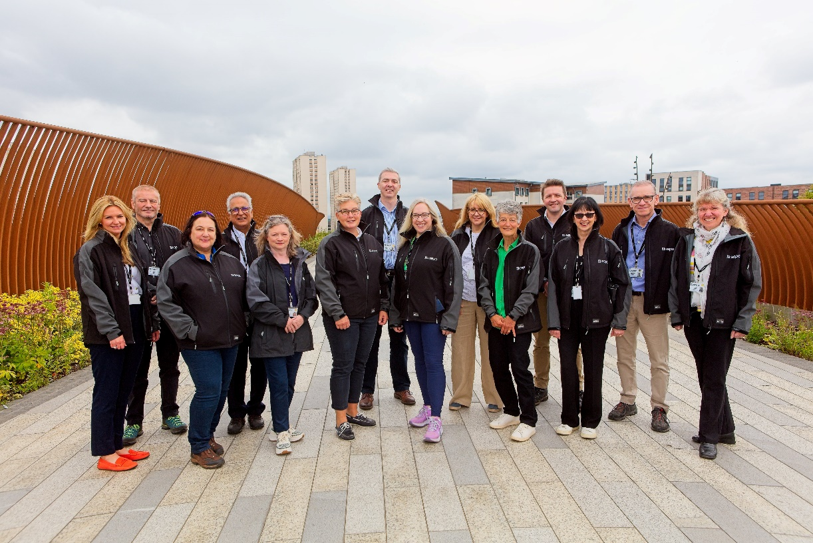
Our Board is responsible for the overall direction and performance of the organisation.
Appointments to the Board are made by Scottish Ministers and are regulated by the Commissioner for Public Appointments in Scotland. Appointments are for a three or four-year term with the possibility of a further term up to a maximum of a further four years. This is subject to evidence of effective performance and satisfying the skills, knowledge and personal qualities required on the Board at the time of re-appointment.
From April 2015 to April 2023, the gender balance of non-executive members of our Board was 60% male and 40% female. This was despite a turnover of both male and female members leaving during those years. The gender balance then changed in 2023 and 2024. The Board is now equally balanced with 50% male and 50% female members.
In 2021, we established a People Committee. In July 2023, following a recommendation from an external audit, the People Committee incorporated the role of remuneration committee. The revised People and Remuneration Committee, continued under a male Chair to February 2024 when a female Chair was appointed to the Committee (the Agency Board Chair). The Board approved a further revised remit and change of name to the Committee on 26 November 2024. The Committee is now known as the People and Resources Committee.
In January 2022, we appointed a female Audit and Risk Committee (ARC) Chair who remains as the committee Chair. The Board approved a revised remit and change of name to the ARC Committee on 26 November 2024. It is now known as the Audit, Risk and Assurance Committee.
A summary of SEPA Board membership is provided in Table 1.

Table 1: SEPA Board membership summary
Date | Total membership male | Total membership  female | Chair | Deputy Chair | Audit chair | CEO SEPA (executive member) | Non exec membership | Non exec membership %
April 2022 | 7 | 4 | M | F | F | M | 6 Male | 60% Male
 |  |  |  |  |  |  | 4 Female | 40% Female
April 2023 | 5 | 5 | M | F | F | F | 5 Male | 56% Male
 |  |  |  |  |  |  | 4 Female | 44% Female
April 2024 | 5 | 6 | F | M | F | F | 5 Male | 50% Male
 |  |  |  |  |  |  | 5 Female | 50% Female

Board recruitment
In 2023, a new Chair was appointed who commenced on 1 January 2024. Six new Board members were also appointed and started on 15 January 2024. Two (male) were appointed for four years to 14 January 2028. Four (one male and three females) were appointed for three years to 14 January 2027.
We took the opportunity in 2023 to improve our recruitment process. We worked with the Public Appointments Team in the Scottish Government and a Public Appointments Adviser appointed by the Ethical Standards Commissioner, to widen the audience, better promote the role of board members and improve the wider diversity of the candidates. This included:
- Revising the role description and personal specification in line with the priority areas of experience and skills we were seeking.
- Developing a supporting letter from the Chair of the Agency Board encouraged applications from women, disabled people, LGBT+ people, people from ethnic minority communities and people aged under 50.
- Creating a Board recruitment information web page with soundbites from continuing Board members, Frequently Asked Questions, and the information pack for applicants.
- Introducing a Board appointment campaign focused on a short period of high frequency and impactful activity; paid-for and organic content, including press advertising in The Times print and LinkedIn; and targeted digital marketing.
- Holding online events with Changing the Chemistry and the Institute of Directors for prospective applicants.
- Posting the jobs on Goodmoves, Women on Boards (including email circulation), and on the Scottish Government public appointments website and SEPA website. Publicity details were circulated to those who receive information about Ministerial public appointments and to SEPA employees and several partner organisations to share with their contacts.
- Working with a variety of equality groups to promote vacancies. The appointment was forwarded to several organisations which support and promote women within the workplace including the 2% Club; Women on Boards; and Scottish Changing the Chemistry who were asked to promote the appointments to their members.
- Using social media channels and equality organisations to advertise the vacancies.
These activities will continue with the next rounds of recruitment due in 2025-2026 as we focus on developing our approach to the attraction and selection of future Board members. Specifically, we will also:
- Review the information available on the SEPA Board website to ensure there is a greater awareness of the role of the Board and individual Board members.
- Work with Scottish Government Sponsor Unit and the Public Appointments Team to develop future recruitment and selection campaigns to increase diversity of candidates.
- Review the skills and experience that are used as the basis for the development, recruitment and selection of Board members.

Section 5: Pay gaps and equal pay


Gender pay gap
The gender pay gap is a measurement of the difference in the average pay of men and women, regardless of the nature of their work. This is expressed as a percentage of male earnings. The gender pay gap can be driven by the different number of men and women across all roles. Gender Pay Gap is different from Equal Pay, which involves the direct comparison of two people or groups of people conducting the same, similar or equivalent work.
In line with guidance from the Equality and Human Rights Commission (EHRC), we report both the ‘mean’ and the ‘median’ pay gap. The gender pay gap calculation is based on basic hourly pay and does not reflect additional pay elements such as allowances or overtime. The Gender Pay Gap metrics applicable to us are:
- Median gender pay gap – the difference between the median hourly rate of pay of male and full-pay relevant employees and that of female full-pay relevant employees.
- Mean gender pay gap – the difference between the mean hourly rate of pay of male and full-pay relevant employees and that of female full-pay relevant employees. The mean pay gap is the average hourly pay rate, calculated by adding the hourly pay rate for employees then dividing by number of employees.
Table 2 shows our pay gap for all employees and how we compare against the Scottish and wider UK figures. The figures in this table are based on the Office of National Statistics 2024 provisional data set and the 2022 revised data set. The mean and median gender pay gap for all employees, based on full time salary, as at 31 October 2024 can be found in Appendix 1 (Table 36) of our People Information Report 2025.
Our organisational mean gender pay gap is 7.59%. This reflects an hourly pay difference of £1.97 more for male employees than female employees. This is broadly in line with the mean pay gap reported in 2022 of 7.53% and remains lower than the pay gap at both UK and Scotland level.
Our median pay gap is 10.78%. This reflects an hourly pay difference of £2.68 more for male employees than female employees. We have seen a change in our median pay gap from the -4.86% previously reported in favour of female employees. This shift in positioning results from a combination of a smaller percentage of males in the organisation, but a greater proportion of them being on higher value pay steps compared to females, giving male employees a higher median salary. Our median pay gap remains lower than the UK level but is now higher than the Scottish level.
If we continue to have a higher proportion of males at higher pay points compared to females, it will be challenging to reduce the gender pay gap.
Table 2: UK, Scotland and SEPA mean and median gender pay gap
Year | UK mean | UK median | Scotland mean | Scotland median | SEPA mean | SEPA median
2024 (30/10) | 13.80% | 13.10% | 8.20% | 9.4% | 7.59% | 10.78%
2022 | 13.40% | 14.40% | 10.90% | 12.00% | 7.53% | - 4.86%

Ethnicity and disability pay gap
Our time window for collecting the protected characteristic data which informs the ethnicity and disability pay gap information was limited. We will continue to encourage all employees to complete their information and provide a response. This should enable more practical analysis of any potential areas for consideration.

Disability pay gap
The disability pay gap is defined as the difference between the average hourly pay of disabled and non-disabled people, expressed as a percentage of non-disabled people’s pay. The following calculations are based on 56 colleagues declaring they were disabled, up from 29 in 2023, and 539 colleagues declaring they were not disabled, down from 1,032 in 2023. Full information on our disability pay gap can be found in our People Information Report 2025 Appendix 2 (table 41).
Our organisational mean disability pay gap is 2.30%, with non-disabled employees earning £0.57 per hour more than disabled employees. This is an increase compared to the mean pay gap reported in 2023 of 1.42%.
Our organisational median disability pay gap is 8.64%, with non-disabled employees earning £2.10 per hour more than disabled employees. This is an increase compared to the median pay gap reported in 2023 of 4.61%.
The pay data identifies that employees who have declared a disability are in receipt of the lowest mean and median pay rate at £24.23 and £22.18 per hour respectively. Those who have not provided any information as yet have the highest mean pay rate of £25.10 per hour and median pay of £24.28.
Of the small number of employees who have declared a disability, a smaller proportion of those are in the higher pay bands when compared to the other groups, resulting in the disability declared group having the lowest overall mean and median hourly pay. However, as the total number of employees who have declared a disability is less than 5%, and 46% of employees have not provided disability information, it is difficult to draw any meaningful conclusions from the data.

Ethnicity pay gap
The ethnicity pay gap is defined as the difference between the average hourly pay of ethnic minorities and White British people, expressed as a percentage difference. The following calculations are based on 16 employees declaring an ethnicity other than White, down from 30 in 2023. Full information on our ethnicity pay gap can be found in our People Information Report 2025 Appendix 2 (tables 37, 38, 39 and 40).
Our organisational mean ethnicity pay gap is 12.7%, with White employees earning £3.14 per hour more than non-White employees. Due to the change in how we collect equality data (aligned to Scottish census), we cannot compare this to 2023.
Our organisational median ethnicity pay gap is 15.3%, with White employees earning £3.72 per hour more than non-White employees. Due to the change in how we collect equality data (aligned to Scottish census), we cannot compare this to 2023.
The ethnicity group of ‘mixed or multiple ethnicity’ has the highest mean and median pay rates at £25.27 and £26.82 respectively. The ethnicity group of ‘Black and Caribbean’ has the lowest at £20.08 for both mean and median hour rate. A difference of 20.5% for mean and 25.2% for median. However, as between these two groups, only 0.4% of employees declared themselves, these small numbers make it very difficult to conduct any meaningful analysis.
As the total number of employees who have declared an ethnicity other than White is less than 2%, and 45% of employees have not provided ethnicity information, it is difficult to draw any meaningful conclusions from the data.
Information on our ethnicity and disability pay gap can be found in our People Information Report 2025 Appendix 2 (tables 37, 38, 39, 40 and 41).

Occupational segregation

Occupational segregation refers to people of different characteristics being clustered in different levels or of types of work. A full summary of information on our occupational segregation in terms of gender (Table 42), race (Table 43) and disability (Table 44) is available in our People Information Report 2025 Appendix 3.

Section 6: Our Equal Pay Policy
Our Equal Pay Policy was updated in February 2025 and is published on our website.

Appendix 1 - Specific duties of the Equality Act
Table 3: Meeting the specific duties of the Equality Act
Duty | Equality Act reference | Summary of requirements | Frequency | Last published
Mainstreaming progress | Section 3 | Publish a report on the progress made to make the equality duty integral to the exercise of functions | At least every 2 years | April 2025
Equality outcomes | Section 4 (1) & (2) | Publish a set of equality outcomes having involved protected characteristic groups/ individuals and used available evidence | At least every 4 years | April 2025
Progress against equality outcomes | Section 4 (1) & (2) | Publish a report on the progress made to achieve the equality outcomes | At least every 2 years | April 2025
Equality and Human Rights Impact Assessments | Section 5 | Conduct EqHRIAs for new/revised policies and publish these | Ongoing | Published on SEPA website regularly.
Gather and use employee information | Section 6 (1) & (2) | Gather information on staffing composition, recruitment, development and retention against protected characteristics | Annual | April 2025
Include employee information in mainstreaming report | Section 6 (3) | Include employee information and progress made in gathering & using this in mainstreaming report. | At least every 2 years | April 2025
Gender pay gap information | Section 7 | Publish percentage difference between hourly pay rates for men and women | At least every 2 years | April 2025
Statement on equal pay policy & occupational segregation | Section 8 | Publish equal pay policy and analysis of employment by grade/role for gender, disability and race | At least every 4 years | April 2025

