


Chief Executive’s Report
February 2025

Contents

1. Introduction 2
2. Collaboration and partnership 5
3. Public Sector Reform 8
4. Transformation 9
5. Focused on delivery 10
6. Spotlight on… 17

If you would like this document in an accessible format, such as large print, audio recording or braille, please contact SEPA by emailing: equalities@sepa.org.uk

Introduction
2024 was a year of delivery, transformation and improvement for the Agency. We launched our new Corporate Plan for 2024-2027. In it we set out an ambitious programme of priorities to focus on: Net Zero, Climate Resilience, Water Environment, Resource Efficiency and Business Environmental Performance. Our teams have worked continuously to achieve them.
As we enter the new year, I am proud of what the Agency has delivered for Scotland highlighting the depth of professionalism and passion our teams have for protecting Scotland’s environment.
Looking forward, the development of the Agency’s Annual Operating Plan for 2025-2026 is well underway ensuring alignment to Scottish Government objectives and outcomes.
The end of the year was busy with a great deal of engagement with partner agencies. At the end of November, as a guest of the James Hutton Institute, I attended an inspiring evening at the Nature of Scotland Awards. The Awards, led by the Royal Society for the Protection of Birds, has been taking place for more than a decade and celebrates the very best in nature conservation, the passion and people at the very heart of protecting Scotland’s Environment. I was delighted to see the Agency were finalists for an award working in collaboration with East Renfrewshire Council on the Levern Water River Restoration Project, funded through the Scottish Government’s Water Environment Fund. More information on this can be found on this later in this report.
I attended a joint meeting with Scottish Water, Water Industry Commission Scotland, Drinking Water Quality Regulator, Consumer Scotland and the Scottish Government looking at different policies, visions and a long-term strategy.
In December, I, along with the Agency’s Chief Operating Officer for Data, Evidence and Innovation, was invited to a briefing session at Bute House with the First Minister, several Cabinet Secretaries, and the Permanent Secretary on flood resilience. The First Minister looked to discuss the Scottish Government’s strategic approach to mitigating flood exposure and impacts in light of the recent catastrophic flooding events in Wales and Spain.
We provided assurance about our winter preparedness with an impressive list of recent work including training and exercising with partners, training and on boarding of new duty officers, improvements to our hydrometric networks and flood warning systems and the “Prepare and Be Aware” SEPA Flood campaign launched the week before. Following the severe weather event at the turn of the year, which is detailed later, I was pleased to share a letter from the First Minister with colleagues thanking them for their work keeping people and communities safe, particularly over that period.
In a series of meetings across December and January, the Agency’s Chief Operating Officers and I met with a range of customers and stakeholders including the Chief Executive from the Chemicals Industry Association and the Chief Executive of Food Standards Scotland. They were introductory meetings where we also spoke of joint ways of working, and future areas for collaboration.
Work on one of our key regulatory transformation projects continues with the development of proposals for the Environmental Performance Assessment Scheme. This scheme is a replacement for our historic Compliance Assessment Scheme and is expected to be released for public consultation by the end March 2025. More on this can be found later in this report.
I mentioned the 2023 classification results in my September 2024 report, and I am delighted to say (noted later in this report) that we have published the 2023 classification results in the state of the water environment report. The good news is that the classification results demonstrate that once again the status of our water environment has improved, continuing the progressive advances since 2008. The results are powerful evidence of our commitment to protecting and improving Scotland’s water environment – one of our strategic priorities. The consistent improvement in water environment quality is a testament to the work of people across the Agency and our partners throughout Scotland who are committed to safeguarding and enhancing our precious water environment.
We continue to invest in staff and their leadership and management competencies and capacity through the launch of our ‘Management Means’ programme to our ‘Band B’ Managers. Sessions are taking place across the Country with colleagues in their local geography led by Discovery Coaching.
I am also delighted to report that colleagues have been shortlisted for several awards, testament to their commitment to transformation and modernisation of the Agency. These include Team of the Year, Individual Practitioner and Rising Star Award nominations in the eCase FOI Awards which, following the recognition of the Scottish Information Commissioner of the progress made in access to information, is a further endorsement of the energy and commitment shown by the team in Governance, Performance and Engagement.
Our Chief Officer, for Finance, Modernisation and Digital and her Finance team have also been shortlisted for two categories at the Scottish Chief Financial Officer Awards - Scottish CFO of the Year 2024 of a Not-for-Profit organisation and Team of the Year. This recognition is testament to their hard work supporting SEPA as we focus on organisational sustainability and providing value as a public body. Winners are announced in March so good luck to all involved.
This report features some highlights as our teams continue to deliver for Scotland.

Collaboration and partnership

We recognise the impact of progressive partnerships and collaborative working across the public, private and third sectors, as well as with communities. We share service delivery so that we offer better outcomes more efficiently, and with a customer focus.

Levern Water, Water Environment Fund project shortlisted for two awards
The Levern Water project in Barrhead was shortlisted for the Holyrood’s Climate Action Awards in November 2024 and the Royal Society for the Protection of Birds Nature of Scotland Awards in December 2024. Completed in 2023, the project was funded by the Water Environment Fund, in partnership with East Renfrewshire Council, Green Action Trust and the Clyde River Foundation. The project restored 1.5 km of urban river, removed two barriers to migrating fish and created new woodland, meadow and wetland habitats.
The Levern project demonstrated net zero approaches to reduce impact of the work by setting a sustainable ethos early on, creating wetland and habitats, reusing waste, rock and soils on site avoiding transportation and landfill. Clever river design innovation to avoid disturbance of contaminated ground and potential disposal was important in reducing the impact of the works. The works contractors also used Hydrotreated Vegetable Oil fuel in all plant on site and eco huts for staff offices during the construction period.
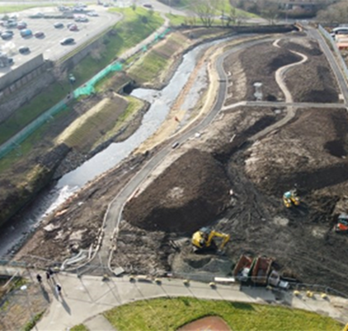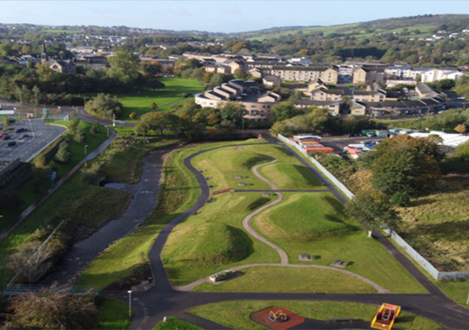
The images above show the River Levern during and after groundworks.

Partnership working to tackle environmental crime – intervention to deter
We collaborated with Trading Standards Scotland to publish a Scam Share Bulletin warning consumers of the risk of unregistered waste collectors advertising online. This warning, and follow-up advice to communicate with us when in doubt, has been circulated by both Trading Standards Scotland and Neighbourhood Watch Alert to approximately 30,000 members of the public. The purpose of the bulletin is to increase understanding of the risks of using unregistered waste carriers with members of the public to deter them from using illegal operators and protect themselves.
An example of the Scam Share Bulletin is shown below.
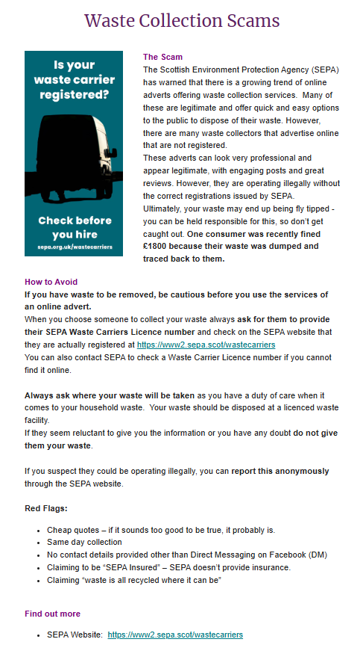

Partnership working recognised by Scottish Parliament
We were recognised by the Scottish Parliament as a key partner in an award-winning project led by Falkirk Council to restore the former Kinneil Kerse landfill site. The 375-acre site was used as landfill from the 1920’s until 2000. It posed various environmental risks upon its closure, including pollution and harm to nearby water sources. We worked closely with partners including Falkirk Council, WSP Consultants, and the British Trust for Ornithology as part of the £2.6 million restoration project to transform a potential hazard to a beautiful greenspace that now offsets 4.4 tonnes of carbon each year.
The project won the 2024 Brownfield Award for enhancing biodiversity. It has now also won the WSP Project of the Year 2024 (from over 300 entries) showcasing the innovative approach, teamwork, and commitment to environmental and community improvement that the partners all embodied throughout the project. The achievement reflects the collective mission to transform the landfill into thriving a space that benefits the environment.
The image below shows colleagues from SEPA, Falkirk Council and WSP at the former Kinneil Kerse landfill site.
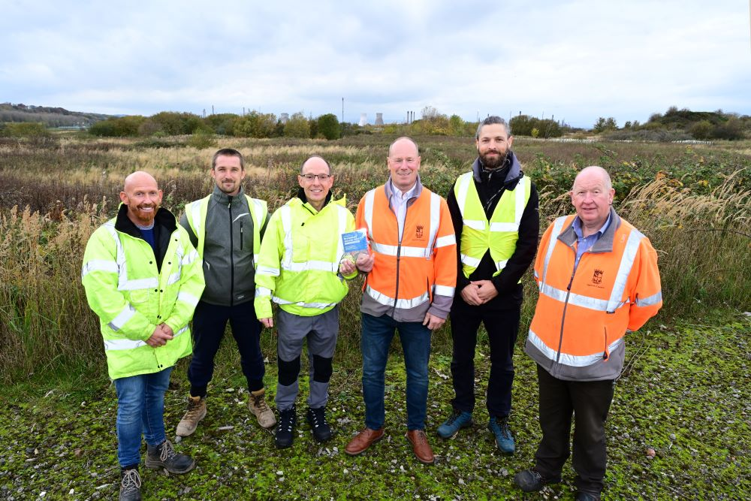

Winter resilience and stakeholder engagement
From October to March, SEPA participates actively in regular Scottish Government Winter Readiness meetings. These include most Category 1 and Category 2 responders and concentrate on organisational winter service preparation awareness. At these meetings we highlighted our investment in recruiting new duty officers this year, with 19 now fully contributing to the service and 34 staff training to be an active part of the service later in 2025. We are doubling up on rota cover during festive periods and coastal rota during periods of high spring tides. We also continue to undertake joint training with local authorities and Police Emergency Procedures Advisers.
Category 1 and 2 responders key stakeholders' workshop
We conducted our annual Category 1 and 2 responders key stakeholders' workshop with the Met Office Public Weather Service and Scottish Government at Victoria Quay, Edinburgh on 12 December 2024. This provided an opportunity to share service and product updates, gain critical feedback and discuss future collaboration around flood events. One theme this year was around gaining better flood impact verification to quality assure the Floodline service.

Public Sector Reform

As a public service, we continue to respond effectively to the increasing pace of change and are committed to considering the best models for delivery of all our services. SEPA continues to lead and engage with a range of initiatives to further the objectives of public sector reform.

Environment Futures Group
We continue to play a leading role in Scottish Government’s Environment Public Sector Reform initiative. The Environment Futures Group workstream has proposed to trial a place-based approach to dealing with land-use derived environmental impacts and opportunities.
Subsequently, the Environment Public Sector Reform Governance group of 10 December 2024 has agreed to the development of pilot projects for the Aberdeenshire Dee and the Angus South Esk catchments. These place-based projects will require a much higher degree of coordination and collaboration between the environment agencies and greater policy and funding alignment. The potential for multiple benefits is great, and include enhanced natural flood management, food security, biodiversity, and water quality and supply.

Workspaces
As part of our How We Work programme and wider People Strategy, we continue to review our estate and realise opportunities to co-locate office and storage space. Recently, we successfully moved into a shared workspace with Comhairle nan Eilean Siar in Stornoway, ending our previous lease. This aligns to SEPA's strategic direction to move away from leased and owned to co-located workspaces, reducing costs and our carbon emissions and creating synergies with organisations across the public sector. Our Stornoway team is already enjoying the benefits of this new collaborative environment.

Transformation

To deliver effectively for Scotland, we need to transform areas of our organisation and embed a customer and delivery focus in everything we do. Doing so will mean we can design and offer better, more resilient services that meet the needs of our customers.

Environmental Performance Assessment Scheme (EPAS)
We continue to develop proposals for one of our key regulatory transformation projects – the Environmental Performance Assessment Scheme (EPAS). This replacement for our previous Compliance Assessment Scheme is expected to be released for public consultation by the end March 2025. Business environmental performance is key to ensuring we can maintain a healthy environment that can support future business opportunities and economic growth.
EPAS will allow for different types of activities to be compared in a single transparent process. It has been designed to support swifter action to address issues that do or could cause environmental harm and report performance on a continuous basis following compliance checks. To achieve continuous reporting, we will be developing new digital systems that deliver efficiencies.

Intelligence and investigation management system
Phase one of the implementation of our new intelligence and investigation management system has been completed. The system, known as CLUE, has been fully configured for the submission and searching of intelligence. It is typically used by organisations for the purposes of intelligence gathering, development and analysis as well as criminal investigations and other internal investigation types. The final stages of onboarding staff will be completed by end of January 2025.

Focused on delivery

SEPA is Scotland’s principal environmental regulator, and our purpose is to protect and improve Scotland’s environment. Our approach to deliver for Scotland focuses on what we do and our corporate plan priorities. We also continue to develop our approaches to communicate and engage effectively with all our customers, the public and communities.

Protect 

Partnership working to tackle environmental crime – intervention to disrupt
We published and publicised our first Varied Monetary Penalty associated with the pilot project under the Scottish Government’s National Litter and Flytipping Strategy. The Variable Monetary Penalty of £3,277 and SEPA costs of £983 were imposed on Habib Safi for flytipped waste deposited at Kingarth Lane in Glasgow. The investigation and outcome were the result of early and sustained partnership working with Glasgow City Council to tackle activities at a site described as one of Glasgow’s worst fly tipping spots.
The result was also covered in several media outlets (STV News: Man caught fly-tipping bags of waste and kitchen equipment fined | STV News; Glasgow Live: Glasgow flytipper fined £3k for dumping piles of rubbish in notorious Govanhill lane | Glasgow Live; and the Glasgow Times: Glasgow man fined more than £3k for fly tipping in lane | Glasgow Times). The extended coverage by media outlets is a further intervention tactic that will help deter future activity.

Radioactive substances
In December 2022 a shipment of metals received at a yard in Bellshill was found to have elevated levels of radioactivity. Subsequent analysis showed that the activity was low but just within scope of environmental regulation under Environmental Authorisations (Scotland) Regulations 2018. The company was not authorised to hold such material. As such, arrangements were made to return the shipment to the sender, a company based in Wales. Making these arrangements required extensive engagement with the Office of Nuclear Regulation, who are the authority with the responsibility of overseeing the transport of nuclear materials, and Natural Resources Wales. The shipment was successfully returned to Wales in December 2024.The metals remained within the original shipping containers and did not cause any environmental impact whilst stored at Bellshill.

UK security requirements for radioactive sources
The UK updated its requirements for keeping radioactive sources secure in summer 2024. We carried out a targeted consultation earlier this year, on our proposals for implementing the updated requirements. Following this, we published our revised Environmental Authorisation (Scotland) Regulations 2018 (EASR) Standard Conditions in November. We have also been working closely with Police Scotland’s Counter Terrorism Security Advisers to develop our Regulatory Position Statement – Security Requirements for Radioactive Sources – RS-POL-010, which we have now issued to operators in Scotland. This statement explains how we intend to regulate and enforce the updated security requirements. We expect operators to work toward full compliance with them as soon as possible, and by 30 June 2029 at the latest.

New tier 4 approval for His Majesty's Naval Base Clyde
The Environmental Authorisations (Scotland) Regulations 2018 (EASR 18) do not apply to radioactive substances activities carried on at premises occupied on behalf of the Crown for naval, military or air force purposes or for the purposes of the Ministry of Defence. However, a Memorandum of Understanding between SEPA and the Ministry of Defence is in place.
This provides a framework for applying the requirements of the environmental regulations through administrative arrangements known as approvals. A tier 4 approval is equivalent to a permit issued under EASR 18.
Following an extensive consultation, the application made by the Ministry of Defence for new approvals to manage radioactive wastes at His Majesty's Naval Base Clyde was determined. The new tier 4 approval was issued and became effective on 1 January 2025.

Keep Scotland Beautiful – Local Environmental Quality Conference
We were invited to present at Keep Scotland Beautiful’s Local Environmental Quality Conference. We used the opportunity to showcase our priorities for tackling environmental crime and the use of interventions to deliver sustainable disruption alongside traditional enforcement tools. We also highlighted our recent pilot work supporting Scottish Government’s Litter and Flytipping Strategy using Digital Disruptions and working with local authorities to tackle flytipping cases.
We emphasised the importance of intelligence in our work and the critical partnership with local authorities who are the eyes on the ground that can help us piece together vital intelligence on environmental crime. This has led to increased engagement with our partners.

Improve 

Air quality
Under the Environment Act 1995 and associated regulations, all Scottish local authorities are required to regularly review air quality in their areas against legal objectives for several pollutants of particular concern for human health. If this work indicates that any objective will not be achieved by the due date, the local authority concerned must declare an Air Quality Management Area and produce an action plan setting out how it will tackle the issues identified.
The local authority review and assessment reporting has now been completed for 2024. All Annual Progress Reports were submitted to Scottish Government and SEPA and assessed. For the second consecutive year, Scotland met all air quality objectives at automatic monitoring stations across the country for nitrogen dioxide (NO2). In conjunction with improving trends in air quality, the number of Air Quality Management Areas in Scotland has reduced to 22 during 2024 with a further 12 revocations currently underway for completion during 2025.
We have worked hard to build good working relationships with all 32 local authorities and help deliver air quality improvements. These improvements include improving the processes surrounding air quality management to make them as user-friendly and streamlined as possible for local authorities. This cross-government partnership approach has resulted in significant improvements to how we manage air quality and the observed results which have been achieved.

One SEPA Monitoring Plan approved by Regulation and Environment Group
The Agency’s Senior Leaders have approved SEPA's monitoring plan for 2025, which is the first time we have developed a single plan covering water, air, waste (including impact on soils) and nuisance issues (noise, dust, odour). The plan is organised around five pillars: understanding our environment, compliance with authorisation conditions, planned investigations, reactive investigations, and development and assurance work. As this process is refined during 2025, focus will be on obtaining strategic direction and the re-establishment of rolling monitoring programmes for 2026, where appropriate.

Successful completion of coastal survey work for 2024
In 2024, we completed our largest and most successful coastal water survey programme for many years. Part of that success was down to our innovative shared services arrangement with the Scottish Government’s Marine Directorate. Under this arrangement, Marine Directorate’s experienced fleet management team has been managing and crewing our survey vessels, the Sir John Murray and Iona, enabling us to focus on environmental monitoring to support regulation. The arrangement also helps maximise the use of the Sir John Murray for public benefit, with the Scottish Government and other government agencies able to use the survey vessel to carry out their own work at sea when she is not on survey for SEPA.
Our scientists on board carried out an ambitious programme of work over the year, collecting samples to assess the ecological and chemical condition of the seabed and seawater in the vicinity of 23 marine fish farms. The team also collected underwater camera footage to help map sensitive priority marine features. The imagery collected is being used to train a machine learning model. In due course, we hope to use this model to automate analysis of seabed imagery, streamlining assessments of fish farm applications, and aiding compliance verification.
The images below show our survey vessel, the Sir John Murray.
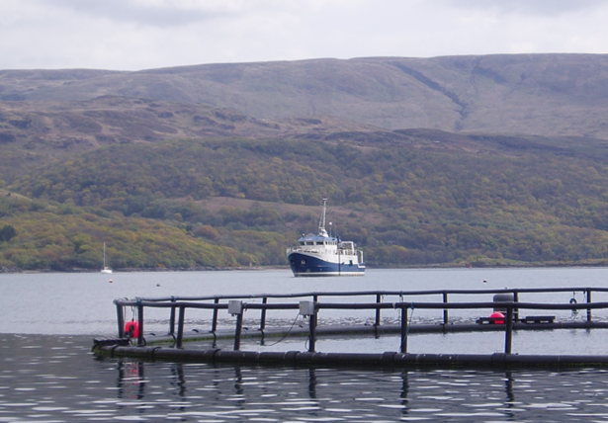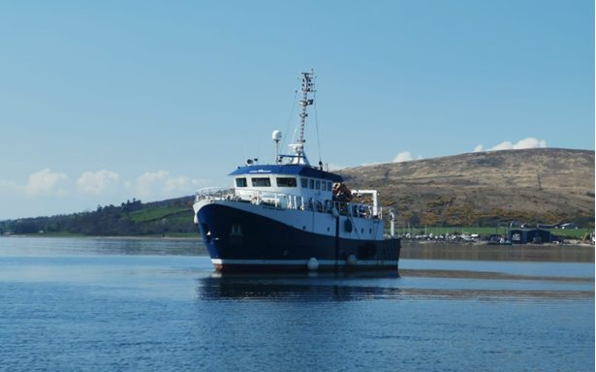

Adapt 

Lithium-Ion Battery Symposium 2024
The rise in electric car purchases and the construction of Battery Energy Storage Sites is seen as a major step in the move towards a greener economy. However, this coupled with the increase in use of Lithium-Ion batteries in consumer electronics, has seen a spate of fires around the world. Often at waste processing facilities, but also in private vehicles and homes, these fires escalate quickly and can have devastating consequences.
In 2024, we responded to multiple events where batteries were either identified or suspected to be the cause of the fire. These responses often involve colleagues from Health Boards. In November 2024, Ayrshire and Arran Health Board held a Lithium-ion battery symposium aimed at raising awareness of the risks around the ever-increasing use.
The event was attended by over 200 people and featured presentations from experts in battery technology and health. We presented to the gathered attendees on our approach to the regulation of various battery sites, and our approach to event response.
Feedback has been very positive and there is optimism that this will lead to improved practices around Battery Energy Storage Sites, and the use of and after-life processing of lithium-ion batteries in Scotland.

Avoid 

Latest waste statistics published
SEPA has published the 2023 statistics for Scottish household waste, as well as for all waste landfilled and incinerated in Scotland, via a new fully accessible and interactive format developed in partnership with Scottish Government (https://data.gov.scot/sepa/waste/index). These reports show that Scotland is making positive steps towards lowering the carbon impact of household waste, with lower amounts of waste generated and disposed of to landfill, which is key to addressing the environmental impact of waste management.
We continue to play our part in helping Scotland transition to a circular economy, working collaboratively with Scottish Government, Zero Waste Scotland, Scottish Councils, and Scotland’s reprocessing and waste management sector. Currently our methods include the digital disruption of illegal waste collection by monitoring social media posts to identify unregistered waste carrier advertising services and following up with regulation. We are also working closely with partners to implement the UK Extended Producer Responsibility reforms, which will give producers responsibility for the costs of their packaging throughout its life cycle.

Warn 

Hogmanay flood event
Preparations for Hogmanay were disrupted by severe flooding in northern and central Scotland. This particularly affected the Spey valley, the Great Glen and the River Tay and River Forth catchments. Impacts included extensive disruption to the transport network with closure of railway lines, flooding of the A9 and many local roads and access to properties (Railways 'unsafe' and hundreds hit by power cuts amid downpours - BBC News).
We issued 10 regional Flood Alerts, over 50 local Flood Warnings and three Severe Flood Warnings across the period of 29-31 December 2024, with the event lasting until 2 January 2025. Risk level in the daily Flood Guidance Statement was raised to High (Amber) on 30 and 31 December 2024. We attended the Scottish Government Resilience Room chaired by the First Minister on 30 December 2024. There was also strong media interest with several radio and TV interviews with BBC Scotland.
The three Severe Flood Warnings were issued following consultation with Police Scotland for areas around Aviemore and Carrbridge, on 30 December 2024 and into Tuesday 31 December 2024, when forecasts indicated a risk of severe flooding overnight and the requirement for some evacuations. Fortunately, the forecast changed overnight – with river levels still high but not extreme - and the warnings were updated accordingly early on 31 December 2024.
All SEPA systems and data from the hydrometric network worked well during the event. Duty staff were also well prepared with support resources available to cover the whole period of intense activity. We also activated the Satellite Emergency Mapping Service. Data will be shortly collated and analysed so that we can learn from the event and inform future flood forecasting and warning in those areas.

Flood Early Warning System
The Flood Early Warning System is a vital piece of Hydrology software. It is the core flood warning prediction tool which the service needs to run 24/7/365. We are completing a project to deliver a step change improvement in its resilience. This has involved building and running two offsite Flood Early Warning Systems concurrently and in separate places on the cloud. We reached a major milestone with the system ready for use as a business continuity measure during the festive period should it have been necessary. We are now making the final preparations to launch it operationally in February.

We are undergoing a major long-term programme of rolling upgrades to the accuracy of the catchment-specific flood warning prediction models. To date, the work has considered the effects of climate change and changes in the catchment of time. In future, it will increasingly bring in artificial intelligence and other new technology to enhance the effectiveness and efficiency of both the real-time modelling and the process of upgrades.
This year’s planned work is making timely progress. A major contract tender was returned in December to undertake the upgrade work on coastal forecasting in the Firth of Forth and Tay. We expect the appointment of the successful consultant in January.
A number of SEPA colleagues have joined the 24/7 flood warning staffing rotas to help address rising pressures on the service. 19 additional staff are fully contributing to the service, with a further 34 staff in training. We continue to undertake joint training with local authorities, and Police Emergency Procedures Advisers. This helps reduce the pressure on staff during an emergency event.

Spotlight on…

Transition to our new customer experience model
In line with public sector reform principles, we have made both capacity and financial savings while enhancing our customer services. Our Category 1 responder role remains at the heart of the planning of our customer hub services.
The change has involved a transition to an automated out of hours service that directly links critical calls to our duty officers to provide the appropriate response.
SEPA’s 24-hour availability to the Scottish public remains fully in place, ensuring that we provide critical support for Scotland’s communities and environment. Where appropriate, this includes direct access to a SEPA officer to ensure a timely and effective response. Additionally, we are introducing new ways for customers to contact us, giving options that best suit their preferences. This includes becoming a true multi-channel service, enabling access through various platforms to enhance the customer experience and better meet modern communication needs.
Our automated system is designed to handle minor, non-urgent matters digitally, either online or through our intelligent interactive voice response system. This ensures these lower-priority issues are managed efficiently without impacting our ability to respond to significant events. Any significant incidents reported are immediately escalated to colleagues who are available 24/7 across the country to respond, investigate, and take necessary action.
This approach is informed by a comprehensive analysis of customer contact data, allowing us to align our services with the times and methods that customers most frequently use. The data shows a clear preference for digital solutions when reporting or discussing issues, and this modern, forward-looking approach allows us to meet these needs while maintaining the capacity to respond immediately to significant incidents.
For all significant environmental incidents, any communication reporting a major event, regardless of the time, will be sent directly to a member of our team. This ensures the appropriate action is taken promptly and effectively.
We remain committed to supporting Priority Partners, including MSPs, emergency services, and specific businesses. These partners will always have direct access to human assistance for significant environmental events, ensuring smooth communication and rapid action when necessary. This refined approach ensures a balanced, efficient operating model that aligns with industry standards and optimises public sector funds. By focusing resources during peak contact times, we continue to deliver a premium service while maintaining financial responsibility.

Keeping public, communities and our partners engaged and involved
This year, we established a new engagement and insights service that aims to provide end-to-end support as we consult and engage on new policies and proposals. This has involved a new process for designing consultations which was applied to external engagement on the Integrated Authorisation Framework. The enhanced process follows good practice guidance in ensuring our consultations our inclusive, accessible and meaningful to communities impacted with full transparency - including a dedicated you said we did page on our consultation hub (Consultations | Scottish Environment Protection Agency (SEPA).
In achieving this, a One SEPA approach is applied with expertise from communications, legal and equalities at key stages of the design process. We continue to develop the design and reach of our consultations through user research and accessibility enhancements – ensuring that how we deliver policy and practice is informed by the voices and lived experience of those impacted.
Our corporate approach to engagement and consultation is a real opportunity for us to raise visibility, educate and empower our communities and stakeholders, improve customer experience, and facilitate collaboration and innovation.
This report represents an overview of SEPA’s delivery activity across the period.
For the Future of Our Environment.

Nicole Paterson
Chief Executive Officer
February 2025

