



Quarter 3 2024-2025
February 2025
Corporate Performance Summary Report

Contents

1. Executive Summary 3
2. Performance Summary 4
3. Performance Updates 5
4. Suite of Organisational KPIs Summary 31

If you would like this document in an accessible format, such as large print, audio recording or braille, please contact SEPA by emailing: equalities@sepa.org.uk

1. Executive Summary
This year’s Annual Operating Plan includes 12 performance measures. Each quarter we will produce a report to explain how we are progressing with those measures. This is the third quarterly report covering the period October 2024 – December 2024.
In the third quarter we are on track to achieve 11 of the 12 performance measures. We have one measure with a status of ‘partially achieved’ - measure two: annual reports of greenhouse gas emissions by SEPA is reducing. Action is being taken to improve performance against this measure.
Key highlights this quarter are:
- Net zero - Emissions associated with our grey fleet mileage have been reduced by almost 20%.
- Water Environment- The 2023 classification of the water environment was completed, and the 2023 State of the Environment Report was published in November 2024. The overall condition of both surface water and groundwater bodies have shown improvement since last year.
- Resource Efficiency - The Waste Landfilled in Scotland 2023 statistics were published on schedule in October 2024. These show a 14.8% reduction of household waste landfilled in Scotland from the previous year.
- Our organisation and transformation – Ten complaints were closed, six at Stage 1 and four at Stage 2, within the timescales set out in our Complaints Handling Procedure.
We continue to develop a new performance framework and reporting mechanisms to enable effective scrutiny of delivery of our objectives. In this report, where possible, we have added information on some additional KPIs. We will continue to develop both our KPIs and reporting style in the upcoming period.

2. Performance Summary

A high-level summary of the progress of each performance measure for quarter three is below.

 | Priority | Aim | Measure | Status
1 | Net Zero | Greenhouse gas emissions are reduced | Annual greenhouse gas emissions in the Scottish Pollutant Release Inventory– Reducing | Achieving
2 | Net Zero | Greenhouse gas emissions are reduced | Annual reports of greenhouse gas emission by SEPA - Reducing | Partially Achieving
3 | Climate resilience | The impact of flooding and water scarcity is reduced. | Number of flood warnings and alerts issued by SEPA - Maintaining | Achieving
4 | Climate resilience | The impact of flooding and water scarcity is reduced. | Proportion of developments approved in accordance with SEPA’s advice on flood risk – Increasing | Achieving
5 | Water environment | The condition of the water environment is improving. | Classification of water bodies across Scotland - Increasing | Achieving
6 | Resource efficiency | Resource efficiency is improved. | Rates of waste to landfill in annual Scottish household waste data - Reducing | Achieving
7 | Business environmental performance | Interventions to tackle environmental crime are increasing. | Number of successful interventions per year – Increasing | Achieving
8 | Our organisation | Enabling aims. | Percentage of customer complaints responded to within statutory timescales - Maintaining | Achieving
9 | Our organisation | Enabling aims. | Number of vehicles in our fleet to electric and enhancing our EV charger facilities - Increasing | Achieving
10 | Our organisation | Enabling aims. | Percentage of Freedom of Information (FOI) requests and Environmental Information Requests (EIRs) responded to within statutory timescales - Increasing | Achieving
11 | Our organisation | Enabling aims. | Percentage efficiency savings – Maintaining | Achieving
12 | Our organisation | Enabling aims. | Percentage of invoices paid within 10 days – Maintaining | Achieving

3. Performance Updates

Net Zero

Our ambition is to fully play our part in helping Scotland become a net zero country by 2045 and reduce our own emissions towards net zero.

3.1 AOP Measure 1: Annual greenhouse gas emissions in the Scottish Pollutant Release Inventory – Reducing
Status: Achieving
This measure and measures five and six (rates of waste to landfill in annual Scottish household waste data – reducing, and classification of water bodies across Scotland – increasing) are long term, Scottish performance measures. Whilst, we are responsible for reporting Scottish data, we are not wholly responsible for achieving these measures.
Preparations for the upcoming Scottish Pollutant Release Inventory (SPRI) data collection are currently underway. Information notices were sent to new and transferred sites in November 2024 to inform them of the upcoming process. Additionally, the official data returns have been sent to the operators on the 13 January 2025.
Work in this area has also included:
Identification of priority sites for industrial decarbonisation and energy efficiency improvements
We have considered the evidence available in SEPA through Pollution Prevention & Control regulations (PPC), Emissions Trading Scheme (ETS) and Energy Savings Opportunities Scheme (ESOS) in conjunction with legal advice, to inform the choice of two sites to undertake a closer assessment of energy efficiency. Senior leadership will consider and approve site selection methodology in early quarter four, with sites identified by the end of March 2025.
Once sites are selected, it will be possible to legally request data (under PPC) on ETS producer efficiency and ESOS assessments. This will enable us to bring together our regulatory tools for a more holistic and robust approach to our work on energy efficiency and decarbonisation. It will help inform discussions with operators around their ESOS assessments and improve our understanding of what might be considered Best Available Techniques (BAT) for a specific operation in terms of efficiency based on the production efficiency information within ETS.

3.2 AOP Measure 2: Annual reports of greenhouse gas emission by SEPA – Reducing
Status: Partially achieving
As Scotland’s environmental regulator, we are requiring and encouraging businesses to reduce their impacts. We must do the same. Our Net Zero Routemap sets out our goal to reduce all our greenhouse gas emissions to at least net zero by 2035 and an interim target to reduce our direct greenhouse gas emissions by 15% by March 2026. This means our target is 1481 tCO2e by March 2026.
We report our greenhouse gas emissions one quarter in arrears due to the time lag in securing data (e.g. from travel expenses, which have a 60-day claim window). This report therefore relates to quarters 1 and 2 of 2024-2025.
Overall, our direct emissions for quarters 1 and 2 of 2024-2025 are 867.3 tCO2e compared to 798.9 tCO2e for the same period last year, this represents an 8.6% increase year on year.
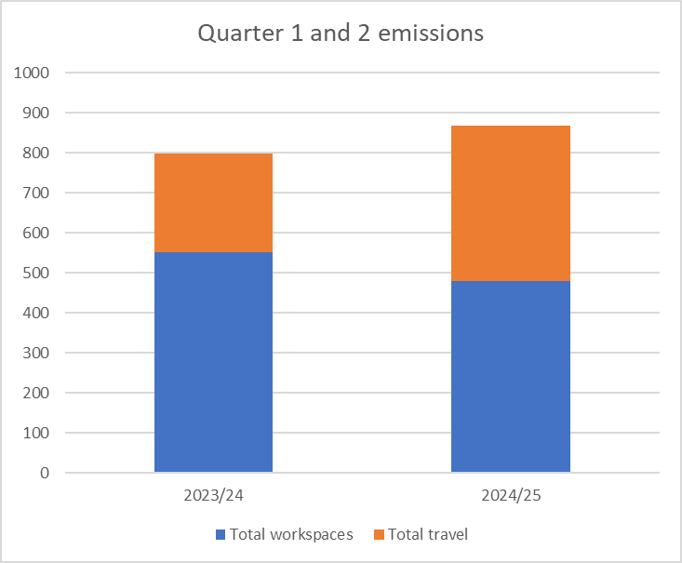
The increase is almost entirely due to increased use of the Sir John Murray (SJM) survey vessel which has returned to full operational capacity this year after several years operating below capacity. Marine fuel is a significant source of emissions. The SJM undertakes marine monitoring surveys (mostly associated with aquaculture) that provide an important part of the evidence for our understanding of impacts on the marine environment. We have recently entered into a sharing agreement with Marine Scotland to optimise the shared value from the vessel. The emissions reported here relate only to SEPA’s use of the vessel.
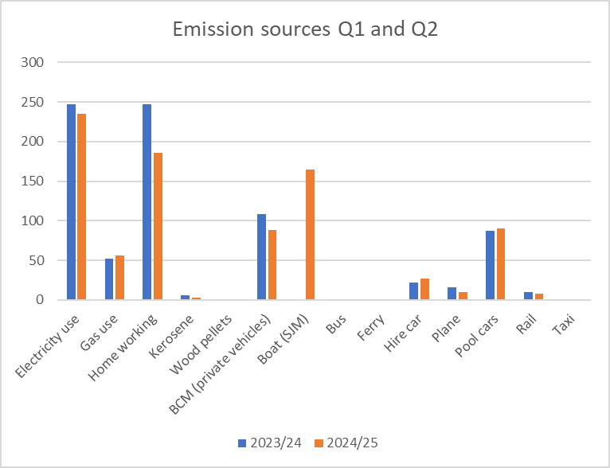
Removing SJM from the emissions figures, most other sources of emissions have seen reductions.

Emissions from workspaces have declined as fewer staff are working from home and more people are working in offices. We are likely to see further workspace emission reductions as we will be closing some offices (Stornoway and Arbroath). These will be compensated for to some extent by proposed new office spaces, but we do expect emission reductions overall.
Emissions associated with our grey fleet mileage have reduced by almost 20%. While there has been a small compensatory increase in our pool and hire car emissions, overall, the emissions associated with our vehicle mileages have reduced.
KPIs to support this theme:
KPI 01 | Baseline | Target | Q3 Performance
Tonnes of CO2e emissions by SEPA | 1742 tCO2e in 2022/23 | Reduce direct emissions by 15% by March 2026 (Target: 1481 tCO2e). Reduce all greenhouse gas emissions to at least net zero by 2035. | Our direct emissions for quarters 1 and 2 of 2024-2025 are 867.3 tCO2e compared to 798.9 tCO2e for the same period last year, this represents an 8.6% increase year on year.  To meet our target we will need to continue to make significant reductions in emissions from our workspaces and vehicle fleet. Actions are underway in both these areas so, although the current report shows some slippage against the target, this is largely due to a single emissions source. It is anticipated that the workspaces and fleet strategies will deliver emission reductions in time.

Climate Resilience

Our ambition is that the damaging impacts of floods and droughts is reduced, and that operators are prepared for and resilient to the impacts of a changing climate.

3.3 AOP Measure 3: Number of flood warnings and alerts issued by SEPA - Maintaining
Status: Achieving
Flooding is a frequent natural hazard in Scotland. It can have devastating impacts on people, on activities, and on the natural and built environment.
Our 24/7 flood forecasting and warning service enables people, businesses, and communities to take action to protect themselves. We also advise civil contingency responders before and during flood events. This is part of Scotland’s multi-agency emergency planning and incident response.
Every day we issue a daily flood guidance statement to responders (more than 900 people) to assist with tactical planning decisions around flooding. Ahead of flooding periods, we issue regional flood alerts and local flood warnings to inform the public. We operate a network of rainfall, river, and coastal water level gauges. These feed into our real-time forecasting models, along with meteorological forecasts. A dedicated communication system issues the flood guidance statements, alerts and warnings.
A total of 69 regional flood alerts, 186 local flood warnings and three severe flood warnings were issued during quarter three. Overall, the total number of messages was average for this period of year.

Preparations for Hogmanay were disrupted by severe flooding in northern and central Scotland, affecting in particular the Spey valley, the Great Glen and the River Tay and River Forth catchments. Impacts included extensive disruption to the transport network with closure of railway lines, flooding of the A9 and many local roads and access to properties disrupted (Railways 'unsafe' and hundreds hit by power cuts amid downpours - BBC News).

SEPA issued 10 regional Flood Alerts, over 50 local Flood Warnings and 3 Severe Flood Warnings across the period of 29-31 December, with the event lasting until 2 January. Risk level in the daily Flood Guidance Statement was raised to High (Amber) on Monday 30 and Tuesday 31 December. SEPA attended the Scottish Government Resilience Room (SGoRR) chaired by the First Minister on 30 December. There was also strong media interest with several radio and TV interviews with BBC Scotland.

All SEPA systems and data from the hydrometric network worked during the event and duty staff were also well prepared with support resources available to cover the whole period of intense activity. We also activated the Satellite Emergency Mapping Service.
KPI 02 | Baseline | Target | Q3 Performance
Percentage of daily Flood Guidance Statements and Scottish Flood Forecasts issued on time ​ | (for 2023/24)  84% by 10:30  98% by 11:00 | Maintain at 2024 baseline or above. | (for Oct-Dec 2024)  80% by 10:30  100% by 11:00

The target for percentage of daily flood guidance statements issued by 11:00 was exceeded.
The target for percentage of daily flood guidance statements issued by 10:30 was not achieved this quarter. However, it was only marginally missed: out of the 18 days when the target was missed, nine were by less than 5 minutes and a further five by less than 10 minutes. In most cases, the failures were because of a complex flood risk situation, requiring enough time to map the areas of concern or redrafting after the risk assessment call. There were two days when the target was missed more significantly (after 10:45) because of some technical issues.

3.4 AOP Measure 4: Proportion of developments approved in accordance with SEPA’s advice on flood risk – Increasing
Status: Achieving
We deliver flood risk advice, evidence and guidance for the land use planning system, to ensure new developments can avoid flood risk and help existing communities and services become more resilient to flooding. We take a proportionate, risk-based approach to focus our site-specific advice to the highest risk places and work with partner authorities to support the implementation of National Planning Framework 4.
In quarter three, approximately 99% of developments have been approved in accordance with SEPA’s advice on flood risk. 83% of cases were handled within the agreed timescale.

Consultations on flood risk advice | Quarter 1 | Quarter 2 | Quarter 3
Number of consultations for flood risk advice from planning authorities responded to | 361 | 429 | 285
Number of consultations that were new applications previously not advised on | 185 | 203 | 121
Number of applications approved to go ahead in flood risk areas against SEPA’s advice during the same time period notified to Scottish Ministers | 2 | 5 | 3

KPI 03 | Baseline | Target | Q3 Performance
Percentage of responses to planning consultations within time​ | 70% within time cumulatively 2023-24. | Increase the percentage of consultations responded to within time. | 95% of consultations within time, compared to 75% in Q2. The cumulative figure for the year so far is 85%, compared to 78% in Q2.

Water Environment

Our ambition is for the water environment to be protected with no deterioration of condition and that more of our water environment is improved to a good or better condition.

3.5 AOP Measure 5: Classification of water bodies across Scotland – Increasing
Status: Achieving
This measure and measures one and six (annual greenhouse gas emissions in the Scottish Pollutant Release Inventory – reducing, and rates of waste to landfill in annual Scottish household waste data – reducing) are long term, Scottish performance measures. Whilst, we are responsible for reporting Scottish data, we are not wholly responsible for achieving these measures.
Classification is the approach (based on EU and UK guidance) used to define the state of Scotland’s water environment and is produced annually for all water bodies in Scotland. We currently analyse results for 3,652 water bodies across Scotland. Surface water bodies (rivers, lochs, transitional and coastal) are classified using a system of five quality classes (high, good, moderate, poor, bad). Ground water bodies are classified as good or poor.
We completed the 2023 classification of the water environment and published the 2023 State of the Environment Report on 22 November 2024. Since the start of water environment classification for River Basin Management Planning in 2008, the overall condition of Scotland’s water bodies has improved each year. The percentage of surface water bodies that were classed as good or better in 2008 was 61% and is now 65.6%, demonstrating an improvement of 4.6% since 2008. The number of surface water bodies classed as bad overall condition has decreased from 224 in 2008 to 57 in 2023, an improvement of 74.6% that indicates an upward trend in overall condition.

The graph below shoes the long-term trend in the overall condition of surface water bodies.
Long-term trend in the overall condition of surface water bodies
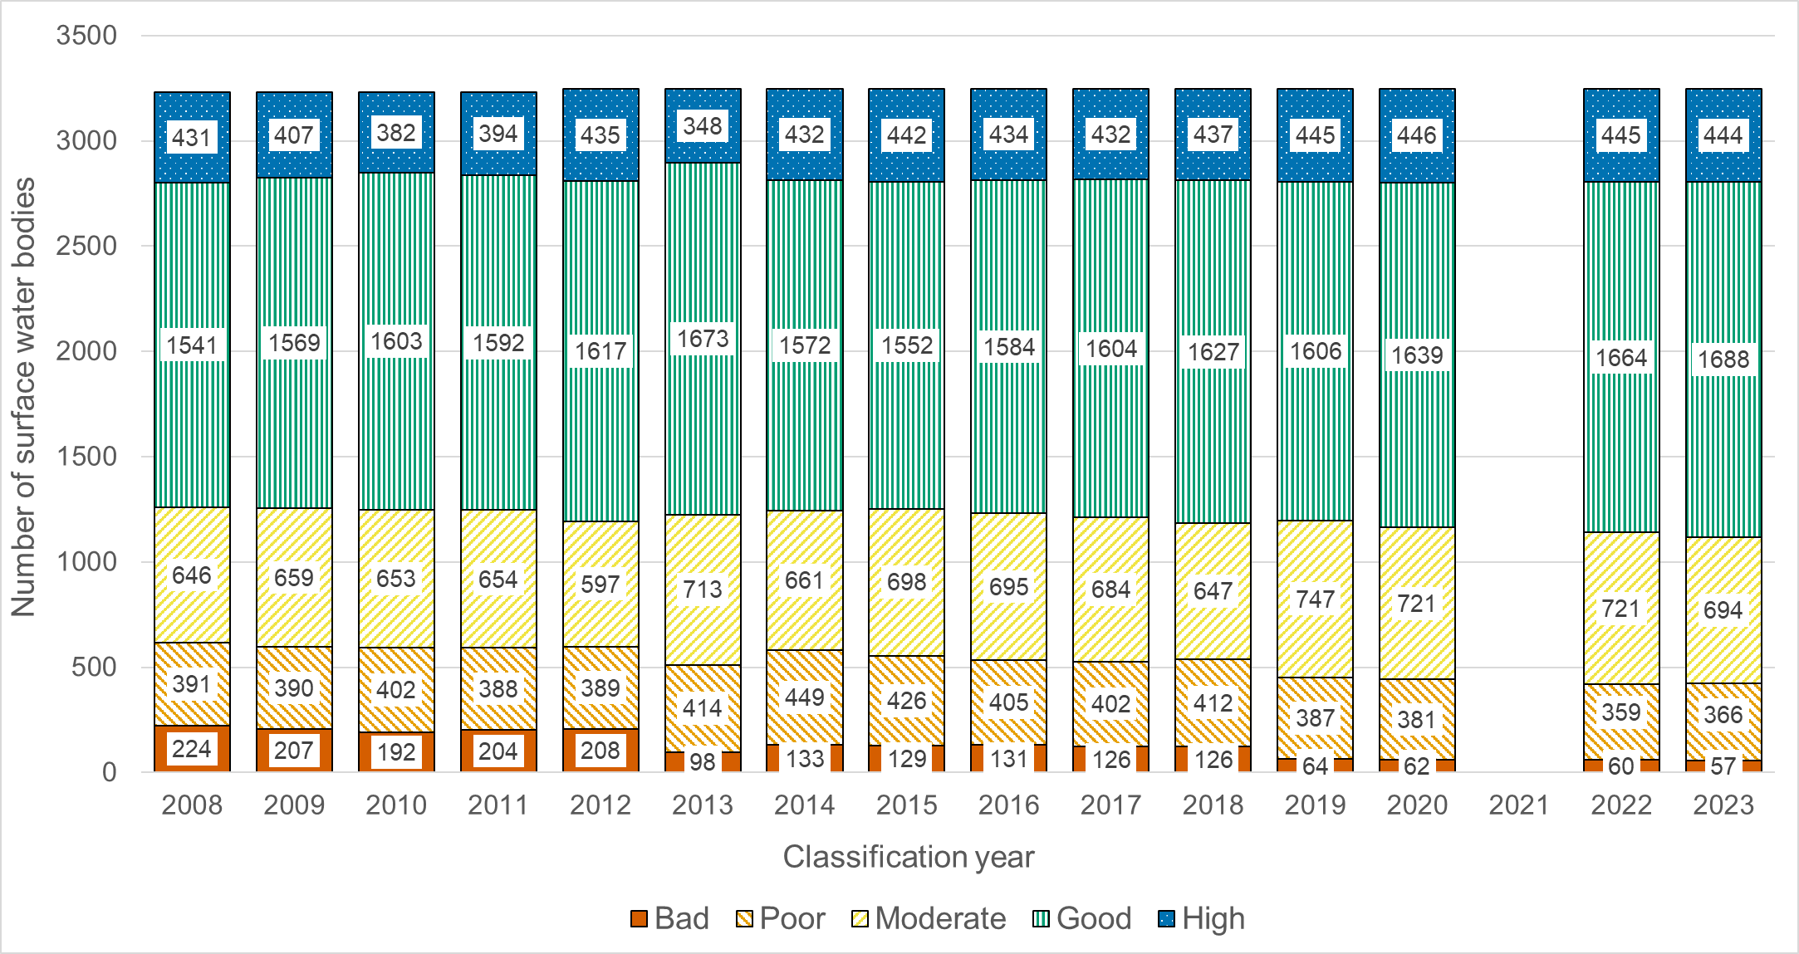
The percentage of groundwater bodies that were classed as good in 2008 was 77.3% and is now 85.9%, demonstrating an improvement of 8.6 percentage points since 2008. The graph below shows the long-term trend in the overall condition of groundwater bodies.
Long term trend in the overall condition of groundwater bodies
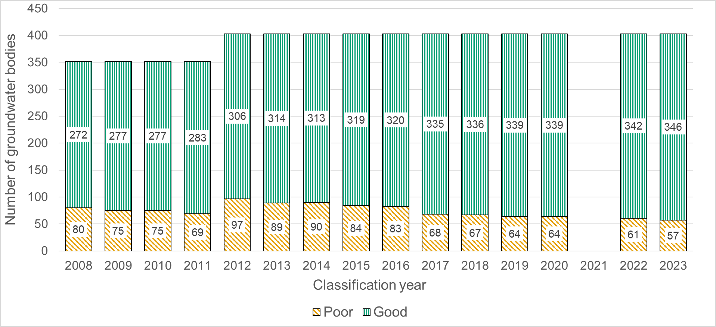

In 2020, the proportion of our water environment (surface waters and groundwaters combined) was assessed as being in good or high overall condition was 66.4%, in 2022 this increased to 67.1%, and in 2023 it increased again to 67.9%. Specifically, in 2023 the overall condition of 43 water bodies were upgraded to good or high. Only 16 water bodies were downgraded to less than good condition. This means that 3,593 out of 3,652 water bodies, or 98.4%, have not deteriorated.
Detailed percentages for the 2023 classification status of each of the river basin management planning themes are provided in the graphs below for surface waters and for groundwaters.
Overview of the state of surface water bodies in 2023 classification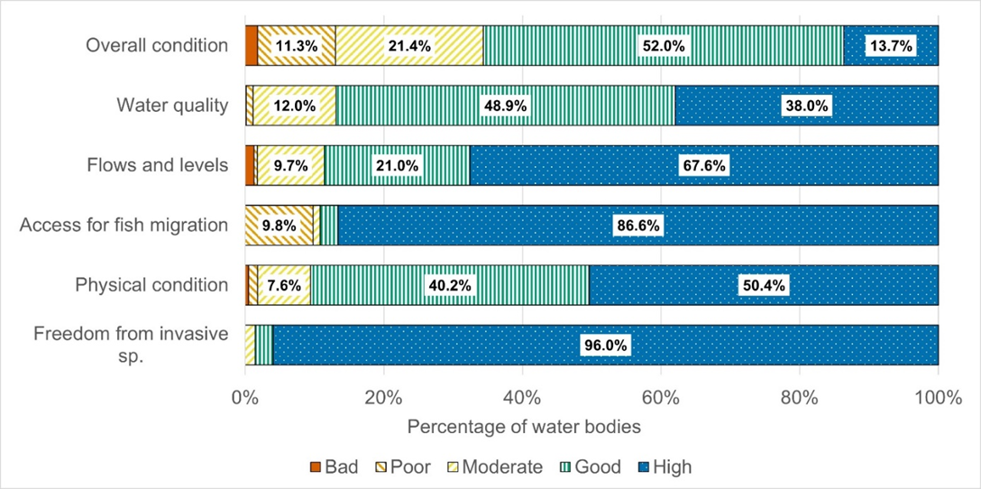
Overview of the state of groundwater bodies in 2023 classification
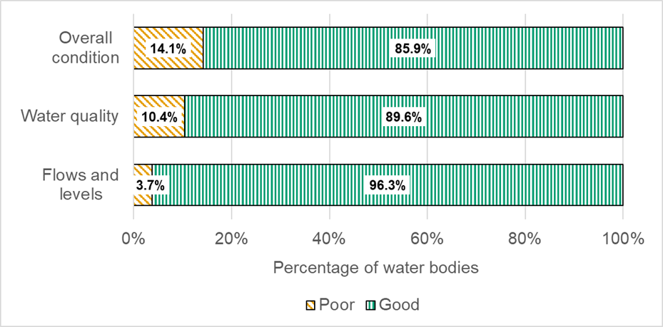

While we are not wholly responsible for delivering this measure, as the regulator and responsible authority for River Basin Management Planning, we are tasked with protecting and improving the water environment. We do this by protecting the water environment from deterioration through permitting, compliance activities, incident response, and our advisory role in relation to new developments. We also aim to secure improvement through our regulatory work with key sectors and through our deployment of the Water Environment Fund. The consistent improvement shown in the classification results indicates that our combined activities and work with partners throughout Scotland are having a tangible impact on the condition of Scotland’s water bodies.

Resource Efficiency

Our ambition is to fully play our part in helping Scotland to transition to a circular economy, and that the management of waste does not cause harm to the environment or communities.

3.6 AOP Measure 6: Rates of waste to landfill in annual Scottish household waste data – Reducing

Status: Achieving
As previously mentioned, this measure and measures one and five (annual greenhouse gas emissions in the Scottish Pollutant Release Inventory – reducing, and classification of water bodies across Scotland – increasing) are long term, Scottish performance measures. Whilst, we are responsible for the reporting of Scottish data, we are not wholly responsible for achieving these measures.
We are seeing a positive reduction in the rates of waste to landfill reported annually. All required data was provided and verified on time, enabling publication as scheduled.
Annual household waste to landfill statistics published
The Waste Landfilled in Scotland 2023 statistics, for all waste landfilled and incinerated in Scotland, were published on schedule on 29 October 2024. A new fully accessible and interactive format has been used for publishing these Official Statistics in partnership with Scottish Government. The total amount of household waste was the lowest amount generated since the start of the current time series in 2011. The amount of Scottish household waste landfilled decreased by 30.2% from 2022 as can be seen in the graph below.

Waste Landfilled in Scotland by Category 2005-2023
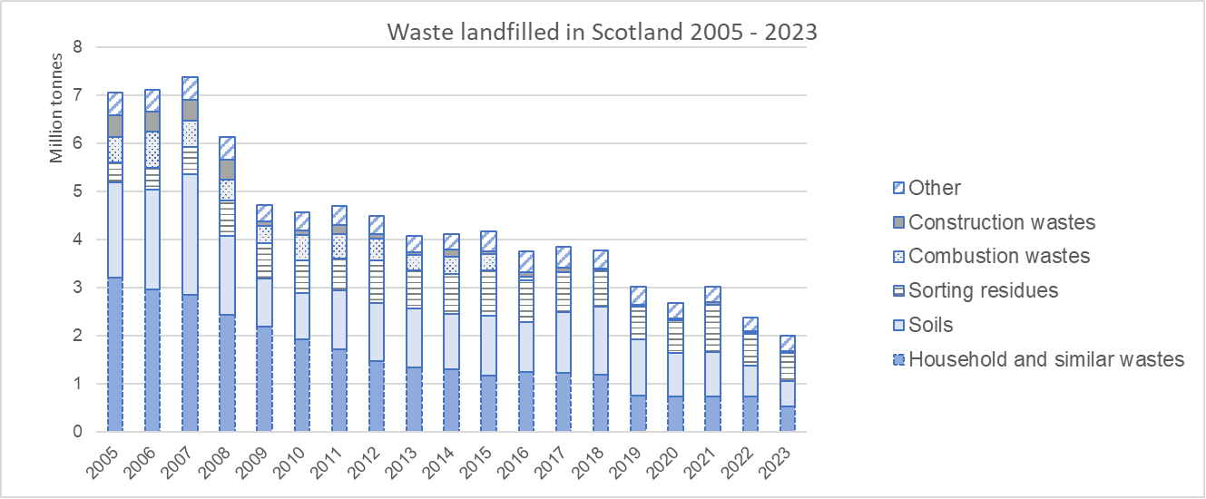

Other related work which will contribute to this measure include:
Deliver actions on digital disruption of illegal waste collection and landowner roles and responsibilities.
The purpose of this project is to detect and disrupt illegal waste operators advertising their waste collection businesses on social media, principally Facebook. It is our assessment that approximately 40% – 50% of all identified profiles are used by unregistered waste carriers. Therefore, members of the public using them to dispose of their own waste may be contributing to fly tipping and other waste crimes. Disruption efforts are focused on both overt challenge of operators and follow-up formal enforcement when there is sufficiency of evidence. From start of the project to date, the project has achieved:
Action | Q1 | Q2 | Q3
Information Notices Issued | 12 | 13 | 13
Profiles closed | 23 | 24 | 26
Texts to unlicensed operators | 39 | 39 | 48
Public Facebook posts | 51 | 51 | 63
Waste Carrier Applications Received | 5 | 7 | 8
Fixed Monetary Penalties Issued | 1 | 4 | 4
Prepare for the implementation of UK Extended Producer Responsibility (EPR) reforms.
SEPA has continued auditing producer data supplied during 2024 and has been assisting producers in the lead up to the Main Statutory Instrument coming into force on 1 January 2025. Preparations by SEPA are on track to regulate and charge Materials Facilities against new requirements to sample and report on recyclate from 1 April 2025, which will support the subsequent UK EPR scheme.
Progress the implementation of digital waste tracking (DWT).
SEPA continue to support the DEFRA led programme for a UK wide DWT system. In quarter three, requirements of the system were submitted to DEFRA for consolidation with those of the other three national agencies. This area is currently awaiting announcements from DEFRA regarding 2025-26 investment, final system capabilities and revised launch and mandatory dates.

Business Environmental Performance

Our ambition is to protect the environment and communities from harm; for Scotland to be an inhospitable place for environmental crime and regulation enables businesses to reduce their environmental impact.

3.7 AOP Measure 7: Number of successful interventions per year – Increasing
Status: Achieving
Illegal Sites and illegal operators are those which are operating without the required environmental authorisation or in contravention of environmental legislation. Our target for this year is to increase the number of interventions we take to tackle environmental crime, and as such cause the number of illegal sites to reduce or downgrade in risk.
The graph below shows that in quarter three we deployed 24 interventions.

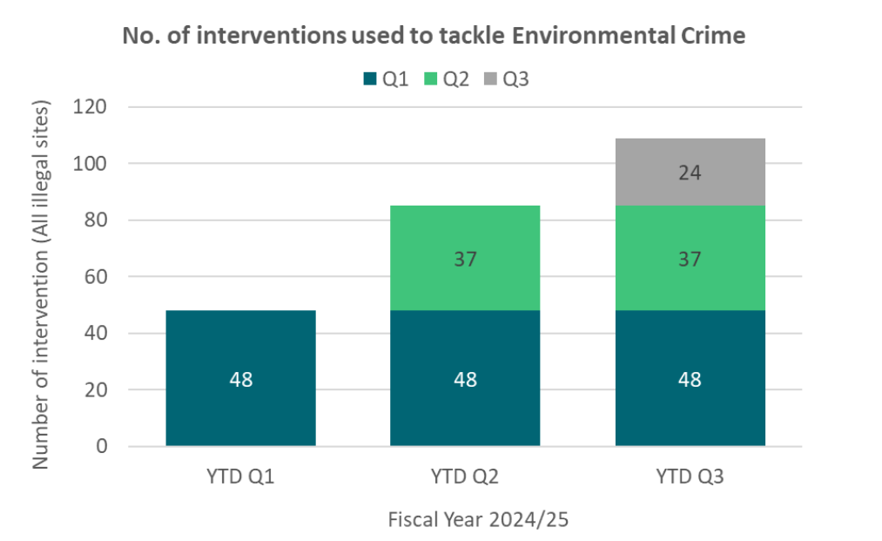
The diagram below demonstrates the breadth of actions by illustrating a sample of the types of interventions used.

The successful interventions we take should result in a continued downward trend in illegal sites, along with a continued increase in Enforcement Actions we take. In the latest quarter, we concluded our investigations and enforcement at eight illegal sites, achieving a total of 81 sites concluded on a year-to-date basis:
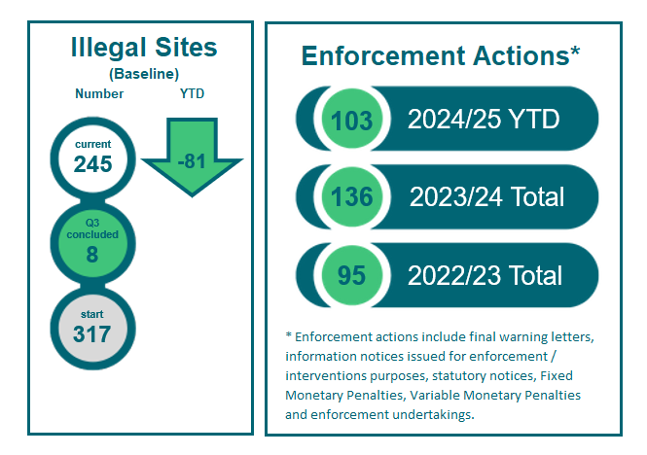
We have a legal obligation across various sectors to complete permit reviews. We must complete these within the legally required or internally set deadlines.
KPI 04 | Baseline | Target | Q3 Performance
Percentage of statutory permit reviews completed on time. | 85% of statutory permit reviews completed on time in the previous year. | 80% of statutory permit reviews completed within the required timeframe. | In quarter three, the year-to-date percentage completed is 17%.
Progress with completing the 2024-2025 reviews has been restricted as we have focussed on completing the backlog of statutory permit reviews (outstanding from previous years) and Medium Combustion Plant permit variations. Prioritising our activity across the range of statutory permit reviews required during 2024-25 means likelihood of achieving the 80% completion target is significantly low.

KPI 05 | Baseline | Target | Q3 Performance
Percentage of statutory reports published by the scheduled date​ ​ | On-time publication rate from the previous year. | 100% | 100%  Four statutory reports published on time by scheduled date.
KPI 06 | Baseline | Target | Q3 Performance
Percentage of applications determined within statutory determination times | 92% for all applications  75% for permitting (licences)  97% for permitting (registrations) | Increase the percentage of applications determined within statutory timelines. | 94% for permitting (all applications)  85% for permitting (licences)  98% for permitting (registrations).

Our Organisation and Transformation

Our ambition is to focus on our people as we ensure SEPA is an efficient, effective and sustainable organisation.

3.8 AOP Measure 8: Percentage of customer complaints responded to within - Maintaining
Status: Achieving
Our target for this year is to respond to 85% of complaints within the timescales set out in our complaints handling procedure. This reflects the measure set by the Scottish Public Services Ombudsman (SPSO) and recognises the fact that some complaints cannot be completed within the planned timescales, due to their seriousness or complexity.
In quarter three, we closed ten complaints, six at Stage 1 and four at Stage 2. All were closed within the timescales set out in our Complaints Handling Procedure.
Overall, we responded to 100% of complaints within timescales in quarter three.
Looking at the 2024-2025 performance for periods quarter one to quarter two inclusive, we responded to 90% of Stage 1 complaints and to 91% of Stage 2 complaints within the target timescales. We are achieving this measure.

KPI 07 | Baseline | Target | Q3 Performance
Percentage of customer complaints responded to within recommended timescales ​ | 89% of complaints responded to within the timescale in Q1 2024.​ | 90% or higher response rate within the recommended timescales.​ | 100% within recommended timescales.​

3.9 AOP Measure 9: Number of vehicles in our fleet to electric and enhancing our EV charger facilities – Increasing

Status: Achieving
This year we are looking to increase the number of electric vehicles in our fleet and increase the number of electric charging facilities over our estate. Scottish Government has approved our plan to replace our fleet vehicles with electric vehicles and our sourcing strategy is in place.
During quarter three, we placed orders for six new electric cars to replace ageing, diesel cars. We expect delivery by the end of quarter four. Two replacement charging units at the Angus Smith building were fitted and commissioned. No further new installations are planned for the remainder of 2024-2025.
KPI 08 | Baseline | Target | Q3 Performance
Fleet - Percentage of vehicles that are ultra-low emissions vehicles (ULEV)​ | October 2024 baseline established of 25% (16 ULEV vehicles of 64) | 34% (22 of 64) | 16 vehicles in SEPA’s fleet are EVs and therefore Zero Emission (ZE).  We disposed of two diesel vehicles, one car and one light commercial vehicle.  Expected delivery of six ZE cars in quarter four, bringing the total to 22 ZE vehicles in the Fleet.

3.10 AOP Measure 10: Percentage of Freedom of Information (FOI) requests and Environmental Information Requests (EIR) responded to within statutory timescales – Increasing

Status: Achieving

This year, our aim is to process at least 90% of requests within 20 working days by the end of March 2025.
We are continuing to see improving performance with responses complete on or under time significantly above the 2023-24 baseline of 82%, shown as the green line in the graph below. This was recognised in November 2024 when the Scottish Information Commissioner closed the level 2 intervention on SEPA.

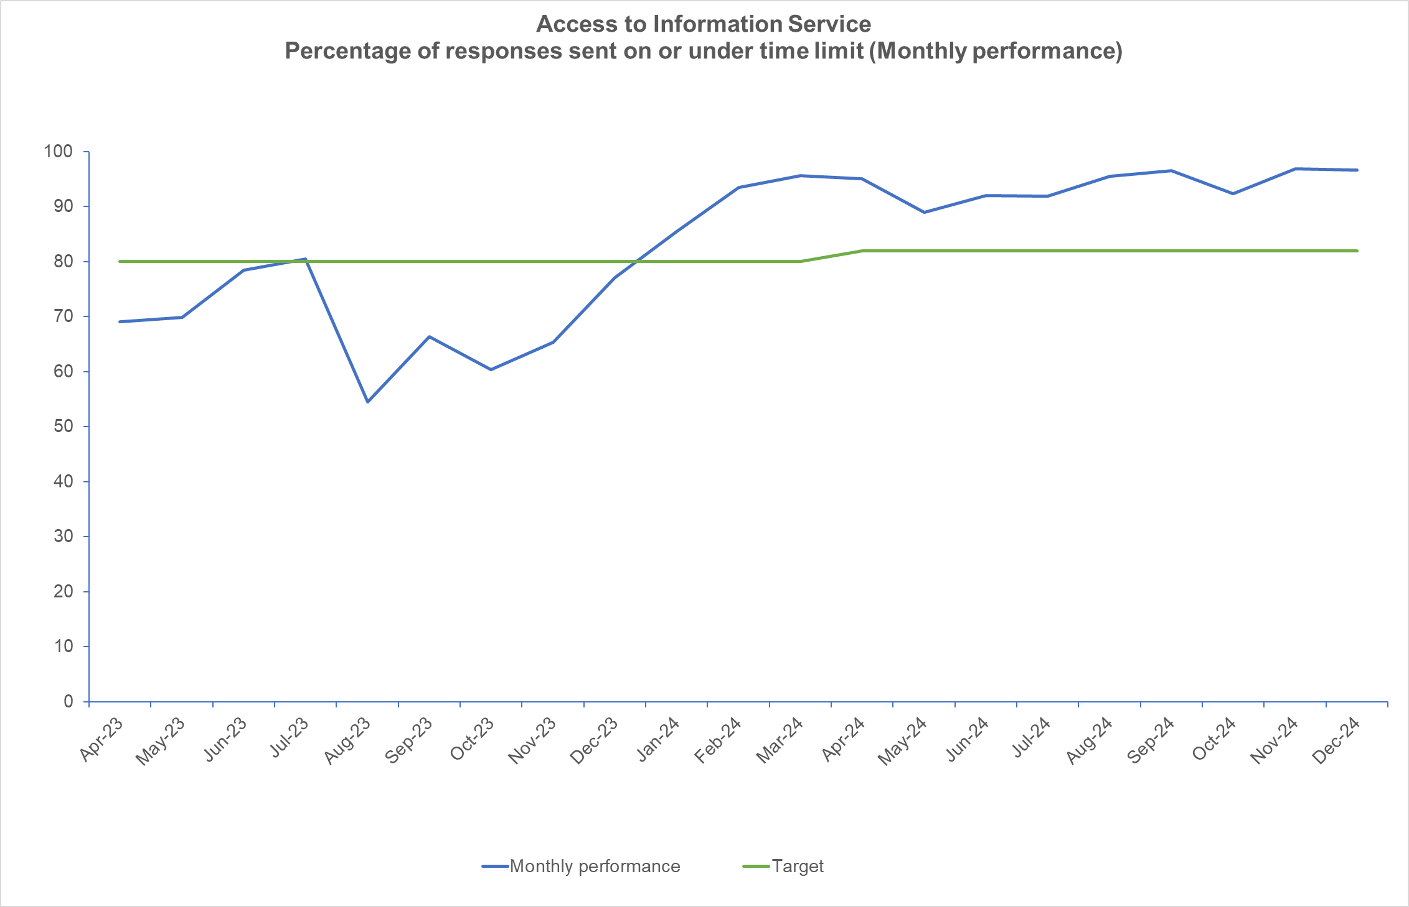

We received 11 FOI requests in quarter three, compared to 16 in quarter two and 10 in quarter respectively.
We continue to receive a high number of EI requests. We received 447 EI requests in quarter three, compared with 549 requests in quarter two and 434 in quarter one. Requests primarily related to the water environment and regulatory information.
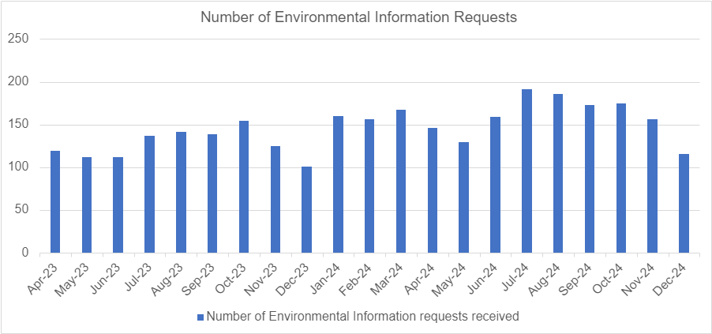

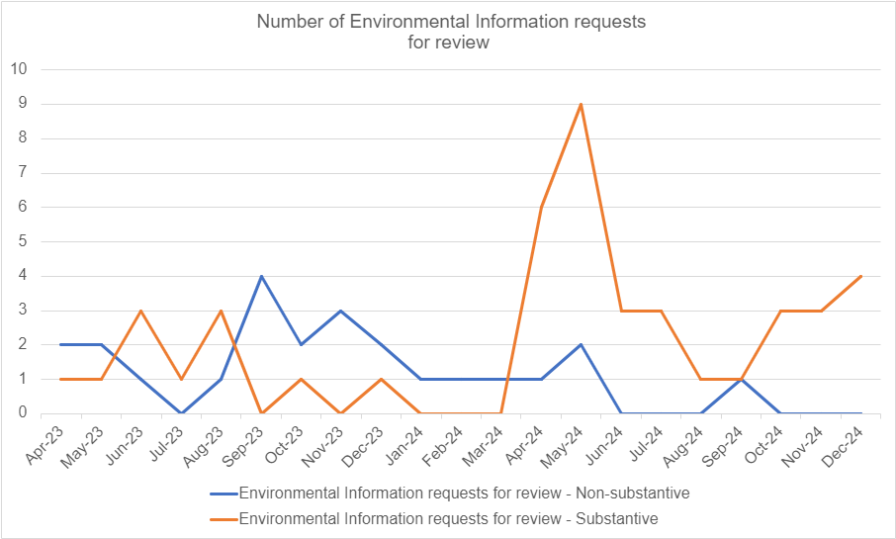
People have the right to request a formal review of how we handled their request (non-substantive review) if they do not receive it on time. They also have the right to request a formal review if they wish to query the information we have sent to or withheld from them (substantive review). This involves significant resource to investigate how we handled a request to resolve a person’s query.

The graph above shows the number of substantive formal reviews in quarter three was up on the previous quarter while the number of non-substantive reviews was down. It should be noted the number of reviews compared to the number of requests received remains low.

If people are unhappy with the outcome of a formal review, they have the right to appeal to the Scottish Information Commissioner (SIC) to investigate how we handled their original request and their request for a formal review. One appeal was closed in quarter three, following completion of the SIC’s investigation and SEPA’s compliance with the Decision Notice. Five outstanding appeals remain with the SIC and SEPA's submissions have been communicated.
During quarter three, we received notice of two new appeals from the SIC.
KPI 09 | Baseline | Target | Q3 Performance
Percentage of Freedom of Information (FOI) requests and Environmental Information Requests (EIRs) responded to within statutory timescales​ | 82% | 90% | We achieved 92% in October and 97% in November and December.

3.11 AOP Measure 11: Percentage efficiency savings – Maintaining
Status: Achieving
In the 2022 Resource Spending Review, the Scottish Government set an expectation that public bodies would deliver annual recurring efficiency savings of at least 3% of their cash revenue grant in aid. In 2024-2025, this equated to £1.2m of SEPA’s revenue budget.
To achieve a balanced budget in 2024-25, we set a vacancy management savings target of £3.5m, which is £2.3m higher than the target required by Scottish Government.
KPI 10 | Baseline | Target | Q3 Performance

Percentage efficiency savings per annum in Grant in Aid | 0% (1st April, resetting every year) | 3% (Year end 31st March)​ | We are maintaining this performance and are on target in quarter three.

3.12 AOP Measure 12: Percentage of invoices paid within 10 days – Maintaining
Status: Achieving
We are working to the Scottish Government target to pay all valid invoices within 10 working days.
KPI 11 | Baseline | Target | Q3 Performance

Percentage of Invoices Paid Within 10 Days​ | Calculate the percentage of invoices paid within 10 days from the previous fiscal year.​ | Achieve a minimum of 90% of all supplier invoices paid within 10 working days each quarter.​ | 91% of supplier invoices were paid within 10 days.

4. Suite of Organisational KPIs Summary
KPI No | KPI | Baseline | Target | Q3 Performance | Status
KPI 12 | Employee Voluntary Turnover Rate | 2024 baseline established as 6.05% for voluntary leavers in 2023-24. This excludes deceased, dismissed, end of fixed term contract and voluntary severance. 2024 baseline for all leavers established as 7.89%. | Less than 6.05% for voluntary leavers. | 0.73% for voluntary leavers | Achieving
KPI 13 | Number of "Near Miss/Hazard spotted" Reports Submitted​ | 2024 baseline established as 16 Hazard spotted and 14 Near miss reports. | Increase the number of hazards spotted and near misses reported to H&S on the 2024 baseline figures. | 23 hazard spotted reports.  24 near miss reports. | Achieving
KPI 14 | Number of reportable health and safety incidents (Number of RIDDOR)​ | 2024 baseline established as 0. | Maintain or achieve a reduction in the number of reportable incidents each year, aiming for a zero-incident target. ​ | 0 reportable health and safety incidents | Achieving
KPI 15 | Net Promoter Score (NPS) from external stakeholders – Member of Scottish Parliament sentiment towards SEPA ​ | Baseline of 69% established in 2023. This is an annual measure so progression cannot be monitored on a quarterly basis. | Greater than 69%. | Favourability sentiment score is 52% in 2024, down from 69% in 2023.  Awareness sentiment score is 82%, down from 87% in 2023.  Comparability and analysis on the sample is limited and so there is no clear driver for the change. SEPA will be developing a new broader approach to reputation and sentiment analysis to support our understanding and response. | Partially Achieving
KPI 16 | Customer experience CSAT​ | Baseline to be established. | This will be determined once the baseline is established. Will start in Q2 2025. | Will report in Q3 2025. | Not reported as yet
KPI 17 | Employee engagement score ​ | Baseline to be established. | Maintain at baseline or above | Will report in Q2 2025 | Not reported as yet
KPI 18 | Absenteeism Rate​ | Overall organisational lost working time due to sickness absence in 2023-2024 was 3.09%. | Maintain at 2024 baseline or below | 2.45%. | Achieving
KPI 19 | Absenteeism Rate due to workplace stress​ | Overall organisational lost working time due to stress and mental health reasons in 2023-2024 was 0.9%. | Maintain at 2024 baseline or below | 0.57%. | Achieving
KPI 20 | Gender Balance in Leadership Positions​ | 50.6% of employees being paid at Band A, B and CLT levels were female, as at 31/3/2024. | 50% or above. | Females account for 47.12% of employees in Band B+ roles.  There will be ongoing fluctuations of this indicator over time due to natural turnover in positions across band B+ roles. We will continue to keep this under review as recruitment opportunities at these levels arise. | Partially achieving.
KPI 21 | Debt Recovery Rate​ | For 2023-2024, the debt recovery rate for debtors paid within 90 days was 95%. | Achieve a debt recovery rate of 80% or higher for all receivables within 90 days of the due date.​ | The cumulative outturn is 89.2%. | Achieving
KPI 22 | Percentage of up-to-date Business Continuity Plans​ (BCPs) | For 2023-2024, 32% of BCPs were current and compliant with SEPA’s review schedule. | Achieve and maintain 100% of business continuity plans being reviewed and updated within the scheduled timeframe each year.​ | 92%  We have 25 Business Continuity Plans across SEPA. 23 are now up to date. The remaining two plans are in progress. | Achieving
KPI 23 | Number of security breaches ​ | 2024 baseline established as 65 (of which 33 were personal data breaches) using the number of security breaches reported in the previous year  - Q1 = 13  - Q2 = 16  - Q3 = 11  - Q4 = 25 | Short term, to increase the awareness and need for staff to report security breaches.  Longer term, to achieve a year-over-year reduction in the number and significance of security breaches. | Quarter three – 25 (including one duplicate report) of which 14 were personal data breaches.  Quarter two – 31 of which 18 were personal data breaches.  Quarter one – 15 of which seven were personal data breaches. | Achieving
KPI 24 | Number of reportable security breaches to Information Commissioner​ | Zero | Zero | No personal data breaches reported to the Security Incident Response Group (SIRG) in Q3 met the criteria to be reported to the Information Commissioner. | Achieving
KPI 25 | Time to recruit from application to offer ​ | 2024 baseline established as 61 days. This indicator measures the time taken from when a job offer is made to when the candidate starts. | 40 days. | 55 days  We are reducing the time taken from offer to start date compared to 2024 baseline, however, are not yet fully achieving our target. Implementation of our new recruitment system in 2025 will ensure we will have enhanced functionality and improved tracking of candidates throughout the whole process, supporting improved performance against this indicator. | Partially achieving
KPI 26 | Average cost per hire​ | 2024 baseline established as £2,000 per role. | Reduce by 10%. | £1063  Please note, the average cost is currently considerably lower than anticipated. This is due to multiple TEPO candidates (14) being hired from a single campaign. | Achieving
KPI 27 | Percentage of mandatory training completed​ | 2024 baseline established as 80%. | 90% | 97.5%. | Achieving
KPI 28 | Number of Employee Development Activities Completed​ | 2024 baseline established as:  - 124 facilitated workshops run.  - Six Learning Plans created.  - 135 E-Learning Courses Available | Increase the number of (relevant) workshops, learning plans and e-learning courses to meet employee needs | We:  - Facilitated 39 workshops.  - Published five learning plans, with three in progress.  - Published 142 learning resources in Discover library | Achieving
KPI 29 | Number of SEPA solely owned or leased buildings​ | A baseline of 11 buildings has been established. | A reduction of up to two workspaces per annum. | One workspace reduced - We have now exited the SEPA leased workspace in Stornoway to colocation with Comhairle nan Eilean Sar.  One workspace in progress - Plans are in place to progress the exit of our Arbroath workspace by March 2025. | Achieving

These are national outcomes for Scotland and SEPA plays a contributing role.
These are national outcomes for Scotland and SEPA plays a contributing role.
These are national outcomes for Scotland and SEPA plays a contributing role.
Information reported was extracted from SEPA systems on 14/01/2025. Systems may be updated after this date and each quarter.

