


IND-G-008

EASR guidance:
Version 1.0 August 2025
Registration activity Road vehicle respraying

Contents
Introduction 1
What does this guidance apply to? 1
Road vehicle respraying process 2
Overview 2
Diagram 1: Overview of respraying process including VOC release points 3
Coating application methods 4
Surface cleaning and preparation 4
Coating application 4
Equipment cleaning 5
SMART spraying 5
Portable spraybooth 5
Environmental controls 6
Solvent and coatings 6
Table 1: Compliant Coatings 6
Site design and infrastructure 7
Storage 8
Housekeeping 9
Emission stacks 9
Diagram 2: Examples of stack heights and distances 10
Emissions monitoring 11
Management techniques 12
Maintenance 12
Operator training 13
Resource use and efficiency 13
Raw materials 14
Water 14
Waste 14
Heat 14
Energy 14
Interpretation of terms 15
Disclaimer 15

If you would like this document in an accessible format, such as large print, audio recording or braille, please contact SEPA by emailing equalities@sepa.org.uk

Introduction
This document provides information and guidance for anyone undertaking respraying of road vehicles which may be authorised under the Environmental Authorisation (Scotland) Regulations (EASR). It should be read alongside the standard conditions for this activity.

What does this guidance apply to?
This guidance applies to:
- The repainting or respraying of road vehicles, or parts of them, using two or more tonnes of organic solvent in a 12-month period.
It also applies to:
- The temporary storage of materials used or generated as part of the activity including paint storage and paint mixing.
- The storage of any associated waste materials.
It does not apply to:
- Road vehicle respraying using isocyanate coatings.
- Vehicle coating at new vehicle manufacturing sites.
- Vehicle refinishing at sites where road vehicles are being coated for the first time.
- The coating of trailers.
- The re-painting or respraying of non-road vehicles.
The above activities require a permit from SEPA.

Road vehicle respraying process

Overview
Road vehicles require respraying as part of a vehicle repair, conservation, or for decorative purposes. Coatings used to repaint or respray road vehicles contain organic solvents so that they can be applied in liquid form and dried to create a thin layer of solid covering. An overview of this process can also be seen in Diagram 1 on the next page.
Organic solvents are problematic because they are composed of volatile organic compounds (VOCs) which contribute to the formation of photochemical oxidants such as ozone which in high concentrations can impair human health and damage vegetation and materials. Ozone is also a greenhouse gas and contributes to atmospheric warming and climate change. Some volatile organic compounds are classified as toxic, carcinogenic or teratogenic. These emissions represent a significant contribution to air pollution in urban areas and may also cause odour problems.

Diagram 1: Overview of respraying process including VOC release points
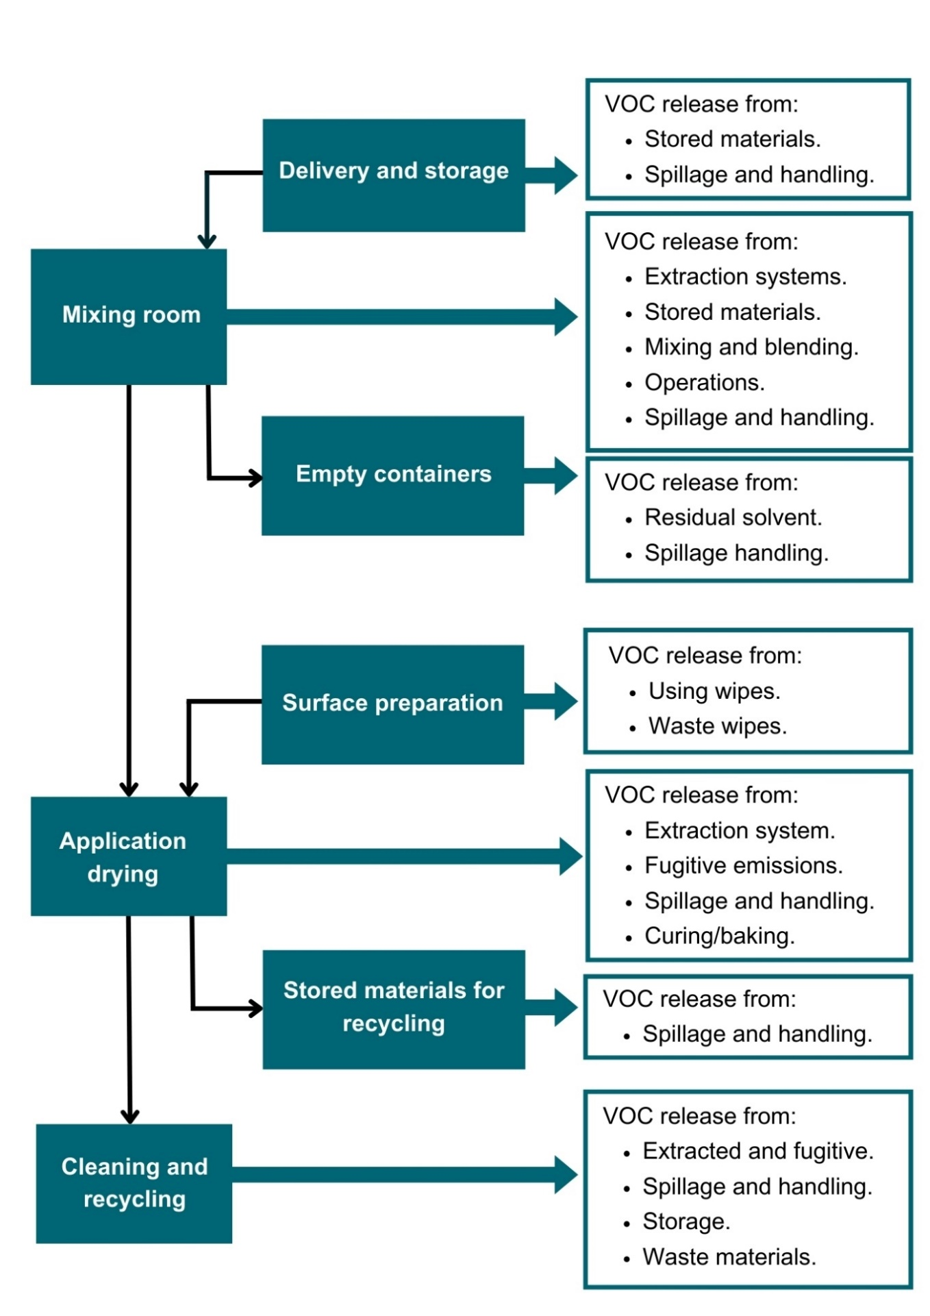

Coating application methods
Most coatings are applied in vehicle spray booths usually with a hand-held spray – spraying in the open workshop must not occur. There are different types of hand-held spraying: compliant compressed-air; high-volume low-pressure; airless; air-assisted airless; and electrostatic assisted. A small amount of coating or remover may be applied by brush, roller or with a knife.

Surface cleaning and preparation
Surfaces to be coated need to be smooth and clean to achieve a good finish and any undulations are smoothed out with stopper. Cleaning is generally done manually using brushes and cloths with organic solvents or aqueous cleaners. Abrasive blasting may be used to improve paint adhesion and to assist underbody protection. Surface unevenness is addressed before painting, with depressions filled with stopper which is then sanded down once it has cured.
Sanding and grinding can be wet or dry using mechanical equipment. Equipment for dry sanding or grinding is equipped with a suction device to collect dust either locally or centrally.
The use of methylene chloride paint strippers has been restricted so damaged vehicle panels are more usually replaced than beaten out, stripped and repainted. The repair of vintage cars is one area of continued use and requires very good ventilation.

Coating application
Primer, stopper and top-coats are applied as necessary and sanding between coats may be required. In addition, various specialist coatings for seam sealing, stone-chip protection, cavity sealing and undersealing may be required as well as bonding adhesives for attaching add-on parts.

Equipment cleaning
The tools used for applying coatings such as spray guns, mixing vessels and measuring breakers have to be cleaned after use. Where products have been used that contain solvents, the equipment is cleaned with solvent-based cleaner.
Spray guns are cleaned in fully or semi enclosed gun cleaning machines with suitable extraction for health and safety purposes which usually vents directly to the atmosphere. The organic solvent cleaner is re-used until it is spent and disposed of to a specialist company. It must not be discharged to a drain.
Spray booths are kept clean by repainting them or using disposal walls coverings; and covering lights with a clear removable coating/film.

SMART spraying
SMART spraying (small and medium area repair technique) tends to be a mobile process. This is the surface coating of part of a motor vehicle outside of a spray booth or room, typically using a mini-spray gun, an air brush or pre-packaged aerosol can. Often a protective enclosure will be used which may have filtration. The parts coated should only be small chips or scrapes and not extend to a complete panel or panels. This activity is extremely unlikely to breach the permitted threshold of 2 tonnes of solvent in a 12 month period.

Portable spraybooth
These are fully enclosed inflatable spraybooths with filtration which carry out SMART activities. If the throughput exceeds 2 tonnes of VOC in a 12 month period, they will require a Registration.

Environmental controls
It is expected that the methods described in this section are utilised to control emissions from road vehicle respraying activities. Where other methods are used, they should offer at least an equivalent level of environmental protection.
Containment and extraction of dusty air through filtration are considered the best ways to control dust emissions. Emissions of volatile organic compounds (VOCs) should be controlled by using compliant coatings and minimising fugitive emissions.

Solvent and coatings
Only compliant coatings may be used. This is a requirement of The Volatile Organic Compounds in Paints, Varnishes and Vehicle Refinishing Products Regulations 2012. Compliant coatings must contain equal or less than the VOC limits detailed in the table on the next page. These coatings must be labelled with the VOC content in grams per litre (g/l) and the VOC content limit in g/l that applies to that category of product.

Table 1: Compliant coatings
Product subcategory | Coating | VOC (g/l)⁽¹⁾
Preparatory and cleaning | Preparatory  Pre-cleaner | 850  200
Body filler / stopper | All types | 250
Primer | Surface / filler and general (metal) primer  Wash primer | 540  780
Topcoat | All types | 420
Special finishes | All types | 840
- gram/litre of ready to use product with any water content of the product discounted, except for preparatory and cleaning products.

Site design and infrastructure
- Respraying of road vehicles or their parts must only take place in purpose-built totally enclosed booths / rooms with filtered extraction designed to emit less than 10mg/m³ (under normal conditions) of dust and the enclosed space must be maintained under negative pressure to prevent fugitive emissions.
- To demonstrate compliance with the dust emission limit, a spraybooth manufacturer should be able to provide the operator with a guarantee that the dust emission limit will be met, supported by emission test data for the spraybooth type which has been installed or upgraded. The spraybooth must then be operated in line with the manufacturer’s instructions for use to guarantee compliance with the dust emission limit. Servicing and maintenance must also be in line with the manufacturer’s recommendations.
- If no guarantee can be supplied, annual dust emission monitoring will be required to demonstrate compliance with the dust emission limit.
- Sanding and grinding should be carried out by mechanical means fitted with local ventilation or air extraction-fitted equipment which is vented to arrestment plant.
- Abrasive blasting should only carried out in a purpose-built contained area designed to emit less than 50mg/m³ (under normal conditions).
- Arrestment equipment should be regularly checked and maintained to ensure it is fully operational.
- The method of collection of dust from dry arrestment plant should be done in a manner that does not create dust emissions.
- Cleaning of spray guns should only be done in the gun cleaning machine with the extraction running and a receptacle in place to collect the solvent used to clean the gun.
- Manual dispensing of cleaning solvents should only be done with pump dispenser or similar method to minimise use of cleaner.
- Dirty solvent and waste paint should be recycled on or off-site. Spray coatings should only be applied to road vehicles by the following methods:
  - High volume low pressure (HVLP) spraying equipment with a maximum atomisation pressure of 67.5kPa).
  - Air assisted airless spraying equipment.
  - Airless spraying equipment for commercial vehicles only.
  - Electrostatic spraying equipment.
  - A system capable of achieving a transfer efficiency of at least 65%.

Storage
- Fugitive emissions of VOCs should be minimised by appropriate storage, handling and preventing spills of solvent-containing materials. These materials should be in a closed container when not in use and the exposure to atmosphere time should be kept as short as possible.
- Waste contaminated with solvent should be kept in enclosed containers.
- Impregnated solvent wipes should be kept in an enclosed container.
- Dusty wastes should be stored in enclosed containers.

Housekeeping
- Spillages should be dealt with as soon as possible with no dry sweeping of dusty materials and suitable solvent spillage equipment should be available in solvent handling areas.
- A high standard of housekeeping should be maintained. There should be no significant deposits of dust in process buildings or on equipment.

Emission stacks
- Emission stacks for any vehicle respraying or abrasive blasting should have a height as follows:
  - For a stack located on a building, the stack height should be greater than or equal to 3 metres above the building’s roof ridge height.
  - For a stack located separately to any building, the stack height should be great than or equal to 3 metres above the ground.
  - All stacks should be at least the same height of any building which is located within a distance of 5 times the uncorrected stack height.
- Emission stack height examples:
  - A stack exits through the roof of a building with a roof ridge height of 6 metres. The stack will need to be tall enough to extend to at least 9 metres from the ground line of the building so that it is 3 metres above the roof ridge. As it exits through the roof, the stack won’t need to be 9 metres long itself, just long enough to reach a 9 metres height from the building ground-level.
  - A stack stands beside the building which it serves. The building roof ridge height is 6 metres. In this case the stack will need to be at least 9 metres tall.
  - In both the above cases, there is another building located within 5 times the uncorrected stack height i.e. 5 x 9 metres = 45 metres. This building has a roof ridge height of 12 metres. Both stacks will need to be extended a further 3 metres in order to have a corresponding height of this additional building.
Diagram 2 shows examples of stack heights and distances from other buildings.

Diagram 2: Examples of stack heights and distances
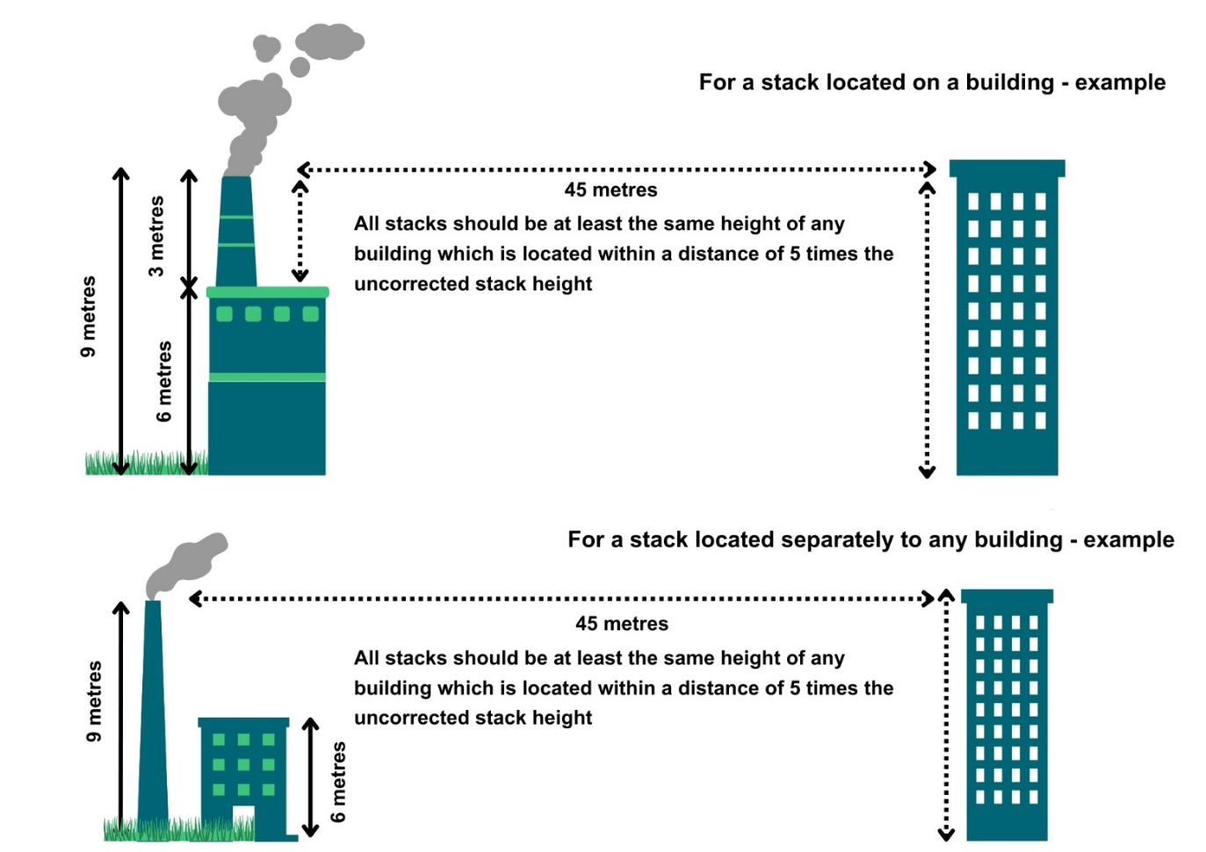

- Flues and ductwork should be cleaned to prevent the accumulation of materials as part of the routine maintenance programme.
- The target velocity of the stack should be 15m/s under normal operating conditions so that adequate dispersion is achieved. A cone may be used to increase exit velocity, but no other type of restriction is to be used.
- Wet arrestment may be used in some circumstances, and this will require an exit velocity of less than 9m/s in order to prevent unacceptable emissions of droplets or else a mist eliminator should be used.

Emissions monitoring
- Dust emissions from the vehicle respraying stack must not exceed 10 mg/m³.
- Dust emissions from the abrasive blasting stack must not exceed 50 mg/m³.
- If a manufacturer’s guarantee is not in place for the spraybooth, dust monitoring is required at the vehicle respraying stack.
- For all sites where abrasive blasting is taking place, dust monitoring is required.
- Monitoring must be carried out:
  - At the vehicle respraying and abrasive blasting stack using monitoring standard BS EN 13284-1.
  - Within the first 4 months of starting operations and then annually after that.
  - Without adding air to dilute emissions.
  - During normal operations and under stable conditions.
- The sample point should be:
  - Designed according to BS EN 15259.
  - Installed, maintained and clearly marked to ensure safe and representative sample collection.

Management techniques
Good management techniques, training and well-maintained infrastructure are key to prevent and limit the consequences of accidents which could have an impact on the environment. For example, bunding should be used around liquid storage to contain any spillages, but good management and maintenance would take this a step further by ensuring that the integrity of the bunding is checked regularly to prevent leaks, and deliveries and movements around the site are well controlled. This will enable you to comply with environmental regulations, avoid incidents, and avoid any costs incurred through loss of resources.
- Effective control of emissions starts with proper management, supervision and training for process operators.
- Implement an environmental management system to help identify and provide a systematic approach to manage, monitor and control your environmental issues and maintain efficiency. These can be certified through ISO 140001, BS8555 or EMAS but can also be in-house.
- Develop and maintain an emergency response plans e.g. specific actions for preventing and mitigating spills or runoff that may affect water bodies. For best practice and guidance read the CIRIA Guide to Containment Systems for the prevention of pollution (C736F).

Maintenance
Maintenance can be categorised as ‘preventative’ or ‘corrective’ (also known as ‘reactive’). Preventative maintenance includes regular planned checks, servicing and maintenance of equipment to prevent or reduce failures and breakdowns which can lead to pollution incidents, safety concerns and costly downtime. Corrective maintenance includes identifying and repairing a fault once it has occurred with the aim of restoring equipment or systems to their optimum operational condition(s).
- All aspects of the activity plant, buildings and equipment should be properly maintained and there should be a written maintenance programme with a record that the maintenance has been carried out.
- Equipment should be used properly, and preventative maintenance carried out and ensuring that operators know what to do in the event of an incident which may cause emissions from the activity.
- Spares and consumables should be held on site so that rapid repairs can be carried out and there is no temptation to continue operating with ineffective emission controls in place.
- Spray booths should be serviced and maintained in accordance with the manufacturer’s instructions so as to maintain the validity of the guarantee of maximum emission concentration limit.

Operator training
- Staff at all levels must be trained and instructed as to their duties to control emissions from the activity. Training should include awareness of the SEPA registration requirements and actions to take in the event of incidents that may result in emissions from the activity.
- A training record should be kept for each member of staff.

Resource use and efficiency
Best practice for resource use and efficiency is to review and implement any potential opportunities to reduce emissions and wastes. In addition to reducing the impact on the environment, you will also benefit because resource efficiency is also about:
- Reducing costs (raw material and waste disposal).
- Maximising output of product or service from a given level of materials and energy (competitive advantage).
- Finding an outlet for surplus materials therefore removing them from the waste chain.
- Helping Scotland achieve its goal of becoming a zero waste society.
- Reducing pollution risks and avoiding reputational impacts.
Resources include water, raw materials, energy, fuel and wastes used and produced throughout a regulated process. These can be manged in the following ways:

Raw materials
Raw material use should be managed by tracking use and stores and ensuring that all resources are stored appropriately to avoid contamination, spoilage or leaks. The use of automatic dosing equipment should be considered to ensure that optimum measured quantities are used throughout the process. LEAN methodologies that focus on reducing waste could be beneficial.

Water
Water should be stored in adequate containers and any pipework and taps maintained to avoid leaks and evaporation. Where possible, rainwater harvesting and recycled water should be used.

Waste
Waste should be managed in line with the waste hierarchy (prevention > prepare for reuse > recycle > recover value > disposal). Waste should be segregated and stored appropriately to ensure that it can be managed as high up the hierarchy as possible.

Heat
Where heat is used or generated, optimum temperatures should be maintained during the process; buildings, pipes and tanks should be insulated to minimise heat loss, and where possible heat should be captured and used elsewhere.

Energy
Energy should be used efficiently across the site by monitoring energy use, ensuring any lighting, motors, compressors or other equipment is well maintained and working at optimum, rather than maximum, levels. Consideration should be given to replacement with more energy efficient equipment during upgrades. Servicing should be to manufacturer’s recommendations and preventative maintenance should be carried out, instead of only reactive maintenance after plant faults.

Interpretation of terms
Term | Definition
fugitive emission | Any emission released to the environment in the course of the Activity other than through a single identifiable source.
organic solvent | composed of volatile organic compounds (VOC) which are any organic compounds with a vapour pressure of 0.01kPa or more at 293.15K or having a corresponding volatility under the particular conditions of use.
resource | materials, water, waste, residues and energy used within, or produced from, the authorised activities and in any ancillary processes on site.

Disclaimer
This guidance is based on the law as it stood when the guidance was published.
Whilst every effort has been made to ensure the accuracy of this guidance, SEPA gives no warranty, covenant or undertaking (express or implied) regarding the fitness for purpose of, or any error, omission or discrepancy in this guidance. Reliance on its contents and the contents of any websites that are linked to or from this guidance is entirely at the user’s own risk. SEPA is not liable for any loss or damage that may come from using this guidance. This includes:
- Any direct, indirect and consequential losses.
- Any loss or damage caused by civil wrongs, breach of contract or otherwise.
SEPA reserves the right to depart from this guidance and take appropriate action as it considers necessary or appropriate. Operators are responsible for ensuring that they are compliant with the law. If necessary, independent legal / specialist advice should be sought.

