


WAT-G-026

EASR Guidance:
Version 1.0, August 2025

Engineering:
Activity Guide:
Sediment Management

Contents
1 Purpose 3
2 Introduction 3
3 Sediment management 3
3.1 What is sediment and where does it come from? 3
3.2 Why is sediment important? 5
3.2.1 In rivers 5
3.2.2 In lochs 5
3.3 What is sediment management? 6
Sediment removal 6
Sediment reintroduction 6
Sediment addition 6
Sediment manipulation 7
3.4 Key parts of a watercourse and loch 7
3.5 What are the potential issues with sediment management 8
3.5.1 Activity specific issues 8
3.5.2 Risks to the water environment 14
3.6 Sediment management and climate change 15
4 Good Practice 17
4.1 Demonstrate need 18
4.1.1 Reasons for carrying out the activity 19
4.1.2 Identifying and understanding the problem or need 20
4.2 Identify and appraise options 30
4.2.1 Do nothing 31
4.2.2 Sediment management 31
4.2.3 Other options 43
4.3 Justify the selected option 46
4.4 Use all reasonable mitigation 46
4.5 Monitoring and evaluation 47
Disclaimer 48

If you would like this document in an accessible format, such as large print, audio recording or braille, please contact SEPA by emailing equalities@sepa.org.uk

1 Purpose
This document provides information and guidance for sediment management activities which are subject to authorisation by SEPA under the Environmental Authorisations (Scotland) Regulations 2018, (EASR).

2 Introduction
This activity guide aims to demonstrate Good Practice requirements and to help select sustainable engineering solutions that minimise harm to the water environment. This focuses on the environmental aspects that should be considered when undertaking a project. Using this document will help with the process of obtaining an authorisation for works. It is not intended as a technical design manual, and it is important to recognise that any engineering works must be designed to suit site specific conditions.

3 Sediment management

3.1 What is sediment and where does it come from?
Sediment refers to the natural substrate of the bed of a watercourse or loch and is named in terms of the diameter of the individual pieces of sediment (Figure 1):
- Clay, silt and sand (particles less than 2 millimetres in diameter).
- Gravels (particles 2 to 64 millimetres in diameter i.e. up to tennis ball size).
- Cobbles (particles 64 to 256 millimetres in diameter i.e. up to football size).
- Boulders (particles larger than 256 millimetres in diameter).
Clay, silt and sand sized sediments are collectively referred to as fine sediment, while gravels, cobbles and boulders are collectively referred to as coarse sediment.
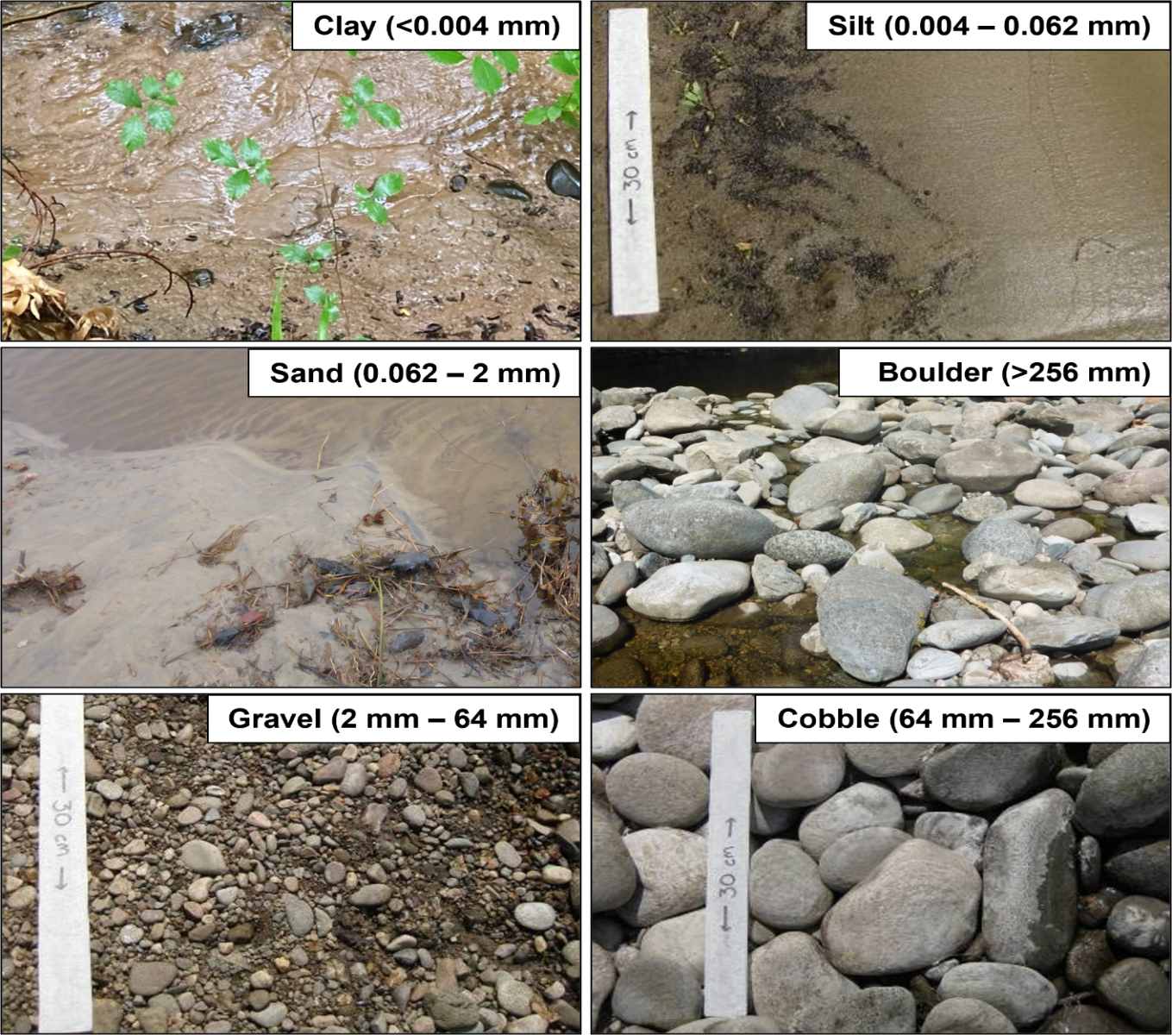
Sediment is supplied to watercourses from eroding hillslopes or by the erosion of channel beds and banks. Once in a watercourse, sediment is moved and sorted during periods of higher flows and comes to rest during periods of lower flows and mobilised again during higher flows. Deposition and transportation rates of sediment is determined by flow and the steepness and degree of confinement of the valley bottom and create erosional, balanced or depositional sediment reaches of a watercourse (see section 4.1.2.1).
Figure 1 Photographs showing the different sediment sizes you may see on the bed of a watercourse or loch

Eventually sediment is transported to the sea, where it is redistributed along the coastline, or into natural lochs or reservoirs, where wind driven waves distribute the sediment around the loch shore or into the deeper parts of the loch. Sediment can also be sourced directly within a loch or reservoir by the erosive action of waves on hillslopes and floodplain.

3.2 Why is sediment important?

3.2.1 In rivers
Sediments are one of the fundamental reasons why rivers look the way they do. The size (width and depth) and shape of a watercourse is largely created by the interaction of high flows with the supplied sediment load. The size and shape of a watercourses that is relatively undisturbed by human activities will naturally adjust to accommodate the amount of water and sediment moving through it and when this occurs the river is said to be ‘in equilibrium’. This means that the processes of water and sediment movement through a watercourse and the way the watercourse looks (its geomorphological ‘forms’) are in balance.
Sediments are an integral part of freshwater ecosystems. Sediment erosion, transportation and deposition create and continually refresh features such as bars, islands, riffles and pools that together provide diverse habitats that are essential for the survival of freshwater plants and animals.
Many important species rely on river sediments for survival. For example:
- Atlantic salmon and lamprey migrate into rivers and move upstream to reach spawning areas, which are normally clean gravel or cobble stretches of faster flowing water. They spawn in these areas, laying eggs in nests (redds) made by moving stones to form a shallow depression. After hatching, both species move to other parts of the river to feed and grow, and a diverse range of substrate sizes and flow conditions are key in providing suitable habitat for all ages of fish.
- Freshwater pearl mussels require clean river sediments and live buried in coarse sand or fine gravel and rely on a healthy salmon or trout population for the dispersal of juveniles.
- Shingle islands, formed from river gravels, support a wide range of plants and invertebrates such as shingle beetles, which in turn provide shelter and food for breeding birds such as ringed plover and common terns.

3.2.2 In lochs
While most lochs have completely different methods of formation to rivers, once a loch has formed and in the absence of significant human modifications, like in rivers, its shore zone in particular will develop an ‘equilibrium’ shape and features that result from the interplay between the shape of the surrounding landscape, the rise and fall of the water surface, the predominant wind direction and the size and quantity of sediment supplied to or sourced from within the loch. The movement of sediment along and around a loch’s shore (longshore drift) is principally controlled by wind-generated waves and creates features such as beaches, spits and bank faces, while the movement of sediment between shallower and deeper sections of the loch is controlled by both waves and variations in loch water level.
As in a watercourse, the equilibrium shape and features of a loch’s shore zone also provide habitats that are essential for a large variety of plants and animals. Wave-washed shores support distinctive invertebrate assemblages, while the coarser sediments found near inlets and outlets, or where water percolates through gravels creating upwellings, can be important spawning areas for fish species such as Arctic charr or even brown trout where stream spawning is limited. Clean, silt-free gravels are also key spawning substrates for some our rarest freshwater fish including powan and vendace.

3.3 What is sediment management?
Sediment management is a term used by SEPA to cover a range of different activities affecting sediment within a waterbody. As outlined below these fit into four broad categories:

Sediment removal
The removal of submerged and/or exposed sediment from the bed of a watercourse or loch. This includes dredging (removing sediment from greater than 50 percent of channel width) and removing all or part of single accumulations of sediment (e.g. skimming gravel bars).

Sediment reintroduction
The placing of natural sediment on the bed of a waterbody, which has been removed from a waterbody (e.g. from behind an impoundment).

Sediment addition
The addition of sediment to a waterbody, which has not been acquired from a waterbody (e.g. obtained from a quarry).

Sediment manipulation
Moving, manipulating/re-organising or reprofiling existing sediment within a set location on the bed of a waterbody.

3.4 Key parts of a watercourse and loch
Key parts and terms of a watercourse and loch are shown in Figures 2 and 3 below and explained in the Glossary.

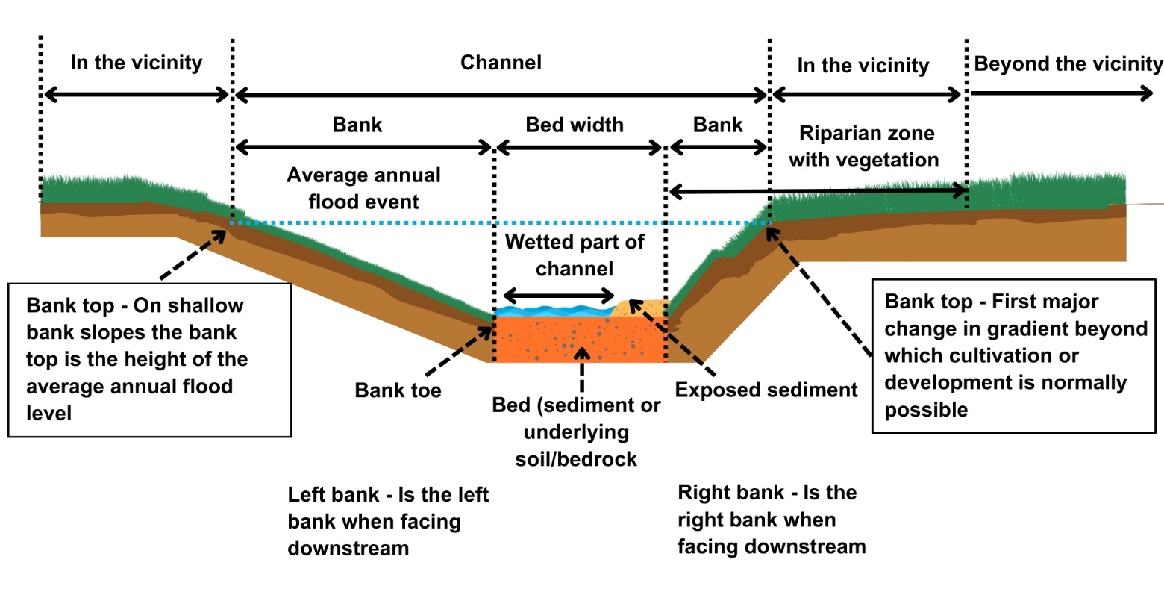
Figure 2 Keys parts of a watercourse

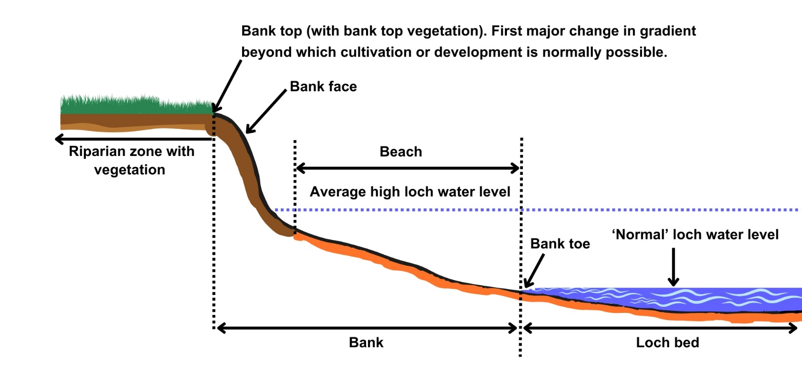
Figure 3 Key parts of a loch

3.5 What are the potential issues with sediment management

3.5.1 Activity specific issues
The risk to the environment from sediment management may vary depending on:
- Size and composition of sediment e.g. predominantly gravel or predominantly silt.
- The scale and extent of works i.e. the volumes of sediment to be managed and the lengths of bed or bank this affects.
- Whether the sediment to be managed is submerged or exposed above the water line.
- The ecological sensitivity of the watercourse or loch to sediment management, e.g. its conservation status or the suitability and prevalence of the sediment for fish spawning.
- The working methods to be used in managing the sediment and the timing and frequency of these works, particularly in relation to ecologically sensitive periods such fish spawning.
- Any previous engineering of the watercourse or loch.
Sediment management can have a range of significant adverse impacts if undertaken without careful consideration.
3.5.1.1 River instability
In many Scottish rivers the bed is made up of a surface layer of generally larger gravels, cobbles and sometimes boulders overlying a sub-surface layer of finer gravels, sand and silt (see Figure 4). The surface layer can be very resistant to erosion, which prevents the sub-surface sediment from being eroded and, because of this protective role, it is called an ‘armour’ layer. An armour layer requires potentially large flood flows to break it up, with this generally occurring towards the peak of the flood. When this occurs, the finer sub-surface layer can be eroded, temporarily lowering the bed level. As the flood flow recedes, however, and as long as there is an uninterrupted supply of sediment from upstream, sediment is redeposited and the armour layer can reform at close to its pre-flood elevation. Thus, while the bed can be very dynamic during a large flood, over the longer term the river remains stable.
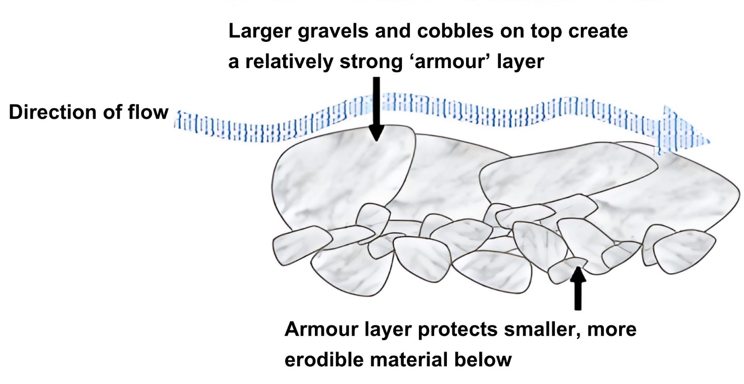
Figure 4: A river bed ‘armour’ layer prevents the underlying finer sediment from being eroded by all but the largest flows.
Sediment management, including the removal of sediment and the armour layer, exposes the finer sub-surface sediment to erosion. This can create a step in the bed called a ‘knick point’. As water flows rapidly over the knick point the bed at its base is scoured and the knick point erodes potentially long distances upstream (see Figure 5). If there is insufficient coarse sediment supply from upstream, for example because the channel bed there is still armoured, there can be a permanent drop in the level of the eroded channel bed, which can undermine the banks and cause potentially extensive bank erosion. This can cause long-term or permanent habitat damage, land loss, and undermine structures such as bridges, culverts, footpaths, roads, railway lines and buildings. Protecting these structures potentially then requires additional engineering interventions that result in cumulatively higher levels of environmental damage. The combination of bed scour and bank erosion can also deliver large volumes of sediment to depositional reaches downstream, decreasing their capacity and potentially increasing flood risk.
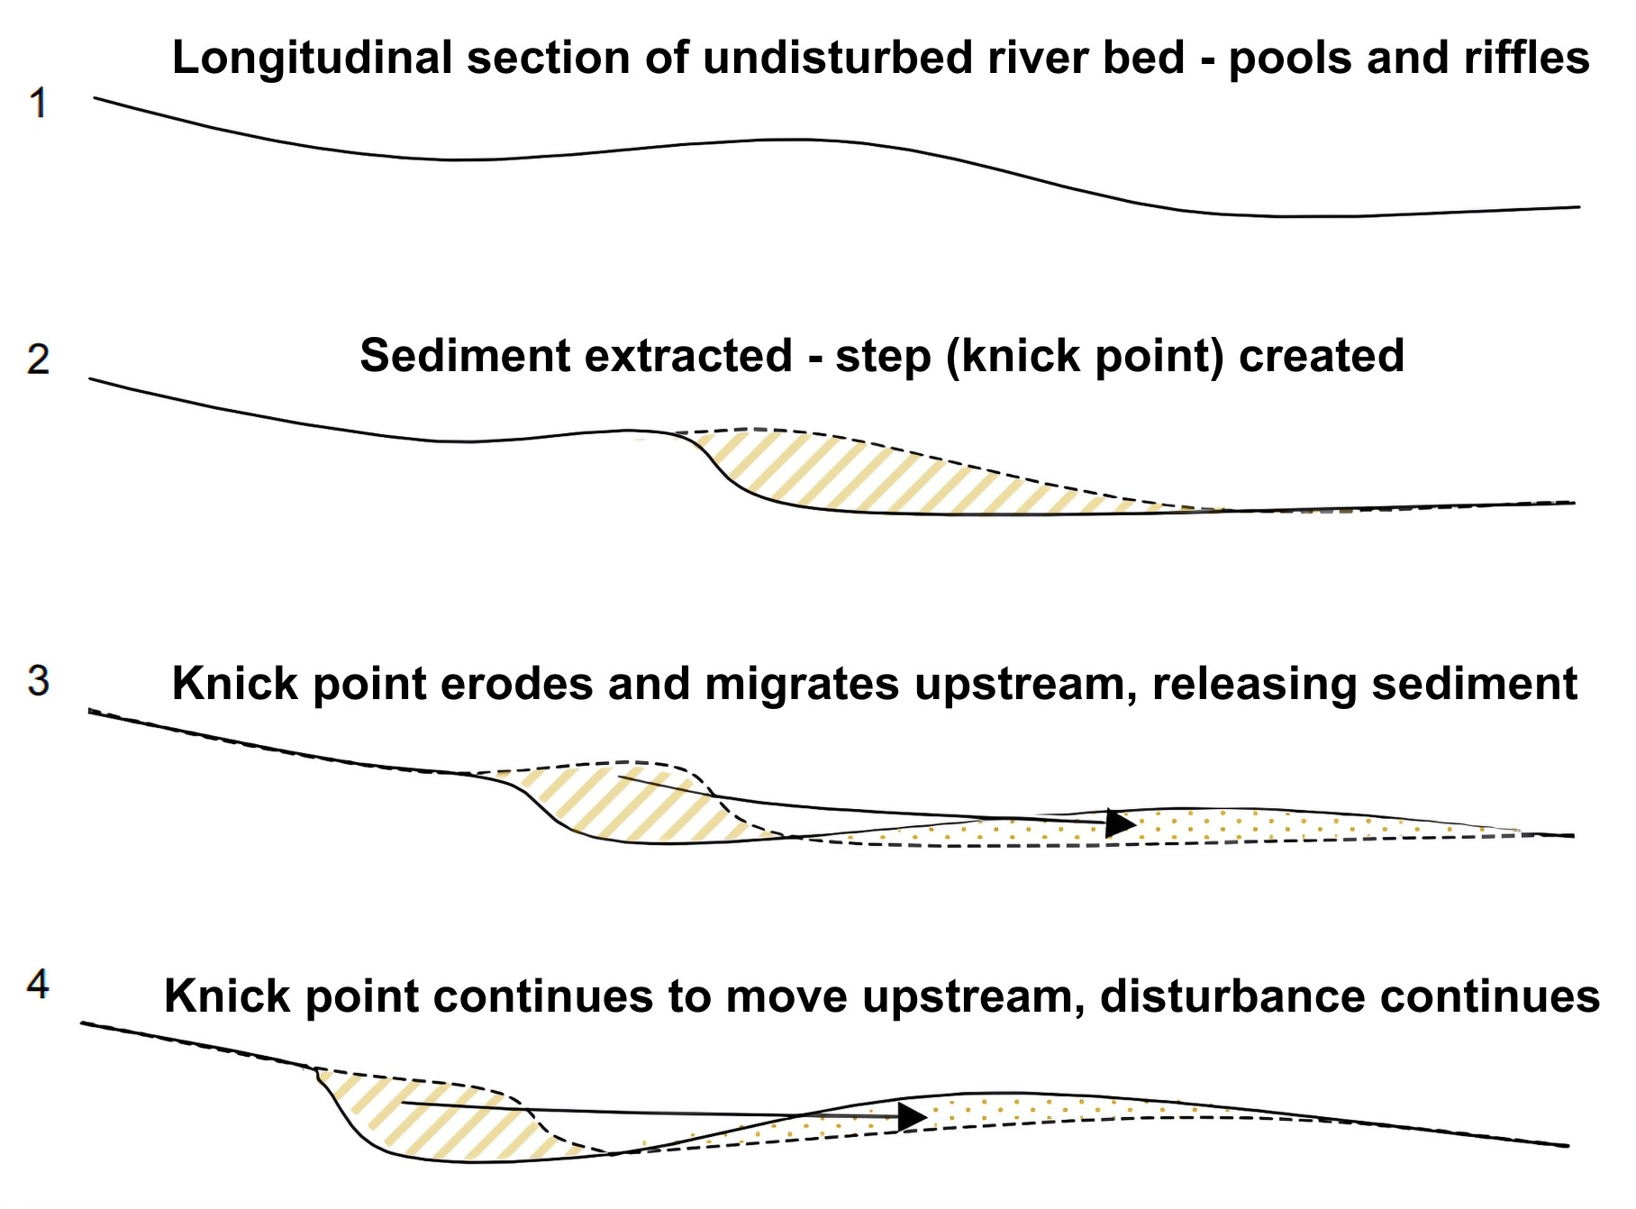
Figure 5: Creation of a knick point and erosion upstream can lead to a drop in the bed level and bank erosion, overloading the river downstream with sediment.

3.5.1.2 Reduction in sediment supply downstream (sediment starvation)
Removing sediment at one location in a river or loch shore reduces the amount transported downstream or along shore, which can lead to sediment ‘starvation’ effects. These manifest themselves as erosion of the channel bed and banks or of the loch shore. In rivers it may appear that sediment supply is abundant in one location as sediment is supplied from upstream but if that sediment is continually removed it cannot be supplied downstream leading to increased sediment starvation effects. This can turn depositional areas into erosional ones or increase the rate of erosion where it already exists. In turn, this can damage or destroy habitats such as bars, riffles and pools and may cause scour and damage to structures such as bridges and flood walls. Even taking out small amounts of sediment at one location can have significant effects downstream for plants, animals or infrastructure.
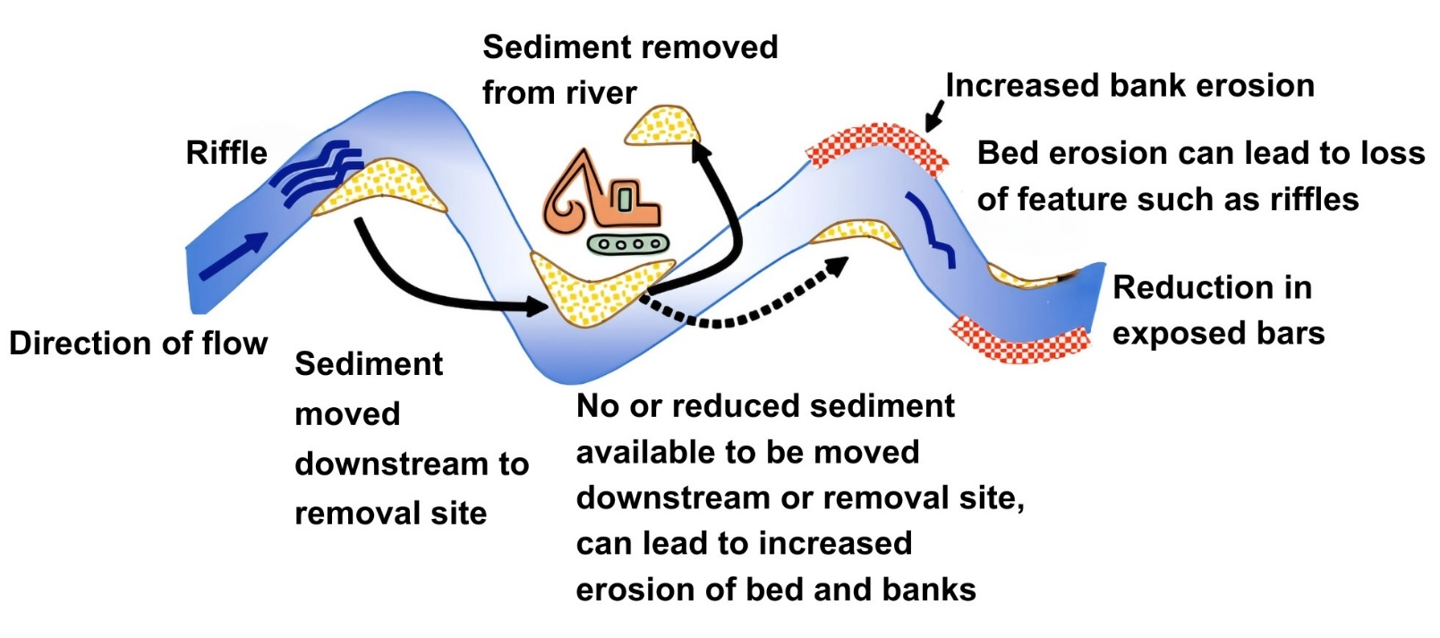
Figure 6: Repeated removal of sediment from one location can reduce the amount of sediment moved downstream leading to ‘sediment starvation’ and bed and bank erosion.
One of the most significant examples of sediment starvation occurs downstream of impoundments. As sediment-transporting flows enter an impounded body of water they lose the energy needed to keep transporting the sediment, with first the coarser, heavier sediments being deposited at the upstream end of the impoundment to form a delta, then the finer silts and clays being transported further into the impoundment to settle in a more uniform layer across the full width and length of the reservoir bottom.
In smaller run-of river impoundments the area upstream can fill with sediment during one storm event. If this is left in-situ, sediment subsequently entering the area simply rolls over the top of the impoundment and continues moving downstream, so the downstream sediment starvation effect may be limited. Because the trapped sediment can interfere with the water supply intakes or damage turbines it is frequently removed. If it is not reintroduced to the downstream channel and if this process is repeated storm after storm, a cumulative sediment starvation effect can develop downstream. In larger run-of-river or storage impoundments it can take several or very many storms for the reservoir to fill with sediment (many decades or centuries in the case of larger storage reservoirs), so it can be a long time before any adverse impact occurs to the impoundment’s intended purpose. In these cases, even if the sediment is left undisturbed in the reservoir it is effectively being removed from the river system and the downstream sediment starvation effect can become extreme and extensive (see Figure 7).
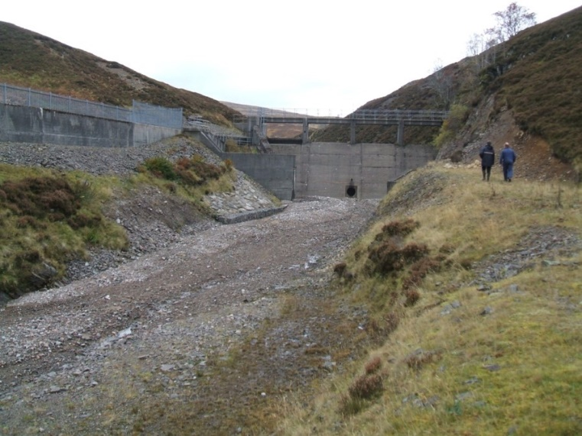 | 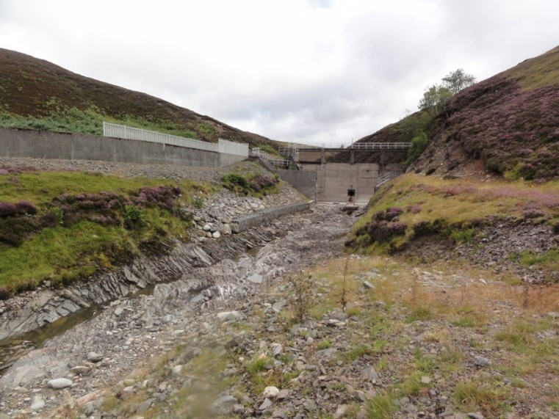
Figure 7 Sediment reintroduced in the channel downstream from a dam (left) washed out following a high flow spill over the dam to exposing the underlying bedrock (right).

3.5.1.3 Flooding
Dredging rivers (making them deeper, wider and smoother) can allow water to move downstream more quickly than it might otherwise do so during flood flows. This can raise downstream water levels higher than they might otherwise be and increase the risk of flooding.
3.5.1.4 Ecology
Removal of substrate can lead to loss or damage of habitat providing anchorage for aquatic plants and animals.
- Plant communities are vital components of river and loch ecosystems, providing a complex habitat, food, shade and shelter. They process nutrients, produce oxygen and play an important role in hydromorphological processes by trapping finer sediments. The root structures of some plants hold mobile sediments in place to build mid channel bars and islands and prevent bed and bank erosion. Removing sediments in which plants can root can cause a loss of biodiversity and lead to increased flow speeds and bed and bank erosion.
- Invertebrate populations are adversely affected by sediment removal, particularly where operations are extensive. Direct destruction and removal of invertebrates by machinery together with downstream siltation caused by disturbing fines in the bed both significantly impact invertebrate populations. This includes rare and protected species such as freshwater pearl mussels that rely on the presence of suitable river substrate.
- Fish species including salmon, sea / brown trout, and lamprey, can be adversely impacted by gravel management due to the loss of, or damage to, suitable feeding and spawning habitat, and by removal of sediments from below the waterline.
In any sediment management works, care should be taken to avoid creating a knick point (see section 3.5.1.1). Should a significant knick point result in, for example, a near vertical face, fish may be unable to pass upstream to reach spawning grounds. Similarly, if these works result in an over-widening and shallowing of a watercourse, this may create a barrier to the movements of fish upstream or, in particular, downstream (e.g. the movement of salmon smolts to sea).
Because fish can also spawn in loch margins, with younger fish in particular relying on inshore habitat gravel management can impact fish in loch environments.
- Breeding birds, particularly oystercatcher, redshank and common sandpiper and grey plover, which nest on gravel banks at the margins of rivers may be adversely affected by the removal of gravel bars and shoals.

3.5.2 Risks to the water environment
The main risks to the water environment from carrying out this activity can be grouped as follows:

Harm to fish
This including impacts on fish migration, spawning and fry development, loss of habitat and direct impacts such as stranding or physical damage.
Scheduling the timing of works to avoid fish spawning times and fish emergence times. Key fish species to consider include salmon and trout (normally October to May), lamprey species (normally March to July). However these times can vary and you should contact Fisheries Management Scotland if you are unsure what fish species are present or what times should be avoided.
Temporary works such as crossings, channel isolation or diversions, blasting, vibration or pile driving, sheet pilling or using artificial lighting at night can affect fish or migrating fish. You should carefully manage these works to minimise any impact and carry out fish rescues, where appropriate.
For more information see WAT-G-032 EASR Guidance: Fish Protection.

Physical impacts & pollution
Physical impacts to the bed and banks of the watercourse which can lead to instability resulting in increased erosion or deposition, loss of habitats and increased flood risk.
Carefully managing construction works is essential to prevent and minimise pollution from sedimentation, leaking oil from machinery and the entry of potentially polluting materials into water such as unset concrete.
Sites should be restored following works to management impacts from disturbance.
Further information on construction works and mitigation can be found in WAT-G-034 EASR Guidance: Construction works and silt/pollution mitigation.

Invasive Non-Native Species
Any Invasive Non-Native Species (INNS) present in or adjacent to site could have the potential to spread. You should identify and plan works with adequate biosecurity measures in place to prevent any spread of INNS. Further guidance can be found in EASR-G-001 EASR Guidance: Invasive non-native species (INNS).

Protected areas and species
You should identify any Protected areas (e.g. SSSI, SAC, SPA) in or adjacent to site and consider any impacts from the works on Protected species such as freshwater pearl mussels and otter. You should contact NatureScot where your activity is in a Protected area or may impact protected species. For further information see WAT-G-008 EASR Guidance: Assessment of impact on Protected areas from inland water activities.

Impacts to other users of the water environment
There could be potential impacts on other water users such as water supplies, fishing, water sports.
All the risks to the water environment, as detailed above, will vary according to:
- The type and design of the engineering activity.
- The timing of the works.
- The working methods and mitigation.
- The reinstatement methods.

3.6 Sediment management and climate change
Climate change predictions indicate there will be significant increases in winter precipitation over the coming decades, which suggests that large floods will occur more frequently.
These changes are making rivers more powerful, which means they will have a greater ability to erode their beds and banks, transport sediment, move from side to side on their floodplains and adjust their planform.
Changing flood frequency means that many channels will:
- Need to increase in size via bed and bank erosion to accommodate larger volumes of water before spilling on the floodplain and
- Have more energy and a greater ability to erode their beds and banks, transport sediment, and adjust their planform.
Climate change changes will impact all parts of the sediment erosion, transport and deposition system.
Because of the significant lack of tree cover in Scotland, many hillsides are vulnerable to increased rates of landsliding from the increasingly heavy winter and summer precipitation that is already occurring in many parts of the country. Where a watercourse flows at the base of a hillside, landsides can deliver large quantities of sediment in a short space of time to the river network (Figure 8).
Lack of tree cover, degraded peatland, compaction of agricultural land by livestock and machinery, and impermeable urban surfaces all greatly reduce the ability of soils and peat in the wider catchment to hold precipitation and release it more gradually to the river network. Combined with increasingly heavy winter and summer rainfall, these changes mean that more water enters the river network more quickly making bigger, more powerful floods happen more often. This will increase rates of bank erosion and bed scour as rivers seek a new ‘equilibrium’ size and shape by becoming wider and deeper or by moving more rapidly from side to side across their floodplains, all of which will supply more sediment to the river network.
As well as having a greater ability to erode river beds and banks, bigger floods also have a greater capacity to transport sediment away from the points of entry to the river network and to problematic depositional areas. Increasing rates of deposition are thus likely to occur at structures such as impoundments, bridges, culverts.
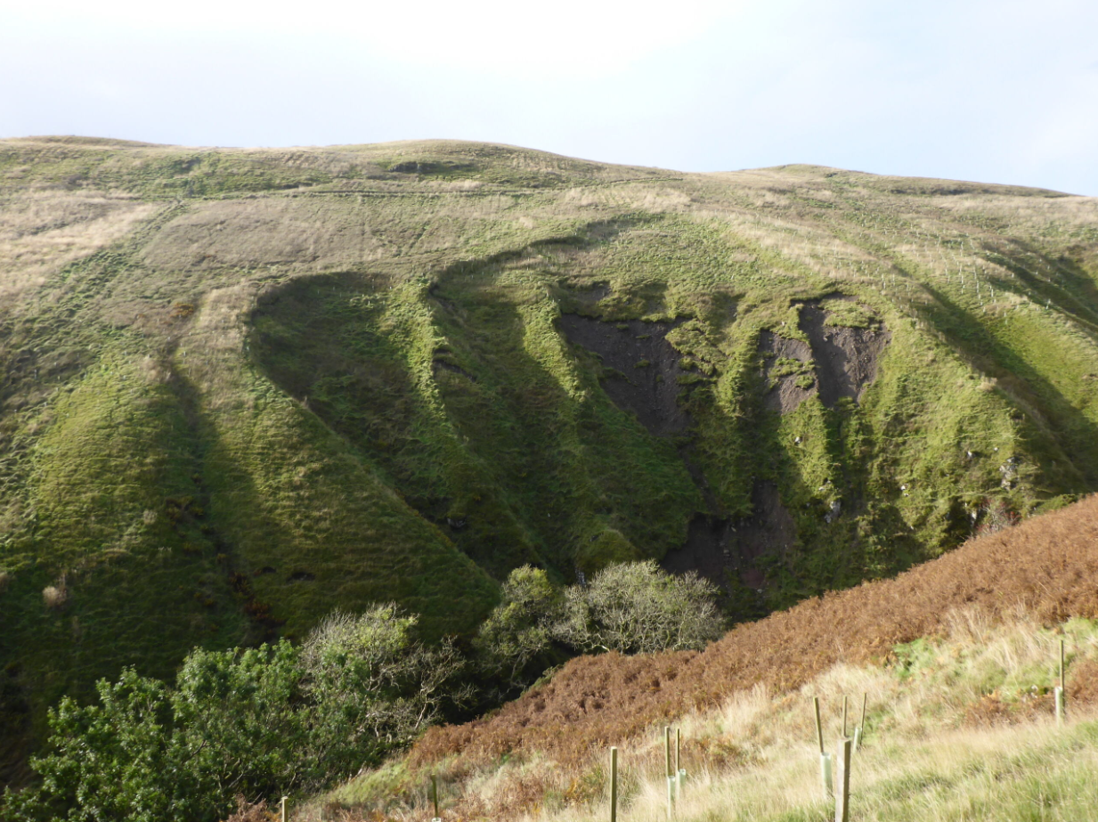
Figure 8: Several landslides roughly 80 metres high deliver large volumes of sediment to a watercourse at the bottom of the hillslope that is just upstream of an impoundment

4 Good Practice
All sediment management should follow the principles of good practice to ensure sustainable design and limit environmental harm to our rivers and lochs.
Good Practice is achieved when the chosen option serves a demonstrated need, while minimising ecological harm, at a cost that is proportionate. It ensures that any negative environmental impacts are proportionate to the environmental, social and economic benefits the activity may bring.
We will carry out a ‘Good Practice Test’ on all Engineering Permit applications to assess whether the activities proposed in any Permit application will meet Good Practice. All such applications must meet Good Practice to be granted. To meet Good Practice you should follow the steps outlined in the Good practice summary below and in the subsequent sections.
For further information please see WAT-G-030 EASR Guidance: Good Practice test for Engineering permits.
Good Practice Summary
To meet Good Practice you must:
- Demonstrate need
- State the reasons for carrying out the activity and the benefits it will bring.
- Identify and understand the problem or need.
- Identify and appraise options
Use sustainable river management principles to:
- Identify a number of options (minimum of three, including do nothing)
- Carry out an options appraisal.
- Justify the selected option
- State why it represents the best practical environmental option.
- Use all reasonable mitigation
- State the mitigation measures you propose to minimise impacts
- Submit method statement(s) detailing how the works will be carried out.

4.1 Demonstrate need
Before undertaking any form of sediment management there should be a clear and justifiable reason or need. You should also have a good understanding of the causes (including the underlying cause), and scale of the problem being addressed.
You must:
- Specify the reasons for carrying out the activity and the benefits it will bring.
- Identify and understand the problem or need.

4.1.1 Reasons for carrying out the activity
You must provide us with:
- Clear reasons why you wish to carry out sediment management.
- The underlying nature or cause of the problem (where relevant) or need being addressed.
The reasons for sediment management will usually be one of the following:

Acquiring material for commercial use
Consideration should be given to using aggregate that is not sourced directly from the aquatic environment, although this may be justified where:
- A sediment budget has been developed for the source watercourse or loch and the volume of sediment present found to be abundant relative to the amount required for the intended use.
- Local habitats are insensitive to such removal.

Flood risk management
Sediment removal (in particular dredging) is often viewed as the solution to flooding on the basis that the channel is made bigger so it can contain more water. The space created by removing sediment from a river is often small compared to the volume of water generated during all but the smallest flood events. Even if sediment removal reduces flood risk locally, it is likely to simply pass the problem downstream. It is also usually not the most effective or sustainable approach to managing flood risk in the medium to long term and may only alleviate the problem in the short term.
Sediment management may be justified where it can be quantitatively demonstrated (e.g. using a hydraulic or sediment transport model or another agreed method) that sediment accumulation is increasing flood risk and that removing the sediment will make a significant difference, and where there are no other significantly better environmental options. However, as it is likely that sediment will continue to accumulate in problem areas, consideration should be given to longer-term and more sustainable approaches to flood management, including approaches presented as part of a catchment-scale natural flood management strategy.

Impoundments
Removal of sediment at an impoundment is often required to ensure its efficient operation, e.g. for water supply, hydropower, or irrigation, or to prevent damage to machinery such as turbines.

Infrastructure protection
To ensure the function or integrity of a structure (e.g. bridge, culvert, outfall, intake) where sediment accumulation is causing a problem. However, consideration should also be given to redesigning the structure if this could be a viable and cost-effective alternative to addressing the problematic sediment deposition. For example, replacing a multi-span bridge with a single span structure.

Maintenance of previously engineered watercourses or navigation
For example, ensuring adequate channel depth for navigation or maintenance of functional field drainage.

Habitat enhancement
In some cases, in-stream habitat can be enhanced by the removal of fine sediment or the addition of coarse sediment. Without a good understanding of the underlying reasons why there is too much fine sediment or insufficient coarse sediment, however, this approach to habitat restoration can be ineffective and unsustainable. For instance, if excess fine sediment is removed from the bed of a channel it will simply reaccumulate if the source of the fine sediment has not been identified and addressed. Similarly, any coarse material added will simply scour away again if the reason why it was scoured in the first place has not been addressed.

4.1.2 Identifying and understanding the problem or need
To identify the best solution to a problem or need it is crucial to:
- Understand the problem or need.
- To identify and understand (where relevant) its cause.
- To understand its value in terms of ecology and river function.
- To understand its impact on human activities, resources or health.
Sediment Management can often be highly intrusive and in many cases carries a high risk of destabilising the bed and banks of a waterbody and therefore should only be carried out with due consideration and purpose. The reasons for any proposed work should be clear and must be provided to support applications for authorisation.
To identify whether sediment management is an appropriate solution you must assess what is causing the problem or need and whether sediment management will address it.
- Is this a new or long-term problem?
- Have recent environmental factors (high flow events) caused or exacerbated the problem?
- Have recent or historical engineering modifications caused or exacerbated the problem?
- Are upstream land management practices causing or exacerbating the problem?
- Is there evidence that the problem will persist without human intervention?
- Are there any existing data (including photographs) to aid with description and quantification of the problem?
- Has a similar problem occurred here or nearby before and, if so, how was this addressed?
- Is the problem associated with the watercourse’s response to climate change?
With answers to these questions it will be possible to identify i) the cause of the problem ii) the most appropriate solution, iii) the site constraints, and iv) develop a range of sustainable sediment management options appropriate for the environment you are working in.

4.1.2.1 Understanding types of sediment reach in rivers
Prior to conducting any sediment management work and to carry out works most effectively and sustainably, it is vitally important to think about how and why sediment is being transported through river ‘reaches’ rather than just at one point on the watercourse. Reaches can vary in length from a few tens or hundreds of meters to several kilometres. It is also important to understand where different types of reach are located relative to each other along a watercourse. There are three broad types of river sediment reaches, each with differing characteristic features and differing sensitivities to sediment management.

Erosional (source) reach
Description
There is a net decrease in sediment within the reach over several years. The bed, banks or adjacent hillslopes will be eroding, perhaps severely.
Key features
- High, unstable and extensive eroding banks or hillslopes, where even well-established vegetation may be undermined and washed away.
- One or both banks are eroding at least slightly and some are eroding very rapidly (greater than 1 metre per year along tens of metres of bank).
- The channel is likely to be increasing in width or depth or both over time.
- Although net erosional, there can often be (sometimes large) deposits of sediment in the channel.

Sensitivity to sediment management
Moderate to very high. This type of reach usually has an excess of energy or too little supply of sediment from upstream, either due to past engineering works or its location in catchment headwaters. Removing more sediment could exacerbate the problem, potentially significantly.

Balanced reach
Description
There is no significant net increase or decrease of sediment within the reach over a period of several years.
Key features
- Balanced does not always mean static. Balanced rivers can still display patterns of erosion and deposition, with the location of erosional and depositional features changing through time.
- Sediment deposits may be covered with perennial vegetation or mosses.
- Rivers that display this natural balance vary in appearance; some may appear to have little or no sediment storage, while others may have extensive bar deposits.
- There should be no major change to the width or depth of the river.
Sensitivity to sediment management
Medium to high. Removing sediment can cause this type of river to become unstable, potentially significantly so, even where there appears to be extensive deposits of sediment.

Depositional (aggrading) reach
Description
There is a net increase in sediment within the reach over several years, which leads to extensive deposition.

Key features
- Large areas of unvegetated sediments whose height and area are likely to have been increasing over time.
- Recent extensive changes to the course of the river (planform) that are likely to be obvious when compared to the historic course of the river on Ordnance Survey maps.
- Localised bank erosion caused by growing sediment bars deflecting water onto the banks.
- Possible increase in bed level over time.
Sensitivity to sediment management
Relatively insensitive so long as care is taken regarding the volume and location of removal, e.g. not introducing a knick point (Section 3.5.1.1, Figure 5) when removing sediment at the upstream end of a depositional reach.
To understand the sediment source, transport and deposition system, where these different sections of rivers are located and assess the magnitude of sediment deposition can be difficult but a range of techniques exist (See section 4.1.2.3).
The techniques chosen should be proportionate to the scale of the problem and determined by what information is required. Some of the techniques will allow sediment erosion/deposition to be quantified, while others will help identify the cause of the erosion/deposition.
It is important to remember that estimated sediment supply character can be subject to change under climate-altered futures.

4.1.2.2 Understanding sediment in Lochs
Although lochs are generally less dynamic than rivers, and the volumes and rates of sediment movement are much lower, the dynamics of sediment movement around loch shores are nevertheless just as important for generating and maintaining habitats as in rivers.
Sediment is supplied to lochs from in-flowing watercourses and from erosion of the loch bed and banks. The movement of sediment along and around the loch shore is principally controlled by wind-generated waves, while the movement of sediment between shallower and deeper sections of the loch is controlled by both waves and variations in loch water level. This movement of sediment creates features such as beaches, spits and cliffs. As in rivers, the loch’s natural shape and distribution of habitats is in balance with the rate at which sediment is transported into, around and out of the loch.

4.1.2.3 Techniques
- Desk-based assessment involves an assessment of some or all of the following sources: historical and contemporary maps, aerial photography, existing LiDAR (Laser imaging, detection and ranging) data, hydrological data and reports. It can provide qualitative and quantitative information that is essential in helping to identifying underlying causes and is an essential pre-requisite to undertaking most of the techniques listed below.
- Repeat fixed point photography provides a visual record from a fixed point within a river reach of changes that occur over time. It may not identify the cause of increased sediment deposition, but it provides qualitative information of use in understanding and interpreting a river or loch’s behaviour.
- Channel cross section surveys are undertaken in a straight line across and perpendicular to the channel, from one bank top to the other, and will show quantitative changes in bed elevation and bank position over time if repeated in the same location. They do not identify the underlying causes of a problem but allow accurate quantification of the magnitude of changes to be made.
- Topographic surveys involve measuring many points across the channel or loch bed, banks and floodplain from which a three-dimensional digital elevation model (DEM) of the river or loch can be built. The measurements can be taken using a range of different tools, such as a total station, green LiDAR and conventional LiDAR. Total stations allow accurate data to be collected above and below the water surface, but many points need to be collected to accurately measure channel shape, so the spatial coverage may be quite limited. Green LiDAR allows the shape of the channel or loch bed to be measured below the water surface. A high density of points can be collected over potentially quite a large area, but the accuracy can be highly degraded if the water is too deep or turbid. Conventional LiDAR can quickly collect a very high density of points over large areas of the channel or loch above water. Repeat surveys allow multiple DEMs to be compared to give accurate, quantitative assessments of how much erosion and deposition has occurred through time. If undertaken at a river reach scale, this approach can be especially useful in identifying whether a reach is erosional, balanced or depositional and thus whether a sediment problem is real or perceived. It may not identify the cause of increased sediment deposition, but it provides accurate quantitative information of use in understanding and interpreting a river or loch’s behaviour.
- River or loch reconnaissance is a walk-over visual survey by an experience geomorphologist, who then provides a written interpretation of the river or loch processes at work and the extent to which these have been affected by human activity. It provides qualitative information that is very important for identifying underlying causes and whether sediment management will be appropriate or effective. A desk-based assessment is an essential pre-requisite.
- Fluvial audit is a more detailed field-based assessment that must be undertaken by an experience geomorphologist. It involves mapping human modifications to the river channel, corridor and valley and measuring the extent of erosional and depositional features. This allows estimates to be made of the areas and volumes of sediment contained in different river reaches and hence to identify whether a reach is erosional, balanced or depositional and thus whether a sediment problem is real or perceived. As with river reconnaissance, it provides information important for identifying underlying causes and an understanding of what processes dominate the proposed extraction site and what sensitive features need protection. A desk-based assessment is an essential pre-requisite.
- Fluvial dynamics assessment is a detailed assessment of a specific site or reach with the aim to understand the interactions between the shape of the channel and the water and sediment flowing through it. It might involve measurements, over a year or more, of: changes to channel width, depth, slope and shape, flow and sediment transport. These will allow the amount of sediment into, through and out of the reach to be quantified.
- Catchment sediment budgets provide a quantification of how much sediment is moving through different river reaches and whether these reaches are erosional, balanced or depositional. It can theoretically also be used to determine how much sediment could be extracted before significant channel instability was triggered, though with less accuracy than a numerical model. The budgets can be generated using data generated from cross-sectional surveys, topographical surveys, fluvial audits and numerical modelling.
- Sediment transport modelling is a complex technique used to quantify how much sediment is moving into, through and depositing within a reach and thus whether a reach is erosional, balanced or depositional. It requires cross-sectional or topographical data to define channel and floodplain shape, hydrological data to define the size of flood flows and the selection of appropriate sediment transport equations. It can assess how changes to the channel’s shape will affect flow hydraulics and patterns of erosion and deposition and hence how much sediment could safely be removed before triggering channel instability that could threaten infrastructure, property or valuable land. It can also assess the extent to which sediment management will reduce flood levels and their spatial extents. Its application requires specialist contractors.

4.1.2.4 Establishing the problem or need and its causes

Increased erosion from weakened banks
A common cause of increased bank erosion and therefore of increased sediment supply to a watercourse or loch, is banks being weakened by a lack of bank top tree cover and by poaching by livestock.
Sustainable solutions
Tree root networks significantly increase river and loch bank strength, so it is good practice to plant bare banks with a mix of native species such as alder, willow and birch. Prior to mature root network to become established, sustainable bank protection can be installed. Watercourses and lochs can be fenced off from livestock and alternative watering points, e.g. troughs or limited river or loch access, provided.

Poor river engineering triggering increased erosion
Removal of sediment in one part of the river can trigger significantly increased rates of erosion by creating a ‘knick point’ in the river bed or by disturbing the ‘armour’ layer (section 3.5.1.1). This increases the sediment supply to the river leading to increased amounts of sediment deposition downstream. If channels are significantly modified, for instance by straightening them, they can become unstable. This also causes increased erosion in one location and increased deposition downstream, with large amounts of erosion and deposition possible in a short space of time if the channel is made very unstable. Increased rates of erosion can also occur over a longer period. For example, if a river has been straightened it can recover its meandering form via gradual outer bank erosion and inner bank gravel bar deposition. These gradual rates of adjustment should be allowed to continue where there is space in the river’s corridor to do so, because they allow the river to evolve to a naturally balanced (dynamic equilibrium) state with a lower risk of adverse consequences downstream. In locations where such space isn’t available, however, a different approach may be necessary. You can view and download a GIS layer showing how wide the river corridor needs to be for all watercourses in Scotland from SEPA’s environmental data hub. Scroll down to the section entitled ‘Water general information’, then down to the ‘Recommended Riparian Corridor’ layer.
Inappropriate channel straightening → steeper river slope → increased erosion → increased sediment supply downstream
Sustainable solutions
River instability can be difficult to address and a suitably qualified geomorphologist should be consulted. If historical channel modifications have led to problems, the following should be considered:
- What is causing the instability? If it is historical river engineering work, can the river be restored to a more natural and balanced state? Doing so would treat the cause, as opposed to the symptom, of the problem and provide a more sustainable solution.
- What is the river’s capacity for natural recovery, i.e. could it recover its natural form without any intervention (self-recover)? More powerful rivers with a good supply of coarse sediment have a greater capacity to self-recover than those with lower power or a poor supply of coarse sediment. SEPA’s River Recovery Potential GIS layer shows the capacity for self-recovery of all water courses with a catchment area great than 10 kilometres squared. You can view and download this layer from SEPA’s environmental data hub. Scroll down to the section entitled ‘Water general information’, then down to the ‘River Recovery Potential’ layer.
- If intervention is required, what type would be most effective? For straightened rivers with a lower capacity to self-recover, for example because of lower stream power or bank protection that prevents recovery of a more meandering shape, assisted self-recovery, e.g. removal of the bank protection, or active intervention, e.g. building a more meandering channel connected to its floodplain, may be required.

Poor river engineering triggering increased deposition
River engineering works that decrease a river’s power, e.g. straightening or re-sectioning that creates an over-wide channel, will decrease its ability to transport the same amount of sediment leading to increased deposition.
Sustainable solutions
If historical channel modifications have created a sediment deposition problem it is worth considering if the river can be restored to a more natural and balanced state. What is the river’s capacity for natural recovery, i.e. could it recover its natural form without any intervention (self-recover)? If there is a good supply of the right size of sediment from upstream, there is a good chance that an over-widened river can recover a more natural channel width. Whether it can be left to do so depends on the extent to which surrounding land uses will be impacted and if these impacts can be accepted.

Sediment deposition at structures
Sediment can build up under, in, or around structures such as bridges, culverts, impoundments and intakes. This can occur even with a natural rate of sediment supply from upstream, as it is the poor design of the structure that can cause sediment to deposit.
Sustainable solutions
Consideration should be given to removal, modification or replacement of the structure. This will avoid the need for repeated sediment removal in the long term.

Increased deposition after rare events
Very large floods can transport significantly more sediment than more frequent smaller floods, leading to sudden and large accumulations of sediment. Other events such as landslides can also rapidly deliver large volumes of sediment to the river system, leading to sudden and large accumulations in depositional reaches. These events are natural occurrences, although they are becoming more frequent because of climate change (section 3.6), and, where there is the space to do so, the river should be allowed to adjust to the change.

4.2 Identify and appraise options
​It is a basic principle of good practice that when addressing any watercourse engineering problem, or need, that several options are identified and evaluated (considering the advantages and disadvantages) to determine the best solution. Each option should be fully evaluated in an options appraisal to determine the best practical environmental option for the situation. You should generally consider a minimum of three options, including ‘do nothing’.
​There are three broad types of options to considering sediment management:
- ​Do nothing.
- ​Sediment management.
- ​Other options.
Understanding the problem or issue is essential to ensuring a sustainable option which is proportionate to the issue/reason for works.
As the nature of a problem is varied and site specific, we cannot detail all possibilities here. As sediment management can have a significant impact on the water environment, once channel modification is determined to be the preferred option, the key is to ensure its impact is mitigated.

4.2.1 Do nothing
​Sometimes the problem may be more perceived than real, and issues may resolve themselves through natural processes over time without causing any significant issues. A good understanding of the problem, its root cause and scale will help ascertain whether doing nothing is a viable option and that self-recovery will occur within an acceptable timeframe. For example, excessive sediment removal upstream can reduce the sediment load in a watercourse so that more energy is available for erosion. Likewise, dredging can create a knick point in the bed that migrates upstream and can trigger bed and bank scour (Section 3.5.1.1, Figure 5). If there are no significant impacts from such adjustments, stopping the river management activities may reduce the amount of erosion and potentially allow the river to return to an equilibrium condition. SEPA encourages natural recovery approaches to river restoration wherever possible.

4.2.2 Sediment management
Where ‘do nothing’ or sediment supply reduction are insufficient to address a real problem, sediment management options can be considered, though they should be the minimum necessary to achieve the required outcome.
Where any sediment removal is proposed there should always be consideration as to whether it is possible and appropriate to reintroduce the sediment elsewhere in the catchment downstream in order to ensure sediment balance is maintained (see section 4.2.2.8).

4.2.2.1 Sediment removal for reducing flood risk
Although the dredging of watercourses has been carried out in the past to reduce flood risk, in many situations the removal of sediment from watercourses has limited or no benefit in managing flood risk. Without careful identification of the flooding source and appropriate risk assessment depending on the scale of the proposal, dredging is unlikely to be supported without consideration of alternative options.
In many situations dredging is not effective because:
- There may be other, more dominant controls on water levels e.g. structures such as bridges and weirs, channel slope, tidal effects or downstream river confluences.
- Flood flows often transport large amounts of sediment that can quickly refill any extra capacity gained. Therefore only temporary reduction flood risk will be obtained and repeat dredging is often required (increasing long term costs).
- Larger flood flows usually have far more water than a dredged channel can contain, so dredging is unlikely to provide any significant reduction to the level of flood risk associated with moderate to large events.
- In some situations dredging may increase flood risk downstream because dredged channels can pass water downstream faster, thus increasing water levels.
Sediment removal may be justified in some situations, including:
- When the reduction in flood risk associated with sediment removal can be quantified and shown to be significant.
- When there are no alternative, more sustainable, options.
- Around structures such as bridges and weirs where natural sediment transport has been disrupted leading to sediment deposition, when natural rates of sediment transport cannot be reinstated and when the structure cannot be modified or redesigned.
- In stretches of small, low gradient watercourses that have been modified in the past, e.g. over-widened, and the modification has disrupted natural rates of sediment transport leading to sediment deposition and when restoration of the watercourse is not possible.
If channels have been historically over-widened they might not be able to transport the sediment currently being supplied, leading to a raising of the bed level or a narrowing of the channel width. These changes may represent the channel recovering to a more natural state, so careful consideration should be given to whether sediment management is appropriate.

4.2.2.2 Sediment removal at crossings
It may be necessary to remove sediment built up in or around structures such as culverts and bridges, that could cause blockages and result in flooding.
- Minimise the area affected and only remove the sediment required to ensure operation of the structure.
- If possible, remove sediment only from the dry deposits.
- Do not remove excess sediment in anticipation of future floods.
- The removal must not result in a vertical step being formed between the downstream river bed and the culvert or bridge invert.
- Where possible and appropriate, place removed sediment downstream (reintroduction).

4.2.2.3 Sediment management at impoundments
Impoundments can trap sediment and stop it moving downstream, causing environmental damage through potentially significant erosion of the channel bed and banks. The accumulation of sediment behind impoundments can affect the efficiency of any abstraction by blocking intakes and screens and cause significant damage to turbines. It can also block fish passes, affecting fish migration.
- Reduce sediment supply from upstream (see Section 4.2.3.1).
- Route sediments downstream to prevent deposition in the impoundment.
Minimising or completely preventing sediments, particularly coarse sediments, from being deposited in the impoundment in the first place. Sediment bypass routing and sediment pass-though routing aim to move sediments respectively around or through the impoundment during each high flow event. Bypass routing involves constructing a channel around the reservoir through which flood flows are guided. Pass-through routing requires drawing the impoundment’s water level down and opening a high-capacity sluice gate during the rising limb of a flood hydrograph to ensure that sediment-transporting water keeps moving quickly though the impoundment and preventing sediment deposition from occurring. As the flood level begins to fall and sediment transport drops off, the sluice gate can be closed to allow the impoundment to refill. Routing techniques have the advantage of passing sediments into the downstream water course at the rate they would have entered it without the impoundment, so the risk of environmental damage being caused is greatly reduced unless artificially high levels of sediment, especially fine sediment, are being generated in the upstream catchment by human activities.
- Remove deposited sediments.
  - Mechanical removal of problematic sediment accumulations from the waterbody at impoundments, either in the dry or by dredging, is the approach that has typically been used. The volume of sediment deposited annually will vary depending on the number and size of storms, so the frequency of sediment management intervention should be adaptable. In dry years no sediment management may be required, while in very wet years several removals may be required. If the level of fine sediment supply from upstream is unnaturally high, consideration should be given to removing this material and depositing it to land to prevent damage to salmonids and fresh water pearl mussels, before removing the coarser sediment for reintroduction to the channel downstream. Fine sediment is important for species such as lamprey, however, so advice from suitably qualified professionals should be sought. Finer sediment tends to deposit mostly towards the downstream end of the impoundment, with the coarser sediment depositing more towards the upstream end.
- Hydraulic excavation uses the power of running water to scour deposited coarse and fine sediment out of the impoundment and into the downstream watercourse. It will generally only be effective at scouring the coarse delta sediments in relatively steep valley settings and in short impoundments that are roughly the same width as the impounded channel. If the valley is too shallow or the impoundment is too long or too wide relative to the inundated channel width, the delta would still be scoured but much of the coarse sediment would be redeposited across the width of the reservoir bottom, with not much entering the downstream water course and not much lost capacity being recovered. Hydraulic excavation requires sluice gates capable of passing very large flows so that the flow through the impoundment generates enough speed to scour and transport the coarse delta sediment. It also potentially delivers several year’s-worth of sediment transport into the downstream watercourse all at once, so care would be required to ensure that this would not increase flood risk or bury sensitive aquatic habitats. If the impoundment traps large volumes of fine sediments, their release all at once could damage fish and their habitats.

4.2.2.4 Sediment removal dry gravel
- Only remove sediment from dry, unvegetated deposits such as gravel bars and islands. Do not remove sediment from the wet, low-flow channel.
- Only ‘skim’ the top of the dry deposits. Do not dig deep enough to reach water and form holes or pits. This can cause sediment pollution, trap fish and increase the risk of erosion and river instability.
- Do not remove sediment more frequently than once every three years within a distance equal to the average river width multiplied by 25. For example, if the average river width is five metres the operation cannot be repeated within a distance of (5 x 25) = 125 metres).
- Maintain a distance of at least two metres between the wet edge of the low-flow channel and the area of removal.
- Removed sediment should not be used to form bank-top embankments. This could act to cut off a river from its floodplain.
- Where possible and appropriate, place removed sediment downstream to help reduce the risks associated with river bed and bank erosion (see section 4.2.2.8).

4.2.2.5 Sediment removal - wet gravel
Pools in rivers are not static features. Over time they fill in, move position and naturally scour. Typically, however, the number of pools and riffles within a given length of river will remain approximately the same, even if their locations change.
Most change in rivers is likely to be seen after high flows. While a flood may have filled in a pool, there may be a new pool being created in a different place. Even if there isn’t, the filled pool may be scoured by the next flood. The need for sediment removal should thus be carefully considered as it may lead to channel destabilisation and increased erosion by creating a knick point (section 3.5.1.1). This in turn may increase sediment supply downstream and lead to other pools being filled in.
- Consider Is the pool filling up? If so, at what rate? Is the overall number of pools in the section of river reducing? If it is remaining constant over a sufficient length of river then removal of sediment to maintain a pool in a static position should be reconsidered.
- Do not create pools where none have existed previously.
- Do not change pools in size (width, length, depth) or frequency (see Figure 9).
- Removed sediment should not be used to form bank-top embankments.
- Where possible and appropriate, place removed sediment downstream to help reduce the risks associated with river bed and bank erosion (see section on reintroduction).
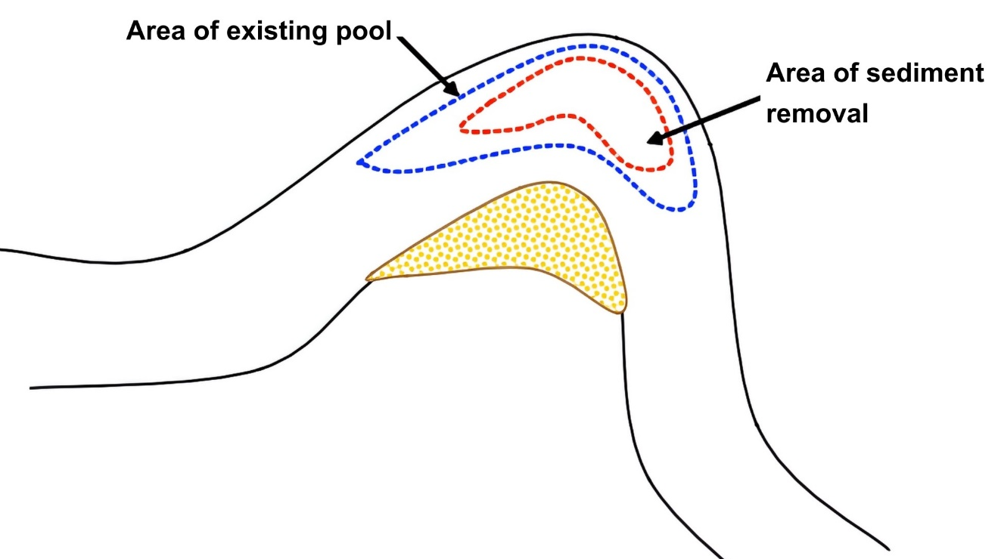

Figure 9: Good practice. Do not increase the area of the original pool

4.2.2.6 Sediment removal - dredging modified channels and ditches
Many small burns have been historically modified and managed to provide land for development and agriculture and to improve land drainage. In many cases this historical modification, usually straightening, deepening and widening burns, makes regular management necessary because the burn can no longer function naturally. For example, deepening and widening channels creates a lower energy environment with slower flows, which means that the burn can no longer move the sediment load supplied from upstream so sediment starts to deposit and the bed level rises. To maintain the burn in its modified form, regular maintenance, such as dredging, may be required.
- Do not straighten, deepen or widen unmodified natural watercourses.
- Consider creating a two-stage channel. Creating a two-stage channel will narrow the low flow channel and may increase the speed of the flow during high flows, which may allow the river to transport more sediment downstream, reducing the amount of sediment deposition and therefore stopping or reducing the need for dredging.
- Removed sediment should not be used to form bank-top embankments. It should be spread evenly over fields away from areas of wildlife interest.

4.2.2.7 Sediment removal from lochs
The process of sediment supply, transport and deposition in lochs generally takes longer than in rivers. This means that any sediment removed from lochs will usually not be replaced as quickly. In general, sediment should only be removed from lochs if there is a risk to infrastructure (e.g. outfalls, intakes, bridges) or to other sustainable development activities (e.g. navigation, flood risk, water supply). If there is no significant risk to these activities then the requirement for sediment management should be reconsidered.
Key habitats should be identified and avoided, including:
- Fish spawning areas.
- Wave washed shores and beaches.
- Areas around loch inlet and outlets.
- Shallow areas near the shore (littoral areas) and bays.
- Aandy and silty deposits.
- Aquatic plants (macrophyte beds).
Removed sediment should not be used to form bank-top embankments. It should be spread evenly over fields away from areas of wildlife interest or transported elsewhere for appropriate disposal.

4.2.2.8 Sediment reintroduction
Where any sediment removal is proposed there should always be consideration as to whether it is possible and appropriate to reintroduce the sediment elsewhere in the catchment downstream in order to ensure sediment balance is maintained. This is likely to only be appropriate for large sediments (gravels etc) rather than fine sediments.
Placing removed sediment downstream (reintroduction) can help minimise some of the impacts of sediment removal, such as sediment starvation, erosion and habitat degradation.
Any sediment reintroduction must be carefully planned. If too much sediment is reintroduced, or reintroduced in the wrong place, it can have a negative effect on the water environment.
How much to put downstream:
- Carefully consider the volume to be reintroduced. It may not be appropriate to place all removed sediment downstream as this would be more than the river would naturally be able to transport and may lead to over-supply of sediment to the downstream reach, thereby causing problems such as smothered habitats and increased flood risk.
- The volume placed downstream should be comparable to what would naturally be transported by the river in a high flow event. If a large amount of sediment is being removed to reduce flood risk it may not be appropriate to put it all downstream, as only some of this sediment would have been transported naturally in a high flow event.
- The river’s ability to transport sediment should also be considered. If there is a large water abstraction at the point of sediment removal (e.g. at a hydropower impoundment) the river may not have enough energy to transport all the sediment, so only some may be able to be placed downstream. If abstracted water is returned to the river at a point downstream of the sediment removal activity (e.g. hydropower schemes) then the location of the returned water should be considered as an appropriate place to reintroduce sediment as the river may regain its energy to transport sediment downstream.
How often:
- In general, the more frequently sediment is reintroduced downstream the more likely it is to correspond to natural rates of sediment transport, and hence levels that natural processes have adapted to.
- Ideally sediment should be removed from a depositional area as it accumulates, comparable to the natural rate of movement.
Where to put it:
- Coarse sediment should be reintroduced as close as possible to and downstream of the removal site. This minimises the length of river that may be affected by sediment starvation.
- It should be placed in the river channel where high flows can easily entrain it, but not in sensitive habitats such as mosses. Existing coarse sediment features such as unvegetated bars, islands and riffles are ideal sites as these are areas of natural deposition.
- When placed on bars, the sediment should be piled no higher than the natural bank height. If the bars are attached to the bank, the sediment should be sloped back to the bank so that the high point of the deposited material is by the bank and not in the middle of the channel.
- In higher energy rivers, which are typical of many hydropower impoundment locations, there may be no in-channel bars or islands. In such cases, and assuming the channel bed can be safely reached, coarse sediment can be spread roughly and evenly across the full channel bed, with no steps.
- If the channel bed cannot be safely accessed, e.g. because of steeply sloping valley sides, coarse sediment can be deposited on the bank face, taking care not to create an embankment on the bank top.
- Do not compact the sediment, as this makes it harder to erode.
- If finer sediment has been removed separately from upstream of the impoundment and there are species dependent on this further downstream, some of it could be spread on the bank tops to be entrained and diluted by flood flows.
- It should be placed where it does not increase flood risk.
- If large volumes of water are abstracted and then returned to the water environment (e.g. for hydropower) then the location of the returned water should be considered as a location for sediment reintroduction as the river may have more energy to transport larger volumes of reintroduced sediment.
- Consider placing sediment downstream of where tributaries join a river, as this may also help in situations where water abstraction might affect the amount of sediment a river can transport.

4.2.2.9 Sediment addition
Where any sediment addition is proposed this should only be considered where it is impractical to reintroduce of natural sediment from within a reach or catchment.
Sediment supplies from external sources such as quarries should be appraised and sediment matching the natural sizes(s) and material/composition to those considered to be naturally present in that reach should be used.
Any material should be washed to ensure that clean sediment is used.
The same principles for volume and placement of sediment should be used as per sediment reintroduction section above.

4.2.2.10 Sediment manipulation
Sediment may be moved around within an area of watercourse or loch by adjusting levels or localised reprofiling of bed for example.

4.2.2.11 Sediment manipulation - Gravel cleaning
Gravel cleaning for the improvement of fish spawning is the breaking up of compacted gravels and displacing fine sediment in locations where spawning is considered likely. The compaction of gravels by excess fine sediment can lead to loss of spawning habitat by a reduction or loss of oxygen flow through the gravel substrate. This can impact not only fish egg survival but can also have adverse effects on invertebrate communities.
Gravel cleaning is usually undertaken using hand tools such as fencing spikes, pinch bars, rakes and small-scale one-person equipment such as pressurised water pumps or modified leaf blowers. Following breaking up of the compacted gravel the flow of the watercourse, with assistance from blowing/ jetting equipment, helps shift the displaced fine sediment away from the gravels usually to a maximum depth of about 300 millimetres.
Where gravel cleaning is carried out within discrete small areas, with hand tools, and with appropriate silt mitigation measures in place the activity is generally considered low risk to the wider water environment.
Whilst considered to be generally effective, the benefits of gravel cleaning are usually of a short to medium term duration (1 to 3 years). Ideally, other more sustainable initiatives which address the fundamental issues in the longer term should be undertaken, instead of, or along with, gravel cleaning.
These can include:
- Reducing sediment inputs in the catchment (reducing silt laden runoff, fencing off, creating buffer strips, improving riparian vegetation, reducing erosion of river banks etc).
- Improving instream habitat and channel morphology through the use of instream wood.
Gravel cleaning can have potential detrimental effects on the water environment where:
- It is carried out too intensively, over too large an area and over long periods of time- this can result in the movement of significant quantities of sediment which could smother downstream habitats and /or species.
- It is carried out at the wrong times of year when it may directly destroy/interfere with spawning or affect juvenile fish development.
- It is carried out without appropriate silt mitigation measures in place to prevent significant sediment pollution downstream.
- It is carried out when flows in the watercourse are very low and cannot successfully disperse the displaced sediment.
- It is carried out in protected areas and/or has potential negative effects on protected species.
- Invasive pink salmon may be present within a catchment. In this situation, care should be taken that actions may not inadvertently assist the spread of the species.

4.2.2.12 Gold panning
SEPA will not normally require an authorisation where individuals pan for gold provided good practice is followed (see below). Panning that does not follow good practice will require an application for a Permit for other sediment management. In addition, where water is removed from the river (abstracted), diverted or dammed (impounded) then the appropriate authorisation will be required.
Good practice requires that:
- Panning is limited to hand panning using only sieves, gold pans, shovels and buckets, portable sluice, a hand operated pump and not using powered machinery/equipment e.g. electric pumps and powered dredges.
- Panning is not undertaken during periods in which fish are likely to be spawning in the watercourse nor in the period between any such spawning and the subsequent emergence of the juvenile fish. Panning would therefore not be carried out between 1 November and 31 May where fish (including Atlantic salmon and trout) are present. For specific dates of when and what fish are present, please consult your local Fisheries Trust or District Salmon Fisheries Board.
- Where hollows are created in the river bed, that the bed material is replaced into the holes on the same day that it was removed.
- The activity does not involve digging into the river banks.
- Panning is not carried out in water where there is a reasonable likelihood that, within 50 metres of such an operation, there are freshwater pearl mussels.

4.2.3 Other options
Where there is an accumulation of sediment causing an issue, the root cause of the deposition should be identified to establish if this can or should be addressed as an alternative, or in addition, to sediment management.
If the assessment of the cause of the problem has identified that there are artificially elevated rates of sediment supply an option is to consider is if measures to reduce this supply are appropriate. For example, reducing sediment supply may mean that sediment removal is not required in the medium to longer term, therefore having less of an environmental impact and being more sustainable. Reducing supply may also reduce or eliminate the need for on-going maintenance, thus being potentially more cost-beneficial.
Measures to reduce sediment supply can grouped into those that:
- Reduce erosion rates.
- Reduce a river’s power.

4.2.3.1 Reducing erosion rates
As explained in Section 3.1, sediment is supplied to watercourses by eroding hillslopes next to watercourses, by rivers eroding their banks to move sideways across their valley bottoms.
- Tree cover/planting
Erosion is greatly exacerbated where there is a lack of tree cover. According to Scottish Government figures, around 18 percent of Scotland was covered by forests and woodland in 2019. And of the roughly 27,000 kilometres of watercourse in Scotland with a catchment area greater than 10 kilometres squared, about 56 percent has no tree cover. Targeted planting of trees in river corridors and on hillslopes in medium to long term provide significant reductions in sediment supply to watercourses. Until such time as tree root networks can develop to maturity, however, hillslopes and river banks may still be vulnerable to erosion.
- Bank Protection
To reduce bank erosion rates in the short to medium-term and to give protect the developing root networks, it can sometimes be useful to use rough bank protection techniques, as described in WAT-G-029 Engineering: Sustainable Bank works. These techniques have the added benefit of improving bank side habitat for a range of animals.
- Fencing
Banks can be weakened by poaching by livestock. Limiting access to banks of watercourses to prevent livestock access.

4.2.3.2 Reducing a river’s power
Reducing a river’s power will reduce its ability to erode its bed and banks and its ability to transport the elevated sediment load supplied to it.
A wide range of Natural Flood Management (NFM) techniques exist to slow this movement, such as:
- Woodland canopy storage.
- Improved infiltration and water retention within catchment soils, for example by tree planting, peatland restoration, or otherwise improving soil structure and organic matter content in agricultural areas via improved land husbandry techniques.
- Temporary floodplain and non-floodplain wetlands and ponds. For example, runoff attenuation features are bunds built in surface runoff pathways to intercept flow, perhaps taking advantage of localised depressions in the ground surface to maximise storage.
- Large, in-channel wood jams to divert higher flows onto the floodplain. More information on how to use these structures in an environmentally sensitive way can be found in WAT-G-024 EASR Guidance: Engineering: Activity Guide: Instream and in-loch structures.
- Planting trees on the banks to roughen the river corridor, thus slowing and reducing the power of flood flows.
As well as stabilising river banks and hillslopes, tree roots can improve soil structure and water infiltration, thus storing more precipitation in the soil and slowing the rate at which it travels to the watercourse. Their effect can be maximised by targeting tree planting on soils with a low capacity to store water, for example because of compaction, and across or along runoff pathways through a catchment, along which rainfall and snowmelt would otherwise travel very quickly. For example, contour planting belts of trees across hillsides can intercept overland flow and allow it to infiltrate to a greater depth in the soil profile than it could otherwise reach. More information can be found in the UK Forestry Standard.
Up to 90 percent of the mass of healthy peat can be water, so healthy peatland can hold very large volumes of water that are only slowly released to the stream network. Scotland has nearly 20,000 square kilometres of peatland, but about 75 percent of this is damaged. Restoration of degraded peatland, for example by removing plantations or blocking drainage ditches, offers a beneficial way to reduce the size and power of floods in catchments with a substantial area of peatland.
As well as helping to address the root cause of a sediment management problem, these interventions can have many other benefits such as for flood risk management, enhancing biodiversity and helping Scotland to reach its net zero target.
More details on all these techniques can be found in SEPA’s Natural Flood Management Handbook and on the UK Government’s website Working with natural processes to reduce flood risk.

4.2.3.3 Structure redesign
Often poor design of structures can result in the need for sediment removal at these locations i.e. where bridges and culverts are undersized and become blocked preventing free flow of water and sediment. The long-term costs of sediment removal should be compared to the cost of removing or redesigning the structure.
In these cases, you should also review the relevant activities guides for those engineering activities, e.g., WAT-G-024 EASR Guidance: Engineering: Activity Guide: Crossings.

4.3 Justify the selected option
After evaluating all the alternatives the best practical and environmental option, with proportionate costs, should be chosen and justification provided. This does not always mean adopting a lowest impact engineering approach or adopting the cheapest solution. The best practical environmental option means choosing the approach that effectively addresses the problem or need and minimises negative environmental impact as far as practical. Proportionate costs are those that correspond to the level environmental harm being minimised or the environmental benefits that the option provides.
Proportionate costs are those that correspond to the level of environmental harm being minimised or the environmental benefits that the option could provide. Large absolute cost in itself does not constitute disproportionate cost.
For example, incurring significant costs to prevent significant environmental harm or achieve significant environmental benefits, e.g. safeguarding protected species and designated sites, is likely to be considered proportionate. But incurring significant costs for minor environmental benefits would likely to be considered disproportionate.

4.4 Use all reasonable mitigation
In order to minimise impacts on the water environment and other water users you must plan to use all reasonable mitigation when carrying out any sediment management works.
Mitigation measures for a proposal should:
- Limit, or offset, potential impacts, including those from construction.
- Be proportionate to the environmental risk.
- Be prioritised by the balance of factors such as environmental benefit, cost, and ease of implementation.
- Must not be used to compensate the impacts of an unjustified activity.
- On demonstrating need and options selection.
As every case is different there is no single answer to what mitigation is considered reasonable.
You should understand the risks and issues as set out in Section 3.5 What are the potential issues with sediment management.
You should prepare a method statement including details on how you intend to carry out the works including the mitigation measures you intend to take and how you will maintain them. This must be submitted with any permit application.
Using suitable mitigation will help you to comply with authorisation conditions. In certain cases, specific conditions relating to mitigation requirements will be contained within an authorisation.

4.5 Monitoring and evaluation
Where sediment management works have been undertaken it may be important to conduct monitoring. It will allow you to assess the success of the project, identify any impacts from works and assess whether remedial works are required and, where relevant, develop longer term management or maintenance strategies. Ideally, initial monitoring should be conducted immediately following construction works to provide a ‘post-implementation’ baseline data set.
Subsequent monitoring should then occur at appropriate intervals (e.g., annually or following a high flow). It is not within the scope of this document to detail the potential monitoring techniques, but they could include (for example) fixed point photography, timelapse imagery, habitat mapping, fluvial audit, topographic surveys, sediment sampling, or unmanned aerial vehicle (UAV) surveys. (see techniques listed in Section 4.1.2.3). Your approach may vary depending on the monitoring aims, available resources, and site conditions. We strongly recommend you take the advice of an experienced fluvial geomorphologist on appropriate monitoring for your site.

Disclaimer
Whilst every effort has been made to ensure the accuracy of this guidance, SEPA gives no warranty, covenant or undertaking (express or implied) regarding the fitness for purpose of, or any error, omission or discrepancy in this guidance. Reliance on its contents and the contents of any websites that are linked to or from this guidance is entirely at the user’s own risk. SEPA is not liable for any loss or damage that may come from using this guidance.
This includes:
- any direct, indirect and consequential losses
- any loss or damage caused by civil wrongs, breach of contract or otherwise
SEPA reserves the right to depart from this guidance and take appropriate action as it considers necessary or appropriate. Operators are responsible for ensuring that they are compliant with the law. If necessary, independent legal / specialist advice should be sought.

