


IND-G-004

EASR guidance:
Version 1.0 August 2025
Registration activity
Dry cleaning

Contents
Introduction 3
What does this guidance apply to? 3
Dry cleaning process 4
Inspection and sorting 4
Pre-treatment 4
Weighing 4
Loading machine 5
Cleaning and drying cycles 5
Dirty solvent distillation 5
Water separation 5
Filtering used solvent 6
Residues 6
Post-treatment 6
Diagram 1: Overview of a dry-cleaning machine 7
Environmental controls 7
Site design and infrastructure 8
Solvent storage, containment and bunding 9
Filling drying cleaning machines with solvent 10
Residue Removal 10
Waste solvent storage 10
Emission limits and records to be kept 11
Management techniques 12
Management 12
Maintenance 12
Operator training 13
Resource use and efficiency 13
Raw materials 14
Water 14
Waste 14
Heat 14
Energy 14
Interpretation of terms 15
Disclaimer 15
APPENDIX 1 Typical checks for dry cleaning machines – minimum requirements 17
APPENDIX 2 Weekly data sheet 18
APPENDIX 3 Calculating your annual solvent emission 21

If you would like this document in an accessible format, such as large print, audio recording or braille, please contact SEPA by emailing equalities@sepa.org.uk

Introduction
This document provides information and guidance for anyone undertaking dry cleaning which may be authorised under the Environmental Authorisation (Scotland) Regulations (EASR). It should be read alongside the standard conditions for this activity.

What does this guidance apply to?
This guidance applies to:
- Dry cleaning which is any industrial or commercial activity using volatile organic compounds (VOCs), in particular perchloroethylene (PER), hydrocarbon solvent (HCS) and siloxane, to clean garments, furnishing and similar consumer goods.
It also applies to:
- The temporary storage of materials used or generated as part of the activity including waste material storage.
- The pre-treatment of goods to be cleaned.
This guidance does not apply to the manual removal of stains and spots in the textile and clothing industry, which does not require an authorisation.

Dry cleaning process
Dry cleaning takes place in a contained machine, similar to a conventional washer/drier, which cleans the garments with solvent and then dries them with hot air whilst recovering solvent in a distillation unit. Diagram 1 on page 4 gives an overview of the dry cleaning process.

Inspection and sorting
The first step involves inspecting and sorting garments, furnishing and similar consumer goods to produce the optimum loads of material types and weights to minimise solvent consumption. Dry cleaning machines have different cleaning programmes and choosing the right one is important for solvent consumption; cleaning results; and drying times. For example, separating dark & light colours; or matching material types such as woollen blankets, suits, dresses.
Some dry cleaners offer a quick turn-around service for cleaning garments, furnishing and similar consumer goods. These are often achieved by cleaning part-loads which can lead to higher solvent consumption per kg cleaned and potentially leading to non-compliance with the emission limit.

Pre-treatment
Stain pre-treatment may take place prior to dry cleaning. This is a manual process of spotting stains with pre-treatment solvents which vary depending on the type of stain.

Weighing
The load is then weighed to confirm the optimum load weight for the selected programme to minimise solvent consumption and to record the weight of material cleaned as this data is required for the emission limit calculation.

Loading machine
The dry-cleaning machine is loaded with garments, furnishing and similar consumer goods and the appropriate cleaning programme is selected. This cleaning programme will also include the load drying cycle which is important for solvent recovery.

Cleaning and drying cycles
During the wash cycle, the cleaning chamber is filled with solvent and rotated to agitate the garments, furnishing and similar consumer goods. This dirty solvent is drained to the distillation unit. The machine then moves to a rinsing cycle where the garments, furnishing and similar consumer goods are rinsed with fresh (clean) solvent. Lastly the extraction cycle starts where solvent is removed from the garments, furnishing and similar consumer goods initially by draining liquid solvent extracted by spinning the chamber; then by drying the garments, furnishing and similar consumer goods using heated air to evaporate the remaining solvent from the clothes and other items, and finally by using cool air which goes through a vapour recovery filter.

Dirty solvent distillation
Dirty solvent (dirt arises from cleaning garments, furnishing and similar consumer goods) is drained from the wash drum and passes through a button trap to remove small objects such as fasteners, buttons and coins from entering the solvent pump. The dirty solvent then goes to a distillation unit where the solvent is condensed to remove impurities and returned to the clean solvent tank for re-use.

Water separation
During the drying cycle of the machine, any moisture within garments, furnishing and similar consumer goods is cleaned, and moisture inside the dry cleaning machine evaporates. This water is condensed out within the water separator and is likely to contain small quantities of the dry cleaning solvent. Secondary treatment of this water is normally required where the heavier solvent sinks below the lighter water which can be skimmed off for disposal whilst the solvent is recycled. This water is usually discharged to the local sewer with permission from Scottish Water.

Filtering used solvent
Clean solvent is used to rinse garments and other items and this solvent is passed through a filter before being returned to the clean solvent tank. Two types of filter are used, a powder or an ecological filter which spins to remove the dirt and associated solvent from the filter surface.

Residues
After a number of distillations, the build-up of residues in the distillation unit are removed by either pumping or raking the dried residues into a sealed container. The material removed from the filters is also sent to the still for solvent recovery. On powder systems, the residues are raked out once cooled as they are ‘dry’.
In ecological systems, distillation can be stopped before residues become ‘dry’ so they can be pumped out by an integral pump to a sealed holding container, or they can be distilled for longer and raked out manually. These residues, which contain a small amount of solvent, are removed by a licensed contractor.

Post-treatment
Post-spotting of stains with air, water, steam and/or vacuum.

Diagram 1: Overview of a dry-cleaning machine
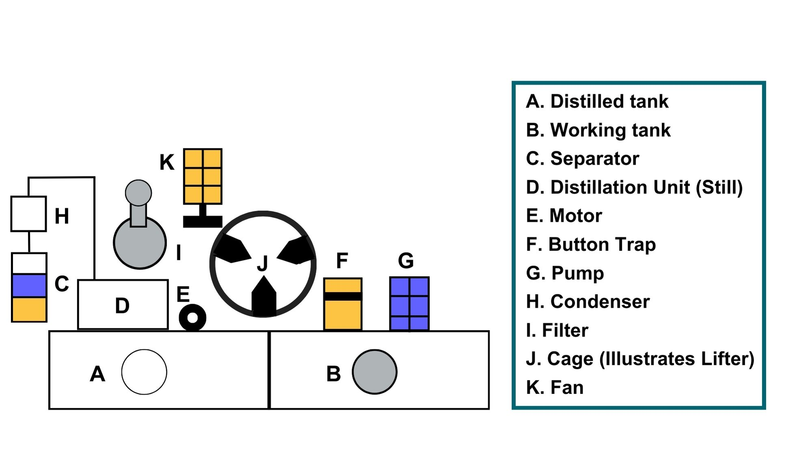

Environmental controls
It is expected that the methods described in this section are utilised to control emissions from dry cleaning activities. Where other methods are used, they should offer at least an equivalent level of environmental protection.
Good practice ensures that emissions of VOCs from dry cleaning solvents don’t escape into the atmosphere and the solvent emission limit is not breached.
VOCs are problematic because they contribute to the formation of photochemical oxidants such as ozone which in high concentrations can impair human health and damage vegetation and materials. Ozone is also a greenhouse gas and contributes to atmospheric warming and climate change. Some VOCs are classified as toxic, carcinogenic or teratogenic. These emissions represent a contribution to air pollution in urban areas and may also cause odour problems.

Site design and infrastructure
- Dry cleaning using solvents must take place within a dry cleaning machine which is designed and built for that purpose. This requirement does not apply to manual spot-cleaning of fabrics.
- Dry cleaning machine loading doors must be kept closed when not in use.
- After loading, the following must be closed before start up and kept closed at all times through the drying and cleaning cycle:
  - Doors.
  - Still.
  - Button trap.
  - Lint filter.
- All dry cleaning machines must have interlocks to prevent start-up of the machine until the loading door is closed and to prevent opening of the loading door until the machine cycle has finished and the cage has stopped rotating.
- All dry cleaning machines must have interlocks to automatically shut down the machine under any of the following conditions:
    - Cooling water shortage.
    - Failure of the cooling ability of the still condenser.
    - Failure of the cooling ability of the refrigeration system.
    - Failure in the machine heating system resulting in the inability to dry the load.
    - The still, button trap and lint filter doors are not properly closed.
- Dry cleaning machines must have a spillage tray with a volume greater than 110% of the volume of the largest tank within the machine, or 25% of the volume of all the tanks together. Dry cleaning machines should be positioned away from drains which may become contaminated as a result of spillage.
- Stills must have a thermostatic control device or equivalent to control the maximum operational temperature, in accordance with the manufacturer’s recommendations for the solvent used.
- To reduce solvent vapour escaping from the dry cleaning machine during loading with materials to be cleaned, an extraction fan may be fitted.
- The fan will maintain a negative pressure within the machine during loading drawing air into the machine and stopping solvent vapour from escaping outwards.
- Where an extraction fan is fitted, the exhaust from this fan should be directed to a carbon adsorption filter prior to discharge to atmosphere.

Solvent storage, containment and bunding
- All solvents should be stored in the containers that they were supplied in with the lids / caps securely closed when not in use so that solvent vapour does not escape; and away from sources of heat and/or bright light to minimise the risk of fire.
- Solvent containers must be stored in a bund/secondary containment system such as a spill tray which is a flat and impermeable structure with a lip to contain spills. This containment system must;
  - For a single container, hold 110% of its capacity.
  - For two or more containers, hold the greater of;
    - 110% of the capacity of the largest container.
    - 25% of the capacity of all the containers together.
  - Catch all spills from the containers and related parts.
  - Be leak proof.
  - Be located and/or protected, to prevent damage as far as reasonably practicable.
  - Any spillages or rainwater must be removed as soon as reasonably practicable.
- Suitable absorbent materials should be held at the installation to clean up spillages of solvent and/or solvent contaminated waste materials.

Filling drying cleaning machines with solvent
- Lids should only be removed when the solvent container is next to the dry cleaning machine as open containers should not be moved far to avoid solvent spillages.
- The containers should be of a capacity which allows the entire contents to be emptied into the dry-cleaning machine at each filling.
- The lid of the empty container should be replaced immediately after filling to avoid release of solvent fumes.

Residue Removal
Solvent contaminated residues should be removed from the dry cleaning machine distillation unit (still) by powder filter rake-out; ecological filter rake-out; or plumbed pump-out systems.

Waste solvent storage
- Solvent contaminated wastes, for example still residues, should be stored;
  - In suitable sealed containers with the lid securely fastened at all times, other than when in use.
  - On a suitable impervious floor.
  - Away from any drains that may become contaminated with residues as a result of a spillage.
  - Away from sources of heat and/or bright lights.
- On permanent cessation of the dry cleaning activity, all machines should be drained of solvent and solvent contaminated residues, which must be disposed of appropriately.

Emission limits and records to be kept
- Emissions of solvent from the installation must not exceed 20 grams of solvent per kilogram of products cleaned and dried per year.
- Compliance with the emission limit is demonstrated by an annual solvent emission calculation which may be completed using the sheet in Appendix 3 or digitally via SEPA’s website.
- The following data must be recorded on a weekly basis for an accurate calculation:
  - The quantities of solvent contaminated residues extracted from the dry cleaning machine distillation units (stills) recorded in litres. Water separator waste should not be included in this figure.
  - The weight of each load of clothes/fabric cleaned in kilograms.
  - Volume of solvent added to the machine recorded in litres.
- The volume of solvent remaining in the machines at both the beginning and end of the 12 month period must be recorded in litres (l).
- This data can be recorded on the example weekly sheet provided in Appendix 2.

Management techniques
Good management practice, training and well-maintained infrastructure are key to prevent and limit the consequences of accidents which could have an impact on the environment. For example, bunding should be used around liquid storage to contain any spillages, but good management and maintenance would take this a step further by ensuring that the integrity of the bunding is checked regularly to prevent leaks, and deliveries and movements around the site are well controlled. This will enable you to comply with environmental regulations, avoid incidents, and avoid any costs incurred through loss of resources.

Management
The operator should produce and implement a schedule of checking and maintenance procedures for each dry cleaning machine, the minimum requirement of which will be that listed in Appendix 1 (typical checks found in dry cleaning machine manufacturers manuals).

Maintenance
Maintenance can be categorised as ‘preventative’ or ‘corrective’ (also known as ‘reactive’). Preventative maintenance includes regular planned checks, servicing and maintenance of equipment to prevent or reduce failures and breakdowns which can lead to pollution incidents, safety concerns and costly downtime. Corrective maintenance includes identifying and repairing a fault once it has occurred with the aim of restoring equipment or systems to their optimum operational condition(s).
- Each dry cleaning machine should be serviced by a suitably qualified person at the manufacturers recommended intervals.
- All aspects of the activity plant, buildings and equipment should be properly maintained and there should be a written maintenance programme with a record that the maintenance has been carried out.
- Equipment should be used properly, and preventative maintenance carried out and ensuring that operators know what to do in the event of an incident which may cause emissions from the activity.
- Spares and consumables should be held on site so that rapid repairs can be carried out and there is no temptation to continue operating with ineffective emission controls in place.

Operator training
- Staff at all levels need to have training and instructions as to their duties to control emissions from the activity. This should include awareness of the SEPA registration requirements and actions to take in the event of incidents that may result in emissions from the activity.
- A training record should be kept for each member of staff.

Resource use and efficiency
Best practice for resource use and efficiency is to review and implement any potential opportunities to reduce emissions and wastes. In addition to reducing the impact on the environment, you will also benefit because resource efficiency is also about:
- Reducing costs (raw material and waste disposal).
- Maximising output of product or service from a given level of materials and energy (competitive advantage).
- Finding an outlet for surplus materials therefore removing them from the waste chain.
- Helping Scotland achieve its goal of becoming a zero-waste society.
- Reducing pollution risks and avoiding reputational impacts.
Resources include water, raw materials, energy, fuel and wastes used and produced throughout a regulated process.

Raw materials
Raw material use should be managed by tracking stores and ensuring that all resources are stored appropriately to avoid contamination, spoilage or leaks. Automatic dosing equipment should be considered to ensure that optimum measured quantities are used throughout the process. LEAN methodologies that focus on reducing waste could be beneficial.

Water
Water should be stored in adequate containers and any pipework and taps maintained to avoid leaks and evaporation. Where possible use rainwater harvesting and recycled water.

Waste
Ensure waste is managed in line with the waste hierarchy (prevention > prepare for reuse > recycle > recover value > disposal). Segregate any waste and store appropriately to ensure that it can be managed as high up the hierarchy as possible.

Heat
Where heat is used or generated, ensure that optimum temperatures are maintained during the process; buildings, pipes and tanks should be insulated to minimise heat loss, and where possible any heat captured and used elsewhere.

Energy
Ensure energy is used efficiently across the site by monitoring energy use, ensuring any lighting, motors, compressors or other equipment is well maintained and working at optimum, rather than maximum, levels. Consider replacing with more energy efficient equipment during upgrades. Servicing to manufacturer’s recommendations and preventative maintenance, instead of only reactive maintenance after plant faults, are also important in ensuring equipment works optimally.

Interpretation of terms
Term | Definition
Dry cleaning | Any industrial or commercial activity using volatile organic compounds in an installation to clean garments, furnishing and similar consumer goods excluding the manual removal of stains and spots in the textile and clothing industry.
Solvent | Any volatile organic compound used for dry cleaning i.e. as a cleaning agent to dissolve contaminants.
Resource | materials, water, waste, residues and energy used within, or produced from, the authorised activities and in any ancillary processes on site.
Volatile organic compound | Any organic compound having a vapour pressure of 0.01kPa or more at 293.15K or having a corresponding volatility under the particular conditions of use.

Disclaimer
This guidance is based on the law as it stood when the guidance was published.
Whilst every effort has been made to ensure the accuracy of this guidance, SEPA gives no warranty, covenant or undertaking (express or implied) regarding the fitness for purpose of, or any error, omission or discrepancy in this guidance. Reliance on its contents and the contents of any websites that are linked to or from this guidance is entirely at the user’s own risk. SEPA is not liable for any loss or damage that may come from using this guidance. This includes:
- Any direct, indirect and consequential losses.
- Any loss or damage caused by civil wrongs, breach of contract or otherwise.
SEPA reserves the right to depart from this guidance and take appropriate action as it considers necessary or appropriate. Operators are responsible for ensuring that they are compliant with the law. If necessary, independent legal / specialist advice should be sought.

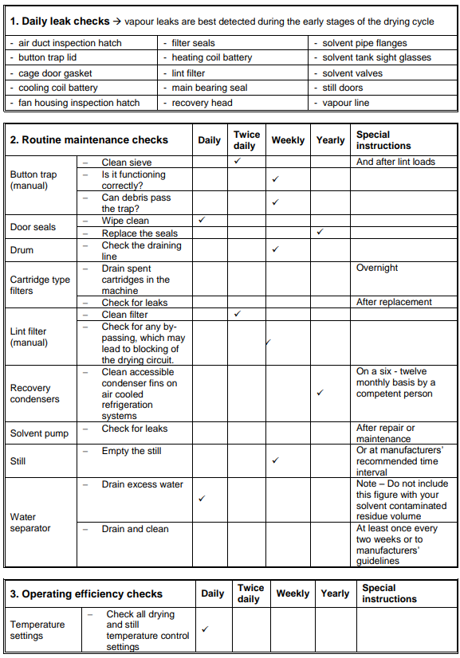
APPENDIX 1 Typical checks for dry cleaning machines – minimum requirements

APPENDIX 2 Weekly data sheet

Machine ref no _________________________________
Week number __________ Week covered ______________ to ______________
Notes:
- You should use a separate weekly sheet for each dry cleaning machine in use at your site.
- Any solvent spillage must not be included in the volume of solvent used.
- The weekly totals should be added up at the year end to produce the annual totals for your whole site and used in your annual solvent emission calculation.

- At the start of Week 1, record the volume of solvent already in the machine. And at the end of Week 52, you need to record the volume of solvent left in the machine.

At Start of Week1 | Solvent already in the machine in litres
At End of Week 52 | Solvent left in the machine in litres

- Record the total weight of clothes and/or fabric cleaned in kilograms (kg)
Date | Weight of clothes or fabric cleaned each day (kg)
 | Load 1 | Load 2 | Load 3 | Load 4 | Load 5 | Load 6 | Daily total
Mon
Tues
Wed
Thurs
Fri
Sat
Sun
Weekly total

- Record any solvent added to the machine in litres and any solvent contaminated residues pumped or raked out of the machine in litres (water separator waste MUST NOT be included in this volume).

 | Date | Solvent added to the machine (litres) | Solvent contaminated residues pumped or raked out of the machine (litres)
Mon
Tues
Wed
Thurs
Fri
Sat
Sun
Weekly total

APPENDIX 3 Calculating your annual solvent emission
IAF registration reference number _________________________________________

Site name ____________________________________________________________

12-month period covered (month & year) _________________ to ________________

Notes:
  - You must keep weekly records to provide the data required in this calculation.
  - The calculation is for the whole dry cleaning site rather than individual machines. A lower performing machine may be balanced out by a better performing one.
  - Any solvent spillage must not be included in the volume of solvent used (Step 3)
Step 1 – Solvent disposed of as waste (solvent contaminated residues)

This is known as ‘A’ and is the volume of solvent contaminated residues pumped or raked out of the still in litres BUT NOT any water separator waste which must not be included in this figure.

Solvent becomes dirty as fabrics are cleaned. This dirty solvent is pumped to the still where it is heated to turn it into a vapour. The vapour leaves the dirt behind and is cooled back into a solvent/water mixture. This mixture then moves to the separator where clean solvent is sent back to the solvent tank and the separated water is drained off, usually to sewer.

However, if you collect the water separator waste instead and put it into the same waste container as the solvent contaminated residues, you must subtract this volume from the amount of solvent contaminated residues disposed of.
A =
Step 2 – Removal factor
The volume of solvent contaminated residues is multiplied by the appropriate removal factor to account for the efficiency of the removal method.

Removal method | Factor
Powder filter rake-out | 0.15
Ecological filter rake-out | 0.35
Plumbed in pump-out | 0.5

B = A x factor
B =

Step 3 – Total solvent used in litres

Volume of solvent in the machine at the start of the year | C =
Total volume of solvent added to the machine during the year | D =
Volume of solvent in the machine at the end of the year | E =
 | F = C + D - E
Total solvent used throughout the year | F =

Step 4 – Overall solvent used in litres
Total volume of solvent used throughout the year as calculated in Step 3 minus the solvent contaminated residues as calculated in Step 2. | G = F – B
Overall solvent used in litres | G =

Step 5 – Convert volume to weight
To convert overall solvent used from litres to grams, multiply G by the following factor depending on the solvent you use.

Solvent type | Factor
Perchloroethylene | 1600
Siloxane | 970
HCS | 970

H = G x factor
H =

Step 6 – Total weight of material cleaned

Total of all the clothes and/or fabric cleaned over the year in kilograms (kg) | I =
Step 7 – Annual solvent emission
Your annual solvent emission (g/kg) is calculated by dividing the weight of solvent used in grams (g) as calculated in Step 5, by the total weight of material cleaned in kilograms (kg) as calculated in Step 6. | J = H ÷ I
Annual solvent emission (g/kg) | J =

Step 8 – Have you met the permitted emission limit?
Permit limit = 20g of solvent per kg of clothes/fabric cleaned  If J exceeds 20 then you are NOT in compliance. | Yes / No

If you are not compliant, please explain why:

