


WAT-G-019

EASR Guidance:
Version 1.0, August 2025
Registration Activity:
Removal of sediment from individual exposed sediment deposits within no more than 1 kilometre of channel

If you would like this document in an accessible format, such as large print, audio recording or braille, please contact SEPA by emailing equalities@sepa.org.uk

Purpose
This document provides information and guidance for anyone undertaking sediment removal from individual sediment deposits in watercourses that requires an authorisation under The Environmental Authorisations (Scotland) Regulations.
This guidance does not cover any other permissions that may be required.

What activity does this guidance apply to?
This guidance applies to engineering activities granted as a registration under the Environmental Authorisations (Scotland) Regulation 2018 for:
Sediment removal from individual exposed sediment deposits within a continuous channel length of no more than 1 kilometre, in any watercourse.

Understanding the activity
This activity is limited to the removal of sediment. Removal of other materials, such as vegetation or debris, do not require authorisation. For further information please see our webpage on activities that don’t require an authorisation.
This registration includes the sediment removal activity and all associated construction works, such as access tracks, temporary works, crossings and structures.
Only exposed sediment (i.e. dry sediment from bars and instream islands, which are dry during normal flow conditions) can be removed under the terms of this registration within a total channel length of 1 kilometre.
Sediment must not be removed from:
- Within 1 metre of the wetted edge of any individual exposed sediment deposit;
- More than 50 percent of the area of an individual exposed sediment deposit;
- More than 30 metres long (measured along the bank toe) in each individual exposed sediment deposit;
- The same individual exposed sediment deposit more than once in three years
- More than one third of the total number of individual exposed sediment deposits.
For further information please see Figures 2 and 3 in Annex 1 for drawing showing these limits.
These limits ensure that sufficient sediment remains within the reach to ensure there is no starvation of sediment within the catchment. It also ensures that the stability of the bed and banks of the river are not put at risk from erosion due to excessive sediment removal as well as protecting the loss of instream bar and island habitat.
The removed sediment cannot be reintroduced or added to any inland surface water without the appropriate authorisation. Whilst sediment reintroduction can be beneficial to reduce the risk of sediment starvation downstream, its placement requires careful consideration. The reintroduction or addition of removed sediment would require a permit application for sediment management.
If your proposed activity exceeds any of the activity thresholds and/or you cannot comply with any of the standard conditions, you should apply for a permit activity under ‘All other sediment management not otherwise described’.

Understanding and minimising risks to the water environment
This sediment removal activity and any associated construction works can cause harm to the water environment. It is important to carefully consider your design and construction options to ensure risks to the water environment and other users are minimised and that you fully comply with your standard conditions.
Due to the intrusive nature of undertaking sediment removal activities careful consideration and planning should be done prior to conducting such activities as the bed and banks can be significantly impacted and become subject to erosion and instability that could also impact adjacent infrastructure.
Good practice should be followed in undertaking this activity to ensure environmental harm is minimised, design is sustainable long terms and maintenance requirements are low. To achieve good practice, you should minimise the footprint of the activity and consider the natural character and processes of the area you are working.
Further information on sediment management can be found in WAT-G-026 EASR Guidance: Engineering: Activity Guide: Sediment management.

Risks to the Water Environment
The main risks to the water environment from carrying out this activity can be grouped as follows:
- Harm to fish
- Including impacts on fish migration, spawning and fry development, loss of habitat and direct impacts such as stranding or physical damage. For more information see WAT-G-032 EASR Guidance: Fish Protection.
- Physical Impacts & Pollution
- Physical impacts to the bed and banks of the watercourse which can lead to instability resulting in increased erosion or deposition, loss of habitats and increased flood risk.
- Pollution from sedimentation, leaking oil from machinery and the entry of potentially polluting materials into water such as unset concrete.
Further information on construction works and mitigation can be found in WAT-G-034 EASR Guidance: Construction works and silt/pollution mitigation.
- Habitats and Species Protection
- Spread of invasive non-native species. Further guidance can be found in EASR-G-001 EASR Guidance: Invasive non-native species (INNS).
- Impacts on species such as freshwater pearl mussels and otter. You should contact NatureScot where your activity is in a Protected area or may impact a protected species. For further information see WAT-G-008 EASR Guidance: Assessment of impact on Protected areas from inland water activities.
- Impacts to other users of the water environment
These risks to the water environment will vary according to:
- The size and composition of the sediment.
- The timing of the works.
- The working methods and mitigation.
- The reinstatement methods.
To minimise risks to the water environment and to help you comply with the standard conditions for this activity, you should follow the Do’s and Don’ts below.

Do’s and Don’ts
Activity Specific do’s and don’ts
- Don’t create any depressions in the worked section. Ensure the worked area is graded and the level of excavation remains above the wetted channel.
- Don’t place removed sediment on the banks such that bank height is increased, or in an area that it can easily be washed back into the water.
- Don’t place removed sediment into any waterbody.
- Don’t modify banks, bank toes and bank tops, ensure they are left undisturbed.
General working in or near water dos and don’ts
Preventing Harm to Fish
- Don’t undertake works if fish are likely to be spawning or young fish are still to emerge. In general, avoid the period between 1 October to 31 May. You should check the exact times with your local fishery board. Details are available from Fisheries Management Scotland.
- Don’t impact fish migration.
- Do make sure all works such as temporary crossings, channel isolation or diversions, blasting, vibration or pile driving, sheet pilling or using artificial lighting at night do not adversely affect fish or migrating fish.
- Do carry out fish rescues, where appropriate etc.
Preventing/ minimising physical and pollution Impacts
- Do install and maintain suitable mitigation before, after and during the works. Including the points below.
- Do minimise the extent, location and duration of works in the wetted part of the channel or loch.
- Do keep vehicles, plant and other equipment out of water wherever possible.
- Do create and maintain a robust and secure dry working area of minimum size, where possible.
- Do minimise disturbance and reinstate banks, bed and vegetation as soon as possible.
  - Minimise vegetation removal and area of bare earth/exposed soil.
  - Re-seed or turf disturbed soil with native vegetation and ideally cover with biodegradable matting to provide temporary protection until vegetation is fully established.
- Don’t cause significant erosion.
- Do store all fuel, machinery and vehicles at least 10 metres from any watercourse, loch or permeable drain.
- Do have oil spill kits, drip trays and bunds on site and available to operators.
- Do prevent any pollutants entering the water environment.
Habitats and Species Protection
- Don’t spread invasive non-native species
  - Check the banks and in water for invasive species.
  - Use biosecurity measures.
- Do check what other species and habitats may be affected (e.g. otter).
- Don’t harm freshwater pearl mussels.
Other Water Users
- Do consider the potential impacts on other water users e.g. water supplies, fishing, kayaking etc.

Glossary
A full list of terms is available in the main Glossary.
Bank is the side of a watercourse or loch between and including the bank toe and bank top.
Bank height is the height of the bank of a watercourse or loch measured vertically from the bank toe to the bank top, including any artificial heightening of the bank (e.g. embankments, retaining walls).
Bank toe is the lowest point on the bank of a watercourse or loch, where the bank meets the bed of the watercourse or loch.
Bank top is the first major break in slope in the bank or any watercourse or loch.
- This is considered the point beyond which cultivation or development is normally possible. Where there is no clear break in slope the bank top is considered to be the height of the average annual flood level in a watercourse,
- In relation to lochs where there is no clearly definable bank zone the bank top is the line along which terrestrial vegetation is present (this often equates to the average high-water level in a loch).

Bed of watercourse is the base of the watercourse, between the toe of one bank and the toe of the opposite bank.
Bed width means the straight-line distance between the opposite bank toes of a river, burn or ditch, and which spans the bed of the river, burn or ditch, including any exposed sediment bars and vegetated islands.
Bed width can be measured as an average along the length of the stretch to be worked or can be based on one measurement of a width that is representative of the stretch.
Beyond the vicinity is the zone that exists beyond the “in the vicinity” zone away from the watercourse or loch.
Boulder is a rock with a width greater than 256 millimetres.
Channel is the area between the bank top on one side of a river, burn or ditch and the bank top on the opposite side. It includes the banks and bed of a watercourse, including any exposed sediment bars and vegetated islands
Channel width means the straight line distance between opposite bank tops of a river, burn or ditch and which spans the bed and banks of a river, burn or ditch, including any exposed bars and vegetated islands.
In the vicinity for a watercourse this is the zone that extends away from the bank top for a distance of 10 metres or two channel widths (whichever is shorter). For a loch this is the zone that extends 10 metres away from the bank top.
Left bank is the left bank of a watercourse when facing downstream.
Protected area means an area designated under International (Ramsar sites), European (Special Areas of Conservation and Special Protection Areas) or National (Sites of Special Scientific Interest) legislation, to provide protection of their notable natural features or biodiversity. This legislation places duties on SEPA to assess whether activities we regulate would harm these sites.
Right bank is the right bank of a watercourse when facing downstream.
Riparian zone of a river is the transitional, semi-terrestrial area of land adjoining a river channel (including most of the river bank) that is regularly inundated and influenced by fresh water and can influence the condition of the aquatic ecosystem (e.g. by shading and leaf litter input).
Sediment refers to the natural material of which the bed of a watercourse or loch is made (includes sand, silt, clay, gravel, cobbles and boulders).
Temporary crossing (Water Registrations and Permits) is a crossing which will be removed after the completion of the authorised activity.
Temporary structure (Water registrations and Permits) is a structure which will be removed after the completion of the authorised activity.
Wetted edge is the point where an exposed sediment deposit meets any water.
Wetted part is the part of any watercourse or loch that is wet while carrying out works in a watercourse or loch.

Annex 1 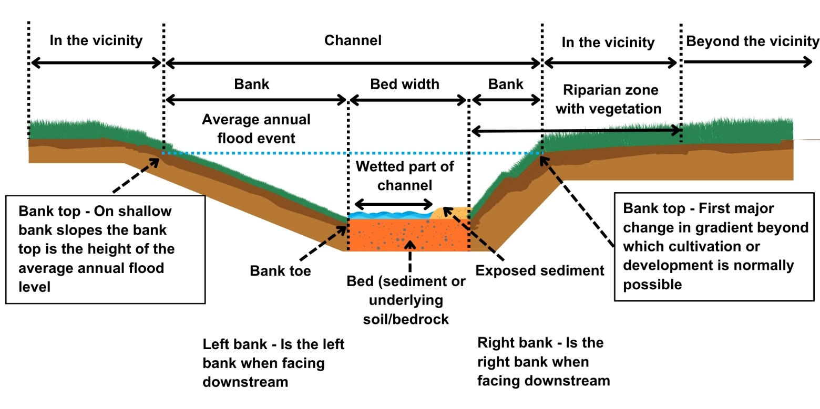
Figure 1: Keys parts of watercourse
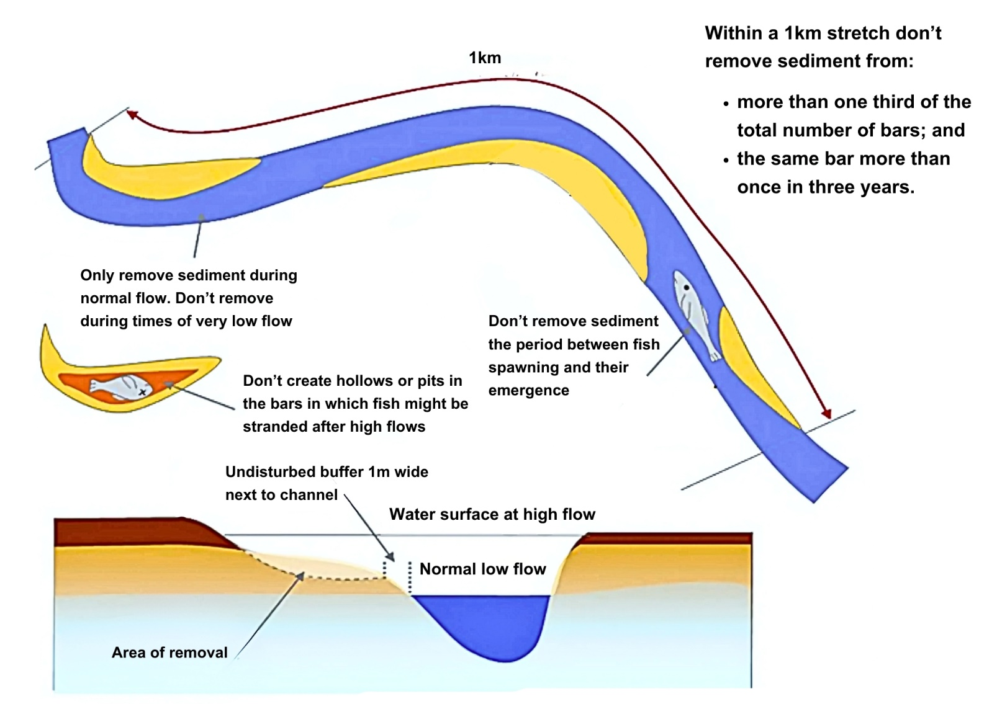
Figure 2: Sediment removal activity limits

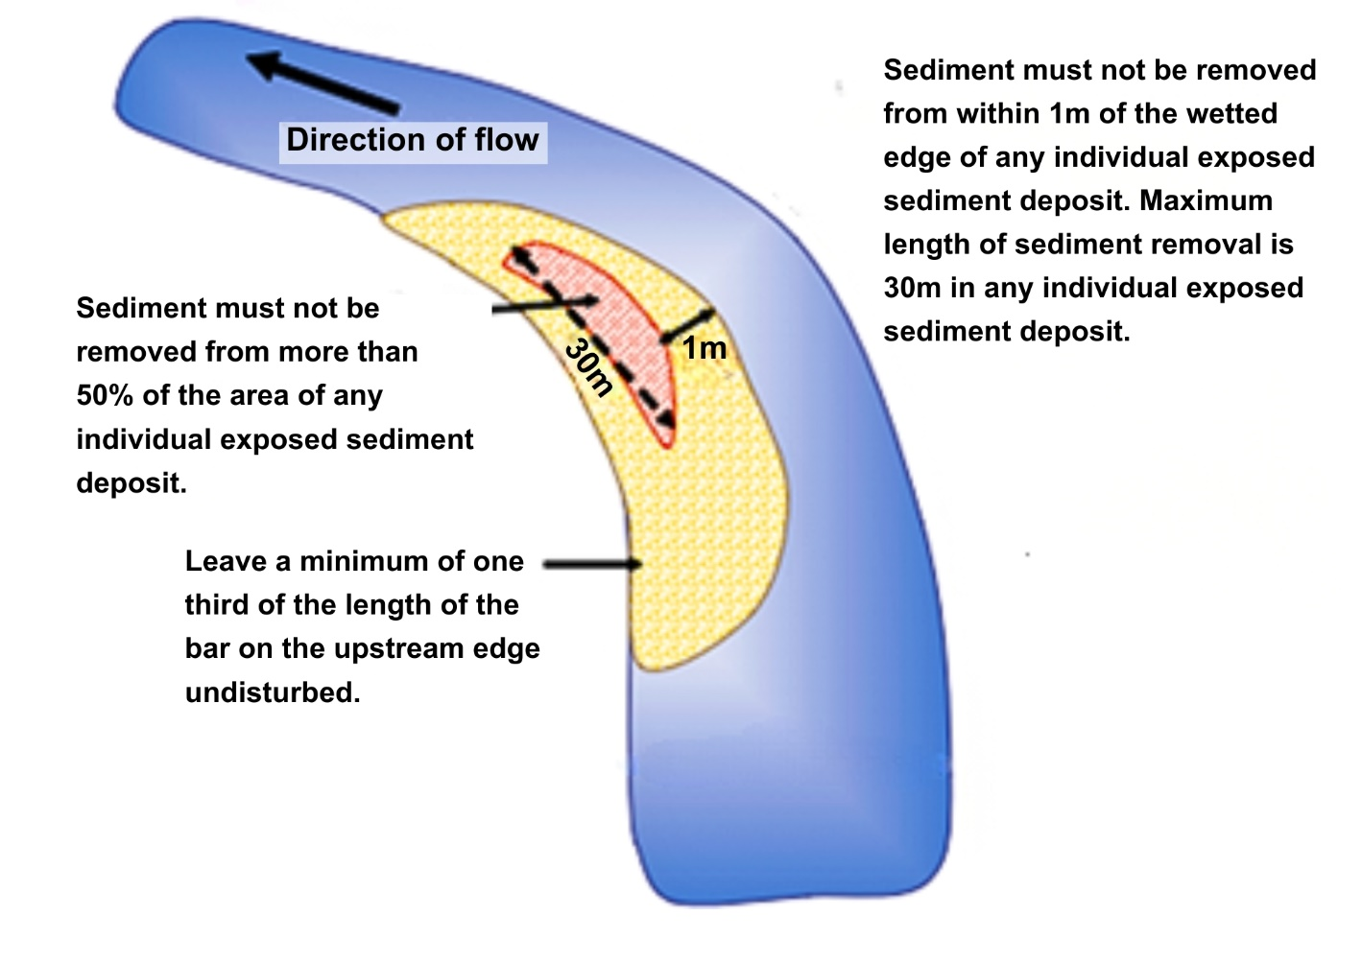
Figure 3: Sediment removal activity limits

Disclaimer
Whilst every effort has been made to ensure the accuracy of this guidance, SEPA gives no warranty, covenant or undertaking (express or implied) regarding the fitness for purpose of, or any error, omission or discrepancy in this guidance. Reliance on its contents and the contents of any websites that are linked to or from this guidance is entirely at the user’s own risk. SEPA is not liable for any loss or damage that may come from using this guidance. This includes:
- any direct, indirect and consequential losses
- any loss or damage caused by civil wrongs, breach of contract or otherwise
SEPA reserves the right to depart from this guidance and take appropriate action as it considers necessary or appropriate. Operators are responsible for ensuring that they are compliant with the law. If necessary, independent legal / specialist advice should be sought.

