


WAT-G-034

EASR Guidance:
Version 1.0, August 2025

Construction works and silt / pollution mitigation

Contents
1 Purpose 2
2 Impacts of construction works on the water environment 2
2.1 Pollution 2
2.2 Damage to habitats 3
3 Good Practice 4
3.1 Planning 5
3.2 Site clearance & set up 7
3.3 Isolation of in water working area 9
3.4 Mitigation methods 18
3.4.1 On land 19
3.4.2 In water 21
3.5 Storage of materials 22
3.6 Machinery, plant & other equipment 23
3.7 Access roads & temporary crossings 25
3.8 Restoration 26
Disclaimer 27

If you would like this document in an accessible format, such as large print, audio recording or braille, please contact SEPA by emailing equalities@sepa.org.uk

1 Purpose
This document provides information and guidance on consideration of construction works and mitigation when carrying out water activities which are subject to authorisation by SEPA under the Environmental Authorisations (Scotland) Regulations 2018, (EASR).

2 Impacts of construction works on the water environment
Although the construction phase of any project is relatively short term, the risk of pollution and damage to the water environment (including habitat, flora and fauna) during construction is very high therefore adequate planning and mitigation should be put in place on any project to eliminate or reduce the risks to the water environment.

2.1 Pollution
Scotland generally experiences the highest annual rainfall in the UK. But within Scotland rainfall can vary considerably. This is an important consideration for construction works in Scotland because rainfall increases the risks of pollution and damage to the water environment increases.
Rainfall and associated surface water run-off during construction works can mobilise and transport pollutants such as sediment, oils, chemicals and other building materials into the water environment causing harm to plants and animals. Heavy rainfall can also flood excavations and other work areas, which subsequently require draining or de-watering. When working in or near watercourses, construction sites are more at risk of flooding from rising water levels.
Pollution from sediment and other pollutants can come from a number of sources on construction sites including:
- Direct disturbance of the banks and bed of rivers and lochs.
- De-watering of excavations.
- Run-off from exposed ground and material stockpiles.
- Run-off from roads, haul routes and river crossings.
- Plant washing/washing areas including cement and cement wash from batching plants.
- Fuel and chemical storage/refuelling areas.
- Leaking/vandalised equipment.
Impacts of pollution can include the following:
- Sediment pollution can smother important habitats such as fish spawning habitats and directly impact fish by coating their gills or may reduce growth rates and resistance to disease.
- Pollution from oil, fuels and other chemicals can have a variety of effects on freshwater ecology and can lead to fish and invertebrates being killed.
- Cement pollution of waters results in high alkalinity and raises the pH, which can be toxic to aquatic life.
- Pollution can also render receiving waters unsuitable for other water users e.g. potable or industrial abstraction, fish farming, angling, agricultural stock watering, and general amenity/tourism.

2.2 Damage to habitats
Important habitats, including protected habitats and species, can be directly lost during construction as sites are cleared, or indirectly lost through pollution and/or disruption. In the worst cases, long-term or even permanent damage may occur. For example:
- If a temporary crossing is a barrier to fish passage at key migratory times, fish will be prevented from reaching upstream spawning grounds.
- Otter holts, water vole colonies, or salmonid and lamprey spawning areas could be destroyed.
- Invasive non-native species such as Japanese knotweed could be spread during construction.

3 Good Practice
This guidance is intended to provide general advice on good practice considerations when undertaking construction projects. There may be additional measures or controls required for projects depending on the site specifics.
Further guidance on how to minimise the environmental impact from activities can be found in Guidance for Pollution Prevention (GPP) documents and from The Construction Industry Research and Information Association (CIRIA).
The site operator/contractor is responsible for the design, construction and maintenance of pollution prevention measures or facilities on any construction site.
The following sections provide information which should be incorporated into the planning, design, construction and management to control pollution, erosion and sedimentation.
Key principles to avoid pollution:
- Prepare by identifying necessary mitigation measures required to prevent and manage silt pollution.
- Divert clean water away from exposed soils and working areas.
- Minimise erosion of exposed soils.
- Prevent silty/contaminated water from leaving site/working area.
- Treat silty/contaminated water appropriately.
- Dispose of treated/collected water and waste materials appropriately.

3.1 Planning
Construction works should be planned to minimise soil erosion (from land, bed or banks). Principles of control are based on the protection of the soil surface from rainfall and run-off, and on containing eroded soil particles. Fine particles can be very difficult to contain once they have been mobilised and the best way to control the generation of sediment is to prevent erosion from taking place.
The risk of pollution and damage to the water environment can be reduced by careful planning. For example:
- Identify the location of all watercourses, lochs, wetlands, burns, ditches, drains and drainage pathways for surface water and how the proposed works will affect them by undertaking an appropriate pre-works survey (desk-based and on-site verification). Buffer strips and working/storage distances from watercourses should be considered.
- Identify Protected areas (including SSSIs, SACs and SPAs), habitats and species on or adjacent to the site. Ensure sufficient protection is in place around these areas.
- Identify any Invasive Non-Native Species (INNS) on site and adopt appropriate biosecurity planning. For further information please see WAT-G-001 EASR Guidance: Invasive Non-Native Species (INNS).
- Identify other parties that could be affected by the works. This could include contacting riparian owners, fisheries and others in the vicinity of, and downstream of, the proposed project as appropriate.
- Assess potential flood risks to the site during the works. Check SEPA Flood Maps for an indication of the extent of site likely to be affected by flooding. Consider appropriate working/storage distances from flood prone areas and come up with emergency plans to deal with flooding.
- Identify potential sources of pollution on site depending on activities being undertaken (e.g. identify safe location for oil, fuel and chemical storage, material stockpiles, vehicle and equipment washing areas etc), consider site layout/geology and topography in planning works (e.g. selecting location of haul routes away from watercourses and providing buffers). Ensure measures are in place to prevent pollution pathways are created.
- Plan the timing of work to avoid sensitive times of the year, e.g. fish spawning, fish migration time and bird nesting season.
- Consider weather conditions. Since the winter months are generally wetter, there will be additional challenges in terms of managing run off and storm events. Snow and ice cover will restrict access and increase risks on site and you may need to factor in treatment of surfaces and equipment with salt and de-icer which can impact if discharged to the water environment. Equally, extended periods of dry weather can make it difficult to manage dust from vehicles and tracks, and vehicle movements may have to be limited. In these instances you should install suitable mitigation such as dust suppression sprays.
- Design appropriate mitigation methods for silt control and where appropriate put aside adequate space for treatment of dirty water including facilities such as settlement ponds. This could require the acquisition of extra land to locate these features.
- Lack of training and awareness of environmental impact can often result in bad practices unwittingly being adopted. All personnel from the site manager to engineers, foremen, plant operatives, sub-contractors, tradesmen and labourers have a part to play in preventing pollution and harm to the water environment during construction. It is crucial that each member of the site staff is aware of the potential impact of their activities and is equipped with the knowledge of how to eliminate or reduce that impact. Consider need for Ecological Clerk of Works (ECOW).
- Think through the possible incidents and emergencies that could arise during construction works and plan accordingly (risk assessments). Put in place an emergency response plan on site with a procedure for dealing with emergencies and communicate this procedure to all site staff. These may include:
  - Pollution incidents (e.g. spillages, failure of temporary works, bank collapse, vandalism and fire).
  - Extreme weather events (e.g. heavy rainfall, flooding, severe frost and snow).
- Ensure that developers, contractors and others involved in earthworks that could pollute the water environment are aware of their responsibilities not to cause water pollution or damage habitats. All such persons should be aware, and should make their employees aware, of the likely causes and consequences of environmental pollution and should be familiar with any control measures and emergency procedures to be deployed.
Site staff responsible for taking action in emergencies should be:
  - Aware of their responsibilities and escalation routes.
  - Trained to use the necessary equipment such as spill control equipment and shut-off valves.

3.2 Site clearance & set up
- Avoid unnecessary vegetation clearance and limit exposed soils, which can be easily mobilised in wet weather. Vegetation removal adjacent to waterbodies is likely to destabilise the banks and/or bed and make them more vulnerable to erosion. Removal of vegetation can also alter flow patterns and induce or accelerate bank or bed erosion. It is vital to take measures to ensure the stability of the bank, particularly where there is a risk of raised water levels (high flows) until the vegetation is re-established.
Do not dispose of removed vegetation in watercourses and prevent debris from vegetation removal operations from falling into the water. This can be done by removing vegetation from behind the bank and pulling it away from the water, or by placing screens or nets between the vegetation and the water. Where this is impractical, use booms or temporary screens to collect any floating debris so that it can then be easily removed. This type of recovery should cause as little disruption to the watercourse as possible.
Where exposed soil is to be left for a long period of time before completion of the works or before seeding or planting can be established, other temporary measures to prevent soil erosion may be required such as covering with geotextile.
- Schedule construction activities to minimise period of time that soil will be exposed. Account should be taken of the time of year and, in the case of sensitive operations, the weather forecast.
- Limit the area of construction. Stage the project where practicable e.g. in 100 metre lengths, with complete rehabilitation of each stage before progressing to the next.
- Intercept clean water from the worked area (e.g. by using cut-off trenches) and divert clean water around the works. Isolate the works area if working in water and work in dry areas by diverting/pumping the water around the working area.
- Keep run-off velocities low and reduce erosion by the provision of appropriate drainage, buffer strips of vegetation around waterbodies, and short slopes with low gradients.
- Stabilise disturbed areas as soon as practicable after construction has finished. This may be achieved through structural methods, utilising synthetic fabrics, seeded biodegradable mattering, hydroseeding and other quick stabilisation/re-vegetation techniques as necessary.
- Develop and maintain a contingency arrangement to deal with environmental pollution incidents. A sketch plan showing the location of the drainage system should be prepared and equipment should be available for emergency situations to plug drains, dam ditches, excavate catchpits or retain oil spillages by placing oil absorbent materials or wooden scum (or baffle) boards across watercourses.
- Be aware that sediments commonly act as transporting agents for other contaminants. Finer grained sediments take longer to settle than coarser particles, so standard erosion and sedimentation control techniques may not be effective in preventing the off-site transfer of contaminants. Thus, other measures may be necessary, such as tankering off-site for suitable disposal to a licensed landfill site or the use of chemicals to promote settlement prior to discharge.
- Where necessary, use settlement ponds or lagoons to remove the sediment that will invariably be present in site drainage (although minimisation of the amount of erosion must always be the first priority) before discharge to watercourses. Such facilities will also be required for the drainage from borrow pits and any on-site quarrying activities. The design and satisfactory operation of settlement ponds or lagoons depends on a number of factors, including the anticipated flow rate of the drainage, the settleability of the soil particles, influence of wind and wave action.

3.3 Isolation of in water working area
Where construction works are carried out in or on the banks of waterbodies, it is often necessary to isolate and de-water the work area to create dry working conditions. Isolation of the works area reduces the risk of sediment entering the waterbody.
The first and most important consideration is whether it is possible to design out the need for such temporary works. This can be achieved by:
- Considering alternative permanent works that do not encroach on the waterbody (e.g. set back bridge abutments and single span bridges).
- Using alternative construction methods (e.g. directional drilling or tunnelling rather than open cut excavation for pipe and cable crossings).
If construction works in or on the banks of rivers, burns, ditches, lochs or wetlands are unavoidable, choose the isolation method that causes the least disturbance to the waterbody but provides the highest level of pollution protection and keep the duration of the isolation works as short as possible.
3.3.1 Cofferdams or temporary barriers and cassions
These structures can be placed within the water environment to isolate part of a waterbody and create a dry working area (See Figures 1 and 2).

Figure 1 Temporary cofferdam to isolate working area
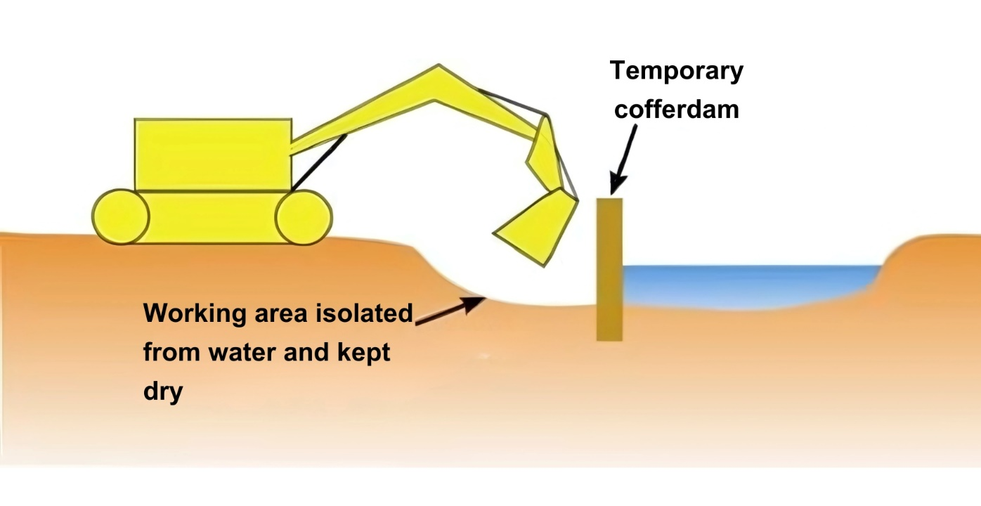

Figure 2 Cassion to isolate working area
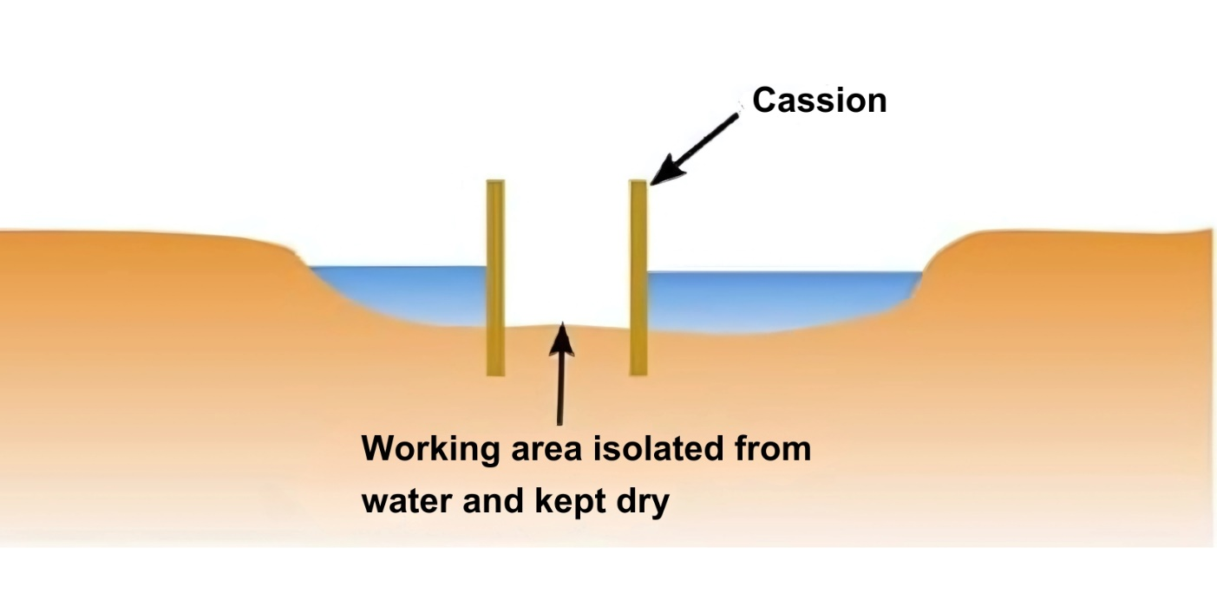

Cofferdams can be constructed from a variety of materials including:
- Sand bags: Woven polypropylene bags are less likely to burst than hessian. They can be reused and give greater control over leakage of the fill material. The fill material should be dense and homogenous (typically coarse grain sand).
The bags should be well compacted and knit together to take up gaps between bags. Place a geotextile filter or impermeable layer on the retained water side of the barrier to prevent seepage of silt through the barrier into the water. Ensure this layer is well anchored along the base of the barrier and extends above the water line, where it should also be well secured.
Advantages:
  - Inexpensive.
  - Materials are readily available.
  - Quick installation and removal for small-scale works.
  - Minimal disturbance to bed.
  - Can easily be shaped to tie-in to banks
Disadvantages:
  - Only suitable for relatively shallow water and small- scale works.
  - Labour intensive installation and removal.
  - Sandbags can rupture releasing sediment into the water.
  - Prone to leakage.
  - Large footprint required for deeper water.
- Sheet piling: (steel, timber, concrete or plastic) Piled cofferdams are normally used for construction in deeper or particularly fast flowing water and/or where excavation below bed level is required for construction of the permanent works. Although it is possible to use timber and pre-cast concrete piles to construct cofferdams in water, the most common choice of material is steel sheet piles. Plastic piles are also available. Piles can be placed in a single line or double skin with an earth fill between the skins.
Advantages:
  - Can be used in fast flowing or deep water.
  - Minimal damage to bed during installation and removal.
  - Minimal space required outside of minimum work area (if single line can be used).
  - Can be installed from bankside.
Disadvantages:
  - Specialist plant required for installation and removal.
  - Susceptible to leakage through pile joints.
  - Vibration and noise during installation.
  - Subsurface obstructions (big boulders) can cause installation problems.
  - Banks may need to be modified to create the upstream and downstream returns of the cofferdam.
  - Installation could disturb the bed.
- Clay/earth bunds: Gravel, clay and earth bunds have risk of causing sediments to pollute the water environment. When used, special precautions must be taken to prevent damage to the bed and release of sediment from the bund.
A silt curtain or similar silt containment method (see below for further information) should be installed before the bund and must remain in place until after the bund is removed. For shallow water depths consider lining the waterside face of the bund with geotextile to prevent washout. Consider placing a geotextile or other durable material on the bed directly under the bund to help prevent damage to the bed during installation and removal.
Advantages:
  - Quick to install and remove.
  - Good seal achievable with clay limiting the need for de-watering of the working area.
  - Can be used on uneven beds.
  - Can be installed from bankside using mechanical plant.
Disadvantages:
  - Susceptible to washout of fine grain material and erosion from passing flow.
  - Susceptible to leakage when sands or gravels are used.
  - Washout due to leakage can also significantly weaken the bund leading to sudden failure.
  - Damage/disruption to bed during installation and removal.
- Specialist proprietary products: There are several different proprietary dam systems available from different suppliers. These include steel framed structures with impermeable membranes and water filled membranes.
Advantages:
  - Minimal disturbance to bed.
  - Some systems can be reused at other projects or locations.
  - Good seal achievable limiting the need for de-watering of the working area.
Disadvantages:
  - Restriction on retained water height (approximate maximum 2 to 3 metres).
  - Some systems are limited by flow velocity.
  - Can be susceptible to movement or breach during flood flows.
A number of factors affect the choice of cofferdam material including:
- Depth of water.
- Available space.
- Duration of works.
- Bed conditions.
- Accessibility.
- Potential ingress of water.
Before choosing which method and material to use, it is also important to consider its potential impact on the water environment. The choice of material will depend on the conditions at a specific site.
The cofferdam must be designed to take into account:
- The reduction in channel capacity (for flood risk).
- The potential increase in flow velocity (for adjacent bed and bank erosion and toe scour).
- Changes in flow patterns (for adjacent bed and bank erosion and toe scour).
- Fluctuations in water level (for adequate freeboard in height of cofferdam).
- Channel substrate (to avoid installation problems).
- Alignment of the cofferdam, particularly at the upstream and downstream ends where bank erosion can be induced.
The installation, use and removal of cofferdams should be carefully managed to avoid significant impact on the bed, bank or channel of a waterbody. The impact on fish passage and migration must also be considered.
3.3.2 Pipes or flumes/temporary diversions (used in conjunction with cofferdams)
Where it is necessary to isolate and keep dry an entire reach of a watercourse the cofferdam will need to be constructed across the full width of the watercourse upstream of the works area. In the vast majority of cases, it will be necessary to transfer water from upstream of this barrier to downstream of the works area, i.e. maintain ‘normal’ flow in the watercourse either side of the isolated reach.
Pipes or flumes/diversion channel can be used to divert the flow/river away from a dry working area. Depending on the gradient of the watercourse, water can be transferred downstream with the use of a gravity fed pipe, i.e. there is no requirement for pumps to be used. This reduces the risks associated with equipment failure and removes the need for back-up/standby pumps to be made available.
The size and type of any pipe or flume/diversion channel (and associated pump(s)) must be adequate to transfer the maximum predicted flows and measures put in place to dissipate energy at the downstream end of the pipe or flume to prevent scour of the bed or bank.
If any pumps are used, they will need to be screened to ensure no harm to fish and any accumulation of sediment/trash at the upstream end monitored and cleared as this may affect pump performance and/or be transferred downstream with the pumped water.
Any flume or diversion channel should be lined to prevent mobilisation of silt and sediment. The lining should normally include a geotextile but, depending on hydraulics, may also be turf, vegetated matting, gravel/cobbles/boulders or a combination of these. Where geotextile is used, one piece should cover the whole channel where possible. Where this is not possible, place strips perpendicular to the flow with minimum 600mm overlaps (upstream piece overlapping downstream). Use gravel and riprap to hold the geotextile in place both on the bed and buried in trenches at the top of the banks. Bury the upstream end of the geotextile into a 600 by 600 millimetre trench in the bed of the diversion channel.
Best practice is normally to line the bed of the diversion channel with suitably sized sediment similar to that in the isolated reach. Careful design is required to ensure that the existing sediment transport regime is replicated as far as possible (i.e. it is important to ensure there is no significant increase in deposition along the diverted reach nor that sediment input from upstream is transported at a significantly increased rate through the diversion) as this could lead to significant geomorphological changes upstream and downstream. Include natural formations such as pools and riffles where appropriate. This may not be necessary for very short duration diversions (e.g. those in place for only a couple of days) but would need to be justified on a case-by-case basis.
Figure 3 Pipe/flume running adjacent to watercourse to take water away from working area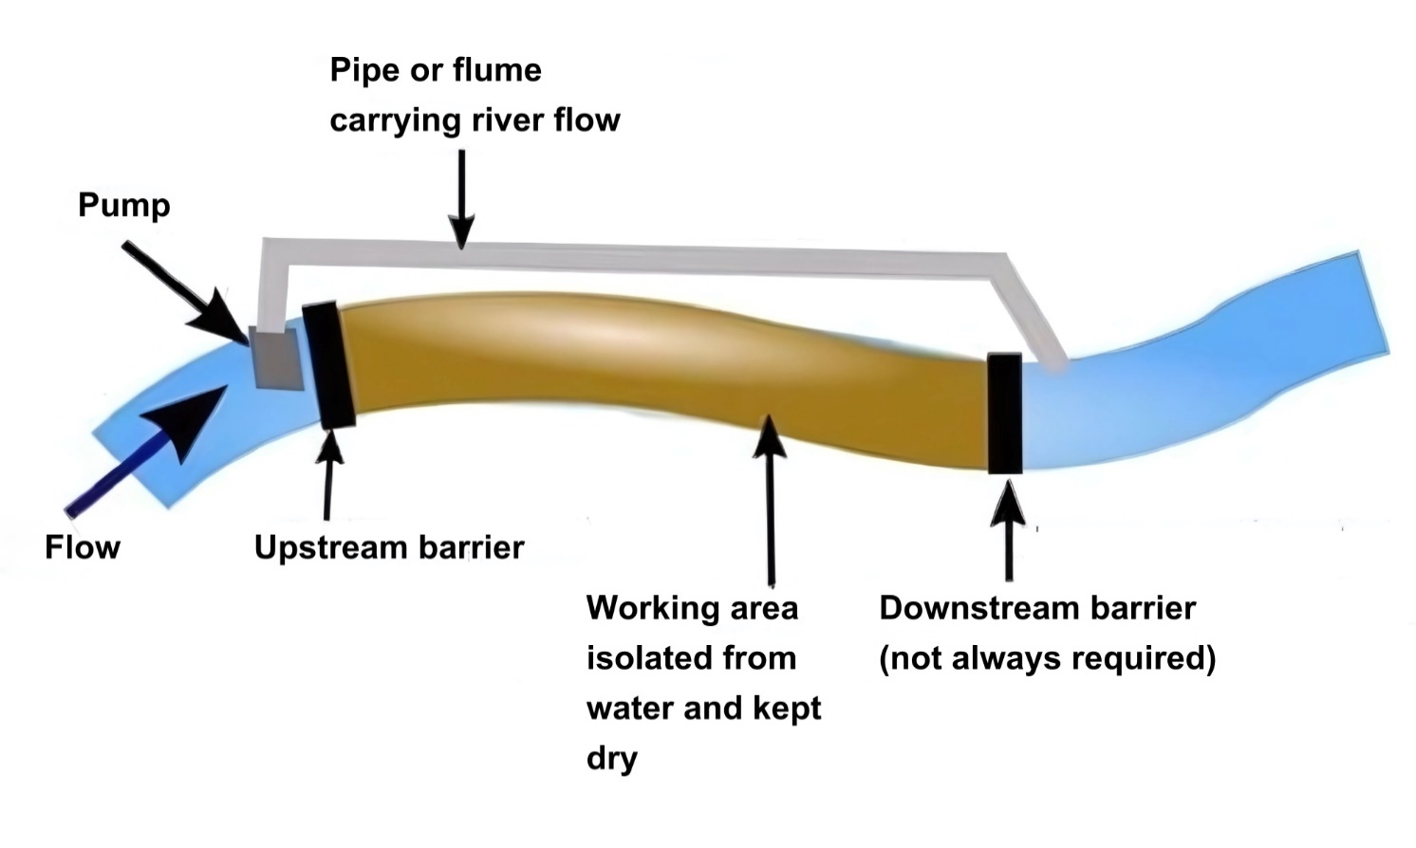

Figure 4 Pipe/flume running within watercourse to isolate working area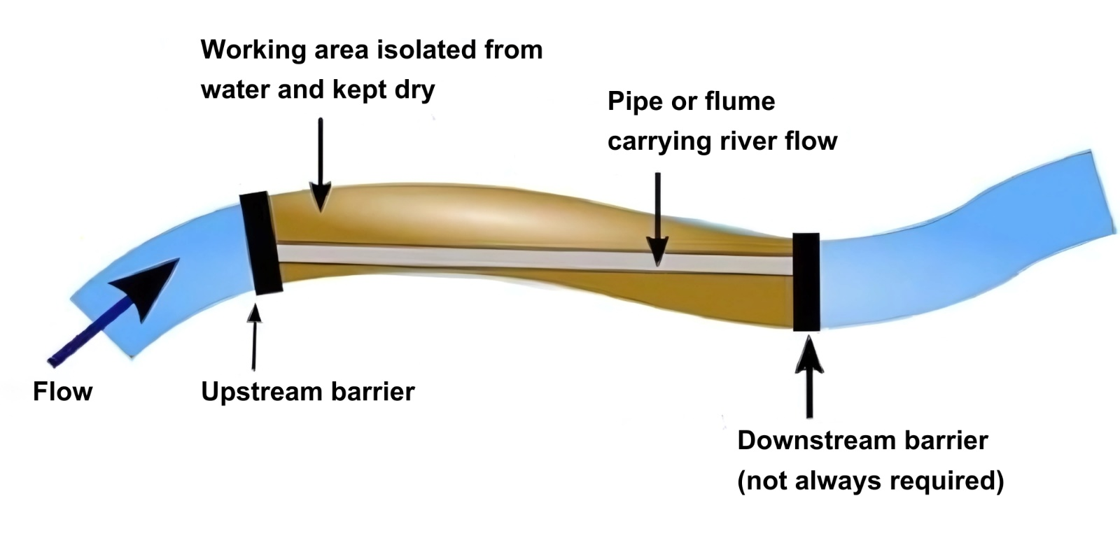
Figure 5 Temporary diversion channel to isolate working area
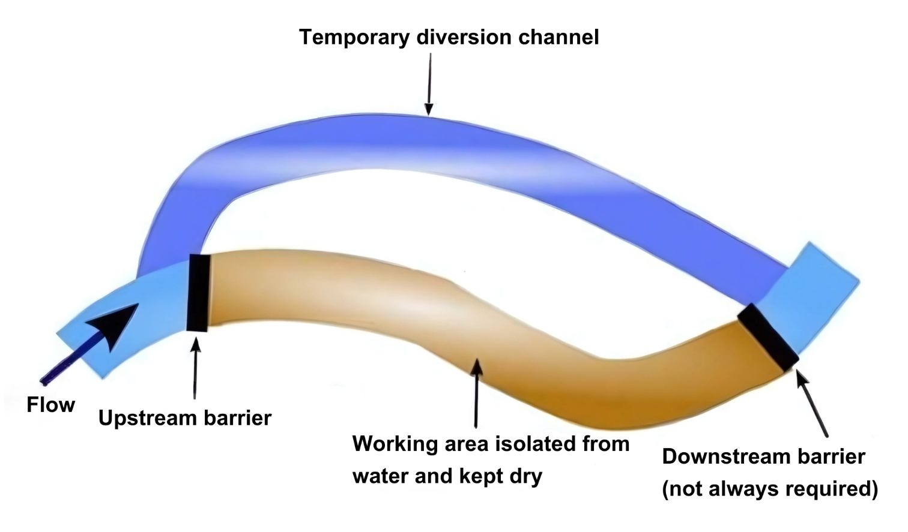
As well as initially de-watering of any isolated work area, most of the isolation methods are likely to require continual or intermittent de-watering due to ingress of surface water, seepage, groundwater or rainwater. Dewatering of the isolated working environment must be managed to ensure the appropriate treatment/disposal of any contaminated water. Clean water can be directed back to original waterbody and contaminated water must be directed to an appropriate treatment facility or sent offsite.
A fish rescue may also be required as part of the dewatering any isolated works area.
Avoid working during high flows. Monitor the weather forecast and expected flows/water levels throughout the works and have a contingency plan in place to prevent damage or pollution during extreme weather and high flow events. Dry weather and low flow conditions are pre-requisites for the safe installation and management of sediment management apparatus, and isolating works such as cofferdams are easier to manage during low flows.
Inspect all control measures and associated equipment regularly (paying particular attention to joins and seals) for movement, structural defects, general deterioration and associated leakage. If not properly maintained, some control measures may cause more damage than they prevent. Regular inspections should also be undertaken to ensure that the water environment has not become polluted. Inspection frequency should be increased at times when the risk of pollution is high, such as during and after heavy rainfall.
Following completion of construction works remove any accumulations of silt or trash against the cofferdam and dispose of it appropriately. Then re-water the isolated work area before removing any cofferdam to avoid sudden ingress of water causing erosion of the replaced bed or bank material. When re-watering, screen the pump inlets to prevent intake of fish or other aquatic animals.

3.4 Mitigation methods
There are various methods available to prevent pollution, treat contaminated run-off and trap sediments. The selection of silt mitigation methods will depend on how effective they will be on a site-by-site basis. The effectiveness of silt mitigation methods will depend on weather, site characteristics and construction activities. It may be likely that a combination of methods will be required on site.
It is important that the selected silt mitigation methods are inspected regularly, and particularly after rainfall, to assess their effectiveness and the need for maintenance or replacement with alternative methods.

3.4.1 On land
There are many techniques and existing guidance to help minimise the mobilisation and loss of sediments/silt into waters. In certain circumstances it may be impossible to prevent erosion of exposed soils. In such circumstances it is necessary to ensure that water polluted by sediment is not allowed to leave the site untreated and that the level of treatment is sufficient to ensure the final discharge is acceptable.
In most cases this will involve collecting the polluted run-off and routing it to treatment by filtration, settlement or specialist techniques. Appropriate treatment and disposal options will depend on a number of factors including volume of water, type and amount of pollutant and area of land available for the treatment. Diversion drains/ditches which route uncontaminated water away should be used in conjunction with any of the below options as this can significantly reduce the volume of water contaminated with sediment which requires to be treated and disposed of.
Treatment and disposal methods include:
- Foul sewer: Permission to discharge to the public sewer must be obtained from Scottish Water.
- Tanker off-site: Water can be stored on-site, then pumped into tankers and taken away for disposal elsewhere at appropriately authorised off-site facilities.
- Settlement/filtration: Dirty water and run-off can be directed to a treatment pond or lagoon. Long term rainfall figures for the area where construction is taking place is an important criterion in determining the size of any ponds or lagoons. Any discharge to the water environment will require authorisation from SEPA. To remove sediment from water by settlement, the water needs to be retained in an undisturbed state (i.e. not moving) for a period of time. This allows particles to fall out of suspension. The rate at which they fall out depends on size, with finer particles taking longer to settle. Also, the deeper the water the longer it will take for particles to settle. Other factors affecting settlement include temperature, particle density and water disturbance.
Settlement ponds and lagoons must be large enough to allow retention for sufficient time for the particles to settle. This may require the use of ponds in series or baffles/check dams or other methods to extend through flow and thus treatment to allow effective settlement. Mechanical filtration and settlement tanks/units can also be used and are available from a number of different suppliers. These can be used in single units or joined together for larger volumes. If the use of flocculants is proposed to aide settlement of fine sediment, contact SEPA in advance to discuss any risks as these agents can be polluting/toxic.
- Filtration: Buffer strips/zones of vegetation (5-10 metres wide) around waterbodies act as sediment filters and will help minimise direct run off entering waterbodies. Exclusion zone can also be created using fences, barriers, screens and signage. Careful consideration should be made to ground topography, type of vegetation and soil conditions.
Use of chemicals
In certain circumstances it may be proposed to use chemicals to aide the process to reduce suspended solids or discolouration via coagulation and flocculation. Coagulation is the use of an additive to destabilise colloidal suspensions, while flocculation is used to promote clumping of the destabilised particles to aid settlement. The most common coagulants in use are iron or aluminium salts. Flocculation involves the addition of polymers to bind the particles together into “flocs” that are more easily separated. It is common for an additive containing both coagulant and flocculant to be referred to simply as a flocculant (e.g. QP 33). Coagulants can be either metal or non-metal based. Operators are encouraged to contact SEPA in advance to discuss the use of chemical additives (e.g. coagulants, flocculants or other settling / clarifying agents) to aid the settlement of solids in a construction phase settlement pond or proprietary treatment system.
SEPA discourage the use of chemical additives to treat water run-off from construction sites as a primary measure. The use of chemical additives to treat water run-off from construction sites presents a high risk to the water environment given the presence of heavy metals and / or hazardous substances. SEPA expect passive (and / or mechanical) treatment systems to be used where possible, and chemical treatment only to be used as a last resort. Where any operator wishes to use chemical treatment, robust justification must be provided, and an application submitted to SEPA for authorisation. The justification must be based on an assessment of site-specific factors, and we will authorise its use and include further discharge limits in the permit to control the impact of any heavy metals and / or hazardous substances present in the selected chemical treatment.
Where the site has a Construction Run-off Permit, the Permit will be used to control the discharges resulting from the chemical treatment use.

3.4.2 In water
Where silt mitigation measures are used within a waterbody the site logistics including the geology, topography, width and depth of the waterbody and the flow/volume of water will be critical in establishing the best option.
Sediment control works best where the flow of water is slowed, e.g. by using a barrier, in addition to a method being employed upstream of the barrier to trap and remove silt where it settles. Fine sediment particles can take a long time to settle out of the water column so water should be slowed over a long length of channel to maximise the amount of settlement taking place. It is important to remove as much of the trapped sediment as possible to avoid releasing a concentrated plume when the silt mitigation measure is removed after completion of the work. The risk of releasing a plume can be further reduced by removing the silt mitigation method slowly from the top down so that the water upstream is released slowly.

Some methods are included below and may need to be used in combination:
- Silt curtains: A permeable screen of fabric, e.g. hessian, vinyl or other geotextile, normally used to isolate an area. The screen is anchored and hangs within the water.

Figure 6 Silt curtain
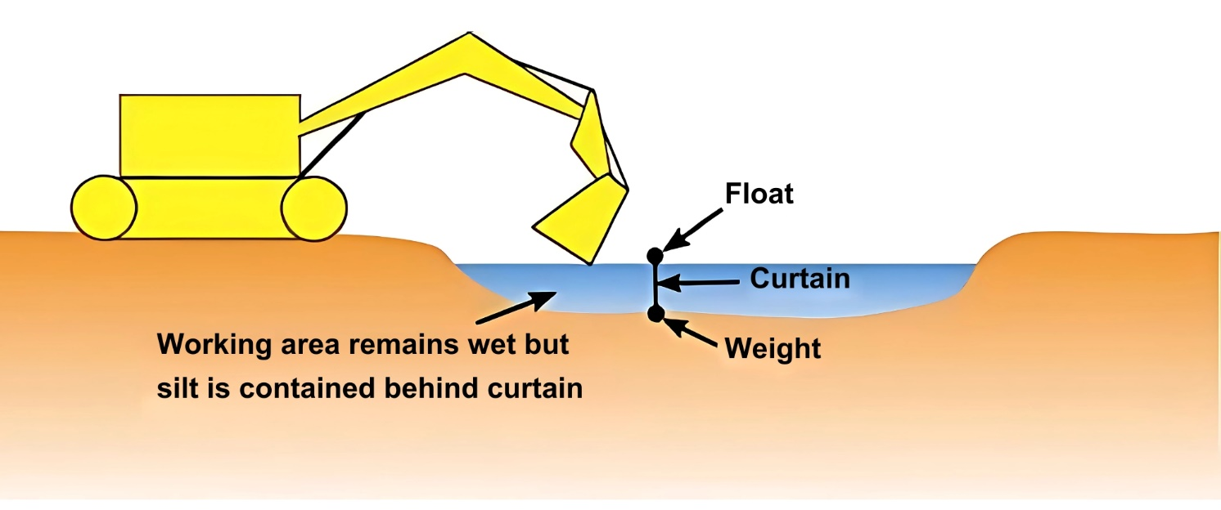

- Sedi-mats: These are products that can be placed on the bed of a river downstream of works to trap sediment as water flows over them. They may be suitable for small and shallow burns or where a barrier has been placed downstream to slow the flow.
- Straw bales: Placement of straw bales downstream of works may help trap suspended sediment while allowing the water through the bales.
- Rock filter dams: temporary barriers placed downstream of works, made from rock and geotextile, which allow water to filter through them, trapping sediment in the process.
All methods require careful installation to trap as much silt as possible and need to be regularly inspected and maintained to prevent failure during works. Sediment that has accumulated should be carefully removed and properly disposed of silt mitigation should be removed as soon as possible after it is no longer needed.

3.5 Storage of materials
Locate stockpiles and spoil heaps as far away as possible from waterbodies and drainage ditches to prevent any collected materials from either falling or being integrated with run-off caused by rain into the water environment.

All refuse and debris arising from the site in the vicinity of the water environment should be collected and removed as required, in accordance with the Duty of Care.
Fuel, oil and chemicals (including petrol, diesel, mineral oil, heating oil, lubricating oil, waste oil, vegetable and plant oil) should all be appropriately stored and placed a minimum of 10 metres away from any watercourse, drain etc. Fuel, oil and chemical storage tanks must be located on an impermeable base and be surrounded by an impervious bund with no surface water outlet. The bund must be capable of retaining at least 110 percent of the volume of the tanks.
If possible, use biodegradable oil in plant and machinery. Biodegradable oil is less toxic than most synthetic oil but should still be used and stored to the same standards as other oils.
Valves and couplings connected to oil storage tanks must be located within the bund and delivery hoses should be fitted with trigger type handles suspended back within the bund after use. Valves and trigger fill handles must be kept padlocked when not in use.
Surface water, together with any material which accumulates within the storage tank bund, must be removed by means of a manually controlled positive lift pump. Oil contaminated water must be disposed of at an appropriate oil recovery plant licensed tip or incineration plant.

Spill kits should be provided at locations where oil fuel and chemicals are stored.

3.6 Machinery, plant & other equipment
- The use of machinery, plant and other equipment in water represents a clear pollution risk and must only be considered where it is impracticable for them to operate on dry land. In the event of there being no feasible alternatives the duration that any machinery, plant or other equipment is used within the water environment should be the minimum necessary to complete the works.
- Any machinery or construction plant and equipment must be cleaned thoroughly beforehand (principally to remove oil and for purposes of biosecurity) and must be maintained in good working order and checked thoroughly for the presence of any potential oil or fuel leaks.
- The refuelling and washing of any machinery, plant or other equipment must be undertaken at least 10 metres away from any waterbody or drain.
- Where pumps are used on site, keep them at least 10 metres from the edge of the channel and on drip trays or within bunds that have a capacity 110 percent of that of the fuel tank. Suspend the inlet to the pump above the bed of the channel to avoid mobilisation of settled silt and sediment from the bed. The inlet could be suspended from an excavator arm or temporary support spanning the channel.
The use of submersible pumps can mobilise silt into suspension through turbulence at or near the inlet. Where submersible pumps are used, place them in a sump that isolates them e.g. on a gravel base inside a large diameter perforated pipe or manhole ring.
Where possible avoid over pumping overnight or between shifts as there should be supervision over any ongoing pumping operations.
- Construction plant washing facilities (including wheel washes) should be provided and designed to operate on total recirculation wherever possible. Where this cannot be achieved, it is advisable to collect the effluent produced for discharge to the foul sewer (this is likely to require the formal permission from Scottish Water) or for off-site disposal via a licensed waste contractor. In the event of these options not being available, discharges to the water environment can only take place with adequate settlement and oil removal prior to discharge. Authorisation from SEPA will be required for such discharges.
- Borehole drilling or other ground investigations can produce a polluting effluent which may require treatment before being discharged to the water environment. An authorisation may be required for such a discharge.
- Concrete/cement washing direct discharge from any concrete batching plant to the water environment will not be permitted.
Drainage from excavations where concrete is being, or has been, newly poured shall not be pumped or allowed to discharge directly into the water environment.

3.7 Access roads & temporary crossings
Where waterbodies transect the construction site it will be necessary to consider the positioning of any access route or temporary crossing points that are required to facilitate works.
Haul routes, access roads and parking areas can generate significant quantities of water polluted with sediment. Being temporary in nature, they are often formed by simply stripping topsoil and grading the subsoil to suit. This means that during heavy rainfall surface run-off can erode the surface. The tracking of plant and machinery across wet or saturated soil can also loosen and mobilise additional sediment.
- Consider applying binder to road surfaces. This will also help to reduce dust pollution during dry weather.
- Shed water from roads onto adjacent vegetation or construct ditches along the road edge(s) to prevent uncontaminated run-off flowing onto the road and to direct contaminated run-off to treatment facilities. Do not allow roadside ditches to discharge directly to rivers, burns, lochs or wetlands.
- Prevent excess water running along the road by installing small earth bunds (like speed bumps) or cut-off ditches at regular spacing to direct water into roadside ditches.
- Splash plates can prevent vehicular traffic from pushing debris over the edge and into waters.
Ideally temporary crossings should be avoided or kept to a minimum to avoid potential damage to the bed and banks of any waterbody.
Where construction plant must cross a waterbody, consider whether existing available crossings can be used where appropriate or provide temporary culverts and/or bridges to enable crossing to take place with minimal disturbance of the bed. The same principles of good practice apply to permanent and temporary river crossings. Further information can be found in WAT-G-024 EASR Guidance: Engineering: Activity Guide: Crossings.
In designing crossings, adopt measures to prevent sediment-laden run-off from entering waterbodies. This can be done by ensuring crossing structures have edge upstands or bunds (e.g. straw bales, sandbags or earth), ensuring road levels shed water away from watercourses and making sure crossings surfaces are sealed (impermeable).
Where inlets to existing surface water drainage are present on- site (e.g. road gullies or yard drains), protect them from run-off polluted with sediment. This is best done by diverting the water away to treatment facilities. Where this is not possible, create a bund around the surface water drain to prevent contaminated water entering.

3.8 Restoration
Following construction, the site should be restored and all temporary crossings, construction waste, including any contaminated soil, excess materials and equipment should be removed.
Where the channel, bed or banks of any waterbody has been impacted by construction works, they should be reinstated at least to their condition immediately prior to the works, as soon as reasonably practicable.
Any exposed soil should be re-seeded with native vegetation or covered with biodegradable matting. For further guidance on riparian vegetation see EASR Guidance: Riparian vegetation.
Where natural bed material of a watercourse has been removed as part of the works and stockpiled to be reinstated following the works, ensure that the elevation and distribution of the bed material is carefully managed. If necessary, it may be useful to carry out a survey prior to works to ensure the bed profile can be reinstated after works using the original bed material where possible.

Disclaimer
Whilst every effort has been made to ensure the accuracy of this guidance, SEPA gives no warranty, covenant or undertaking (express or implied) regarding the fitness for purpose of, or any error, omission or discrepancy in this guidance. Reliance on its contents and the contents of any websites that are linked to or from this guidance is entirely at the user’s own risk. SEPA is not liable for any loss or damage that may come from using this guidance.
This includes:
- any direct, indirect and consequential losses
- any loss or damage caused by civil wrongs, breach of contract or otherwise
SEPA reserves the right to depart from this guidance and take appropriate action as it considers necessary or appropriate. Operators are responsible for ensuring that they are compliant with the law. If necessary, independent legal / specialist advice should be sought.

