
Version 1.0, August 2025


​
WAT-G-010

EASR Guidance:
Registration Activity:
Bank Works less than or equal to 50 metres

Contents
Purpose 3
What activity does this guidance apply to? 3
Understanding the activity 3
Bank Protection 5
Bank Reprofiling 6
Other Bank Works 6
Key parts of a watercourse and loch 7
Understanding and minimising risks to the water environment 9
Risks to the Water Environment 9
Do’s and Don’ts 10
Activity specific do’s and don’ts 10
General working in or near water do’s and don’ts 11
Glossary 13
Disclaimer 15
Appendix 1 – Registration Activity - scenarios 17
What constitutes one registration Bank Works activity? 17
Scenario 1: Single length of bank works 17
Scenario 2 Multiple lengths of bank works- One Registration Activity 18
What constitutes two or more Bank Works registration activities? 19
Scenario 3: Multiple lengths of bank works: Two or more Registration Activities 19
When would a permit application be required for Bank Works? 20
Scenario 4: Some scenarios which will require a Permit application. 20

If you would like this document in an accessible format, such as large print, audio recording or braille, please contact SEPA by emailing equalities@sepa.org.uk

Purpose
This document provides information and guidance for anyone undertaking up to 50 metres of Bank Works which requires a registration, under The Environmental Authorisations (Scotland) Regulations.
This guidance does not cover any other permissions that may be required.

What activity does this guidance apply to?
This guidance applies to engineering activities granted as a registration under the Environmental Authorisations (Scotland) Regulation 2018 for:
Carrying out bank works on a watercourse or loch where:
- The total cumulative length of bank affected is less than or equal to 50 metres.
- There is no alteration to the height of the existing bank top.
It does not apply to any bank works which can be carried out under Water General Binding Rules (GBR’s) 6, 8 and 25.

Understanding the activity
This activity covers any type of bank works, namely:
- Bank protection works.
- Bank reprofiling.
- Other bank works.
where the total cumulative length of bank affected is less than or equal to 50 metres and there is no alteration to the height of the existing bank top.
This registration includes the bank works activity and all associated construction works, such as: access tracks, temporary crossings and temporary structures.
This activity does not apply to bank works which can be authorised by carrying out the activity in accordance with the rules in Water GBR’s 6, 8 and 25.
The bank works must not alter the height of the bank top or the bed width of the watercourse, as doing so could create or exacerbate erosion or depositional areas up or downstream of the works. Any bank works which raises the height of the bank top, such as an embankment or floodwall, must be authorised by a permit.
The activity covers the carrying out of bank works on watercourses or lochs between and including the bank top and the bank toe. It does not include work which only manages or removes vegetation), Figures 1 and 2 Key parts of a watercourse and loch.
In relation to lochs, where there is no clearly definable bank zone, the bank top is the line along which terrestrial vegetation is present (this often equates to the average high-water level in a loch). See Figure 2 Key parts of a and loch.
A single bank works activity can involve multiple lengths of bank works provided the total length of bank work is carried out within a single continuous length of channel less than or equal to 50 metres and the cumulative length of bank affected is less than or equal to 50 metres.
If you are applying for a second registration activity, this must be separated by a gap at least 50 metres of channel length where no new bank works are taking place, otherwise a permit application would be required.
Some bank works scenarios are shown in Appendix 1.
If your proposed activity exceeds any of the activity thresholds or you cannot comply with any of the standard conditions, you should apply for a permit activity under ‘All other bank works not otherwise described’.

Bank Protection
Bank protection works, which address actual or potential erosion issues, may be constructed from a wide variety of materials. We encourage the use of lower impact materials and methods, especially those which mimic natural banks, wherever possible.
Lower impact bank protection includes using techniques or materials, such as:
- Biodegradable geotextiles, coir or vegetation over part or all
of the bank height, and/or
- Un-grouted stone/rock armour (rip rap), coir/rock rolls and/or
untreated wood (restricted to the bank toe).
This can include reprofiling of the protected bank.
Some of the lowest impact techniques are authorised by complying with the Rules under Water GBR 8 or 25 and do not require application for registration or permit. See our guidance for Water GBR’s 8 and 25 and WAT-G-029 EASR Guidance: Engineering: Sustainable Bank works for further details.
Other approaches to bank protection could utilise a combination of ‘lower’ and ‘higher’ impact techniques to provide a mixture of benefits to what is being protected and to the watercourse or loch. Lengths of higher impact bank protection should be minimised wherever possible.
Higher impact bank protection includes using techniques/materials which do not fall into ‘soft/green’ above, such as:
- Concrete; grouted stone, brick, gabion baskets, masonry; sheet piling,
wood piling, metal; non-biodegradable geotextiles, etc, over any height
of the bank, and/or
- Un-grouted stone/rock armour (rip rap), coir/rock rolls and/or untreated
wood which extend above the bank toe.
This can include reprofiling of the protected bank.
Higher impact bank protection measures can sometimes cause unintended impacts. For example, the erosion may just be transferred to nearby banks and riverbed due to high flow energy being deflected rather than absorbed. This risk should be carefully assessed when deciding on the best techniques/option to use.
See WAT-G-022 EASR Guidance: Engineering: Activity Guide: Bank Works in connection with selecting the best bank works option.

Bank Reprofiling
Bank reprofiling is any alteration of the slope of the bank of a river, burn, ditch or loch. It can be carried out by itself or in association with other bank works. It is often carried out to reduce the slope of a riverbank to lessen the risk of erosion and improve stability but may also be carried out to improve riparian habitats. Reprofiling usually involves creating a gentler, more stable slope that spreads out high flow so the bank can better withstand the forces of high flow and encourage riparian vegetation growth.
See WAT-G-022 EASR Guidance: Engineering: Activity Guide: Bank Works in connection with selecting the best option.

Other Bank Works
Intakes
All new intakes which are only on the bank of a watercourse or loch and which affect less than or equal to 50 metres of the bank should be registered under this activity.
Note any intake which affects the bed of a watercourse or a loch is considered to be an instream or in-loch structure and will need to be authorised as such.
Intakes are normally authorised along with any associated abstraction but can be applied for separately.
Outfalls
This registration only applies to outfalls which are only on the bank of a watercourse or loch which extend along the length of watercourse or loch by more than 20 metres and less than or equal to 50 metres.
Outfalls which extend no more than 20 metres of along the length of the watercourse of loch may be subject to the rules in Water GBR 6.
Any outfall which cannot comply with GBR 6 and affects the bed of a watercourse or a loch will be considered an instream or in-loch structure and will need to be authorised as such.
Outfalls are usually authorised along with any associated discharge, but they can be applied for separately.
See our guidance on WAT-G-36 EASR Guidance: Intakes and outfalls and WAT-G-022 EASR Guidance: Engineering: Activity Guide: Bank Works in connection with selecting the best bank works option.
Ramps, access steps, mooring poles etc.
Other types of bank works such as creating access steps, or ramps for boating access are sometimes required. These can be applied for and authorised under this registration activity.

Key parts of a watercourse and loch
Figures 1 and 2 show the key parts of a watercourse and loch. and explained in the Glossary.
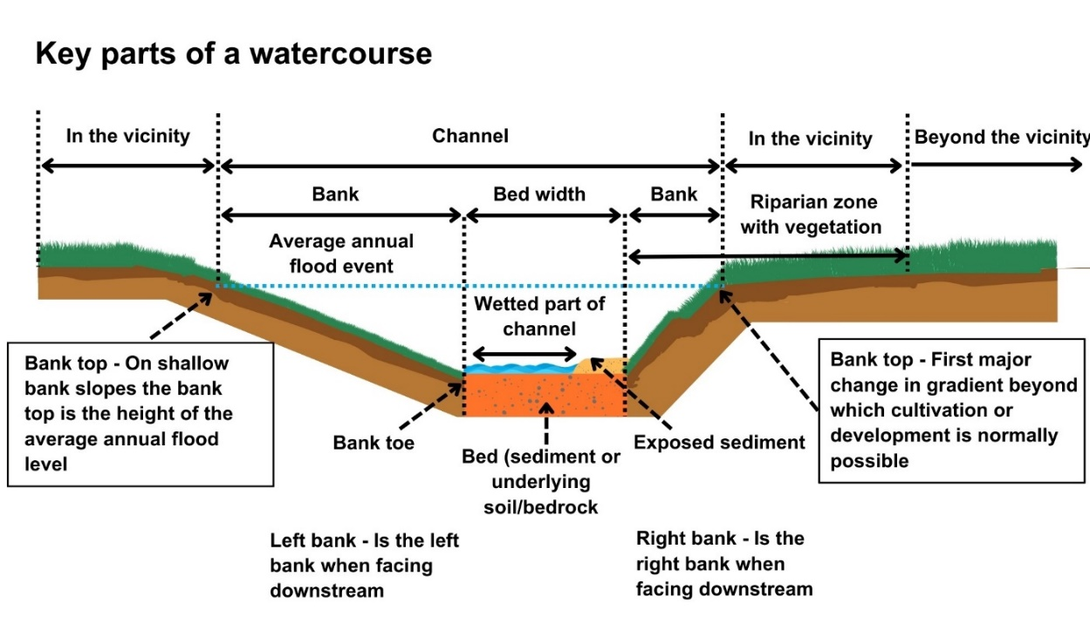
Figure 1: Key parts of a watercourse
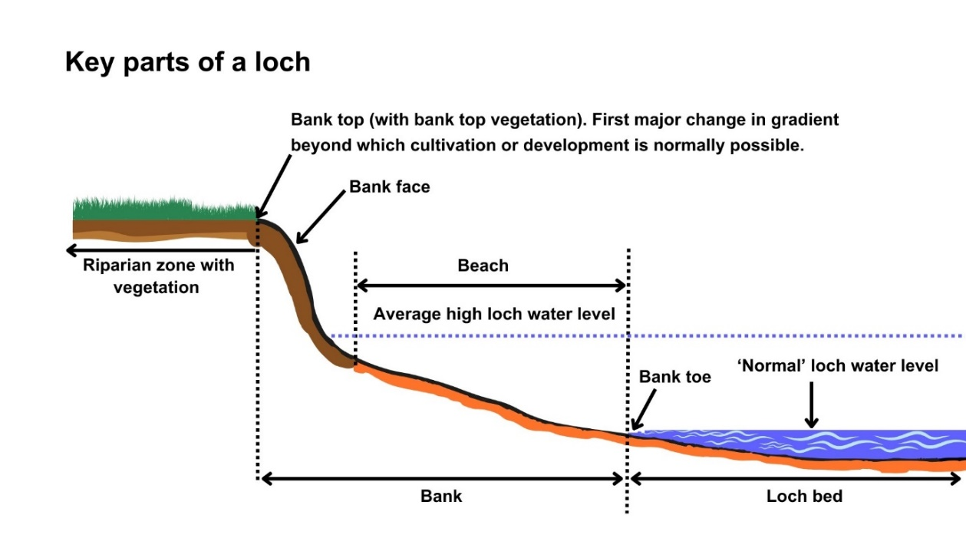
Figure 2: Key parts of a loch

Understanding and minimising risks to the water environment
Carrying out this bank works activity and any associated construction works can cause harm to the water environment. It is important to carefully consider your design and construction options to ensure risks to the water environment and other users are minimised and that you fully comply with your standard conditions.
Good practice should be followed in undertaking this activity to ensure environmental harm is minimised, design is sustainable long-term and maintenance requirements are low. To achieve good practice, you should minimise the footprint of the activity and should consider the natural character and processes of the area you are working.
Further information on bank works and sustainable design can be found in WAT-G-022 EASR Guidance: Engineering: Activity Guide Bank Works.

Risks to the Water Environment
The main risks to the water environment from carrying out this activity can be grouped as follows:
- Harm to fish including impacts on fish migration, spawning and fry development, loss of habitat and direct impacts such as stranding or physical damage. For more information see WAT-G-032 EASR Guidance: Fish Protection
- Physical Impacts & Pollution
  - Physical impacts to the bed and banks of the watercourse which can lead to instability resulting in increased erosion or deposition, loss of habitats and increased flood risk.
  - Pollution from sedimentation, leaking oil from machinery and the entry of potentially polluting materials into water such as unset concrete.
Further information on construction works and mitigation can be found in WAT-G-034 EASR Guidance: Construction works and silt/pollution mitigation.
- Habitats and Species Protection
- Spread of invasive non-native species. Further guidance can be found in EASR-G-001: Invasive non-native species (INNS)
- Impacts on species such as freshwater pearl mussels and otter. You should contact NatureScot where your activity is in a Protected area or may impact protected species. For further information see WAT-G- 008 EASR Guidance: Assessment of impact on Protected areas from inland water activities.
- Impacts to other users of the water environment.
All the risks to the water environment detailed above will vary according to:
- The type and design of the engineering activity.
- The timing of the works.
- The working methods and mitigation.
- The reinstatement methods.
To minimise risks to the water environment and to help you comply with the standard conditions for this activity, you should follow the Do’s and Don’ts below.

Do’s and Don’ts

Activity specific do’s and don’ts
- Do extend bank protection works a short distance beyond any erosion and tie the works in at an appropriate angle to prevent outflanking at the up and downstream ends.
- Don’t alter the height of the bank. Heightening can increase erosion and alter flood risks.
- Don’t alter the bed width. The works should not extend into the channel of the watercourse beyond the existing line of the bank. Altering the width can alter erosion/deposition patterns and flood risks.

General working in or near water do’s and don’ts
Preventing Harm to Fish
- Don’t undertake works if fish are likely to be spawning or young fish are still to emerge. In general, avoid the period between 1 October to 31 May. You should check the exact times with your local fishery board. Details are available from Fisheries Management Scotland.
- Don’t impact fish migration.
- Do make sure all works such as temporary crossings, channel isolation or diversions, blasting, vibration or pile driving, sheet pilling or using artificial lighting at night so that fish or migrating fish are not adversely affected.
- Do carry out fish rescues, where appropriate etc.
Preventing/ minimising physical and pollution Impacts
- Do install and maintain suitable mitigation before, after and during the works. Including the points below.
- Do minimise the extent, location and duration of works in the wetted part of the channel or loch.
- Do keep vehicles, plant and other equipment out of water wherever possible.
- Do create and maintain a robust and secure dry working area of minimum size, where possible.
- Do minimise disturbance and reinstate banks, bed and vegetation as soon as possible:
  - Minimise vegetation removal and the area of bare earth/ exposed soil.
  - Re-seed or turf disturbed soil with native vegetation and ideally cover with biodegradable matting to provide temporary protection until vegetation is fully established.
- Don’t cause significant erosion.
- Do store all fuel, machinery and vehicles at least 10 metres from any watercourse, loch or permeable drain.
- Do have oil spill kits, drip trays and bunds on site and available to operators.
- Do prevent any pollutants entering the water environment.
Habitats and Species Protection
- Don’t spread invasive non-native species.
- Check the banks and in water for invasive species.
- Use biosecurity measures.
- Do check what other species and habitats may be affected (e.g. otter).
- Don’t harm freshwater pearl mussels.
Other Water Users
- Do consider the potential impacts on other water users e.g. water supplies, fishing, kayaking etc.

Glossary
Terms used in this guidance and supporting diagrams are explained below:
Bank is the side of a watercourse or loch between and including the bank toe and bank top.
Bank Height is the height of the bank of a watercourse or loch measured vertically from the bank toe to the bank top, including any artificial heightening of the bank (e.g. embankments, retaining walls).
Bank Toe is the lowest point on the bank of a watercourse or loch, where the bank meets the bed of the watercourse or loch.
Bank Top is the first major break in slope in the bank or any watercourse or loch.
- This is considered the point beyond which cultivation or development is normally possible. Where there is no clear break in slope the bank top is considered to be the height of the average annual flood level in a watercourse,
- In relation to lochs where there is no clearly definable bank zone the bank top is the line along which terrestrial vegetation is present (this often equates to the average high-water level in a loch).
Bank reprofiling is any alteration of the slope of the bank of a river, burn, ditch or loch.
Bank works are any works on the bank between and including the bank top and the bank toe.
Beach is lower part of the bank of a loch (note in some cases the beach may form all of the bank)
Bed of watercourse is the base of the watercourse, between the toe of one bank and the toe of the opposite bank.
Bed of loch is the base of the loch extending from the deepest part of the loch to the edge of the ‘normal’ loch water level.
Bed width means the straight-line distance between the opposite bank toes of a river, burn or ditch, and which spans the bed of the river, burn or ditch, including any exposed sediment bars and vegetated islands.
Bed width can be measured as an average along the length of the stretch to be worked or can be based on one measurement of a width that is representative of the stretch.
Beyond the vicinity is the zone that exists beyond the “in the vicinity” zone away from the watercourse or loch.
Channel is the area between the bank top on one side of a river, burn or ditch and the bank top on the opposite side. It includes the banks and bed of a watercourse, including any exposed sediment bars and vegetated islands.
Channel width means the straight line distance between opposite bank tops of a river, burn or ditch and which spans the bed and banks of a river, burn or ditch, including any exposed bars and vegetated islands.
High loch water level is the average water level typically reached during wet periods.
In the vicinity for a watercourse this is the zone that extends away from the bank top for a distance of 10 metres or two channel widths (whichever is shorter). For a loch this is the zone that extends 10 metres away from the bank top.
Left bank is the left bank of a watercourse when facing downstream.
Loch is a body of standing inland surface water.
Normal loch water level is the water level that occurs for a large part of the year when the loch is not experiencing high water levels. Higher than the minimum water surface elevation.
Protected area means an area designated under International (Ramsar sites), European (Special Areas of Conservation and Special Protection Areas) or National (Sites of Special Scientific Interest) legislation, to provide protection of their notable natural features or biodiversity. This legislation places duties on SEPA to assess whether activities we regulate would harm these sites.
Right bank is the right bank of a watercourse when facing downstream.
Riparian zone of a river is the transitional, semi-terrestrial area of land adjoining a river channel (including most of the riverbank) that is regularly inundated and influenced by fresh water and can influence the condition of the aquatic ecosystem (e.g. by shading and leaf litter input).
Riparian zone of a loch is the area of land extending from the bank top or the limit of terrestrial vegetation and capable of directly influencing the condition of the aquatic ecosystem (e.g. by shading and leaf litter input)
Sediment refers to the natural material of which the bed of a watercourse or loch is made (includes sand, silt, clay, gravel, cobbles and boulders).
Temporary crossing (Water Registrations and Permits) is a crossing which will be removed after the completion of the authorised activity.
Temporary structure (Water registrations and Permits) is a structure which will be removed after the completion of the authorised activity.
Wetted part is the part of any watercourse or loch that is wet while carrying out works in a watercourse or loch.

Disclaimer
Whilst every effort has been made to ensure the accuracy of this guidance, SEPA gives no warranty, covenant or undertaking (express or implied) regarding the fitness for purpose of, or any error, omission or discrepancy in this guidance. Reliance on its contents and the contents of any websites that are linked to or from this guidance is entirely at the user’s own risk. SEPA is not liable for any loss or damage that may come from using this guidance. This includes:
- Any direct, indirect and consequential losses.
- Any loss or damage caused by civil wrongs, breach of contract or otherwise.
SEPA reserves the right to depart from this guidance and take appropriate action as it considers necessary or appropriate. Operators are responsible for ensuring that they are compliant with the law. If necessary, independent legal / specialist advice should be sought.

Appendix 1 – Registration Activity - scenarios

What constitutes one registration Bank Works activity?
A single activity can involve multiple lengths of bank works provided they are all carried out within a single continuous length of channel less than or equal to 50 metres* and the cumulative length of bank affected is less than or equal to 50 metres.
Note the length of channel for this registration is measured following the line of the bank on which bank works are taking place or where banks works are taking place on both banks following the line of the middle of the channel.
Applications can be made for a number of scenarios, as shown below:

Scenario 1: Single length of bank works
A single length of bank works affecting less than or equal to 50 metres of bank.
This scenario is shown in the Figure A1 below.
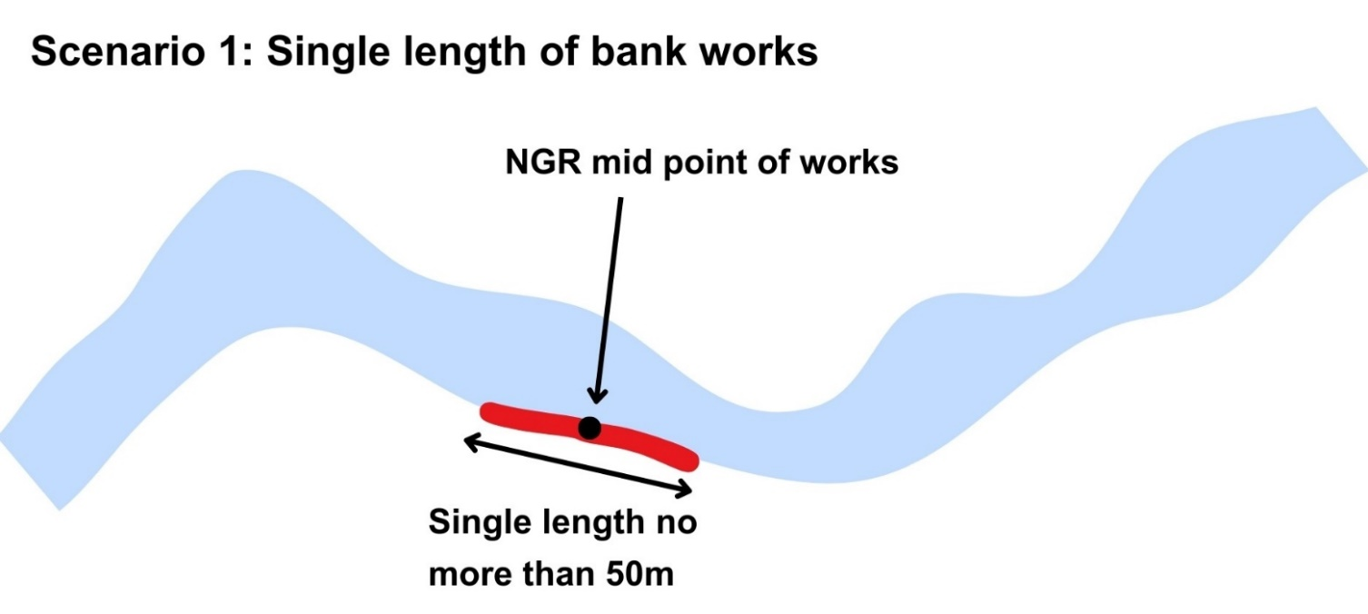
Figure A1 Diagram showing a single length of bank works up to 50 metres in length.

Scenario 2 Multiple lengths of bank works- One Registration Activity
Multiple lengths of bank works, which cumulatively affect less than or equal to 50 metres of bank, carried out on one or both banks within a single continuous 50 metres length of channel. This scenario is shown in the diagram below.
Note the length of channel for this registration is measured following the line of the bank on which bank works are taking place or where banks works are taking place on both banks following the line of the middle of the channel.
These are shown in Figure A2 below.
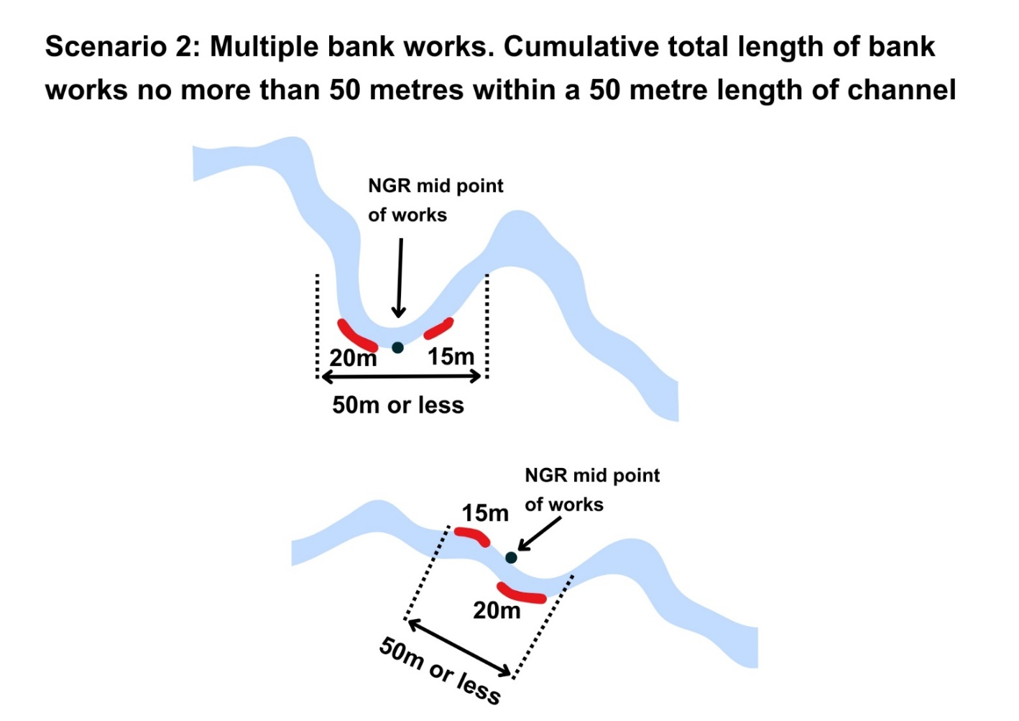
Figure A2 Diagram showing multiple lengths of banks works taking place within a 50 metre length of channel as part of one registration activity.

What constitutes two or more Bank Works registration activities?

Scenario 3: Multiple lengths of bank works: Two or more Registration Activities
Multiple lengths of bank works each within a single continuous 50 metre length of channel, which each cumulatively affect less than or equal to 50 metres and which have gap between these stretches of at least 50 metres is considered as two or more separate bank works registration activities. This scenario is shown in the diagram below.
Note the length of channel for this registration is measured following the line of the bank on which bank works are taking place or where banks works are taking place on both banks following the line of the middle of the channel.
These are shown in Figure A3 below:
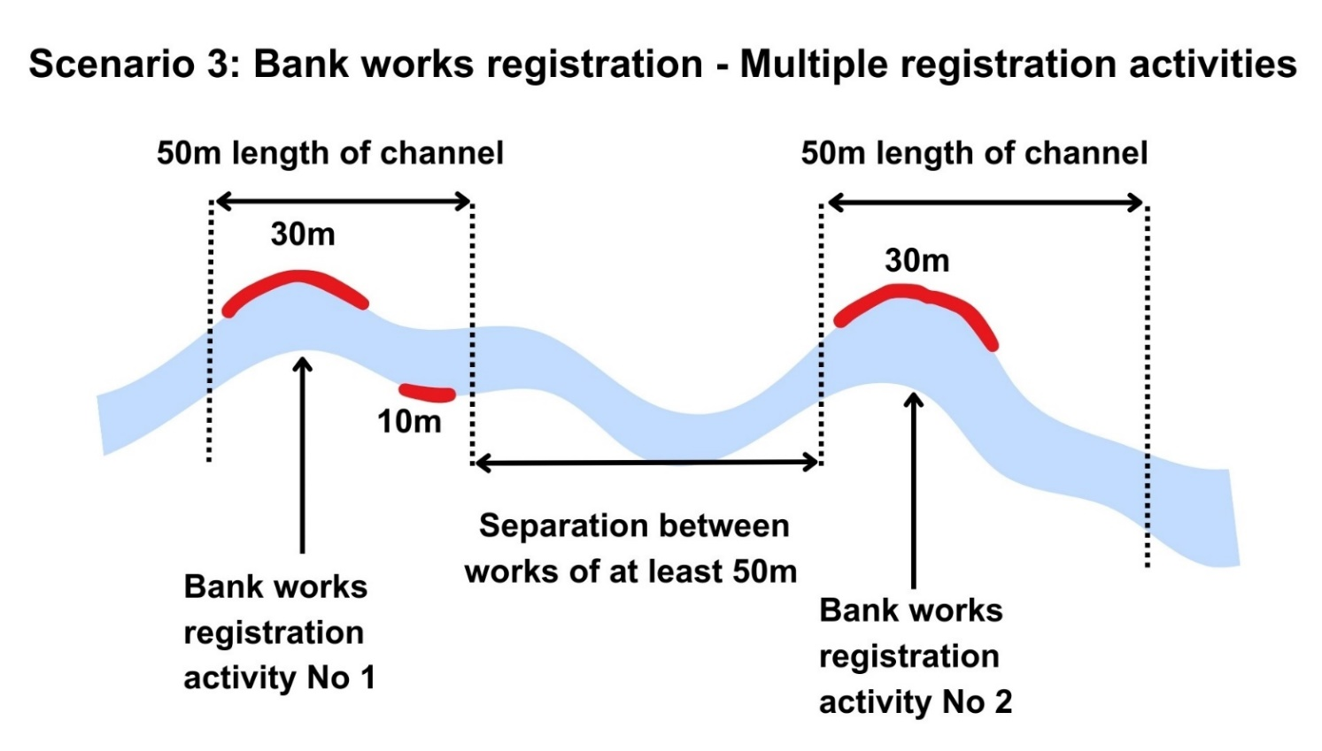
Figure A3 Diagram showing multiple bank works registration activities which are separated by a gap of at least 50 metres where no other bank works is taking place.

When would a permit application be required for Bank Works?

Scenario 4: Some scenarios which will require a Permit application.
- A single length of bank works affects more than 50 metres of bank.
- Multiple lengths of bank works affect more than 50 metres of bank: affecting one or both banks within a single continuous 50m length of channel.
- Multiple lengths of bank works (on one or both banks) where the gap between lengths is less than 50m.
- Standard conditions cannot be complied with.
Some of these are shown in the Figure A4 below:
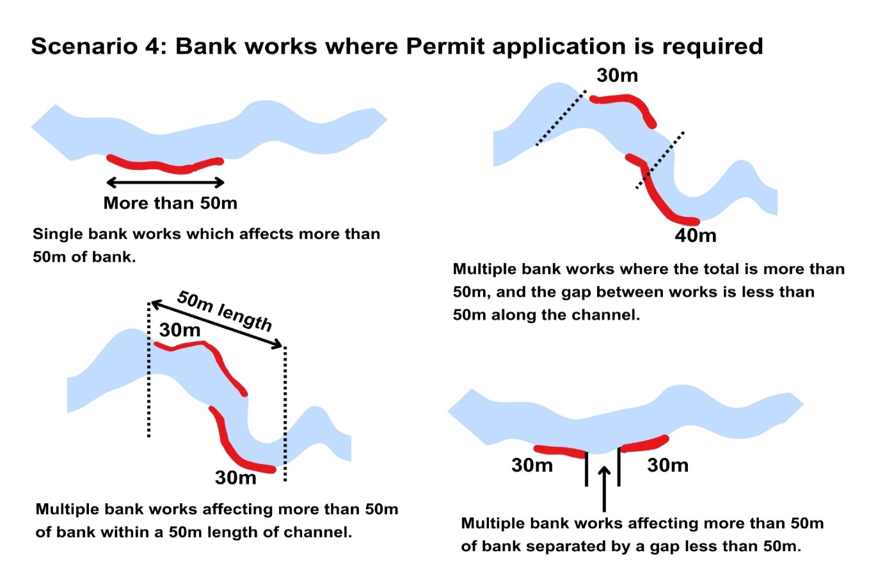
Figure A4 Diagram showing multiple scenarios where a permit application would apply.

