


IND-G-001

EASR guidance:
IND-G-001 Version 1.0 August 2025
General Binding Rule activity Crushing and screening

Contents
Introduction 1
What does this guidance apply to? 1
Crushing and screening process 2
Overview of process 2
Diagram 1: Flow diagram of crushing and screening process 3
Types of crushing plant 4
Jaw crushers 4
Rotary impact crushers 4
Cone crushers 4
Pulverisers (munchers) 4
Types of screens 4
Diagram 2: Overview of a mobile crusher 5
Crushing and screening sites 6
Demolition waste sites 6
Quarries 6
Environmental controls 7
Site design and infrastructure 7
Water for dust suppression 8
Dust arrestment 8
Stockpiles 9
Protection of the water environment 9
Management techniques 10
Management 10
Maintenance 10
Operator training 11
Resource use and efficiency 11
Raw materials 12
Water 12
Waste 12
Heat 12
Energy 12
Interpretation of terms 13

If you would like this document in an accessible format, such as large print, audio recording or braille, please contact SEPA by emailing equalities@sepa.org.uk

Introduction
This document provides information and guidance for anyone undertaking a crushing and screening activity which may be authorised under the General Binding Rules (GBRs) for such activity in the Environmental Authorisation (Scotland) Regulations (EASR). It should be read alongside GBR1 in Chapter 4 of Schedule 9 of EASR.

What does this guidance apply to?
This guidance applies to:
- The crushing, grinding or other size reduction of any designated mineral or mineral product.
- The crushing, grinding or other size reduction using machinery designed for that purpose of waste bricks, tiles, concrete.
It also applies to:
- Pre-screening of demolition material prior to crushing.
- Screening of any graded material.
- The temporary storage of materials used or generated as part of the activity including the raw material feed, mid-process stockpiles and the storage of product at the place of production.
Crushing and screening equipment can be either:
- Mobile plant (designed to move): usually associated with demolition and construction sites.
- Static: usually associated with quarries.
For waste bricks, tiles and concrete arising from demolition processes, the authorised activity is restricted to the place where the material is produced or where the recovered aggregate is to be used, for example at another nearby construction site. This means that if waste bricks, tiles and concrete are crushed and/or screened at a third-party site, the activity will require a waste Registration or Permit.

Crushing and screening process

Overview of process
Crushers can be used to reduce the size of raw materials like rocks and large stones as well as construction and demolition waste like concrete, bricks and tiles. Screening separates materials into different sizes or grades based on size and can take place before and after crushing. Material is moved from stockpiles and fed to the crusher and screened as described in Diagram 1 on the next page.
Crushers and screens may be moved between stockpiles on site, and between sites, usually by low loader.

Diagram 1: Flow diagram of crushing and screening process

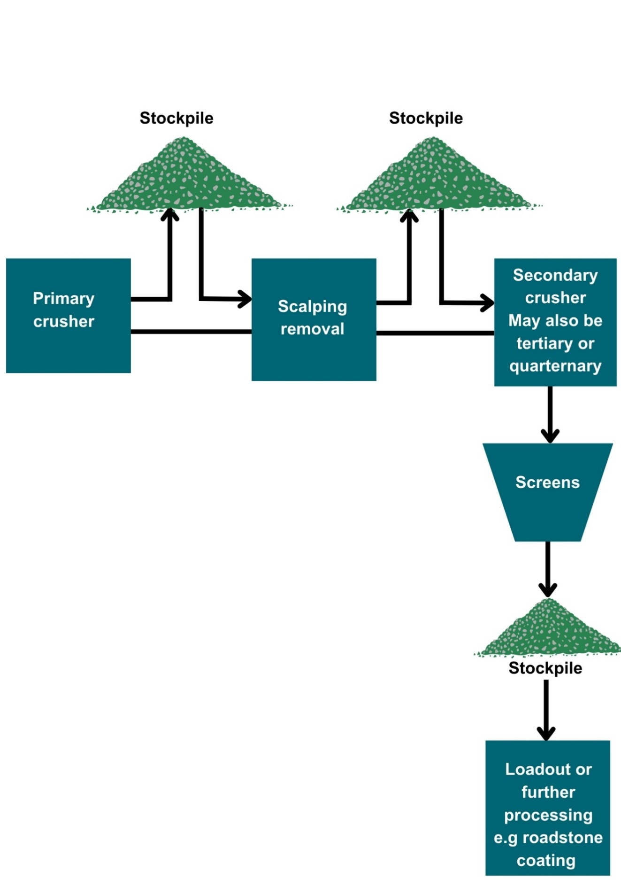

Types of crushing plant
Jaw crushers
Material is loaded through an opening and is broken apart by an active jaw crushing material against a stationary jaw.
Rotary impact crushers
Material is repeatedly struck by rotating metal “blow bars” and thrown against the wall of the chamber.
Cone crushers
The crushing takes place between a revolving cone that presses material against the cone wall. Cone crushers are secondary crushers, usually material will have gone through a rotary impact or jaw crusher beforehand.
Crushing plant can be free-standing units or attachments to be fitted to other plant such as an excavator. Mobile crushers are usually the tracked type which means they are delivered to site via low loader and can be set up and dismantled quickly. Diagram 2 showing the overview of crusher is provided on the next page.

Pulverisers (munchers)
Concrete crushing attachments, known as pulverisers, are attachments for excavators that break concrete into small pieces and can cut through any embedded rebar allowing the concrete to fall to the ground.

Types of screens
Screens are commonly used to sort materials before crushing as well as after crushing. Their purpose is to separate material subject to particle size. Larger material is sometimes processed repeatedly in secondary or tertiary crushing units, screened again and stockpiled.
The screens are essentially large sieves. They vibrate or rotate which causes the particles to be moved across the screen – smaller material falls through the screen while larger material is moved forward and away. Screens can be integrated in the mobile crushing unit or can be free-standing mobile plant.
Examples of types of screeners include:
- Trommels – perforated rotating drums that roll the material around.
- Vibrating screens – most are on an inclined plane that is in constant motion.
- Disc screeners – mounted rotating shafts. Each shaft includes a series of mounted discs. Undersized material falls through spaces between discs.

Diagram 2: Overview of a mobile crusher

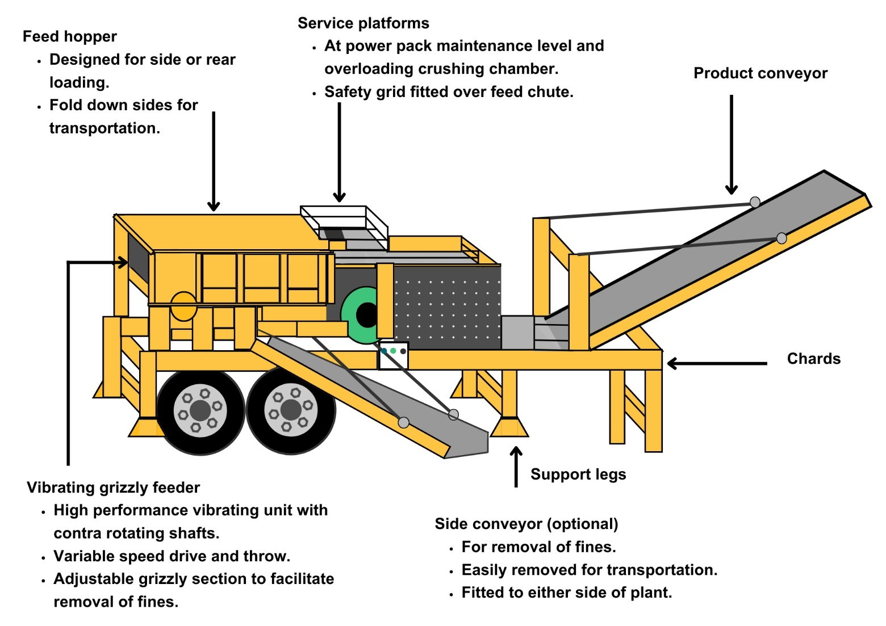

Crushing and screening sites

Demolition waste sites
Mobile crushing plant is often used on sites to process demolition waste for use on the same site or a nearby site for construction, for example as backfill, or for the construction of access roads and parking bays. Demolition waste can also be recycled to meet certain requirements. Information on this can be in SEPA guidance Recycled Aggregates from Inert Waste.
Recycling onsite materials reduces the need to transport primary aggregate to the site and diverts the waste from landfill. While it is usually preferable to recycle materials as much as possible in situ, it may in some cases better to remove it to a dedicated construction and demolition waste recycling site to achieve an optimal final product.

Quarries
Where crushing or screening plant is in operation at a quarry this guidance applies to that activity.
At quarries ‘hard rock’, which has been extracted by quarrying, is crushed and sized and primarily used as construction aggregates. Softer rock like limestone and dolomite are also crushed and often used to manufacture lime, cement and other fine powders for use as feedstock for industrial processes.
At sand and gravel quarries, material is excavated with a mechanical shovel and conveyed to plant where it is crushed, washed and screened. Usually, the material is wet so it doesn’t give rise to dust emissions, but the GBRs apply if there is the potential for dust emissions from the process.

Environmental controls
It is expected that the methods described in this section are utilised to control emissions from crushing and screening activities. Where other methods are used, they should offer at least an equivalent level of environmental protection.
Containment and/or enclosure of dusty processes, and water suppression, or both are considered the best ways to control dust emissions from the crushing and screening activities. Measures to ensure protection of the water environment from water used to suppress dust should also be implemented.

Site design and infrastructure
- Where activities are taking place indoors, process buildings must be as dust tight as possible and fitted with self-closing doors and close-fitting entries and exits for conveyors.
- Where local exhaust ventilation is used within a building, dust arrestment of these emissions will be necessary.
- The method of collection of dust from dry arrestment plant should be done in a manner that does not create dust emissions.
- Conveyors and discharge points to and from conveyors must be enclosed.
- Crushing, grinding, screening and separation processes and associated plant must be enclosed, and/or water sprays must be in use when these processes are being carried out.
- Drop heights must be minimised by using:
- Variable height conveyors.
- Chutes.
- Surfaces subject to vehicle movements should have a consolidated surface which is kept in good repair.
- Consideration should be given to the site layout to minimise vehicle movements and the double handling of dusty materials. The number of movements of materials must be minimised.
- Vehicles entering or moving around the site should have exhaust pipes that do not point downwards to minimise fugitive dust emissions.
- Vehicles transporting dusty materials should be covered and the loading and unloading of dust materials must be shielded from the wind.
- A wheel-wash for vehicles leaving the site may be necessary.
- House-keeping and cleaning should be to a high standard. There should be no significant deposits of dust in process buildings or on equipment.

Water for dust suppression
- Adequate water supply must be available to ensure dust suppression can take place when needed.
- Non-mains fed tanks should be fitted with low level alarms.
- The water suppression system should be equipped to ensure it is protected from frost.

Dust arrestment
- Arrestment equipment must be:
  - Designed to emit less than 50mg/m³ of dust.
  - Fitted with continuously indicative monitor which provides visual and audible notification when 75% of the emission limit is reached.
- Arrestment equipment must be regularly checked and maintained to ensure it is fully operational.

Stockpiles
- Stockpiles of dusty material should be sited away from the site boundary. The prevailing wind direction, and proximity of neighbours should also be taken into consideration.
- Stockpiles must be:
- Fully covered.
- Shielded using wind-breaks, bunding or fencing.
- Profiled so as to reduce wind-whipping.
- Water suppression equipment of stockpiles must take place regularly.
- Movements of material to and from stockpiles must be made in a manner that minimises fugitive dust emissions e.g. use of water spray bars at the discharge point from conveyor to stockpile, rubber socks, or low discharge heights.

Protection of the water environment
- Buffer zones should be created around water bodies where dust suppression activities are prohibited or restricted to prevent any potential contamination. Vegetative strips or silt fences should be used as physical barriers between the work area and water bodies to capture any potential runoff.
- Containment measures such as bunding, berms or dykes should be used around the site to prevent runoff or spillages from entering nearby water bodies.
- Areas where dust suppression is being carried should not slope toward water bodies, reducing the risk of water runoff entering the environment.
- Drip pans or liners should be placed underneath vehicles or equipment used for dust suppression to catch any potential leaks or spills.
- Spill response kits and equipment should be readily available on-site to deal with any accidental releases of chemicals, water or oils that could potentially harm the water environment.

Management techniques
Good management techniques, training and well-maintained infrastructure are key to prevent and limit the consequences of accidents which could have an impact on the environment. For example, bunding should be used around liquid storage to contain any spillages, but good management and maintenance would take this a step further by ensuring that the integrity of the bunding is checked regularly to prevent leaks, and deliveries and movements around the site are well controlled. This will enable you to comply with environmental regulations, avoid incidents, and avoid any costs incurred through loss of resources.

Management
- Effective control of emissions starts with proper management, supervision and training for process operators.
- Implement an environmental management system to help identify and provide a systematic approach to manage, monitor and control your environmental issues and maintain efficiency. These can be certified through ISO 140001, BS8555 or EMAS but can also be in-house.
- Develop and maintain an emergency response plans e.g. specific actions for preventing and mitigating spills or runoff that may affect water bodies. For best practice and guidance please read CIRIA Guide to Containment Systems for the prevention of pollution (C736F).

Maintenance
Maintenance can be categorised as ‘preventative’ or ‘corrective’ (also known as ‘reactive’). Preventative maintenance includes regular planned checks, servicing and maintenance of equipment to prevent or reduce failures and breakdowns which can lead to pollution incidents, safety concerns and costly downtime. Corrective maintenance includes identifying and repairing a fault once it has occurred with the aim of restoring equipment.
- All aspects of the activity plant, buildings and equipment should be properly maintained and there should be a written maintenance programme with a record that the maintenance has been carried out.
- Equipment should be used properly and preventative maintenance carried out.
- Spares and consumables should be held on site so that rapid repairs can be carried out and there is no temptation to continue operating with ineffective emission controls in place.

Operator training
- Staff at all levels need to have training and instructions as to their duties to control emissions from the activity. This should include awareness of the SEPA GBR requirements and actions to take in the event of incidents that may result in emissions from the activity.
- A training record should be kept for each member of staff.

Resource use and efficiency
Best practice for resource use and efficiency is to review and implement any potential opportunities to reduce emissions and wastes. In addition to reducing the impact on the environment, you will also benefit because resource efficiency is also about:
- Reducing costs (raw material and waste disposal).
- Maximising output of product or service from a given level of materials and energy (competitive advantage).
- Finding an outlet for surplus materials therefore removing them from the waste chain.
- Helping Scotland achieve its goal of becoming a zero-waste society.
- Reducing pollution risks and avoiding reputational impacts.
Resources include water, raw materials, energy, fuel and wastes used and produced throughout a regulated process.

Raw materials
Raw material use should be managed by tracking stores and ensuring that all resources are stored appropriately to avoid contamination, spoilage or leaks. Automatic dosing equipment should be considered to ensure that optimum measured quantities are used throughout the process. LEAN methodologies that focus on reducing waste could be beneficial.

Water
Water should be stored in adequate containers and any pipework and taps maintained to avoid leaks and evaporation. Where possible use rainwater harvesting and recycled water.

Waste
Ensure waste is managed in line with the waste hierarchy (prevention > prepare for reuse > recycle > recover value > disposal). Segregate any waste and store appropriately to ensure that it can be managed as high up the hierarchy as possible.

Heat
Where heat is used or generated, ensure that optimum temperatures are maintained during the process; buildings, pipes and tanks should be insulated to minimise heat loss, and where possible any heat captured and used elsewhere.

Energy
Ensure energy is used efficiently across the site by monitoring energy use, ensuring any lighting, motors, compressors or other equipment is well maintained and working at optimum, rather than maximum, levels. Consider replacing with more energy efficient equipment during upgrades. Servicing to manufacturer’s recommendations and preventative maintenance, instead of only reactive maintenance after plant faults, are also important in ensuring equipment works optimally.

Interpretation of terms
Term | Definition
Aggregate | Inert granular materials such as sand, gravel or crushed stone used to make concrete or other construction material.
Designated mineral or mineral product | - Clay, sand and any other naturally occurring mineral other than coal or lignite.  - Metallurgical slag.  - Boiler or furnace ash produced from the burning of coal, coke or any other coal product.  - Gypsum which is a by-product of any activity.
Resource | Materials, water, waste, residues and energy used within, or produced from, the authorised activities and in any ancillary processes on site.

Disclaimer
This guidance is based on the law as it stood when the guidance was published.
Whilst every effort has been made to ensure the accuracy of this guidance, SEPA gives no warranty, covenant or undertaking (express or implied) regarding the fitness for purpose of, or any error, omission or discrepancy in this guidance. Reliance on its contents and the contents of any websites that are linked to or from this guidance is entirely at the user’s own risk. SEPA is not liable for any loss or damage that may come from using this guidance. This includes:
- Any direct, indirect and consequential losses.
- Any loss or damage caused by civil wrongs, breach of contract or otherwise.
SEPA reserves the right to depart from this guidance and take appropriate action as it considers necessary or appropriate. Operators are responsible for ensuring that they are compliant with the law. If necessary, independent legal / specialist advice should be sought.

